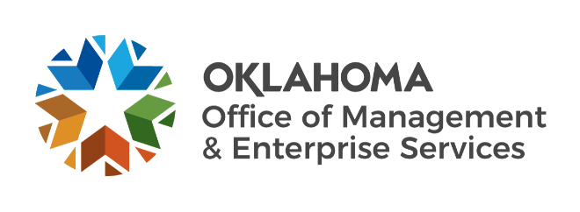

We are OMES recognition July 2022

June new hires – Welcome on board! Glad you have joined us.

BUDGET, POLICY AND GAMING COMPLIANCE
Joselyn Alonso, Budget and Policy Intern.

CAPITAL ASSETS MANAGEMENT
Dylan Jernigan, Maintenance Technician I.
Kevin Spinks, Maintenance Technician II.
Marcos Serna, Loss Prevention Specialist.

CENTRAL ACCOUNTING AND REPORTING
Elizabeth Harrell, Procurement Specialist.
Melody Kellogg, AR Accounting and Procurement Support.

HUMAN CAPITAL MANAGEMENT
Brayden Love, Civil Service Division Assistant.
Katherine Hansen, Legal Intern.

INFORMATION SERVICES
Collin McHugh, Network Technician Intern.
James Yother, Computer Support Technician.
Kristian Lynch, Service Desk Technician.
Michael Major, Temporary.
Robert Knittle, Cyber Operations Analyst.
Whitney DeCock, Applications Developer.

SERVICE OKLAHOMA
Kimberley Owen, Transition Manager.

June position changes – Congratulations! Keep up the good work.
Roy Garcia, Certified Public Accountant I to Financial Reporting Manager, Central Accounting and Reporting.
David Sinclair, Research and Resolution Manager to Reconciliation Manager, Employees Group Insurance Division.
Kelli Haddox, Accountant to Manager of Fiscal Reporting, Employees Group Insurance Division.
Lori Whittern, Group Management Specialist II to Group Management Manager, Employees Group Insurance Division.
Alan Field, Applications Developer to State Cost Efficiency Analyst, Information Services.
Deborah Kennington, Service Desk Technician to Service Desk Specialist, Information Services.
Isaac George, Technical Architect to Chief Technology Officer, Information Services.
Joshua Gibson, Executive Support Specialist to Sr. Security Analyst, Information Services.
Will El Assili, Sr. Security Analyst to Security Engineer, Information Services.

June longevity – Thank you! You are much appreciated.
Jeannette Pascher, 46 years of service.
Kristi Kime, 37 years of service.
Christi Duren, 30 years of service.
Mitchell Henry, 20 years of service.
DeAnn Robinson, 15 years of service.
Sarah Mouton, 15 years of service.
Tammy McDaniel, 15 years of service.
Juana Riley, 10 years of service.
LaDonna Newsom, 10 years of service.

Retirements – Best of luck! We will miss you.

JUNE
Johnny Burks, Application Services Manager, Information Services, 36 years of service.
Douglas Kellogg, Capitol Administrator, Capital Assets Management, 21 years of service.
Milton Bear, Applications Developer, Information Services, 11 years of service.

AUGUST
Catherine Fellingham, Insurance Benefits Specialist, Employees Group Insurance Division, 25 years of service.
Linda Pettet, Life Insurance Coordinator, Employee Group Insurance Division, 9 years of service.

