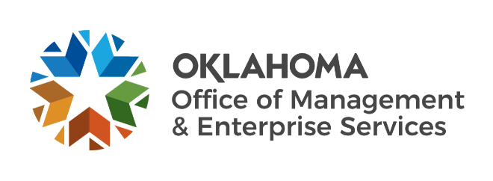

We are OMES recognition January 2023

December new hires – Welcome on board! Glad you have joined us.

CAPITAL ASSETS MANAGEMENT
Kendrick Britton, Material Management Specialist.
Rebecca Watson, Programs Coordinator.
Thomas Pendleton, Maintenance Technician II.
Tatiana Ryland, Central Printing Graphic Artist.

CENTRAL ACCOUNTING AND REPORTING
Dean Gregory, Financial Reporting Analyst.
Jarren Carter, Supplier Registration Specialist.
Lisa Escott, Accountant.

EMPLOYEES GROUP INSURANCE DIVISION
Brandi Smith, Former Employee Enrollment Specialist.
Carmen Silva, Accountant.

INFORMATION SERVICES
Anton Bondarev, Senior Security Engineer.
Bharadwaj Gadiraju, Data Analyst.
Jacob Herl, Service Desk Technician.
Karen Carlaw, Automation and Process Improvement Manager.
Lori Pierce, Senior Compliance Specialist.
Nomel Esso, Data Analyst.

SERVICE OKLAHOMA
Adam Snider, Communications Manager I.
Cassandra Patterson, Administrative Officer.
Robert Thompson, Videographer.

December position changes – Congratulations! Keep up the good work.
Bryan Ramsey, Reconciliation Specialist to Flexible Benefits Representative III, Human Capital Management.
Kinjal Patel, Benefits Account Auditor to Flexible Benefits Representative III, Human Capital Management.
Lisa Michael, Voice Communication Specialist to Computer Support Technician, Information Services.
Marc Brown, Contracting Specialist II to Statewide Contracts Supervisor, Central Purchasing.
Patrick Lucero, Executive Support Specialist to Computer Support Supervisor, Information Services.
Rebecca Thompson, Budget Analyst to Finance Manager, Service Oklahoma.
Trey Smith, Maintenance Technician II to Senior Operations Technician, Capital Assets Management.

December longevity – Thank you! You are much appreciated.
Charlise Kirk, 42 years of service.
David Dunn, 40 years of service.
Frank Branson, 37 years of service.
Rhonda Tollers, 37 years of service.
Jamie Motley, 25 years of service.
Patricia Nelson, 25 years of service.
Caitlin Owen, 10 years of service.
Matt Stewart, 10 years of service.
Michael Robinson, 10 years of service.
Asha Parks, 5 years of service.
Berry Mulford, 5 years of service.
Brittany Lee, 5 years of service.
Jerry Moore, 5 years of service.
Joseph Ewaniuk, 5 years of service.
Stephanie Portugal, 5 years of service.
Vonceil Plump, 5 years of service.

Retirements – Best of luck! We will miss you.

FEBRUARY
Richard Franks, Facility Administrator, Capital Assets Management, 44 years of service.
Frank Branson, Applications Developer, Information Services, 37 years of service.
Steve Funck, Deputy State Comptroller, Central Accounting and Reporting, 32 years of service.
Jin Jew, Information Systems Application Specialist, Information Services, 23 years of service.
Laurie Ryan, Program and Service Section Manager, Capital Assets Management, 23 years of service.
Paula McGaugh, Automotive Service Advisor/Writer, Capital Assets Management, 9 years of service.

