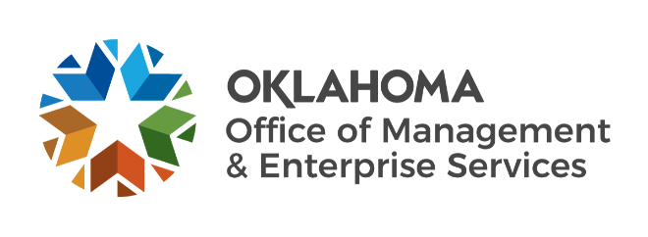

We are OMES recognition January 2022

December new hires – Welcome on board! Glad you have joined us.

EMPLOYEES GROUP INSURANCE DIVISION
Ashley Neely, Reconciliation Manager.
Lori Carroll, Research and Resolution Specialist.

GENERAL COUNSEL
Joshua Huckleberry, Deputy General Counsel.

INFORMATION SERVICES
Andrew Yoon, Service Desk Technician.
Barry Timberlake, Quality Specialist.
Charles Williams, Cyber Operations Analyst.
Evelyn Al-Batati, Computer Support Technician.
Jhavonne Tyner, Service Desk Supervisor.
Joshua Swenson, Senior Director of Network and Server Operations.
Matthew Freeze, Service Desk Technician.
Nagendra Sah, Service Desk Technician.
Otis Greenhoward, Service Desk Technician.
Randall Munsinger, Computer Support Technician.
Salim Khan, Quality Specialist.
Tyler Oravetz, IT Admin Intern.
Travis Reed, Computer Support Technician.

LEGISLATIVE AND PUBLIC AFFAIRS
Charles Ortega, Government Relations Director.

December position changes – Congratulations! Keep up the good work.
Adrienne Stroud, Executive Assistant to Event Coordinator, Administration.
Charles Fife, Network Administrator to Network Team Supervisor, Information Services.
Cody Duke, Fleet Specialist to Maintenance Technician I, Capital Assets Management.
Dana Dale, Deputy Director to Director of Internal Audit and Fiscal Analysis, Administration.
Evan Palmer, Network Support Specialist to Network Administrator, Information Services.
Jacob Thomas, Network Specialist to Network Technician, Information Services.
Joseph Ewaniuk, Senior Operations Tech to Operations Supervisor, Capital Assets Management.
Kevin Jernigan, Maintenance Technician II to Senior Operations Technician, Capital Assets Management.
Morgan Heard, Human Resources Specialist to Human Resources Business Partner, Human Capital Management.
Stacey Egelhoff, Network Technician to Technical Analyst, Information Services.
Stephanie Nicholson, Former Employee Enrollment Manager to Director of Member Accounts, Employees Group Insurance Division.
Timothy Verstraete, Service Desk Technician to Technical Analyst, Information Services.

December longevity – Thank you! You are much appreciated.
Janice Francis, 43 years of service.
Janice Wesley, 40 years of service.
David Dunn, 39 years of service.
Frank Branson, 36 years of service.
Rhonda Tollers, 36 years of service.
Nadim Haddad, 25 years of service.
Amy Southall, 20 years of service.
Janine Adams, 20 years of service.
Steven Laubach, 20 years of service.
Liz Brandon, 15 years of service.
Teresa Terry, 15 years of service.
Vicky Simpson, 10 years of service.

Retirements – Best of luck! We will miss you.

DECEMBER
Joe McCoy, Director of Internal Audit and Fiscal Analysis, Administration, 27 years of service.
Peter Lemmon, Applications Developer, Information Services, 26 years of service.
Richard Carson, Systems Analyst, Information Services, 16 years of service.
Susan Thompson, Systems Analyst, Information Services, 11 years of service.

JANUARY
Gary Nguyen, Information Systems Planning Specialist, Information Services, 33 years of service.
Eun Young Clifton, Applications Developer, Information Services, 32 years of service.
Edward Hou, Database Administrator, Information Services, 28 years of service.
Greg Nicholas, Facilities Technician, Information Services, 28 years of service.
JoAnn Muzny, Applications Developer, Information Services, 4 years of service.

FEBRUARY
Janice Francis, Asset Management Lead, Information Services, 43 years of service.
Paul King, Deputy Administrator, Employees Group Insurance Division, 35 years of service.

