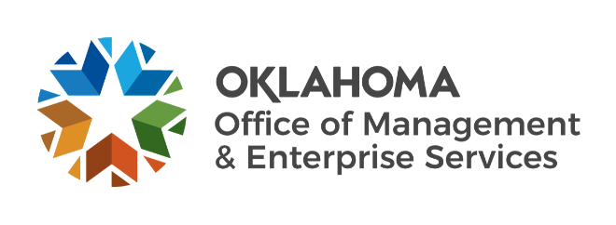

We are OMES recognition February 2022

January new hires – Welcome on board! Glad you have joined us.

CAPITAL ASSETS MANAGEMENT
Dalton Jernigan, Maintenance Technician II.
Gary Schellenger, Mechanical Systems Technician.
Maddison Knoch, Temporary.
Zara Raja, Real Estate and Leasing Services Intern.

CENTRAL ACCOUNTING AND REPORTING
Tammi Branton, Accountant.

CENTRAL PURCHASING
Melisha Platt, Procurement Specialist.

EMPLOYEES GROUP INSURANCE DIVISION
Daniel Williams, Policy Analyst.
Demenica Prince, Policy Analyst.
Forrest Stewart, Director of Compliance and Contracts.
Preston Cody, Project Manager.
Vanessa Ford, Accountant.

FINANCE
Sunu Abraham, Procurement Specialist.

HUMAN CAPITAL MANAGEMENT
Christine Eubank, Human Resources Business Partner.
Rachel Spitz, Human Resources Specialist.

INFORMATION SERVICES
Alexander Kalman, Network Support Specialist.
Alexander Stroud, Service Desk Technician.
Angat Yogi, Cybersecurity Intern.
Antoine Charles, Third Party Risk Specialist.
Connor Kunzmann, Service Desk Technician.
Cooper Catlege, Deputy General Counsel.
Dakota Rennels, Data Analyst.
Damien McCormick, Project Manager.
Destiny Elliott, Service Desk Technician.
Dustin Gregory, Security Engineer.
Grace Felter, Program Manager.
Holly Ivie, Computer Support Technician.
John Dill, Mobile Device Technician.
Kathleen McCullough, Program Manager.
Mario Valenciano, Service Desk Technician.
Michele Coffman, Network Support Specialist.
Radeana Rumpl, Administrative Assistant.
Shawn Kester, Service Desk Technician.
Steve Burton, Physical Threat Analyst.
Tina Dodson, Service Desk Technician.
Trent Dugas, IS Manager.

January position changes – Congratulations! Keep up the good work.
Alexus Coleman, Human Resources Business Partner to Training Coordinator, Human Capital Management.
Amy Spehar, Content Coordinator Supervisor to Outreach Manager, Information Services.
Ashley Neel, Director of Finance to Chief Financial Officer, Finance.
Carissa Terry, Director of Outreach to Director of Supply and Asset Management, Information Services.
Courtney Moore, Contracting Officer to State Assets Management System Manager, Capital Assets Management.
Denise Varley, Current Employee Enrollment Supervisor to Current Employee Enrollment Manager, Employees Group Insurance Division.
Jacob Meyer, Software Engineer to Modernization Manager, Information Services.
Lesli Bajema, Current Employee Enrollment Manager to Procurement Compliance Lead, Central Purchasing.

January longevity – Thank you! You are much appreciated.
William Dingler, 41 years of service.
Jacob Evans, 40 years of service.
Justin Baustert, 25 years of service.
Judy Jackson, 25 years of service.
Hongshing Lai, 25 years of service.
Deanna Ferron, 20 years of service.
Brandy Manek, 20 years of service.
Rhonda Spain, 20 years of service.
Clinton Moore, 15 years of service.
Shannon Newman, 15 years of service.
Colleen Flory, 10 years of service.
Casey Williamson, 10 years of service.
Kelsey Bridges, 5 years of service.
Megan Brondel, 5 years of service.
Melissa Flemings, 5 years of service.
Holly Gray, 5 years of service.
Anish Peringol, 5 years of service.
Harvey Weber, 5 years of service.

January retirements – Best of luck! We will miss you.
Gary Nguyen, Information Systems Planning Specialist, Information Services, 33 years of service.
Eun Young Clifton, Applications Developer, Information Services, 32 years of service.
Edward Hou, Database Administrator, Information Services, 28 years of service.
Greg Nicholas, Facilities Technician, Information Services, 29 years of service.
JoAnn Muzny, Applications Developer, Information Services, 4 years of service.

