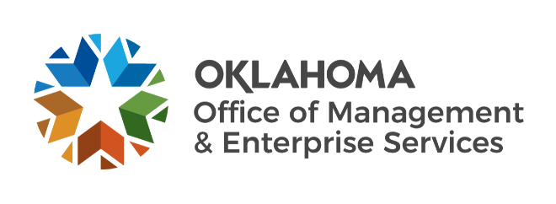

We are OMES recognition December 2022

November new hires – Welcome on board! Glad you have joined us.

CAPITAL ASSETS MANAGEMENT
Ronald Whisenhunt, Maintenance Technician II.

EMPLOYEES GROUP INSURANCE DIVISION
Dana Culton, Research and Resolutions Specialist.

FINANCE CENTER OF EXCELLENCE
Faisal Haq, PeopleSoft Administrator.

GRANTS MANAGEMENT OFFICE
Carrie Reddick, Grants Analyst.
Nicole Mukes, Reporting Analyst.
Ryan Sherer, Performance Analyst.
Stephanie Spencer, Grants Analyst.

HUMAN CAPITAL MANAGEMENT
McKenzie Black, Human Resources Business Partner.

INFORMATION SERVICES
Andrew Workman, Software Analyst.
Anna Martinez, Computer Support Technician.
Brian Davis, Applications Developer.
Dustin Claunch, Master Data Management Specialist.
Jeff Hardin, Computer Support Technician.
Kayla Statton, Computer Support Technician.
Leonard Davis, Computer Support Technician.
Randall Gollhofer, Computer Support Technician.
Mariam Reynolds, Business Analyst.
Matt Runkle, Data Engineering Manager.
Whitney Valdivia, Computer Support Technician.

SERVICE OKLAHOMA
David Dean, Writer and Copy Editor.

November position changes – Congratulations! Keep up the good work.
Joana Stenulson, Supplier Registration Specialist to Senior Registration Specialist, Central Purchasing.
Lesli Bajema, Procurement Compliance Lead to Procurement Services Manager, Central Purchasing
Blaine Bridges, Procurement Analyst to Procurement Manager, Central Purchasing.
Cameron Hall, Server Operations Support to Server Cloud Engineer, Information Services.
Raymond Brown, Asset Management Specialist to Computer Support Technician, Information Services.

November longevity – Thank you! You are much appreciated.
Richard Franks, 44 years of service.
Laura Custer, 37 years of service.
Gwen Martin, 36 years of service.
Aimee Pittman , 10 years of service.
Denise White, 10 years of service.
James Peno, 10 years of service.
Luciana Perez, 10 years of service.
Marissa Sockwell, 10 years of service.
Morris McKinney, 10 years of service.
Dustin Greenberg, 5 years of service.
Jacob Hurst, 5 years of service.
Kasey Heiderich, 5 years of service.

Retirements – Best of luck! We will miss you.

JANUARY
Terry Zuniga, Fleet Manager, Capital Assets Management, 17 years of service.
Nancy Romyak, Group Management Specialist, Employees Group insurance Division, 16 years of service.
Thomas Finch, Senior .NET Developer, Information Services, 16 years of service.
Sheri Diehm, Procurement Training Coordinator, Central Purchasing, 15 years of service.

