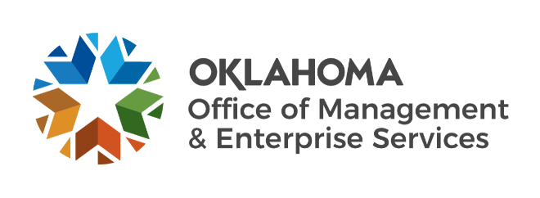

We are OMES recognition August 2022

July new hires – Welcome on board! Glad you have joined us.

ADMINISTRATION
Jeffrey Carlson, Sr. Director of Operations.

CAPITAL ASSETS MANAGEMENT
Jessica Hodges, Maintenance Management Systems Specialist.
Nathan Feldman, Maintenance Management Systems Specialist.

EMPLOYEES GROUP INSURANCE DIVISION
Jessica Brinton, Former Employee Enrollment Specialist.

FINANCE
Kaylee Martinez, Procurement Specialist.

HUMAN CAPITAL MANAGEMENT
Tara Walker-Price, HR Management Specialist.
Thomas Hill, Classification and Compensation Analyst.

INFORMATION SERVICES
Bailey Hein, Sr. Data Analyst.
James Huckleberry, Quality Specialist.
Kelly Thomas, ITOCC Manager.
Matthew Findley, Network Technician.
Matthew Highfill, Service Desk Technician.
Mehry Taremi, Deputy General Counsel.
Rachael Want, Deputy General Counsel.

July position changes – Congratulations! Keep up the good work.
Diedra O'Neil, Director of Business Optimization to Chief Strategy and Operations Officer, Administration.
Reagan Allen, Temporary to Procurement Specialist, Central Accounting and Reporting.
Tara Brown, Member Services Specialist to Group Management Specialist, Employees Group Insurance Division.
Tasneem Khan, Research and Resolution Specialist to Research and Resolution Manager, Employees Group Insurance Division.
Claudia Bounds, Peoplesoft Administrator to Finance Center of Excellence Manager, Finance.
Brayden Love, Civil Service Division Assistant to Mediation Program Manager, Human Capital Management.
Cara Guilfoyle, Business Analyst to Data Analyst, Information Services.
Lucille Hicks, Temporary to Systems Analyst, Information Services.
Randy Phan, Server Operations Support to Server Infrastructure Support, Information Services.
Scott Campbell, Project Manager to Program Manager, Information Services.

July longevity – Thank you! You are much appreciated.
Bich Pham, 38 years of service.
Glen Ryland, 25 years of service.
Lisa Livesay, 25 years of service.
Lori Whittern, 25 years of service.
Kirk Hager, 20 years of service.
Nguyet Kieu, 20 years of service.
Thomas Peter, 20 years of service.
Anthony Latham, 15 years of service.
Sheri Diehm, 15 years of service.
Christopher Lozano, 15 years of service.
David Mihm, 15 years of service.
Debbie Andrews, 15 years of service.
Miguel Samuels, 15 years of service.
Toshawnya Clay, 10 years of service.
Lamar Bridges Jr., 5 years of service.

Retirements – Best of luck! We will miss you.

AUGUST
Taffy Fellingham, Insurance Benefits Specialist, Employees Group Insurance Division, 25 years of service.
Linda Pettet, Life Insurance Coordinator, Employees Group Insurance Division, 9 years of service.

SEPTEMBER
Cathy Stephens, Principal Assistant, Employees Group Insurance Division, 32 years of service.
Linda Haley, Technical Account Manager, Information Services, 31 years of service.

