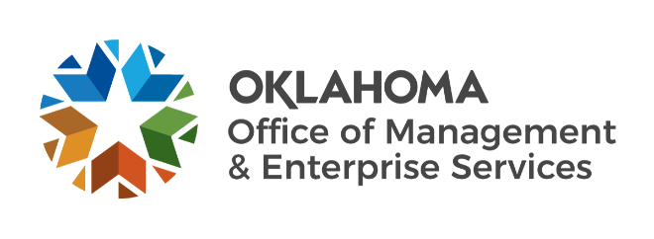

We are OMES recognition April 2023

March new hires – Welcome on board! Glad you have joined us.

AGENCY BUSINESS SERVICES
Kayla Beier, Accounts Receivable Accountant.
Lori Judkins, Accounts Payable Accountant.

CAPITAL ASSETS MANAGEMENT
Jeoffrey Brown, Maintenance Technician II.

CENTRAL ACCOUNTING AND REPORTING
Alexander Coleman, Payroll Specialist.
Amber Shawareb, Payroll Specialist.

CENTRAL PURCHASING
Samantha Fox, Procurement Specialist.

HUMAN CAPITAL MANAGEMENT
Robin Gagel, Human Resources Business Partner.

INFORMATION SERVICES
Adam Arnold, Computer Support Technician.
Avery Wilson, UI/UX Designer.
Billy Wagner, Senior .NET Developer.
Jim Norton, Computer Support Technician.
Josh Dowdy, Network Technician.
Josh Slaughter, Service Desk Specialist.
Patrick Mayfield, Applications Developer.
Paul Little, Program Manager.
Shari Wile, Systems Analyst.

March position changes – Congratulations! Keep up the good work.
Jeffery Martin, Maintenance Technician II to Construction/Maintenance Administrator II, Capital Assets Management.
Wednesday Shafer, Procurement Compliance Specialist to Compliance Supervisor, Central Purchasing.

March longevity – Thank you! You are much appreciated.
Charlyn Neal, 49 years of service.
Michael Bailey, 38 years of service.
Sherri Henderson, 37 years of service.
Marquisette Johnson, 35 years of service.
Eric Taylor, 25 years of service.
Darren Garvin, 10 years of service.
Vidya Karri, 10 years of service.
Lisa Kirk, 10 years of service.
Jesse Leveritt, 10 years of service.
Aaron Martin, 10 years of service.
Megan Meers, 10 years of service.
Samantha Castro, 5 years of service.

May retirements – Best of luck! We will miss you.
Cynthia Shackelford, Enterprise Programs Manager, Information Services, 42 years of service.

