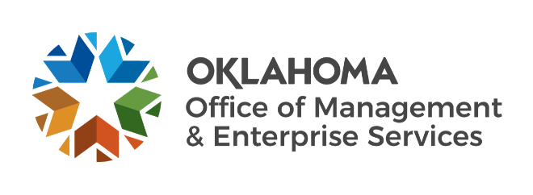

We are OMES recognition April 2022

March new hires – Welcome on board! Glad you have joined us.

CENTRAL ACCOUNTING AND REPORTING
Taylor Barnes, Supplier Registration Specialist.

EMPLOYEES GROUP INSURANCE DIVISION
Shannon Highsmith, Former Employee Enrollment Specialist.

HUMAN CAPITAL MANAGEMENT
Corina Sanchez, Human Resources Specialist.
Tonya Fugett, Human Resources Business Partner.

INFORMATION SERVICES
Brian Marcum, Computer Support Technician.
Christopher Mayo, Applications Developer.
Curtis Scott, Applications Developer.
Kevin Marshall, Business Process Executive.
Kirsten Tillett, Project Manager.
Michael Frye, Cyber Operations Analyst.
Noah McGehee, Systems Analyst.
Preston Smith, Computer Support Technician.
Seth Williams, Applications Administrator.
Tristan Fry, Cyber Operations Analyst.
Tyler Womack, Security Technician.

LEGISLATIVE AND PUBLIC AFFAIRS
Maria DeLoera, Content Coordinator Intern.
Kayla Pham, Content Coordinator Intern.

March position changes – Congratulations! Keep up the good work.
Amy Watkins, Procurement Assistant to Procurement Specialist, Central Accounting and Reporting.
Bart Magar, IT Operations Analyst to Network Administrator, Information Services.
Brittany Lee, Senior Financial Analyst to Finance Manager, Finance.
Egor Rusakov, Quality Specialist to Testing Analyst, Information Services.
Jake Lowrey, eGov Manager to External Communications Manager, Legislative and Public Affairs.
Jeff Jones, Network Technician to Computer Support Technician, Information Services.
Melissa Forrestier, Director of Statewide Operations to Director of Strategy, Capital Assets Management.
Sam Wegrzynski, Service Desk Analyst to Service Desk Technician, Information Services

March longevity – Thank you! You are much appreciated.
Charlyn Neal, 48 years of service.
Sherri Henderson, 36 years of service.
Stephanie Tomlinson, 30 years of service.
Collette Stender, 15 years of service.
Danny Ingram, 15 years of service.
Jon Trushenski, 15 years of service.
Preston Smith, 15 years of service.
Sacha Cason, 15 years of service.
Elyse Seals, 10 years of service.
Ben Bigler, 5 years of service.
Landon Jones, 5 years of service.
Lesli Bajema, 5 years of service.
Radeana Rumpl, 5 years of service.

Retirements – Best of luck! We will miss you.

MARCH
Mike Jones, Director of Construction and Properties, Capital Assets Management, 44 years of service.

APRIL
Latisha Edwards, Procure to Pay Manager, Central Accounting and Reporting, 34 years of service.
Esther Ward, Senior Programs Officer, Capital Assets Management, 27 years of service.
James Glover, Firewall Technician, Information Services, 27 years of service.
Lynne Bajema, State Comptroller, Central Accounting and Reporting, 26 years of service.

MAY
Roger Power, Maintenance Technician, Capital Assets Management, 43 years of service.
Cortis Crosby, Construction/Maintenance Technician, Capital Assets Management, 11 years of service.

