Exploring the Learn Center Homepage

This quick bit provides information regarding the navigation of the Learn Center homepage. Navigate to State of Oklahoma Learn Center and complete the login process.
Learn Center Login

User Login
Enter your user name and password. (User name will be your Employee ID and a temporary assigned password.) Select Enter.
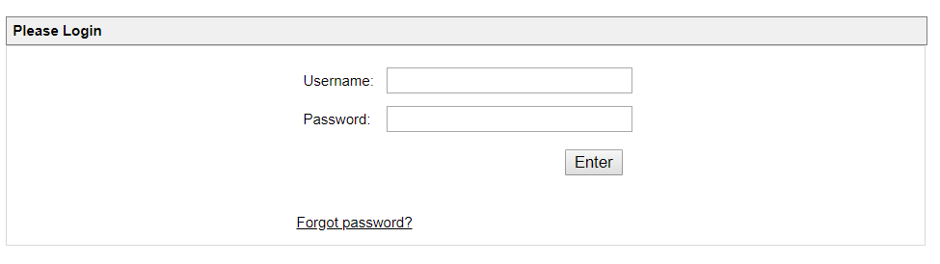
Note: If this is your first time logging on, you will be required to provide three security questions and change your password.
Note: With the exception of the agencies under Choose Your Learn Center, all state training opportunities will be housed in the HCM Learn Center.
Those agencies listed below will be able to enroll in agency-specific training by selecting their agency link. Refer to your agency learning administrators for information regarding agency-specific training.
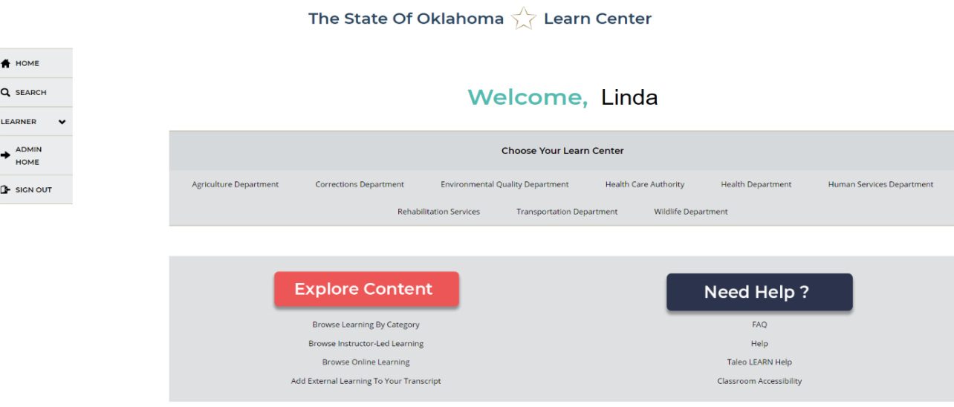

Explore Navigation Tabs
The HCM landing page includes the left tab list. Information regarding the LEARNER expanded tab is contained in the Learner User Navigation Quick Bits.
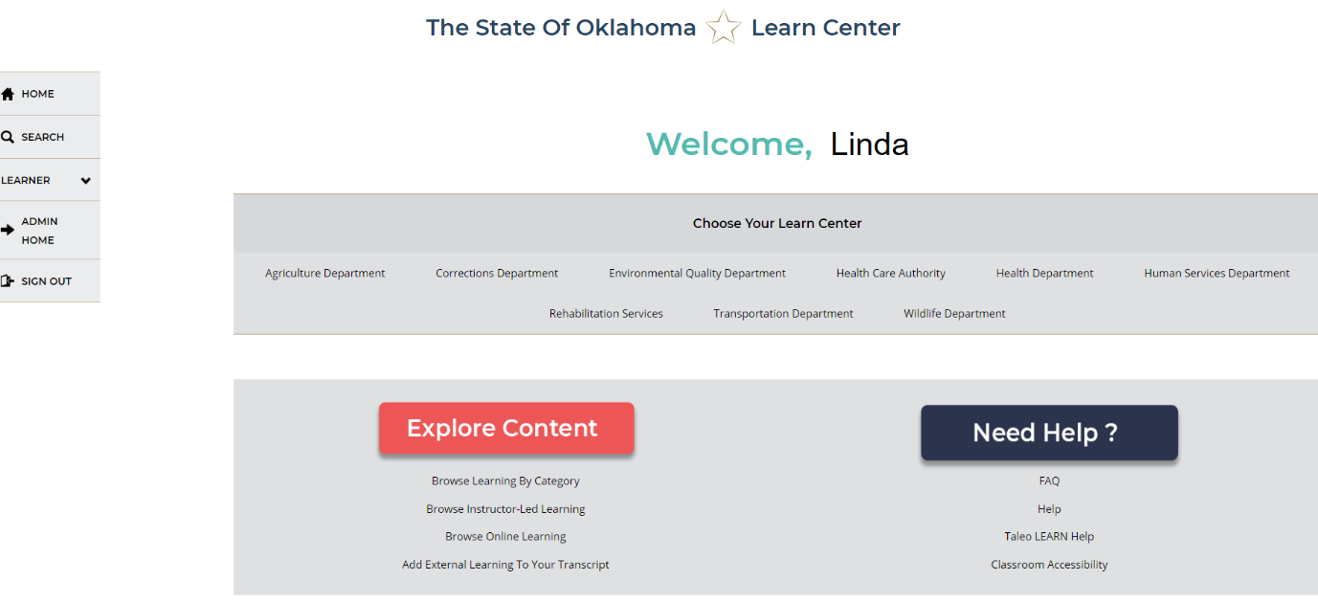
HOME returns the user to this landing page when navigating within the system.
The Search icon allows users to search for training by name. Type the name or part of the name of training, and a selection matching your search will appear.
For example, if you type Customer in the search, all training with Customer in the title will appear.
Note: You can also use the filtering options or the ADVANCED SEARCH option to further confine your search.
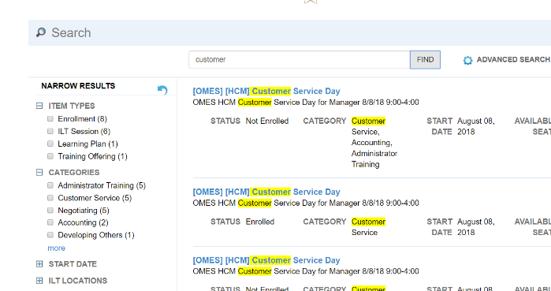
The SIGN OUT tab is where you can sign out of the LEARN system.
NOTE: There may be additional tabs, depending on user role of the employee. For example, a supervisor would have another tab for additional responsibilities. (See Supervisor Quick Bits for further information regarding the supervisor role).

Explore Links
On the screen are two boxes, Explore Content and Need Help? Each area has navigation links to make it easier for learners to enroll in training, view their details and get help.
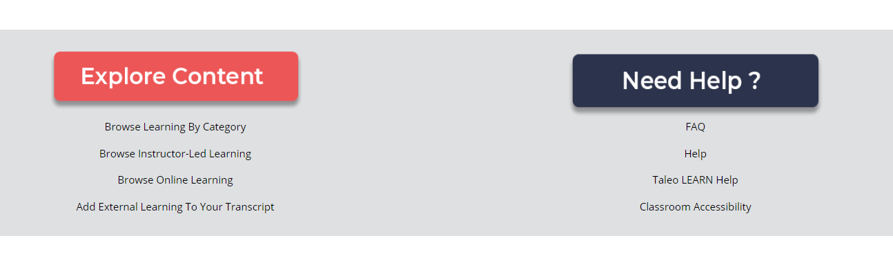

Explore Content
Explore Content allows you to filter to the type of training you want. You can Browse Learning By Category, Browse Instructor-Led Learning, Browse Online Learning or Add External Learning To Your Transcript.
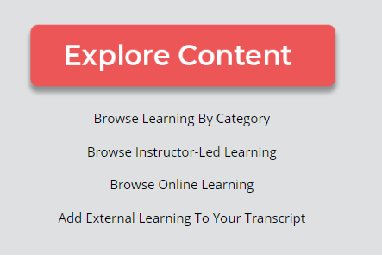

Browse Learning By Category
When you choose Browse Learning By Category, the screen changes to display category options. For ease of use, you can change the view from list to card view with the icons in the upper right corner of the window.
To see available training under a particular category, choose the category title.
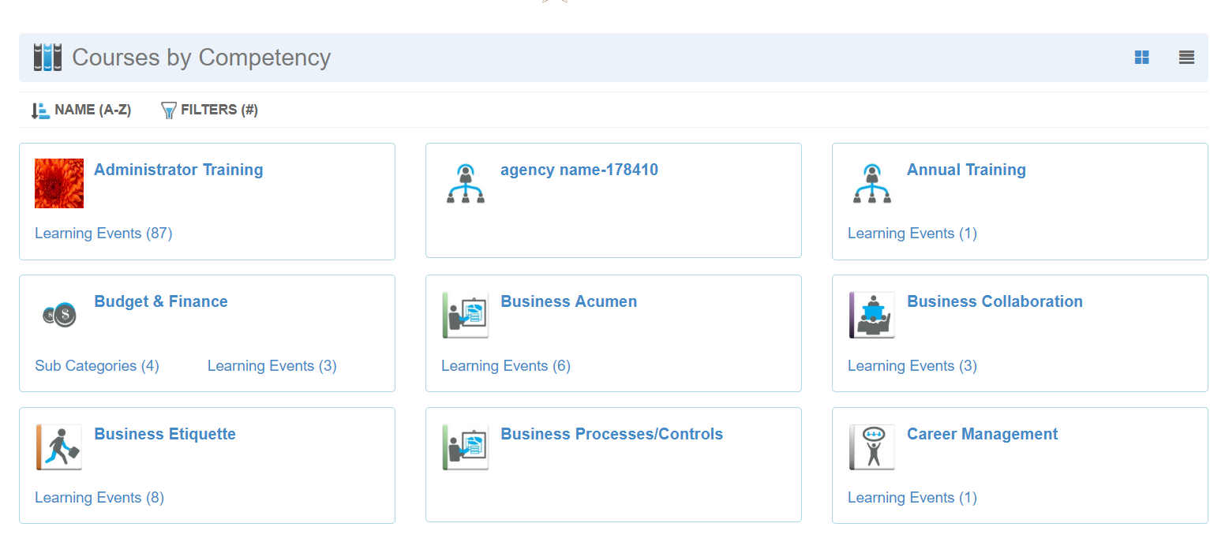

Browse Instructor-Led Learning
Choose Browse Instructor-Led Learning to filter by category only the training that is in classroom instruction.

Browse Online Learning
Choose Browse Online Learning to filter by category only to the training that is web-based.

Add External Training To Your Transcript
External training is all training that is not offered through the State of Oklahoma Learn Center or through an agency learn center. This can include conferences, training conducted by professional organizations, or training approved by a supervisor or agency.
To add that training, select the link Add External Training To Your Transcript. My Tasks window opens where you would enter external training. (See Common Learner Tasks.
Note: HCM employees must have supervisor approval before the training is added to the employee LEARN transcript. Agencies may have their own process regarding external training approval. For example, some agencies may require approval before uploading. See your learning administrator for guidance.

Need Help?
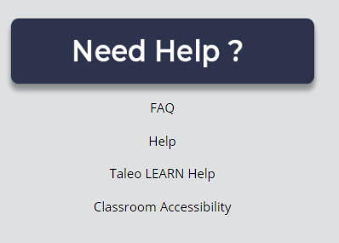
In this area, learners can find helpful resources such as FAQ (Frequently Asked Questions), access to LEARN training manuals, link to Taleo LEARN Help, and a Classroom Accessibility link to notify staff of accessibility needs for classroom/course training or testing.
Related Topics:
Learner Navigation Quick Bit
Common Learner Tasks

