Enabling Windows Updates on a Personal Computer
By default, Windows 10 automatically updates your computer. To ensure this is happening, follow the instructions below.
Note: The support lifecyle on Windows 7 has ended. More information on this can be found on Microsoft’s website.
- Go to the Start button, then Settings>Update & Security>Windows Update.
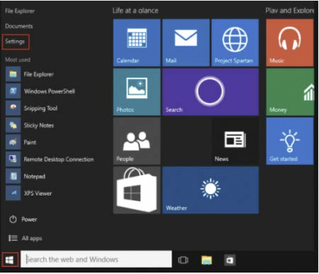
- Choose Check for updates if you want to check the updates manually.
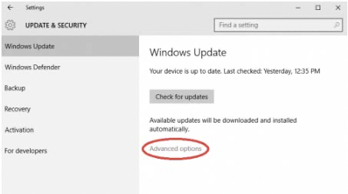
- Next, select ADVANCED OPTIONS, and then under Choose how updates are installed, select Automatic (recommended).
