Employee Self Service Manual

Revised: August 1, 2010

Authorized by: [_CORE_] Original Issue: [02/03/2009]
Maintained by: [____Training Lead___] Current Version: [08/01/2010]
Review Date: [12/30/2010]

Table of Contents

Document History 4
Employee Self Service 5
Objectives 5
Overview 5
Step I – Signing Into Your System 6
Step II – Changing My System Profile 10
Forgot Your Password 13
Overview 13
Step 1 14
Step 2 14
Step 3 15
Step 4 16
Step 5 17
Step 6 18
Personal Information Components 20
Personal Information Changes – Phone Number(s) 21
Personal Information Changes – Email Addresses 23
Personal Information Changes – Emergency Contact 25
View Only Access 30
View Paycheck 31
Payroll Advice 32
General 33
Tax Data 33
Paycheck Year-to-Date 33
Earnings 33
Taxes 34
Before Tax Deductions, After Tax Deductions and Employer Paid Benefits 34
Net Pay Distribution 34
View Leave Statement 35
Leave Accrual Report 35
Voluntary Deductions 36
Direct Deposit 36
Compensation History 37

Document History

Document Revision | Date | Description
1.0 | 07/01/2004 | Initial Document
1.1 | 06/15/2009 | Revised to update screen shots to comply with Federal Section 508 accessibility standards
1.2 | 06/25/2009 | Included the General Profile Page
1.3 | 09/17/2009 | Included reminder concerning year-to-date totals that are only reflected on the most current paycheck
1.4 | 10/22/2009 | Provided leave balances reflected in hours, as well as message and reminder about printing the payroll advice.
1.5 | 02/24/2010 | Inserted Forgot Your Password Section
1.6 | 03/31/2010 | Activation of the Employee Self Service account will be provided by the OSF Help Desk. The Leave Statement was added.
1.7 | 05/18/2010 | Clarification of screen shots for ADA compliance.
1.8 | 07/20/2010 | Standardizing the CORE manuals.
1.9 | 08/01/2010 | Revised View Paycheck to print on one page.

Employee Self Service

Objectives
- Sign On and Navigate
- Update Records
  - Phone Number
  - Email Address
  - Emergency Contacts
- View Records
  - Personal Information Summary
  - Paycheck
  - Leave Accrual Statement
  - Voluntary Deductions
  - Direct Deposit
  - Compensation History

Overview

Employee Self-Service, (ESS) is a web-based application that provides employees with information related to their employment. The release of ESS provides the employee the ability to view and maintain human resource and payroll data in the Human Resource/Payroll System.

ESS provides an excellent opportunity for you to ensure that the HR/Payroll information is accurate and kept up to date. The information can affect the accuracy of your employment data, including the pay and benefits you receive.

One of the advantages of the ESS system is the data in real-time data. The following table describes the components that will be used.

Page Name | Page Description
Personal Information | Personal Information Summary, Phone Numbers, Email Addresses, Emergency Contacts
General Profile Information | Password, Personalization’s, Alternate User, Workflow Attributes, Email
Payroll and Compensation | View Paychecks, Voluntary Deductions, Direct Deposit, View Compensation History

Step I – Signing Into Your System

- Call the Office State Finance Help Desk to activate your Employee Self Service Account

OSF Help Desk Phone Numbers: 405 521-2444 or 866 521-2444 (Toll Free)

- Open your Internet web browser – Explorer.

- Enter Employee Self Service Link: https://corehr.ok.gov/mrhri/signon.html

- You may see a security alert message; click to proceed.

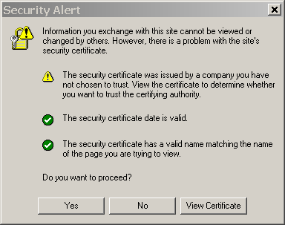

The PeopleSoft sign-in page will appear:
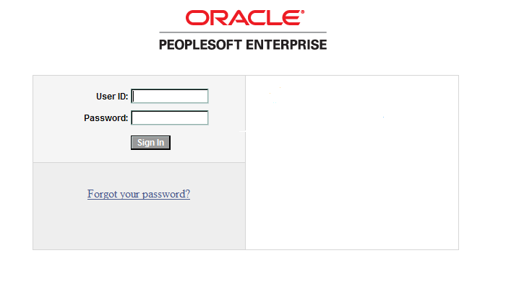

- Enter your User ID and the Password supplied by the OSF Help Desk. User ID and Password are case sensitive.

User ID – your 6 digit Employee ID

Password: – The initial password will be provided by the OSF Help Desk.

OSF Help Desk Phone Numbers: 405 521-2444 or 866 521-2444 (Toll Free).

NOTE: Passwords always appear as asterisks in the display as you type them. If the password is entered incorrectly three (3) times, ESS will automatically lock out the user. After the initial log in, if you stop before the third incorrect entry, you may still use the Forgot Your Password link to reset your password. To have your password reset due to lock out, call the Office of State Finance Help Desk Phone Numbers are 405 521-2444 or 866 521-2444 (Toll Free).

Click .

The PeopleSoft online system will validate your User ID and Password.
The first time you sign on to the system the Change your Password screen will appear.

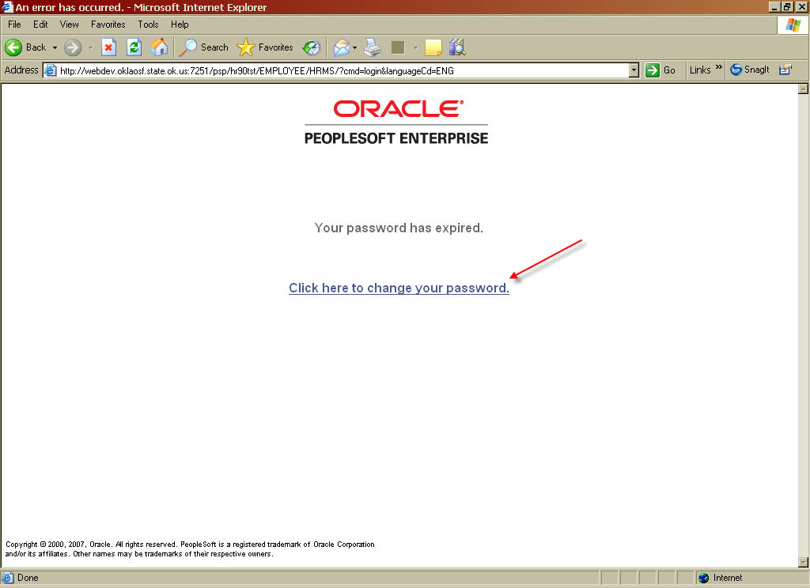

- Click Click here to change your password link.

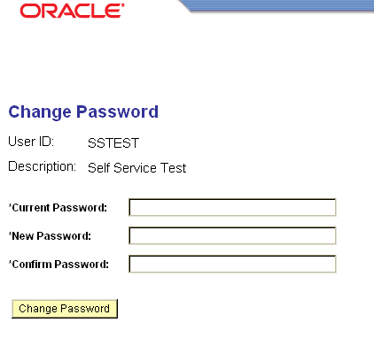

Current Password – When you call the OSF Help Desk, you will receive the initial/current password. An asterisk (*) in front of a field indicates it is a required field to complete.

New Password – Type in a new password. New password must be at least 8 (eight) characters and contain at least 1 (one) number. You can use both CAPITAL and/or lower case characters. Your password will expire every 90 days.

Confirm Password – Retype the new password.

Click 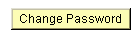 and the following message will appear.
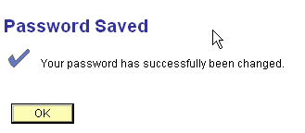

Click .

The system will display the following:

NOTE: There are three (3) menu options on the top right hand corner of the web page Home, Help, and Sign out.

- Home link will take you to the first page. If you get lost, selecting Home will bring you back to the beginning.
- Sign Out link will log you out.
- Help link is not functional, at this time.

Step II – Changing My System Profile

In order for the Office of State Finance Help Desk to ensure you are the person requesting a password reset, you must complete the General Profile Information Page under My System Profile link. In addition, in order for you to use the Forgot Your Password steps, you must have completed the Change or set up forgotten password help process.

Navigation: My System Profile

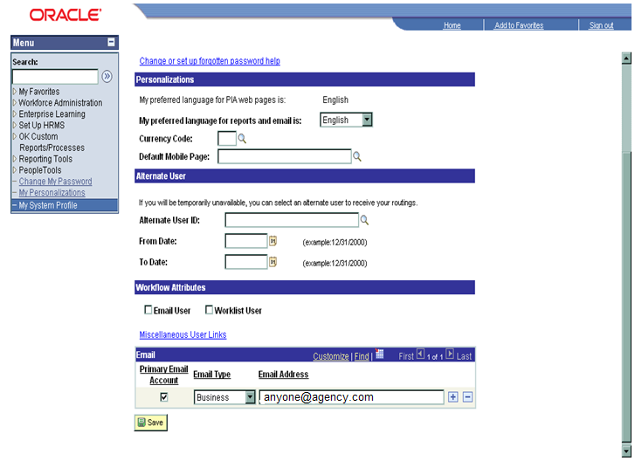

Click Change or set up forgotten password help link.
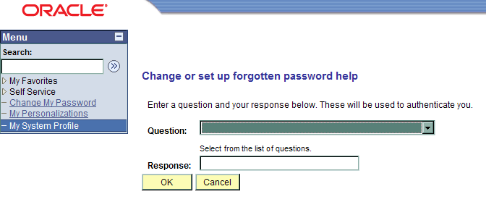

Question – Select drop down menu and choose a question.

Response – Enter the answer to the question selected.

Click .

The Personalization’s and Alternate User sections will not be utilized at this time.

In the Email Section: Select the Primary Email Account box, on the Email Type field, click drop down menu and choose Business and in the Email Address field enter your agency’s Email address. To add another e-mail address, click , choose Email Type and enter email address. If more than one (1) type of Email is entered, one (1) of the Emails must have the Primary Email Account box checked. If you do not have Email, enter your supervisor’s Email address.

NOTE: The Emails on the General Profile Information Page and Personal Information Page provides separate functions within the various PeopleSoft modules. After the Email(s) have been entered on both pages, the system will provide employees with proper and timely notifications.

REMINDER: Your Email(s) must be updated whenever there is a change to the address.

Click .

Forgot Your Password

Overview
In the Employee Self Service, (ESS) application, there is a capability to Reset your own password after the initial log-in, however, you must be aware of a few issues.

NOTE: If you have not previously set up your challenge question in the My System Profile link within ESS application, please call the Office State Finance Help Desk at 405 521-2444 or 866 521-2444 (Toll Free) to reset your password.

NOTE: If the password is entered incorrectly three (3) times, ESS will automatically lock out the user. If you stop before the third incorrect entry, you may still use the Forgot Your Password link to reset your password. To have your password reset due to lock out, call the Office of State Finance Help Desk Phone Numbers are 405 521-2444 or 866 521-2444 (Toll Free).

Following are dates when ESS will not be available.

Maintenance Schedule:

- 2nd Saturday of each month
- 4th Saturday of each month
- 2nd Weekend of each quarter

Maintenance Schedule Link:
http://www.ok.gov/OSF/OSF_Help_Desk/Helpdesk_-_PeopleSoft_System_Availability.html

Step 1

Click Forgot your password? link.

Step 2

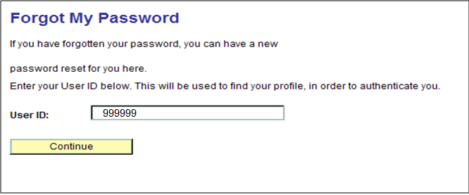

In the User ID Field: Enter your six (6) digit Employee User ID number.

Click .

Step 3

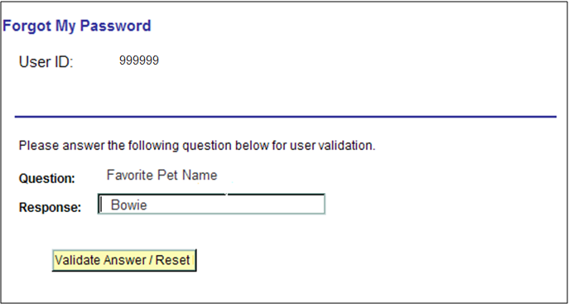

System Prompts: Security Question you previously answered.

In the Response Field, enter your response to the question.

Click .

Step 4

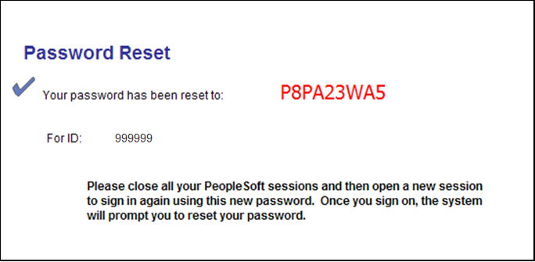

The reset password is temporary.

SUGGESTION: Write down the Temporary Password and note the Temporary Passwords are a mixture of numbers and CAPITAL letters.

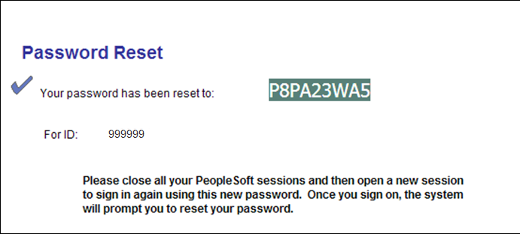

Highlight and copy the RESET CODE. HINT: Use Control C to copy the Reset Code.

Exit Employee Self Service.

Click File

Click Exit.

Step 5

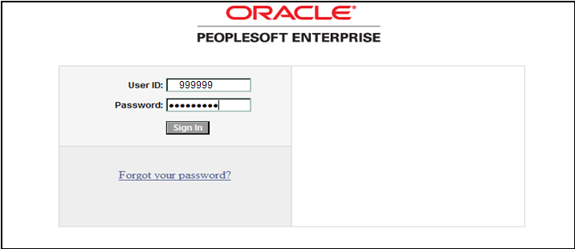

Log into Employee Self Service.

Employee Self Service Login Link: https://corehr.ok.gov/mrhri/signon.html

Enter User ID Number. In the Password field type the Temporary Password or:

Hint: Control V will paste the previously copied temporary password.

System Prompts: “Your password has expired.”

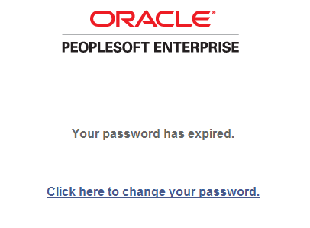

Click link: Click here to change your password.

Step 6

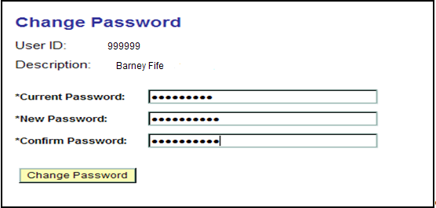

In the Current Password field, type the Temporary Password.
REMEMBER: Temporary Passwords are a mixture of numbers and ALL CAPITAL letters.
HINT: Control V will paste the previously copied temporary password.

Enter New Password: The password must be eight (8) characters and include at least one (1) number, and cannot be a previously used password and characters can be upper and lower case.

Enter New Password in the Confirm Password field.

NOTE: The Confirm Password field must be entered exactly as the New Password field. If the password is entered incorrectly three (3) times, ESS will automatically lock out the user. If you stop before the third incorrect entry, you may still use the Forgot Your Password link to reset your password. To have your password reset due to lock out, call the Office of State Finance Help Desk Phone Numbers are 405 521-2444 or 866 521-2444 (Toll Free).

Click .
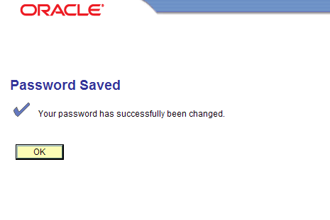

To save your new password, click .

You have successfully reset your password and should be viewing the ESS Main menu page.

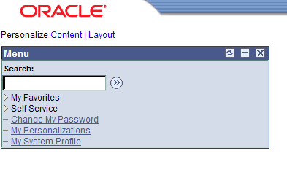

Personal Information Components
Navigation: Self Service > Personal Information > Personal Information Summary

The system displays the following:

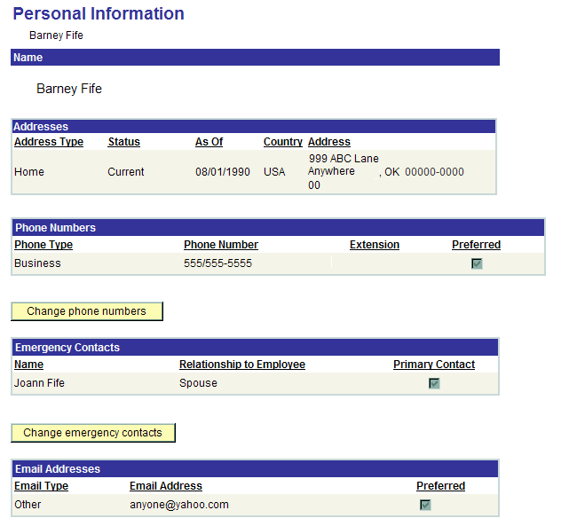

EXCEPTION: The employee will not be able to update any of the information on the Personal Information Page if your agency has chosen View Only. On the Personal Information Page, the employee will only be able to view their personal information. Contact your Agency’s Human Resource Division if changes to the data are required.

Personal Information Changes – Phone Number(s)

Navigation: Self Service > Personal Information > Phone Numbers

The system will display the following:

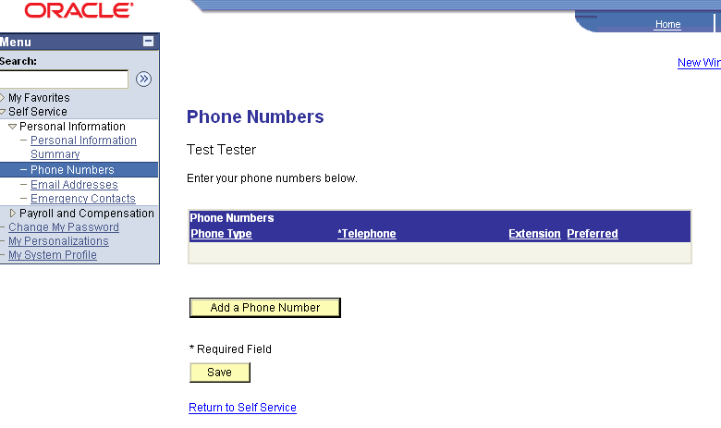

Click 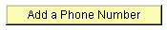 and the fields will become available.

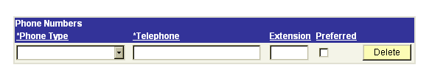

Phone Numbers Phone Type – Select drop down menu and choose Phone Type.
Telephone – Enter phone number.
Extension – Enter Extension, (if part of phone number).
Preferred box – Select for the preferred phone number.
Click at the bottom of the page.

Add additional Phone Numbers

Click and a blank row will be added.

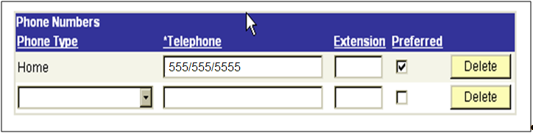

Phone Numbers Phone Type – Select and choose Phone Type.

Telephone – Enter phone number.

Extension – Enter Extension, (if part of phone number).

Preferred box – Only one box must be checked as preferred.

Click .

NOTE: To change/correct previously entered phone numbers, type over the exiting data or click .

Click .

Personal Information Changes – Email Addresses

Navigation: Self Service > Personal Information > Email Addresses

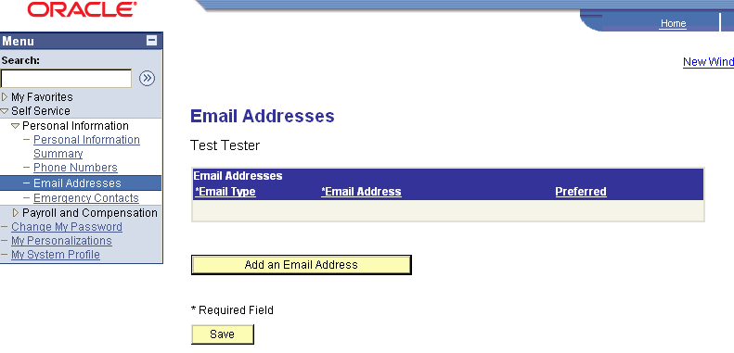

Click and the fields will become available.

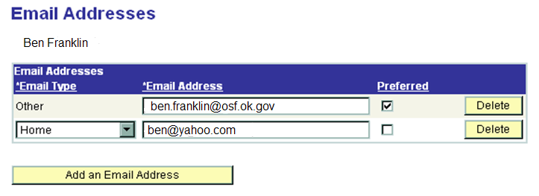

Email Type – Select drop down menu and choose Other as the Email type.

Email Address – Enter agency Email address and check the preferred box. Click to add another type of Email. If more than one (1) type of Email is entered, one (1) of the Emails must have the Preferred box checked. If you do not have Email, enter your supervisor’s agency Email address.

NOTE: The Emails on the General Profile Information Page and Personal Information Page provides separate functions within the various PeopleSoft modules. After the Email(s) have been entered on both pages, the system will provide employees with proper and timely notifications.

REMINDER: Update your Email(s) whenever there is a change.

Click .
Add Email address.

Click and a row will be added.

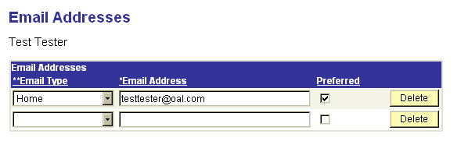

Email Type – Select drop down menu and choose Email type.

Email Address – Enter Agency Email address. One (1) of the Emails must have the Preferred box checked.

Click at the bottom of the page.

REMINDER: Update your Email(s) whenever there is a change.

Personal Information Changes – Emergency Contact

Navigation: Self Service > Personal Information > Emergency Contact

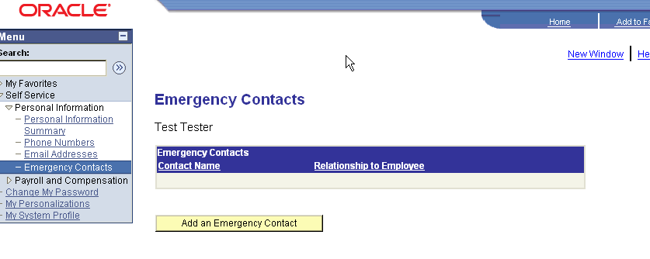

Click and the fields will become available.
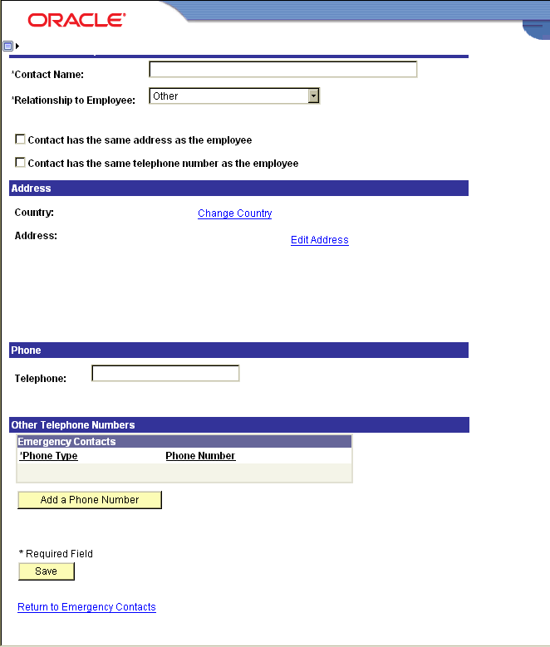

Contact Name – Enter the contact name

Relationship to Employee – Select the drop down menu and choose relationship.

If the address is the same as the employee check the box .

If the telephone number is the same as the employee check the box .

Select the drop down menu on the Address Type field and choose correct type.

Select the drop down menu on the Phone Type field and choose correct type.

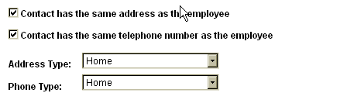
If the contact address is different than employee complete the following:

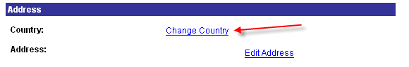

Click Change Country link.

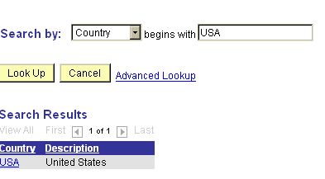

Type “USA" and select USA link.

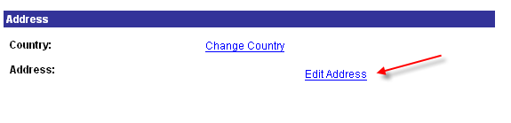

Click Edit Address link.
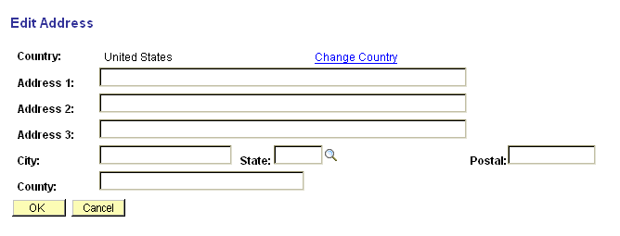

Address 1: – Enter address fields. Do not use punctuation in abbreviations (i.e.,St. or N.W. or Ave.) Use mixed case only, and do not use all caps.

State: - Enter OK for Oklahoma or click the magnifying glass for the “Lookup” menu (enter the first letter to narrow your search for the proper two (2) letter abbreviation. Select the proper state.

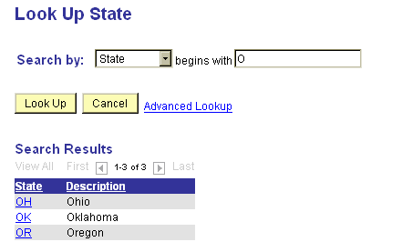

Postal – Enter the Zip Code

Click to return to previous page.

Click .
If the contact phone number is different than employee, complete the following steps:

To enter new information, enter the text in the blank field. To change existing information, type over the data and click

To add other emergency contact phone numbers select and phone type and phone number will become available.

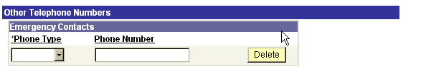

Phone Type – Select the drop down menu and select phone type.

Phone Number – Enter phone number.

Click .

NOTE: To change existing information, type over the data and click .

View Only Access

Navigation: Self Service > Payroll and Compensation

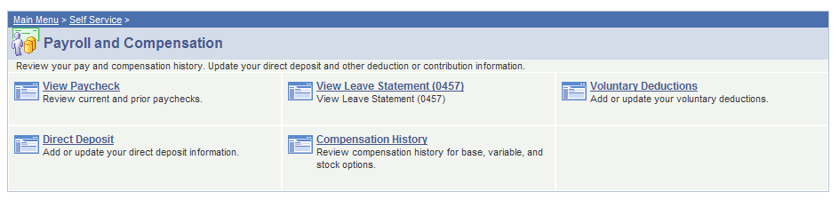

Links to choose:

- View Paycheck
- View Leave Statement
- Voluntary Deductions
- Direct Deposit
- Compensation History

Select the information you want to view.

View Paycheck

Navigation: Self Service > Payroll and Compensation > View Paycheck

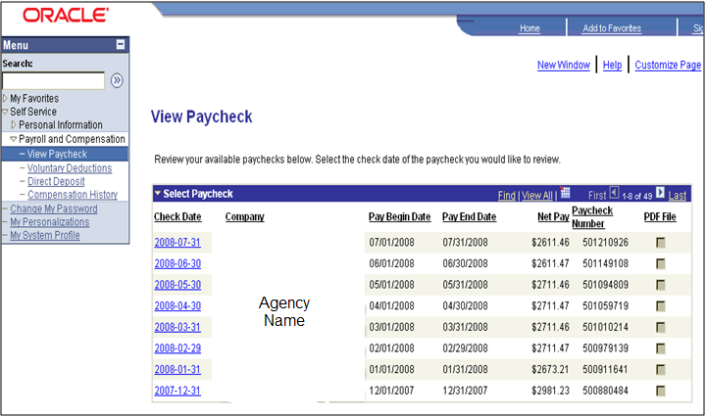

Select the check date you want to review. Click blue Check Date link. The most current paycheck date will provide the year-to-date totals and leave balances even if the net pay is zero. The e Statement will appear in a separate window. Print statement as needed.

A zero net pay check is due to sick and/or annual leave time reported after the regular payroll has processed. An additional payroll is processed to update leave balances resulting in zero net pay.

Payroll Advice

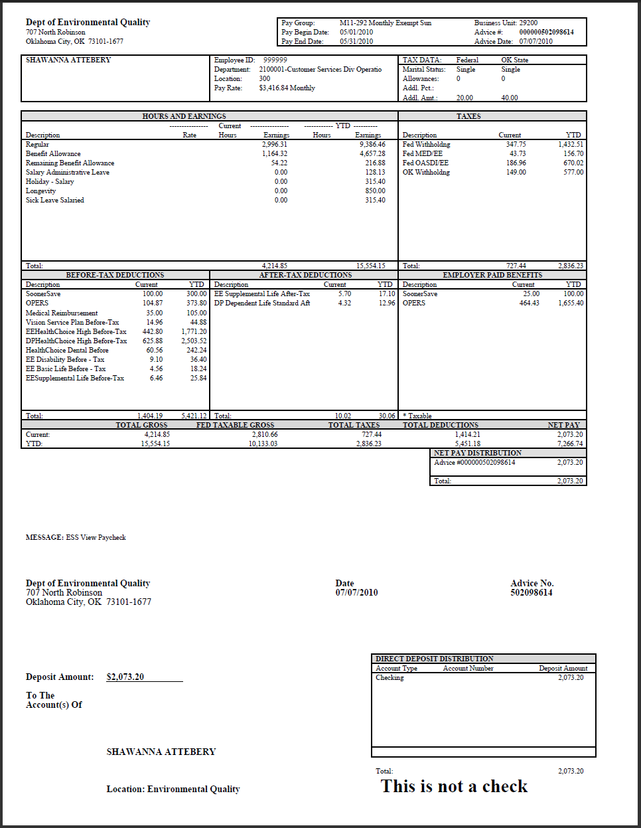

This page will now print on one page. The following screen prints break down each section of the payroll advice.
General

Tax Data

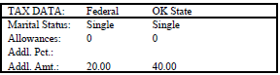

Paycheck Year-to-Date

Earnings

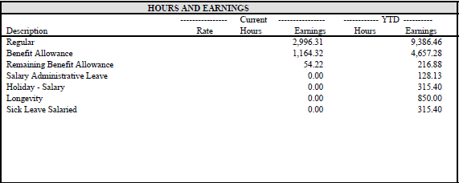

Taxes
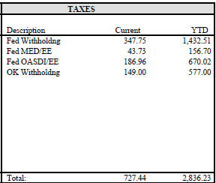

REMINDER: The most current paycheck date will provide year-to-date totals and leave balances even if the net pay is zero.

Before Tax Deductions, After Tax Deductions and Employer Paid Benefits

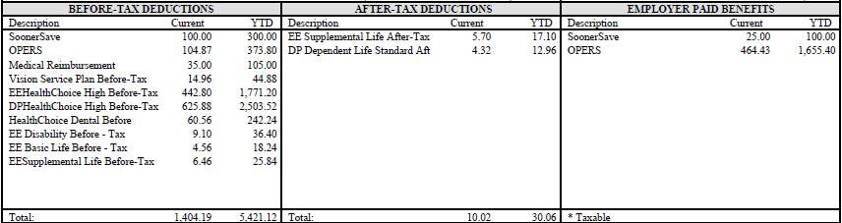

Net Pay Distribution

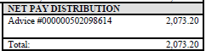

View Leave Statement

Leave Accrual Report

Step I – Navigate to the Payroll and Compensation Components

Navigation: Self Service > Payroll and Compensation > View Leave Statement (0457)

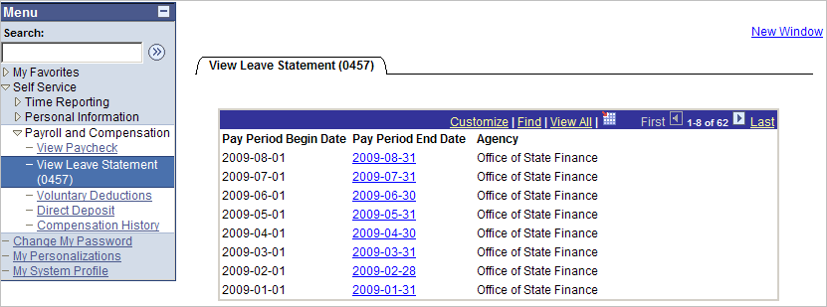

Step 2 – Click Pay Period End Date link you wish to view the Leave Accrual Statement. The Leave Accrual Statement will appear in a separate window. Print statement as needed.

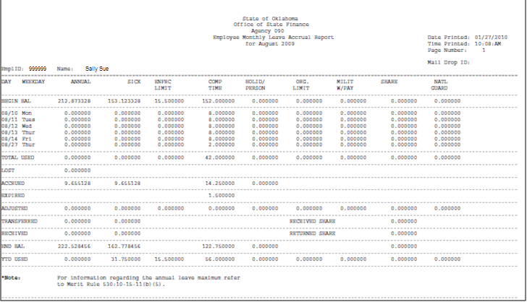

Voluntary Deductions

Navigation: Self Service > Payroll and Compensation > Voluntary Deductions

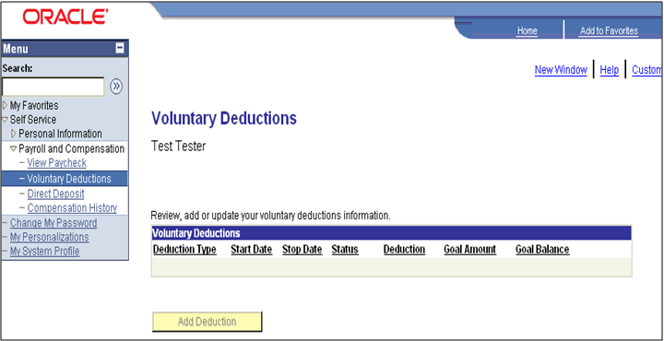

NOTE: Be patient, the voluntary deductions can take time to load.

Direct Deposit
Navigation: Self Service > Payroll and Compensation > Direct Deposit

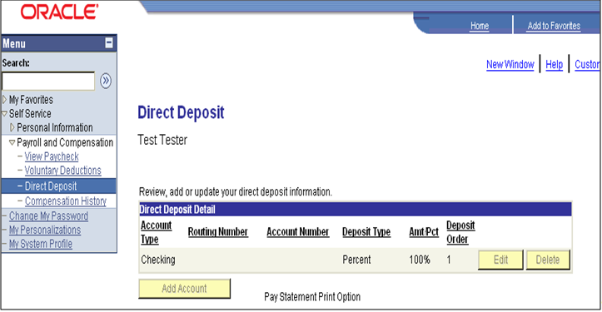

NOTE: This is a view only page and the Edit, Delete and Add Account buttons have been grayed out.

Compensation History

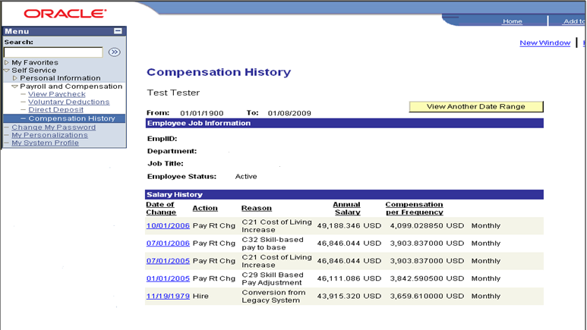

Click Date of Change column blue link to view additional information.

Click Return to Employee Self Service link or

Click Return to Payroll and Compensation link.

