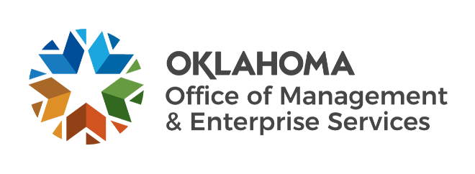

Statewide Contracts team metrics – May 2023

Number of statewide contracts by fiscal year:
- FY 2019 – 173.
- FY 2020 – 181.
- FY 2021 – 192.
- FY 2022 – 189.
- FY 2023 (as of May 1) – 174.

IT reported spend:
- FY 2019 – $208 million.
- FY 2020 – $247 million.
- FY 2021 – $329 million.
- FY 2022 – $357 million.
- FY 2023 (as of May 1) – $256 million.

Non-IT reported spend:
- FY 2019 – $343 million.
- FY 2020 – $382 million.
- FY 2021 – $388 million.
- FY 2022 – $439 million.
- FY 2023 (as of May 1) – $317 million.

Fiscal year 2023 to date:
- 930 statewide supplier agreements.
- 32 requests for proposals initiated.
- 41 new supplier agreements entered.
- 955 supplier renewals.

