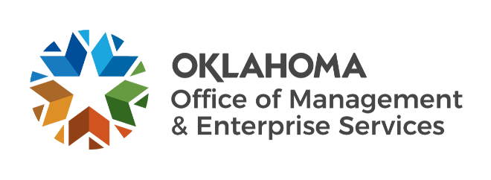

Statewide Contracts team metrics – August 2023

Number of statewide contracts by fiscal year:
- FY 2019 – 173.
- FY 2020 – 181.
- FY 2021 – 192.
- FY 2022 – 189.
- FY 2023 – 178 (fiscal year-end).

IT reported spend:
- FY 2019 – $208 million.
- FY 2020 – $247 million.
- FY 2021 – $329 million.
- FY 2022 – $357 million.
- FY 2023 – $367 million (fiscal year-end).

Non-IT reported spend:
- FY 2019 – $343 million.
- FY 2020 – $382 million.
- FY 2021 – $388 million.
- FY 2022 – $439 million.
- FY 2023 – $415 million (fiscal year-end).

Fiscal year 2024 to date (as of July 31, 2023):
- 967 statewide supplier agreements.
- 4 requests for proposals initiated.
- 4 new supplier agreements entered.
- 0 supplier renewals.

