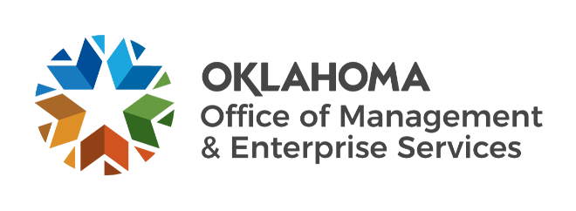

Agency Acquisitions team metrics – August 2023

Number of purchase/change orders processed per fiscal year:
- FY 2019 – 452.
- FY 2020 – 633.
- FY 2021 – 710.
- FY 2022 – 785.
- FY 2023 – 713 (fiscal year-end).

Processed purchase/change orders spend:
- FY 2019 – $354.4 million.
- FY 2020 – $574.3 million.
- FY 2021 – $718.1 million.
- FY 2022 – $769.5 million.
- FY 2023 – $853.1 million (fiscal year-end).
- FY 2024 – $196.6 million.

Fiscal year-end 2023:
- 132 requisitions received.
- 127 requests for proposals initiated.
- 89 awarded contracts from solicitations.
- Contracts processed spend – $196.62 million (90.82%).
- Contracts processed savings – $19.89 million (9.18%).

