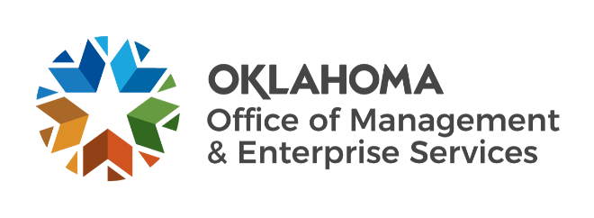

Agency Acquisitions team metrics – May 2023

Number of purchase/change orders processed per fiscal year:
- FY 2019 – 452.
- FY 2020 – 633.
- FY 2021 – 710.
- FY 2022 – 785.
- FY 2023 (year to date) – 663.

Processed purchase/change orders spend:
- FY 2019 – $354.4 million.
- FY 2020 – $574.3 million.
- FY 2021 – $718.1 million.
- FY 2022 – $769.5 million.
- FY 2023 (year to date) – $1,007.5 million.

Fiscal year 2023 to date:
- 110 requisitions received.
- 105 requests for proposals initiated.
- 70 awarded contracts from solicitations.
- Contracts processed spend – $146.04 million.
- Contracts processed savings – $19.46 million.

