Requisition Change Orders

Adding New Requisition Line(s)
Navigation: Purchasing > Requisitions > Add/Update Requisitions

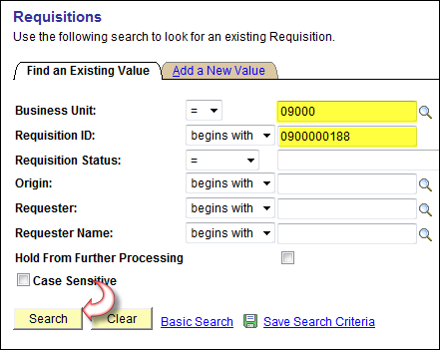

From Find an Existing Value Tab, enter Business Unit and Requisition ID number to be changed.

Click .

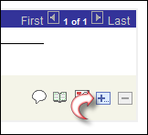

On the Maintain Requisition screen, at the far right of the last requisition line, click .

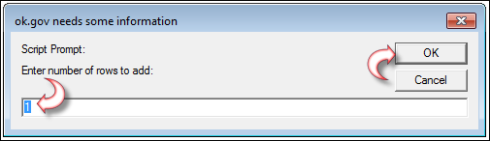

Enter the number of rows to be added. Click .

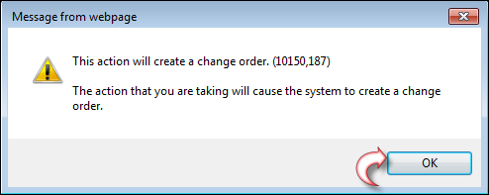

Click .

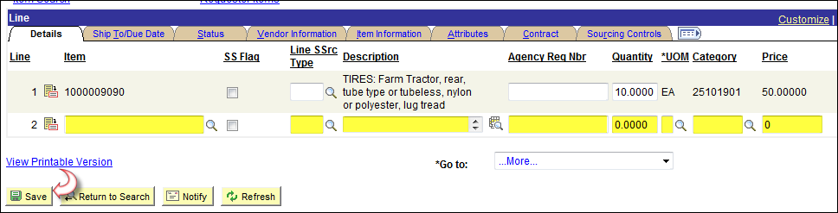

Enter all criteria for the new line, schedule and distribution, same as creating a new requisition.
Click

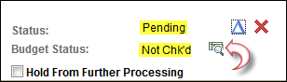

Notice the Requisition Status is Pending and the Budget Status is now Not Chk’d.
Click to budget check the requisition.

The Requisition now needs to be Approved.

Navigation: Purchasing > Requisitions > Approve Amounts

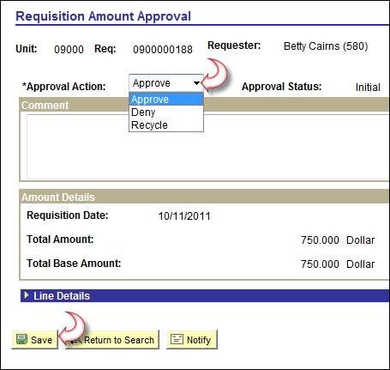

Click and select Approve.

Click

Adding New Requisition Schedule Line(s)
Navigation: Purchasing > Requisitions > Add/Update Requisitions

From Find an Existing Value Tab, enter Business Unit and Requisition ID number to be changed.

Click .

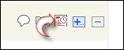
From the far right of the line you want to add a schedule to, click

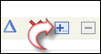
From the far right of the last schedule line, click .

Enter the number of new schedule line(s) to be added. Click .

Click .

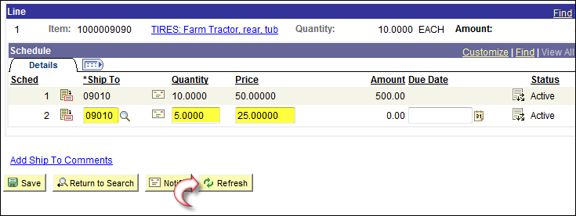

Enter all criteria for new schedule line(s). Click .
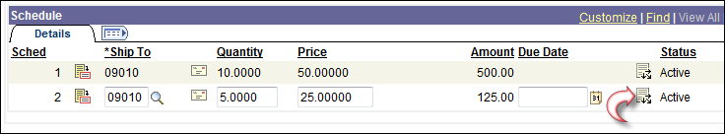

Click . Distribute line icon.

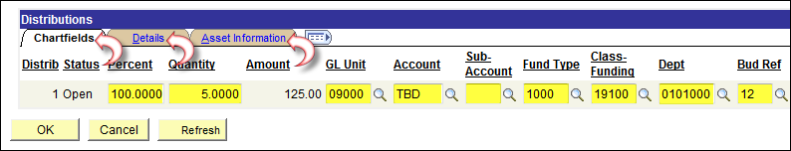

Verify all fields on each of the Tabs on the distribution line to be sure it is what you want it to be.

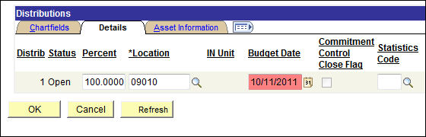

Pay close attention to the Details Tab, this is where you will find the budget date that defaults in form
the header page.

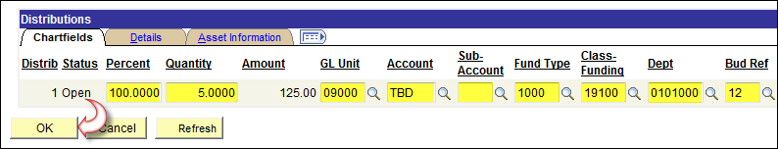
Once you are satisfied with the criteria, click .
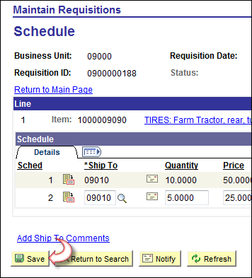

Click

You will need to Re-Budget Check and Approve the requisition, see page four (4) of this document.

Adding New Requisition Distribution Line(s)
Navigation: Purchasing > Requisitions > Add/Update Requisitions

From Find an Existing Value Tab, enter Business Unit and Requisition ID number to be changed.

Click .

In order to add distribution lines to an existing schedule, you first must change the schedule to
accomadate the new distribution line.

From the far right of the line you want to add a distribution line to, click schedule icon.

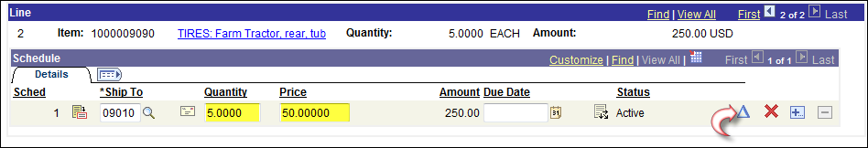

Click and adjust the Quantity and or Price to accommodate the additional distribution line(s).

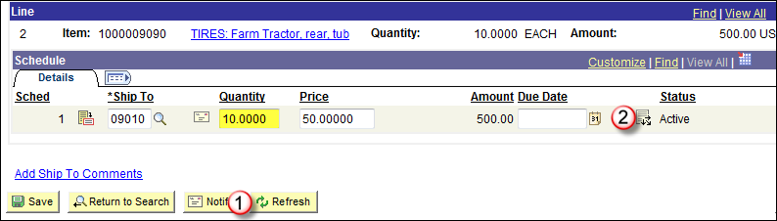
Once Quantity and or Price fields are changed, click . Click .
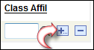
From the far right of the last distribution line, click .
Enter the number of new distribution line(s) to be added. Click .
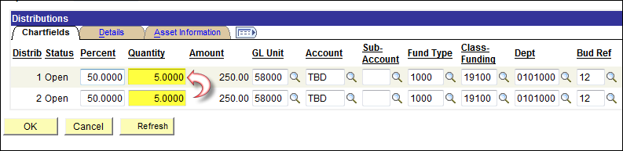

Reduce distribution line 1 to it’s original Quantity and or amount to accomadate the new distribution
line(s).

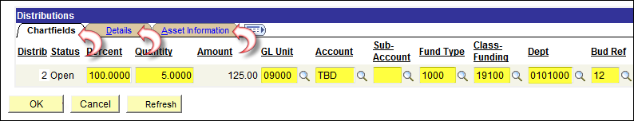

Enter new distribution line(s) criteria and verify information is correct on all Tabs

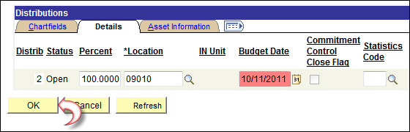

Pay close attention to the Details Tab, this is where you will find the budget date that defaults in form
the header page.

Once you are satisfied with the criteria, click .

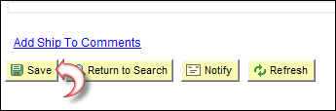
Click
You will need to Re-Budget Check and Approve the requisition, see page four (4) of this document.

