EEO-4 Reports and Query Guide

Authorized by: [_CORE_] Original Issue: [06/01/2005]
Maintained by: [____HCM Lead___] Current Version: [06/01/2010]
Review Date: [06/01/2011]

Table of Contents
Document History 4
Reports 5
EEO-4 State and Local Government (0215) Report 5
EEO-4 Vacant Positions (0342) Report 10
Positions by EEO Category (0083) Report 15
EEO-4 Employee Population (0347) Report 20
Queries 25
Go_HR_EEO4_ACTIONS 26
GO_HR_EEO4_ETHNICITY_GENDER 26
GO_HR_EEO_MISSING_ETHNIC_GRP 26

Document History
Document Revision | Date | Description
1.0 | 06/01/2005 | Initial Document
1.1 | 06/01/2008 | 9/0 Version Updated Reports
1.3 | 06/03/2010 | Updated Reports and Queries

Reports
The following instructions are to assist in the running of the EEO-4 report, EEO-4 Vacant Positions report, Positions by EEO Category report, and Queries to assist with the Affirmative Action Plan reporting.

An Agency User who already has access to PeopleSoft HR will need to run these reports and queries.

EEO-4 State and Local Government (0215) Report
The EEO-4 Report is delivered by PeopleSoft in the EEOC (US Equal Employment Opportunity Commission) mandated format. As Federal updates are made to the process and reporting requirements, updates are provided by PeopleSoft/Oracle.

To run the PeopleSoft delivered EEO-4 Report, navigate to the following page:

Navigation: Workforce Monitoring > Meet Regulatory Rqmts > EEO Reports > EEO- 4 St & Local Gov-Agy (0215)

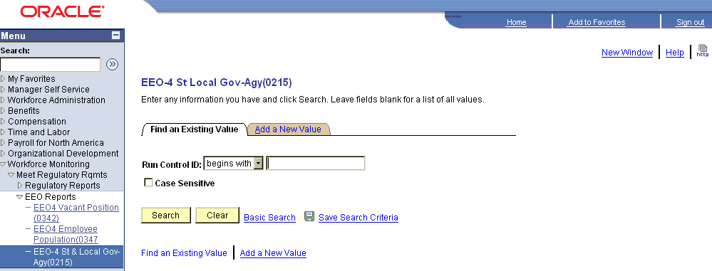

Enter a valid Run Control ID and click or click the Add a New Value link to add a new Run Control ID.

A run control is a database record that provides values for the report parameters. Instead of entering the same values each time you run a report, you create (and save) a run control with those settings. The next time you run the report, you select the run control and the system fills in the settings. A run control can be set up for each report or process or the same one can be used for multiple reports or processes. The Run Control ID can be any value such as initials, report name, etc.
The Report Request Parameters page will be displayed:

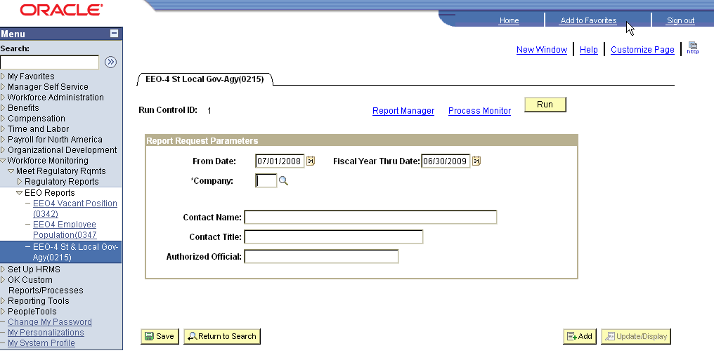

Enter the From Date, which is the beginning of the EEO-4 reporting period.

Enter the Fiscal Year Thru Date, which is the end of the EEO-4 reporting period.

Enter the Company number, which is the three-digit agency number.

Enter the Contact Name, which is the agency person responsible for the EEO-4 report.

Enter the Contact Title, which is the job title of the agency person responsible for the EEO-4 report.

Enter the Authorized Official, which is the Agency Director, or equivalent.

Click .
The Process Scheduler Request page will be displayed:

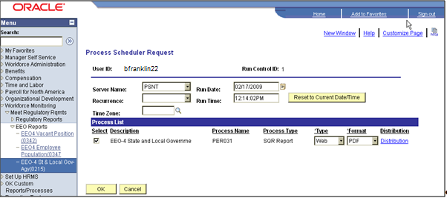

Verify the Server Name is PSNT.

Verify the Select checkbox next to the EEO-4 State and Local Government process is checked.

Verify the Type is Web.

Verify the Format is PDF.

Click .

The report is now processing and you will be returned to the Report Request Parameters page with the Process Instance number displayed.
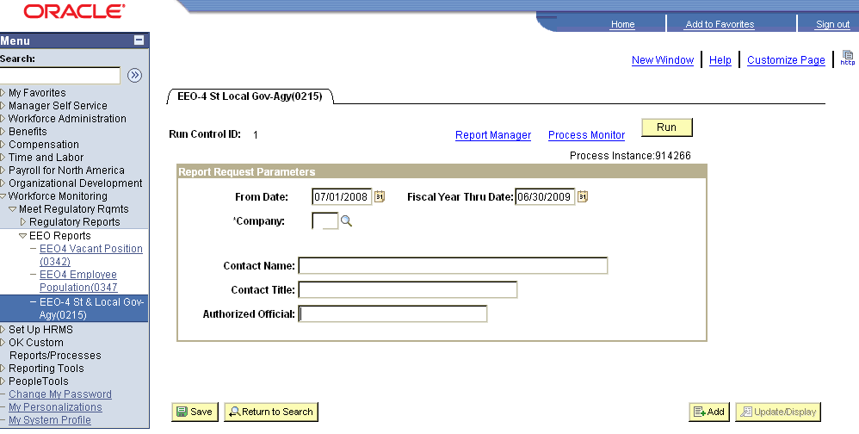

Click the Process Monitor link to monitor the status of the report.

The Process Requests page will be displayed:

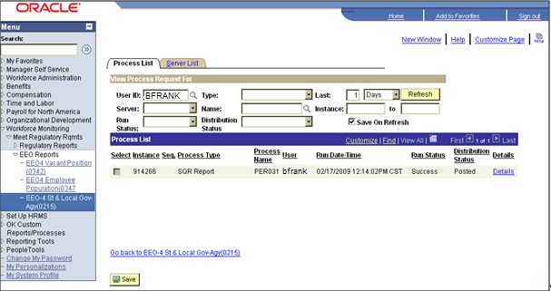

While the Run Status is Queued, Processing or Posting, click repeatedly to refresh the status of the report until the Run Status field reflects Success. Click the Details link to view the Process Detail.
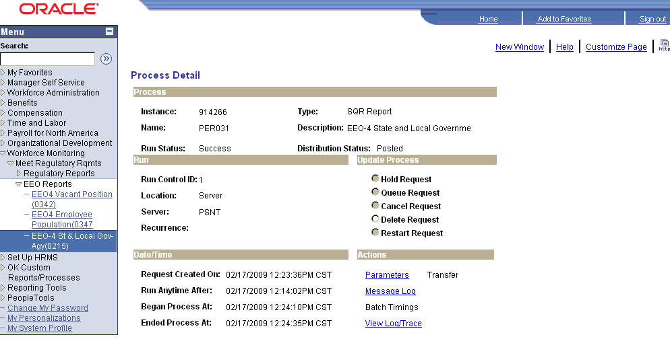

Click the View Log/Trace link to view the Report/Log Viewer.

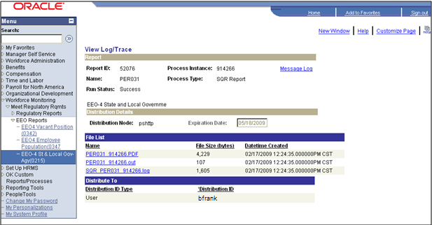

Click the PER031_xxxxxx.PDF (where xxxxxx is the Instance Number) link to view the EEO-4 report.

EEO-4 Vacant Positions (0342) Report
To run the EEO-4 Vacant Positions report, navigate to the following page:

Navigation: Workforce Monitoring > Meet Regulatory Rqmts > EEO Reports > EEO4 Vacant Positions (0342)

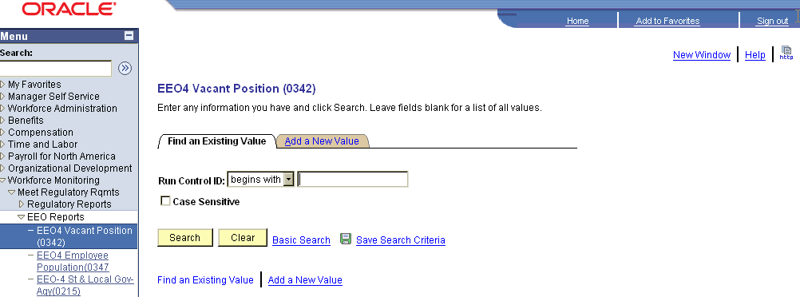

Enter a valid Run Control ID and click or click Add a New Value link to add a new Run Control ID.

A run control is a database record that provides values for the report parameters. Instead of entering the same values each time you run a report, you create (and save) a run control with those settings. The next time you run the report, you select the run control and the system fills in the settings. A run control can be set up for each report or process or the same one can be used for multiple reports or processes. The Run Control ID can be any value such as initials, report name, etc.

The Report Request Parameters page will be displayed:

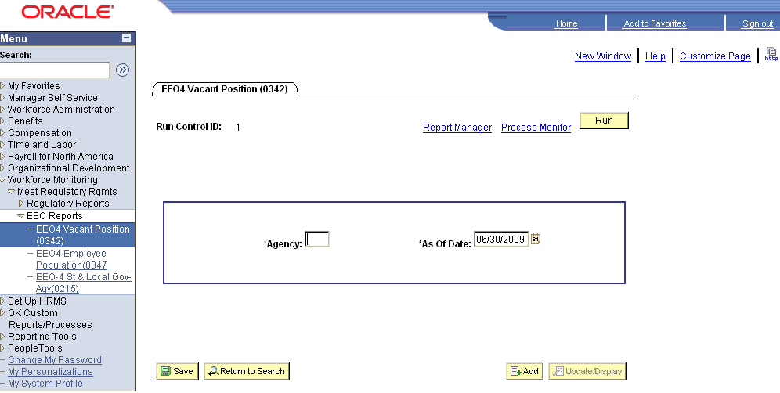

Enter the three-digit Agency number.

Enter the As of Date, typically 06/30/xxxx for Affirmative Action Plan reporting.

Click .

The Process Scheduler Request page will be displayed:
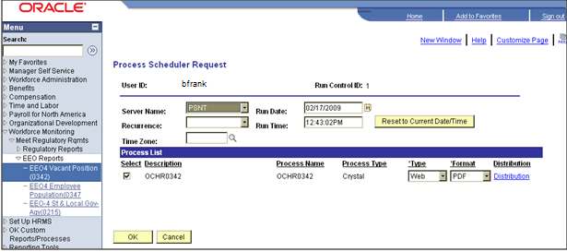

Verify the Server Name is PSNT.

Verify the Select checkbox next to the OCHR0342 process is checked.

Verify the Type is Web.

Verify the Format is PDF.

Click .

The report is now processing and you will be returned to the Report Request Parameters page with the Process Instance number displayed.
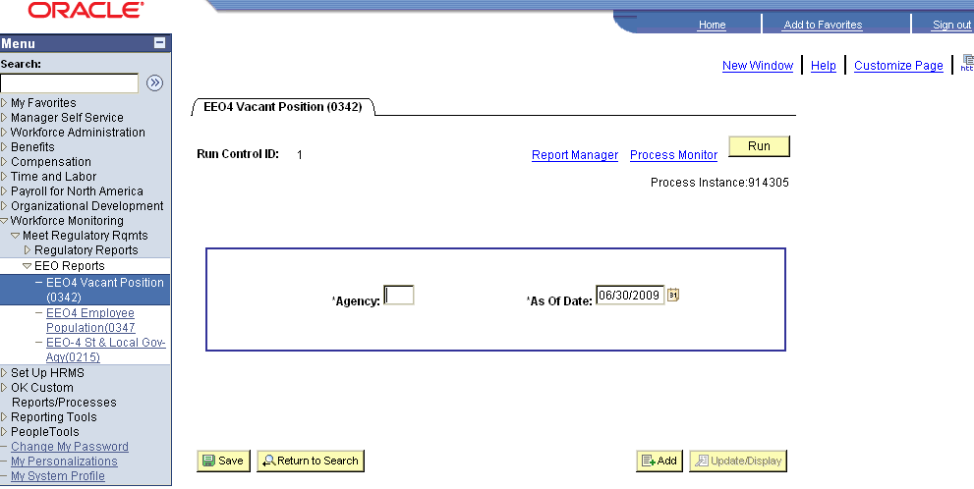

Click the Process Monitor link to monitor the status of the report.
The Process Requests page will be displayed:

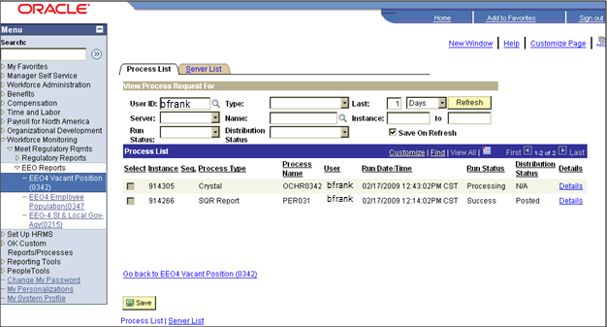

While the Run Status is Queued, Processing or Posting, click repeatedly to refresh the status of the report until the Run Status field reflects Success. Click the Details link to view the Process Detail.
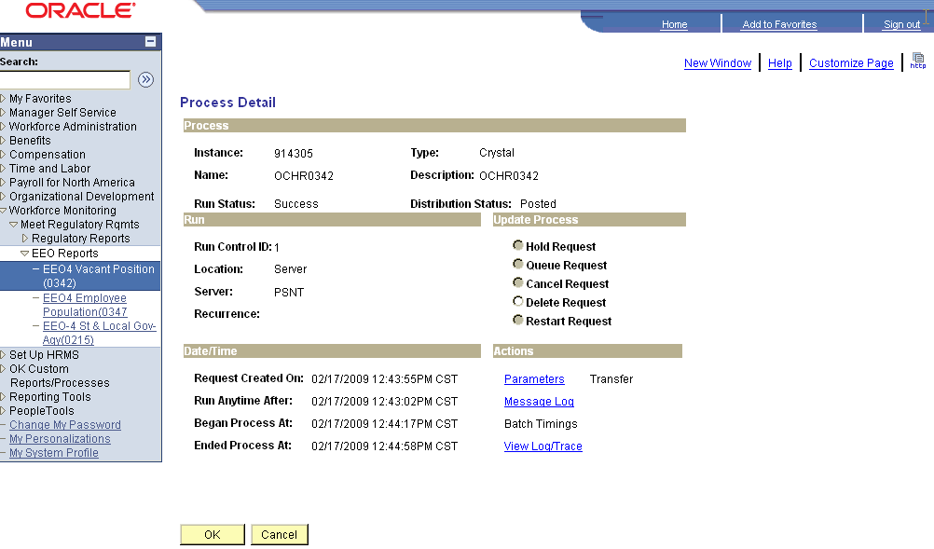

Click the View Log/Trace link to view the Report/Log Viewer.

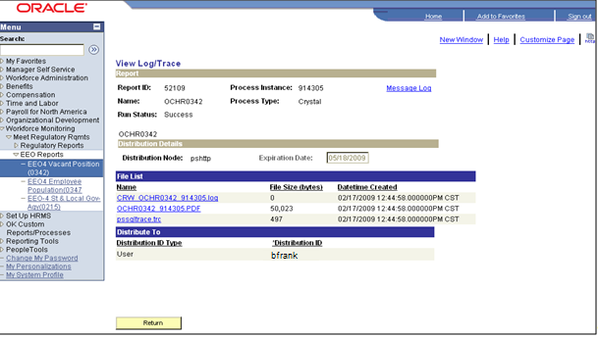

Click the OCHR0342_xxxxxx.PDF (where xxxxxx is the Instance Number) link to view the EEO-4 Vacant Positions report.

Positions by EEO Category (0083) Report
To run the PeopleSoft Positions by EEO Category report, navigate to the following page:

Navigation: OK Custom Reports/Processes > OK Reports > HR > Pos by EEO Category (0083)

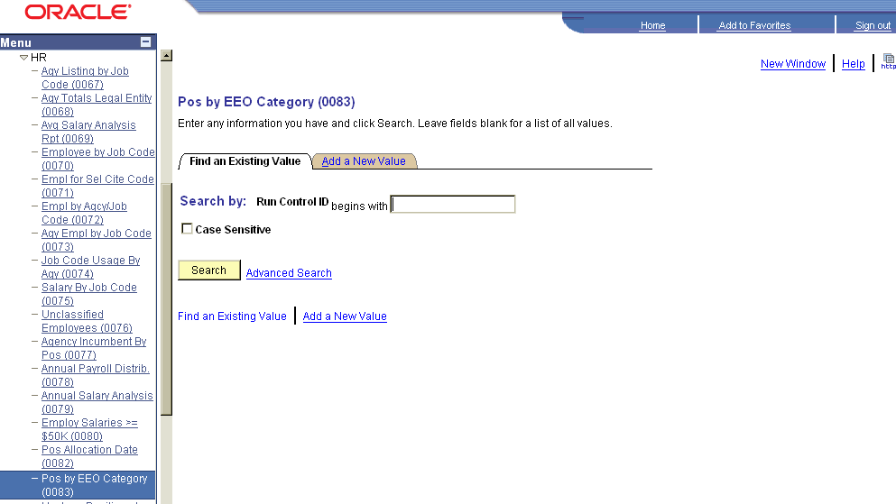

Enter a valid Run Control ID and click or click the Add a New Value link to add a new Run Control ID.

A run control is a database record that provides values for the report parameters. Instead of entering the same values each time you run a report, you create (and save) a run control with those settings. The next time you run the report, you select the run control and the system fills in the settings. A run control can be set up for each report or process or the same one can be used for multiple reports or processes. The Run Control ID can be any value such as initials, report name, etc.
The Report Request Parameters page will be displayed:

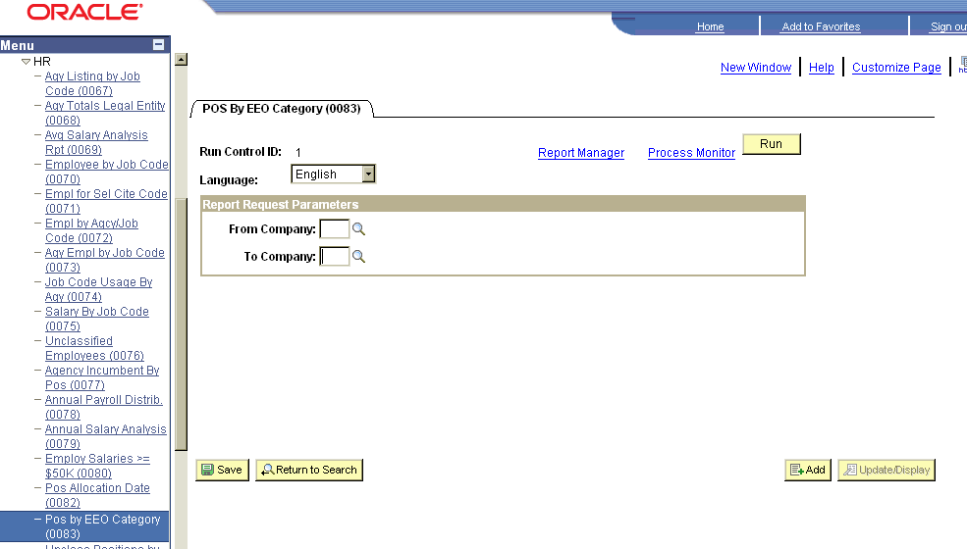

Enter the three-digit Agency number in the From Company and To Company fields.

Click .

The Process Scheduler Request page will be displayed:
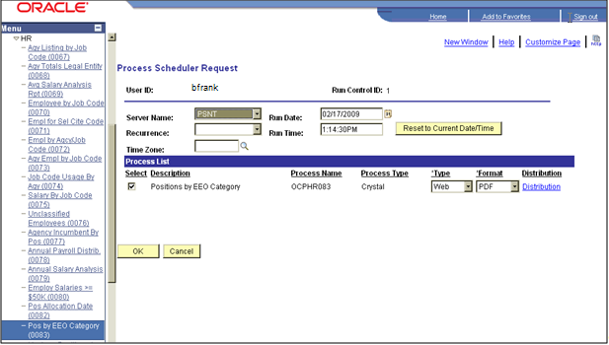

Verify the Server Name is PSNT.

Verify the Select checkbox next to the Positions by EEO Category process is checked.

Verify the Type is Web.

Verify the Format is PDF.

Click .

The report is now processing and you will be returned to the Report Request Parameters page with the Process Instance number displayed.
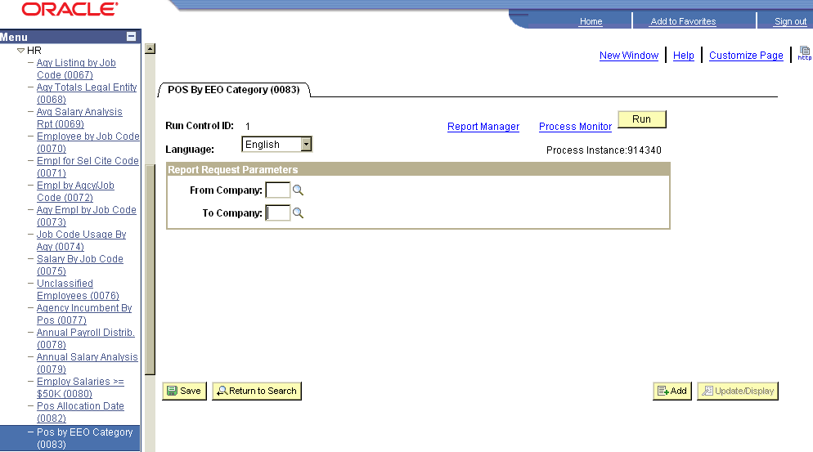

Click the Process Monitor link to monitor the status of the report. The Process Requests page will be displayed:

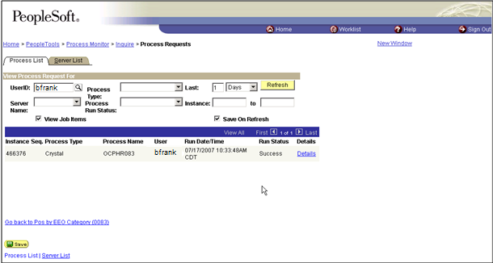

While the Run Status is Queued, Processing, or Posting, click repeatedly to refresh the status of the report until the Run Status field reflects Success. Click the Details link to view the Process Detail.
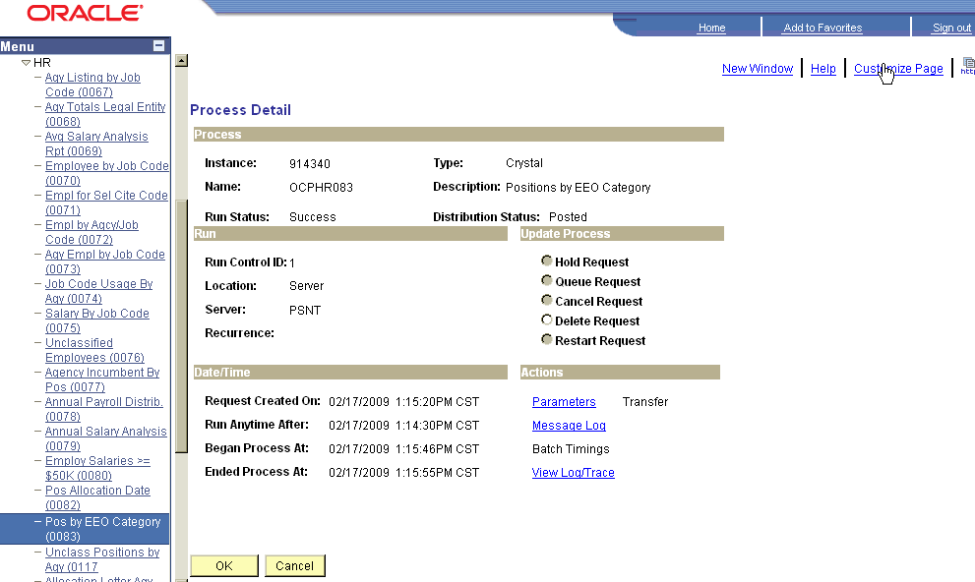

Click the View Log/Trace hyperlink to view the Report/Log Viewer.

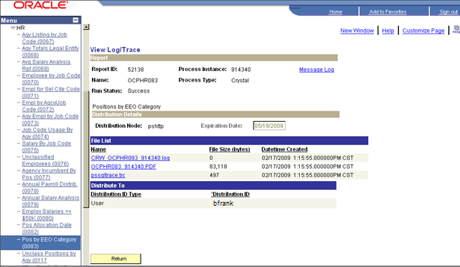

Click the OCPHR083_xxxxxx.PDF (where xxxxxx is the Instance Number) link to view the Positions by EEO Category report.

EEO-4 Employee Population (0347) Report
To run the EEO-4 Employee Population Report, navigate to the following page:

Navigation: Workforce Monitoring > Meet Regulatory Rqmts > EEO Reports> EEO4 Employee Population (0347)

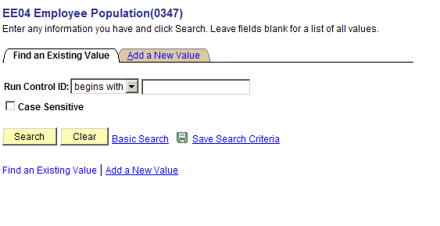

Enter a valid Run Control ID and click or click Add a New Value link to add a new Run Control ID.

A run control is a database record that provides values for the report parameters. Instead of entering the same values each time you run a report, you create (and save) a run control with those settings. The next time you run the report, you select the run control and the system fills in the settings. A run control can be set up for each report or process or the same one can be used for multiple reports or processes. The Run Control ID can be any value such as initials, report name, etc.

The Report Request Parameters page will be displayed:
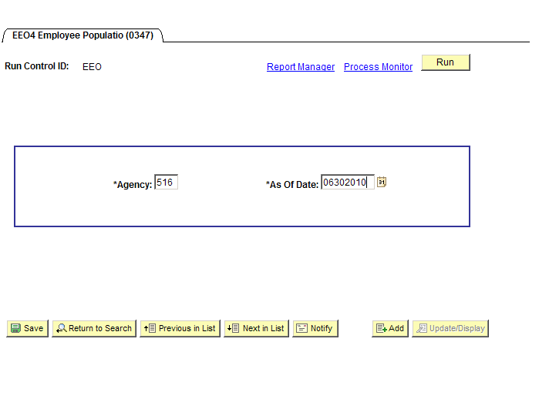

Enter the three-digit Agency number.

Enter the As of Date, typically 06/30/xxxx for Affirmative Action Plan reporting.

Click .

The Process Scheduler Request page will be displayed:
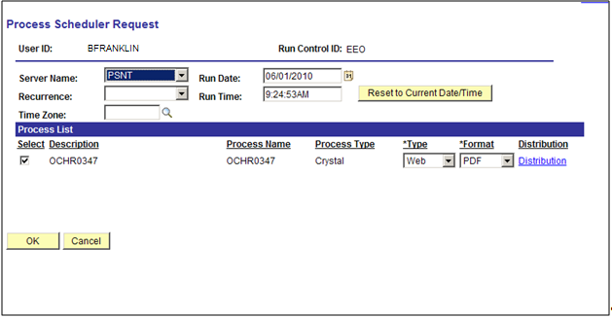

Verify the Server Name is PSNT.

Verify the Select checkbox next to the OCHR0347 process is checked.

Verify the Type is Web.

Verify the Format is PDF.

Click .

The report is now processing and you will be returned to the Report Request Parameters page with the Process Instance number displayed.
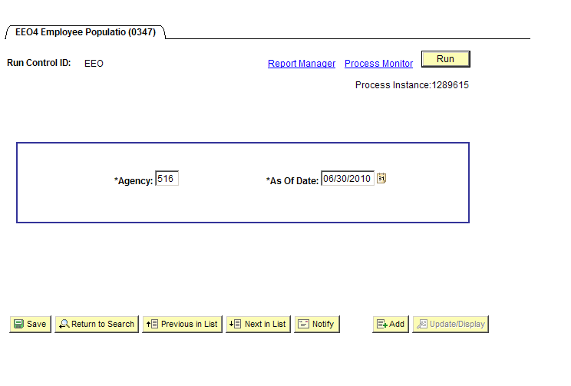

Click the Process Monitor link to monitor the status of the report. The Process Requests page will be displayed.

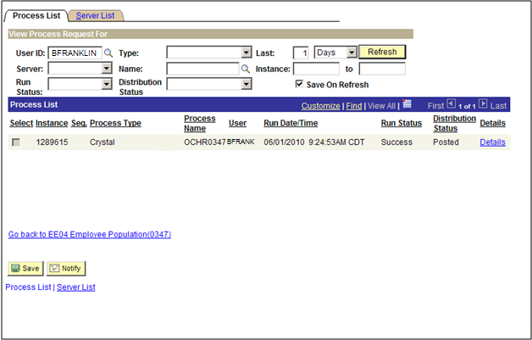

While the Run Status is Queued, Processing or Posting, click repeatedly to refresh the status of the report until the Run Status field reflects Success. Click the Details link to view the Process Detail.
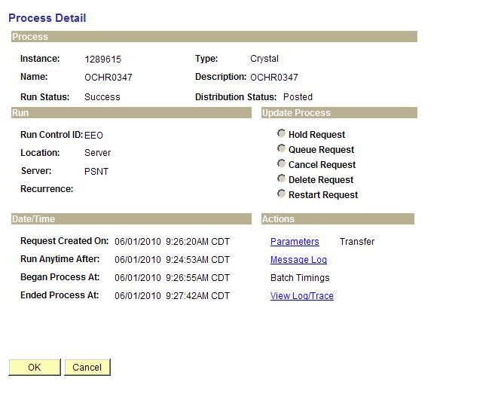

Click the View Log/Trace link to view the Report/Log Viewer.

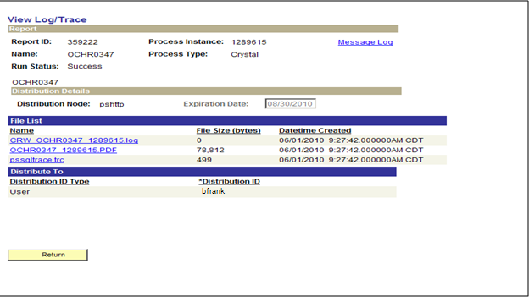

Click the OCHR0347_xxxxxx.PDF (where xxxxxx is the Instance Number) link to view the EEO-4 Employee Population Report.

Queries
The Affirmative Action Plan will be built from queries in the PeopleSoft system and other data, such as census data, and compiled into a comprehensive report.

To use the queries that have been developed to assist with the Affirmative Action Plan, navigate to the following page:

Navigation: Main Menu > Reporting Tools > Query Viewer

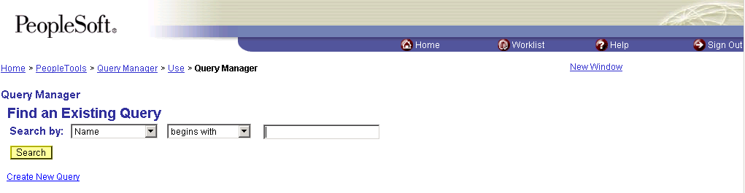

In the text box, enter “GO_HR_EEO” and click .

The Search Results will be displayed:

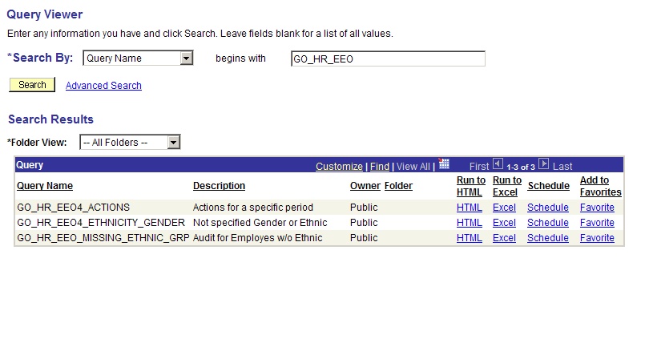

To run queries, click the Run to Excel or Run to HTML link for the report you wish to run.

Go_HR_EEO4_ACTIONS
The GO_HR_EEO4_ACTIONS query displays the following transactions for the date range entered:
- New Hire
- Rehire
- Additional Job
- Promotion
- Demotion
- Termination
- Retirement

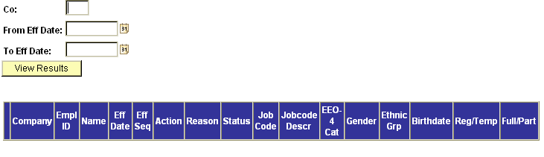

Enter the Company number, From Eff Date and To Eff Date. Click . The query results will be displayed.

GO_HR_EEO4_ETHNICITY_GENDER
The GO_HR_EEO4_ETHNICITY_GENDER query displays any employee who has a Gender of “Unknown” or an Ethnic Group of “Not Specified”.

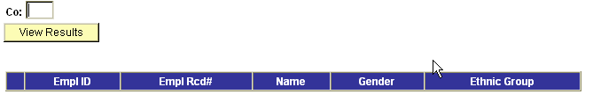

Enter the Company number. Click . The query results will be displayed.

GO_HR_EEO_MISSING_ETHNIC_GRP
Query displays any employee who has an Ethnic Group of ‘blank’.

Click the HTML or Excel. The query results will be displayed in a new window.

