COR453 E-Procurement Approval Manual
Table of Contents
COR453 E-Procurement Approval Manual 1
Document History 3
e-Procurement Workflow Introduction 4
Overview 4
Requisition Approval Steps 6
I. E-Procurement Workflow Security/Design 7
II. E-Procurement Requisition Workflow 11
Edit Requisition’s Funding/Asset Profile 22
Asset Profile 27
III. E-Procurement Requisition Workflow-Ad Hoc Feature 31

Authorized by: [_CORE_] Original Issue: [03/19/2012]
Maintained by: [____Purchasing Lead___] Current Version: [04/07/2014]
Review Date: [04/08/2015]

Document History

Document Revision | Date | Description
1.0  1.1 | 03/19/2012  02/08/2013 | Initial Document  Updated for Statewide use
1.2 | 04/07/2014 | Udated page 7 & 8 with responsibilities

e-Procurement Workflow Introduction

Overview
Requisition Approval is the process of taking a transaction through the organization until it is accomplished or stopped. Using the Approve Requisitions feature, approvers and reviewers join the business analysts, and requestors to complete the approval workflow process. When the process is complete, the transaction is promoted to its next stage. In the case of a requisition, for example, it's sourced as a purchase order.
After a requisition is created, the system routes it to approvers. The system routes the requisition approval to approver and the user can view and take action in two ways. One is through the worklist, and the other is through the Approve Requisitions page. In either case, you can preview, in a graphical format, the path a transaction approval will take and who has already approved the transaction, and see any comments previous approvers have entered.
While the system awaits approval action, the approval workflow engine maintains the overall state of the transactions approval status, invokes routings, and interacts with the application classes.
During the approval process these actions take place:
- The system notifies approvers and reviewers that there is a pending transaction that needs their attention.
- Approvers and reviewers access the transaction details, provide comments, and take action (approve, deny, or push back) for the transaction.
- The system checks for additional routings in the same routing path.
- If all steps have been completed for the stage then the next step is started in the next stage. If there are multiple routing paths, the system routes them in parallel.
- Once all approvers on a transaction have approved, the engine notifies the eProcurement application. The requisition is then prepared for sourcing.
Mass Approval
The approver may select multiple requisitions, and complete the approvals at one time without approving each requisition individually. The approver must participate in a role that is associated to the new eProcurement role action of MASS_APPROVER.
Email Approvals
Email approvals are designed to route approvals to the approver's email address to take action, yet not require the approver to log into the system. The approver can approve, deny, add comments, and submit
Reference People Books.

NOTE: Throughout this training manual, you will be asked to click , , or while entering information. It is important to remember that clicking just accepts the information on a sub-page and returns you to the main page. It does not save the information if you exit the transaction. Only actually saves the information you have entered. Clicking updates the display to incorporate the information and defaults you have entered.

Requisition Approval Steps

The major steps in approving an e-Procurement Requisition are:

Log Into PeopleSoft
Navigate to Worklist
Select Purchase Order to Approve
Review Requisition
Approve/Deny Requisition-Work Flow
Edit Requisitions –Limited Access

E-Procurement Workflow Security/Design

NOTE: Agencies will determine which of the following steps are used in their workflow design. It is the Agencies/Approver’s responsibility to complete the forms necessary for routing to be correct. This will be accomplished with the coordination of the Agency, DCAM/Central Pruchasing and the ePro Adminstrator. Not all steps are nessary and not advised to complet an Agency’s workflow process.

Accounting Validation: The agencies accounting department will have the opportunity to Review, Approve or Deny all requisitions being created for their Agency. The Accountant will determine if the correct funding has been assigned, if not the Accountant can update the funding on the Requisition before sending it to the additional approvers.
Service Director: OMES Service Directors will have the opportunity to review, Approve or Deny all requisitions being created for their Department(s). The Department ID will be used to route the requisitions to the appropriate approver.
Business Segment Director: OMES Business Segment Directors will have the opportunity to review, Approve or Deny all requisitions being created by their designated agencies. The Agency Business Unit will be used to route the requisition to the appropriate approver.
Chief of Staff: OMES Chief of Staff will have the opportunity to review, Approve or Deny all IT Requisitions exceeding 300,000.00.
CIO: OMES CIO will have the opportunity to Review, Approve, or Deny all IT Requisitions exceeding 500,000.00
Asset Manager: The agencies Asset Managers will have the opportunity to Review, Approve or Deny all IT Asset Requisitions. The Asset Manager will determine if the Asset was assigned to correct Asset Profile and Useful life, if not the Asset Manager can update the Requisition with the correct Asset Profile. The Asset Profile being present on the Requisition will determine if the IT Asset Requisition is submitted to the Asset Manager.
Telecommunication: The OMES Telecommunication Manager will have the opportunity to Review, Approve, Deny all Telecommunication Requisitions for the State of Oklahoma. The category code will determine which Requisitions will be routed to the Telecommunication manager.
Form 001 Requisitions Approver: Agencey’s signature authority will have the opportunity to Review, Approve or Deny Requisitions being created for their agency.
Agency Buyer/CPO: The Agency Buyer/CPO will have the opportunity to Review, Approve or Deny Requisitions being created for their agency.
ISD Buyer Assignment: OMES Buyer will have the opportunity to Review, Approve, or Deny IT Requisitions Submitted by the State of Oklahoma.
Branch Manager: Reqisitions route to DCAM/Central Purchasing if the requisition is over the Agency’s dollar threshold.
Sole Source Approver: Requisitions route to DCAM/Central Purchasing if the requisition is marked as Sole Source and over the Agency’s dollar threshold.
State Purchasing Director: Requisitions route to DCAM/Central Purchasing if the requisition is over $500,000.00.
DCAM Front Desk CAP: Requisitions route to DCAM/Construction and Properties if requisitions are using Construction and Properties category codes.
DCAM IDIQ/On Call: Requisitions route to DCAM/Construction and Properties if requisitions are using IDIQ/On Call category codes.
DCAM Roofing: Requisition route to DCAM/Constructions and Properties if requisitions are using Roofing category codes.
DCAM Front Desk LSG: Requisitions route to DCAM/Real Estate and Leasing Services if requisitions are using Leasing category codes.
Approver 1: Requisitions route to the immediate Supervisor of the requisition requestor. (Approver responsible for updating ePro form with employee changes)
Approver 2: Requisitions route to this step based on the department id used on the requisition.(This step is used by Agency 220)
Approver 3: Requisitions route to this step based on department id or department id and under an Agency specified dollar amount.
Approver 4: Requisition route to this step based on department id and over an Agency specified dollar amount.
Service Chief/Supervisor II: Requisitions route to the immediate Supervisor of Approver 1.
Financial Coordinator: Requisitions route to this step based on department ids.
Agency IT Approver: Requisitions route to this step if requisitions are using IT or Telecommunication category codes.
Division Manager: Requisitions route to this step based on the Sub Account used on the requisition.
Agency Comptroller: Requisitions route to this step based on Fund Type and dollar amounts greated than $5,000.00.
Fund Manager: Requisitions route to this step based on Class Funding.
Agency Senior Buyer: Requisitions route to this step based on department id and dollar amounts greated than $5,000.00.
AdHoc Requisition Approver: Can Review/Approve requisitions on an adhoc basis.

Examples
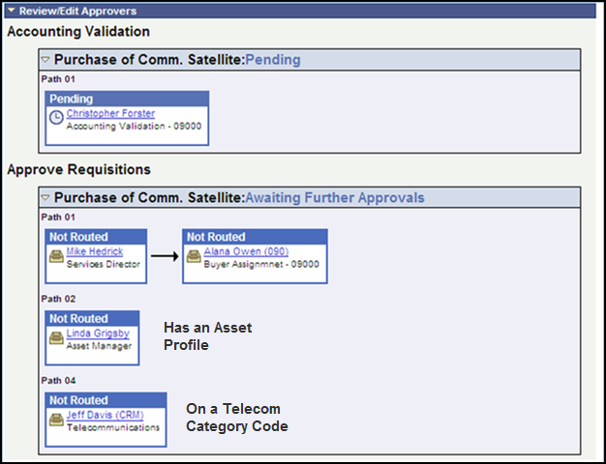
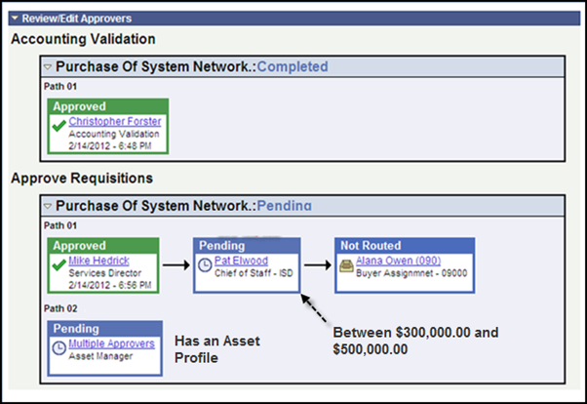

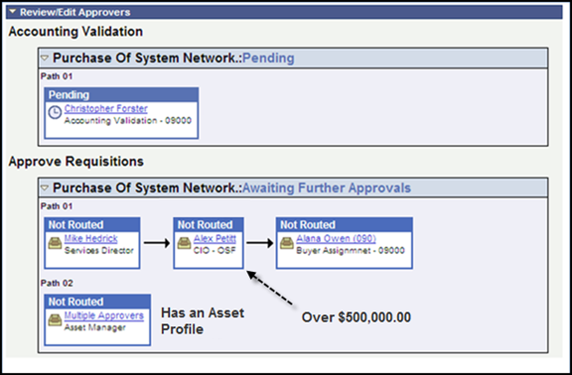

E-Procurement Requisition Workflow

Approve/Deny Requisition

Step 1-Log onto PeopleSoft
There are two ways the Approver can receive notification that there is a Requisition ready for their approval.
E-Mail: The Approver can receive an e-mail notification. The e-mail notification will contain a hyperlink which will take them directly to the People Soft Sign In page.
Worklist: The Approver must first log into PeopleSoft then navigate to their worklist. A PeopleSoft Log In short cut can be placed on their computer to make it easier.
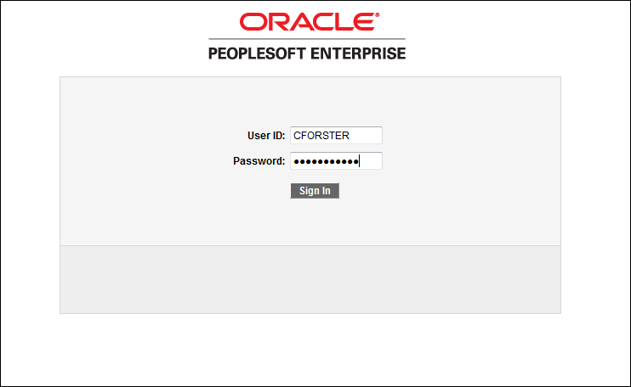
From the PeopleSoft Sign In Page input your User ID and Password then click the button.

Step 2-Select Purchase Order to Approve
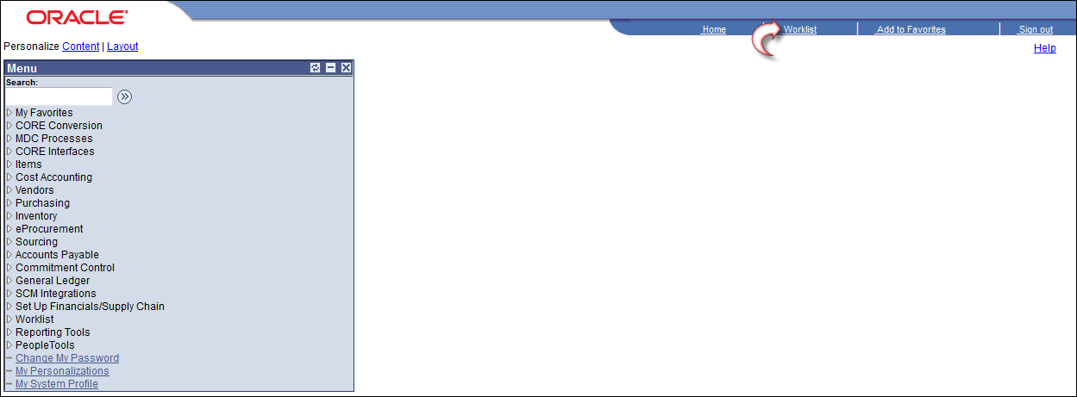
Click on the link located at the top right hand corner.
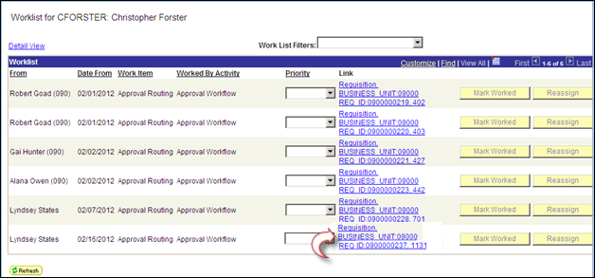
From: Displays the individual who triggered the work item.
Date From: Displays the date when the work item was triggered.
Due Date: Displays the due date of the specified action, if added.
Work Item: Displays the action that generated the workflow item, such as Approval Routing. You can have multiple entries with the same action, but each entry represents a different item that requires attention.
Worked by Activity: Displays the activity for the action required.
Link: Click a Details link in this column to access the target page—the page where you work on the item.
Mark Worked: Click an icon in this column to mark an item as worked if you have performed the necessary actions. This removes items that Requisition workflow processes generates. Once the Approver has approved the Requisition it will automatically be removed from the Approvers WorkList.
Click on the Requisition Link

Step 3-Review Requisition

Funding Information
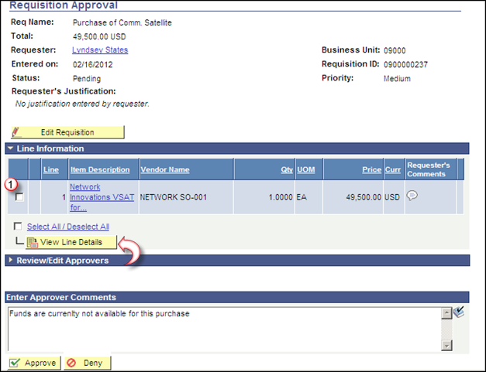
To review the funding on the Requisition click the box located to the left of the Requisition Line and click the button.
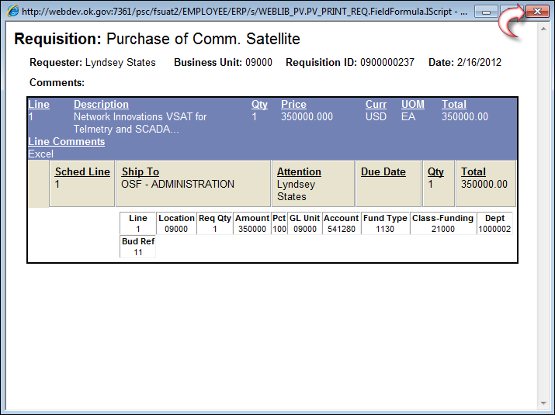
If the funding is correct then the requisition is ready for the Accountant to approve it.
To exit out of the funding screen click the located in the top right hand corner.
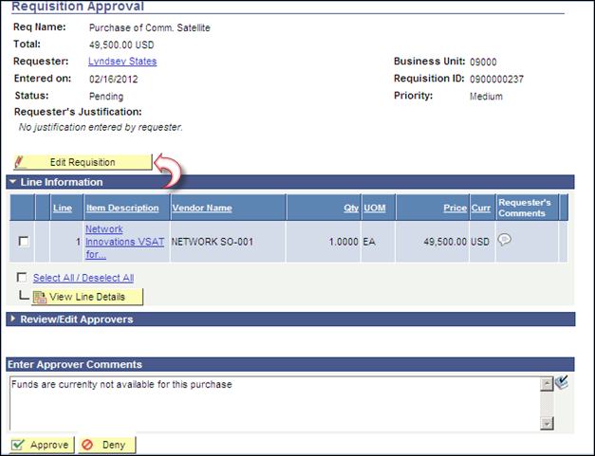
If the accountant needs to change the funding then click the button from the previous page.
Requester Comment
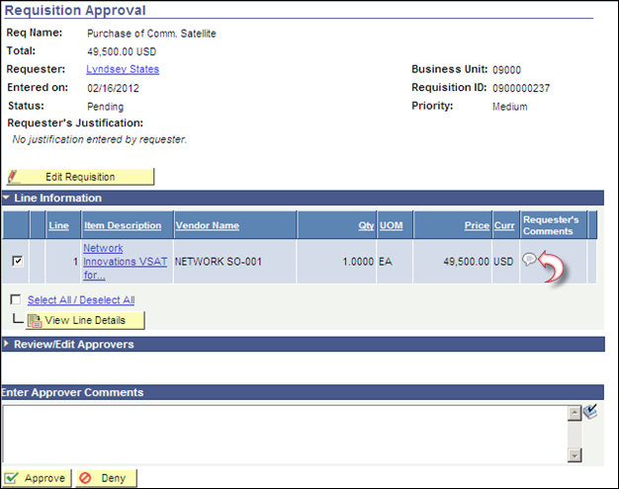
To review the Requestor comments, click on the Comment Icon (If no comments have been entered, the Comment Icon will appear as blank )
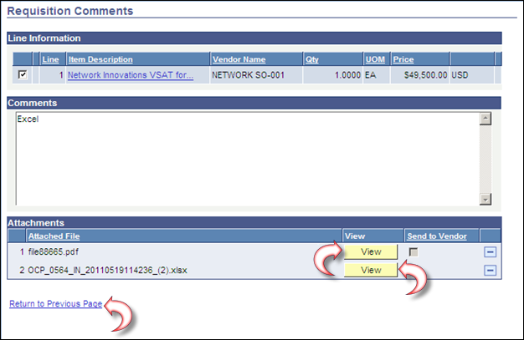
Click the button to review the attached files. (To review an XLS or Word file you may need to hold down the Ctrl Key)
Click .

Step 4-Approve/Deny Requisition
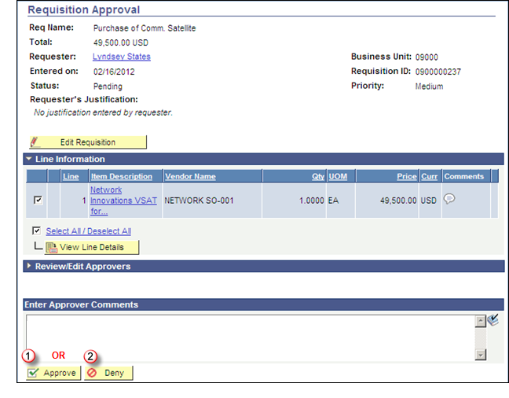
To Approve the Requisition Line, click the box located to the left of the requisition line and click the button. To Deny the Requisition input an Approver Comment, click the box located to the left of the requisition line and click the button. The Requisition will be sent back to the requestors Worklist and the approval will start over once the requestor fixes and re-submits the requisition.
Click the button.
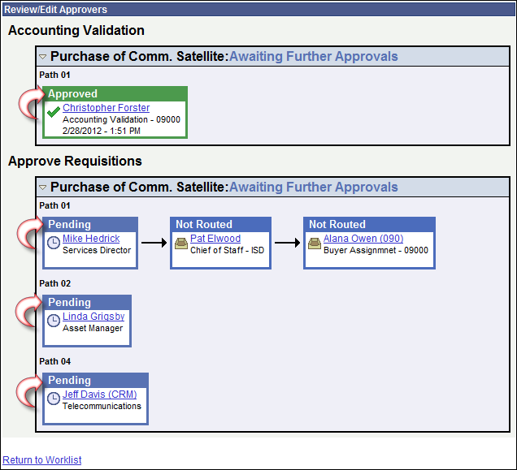
Notice the Accounting Validation box is now set as Approved. The Services Director, Asset Manger, and Telecommunications boxes are set as Pending and the requisition is now in their Worklist waiting for them to Approve the Requisition.
Click the link to select another requisition.
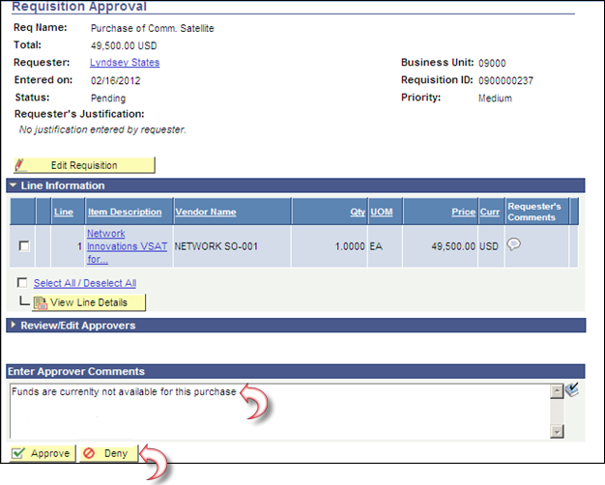
If you select the button, you must enter a reason in the Approver Comments field.
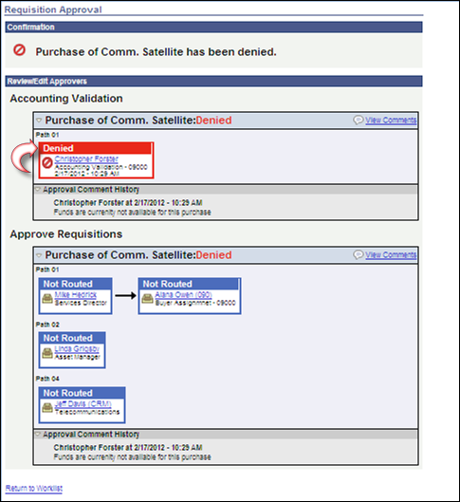
Notice the Accounting Validation box has been marked as denied. The requisition has been sent back to the Requester and is now in their Worklist.
Click the link to select another requisition.

Edit Requisition’s Funding/Asset Profile

Funding
The Edit Requisition button is only available to the Accounting Validation, Asset Manager, and CPO security.
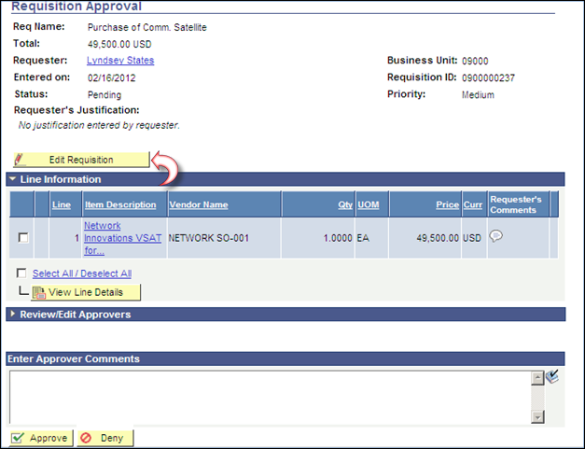
Click the button.
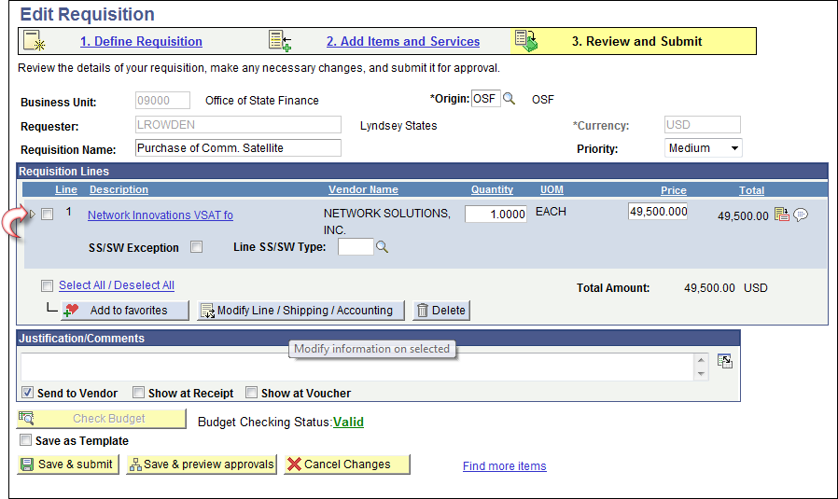
To update the funding click the Expand icon .
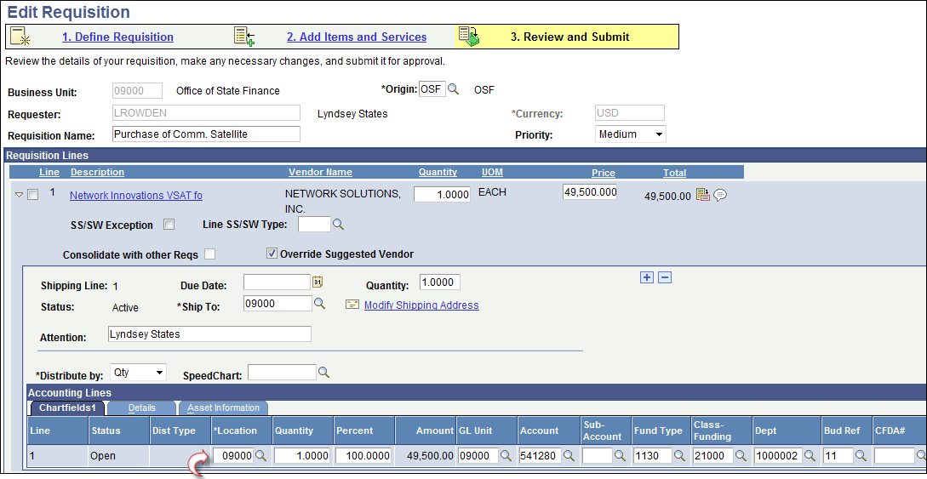
Any of the chartfields are available for the Accountant to Update currently the following are used.

- GL Unit
- Fund
- Class
- Department
- Bud Ref
- PC BU
- Project
- Activity
- Category
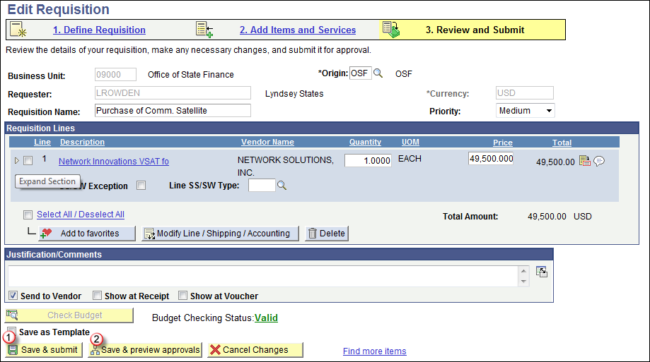
Once the chartfields have been updated then either click on the or .
will initiate the Workflow processes.
will let you review the workflow prior to submitting it. If you choose this option you will have to click on the button on the following page.
Click .
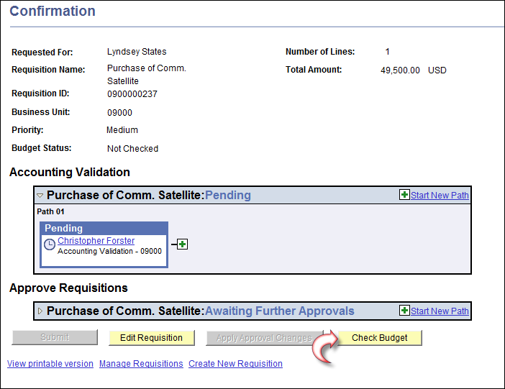
The accountant has a choice; the budget checking process can be ran from this page for this requisition by clicking on the button or they can wait until either the noon or evening batch budget checking process is ran.
Click the button.
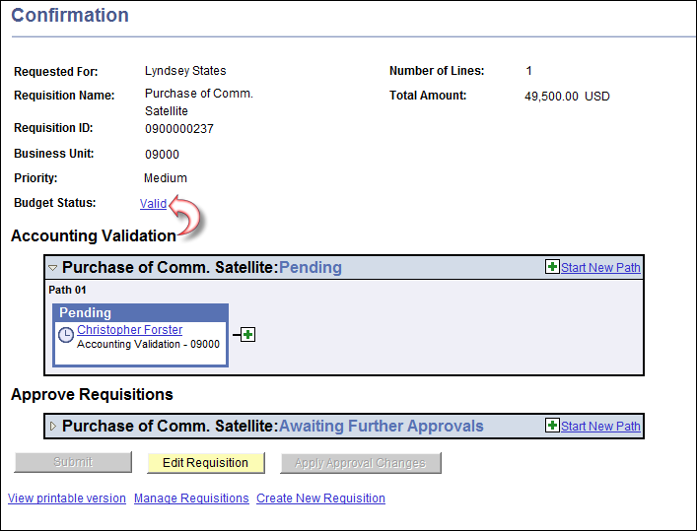
The budget checking status is valid. If the status went to Error, the user can click on the link and review the error message.
To approve the requisition the Approver can click link and following the above instructions.

Asset Profile
The Edit Requisition button is only available to the Accounting Validation, Asset Manager, and CPO security.
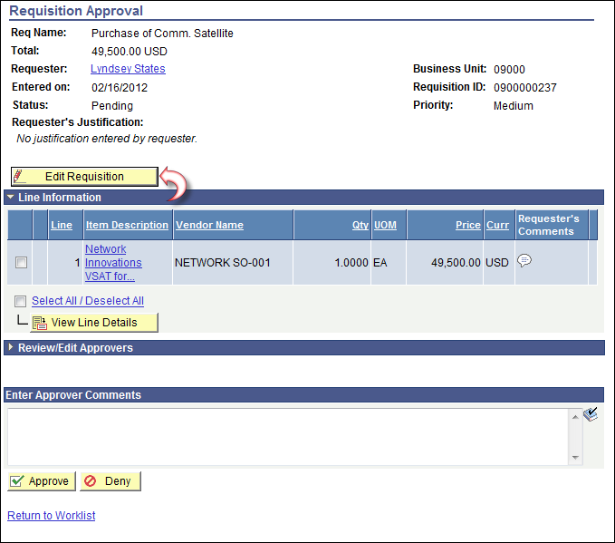
Click the button.
To update the funding click the Expand icon .
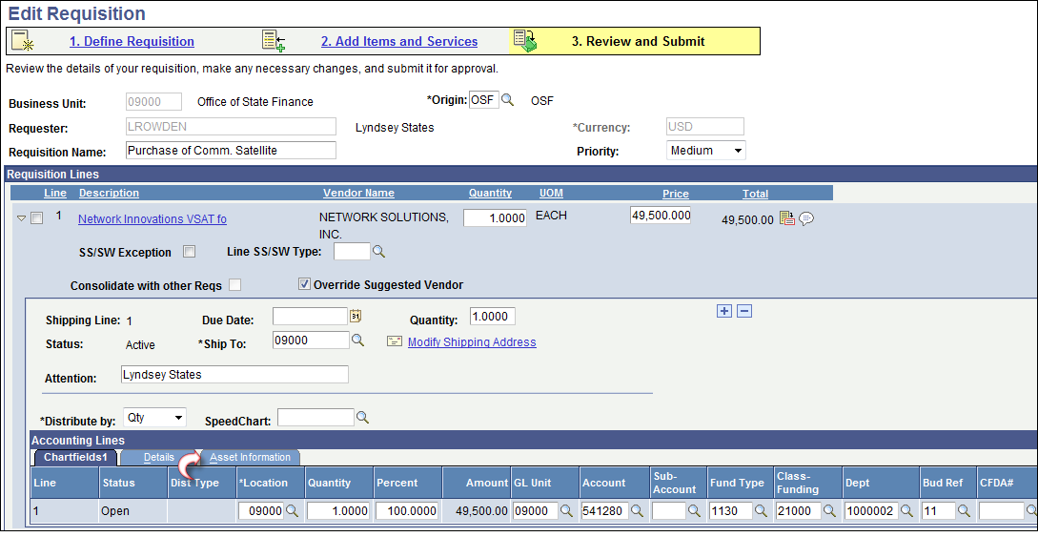
Click the tab.
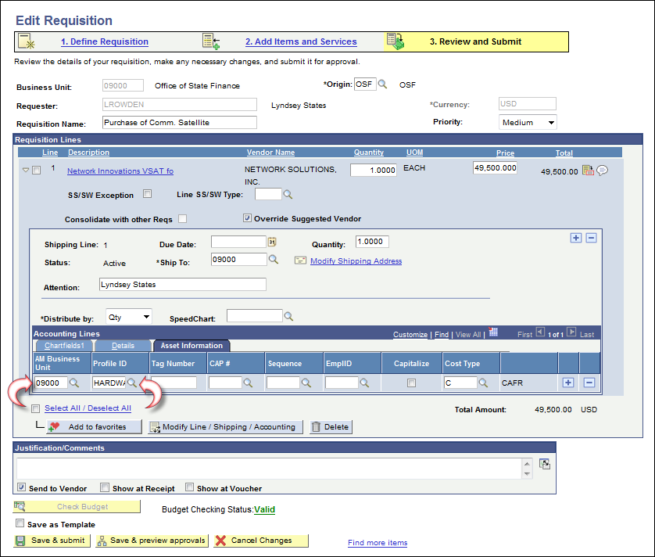
- The AM unit will be the BU that is responsible for the Asset.
- Profile ID-
You can update the data by clicking the look up icon located to the right of the field.
Once the AM Unit and Asset Profile have been updated then either click on the or .
will initiate the Workflow processes.
will let you review the workflow prior to submitting it. If you choose this option you will have to click on the button on the following page.
Click .

III. E-Procurement Requisition Workflow-Ad Hoc Feature
Prior to approving a PO an Approver can, if needed, ad hoc an addition step into the workflow.
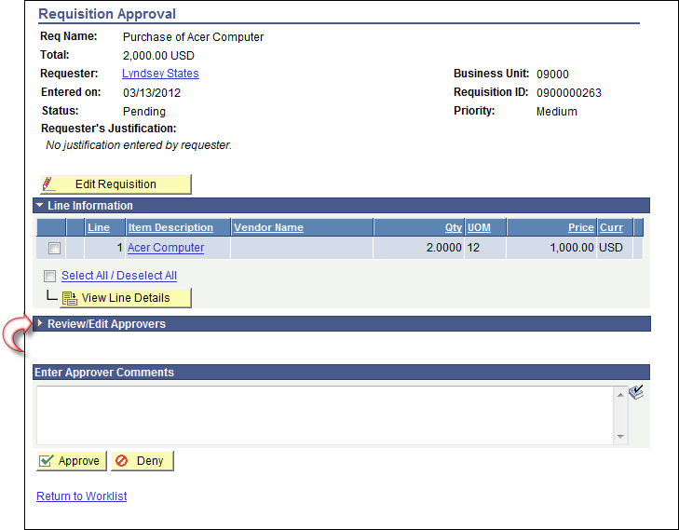
Click the expand icon in the bar.
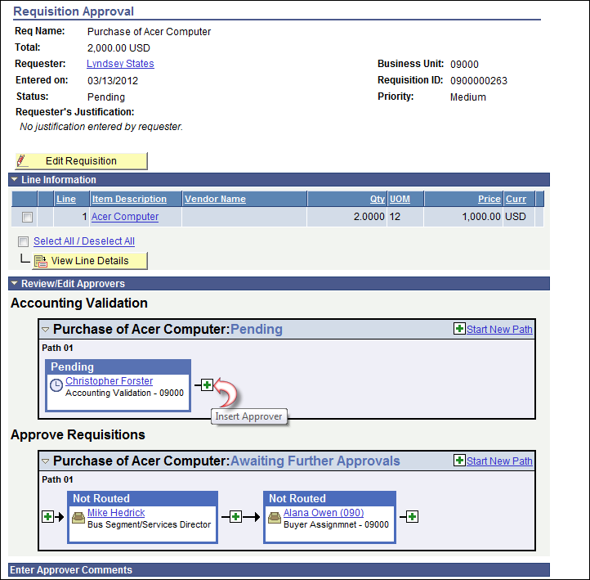
Click the icon to insert an Approver or Reviewer.
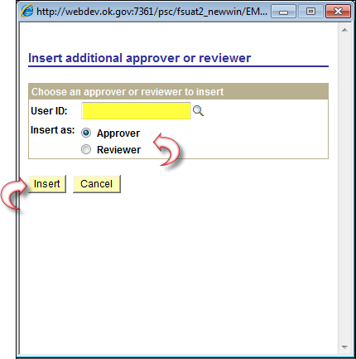
Enter the PeopleSoft user id of the person you wish to add to the workflow.
Select the icon to the left of either Approver or Reviewer.
Click the button.

NOTE: If you select Approver, the user id you select MUST be an eProcurement Requisition Approver. If they are not an eProcurement Requisition Approver, they will not have the authority to approve the requisition and as a result, the requisition will become “stuck” in the approval process.

