COR435 Project Costing –

Project Cost and Revenue Manual

The content of this training manual is based largely on a generic system configuration and illustrates the base-line functionality required to execute transactions in the module. Your agency may be utilizing more or less of the functionality illustrated in this manual. This manual is intended to be a framework upon which agencies can add agency-specific training content that speaks specifically to the system functionality that they have deployed and related configuration that they use for transaction processing. Agencies should not depend on these manuals for end-user training or problem resolution until they have been reviewed by the agency for appropriateness.

Authorized by: [_EBS_] Original Issue: [05/01/2014]
Maintained by: [____Project Costing Lead___]
Review Date: [05/01/2014]

Table of Contents

Table of Contents 3
Document History 5
Project Transaction Overview 6
Key Terms 7
Project Costing Business Unit 7
Project ID 7
Activity ID 7
Analysis Type 7
Analysis Group 7
Budget Item 7
Work Breakdown Structure 8
Project Budget 8
Project Accounting 8
Project Trees 8
Project Transaction 8
Process Flows 9
Guidelines, Concepts and Alternatives 12
Viewing Project Transactions 14
Transaction Definitions 14
Transaction List Page 15
Transaction Detail Page 16
Show All Transaction Details Page 17
Adding Project Transactions 21
Add Project Transactions 21
Add Transaction Page 22
Transaction Detail Page 23
Collect Project Costs 24
Collect Cost from General Ledger 24
General Ledger Page 25
Collect Accounts Payable Costs 27
Payables Page 28
Collect Purchasing Obligations 30
Purchasing Page 31
Project Revenue Collection 33
Retrieve Billing Items 33
Retrieve Billing Items Page 34
Retrieve Revenue from Contracts 36
Retrieve Revenue from Contracts Page 37
Pricing Engine 39
Rate Sets Tab 40
Target Tab 41
Running the Pricing Engine 42
Pricing Page 43
Project Accounting 45
Step 1: Define Accounting Rules 45
Accounting Rules Page 47
Step 2: Create Project Accounting Entries 48
Process Project Accounting Page 49
Manager Transaction Review 51
Project Manager Transaction Review 51
Manager Transaction Review Tab 51
Cost Review Tab 53
Billing Review Tab 54
Time and Labor Collection 55
Step 1: Run the Cost Share Analysis Type Update 55
Update Cost Share Analysis Type Tab 56
Step 2: Load Transactions into Projects 58
Load Transactions Page 59

Document History

Document Revision | Date | Description
1.0  2.0 | 04/30/2010  05/01/2014 | Initial Document  Upgrade Update

Project Transaction Overview

With the exception of programs (summary projects), each Project is composed, at the most basic level, of transactions. Transaction rows in the Project Transaction table (PROJ_RESOURCE) contain the quantity and amounts associated with each transaction and all of the identifying information that accompanied those costs. All project transactions are stored in the Project Transaction table (PROJ_RESOURCE). Project transactions provide the basis for project reporting, analysis, billing, and asset capitalization.

This manual describes the processes used to collect costs and revenue in the Project Costing module.

Key Terms

Project Costing Business Unit: Each agency has one, and only one Project Costing Business Unit. The Business Unit is the three (3) digit agency code, plus 00. For example, Office of State Finance is 09000.

Project ID: The Project ID represents the basic unit that serves to establish budgets and collect costs and revenue for analysis purposes. Projects serve to collect construction costs and capitalize Assets in conjunction with the Asset Management module. Project ID is also a Chartfield and as such a part of the distribution line.

Activity ID:An Activity ID generally represents a task that makes up a Project. Project Costs and Budgets are stored in Activities.

Analysis Type: Analysis Types are used in both Grants and Project Costing to reflect the nature of transactional data as it flows thru the system. PeopleSoft delivers a set of Analysis Types that support the functionality of software particularly in Grants and Projects. This set of Analysis Types should not be altered. However, if a business process requires that additional Analysis Types be added (this is likely) additional “agency specific” Analysis Types can be added and used.

Each project is composed, at the most basic level, of transactions. Transaction rows in the PROJ_RESOURCE table contain the quantity, amount, chartfields and other detailed data elements associated with each transaction (PO#, Req#, Voucher#, Vendor, etc.).

Analysis types are assigned to individual transactions to identify the different types of transactions, such as estimated costs, budgeted amounts, actual costs and billed costs. For a single transaction, the Analysis Type can change as the transaction flows thru the system. For example, a requisition begins with and Analysis Type = REQ, when the requisition is sourced into a Purchase Order another transaction is created with an analysis type of COM. Finally, when the PO is copied into a voucher for payment, a third transaction is created with the ACT analysis type. In this way, analysis types describe the nature of a transaction within Project Costing or Grants.

Analysis Group: A collection of Analysis Types used for securing Project Transactions, calculating Billable costs and Reporting.

Budget Item: An agency defined category of budgeting. These could be similar to a roll-up account like Labor, Equipment or Travel.

Work Breakdown Structure: Organization of Activity ID’s to define the total scope of each Project. Each descending level represents an increasingly detailed definition of a project component.

Project Budget: Project Budgets are Cost or Revenue budget estimates that are distributed to Project Activities and Budget Items across time periods for budgetary or project performance measurement.

Project Accounting: The Accounting for Projects feature provides a method for translating Project transactions into accounting entries that can be sent to General Ledger. Using Accounting Rules, the system converts transactions in Project Costing to accounting lines that the Journal Generator Application Engine process (FS_JGEN) later converts into journal entries.

Project Trees: Project Trees define how Projects are related to each other. The relationships between projects determine the level of detail achieved when tracking and reporting costs. Within a Project Tree, a project can be hierarchically related to as many projects as necessary to achieve the necessary degree of cost tracking and analysis.

Project Transaction: Project Transactions represent the cost, revenue or budget amounts defined for and collected in a Project. A Project Transaction can be a Purchase Order encumbrance, a Voucher cost, a Billing amount or a Budgeted estimate. Project Transactions make up the amounts and estimates by which Project Accounting and Reporting is accomplished.

Process Flows

Diagram 1: Project Costing Module Integration

Diagram 2: Project Costing to Billing Integration

Diagram 3: Project Costing-Billing-Contracts-Receivables Integration

Guidelines, Concepts and Alternatives

Table 1: Available Analysis Types

Analysis Type | Description | Analysis Type | Description
ACT | Actual Cost | FRV | Fixed-Cost Revenue Amount
ASP | Express Asset Percentage Distribution | FTC | Forecast Cost to Complete
BAJ | Billing Adjustment | GLE | General Ledger Expense
BD1 | Total Cost Budget - Scenario 1 | GLR | General Ledger Revenue
BD2 | Total Cost Budget - Scenario 2 | GNT | Grant Reimbursement
BD3 | Total Cost Budget - Scenario 3 | OLT | Over Limit Amount
BD4 | Total Cost Budget - Scenario 4 | ORD | Order
BD5 | Total Cost Budget - Scenario 5 | PAY | Time and Labor Actual
BD6 | Total Cost Budget - Scenario 6 | PCA | Profile Adjustment
BD7 | Total Cost Budget - Scenario 7 | PCL | Profile Cost Summary
BD8 | Total Cost Budget - Scenario 8 | PFS | Proceeds from Sale of Asset
BIL | Billable Amount | PSD | Purchase/Sold Time Discount
BLD | Billed Amount | PSR | Proceeds from Sale Summary
BRT | Billing Retainage | PST | Purchase/Sold Time
BUD | Total Cost Budget | RAJ | Released Retainage Adjustment
CAC | Cost Sharing Actuals | RB1 | Revenue Budget 1
CBA | Cost Budget Adjustment | RB2 | Revenue Budget 2
CBU | Cost Sharing Budget | RB3 | Revenue Budget 3
CCA | Closed Commitment Adjustment | RBD | Revenue Budget
CCO | Cost Sharing Commitment | REB | Rebate
CFA | Cost Sharing Finance and Administration | REQ | Requisition
CGE | Cost Sharing General Ledger Expense | RET | Retirement Cost
CLS | Asset Cost Summary | REV | Revenue
COM | Commitment including Purchase Order & Subcontractor | RRT | Released Billing Retainage
COR | Cost of Removal of Asset | RRV | Requisition Reversal
CPY | Cost Sharing Payroll | SFA | Sponsor Finance and Administration
CRQ | Cost Sharing Requisition | SHD | Shared Discount
CRR | Cost of Removal Cost Summary | SHR | Shared Revenue
CRV | Commitment Reversal | SUT | Sales/Use Tax
CST | Costing (without PeopleSoft Contracts) | TLA | Time and Labor Estimate
DEF | Deferred Amount | TLB | Time and Labor Estimate for Billing
DSC | Billing Discount | TLC | Time and Labor Contractors
EMP | Project Costing Employee Time | TLX | Cost from Time Traveler
ESB | Engagement Plan Bill Estimate | UAJ | Prepaid Utilization Adjustment
ESC | Engagement Plan Cost Estimate | UTL | Prepaid Utilization (Billing)
FBD | Fixed Cost Billed Amount | VAR | Variance
FCC | Completion Cost | VIN | Not Recoverable Value Added Tax
FND | Fund Distribution | WTO | Write Off
FND | Fund Distribution

* Commonly used Analysis Types are displayed on BOLD in this table.

Viewing Project Transactions
At a basic level, Projects are made up of Project Transactions (costs, budgets, revenue). Generally, these transactions are pulled into Project Costing from feeder modules (Purchasing, Payables, and General Ledger). Project transactions can be viewed once they have been collected into the Project Costing module. These transactions can be costs, revenue or budget in nature.

Analysis types are assigned to individual transactions to identify different types of transactions, such as estimated costs, budgeted amounts, actual costs, and billed costs. When viewing Project transactions Analysis Types are critical in understanding what makes up a Projects transactions.

Transaction Definitions

Navigation: Project Costing > Transaction Definitions > Transaction Lists > Find an Existing Value

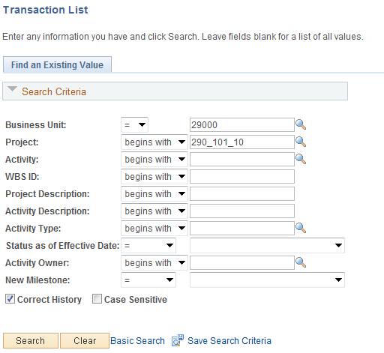

Use the Search Criteria to retrieve the Project containing transactions.

Business Unit – is the Agency in which the Project is stored.

Project – the Project ID containing transactions.

Description – search by Project Description.

Click to enter the Project Transaction pages.

Transaction List Page

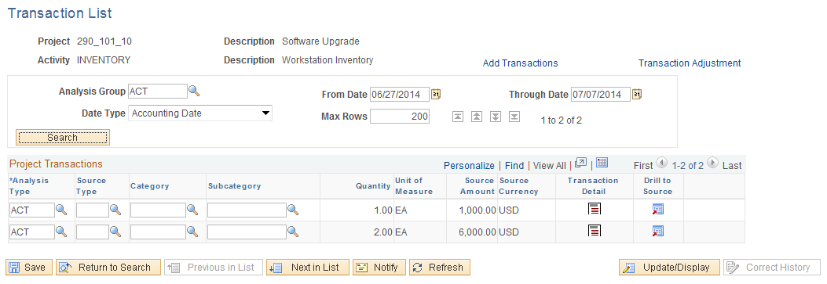

The Transaction List page displays all Project transactions meeting the criteria defined at the top of the page.

NOTE: All Project transactions may not be visible on the page initially. Use to scroll through the Project transactions. Or, click the View All link.

Analysis Group – all transactions with an Analysis Type defined in this Analysis Group will be retrieved.

From/Through Date – define a date range that will be used to select Project transactions.

Date Type – define the Accounting or Transaction date used in combination with the From/Through Date option.

Click to retrieve the Project transactions.

Click the Transactions Detail icon for transaction row to view Project transaction details.

Transaction Detail Page

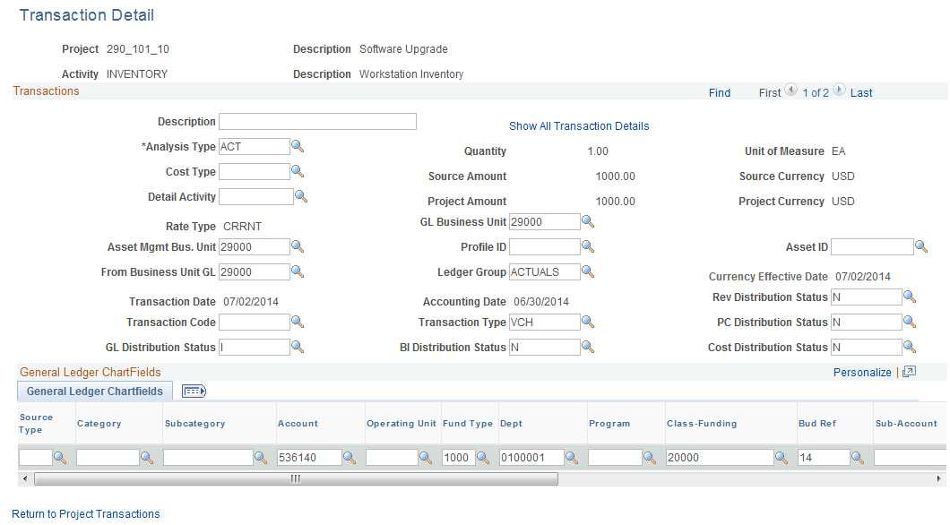

The Project Transaction Detail page displays specific data elements from the transaction. These include Descriptions, Dates and Chartfield information.

Analysis Type – this value defines the type of Project transaction that is being viewed.

General Ledger Chartfields – this section of the page displays all chartfield values on the transaction.

Click the Show All Transaction Details link.

Use to scroll through the Project transactions.

NOTE: Analysis Type is defined on the transaction row when integrated from the feeder module.

Show All Transaction Details Page

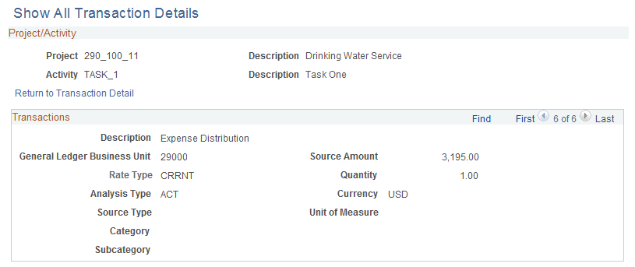
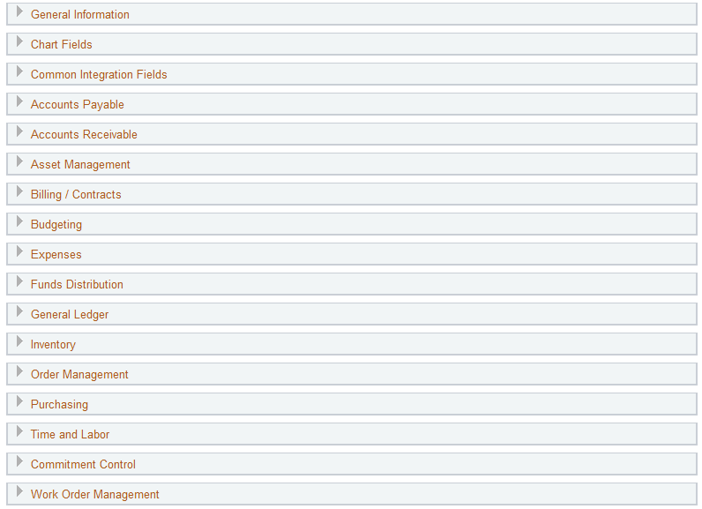

The Show All Transaction Details page displays information from the feeder modules that integrate with Project Costing.

Use the Expand Section icon to expand any section of the page.

Show All Transaction Details page continued

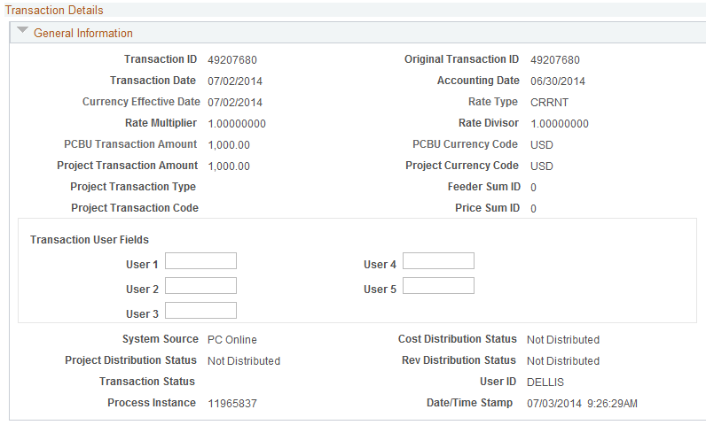

The General Information section of the page displays basic Project transaction information including Dates, Amounts, User Fields (if applicable), System Source and User ID.

Transaction ID – a system created and assigned number for an individual Project transaction.

NOTE: User Fields are editable on this page allowing the user to associate User values to the
Project transaction.

Show All Transaction Details page continued

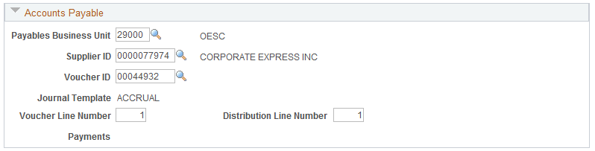

For Project transactions collected from Payables, the Accounts Payable Voucher information is available.

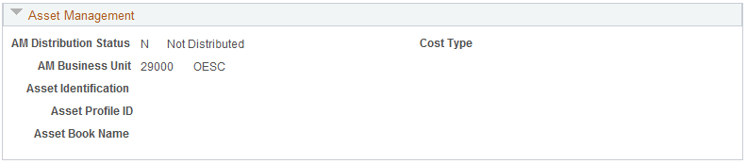

For Project transactions identified as capital for Asset Management, Asset information will be available.

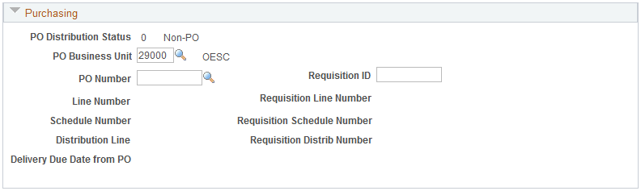

For Project Encumbrances, the Requisition (if applicable) and PO Number, Line, Schedule and Distribution information is available.

Show All Transaction Details page continued

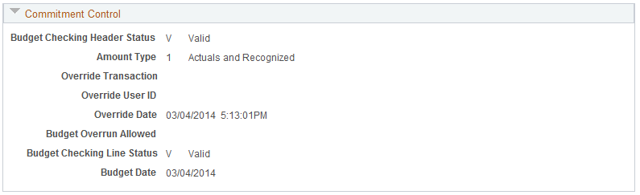

Commitment Control Budget Checking details are available for the Project transaction.

Click the Return to Transaction Detail link.

Click the Return to Project Transactions link to return to the main Transaction List page.

Adding Project Transactions

Project transactions can be collected from other modules within the system or they can be added manually directly into Project Costing. Not all type of Project transactions are allowed to be added directly into Project Costing (controlled by Analysis Type).

Certain state agencies require billing of federal sponsors prior to expenditure or sub-recipient pass thru transactions. In these cases, it may be necessary to manually add Project transactions directly into Project Costing for billing purposes. Through this process, invoice to federal sponsors can be created, receivables balances established, cash collected and subsequent expenditures or pass-thru monies completed.

Add Project Transactions

Navigation: Project Costing>Transaction Definitions > Add Transactions > Find an Existing Value

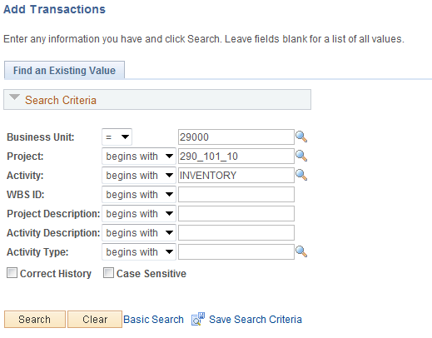

Use the Search Criteria to retrieve the Project containing transactions.

Business Unit – is the Agency in which the Project is stored.

Project – the Project ID containing transactions.

Activity – select the Activity into which the transaction will be added.

Description – search by Project Description.

Click to enter the Project Transaction pages.

Add Transaction Page

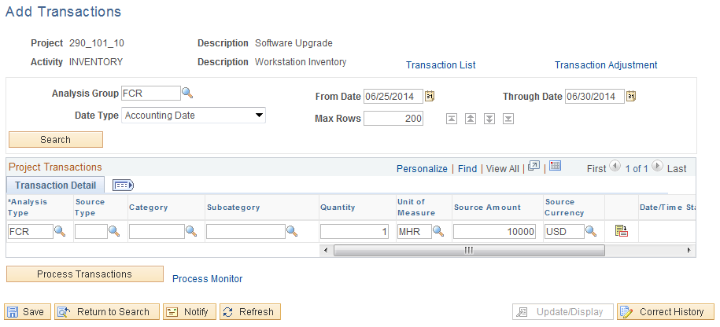

Use the Add Transaction page to define the Project transaction to be added.

Analysis Group – define the Analysis Group that will restrict which Analysis Types are available for selection.

From/Through Date – define a date range that will be used to select Project transactions.

Date Type – define the Accounting or Transaction date used in combination with the From/Through Date option.

Analysis Type – select the Analysis Type for the Project Transaction that will be added.

NOTE: The Analysis Types available for selection are included in the Analysis Group defined on this page.

Source Type, Category, and Subcategory – define the desired Project Costing chartfields if required.

Unit of Measure – define the UOM for the Project transaction.

Source Amount – populate the amount of the Project transaction.

Click the Transaction Detail icon for Project transaction details.

Transaction Detail Page

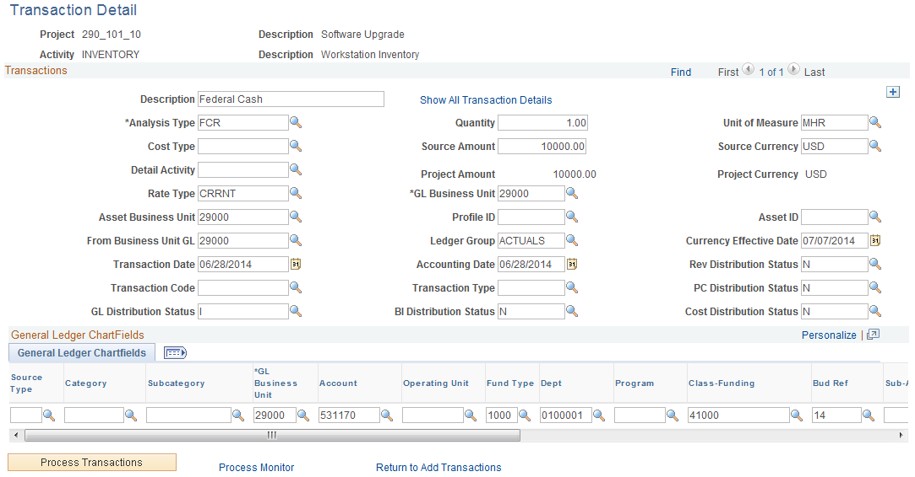

Use the Transaction Detail page to add additional information for the Project transaction including General Ledger chartfileds.

Description – add a description for the Project transaction.

BI Distrib Status – to allow Project Pricing for billing, set this field to ‘N’.

General Ledger Chartfields – add the desired GL Chartfield values.

Click to execute a process that will add the Project transaction to the system.

Use the Process Monitor link to view the status of the process.

Collect Project Costs

Project costs from feeder modules – Purchasing, Accounts Payable, General Leger and Time & Labor – are collected into Project Costing through a batch process. These batch processes are schedule to run nightly but can be executed on an ad hoc basis.

Collect Cost from General Ledger

Navigation: Project Costing > Cost Collection > General Ledger > Find an Existing Value

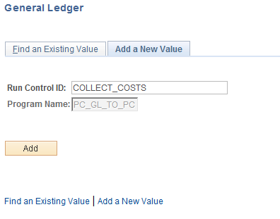

Run Control ID – create a new Run Control or select an existing value from the list. If a new Run Control is created, click , otherwise click to retrieve an existing Run Control.

General Ledger Page

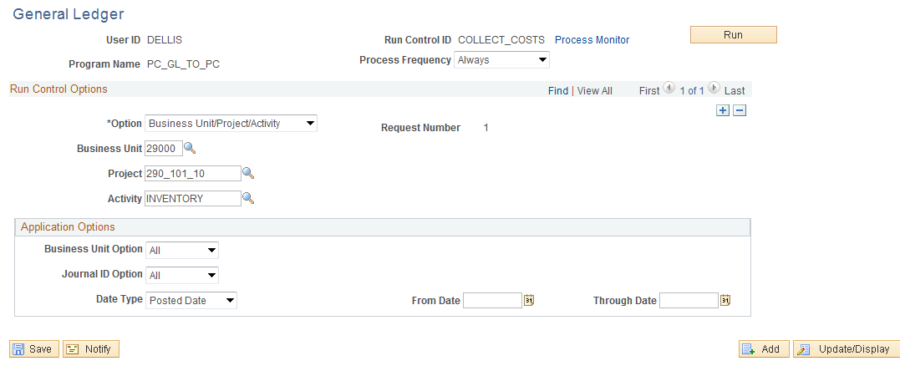

Process Frequence – set to ‘Always’

Option – define the scope of the General Ledger Cost Collection process for this run. The process can be executed by:
All – select all Project Costing Journal transactions for all Business Units. This value will not be used when running the process on an Ad-Hoc basis.
Business Unit – select all Project Costing Journal transactions for an agency Business Unit.
Business Unit/Project – select all Project Costing Journal transactions for an agency Business Unit and Project ID.
Business Unit/Project/Activity - select all Project Costing Journal transactions for an agency Business Unit, Project ID and Activity ID.

NOTE: Use in insert additional rows as needed to select multiple Projects, etc.

Business Unit Option – select all Project Costing Journal transactions for a General Ledger Business Unit.

Journal ID Option - select all Project Costing Journal transactions for a range of Journal ID’s.

Date Type - select all Project Costing Journal transactions within a Date Range.

NOTE: Not all of the fields on this page will display depending on which ‘Option’ value is selected.

Click to execute the Journal Collect process.

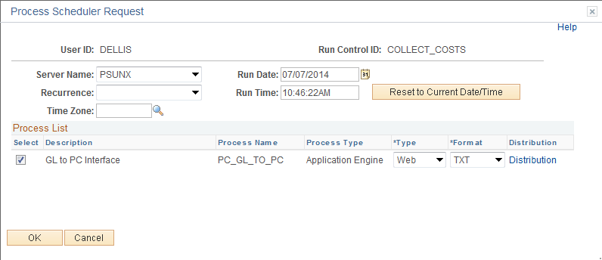

Select the checkbox next to the desired process.

Click to execute the process. Navigate to the Process Monitor link to view the Report instance.

Collect Accounts Payable Costs

Navigation: Project Costing > Cost Collection > Payables > Find an Existing Value

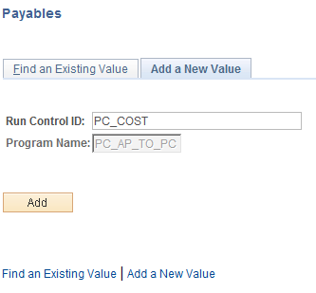

Run Control ID – create a new Run Control or select an existing value from the list.

Click to retrieve an existing Run Control.

Payables Page

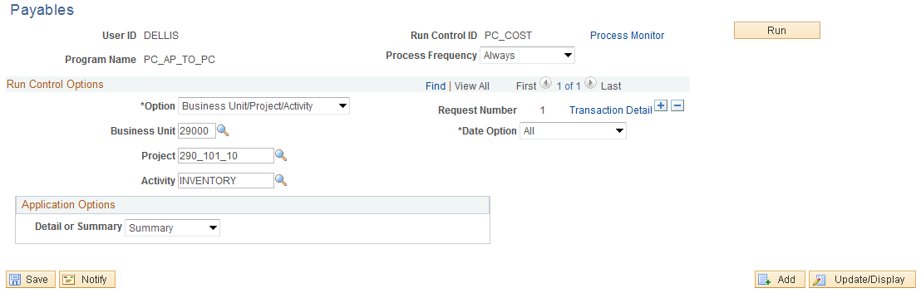

Process Frequence – set to ‘Always’.

Option – define the scope of the Payables Cost Collection process for this run. The process can be executed by:
All – select all Project Costing Payables transactions for all Business Units. This value will not be used when running the process on an Ad-Hoc basis.
Business Unit – select all Project Costing Payables transactions for an agency Business Unit.
Business Unit/Project – select all Project Costing Payables transactions for an agency Business Unit and Project ID.
Business Unit/Project/Activity - select all Project Costing Payables transactions for an agency Business Unit, Project ID and Activity ID.

NOTE: Use in insert additional rows as needed to select multiple Projects, etc.

Business Unit – the agency Project Costing Business Unit.

Project – the agency Project ID.

Activity – the Activity ID within the Project ID selected.

Date Option – narrow the scope of Payables transactions selected by Accounting or Transaction Date.

From Date/Through Date – define a date range to be used as selection criteria for Payables transactions.

Detail or Summary – this option defines how the Payables Project transactions will be displayed in Project Costing.

NOTE: Not all of the fields on this page will display depending on which ‘Option’ value is selected.

Click to execute the Payables Collect process.

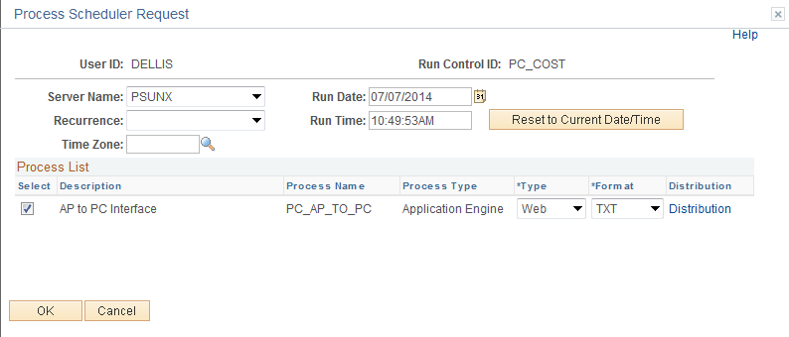

Select the checkbox next to the desired process.

Click to execute the process. Navigate to the Process Monitor link to view the Report instance.

Collect Purchasing Obligations

Navigation: Project Costing > Cost Collection > Purchasing > Find an Existing Value

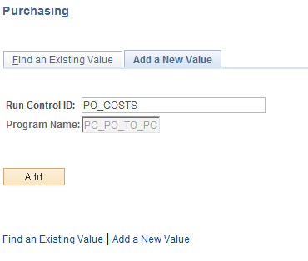

Run Control ID – create a new Run Control or select an existing value from the list.

Click to retrieve an existing Run Control.

Purchasing Page

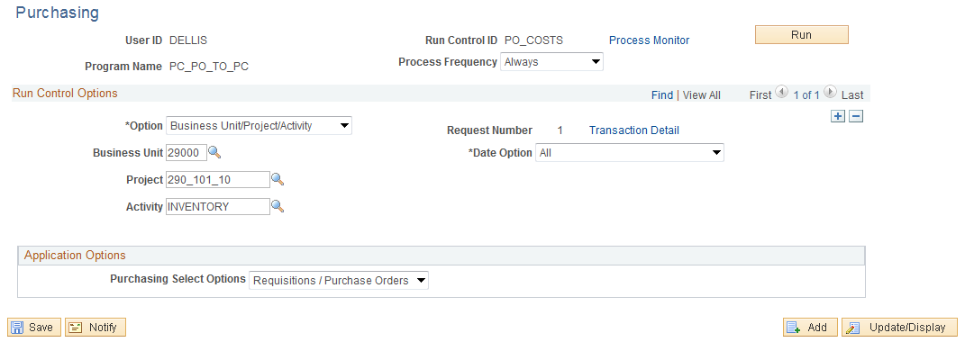

Process Frequence – set to ‘Always’.

Option – define the scope of the Purchasing Cost Collection process for this run. The process can be executed by:
All – select all Project Costing Purchasing transactions for all Business Units. This value will not be used when running the process on an Ad-Hoc basis.
Business Unit – select all Project Costing Purchasing transactions for an agency Business Unit.
Business Unit/Project – select all Project Costing Purchasing transactions for an agency Business Unit and Project ID.
Business Unit/Project/Activity - select all Project Costing Purchasing transactions for an agency Business Unit, Project ID and Activity ID.

NOTE: Use in insert additional rows as needed to select multiple Projects, etc.

Business Unit – the agency Project Costing Business Unit.

Project – the agency Project ID.

Date Option – narrow the scope of Purchasing transactions selected by Accounting or Transaction Date.

Purchasing Select Options – select to collect Purchase Orders, Requisitions or Both.

NOTE: Not all of the fields on this page will display depending on which ‘Option’ value is selected.

Click to execute the Purchasing Collect process.

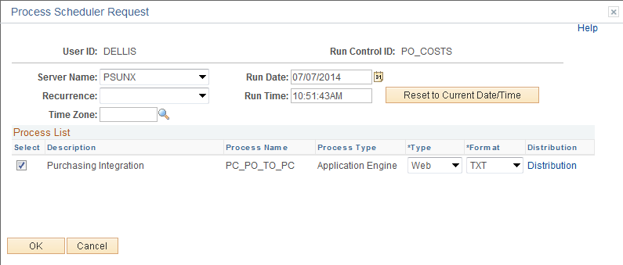

Select the checkbox next to the desired process.

Click to execute the process. Navigate to the Process Monitor to view the Report instance.

Project Revenue Collection

Project related revenue information from feeder modules – Contracts, Billing and Accounts Receivable – is collected into Project Costing through a batch process. These batch processes are schedule to run nightly but can be executed on an ad hoc basis.

When Rate-Based Billing information is finalized in Billing and Project Contracts are updated, that information can be sent to Project Costing in the ‘Retrieve Billing Items’ batch process (PC_BI_TO_PC) to reflect that billing Finalization.

For Fixed-Fee Billing Contract linked to a Project, run the ‘Retrieve Revenue from Contracts’ process (PC_CA_TO_PC) to update the Project Transaction Table with results from Contracts and Billing processes.

Retrieve Billing Items

Navigation: Project Costing > Revenue Collection > Retrieve Billing Items > Find an Existing Value

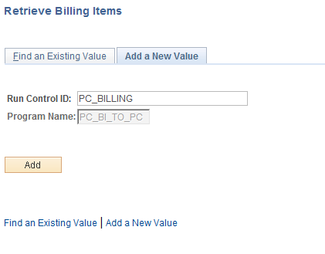

Run Control ID – create a new Run Control or select an existing value from the list. If a new Run Control is created, click , otherwise click to retrieve an existing Run Control.

Retrieve Billing Items Page

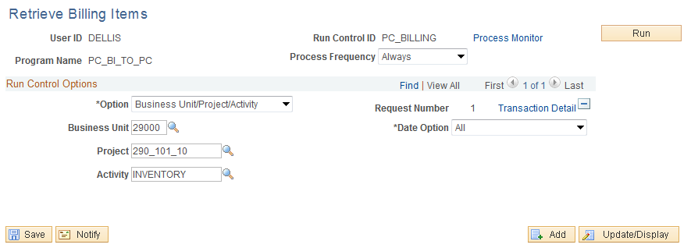

Process Frequence – set to ‘Always’.

Option – define the scope of the Retrieve Billing Items process for this run. The process can be executed by:
All – select all Project Costing Billing transactions for all Business Units. This value will not be used when running the process on an Ad-Hoc basis.
Business Unit – select all Project Costing Billing transactions for an agency Business Unit.
Business Unit/Project – select all Project Costing Billing transactions for an agency Business Unit and Project ID.
Business Unit/Project/Activity - select all Project Costing Billing transactions for an agency Business Unit, Project ID and Activity ID.

NOTE: Use in insert additional rows as needed to select multiple Projects, etc.

Business Unit – the agency Project Costing Business Unit.

Project – the agency Project ID.

Date Option – narrow the scope of Billing transactions selected by Accounting or Transaction Date.

NOTE: all of the fields on this page will display depending on which ‘Option’ value is selected.

Click to execute the Billing Collect process.

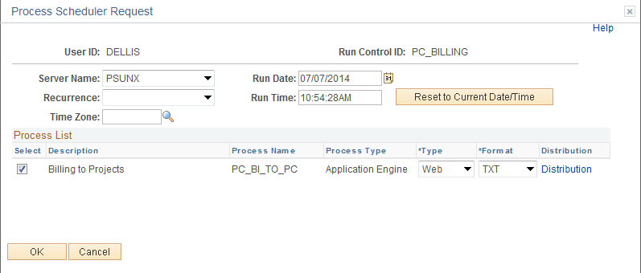

Select the checkbox next to the desired process.

Click to execute the process. Navigate to the Process Monitor link to view the Report instance.

Retrieve Revenue from Contracts

Navigation: Project Costing > Revenue Collection > Retrieve Revenue From Contract > Find an Existing Value

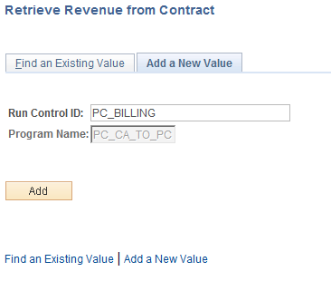

Run Control ID – create a new Run Control or select an existing value from the list. If a new Run Control is created, click , otherwise click to retrieve an existing Run Control.

Retrieve Revenue from Contracts Page

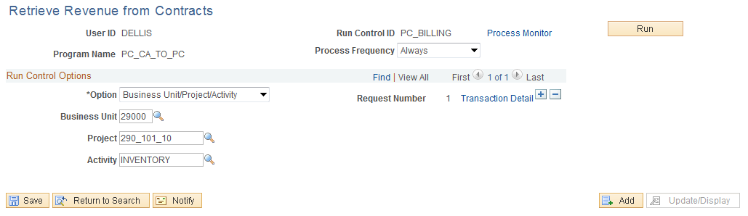

Process Frequence – set to ‘Always’

Option – define the scope of the Contract Revenue process for this run. The process can be executed by:
All – select all Project Costing, Contract Revenue transactions for all Business Units. This value will not be used when running the process on an Ad-Hoc basis.
Business Unit – select all Project Costing, Contract Revenue transactions for an agency Business Unit.
Business Unit/Project – select all Project Costing, Contract Revenue transactions for an agency Business Unit and Project ID.
Business Unit/Project/Activity - select all Project Costing, Contract Revenue transactions for an agency Business Unit, Project ID and Activity ID.

NOTE: Use in insert additional rows as needed to select multiple Projects, etc.

Business Unit – the agency Project Costing Business Unit.

Project – the agency Project ID.

Activity – define the Project Activity.

NOTE: Not all of the fields on this page will display depending on which ‘Option’ value is selected.

Click to execute the Contract Revenue Collect process.

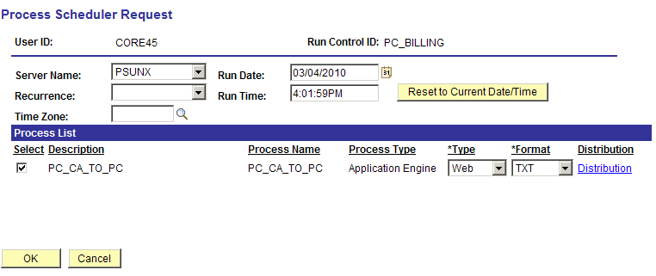

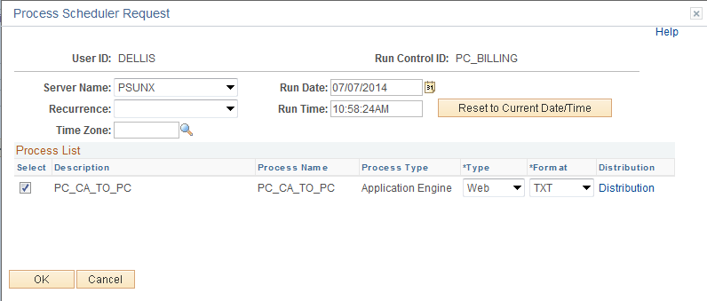

Select the checkbox next to the desired process.

Click to execute the process. Navigate to the Process Monitor link to view the Report instance.

Pricing Engine

The Pricing Process (PC_PRICING) calculates transaction costs, overhead, and revenue amounts from Source Rows, which are transactions that are brought into Project Costing. Source rows entered into a feeder system, such as Accounts Payable, and integrated into Project Costing.

Processes that bring cost transactions into Project Costing automatically trigger the Pricing process. The process matches the costs with Rate Sets that specify what Target Rows to create in the Project Transaction tables. Target rows are transactions that are created as a result of pricing the source transaction row.

Rate Sets can be configured to match source transaction rows by any Chartfield value as well as employee information like Job Code, Employee ID and Time Reporting Code.

Transactions are eligible to price for billing when the Project and Activity are linked to a Rate Set or Rate Plan. Normally this link will be created through Contracts at the contract line level. For example, assume that a voucher is entered in PeopleSoft Enterprise Payables for 100 USD. When the Payables to Project Costing Application Engine process (PC_AP_TO_PC) runs, it selects the cost row from the Voucher Accounting Line table and calls the Pricing process, which creates a billing row from the cost row. When the process completes there are two rows in the Project Transaction table, a row with an analysis type of ACT (actual cost) and a row with an analysis type of BIL (billable amount), as shown in this table Creating Rate Sets.

Navigation: Setup Financial Supply Chain > Product Related > Project Costing > Pricing Structure > Rate Sets > Add a New Value

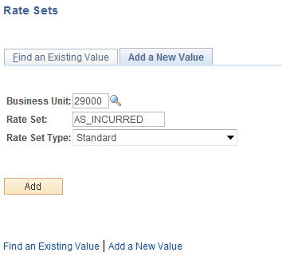

Business Unit – Rate Sets are defined for each agency business unit.

Rate Set – the Rate Set value.

Rate Set Type – set to ‘Standard’

Click create a Rate Sets.

Rate Sets Tab

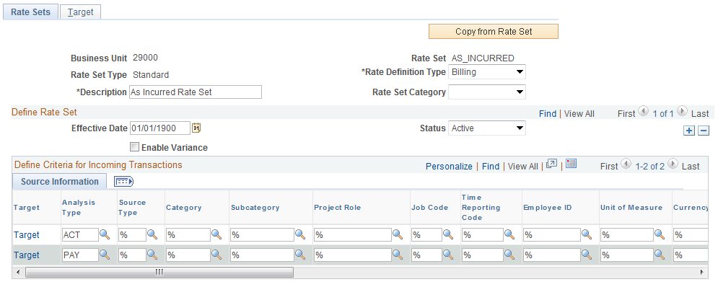

The Tab defines the chartfield values that will be matched against incoming Project transactions to create target rows.

Rate Definition Type – define the Rate Set for ‘Billing’ Project transactions or for ‘Costing’ Project transactions. Rate Sets for Billing are used with the Contracts Module to create Rate Based Billing rows for invoicing. Rate Sets for Cost could be used to create ‘Overhead’ or ‘Mark Up” rows in a Project.

NOTE: This selection will restrict the Target Analysis Types available for selection on the Target page.

Description – create a Description for the Rate Set.

Effective Date – define the date that the Rate Set will be effective.

Analysis Type – define the Analysis Type that the Rate Set will use to match Project transactions for Pricing.

NOTE: The Rate Set page works as a ‘Filter’ that only selects incoming Project Transactions that match exactly the values on the Rate Set page. All incoming transactions that match the field values the Target page are subject to the Pricing Engine. The wildcard value of ‘%’ indicates that any value in that field will match the Rate Set.

Click the Target Tab or use the Target link.

Target Tab

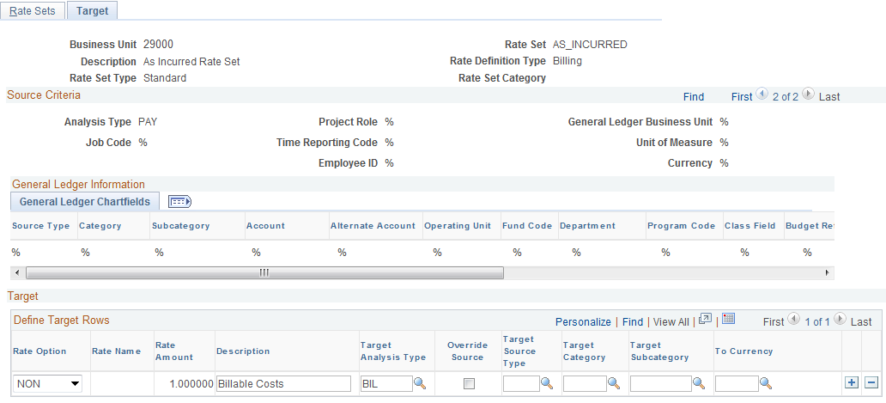

For each row on the Rate Sets Tab, a Target row will be created to define the type of row that will be created by the Pricing Engine.

Rate Option – defines how the target row will be created. This could be a markup or actual cost.

Description – this target row created in Projects will hold the description defined here.

Target Analysis Type – the target row created by the Pricing Engine will have this Analysis Type.

Target Source Type – the target row created by the Pricing Engine will have this Source Type. If left blank, the target row will inherit the Source Type from the source row.

Target Category – the target row created by the Pricing Engine will have this Source Category. If left blank, the target row will inherit the Source Category from the source row.

Target Subcategory – the target row created by the Pricing Engine will have this Source Subcategory. If left blank, the target row will inherit the Source Subcategory from the source row.

NOTE: If a chartfield value is not defined on the Target row, the target row will inherit the chartfield value from the source Project transaction line.

Click to Save the Rate Set.

Running the Pricing Engine

Navigation: Project Costing > Utilities > Pricing > Find an Existing Value

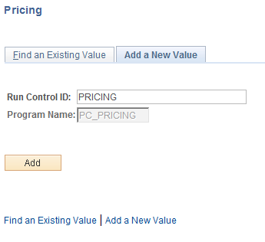

Run Control ID – create a new Run Control or select an existing value from the list. If a new Run Control is created, click , otherwise click to retrieve an existing Run Control.

Pricing Page

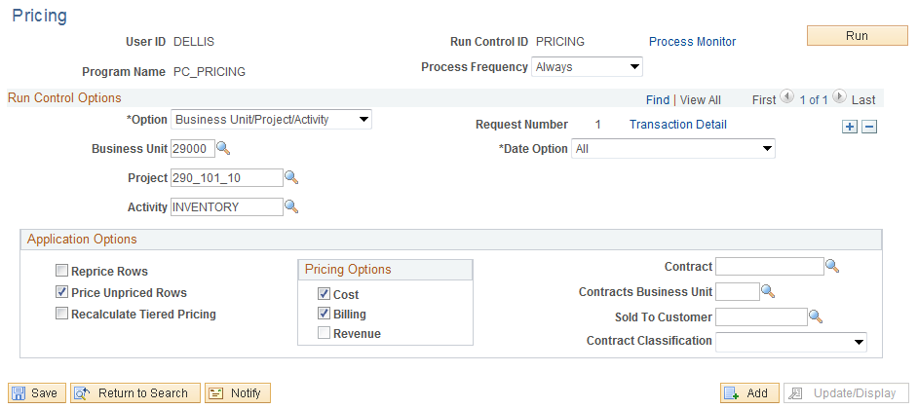

Use the Pricing page to run the Pricing engine on an Ad Hoc basis.

Process Frequence – set to ‘Always’.

Option – define the scope of the Pricing process for this run. The p`rocess can be executed by:
All – Price all Project Costing Journal transactions for all Business Units. This value will not be used when running the process on an Ad-Hoc basis.
Business Unit – Price all Project Costing Journal transactions for an agency Business Unit.
Business Unit/Project – Price all Project Costing Journal transactions for an agency Business Unit and Project ID.
Business Unit/Project/Activity - Price all Project Costing Journal transactions for an agency Business Unit, Project ID and Activity ID.

NOTE: Use in insert additional rows as needed to select multiple Projects, etc.

Application Options – select the action taken on Project transaction rows to Reprice or Price Unpriced Rows. Select Reprice Rows when a project transaction entry has already been priced and it needs to be priced again.

Pricing Option – price Project transactions for Billing or Cost.

Contracts - price only Project transactions related to a particular Contract, Contract BU, Customer or Contract Class.

NOTE: Not all of the fields on this page will display depending on which ‘Option’ value is selected.

Click to execute the Pricing process.

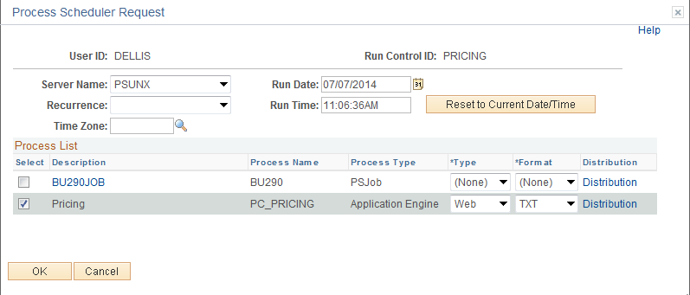

Select the checkbox next to the desired process.

Click to execute the process. Navigate to the Process Monitor link to view the Report instance.

Project Accounting

Accounting Rules are defined to create debit and credit Accounting Entries for Project transactions that need to post Journal Entries in General Ledger. These accounting entries are generally defined for Billable Project transactions but could be defined for other Project transactions.

Accounting Rules are defined to select Project transactions based on particular values in the Project transaction line or the Project definition. For example, an Accounting Rule could be created for a particular Analysis Type and Project Type.

Step 1: Define Accounting Rules

Navigation: Setup Financial Supply Chain > Product Related > Project Costing > General Options > Accounting Rules > Add a New Value

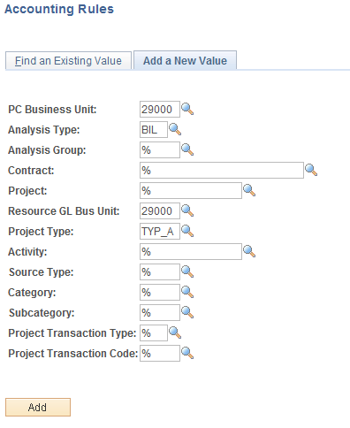

Create the Accounting Entry to match Project transactions that require journal entries in General Ledger. Use the chartfield values that the Project transaction will have so that the transaction will be selected and the accounting entry created.

Project Costing Business Unit – accounting rules are defined for each agency business unit. This value is required.
Analysis Type – accounting rules are defined by Analysis Type. Select the Analysis Type for the Project transactions that require accounting entries.

Resource GL Business Unit – define the General Ledger Business Unit into which the Project accounting entry Journal Entries will be posted. This value is required.

Project Type – to create Accounting Entries by Project Type, define a value.

NOTE: The Project Costing chartfields are optional when defining Accounting Rules. These values would only be populated if a different type of accounting entry (different debits and credits) is desired by Project Costing chartfield.

Click to enter the Project Accounting Entries pages.

Accounting Rules Page

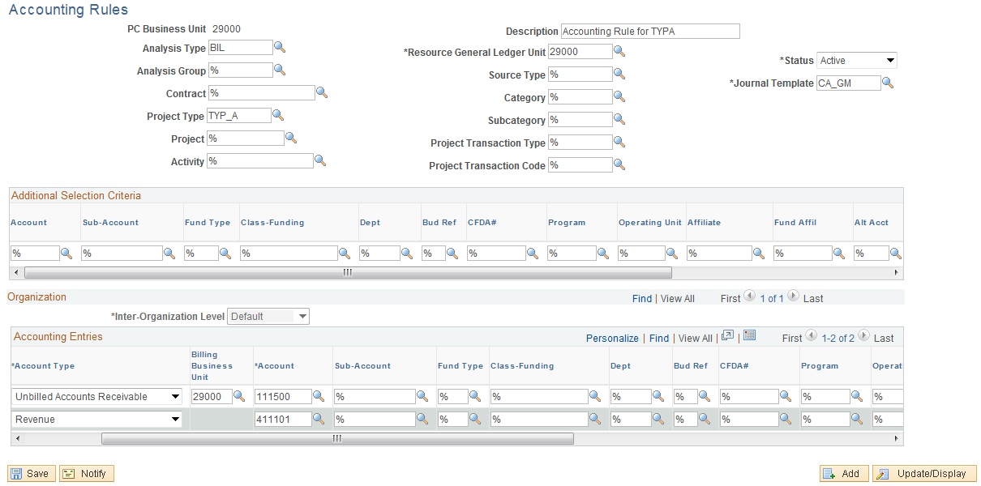

Additional Selection Criteria

Enter ChartField values to search for general ledger ChartFields.

When a new accounting rule is added, all fields in this group box are wildcard symbols (%). The Alternate Account field is enabled or disabled based on the Enable Alternate Account option on the Installation Options page and then based on the Enable Alternate Account option on the General Ledger Business Unit Definition page.

Accounting Rules are defined by Project Business Unit with particular Project transaction values.

Description – define a Description for the Accounting Rule.

Journal Template – define the Journal Template that will summarize, mask and date the Journal Entry created from the Accounting Rule.

Account Type – select from the pre-defined Account Type values that create the Debit and Credit sides of the Accounting Entry.

Billing Business Unit – for Unbilled AR Account Types define the billing business unit.

Account – define the Account for the Debit and Credit sides of the entry.

NOTE: Accounting Rules for billable Project transactions with Analysis Type equal to ‘BIL’ will have a debit to ‘Unbilled Accounts Receivable’ and a credit to ‘Revenue’.

NOTE: For every Accounting Rule with a BIL analysis type, a corresponding accounting rule for BLD analysis type must be created.

NOTE: If a chartfield value is not defined on the Accounting Rule, the accounting entry will inherit the chartfield value from the Project transaction line.

Click to Save the Accounting Rule.

Step 2: Create Project Accounting Entries

Navigation: Project Costing > Accounting>Process Project Accounting > Find an Existing Value

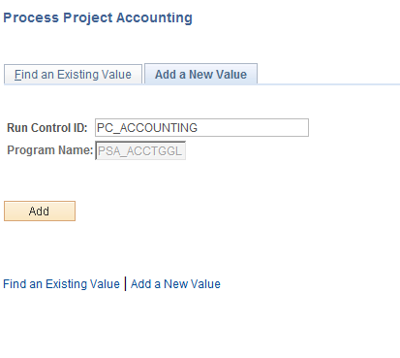

Run Control ID – create a new Run Control or select an existing value from the list. If a new Run Control is created, click , otherwise click to retrieve an existing Run Control.

Process Project Accounting Page

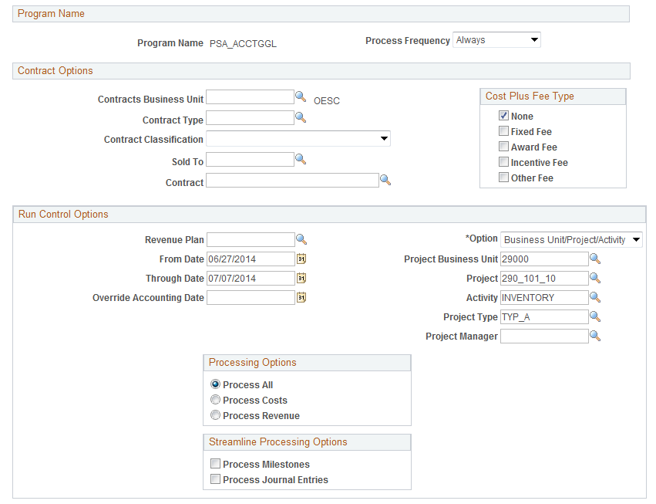

Use the Contract Options section of the page to create accounting entries by Contract information.

NOTE: Project Accounting Entries are often created in combination with a Rate Based Contract to recognize Project Billing Revenue.

Revenue Plan – define a Contract Revenue Recognition Plan to restrict Project Accounting Entries to a specific Revenue Plan.
From/Through Dates - Enter the range of accounting dates to process. The system selects rows in the Project Transaction table with accounting dates that fall on or within these dates.

Override Accounting Date - Enter an override accounting date to have the system stamp the rows that are created in the Accounting Line with this date.

Option – define the scope of the Accounting Entry process for this run. The process can be executed by:
All – create accounting entries for all Business Units. This value will not be used when running the process on an Ad-Hoc basis.
Business Unit – create accounting entries for agency Business Unit.
Business Unit/Project – create accounting entries for an agency Business Unit and Project ID.
Business Unit/Project/Activity – create accounting entries for an agency Business Unit, Project ID and Activity ID.

Project Type – create Project accounting entries for Projects with only a specific Project Type.

Project Manager - create Project accounting entries for Projects with only a specific Project Manager.

Process Journal Generator - Select to automatically run the Journal Generator and Contracts Billing Interface processes after running the Process Project Accounting process.

NOTE: Not all of the fields on this page will display depending on which ‘Option’ value is selected.

Click to execute the Project Accounting Entry process.

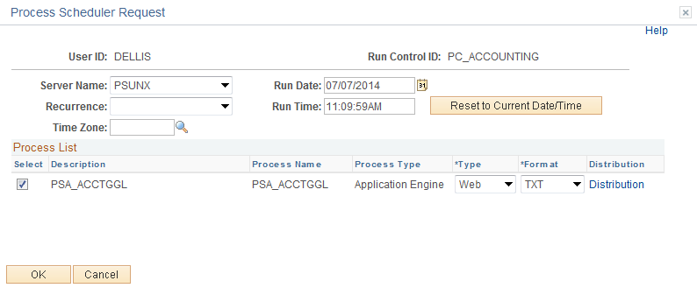

Select the checkbox next to the desired process.

Click to execute the process. Navigate to the Process Monitor link to view the Report instance.

Time and Labor Collection

Project Payroll Costs are initiated in the HCM (Human Capital Management) Product and are interfaced into the Financials Product that houses the Project Costing Module. Payroll costs are recorded by Project and Activity with additional data elements including Employee ID, Job Code, etc.

Interfaced payroll costs are stored by Interface ID which represents a ‘Batch Number’ for a group of interfaced payroll cost lines. Each line within an Interface ID has an Interface Line Number. Both of these values are used to manage the loading of Project payroll transactions.

Once Payroll costs are interfaced into Project Costing, a batch process must be executed to change Analysis Types for Cost Sharing in Grant funded projects. When the process is complete and required Analysis Types have been changed, the Project transactions will be set to ‘New’ status and eligible for posting to Projects.

Step 1: Run the Cost Share Analysis Type Update

Navigation: Project Costing > Third Party Integration > Update Cost Share Analysis Type > Find an Existing Value

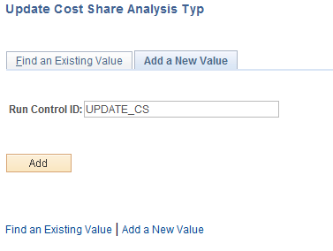

Run Control ID – create a new Run Control or select an existing value from the list.

Click to retrieve an existing Run Control.

Update Cost Share Analysis Type Tab

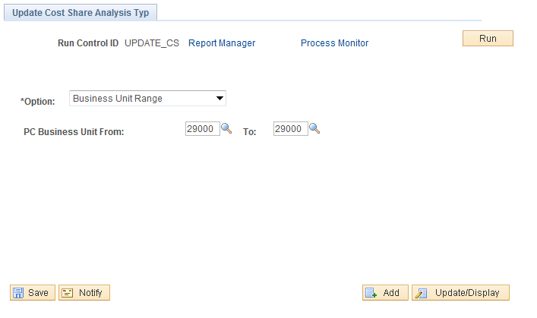

PC Business Unit – select the agency business unit value.

NOTE: The Interface Lines will have two status values – Project Interface Status and Project Interface Load Status. This process will change the required Analysis Types and set the Project Interface Load Status from ‘Pending’ to ‘New’. This status change will make the Project transactions eligible for final posting to Projects.

Click to execute the Update Analysis Type process.

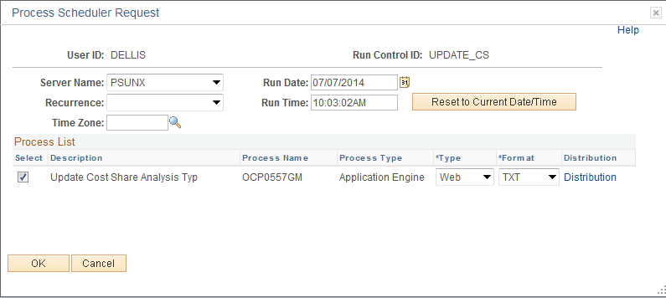

Select the checkbox next to the desired process.

Click to execute the process. Navigate to the Process Monitor link to view the process instance.

Step 2: Load Transactions into Projects

Navigation: Project Costing Third Party Integration > Load Transactions > Find an Existing Value

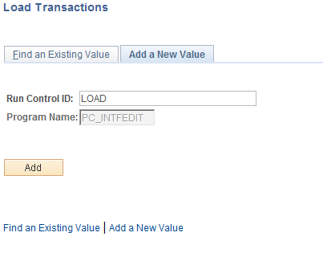

Run Control ID – create a new Run Control or select an existing value from the list.

Click to retrieve an existing Run Control.

Load Transactions Page

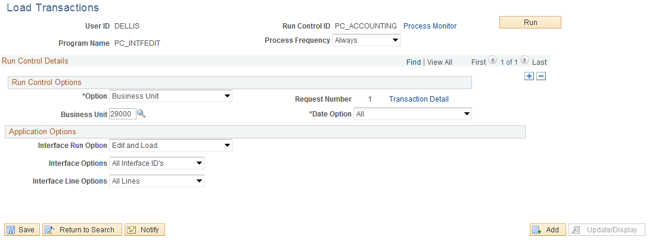

Use the Load Transactions page to identify which Project transactions (payroll costs) will be selected for interface into Projects.

Use the Run Control Options section of the page to identify the project transactions to interface:
Option – select to load Project interfaced transactions or by Business Unit, Project or Activity. Do Not select the ALL Option!
Business Unit – at a minimum, the interfaced transactions should be selected by agency Business Unit.

Date Option – narrow the selection criteria by date range.

Use the Application Options section of the page to further define the Project transactions by Interface numbers and Interface Line numbers:
Interface Run Option – select to determine if the Project transactions will be ‘Edited’, ‘Loaded’ or ‘Edited and Loaded’.
Interface Option – select to load All matching Project interface lines or a Range of values.

NOTE: When processing a group of Interface lines representing a payroll run, this value would be the Interface ID used in the Cost Share process illustrated in the previous section.

Interface ID – define the range of Interface ID numbers.
Interface Line Option – select to load All Lines within a particular Interface ID or a Range of lines.

Click to execute the Load Transactions process.

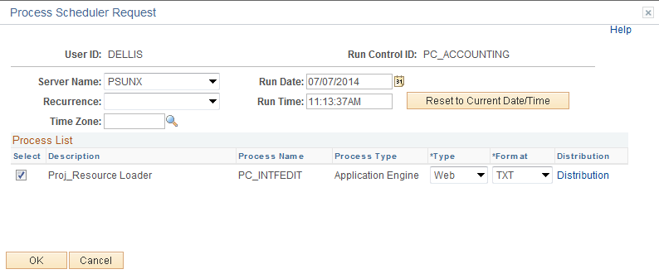

Select the checkbox next to the desired process.

Click to execute the process. Navigate to the Process Monitor link to view the process instance.

NOTE: The Project transactions should be completed and posted to the Project. See the View Project Transaction section of the manual for instructions on reviewing.

