COR434 Project Costing

Definition Manual

The content of this training manual is based largely on a generic system configuration and illustrates the base-line functionality required to execute transactions in the module. Your agency may be utilizing more or less of the functionality illustrated in this manual. This manual is intended to be a framework upon which agencies can add agency-specific training content that speaks specifically to the system functionality that they have deployed and related configuration that they use for transaction processing. Agencies should not depend on these manuals for end-user training or problem resolution until they have been reviewed by the agency for appropriateness.

Table of Contents
Document History 5
Project Definition Overview 6
Key Terms 7
Process Flows 9
Create a Project 10
Step 1: Creating a Project 10
General Information Tab 11
Project Costing Definition Tab 13
Manager Tab 14
Location Tab 15
User Fields Tab 16
Rates Tab 17
Attachments Tab 18
Budget Alerts Tab 19
Step 2: Defining a Project Team 20
Team Tab 21
Team Detail Tab 23
Step 3: Set Project Status 24
Project Status Page 25
Add Project Activities to a Project 26
Step 1: Create Project Activities 26
Project Activities Tab 27
Gantt Chart Tab 30
Step 2: Add Project Activities Details 31
General Information Tab 33
Location Tab 34
Attachment Tab 36
Rates Tab 37
Budget Alerts Tab 38
Step 3: Add Activities Team 39
Activities Team Page 39
Step 4: Add Activities Team 40
Activities Status Page 40
Project Budgeting 41
Step 1: Define Project Budget Plan 41
Budget Plan Page 42
Step 2: Define Project Budget Detail 44
Budget Detail Page 44
Project Adjust Budget Items Page 46
Step 3: Review the Project Budget 52
Transaction List Page 53
Funds Distribution 54
Step 1: Define Funds Distribution 54
Funds Distribution Tab 55
Target Definition Tab 58
Step 2: Running Funds Distribution 61
Funds Distribution Page 62
Project Template 64
Step 1: Creating a Project Template 64
General Information Tab 65
Copy a Project 66
Step 1: Copy a Project 66
Copy Project Page 67
Accounting Rules 69
Accounting Rules 69
Accounting Rules Page 70
Budget Items 71
Budget Items 71
Budget Items Page 72
Project Costing Chartfields 73
Rate Sets 74
Rate Sets 74
Rate Sets Tab 75
Target Tab 76
Project Trees 77
Step 1: Create a Project Tree 77
Tree Definition and Properties Page 78
Enter Root Node for Tree Page 79
Tree Manager Page 81

Authorized by: [_EBS_] Original Issue: [05/01/2014]
Maintained by: [____Project Costing Lead___]
Review Date: [05/01/2014]

Document History
Document Revision | Date | Description
1.0 | 04/30/2010 | Initial Document
1.1  2.0 | 07/14/2011  05/01/2014 | Template Update  Upgrade Update

Project Definition Overview
At the highest level, Projects are managed within a Project business unit. Within each Project, costs are organized and analyzed by Activity. Activities are the specific tasks that make up a Project. During the course of an Activity, transactions are created for such things as labor and materials. Transactions are attached only at the Activity level. Project Costing organizes and groups these transactions to monitor and report on the conditions of a Project.

This diagram illustrates the hierarchy.

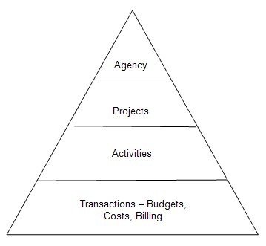

Projects also serve to calculate and store billable transactions. In combination with the Contracts module, transactions in Projects can be priced and become billable cost used for customer billing.

All project transactions are stored in the Project Transaction table (PROJ_RESOURCE). Project transactions provide the basis for project reporting, analysis, billing, and asset capitalization.

Key Terms
Project Costing Business Unit: Each agency has one, and only one Project Costing Business Unit. The Business Unit is the three (3) digit agency code, plus 00. For example, Office of State Finance is 09000.

Project ID: The Project ID represents the basic unit that serves to establish budgets and collect costs and revenue for analysis purposes. Projects serve to collect construction costs and capitalize Assets in conjunction with the Asset Management module. Project ID is also a Chartfield and as such a part of the distribution line. Project IDs are a maximum 15 characters long, and they are alpha-numeric (can be letters and/or numbers). Additionally Project IDs must be unique throughout the system; hence each ID should start with the first three digits of the Agency number. Ex: 090CORE_PHASEII.

Activity ID: An Activity ID generally represents a task that makes up a Project. Project Costs and Budgets are stored in Activities.

Analysis Type: Analysis Types are used in both Grants and Project Costing to reflect the nature of transactional data as it flows thru the system. PeopleSoft delivers a set of Analysis Types that support the functionality of software particularly in Grants and Projects. This set of Analysis Types should not be altered. However, if a business process requires the use of an additional Analysis Type (likely) an “agency requested” Analysis Type can be added. Once an Analysis Type has been added, it will be available for use by all agencies.

Each project is composed, at the most basic level, of transactions. Transaction rows in the PROJ_RESOURCE table contain the quantity, amount, chartfields and other detailed data elements associated with each transaction (PO#, Req#, Voucher#, Vendor, etc.).

Analysis types are assigned to individual transactions to identify the different types of transactions, such as estimated costs, budgeted amounts, actual costs, and billed costs. For a single transaction, the Analysis Type can change as the transaction flows thru the system. For example, a requisition begins with and Analysis Type = REQ, when the requisition is sourced into a Purchase Order another transaction is created with an analysis type = COM. Finally, when the PO is copied into a voucher for payment, a third transaction is created with the ACT analysis type. In this way, analysis types describe the nature of a transaction within Project Costing or Grants.

Analysis Group: A collection of Analysis Types used for securing Project Transactions, calculating Billable costs and Reporting.

Budget Item: An agency defined category of budgeting. These could be similar to a roll-up account like Labor, Equipment or Travel. Budget Item is used in several of PeopleSoft’s delivered inquiry pages.

Work Breakdown Structure: Organization of Activity ID’s to define the total scope of each Project. Each descending level represents an increasingly detailed definition of a project component.

Project Budget: Project Budgets are Cost or Revenue budget estimates that are distributed to Project Activities and Budget Items across time periods for budgetary or project performance measurement.

Project Accounting: The Accounting for Projects feature provides a method for translating Project transactions into accounting entries that can be sent to General Ledger. Using Accounting Rules, the system converts transactions in Project Costing to accounting lines that the Journal Generator Application Engine process (FS_JGEN) later converts into journal entries.

Project Trees: Project Trees define how Projects are related to each other. The relationships between projects determine the level of detail achieved when tracking and reporting costs. Within a Project Tree, a project can be hierarchically related to as many projects as necessary to achieve the necessary degree of cost tracking and analysis.

Project Transaction: Project Transactions represent the cost, revenue or budget amounts defined for and collected in a Project. A Project Transaction can be a Purchase Order encumbrance, a Voucher cost, a Billing amount or a Budgeted estimate. Project Transactions make up the amounts and estimates by which Project Accounting and Reporting is accomplished.

Process Flows

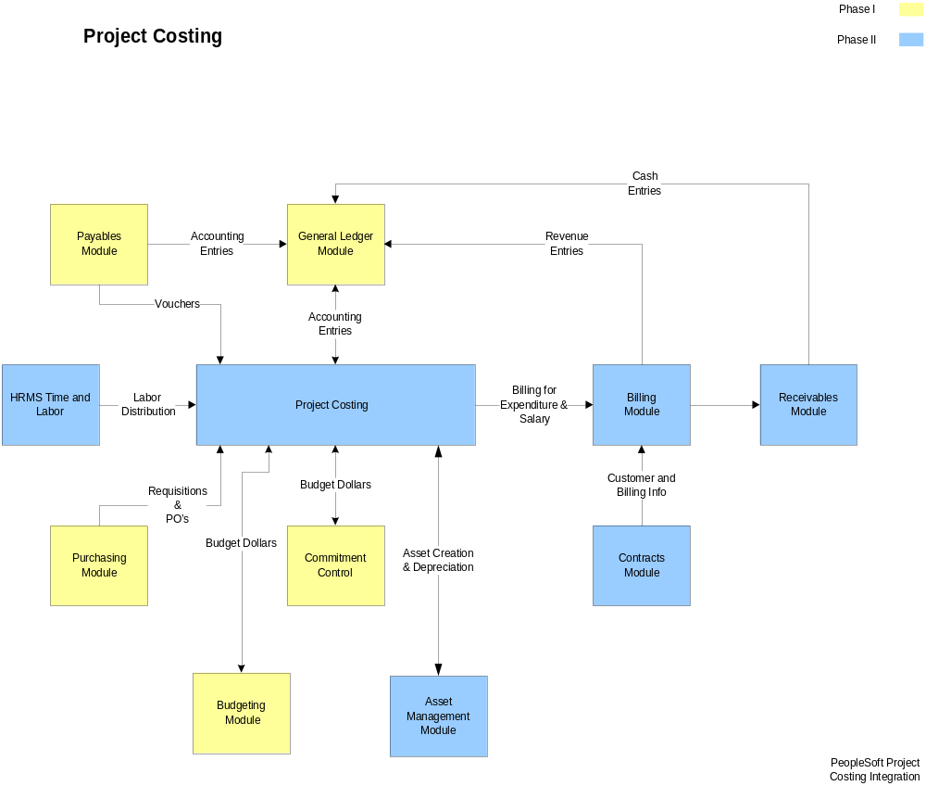

Diagram 1: Project Costing Module Integration

Create a Project
Projects should be defined before actual work begins or costs are incurred. Once a Project is defined, it is available as a Chartfield on the distribution line for recording costs and revenue.

General project maintenance tasks include creating, defining, and updating a Project, as well as tracking a variety of project-related information. Included in the project-related information is:

- Project general information.
- Project schedule dates
- View Project Managers.
- Define Project Locations.
- Assign and tracking rates (Contracts module integration).
- Attach files to projects
- Project Teams
- Project Status

Step 1: Creating a Project

Navigation: Project Costing > Project Definitions > General Information > Add a New Value

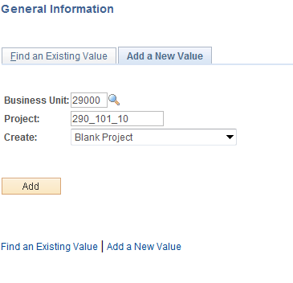

Business Unit – is the Agency in which the Project will be created.

Project – this value will be the Project ID. Each agency will follow a naming convention for their Project ID values.

Create – for new Projects, leave this value as ‘Blank Project’.

Click to enter the Project General Information pages.

General Information Tab

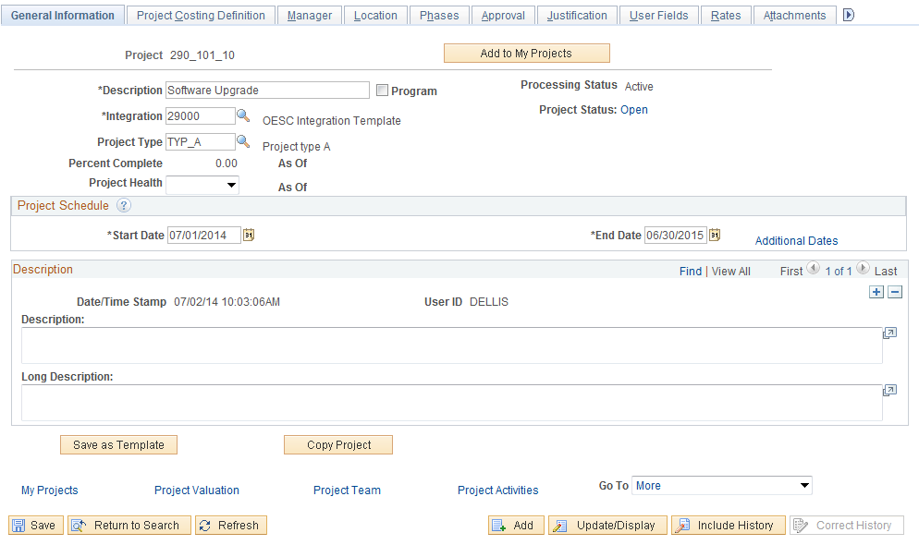

The Tab displays high-level parameters and properties for the Project. Some of these properties are defaulted into the Project ID from Business Unit configuration.

Description – the Project Description should describe the Projects purpose or definition. The Description will also be visible on the distribution line when recording costs or revenue for this Project.

Integration Template – this value defines how the Project ID will integrate with other system modules. This value should be equal to the Project Costing business unit.

Project Type – select the Project Type to categorize the Project. This value can also impact the Revenue Accounting Entries for billable Project Costs.

Start/End Date – the Start and End Dates define the beginning and ending dates for this Project.

Calculate - Select Start Date, End Date, or Duration (days) to specify which one of these three fields is calculated by the system based on the values that you enter for the other two fields. For example, select End Date for the system to calculate the end date based on the values that you enter for start date and duration.

Description – use the Long Description fields to store additional Comments about the Project.

Project Status – there are three project statuses defined in the system:
O = Open
C = Closed
T = Financials Open, T&L Closed
Use icon to populate the project’s Status and the Effective Date of the status. The status must be Open for use with Time and Labor. If the status is Closed, the project cannot be used to process a transaction in any module.

Click to Save values in the Project General page and continue with defining the Project.

The Project ID will be Saved at this point and cannot be changed.

Click the Project Costing Definition Tab.

NOTE: Not all fields available in Project pages will be defined and explained in this training manual. Those fields not referenced in the manual are generally not required for transaction processing.

Project Costing Definition Tab

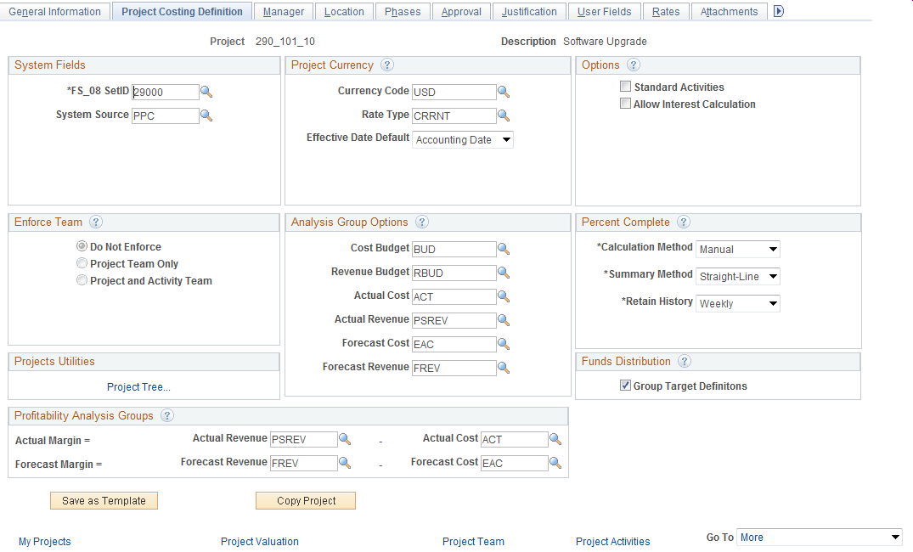

The Tab serves to define various project options, project currency, and analysis groups.

System Source – all transactions created from this Project will carry this system source. This value should not be changed from ‘PPC’.

Enforce Team – this flag dictates how the Time and Labor module will restrict time entry against this Project.

Project Tree – use this hyperlink to add the Project to a Tree for analysis and reporting.

Currency Code – leave this value as ‘USD’.

Analysis Groups – these values default from the system configuration and should not be changed.

Standard Activities – select this checkbox to restrict Project Activities to a pre-defined list.

Percent Complete – defines the rules for calculating ‘Percent Complete’ for this Project.

Funds Distribution - The initial value of this field defaults from the project business unit level. You can override the value set at the business unit level for individual projects on this page.
Select to indicate that the funding source rules can be grouped manually. Each target definition can be associated to a set of rules.

Deselect to indicate that each funding source rule will be associated with separate target definition.

Profitability Analysis Groups - Select analysis groups that are used to calculate actual margin and forecast margin. These values may be the same as the values in the Analysis Group Options group box, but these fields allow users the flexibility to select a different analysis group for calculating profitability.

Click the Tab.

Manager Tab

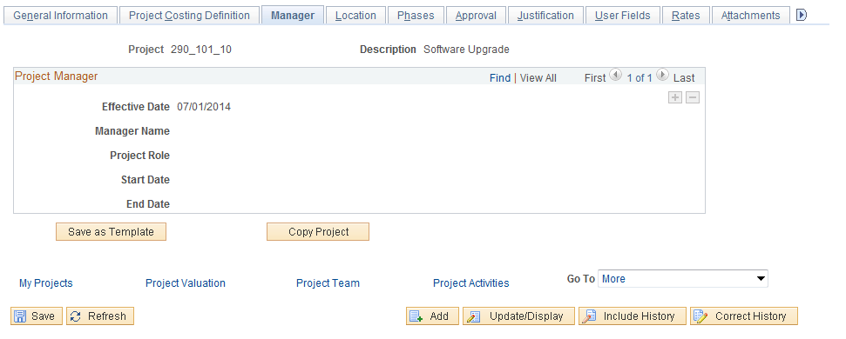

The Tab is blank at this point in the Project definition process, but will be populated when the Project Team is defined. The individual(s) assigned to the Project Manager role will be displayed on this page. See Project Team section later in this manual.

Click the Tab.

Location Tab

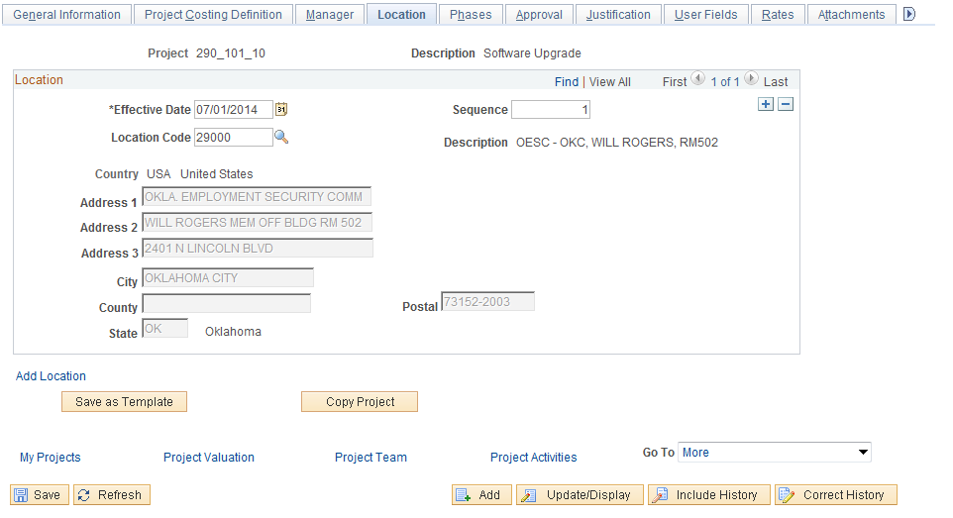

The Tab allows the user to define a physical location for the Project.

Effective Date – define the date that the Project Location is effective.

EFFSEQ – the effective sequence value can be left as ‘1’.

Location Code – select a pre-defined Location Code for the Project. The physical location details for the Location selected will default into the page.

NOTE: Location values are pre-defined and contain Address, City, State and Zip Code. Agencies will maintain the Location values in the system. Locations are also used for Purchasing and Asset Management purposes.

Click the Tab.

User Fields Tab

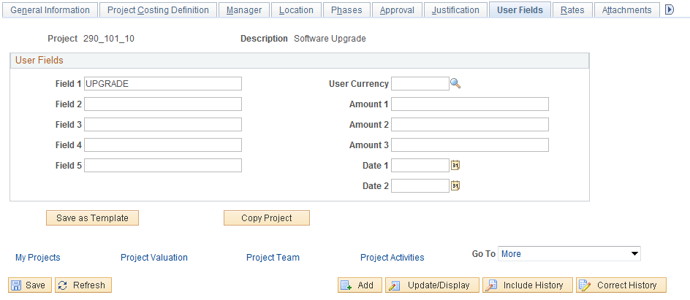

The Tab allows the agency to store additional properties for a Project. These fields are ‘free-form’ in nature and will accept any value that fits the size and type of field on this page.

Field 1-5 – these five fields are ‘Character’ fields and will accept an alpha-numeric value up to 10 characters in length.

Amount 1-3 – these three (3) fields are ‘Amount’ fields with two (2) decimal places.

Date 1-2 – these two (2) fields are ‘Date’ fields and will accept MM/DD/YYY format.

Rates Tab

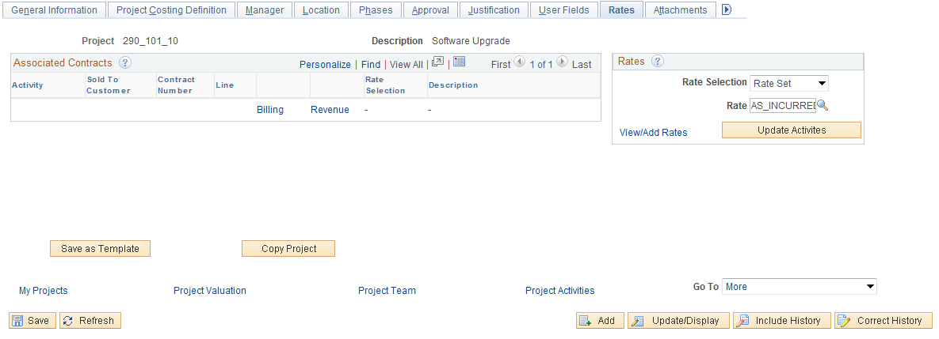

The Tab displays Customer Contract information for Projects that are linked to a Contract for billing purposes. Rates for pricing Project transactions are also visible on this page.

NOTE: The Associated Contracts section of the page will not be populated at this point in the Project definition process. Only after a Contract has been linked to a Project will this section of the page display information. See Contracts manuals.

Rate Selection – defines whether a Rate Set or Rate Plan will be used for pricing on this Project.

Rate – define the type of Rate that will be used for pricing transactions in this Project.

NOTE: For Projects that are linked to Contracts for billing purposes, the Contract definition will define the Rate Selection and Rate value.

Click to copy the Rates from the Project to the Activity for existing Activities.

Click the View/Add Rates link to view the details of the Rate Set.

Click the Tab.

Attachments Tab
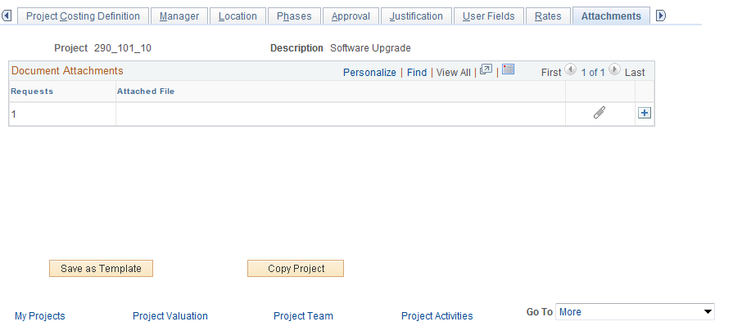

The Tab allows the user attach a document (Microsoft Word, Excel, etc.) to the Project as supporting documentation. These could include work papers, design specifications, etc.

Use the attachment icon to select a file that will be uploaded into the system and attached to the Project.

Once the file is attached, use the delete file icon to remove the file from the Project or the view file icon to view the document.

Click the Tab.

Budget Alerts Tab

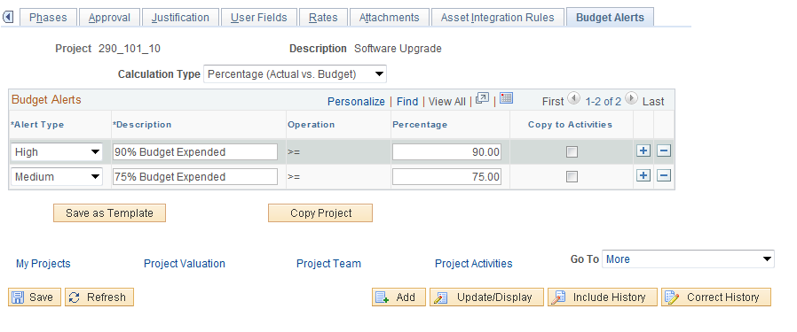

The Tab defines the budget alert rules for the Project. Budget Alerts allow the user to see when Project spending reaches predefined warning levels. These are alerts only and do not effect transactions.

NOTE: The Project Alerts page is populated with the Business Unit default values and can be changed for a particular Project if required.

Calculation Type – defines the budget alert by Percentage or Amount.

Alert Type – defines the type of alert that will be visible on Project Costing page for the Project.

NOTE: Alerts are defined a High = ‘Red’ and Medium = ‘Yellow’.

Percentage – the percentage at which the Project spending relative to Budgets Project Costs will issue a warning. For example, if Project Budget is 100,000 and Project Cost reach 90% of budget (or 90,000) the system will display a High alert.

Copy to Activities – select this checkbox to copy the Alert rules to each Activity in the Project.

Click to Save values in the Project General component and continue with defining the Project.

Step 2: Defining a Project Team

Navigation: Project Costing > Project Definitions > Team > Find an Existing Value

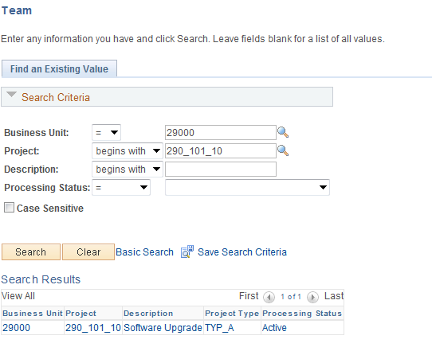

Enter the Search Criteria to retrieve the Project.

Business Unit – is the Agency in which the Project is stored.

Project – the Project ID value.

Description – search by Project Description.

Click to enter the Project Team pages.

Alternatively,

Click the Project Team link from any page in the Project General Information component illustrated in the previous section.

Team Tab

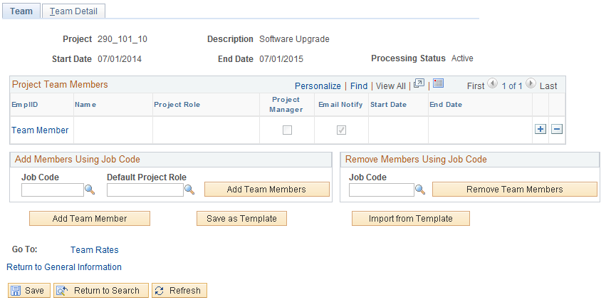

The Tab allows the user to define the team using different options. Team members can be added individually Employee ID or by Job. Team members can also be removed by Job Code on this page.

Job Code – select a Job Code value to populate the Project Team with individuals matching that Job Code.

Default Project Role – for the individuals added to the Project Team by Job Code, assign them a Project Role.

Click to add Project Team members by Job Code.

NOTE: All individuals with the Job Code selected will become members of the Project Team when using the “Add Members Using Job Code” feature.

Use the Remove Members Using Job Code section of the page to remove Team Members by Job Code.

Click the Team Members link to add Team Members individually. Alternatively, click the Team Detail Tab or use to add team members after the initial team member is inserted.

Team Detail Tab

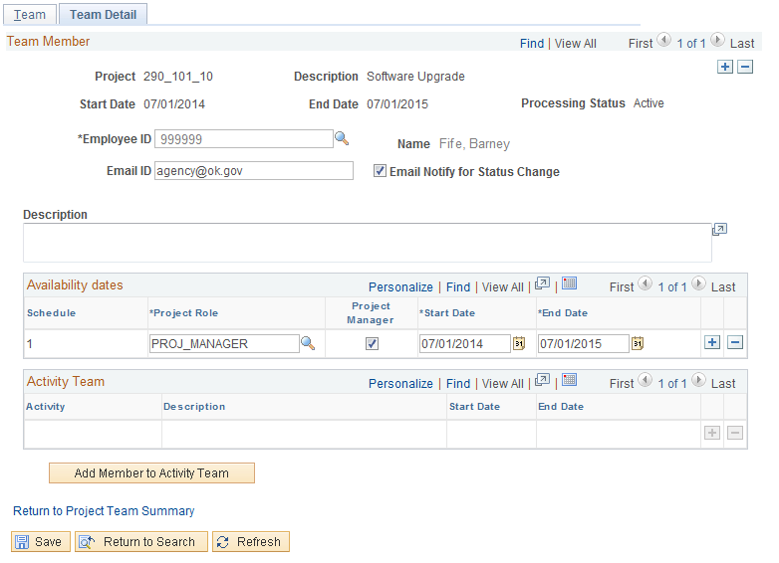

The Team Detail Tab allows the user to select individuals by Employee ID to add to the Project Team.

Employee ID – select the individual to add to the Team.

Email ID – populate an email ID for the employee.

Description – add a long description if desired to explain the inclusion of the Project Team member.

Project Role – select a pre-defined Project Role that the employee will hold on the team.

Project Manager – select this checkbox if this employee will be the Project Manager. This individual will be displayed on the Project Manager page. There can only be one designated project manager per project for a given period of time.

Start/End Date – define the period of time that this employee will be a member of the Project Team.

Use to copy the Project Team members to the Activity Team.

Use to add additional Project Team members as needed.

Click to Save the Project Team.

Step 3: Set Project Status

Navigation: Project Costing > Project Definitions > Status > Find an Existing Value

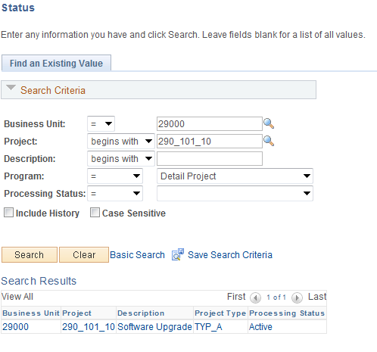

Use the Search Criteria to retrieve the Project ID.

Business Unit – is the Agency in which the Project is stored.

Project – the Project ID value.

Description – search by Project Description.

Click to enter the Project Status pages.

Alternatively,
You can navigate to the Project Status page, by using the drop down field and select the Project Status option from the Project General Information component illustrated in Step 1.

Project Status Page

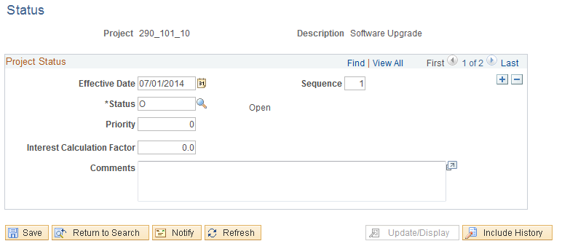

The Project Status page allows the user to define an effective dated Status for each Project.

Effective Date – define the date that the Status will be effective. Generally this will be the Project begin date for the initial status value. Note: the Effective Date will initially default with the current date. Therefore if the project’s start date (effective date) proceeds the date you are entering the project information, be sure to backdate the effective date. If you fail to do so before the saving the page you will eliminate any ability to so in the future.

EFFSEQ – use ‘1’ if the is only one Status for an effective date. This field allows the user to change the Status value multiple times in a single day.

Status – select the Project Status for the Project.

Click to Save the Project Status.

NOTE: Use to insert additional Project Status values.

Add Project Activities to a Project
Once a Project has been defined, Activities must be added to the Project for the Project Definition to be complete.

Activities are generally defined as individual Tasks or Units of Work that make up a Project. Transactions can only be added to a Project at the Activity level.

Activities can be Summary in nature. Summary activities are used to group other activities for reporting and accounting purposes. Transactions cannot be charged directly to Summary Project Activities.

Summary and Detailed Activities are maintained in a Work Breakdown Structure (WBS). A project’s WBS is represented by a hierarchical grid that shows Project Activities and their relationships.

Activities are available on the distribution line to record budgets, expenditures and revenue against a Project.

Step 1: Create Project Activities
Navigation: Project Costing > Activity Definitions > Project Activities > Find an Existing Value

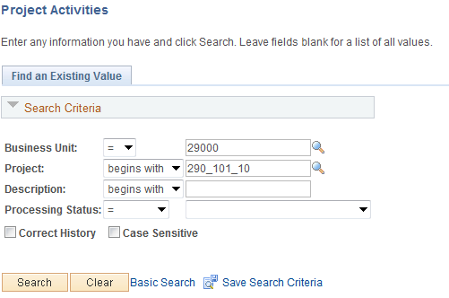

Use the Search Criteria to retrieve the Project ID.

Business Unit – is the Agency in which the Project is stored.

Project – the Project ID value.

Description – search by Project Description.

Click to enter the Project Activity pages.

Alternatively, Click the Project Activities link from any page in the Project General Information component illustrated in the previous section.

Project Activities Tab

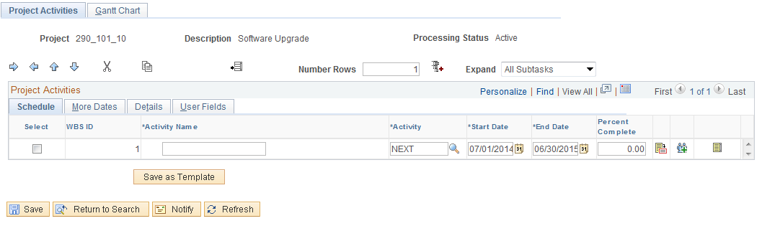

The Tab allows the user to enter multiple Activities for the Project. Activity ID, Description and Dates will be added.

Click the Sub-Tab.

Activity Name – create the Activity Name as a description of the Activity. This value will be visible when prompting for an Activity from the distribution line. It will display as the Activity Description.

Activity – the Activity ID is the Activity value.

NOTE: The Activity ID value should be 10 characters in length and have no spaces.

Start/End Dates – define the beginning and ending dates for the Activity. Generally these will be dates that represent the task start and end. The defaulted dates will initially populate as the start and end date of the project.

End Date - Enter the activity completion date. If the activity end date is after the project end date, the system adjusts the project end date accordingly.

Use to save the Activity as a Template to be used later to create other Activities.

Click the sub-Tab.

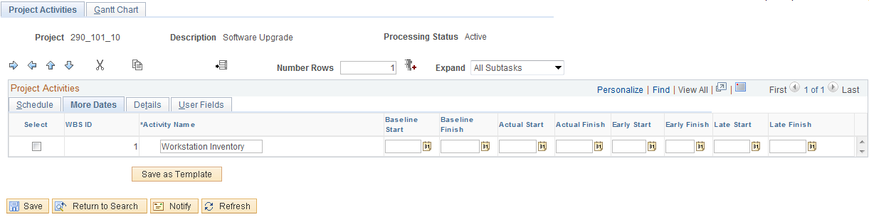

Use the Tab to define additional dates for the Project Activity.

Click the Sub-Tab.

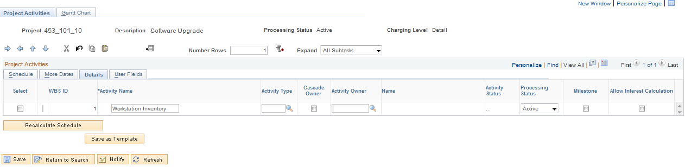

Activity Type – if desired, define the Activity Type for grouping Activities for analysis and reporting purposes.

Activity Owner – if desired, select an Activity Owner for the Activity.

Milestone – define the Activity as a Milestone for Contract Billing. See Contracts training manuals.

Click the Sub-Tab.

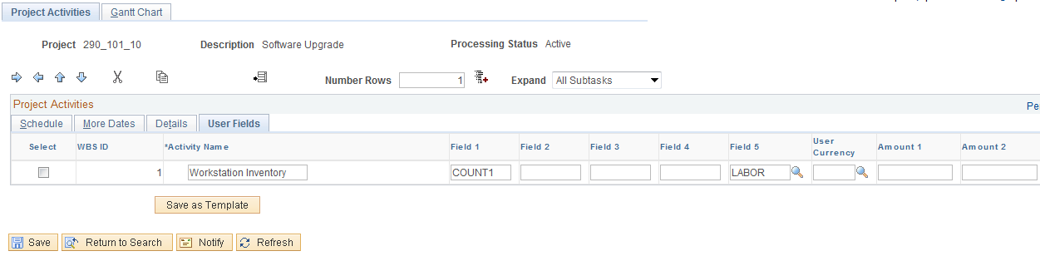

Define up to five (5) additional Alpha-numeric values, three (3) Amount values and two (2) Date values. These fields will accept free-form values for each field type.

Field 5 – this Activity User field is reserved for state agencies to designate an Activity as Labor bearing or Non-Labor bearing.

NOTE: Activities flagged as Labor will be available in the Time and Labor module for employees to enter time against the Activity.

Click the Sub-Tab.

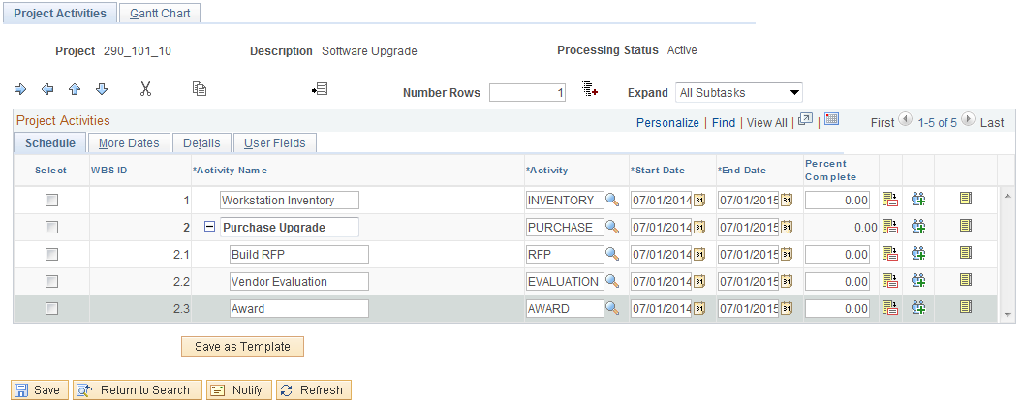

To add additional Activities to the Project use select the checkbox next to the Activity “under” which the new Activity will reside. The new activity could be a sibling to an existing Activity (reside on the same level in the WBS) or it could be a child of an existing Activity (reside on a level below in the WBS).

Click the Add icon to insert a new Activity.

Use to indent (or remove the indent) the Activity and move the Activity to a lower level of the WBS.

NOTE: When indenting an Activity to move the value down in the WBS, the ‘parent’ Activity becomes a Summary Activity and cannot have charged transactions to the Activity.

Use to move the Activity up or down in the WBS.

WBS ID – this value represents the Activities place in the WBS.

Click the Tab to view the Activities in a Gantt Chart format.

Click to Save the Project Activities.

Gantt Chart Tab
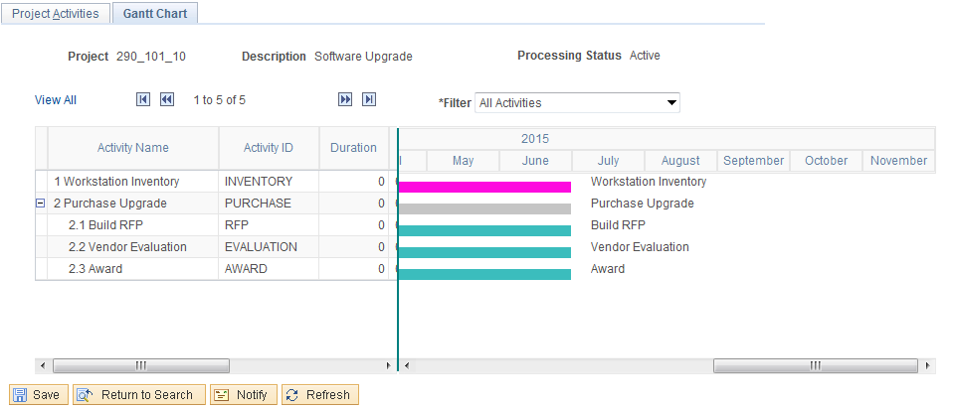

The Tab displays the WBS format of the Activities and related dates.

Use the  to view all Activities.

Step 2: Add Project Activities Details

Navigation: Project Costing > Activity Definitions > General Information>Find an Existing Value

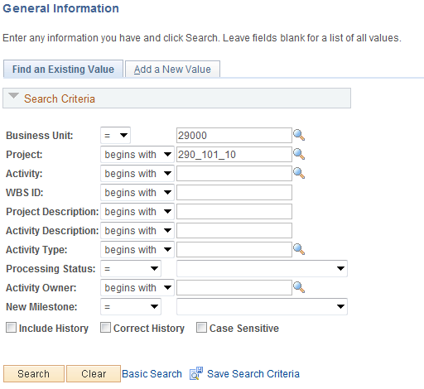
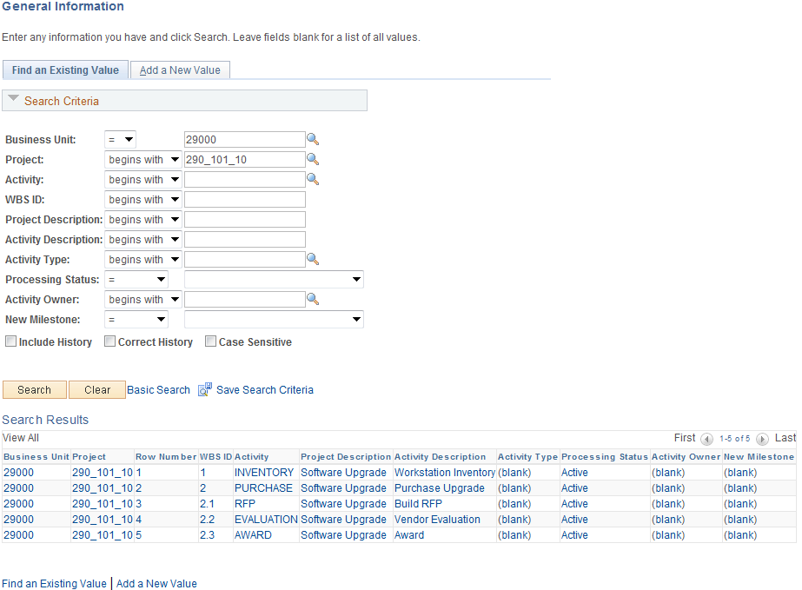

Use the Search Criteria to retrieve the Activity ID

Business Unit – is the Agency in which the Project Activity is stored.

Project – the Project ID value that holds the Activity.

Description – search by Activity Description.

Activity Type – search by Type of Activity.

Click to enter the Project Activity pages.

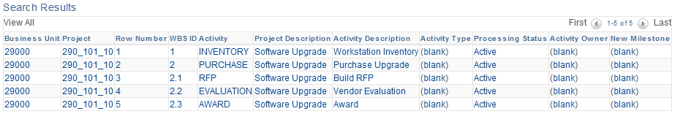

For Projects with multiple Activities, select the Activity that should be updated to enter the Activity General Information component.

Alternatively,

Click the Activity Definition icon from the schedule tab in the Project Activities section.

General Information Tab

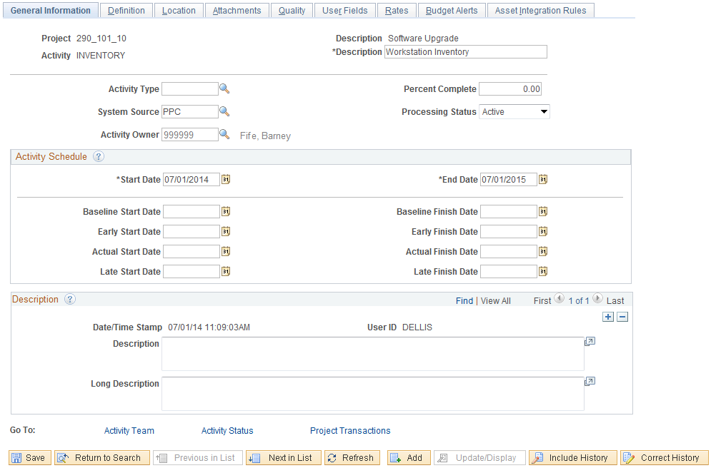

The Tab displays high-level values for the Activity.

NOTE: When creating Activities through the Project Activities component (illustrated in the previous section) many of the fields on this page will already be populated.

Description – enter a long description for the Activity.

Click the Tab.

Definition Tab

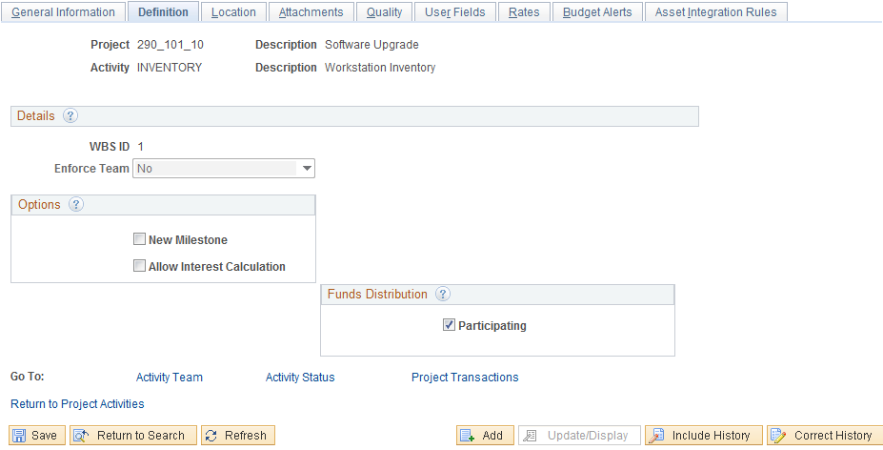

The Tab is the place to set the Funds Distribution preference for the Activity.

Participating – Select to indicate that the activity is eligible to be selected as a source to Funds Distribution. If this field is deselected the activity will be prevented from being processed by the Funds Distribution process. This field allows specific activities that are not reimbursable to be excluded from the Funds Distribution process. For example, you could define a single distribution rule for a project and use this attribute to exclude selected activities.

Click the Tab.

Location Tab
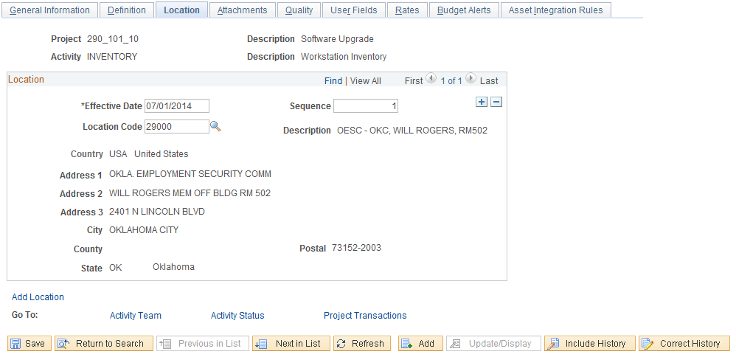

The Tab allows the user to define a physical location for the Activity.

Effective Date – define the date that the Activity Location is effective.

EFFSEQ – the effective sequence value can be left as ‘1’.

Location Code – select a pre-defined Location Code for the Activity. The physical location details for the Location selected will default into the page.

NOTE: Location values are pre-defined and contain Address, City, State and Zip Code. Agencies will maintain the Location values in the system. Locations are also used for Purchasing and Asset Management purposes.

Click the Tab.

Attachment Tab
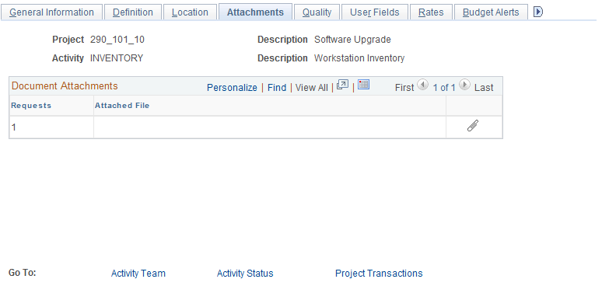

The Tab allows the user attach a document (Microsoft Word, Excel, etc.) to the Activity as supporting documentation. These could include work papers, design specifications, etc.

Use the icon to select a file that will be uploaded into the system and attached to the Activity.

Once the file is attached, use the icon to remove the file from the Project or the icon to view the document.

Click the Tab.

Rates Tab
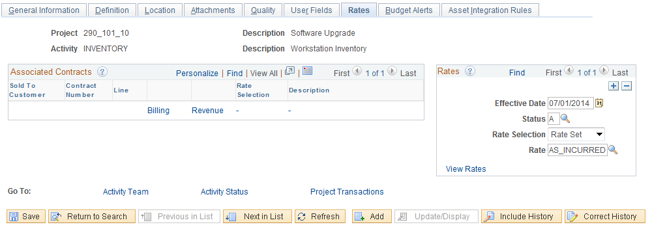

The Tab displays Customer Contract information for Project Activities that are linked to a Contract for billing purposes. Rates for pricing Project transactions are also visible on this page.

NOTE: The Associated Contracts section of the page will not be populated at this point in the Activity definition process. Only after a Contract has been linked to a Project and Activity will this section of the page display information. See Contracts manuals.

Rate Selection – defines whether a Rate Set or Rate Plan will be used for pricing on this Activity.

Rate – define the type of Rate that will be used for pricing transactions in this Activity.

NOTE: For Project Activities that are linked to Contracts for billing purposes, the Contract definition will define the Rate Selection and Rate value.

NOTE: The Effective Date, Status and Rate values will default from the Project if they are defined for the Project before the Activity is created.

Click the View Rates link to view the rate plan.

Click theTab.

Budget Alerts Tab

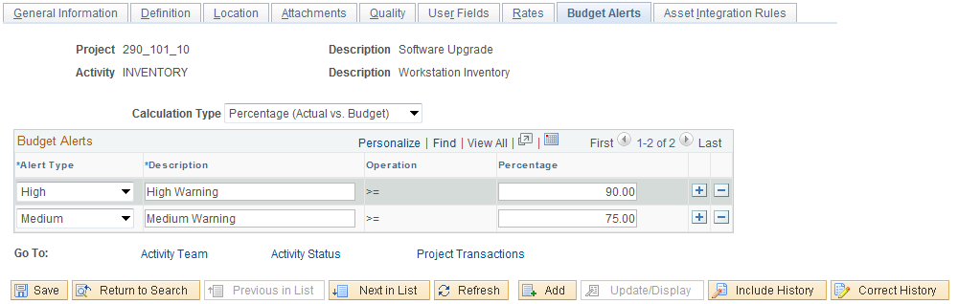

The Tab defines the budget alert rules for the Activity. Budget Alerts allow the user to see when Project Activity spending reaches predefined warning levels.

Calculation Type – define the budget alert by Percentage or Amount.

Alert Type – defines the type of alert that will be visible on Project Costing page for the Project.

NOTE: Alerts are defined a High = ‘Red’ and Medium = ‘Yellow’.

Percentage – the percentage at which the Project spending relative to Budgeted Activity Costs will issue a warning. For example, if Activity Budget is 100,000 and Activity Cost reach 90% of budget (or 90,000) the system will display a High alert.

Click to Save values in the Activity General component and continue with defining the Activity.

Click the Activity Status and Activity Team links to define the Activity Team and Status respectively.

Alternatively,

Navigation: Project Costing > Activity Definitions > Team>Find an Existing Value

Navigation: Project Costing > Activity Definitions > Status>Find an Existing Value

Step 3: Add Activities Team

Activities Team Page

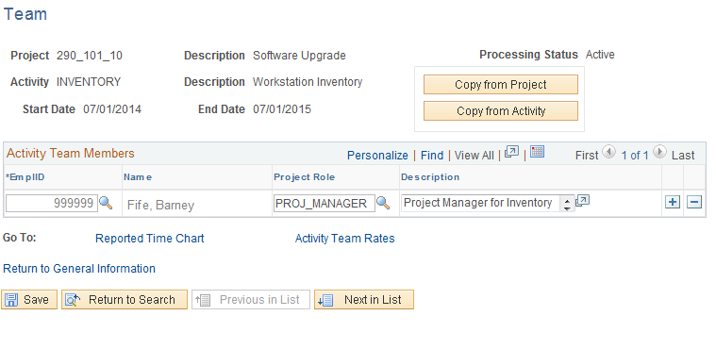

Add Activity Team Members using the Team page.

NOTE: In order for an individual to be added to an Activity Team they must first be added to the Project Team.

Employee ID – select the individual to add to the Team.

Project Role – select a pre-defined Project Role that the employee will hold on the team.

Description – add a description if desired to explain the inclusion of the Activity Team member.

Use to copy team members from the Project to the Activity.

Click to Save the Activity Team.

Step 4: Add Activities Team

Activities Status Page

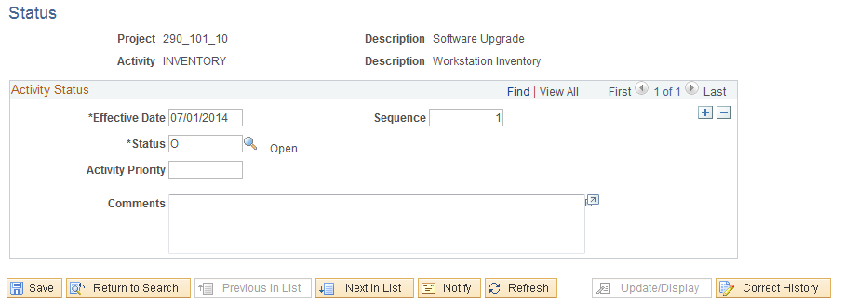

The Activity Status page allows the user to define an effective dated Status for each Activity.

Effective Date – define the date that the Status will be effective. Generally this will be the Activity begin date for the initial status value.

EFFSEQ – use ‘1’ if there is only one Status for an effective date. This field allows the user to change the Status value multiple times in a single day.

Status – select the Activity Status for the Project.

Comments – use this field to store information related to the Status change.

Click to Save the Activity Status.

NOTE: Use to insert additional Activity Status values.

Project Budgeting
Project Budgets are defined at the Project and Activity levels of detail. Activity Budgets are a breakdown of a Project Budget.

With Commitment Control enabled, a Project Ledger (Parent) and an Activity Ledger (Child) are defined to track Project costs. These Ledgers can be defined to stop Project spending when budget levels are reached (Control) or they can be defined to simply record Project spending against pre-defined budget levels (Track with Budgets). Project Budgets are created in the Project Costing module and published to Commitment Control.

Project Budgets are defined initially as a Budget Plan and then as a Detailed Budget.

Project Budgets can be Cost or Revenue Budgets. Cost Budget defines spending budget levels while Revenue Budgets estimate revenue levels for a Project.

Project Budgets can be defined in a ‘Top-Down’ method or a ‘Bottom-Up” method. The Top-Down method starts with the total Project budget and allocates budgeted dollars to Activities and finally Budget Items. The Bottom-Up method starts with Budget Item dollars and allocated up to the Activity and Project.

Step 1: Define Project Budget Plan

Navigation: Project Costing > Budgeting>Budget Plan > Add a New Value

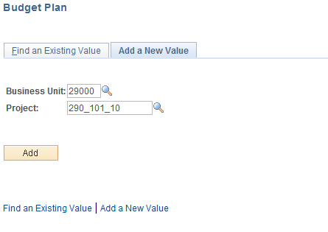

Business Unit – is the Agency in which the Project Budget will be created.

Project – the Project ID value for which the budget will be created.

Click to enter the Project Budget Plan pages.

Alternatively,

Use the drop down to select the Project Budgeting option from any page in the Project General Information component.

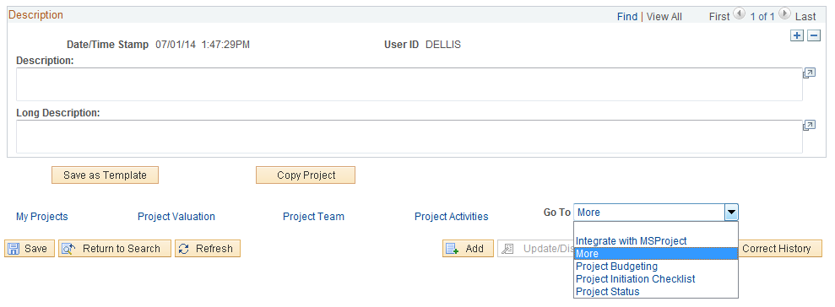

Budget Plan Page

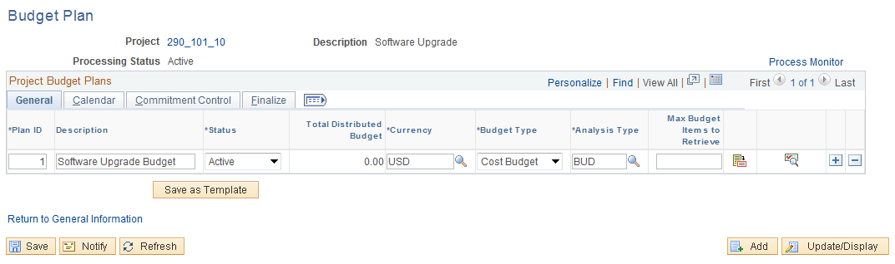

The Budget Plan page allows the user to define a high-level Budget Plan for the Project.

Analysis Type – the Analysis Type will default to ‘BUD’

Plan ID – this value can be left as ‘1’.

Description – add a description for this Project Budget.

Status – set to ‘Active’

NOTE: Only one Cost and Revenue can be Active at a time.

Total Distributed Budget – this field will be zero when initially creating the Budget but will be populated dynamically when the Detail Project is defined.

Budget Type - set this value to ‘Cost’ for an expenditure budget and ‘Revenue’ for a revenue estimate budget.

Use to save the Budget Plan as a template to use in the future.

Click the Tab.

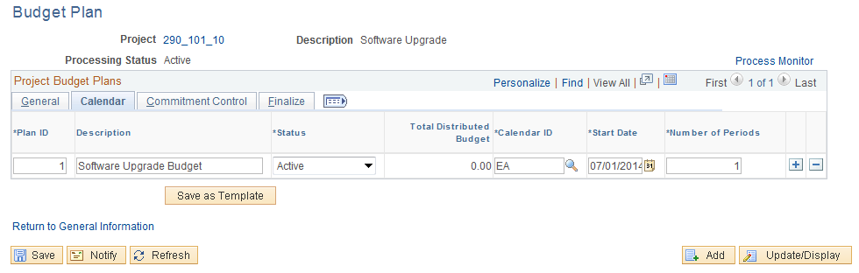

The Calendar Tab allows the user to select a pre-defined calendar ID information.

Calendar – select the fiscal year calendar ‘EA’.

Start Date – define the start date for the Project Budget. Generally, this will be the Start Date for the Project.

Number of Periods – this value will split the calendar value into Periods. For example, the value of ‘1’ will create one Budget Period in the Calendar (year).

Click the Tab.

From the General Tab, select the icon to enter the Project Details page and define the budget amounts.

Step 2: Define Project Budget Detail

Budget Detail Page

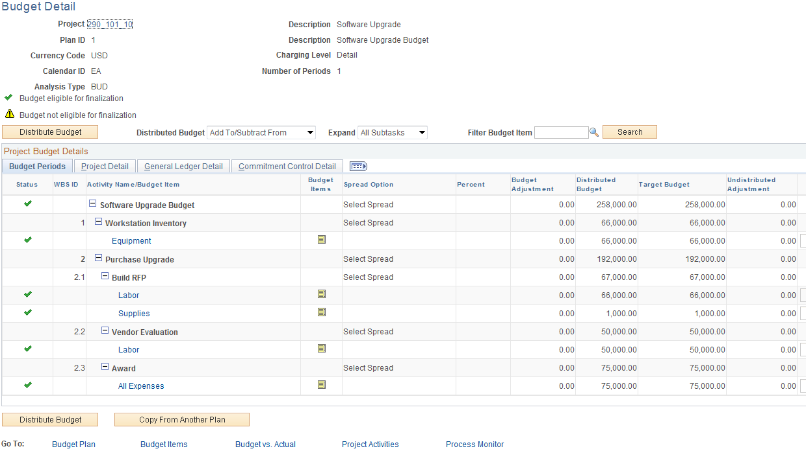

The Budget Detail page allows the user to define the Project Budget at the Activity and Chartfield level of detail. Budget Items can also be used to define low level budgets by expenditure type.

The will be used to allocate or distribute budget dollars to the Activity and Item level of detail.

Distributed Budget – select the Add To/Subtract From option to enter or adjust a budget.

Expand – allows the user to view certain levels of the Activity Work Breakdown Structure (WBS).

Scroll to the right of the page to view the Project Budget Detail status and amount section of the page.

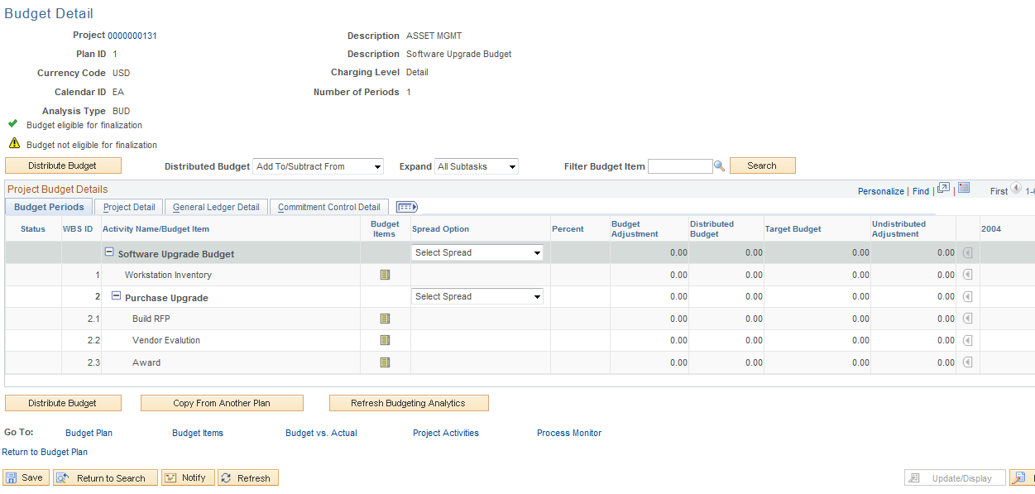

The Project Budget Detail page allows the user to define a Budget for each Activity and Budget Item if desired.

Status – displays the status of the Activity budget. The icon indicates if budget adjustments are fully distributed to the activity, budget item, and period level. The icon indicates the budget adjustment for this budget item is not fully distributed down to the period level.

Activity Name/Budget Item –displays the Project and Activity levels in the Project structure. Project and Activity Descriptions are visible. The first row displays information about the total project, which represents WBS level 0.

Budget Items – the budget item icon allows the user to retrieve the Budget Items page to define budget dollars by expenditure category.

NOTE: Project Budgets can be defined in a ‘Top-Down’ method or a ‘Bottom-Up” method. The Top-Down method starts with the total Project budget and allocates budgeted dollars to Activities and finally Budget Items. The Bottom-Up method starts with Budget Item dollars and allocated up to the Activity and Project.

Spread Option - select an option to spread the Budget Adjustment amount to activities.

Click the icon to begin the Bottom-Up Budgeting Method. Begin at the lowest level of the WBS to build the Budget in a Bottom-Up method. The budget will roll-up from the lowest Activity level to higher level Summary Activities.

Project Adjust Budget Items Page

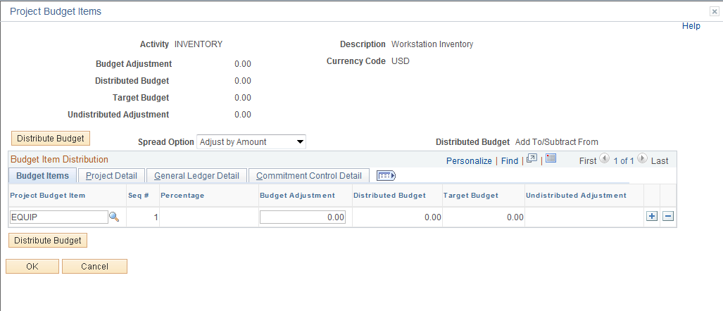

The Budget Items page initially displays with no chartfield or amount information. The Budget Item will be selected and budget amounts defined.

Activity – displays the Activity for which the budget will be created at a Budget Item level.

Spread Option – select ‘Adjust by Amount’ to define a budget amount for each Budget Item in the Activity.

NOTE: Agencies will define their own Budget Item values. These values should represent the appropriate level of expenditure category. These could be similar to the ‘Roll-Up” account level as in Labor, Equipment, Travel, etc.

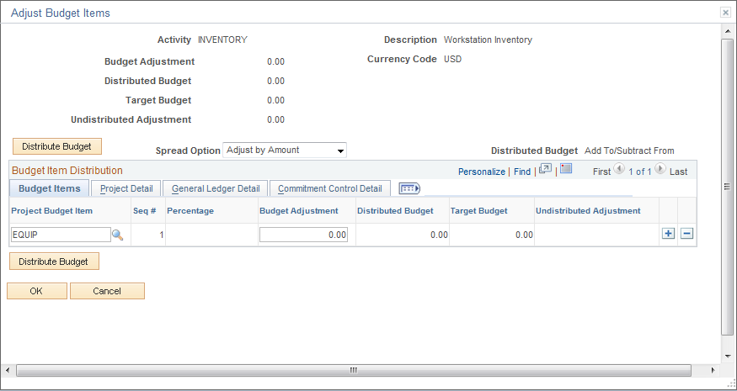

Select the Budget Items that will make up the Activity Budget. Use to insert additional rows as necessary for the budget.

Budget Item – select the Budget Item value for the Activity Budget.

Chartfields – select the appropriate chartfields for the Budget Item. These can be General Ledger chartfields like Class Fund or Department or Project Costing chartfields like Source Type or Category.

NOTE: Any chartfields can be used to add additional detail to the budget but only Project, Activity and Account will be used to track and control budgets in Commitment Control module.

Budget Adjustment – populate with the Amount of the budget.

When all Budget Items for the Activity are created, click to allocate the Budget Adjustment amounts.

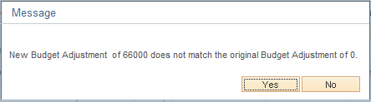

Since the Budget is being defined in a Bottom-Up method, the Project Budget does not yet have an amount (amount is zero). Click to allocate the Budget Amounts defined at the Budget Item level for the Activity to the parent Project.

NOTE: When defining a Budget using the Top-Down method, this warning message will change as the Budget Items are populated to match the Project (parent) budget amounts.

Click from the Adjust Budget Items page.

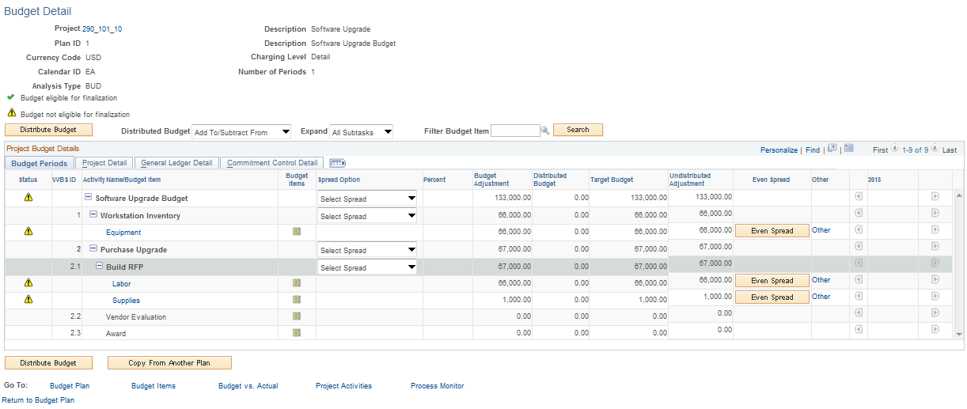

The Budget Detail page now displays the details of the budget amounts at the Budget Item level of detail.

Activity Name/Budget Item – this column now shows the budget amounts for the Activity. The Budget Items will also be visible with the corresponding budget amount for each.

NOTE: The icon is visible for each Budget Item at this point indicating that the budget has not yet been distributed to the Budget Period level (defined on the Budget Plan initially).

Click for each of the Budget Item that has been defined.

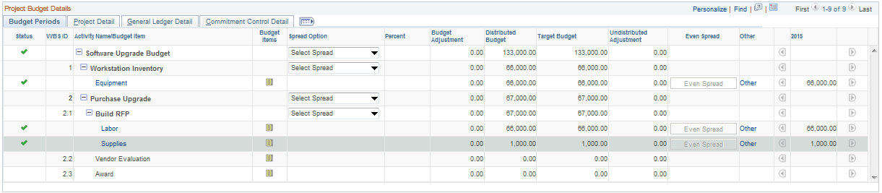

The Period (2010, etc.) column will display the distributed budget amount.

NOTE: The icon is visible for each Budget Item at this point indicating that the budget has been distributed to the Budget Period level.

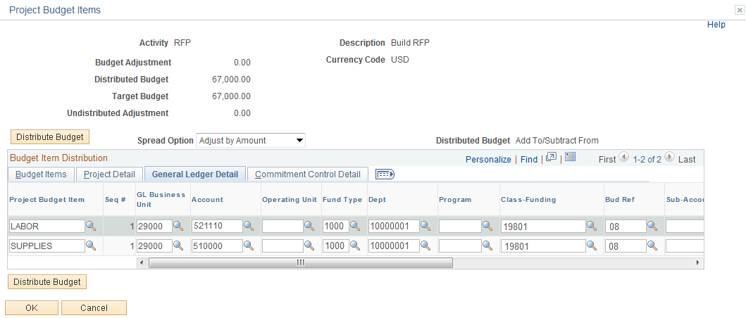

NOTE: Any chartfields defined for the Budget Item are also visible in the Tab Project Budget Details section of the page when scrolled to the right.

Continue to populate each Budget Item for each Activity until the entire Project Budget is defined.

NOTE: When using the Bottom-Up method, a Project or Activity level of budget is not entered. Rather the Budget Items hold the budget amounts that are rolled-up to the Activity and Project levels.

Click to Save the Project Detail Budget.

NOTE: All Status values for each Budget Item and the Project must be set to before the Budget can be Finalized.

Click the Budget Plan link to navigate back to the Budget Plan for Finalization.

NOTE: Not all Activity Budget have to be Finalized at one time. Certain Activity Budgets can be Finalized and others can be Finalized at a later time.

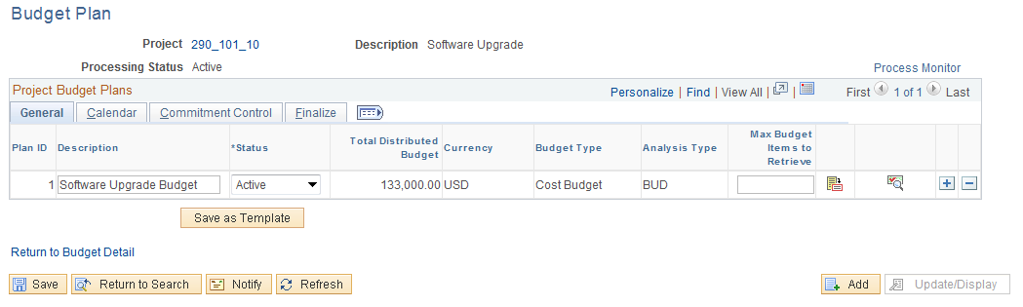

The Budget Plan page now will display the Total Distributed Budget amount rolled-up to the Project level.

Click the Finalize Tab.

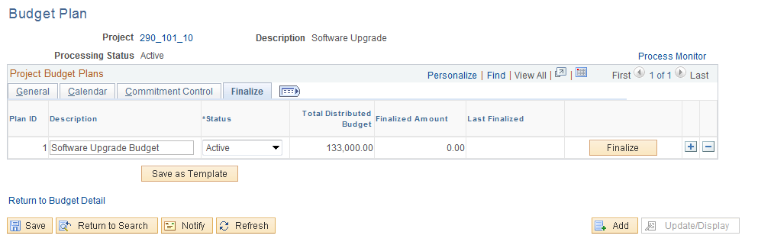

Click to Finalize the Project Budget.

NOTE: This will execute a process to Finalize the Budget and post to the Project in Project Costing as well as publish the Budget to Commitment Control.

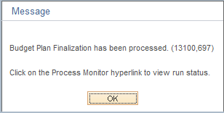

Select to the warning message. Use the Process Monitor link to view the status of the Process.

Step 3: Review the Project Budget

Navigation: Project Costing > Transaction Definitions > Transaction List > Find an Existing Value
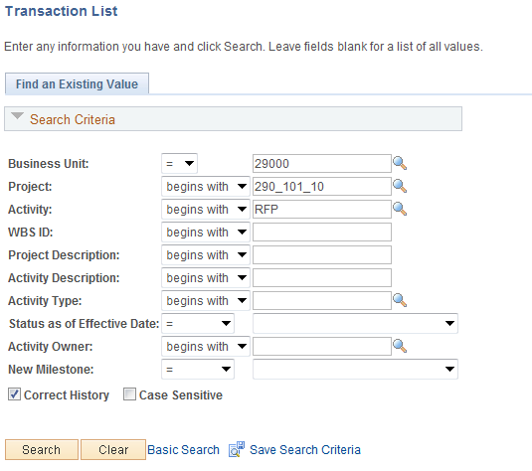

Use the Search Criteria to retrieve the Project.

Business Unit – is the Agency in which the Project Budget is stored.

Project – the Project ID value to view Budget transactions.

Activity – select the Activity to view Budget transactions.

Click to enter the Project Team pages.

Transaction List Page

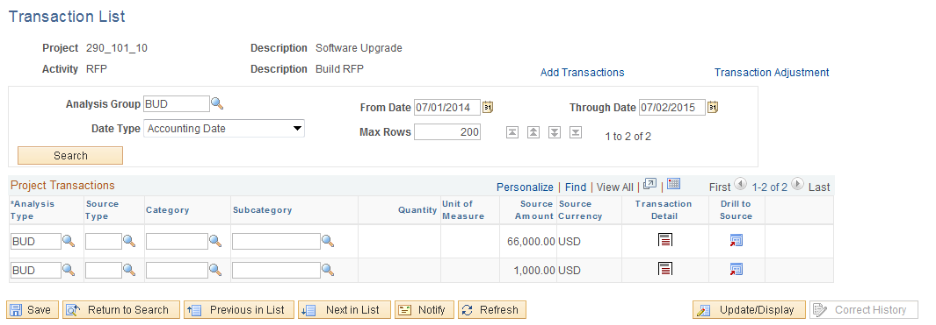

Analysis Group – to view only Budget transactions select ‘BUD’

From/Through Date – populate with dates that will include the Project Budget periods.

Click to retrieve the Budget transactions for the Project Activity.

Funds Distribution

Project transactions can be split or distributed among multiple funding sources. A Funds Distribution process (PC_FND_DIST) distributes funding by applying Funds Distribution rules to incoming transactions from feeder systems, and assigning costs accordingly. These distributed transactions can be priced using the Pricing Engine (PC_PRICING) for billing purposes.

Funds Distribution is a three-step process:
- Identify Project transactions that are eligible for distribution at the Activity level.
- Define Funds Distribution rules—the percentages of the Project transaction amounts that are
passed on to each funding source.
- Run the Funds Distribution process

Step 1: Define Funds Distribution - Source

Navigation: Project Costing > Funds Distribution > Funds Distribution > Find an Existing Value

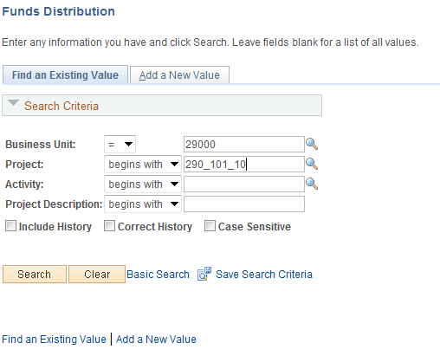

Use the Search Criteria to retrieve the Activity for Funds Distribution.

Business Unit – is the Agency in which the Project is stored.

Project – the Project ID for Funds Distribution.

Activity – select the Activity for Funds Distribution.

Click to enter the Funds Distribution pages.

Funds Distribution-Source Page

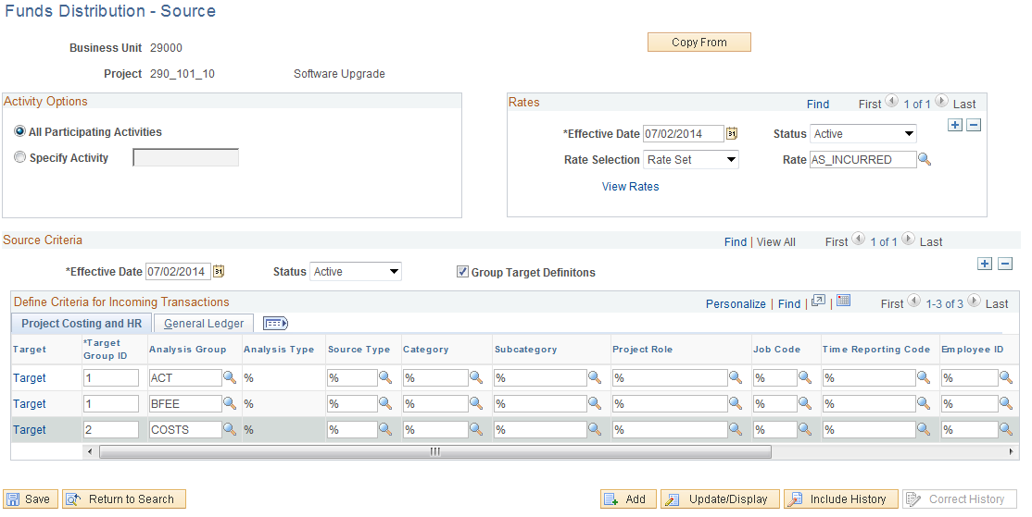

Use the Funds Distribution – Source Page to define the incoming Project transactions that are subject to Funds Distribution rules.

Click to copy funds distribution rules from another Activity in the same Business Unit.

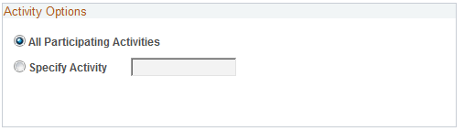

All Participating Activities – This allows all activities, for a particular project, that have the Participating feature checked on the Activity Definition page under Funds Distribution, to be grouped together. As a group, the same source rules will apply to all the activities and the group can be associated with one Target definition.

Specific Activity – Select to indicate that the source rule applies to one activity in the project. Enter the activity in the field to the right.

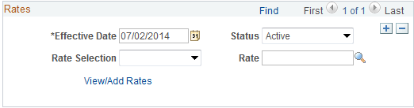

Effective Date – define when this Funds Distribution Rule is effective.

Rate Selection – allows you to select a Rate Set or a Rate Plan

Rate – Select a rate plan or a rate set, depending on the selection in the Rate Selection field.

Group Target Definitions – This value will default from the Project Costing Options page at the Business Unit level if checked. Otherwise it will default from the Project Definition page of the current project, if checked. The default can be overridden on this page.

Select it to indicate that the funding source rules can be grouped manually, each Source Analysis Group associated with its own Target rule.

Deselect to indicate that each Funding Source rule will be associated with a separate Target Definition.

Project Costing and HR Tab

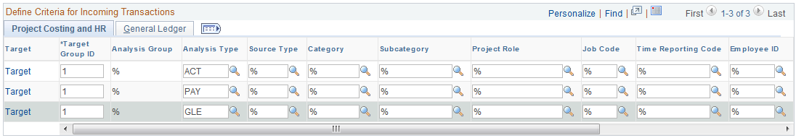

Target Group ID – Assign this ID based on which source rules will be grouped together. This takes alphanumeric combinations or sequential numbers. Basically, each line which shares the same Target Group ID shares the same source funding. This field is only visible if Group Target Definitions checkbox is selected.

Analysis Group - This field defaults to ‘%’. For a particular source rule you can only enter a value for either Analysis Group or Analysis Type. If source rule is entered by analysis group then the corresponding target definition will apply to all the analysis types within that analysis group.

Analysis Type – for incoming Project transactions, define which Analysis Types are subject to distribution. If this field is populated, Analysis Group cannot be used.

Source Type – for incoming Project transactions, define which Source Types are subject to distribution.

Category – for incoming Project transactions, define which Category values are subject to distribution.

Subcategory – for incoming Project transactions, define which Sub Category values are subject to distribution.

General Ledger Tab

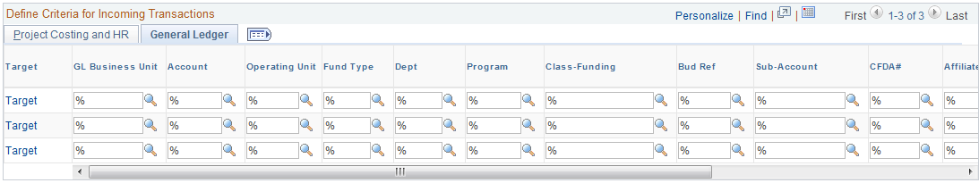

General ledger chartfields can be overridden here, but caution should be used to ensure that any changes made to chartfields are in accordance with accepted business practice.

NOTE: Use the % (wildcard) symbol to indicate all values in that field are eligible for distribution.

Click the Target link on the line to view the Target page.

Funds Distribution - Target Page

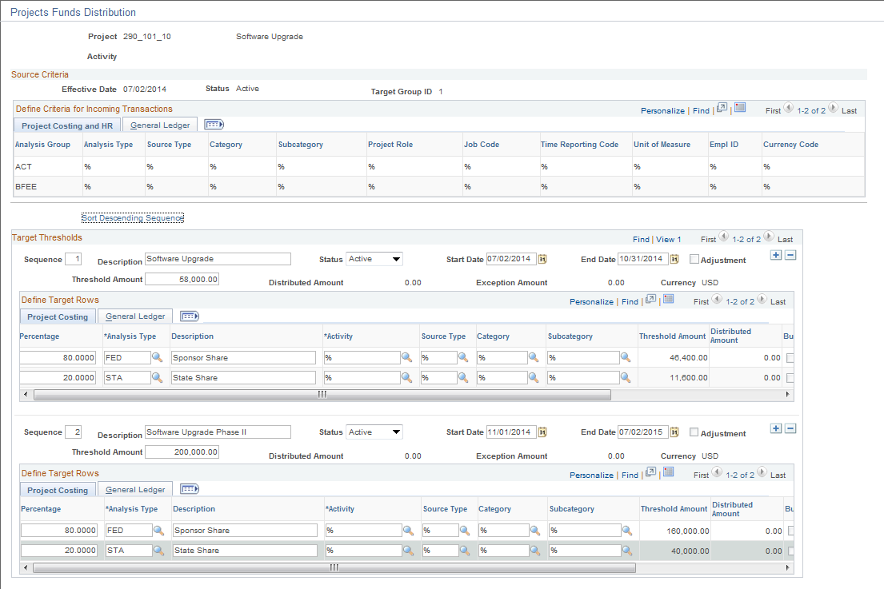

Use the Funds Distribution-Target Page to define percentages that will be used to split Project transactions between funding sources.

Sequence – Funding can be applied sequentially. Each sequence represents an approved amount of available funding to which costs can be distributed. Different rules can be set up for each sequence of funding. When one funding sequence is depleted, the costs start applying to the next sequence.

Status – this field allows you to make a particular sequence Active or Inactive within a rule. If you make a sequence Inactive, it can only be made Active if the Distributed Amount within the sequence is equal to zero.

Adjustment – Indicates the particular sequence is for adjustments. The Target Percentage Distribution field is not available for entry. This option enables you to synchronize the manual adjustments from Billing with the funds distribution rules and reports. Adjustment sequences are not processed by the Funds Distribution process. When the Threshold amount and Distributed amount in the sequence is equal to zero, the Adjustment check box can be changed.

Start/End Dates – Costs with an accounting or transaction date that fits within the date parameters can be distributed in the sequence. If the Adjustment check box is selected, these dates do not apply.

Threshold Amount - Enter an amount that represents the maximum amount of source transactions that may be distributed to funding sources according to the distribution rules defined for the sequence. If the Update Threshold Amounts field on the Installation Options - Project Costing Integration page is selected, then this field can be modified after costs have been distributed against the threshold. However, the threshold amount cannot be less than the distributed amount. If the Update Threshold Amounts field on the Installation Options - Project Costing Integration page is not selected, then this field cannot be modified after costs have been distributed against the threshold. If additional funding is received, a new sequence must be added to create additional distribution rows.

Distributed Amount – Displays the amount of costs distributed for the sequence.

Exception Amount – Displays the amount of costs distributed that have been held from additional process due to Budget checking exceptions. These are not in PROJ_RESOURCE, use Budget Exceptions page to correct.

Project Costing Tab

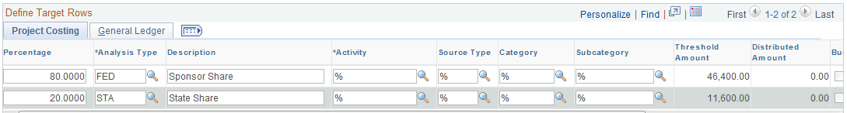

Percentage – define the percentage split for each funding source.

NOTE: For each incoming Project transaction that meets the Source Criteria, the system creates a Target row in the Project Transaction table with an amount equal to the defined percentage of the cost, and it uses the Analysis Type, Activity, Source Type, Category, and Subcategory that are defined in this row in the Define Target Rows section of the page.

NOTE: Use to insert as many rows as necessary to accomplish the desired split.

Target Analysis Type – define the Analysis Type for the target row that will be created from the distribution.

Description – this description will be populated on the Target row that is created from the distribution.

Target Activity – optionally, assign the distributed costs to a different Activity within the Project.

Target Source Type/Category/Subcategory – populate these fields to change the value on the Target row.

NOTE: If no Target Source Type, Category or Subcategory is defined, the target row will inherit these values from the Source row.

Threshold Amount – Displays the percent of the total threshold amount for the source.

Distributed Amount – Displays the total costs that are distributed to the funding source specified for the row.

Budget Check – Select to indicate the resulting distribution is to be budget checked.

Reversals – Select to indicate reversals are allowed for the row.

Balancing – Select one row in a sequence to indicate that this target row should be used by the system if rounding differences are encountered during the Funds Distribution process.

General Ledger Tab

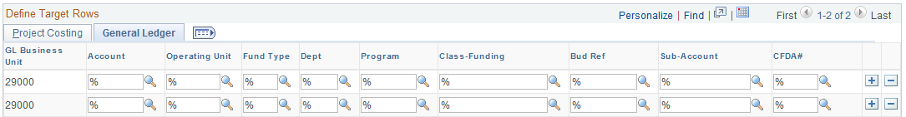

General ledger chartfields can be overridden here, but caution should be used to ensure that any changes made to chartfields are in accordance with accepted business practice.

Click to save the Funds Distribution Rule.

Step 2: Running Funds Distribution

Navigation: Project Costing > Funds Distribution >Process Funds Distribution Find an Existing Value

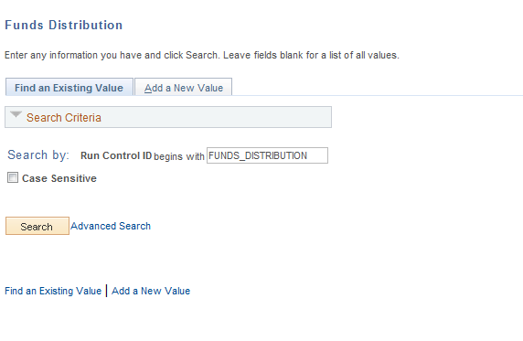

Run Control ID – create a new Run Control or select an existing value from the list.

NOTE: The Funds Distribution process is called when Project transactions are interfaced from feeder modules into Project Costing. The process can also be executed on an ad hoc basis as illustrated here.

Funds Distribution Page

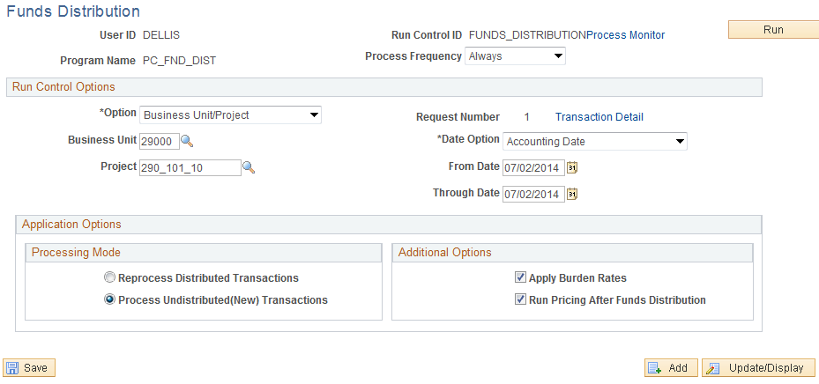

Process Frequency – set to ‘Always’

Option – define the scope of the Funds Distribution process for this run. The process can be executed by:
- All – Agencies will NOT use this setting! Select all Project Costing transactions for all Business Units. This value should likely not be used when running the process on an Ad-Hoc basis.
- Business Unit – select all Project Costing transactions for an agency Business Unit.
- Business Unit/Project – select all Project Costing transactions for an agency Business Unit and Project ID.
- Business Unit/Project/Activity - select all Project Costing transactions for an agency Business Unit, Project ID and Activity ID.

From/Through Date – define a date range that will limit the Project transactions selected by the Funds Distribution process.

The Funds Distribution process can be used to:

- Process new source transactions that have not been distributed by the Funds Distribution process.

- Redistribute source transactions that have been distributed in a previous run of the Funds Distribution process.

Apply Burden Rates - Select to run the Pricing process (PC_PRICING) before running the Funds Distribution process.

Run Pricing After Funds Distribution – select to run the Pricing process after the Funds Distribution process.

Click to execute the Funds Distribution process.

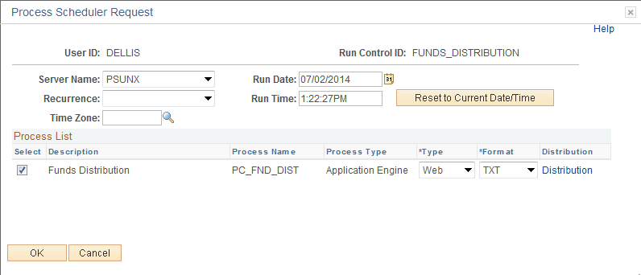

Select the checkbox next to the desired process.

Click to execute the process. Navigate to the Process Monitor link to view the Process instance.

Project Template

Users can create and modify an unlimited number of reusable Project templates to populate new Projects with preset standard information such as Project and Activity-level information, teams, budget plans, and attachments. You can also modify existing active or pending Projects using data from templates.

To create a template, either save a new or existing Project as a template, or create a new template by starting with a blank project.

Step 1: Creating a Project Template

Navigation: Project Costing > Project Definitions > General Information > Find an Existing Value

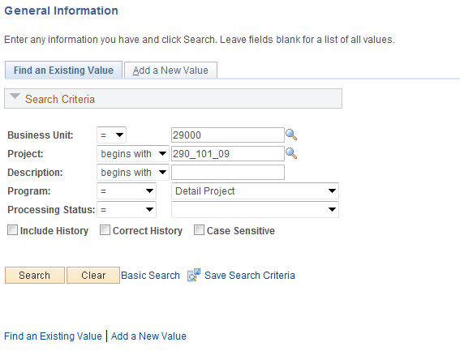

Business Unit – is the Agency in which the Project will be flagged as a Template.

Project – this value will be the Project ID.

Program – defines an existing Project as a ‘Detail’ or ‘Program’ (summary).

Click to retrieve an existing Project and flag as a Template.

NOTE: A Project can be flagged as a Template at time of creation or afterward.

General Information Tab

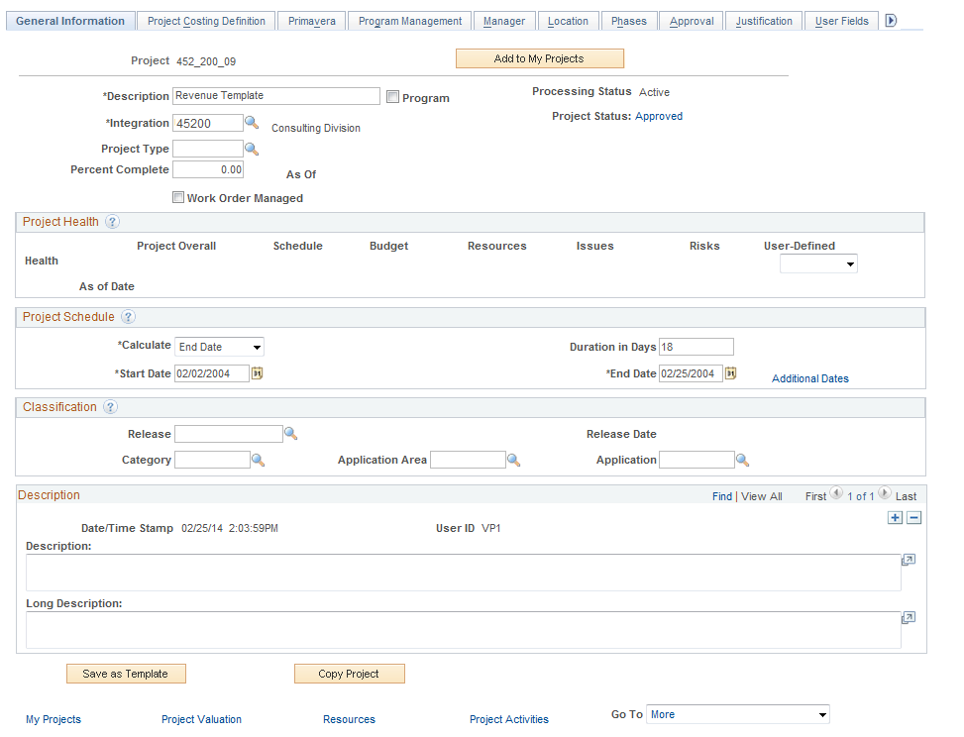

Click, then the button is activated. Click to designate the Project as a Template.

Copy a Project

When creating a new Project, an existing Project can be used as a template to copy from. Projects and Activities can be copied to the new Project.

Step 1: Copy a Project

Navigation: Project Costing > Utilities > Copy Project > Find an Existing Value

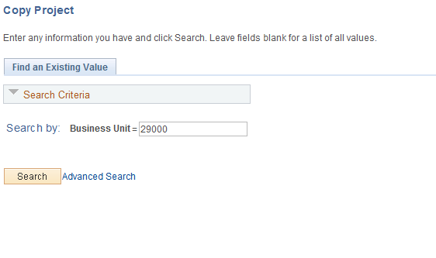

Business Unit – the agency Project Costing business unit where source Projects will be found to copy from.

Click to retrieve the Project Copy pages.

Copy Project Page

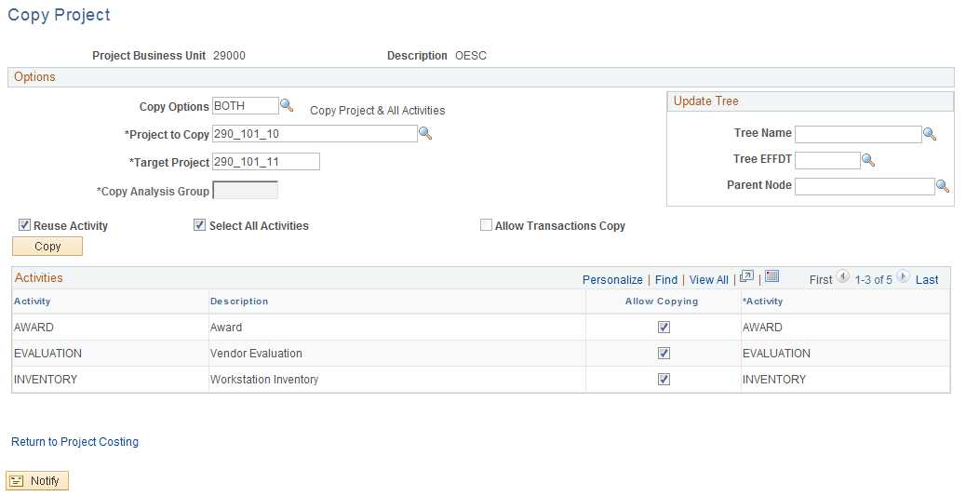

Copy Options – define what IS to be copied from the Source Project.
- ACTV – copy only the Activity.
- BOTH – copy the Project and all Activities
- PROJ – copy only the Project ID

Project to Copy – define the source Project that will be copied from.

Target Project – define the new Project ID for the Project that will be created.

Copy Analysis Group – define by Analysis Group the Project Transactions what will be copied to the new Project. (Not used statewide).

The Activity section of the page displays the Activities for the source Project.

Allow Copying – select the Activities that will be copied to the new Project.

Click to execute the Copy feature.

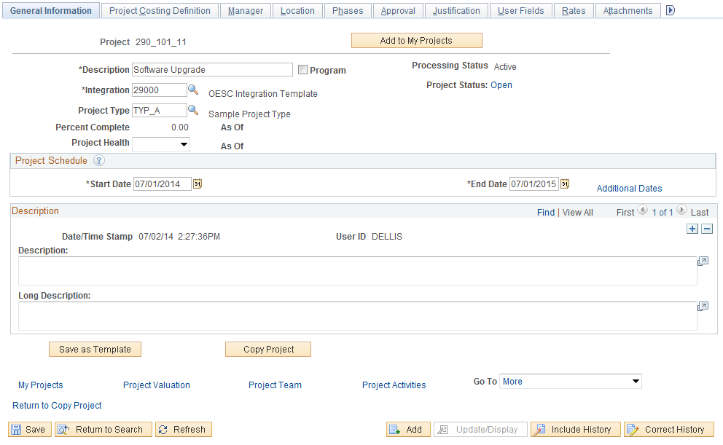

The newly created Project from the Copy feature is available and ready to be modified and saved.

Accounting Rules

Accounting Rules are defined to create a debit and credit for Project transactions that need to reflect accounting entries. These accounting entries are generally defined for Billable Project transactions but could be defined for other Project transactions.

Accounting Rules are defined to select Project transactions based on particular values in the Project transaction line or the Project definition. For example, an Accounting Rule could be created for a particular Analysis Type and Project Type.

Accounting Rules

Navigation: Setup Financial Supply Chain > Product Related > Project Costing > General Options > Accounting Rules > Find an Existing Value

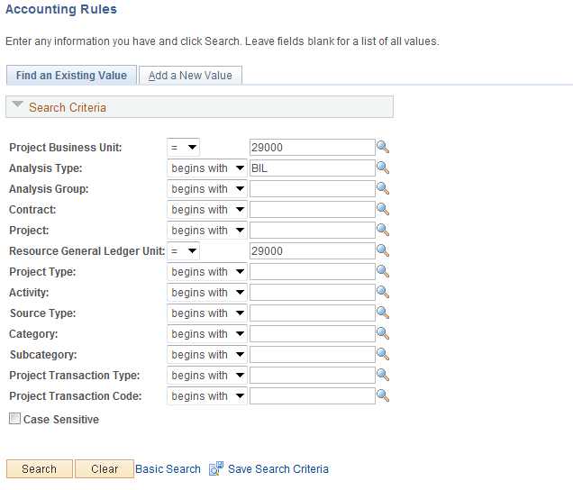

Use the Accounting Rule search criteria to find an Accounting Rule.

Project Costing Business Unit – accounting rules are defined for each agency business unit.

Analysis Type – accounting rules are defined by Analysis Type.

Resource General Ledger Unit - Required

Click to find Accounting Rules that match the search values.

Accounting Rules Page

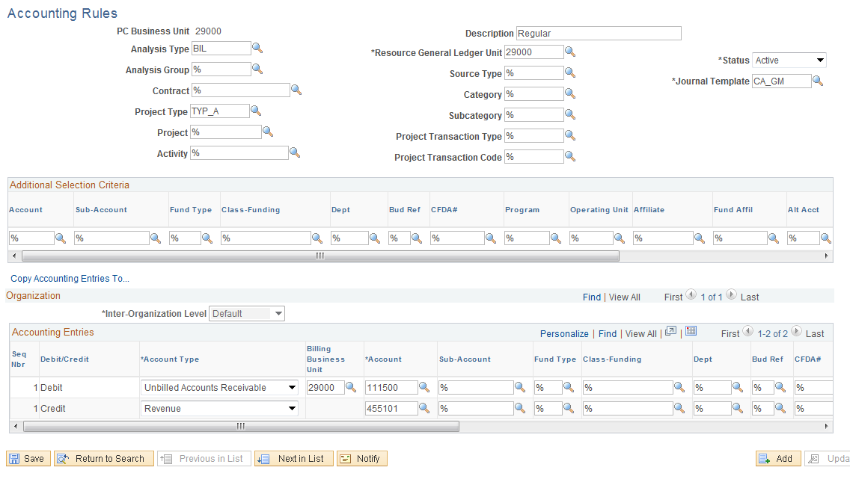

Accounting Rules are defined by Project Business Unit with particular Project transaction values. In the example above the BIL row that was created by having a project connected to a contract with an active Rate Set, will have Account 111500 as the Unbilled Accounts Receivable and Account 455101 as the revenue. Additionally this Rule only applies to BIL rows that were created from a project has a Project Type of TYP_A.

NOTE: Accounting Rules for billable Project transactions with Analysis Type equal to ‘BIL’ will have a debit to ‘Unbilled Accounts Receivable’ and a credit to ‘Revenue’.

NOTE: If a chartfield value is not defined on the Accounting Rule, the accounting entry will inherit the chartfield value from the Project transaction line.

Budget Items

Budget Items define the Budget Categories that Project Costs and Revenue can be defined by. Budget Items are generally similar to a high-level account code like Equipment, Travel or Personnel Costs.

When used in Project Budgeting, Budget Items can default other chartfield values into a Project Budget line. These could be General Ledger chartfields or Project Costing chartfields.

Budget Items

Navigation: Setup Financial Supply Chain > Product Related > Project Costing > General Options > Budget Items > Find an Existing Value

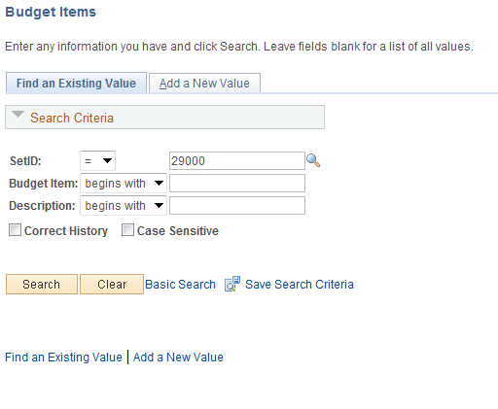

SetID – Budget Items are defined by agency specific Set ID (agency business unit number).

Budget Item – the Budget Item ID.

Click to find Budget Items that match the search values.

Budget Items Page

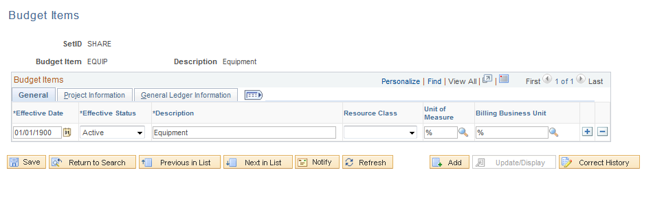

The Tab displays high-level information for the Budget Item.

Click the Tab.

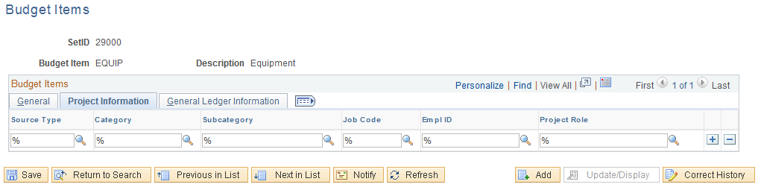

The Tab defines the chartfields that will default into the Project Budget line when this Budget Item is used.

Project Costing Chartfields

Navigation: Project Costing > Project Definitions > General Information>Find an Existing Value

Project ID – Project ID represents an agency effort, goal or initiative required to accomplish agency services. Project ID is a chartfield on the distribution line for cost and revenue, but also houses properties like Status, Teams and Types. Cost and Revenue can be budgeted by Project ID and actual costs and revenue can be collected in a Project. Project IDs are a maximum 15 characters long, and they are alpha-numeric (can be letters and/or numbers). Additionally Project IDs must be unique throughout the system; hence each ID should start with the first three digits of the Agency number.
Ex: 090CORE_PHASEII

Navigation: Project Costing > Activity Definitions > Project Activities > Find an Existing Value

Activity ID – Activity ID generally represents a specific task required to accomplish Project goals. Activity ID is a chartfield on the distribution line for cost and revenue, but also houses properties like Status, Teams and Types.

Navigation: Setup Financial Supply Chain > Product Related > Project Costing > Transaction Options > Source Types > Find an Existing Value

Source Type – Source Types generally describe the purpose of a Project transaction. These could be Labor, Equipment or Travel. Source Types are optional for Project Transactions.

Navigation: Setup Financial Supply Chain > Product Related > Project Costing > Transaction Options > Categories > Find an Existing Value

Category – Categories and subcategories further define source types. You can combine categories and subcategories in source groups for reporting and analysis. Although defining categories and subcategories is optional, using them provides greater flexibility and granularity for tracking and analyzing costs.

Navigation: Setup Financial Supply Chain > Product Related > Project Costing > Transaction Options > SubCategories > Find an Existing Value

SubCategory – Categories and subcategories further define source types. You can combine categories and subcategories in source groups for reporting and analysis. Although defining categories and subcategories is optional, using them provides greater flexibility and granularity for tracking and analyzing costs.

Rate Sets

Project transactions brought into a Project from other modules (Payables, Time and Labor, etc.) can be subject to a ‘Pricing Engine’ that creates target rows from these Project Transactions. These target rows can represent Revenue (billable transactions), Overhead or Marked-up Costs.

The Pricing Engine matches incoming Project Transactions with Rate Sets that define what target rows will be created in the Project.

Transactions are eligible to price for billing when the Project and Activity are linked to a rate set or rate plan through Contracts at the contract line level.

Rate Sets

Navigation: Setup Financial Supply Chain > Product Related > Project Costing > Pricing Structure > Rate Sets > Find an Existing Value

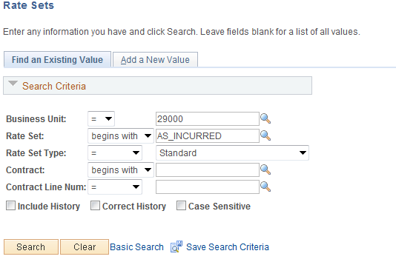

Use the Rate Sets search criteria to find a Rate Set.

Business Unit – Rate Sets are defined for each agency business unit.

Rate Set – the Rate Set value.

Click to find Rate Sets that match the search values.

Rate Sets Tab

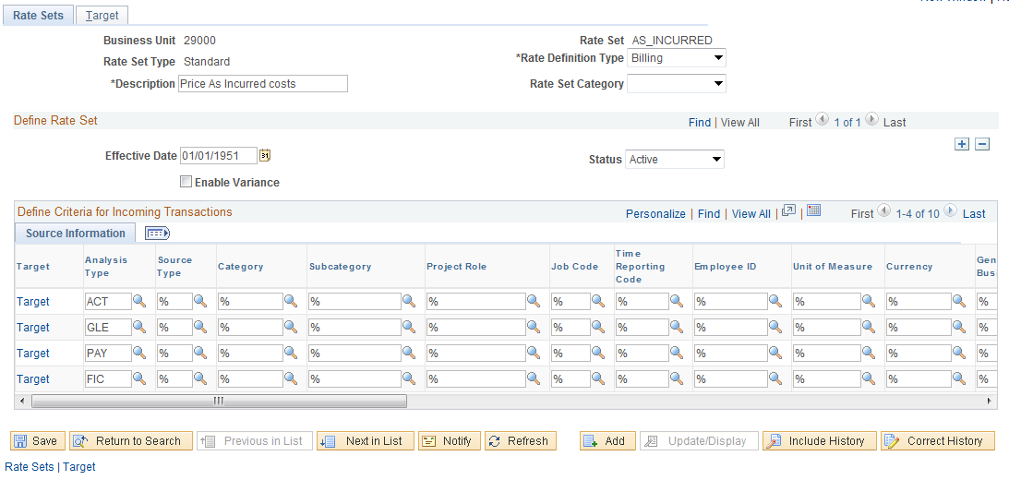

The Tab defines the chartfield values that will be matched against incoming Project transactions to create target rows.

Click the Tab.

Target Tab
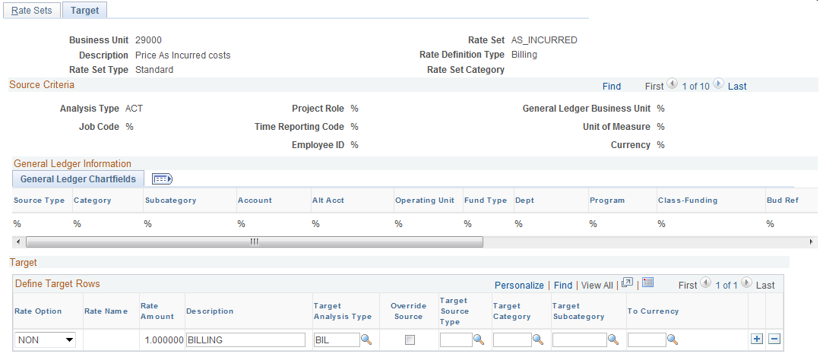

For each row on the Tab, a Target row will be created to define the type of row that will be created by the Pricing Engine.

Rate Option – defines how the target row will be created. This could be a markup or actual cost.

Target Analysis Type – the target row created by the Pricing Engine will have this Analysis Type.

NOTE: If a chartfield value is not defined on the Target row, the target row will inherit the chartfield value from the source Project transaction line.

Project Trees

Project Trees are used for many purposes in the Project Costing and other Financial modules within the system. Project Trees define how trees relate to each other for tracking and reporting purposes. A Project can be hierarchically related to as many other Projects as necessary to achieve the desired level of cost tracking and analysis.

Project Trees can be used for reporting, allocation or security. Agency users will be allowed to create multiple Project Trees for these purposes.

The types of Trees that agencies are allowed to build are limited to certain Tree Structures. A Tree Structure is a ‘Framework’ that an individual Tree is built on. The Tree Structure defines how the tree will look and the values that appear on the Tree.

Trees are built on multiple Levels that allow the hierarchy of the Tree to be defined. Tree Levels are generic in nature and can be used by multiple Trees. Tree Nodes are the values that sit on the defined Tree Levels. A tree Node could be a Project that is used to roll-up costs for other lower-level Projects. For Project Trees, Nodes are selected from valid Project ID’s that are defined in the system.

Step 1: Create a Project Tree

Navigation: Tree Manager > Tree Manager > Create a New Tree

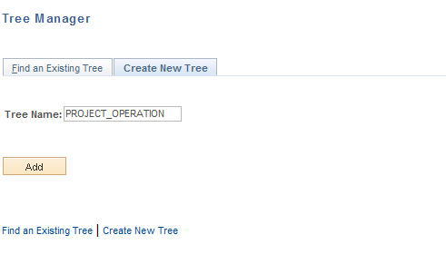

Tree Name – define a name for the Tree that describes its use.

Click to enter the Tree page.

Tree Definition and Properties Page

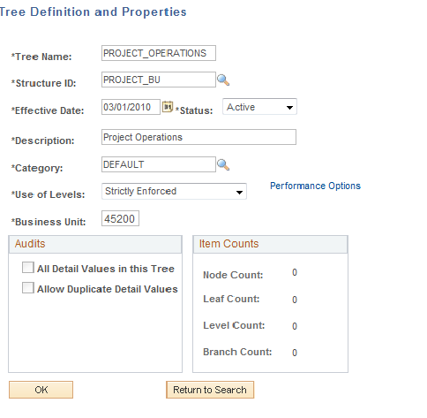

The Tree Definition and Properties page defines how the Tree will be used and values that are valid for the tree.

Tree Name – this value is defined when entering the Tree component.

Structure ID – define the Tree Structure that this Project Tree will be built upon. The Tree Structure defines the values on the tree and the pages used to update these values.

NOTE: For Project Tree creation, agencies will have access to two Tree Structures – PROJECT_BU and PROJECT_GL. PROJECT_BU should be used for project reporting while PROJECT_GL should be used to create allocations of Project transactions.

Effective Date – define the date at which this Project Tree will be effective.

Description – define a description for the Tree that will be visible when searching Tree values.

Category – set this value to ‘Default’.

Use of Levels – set this value to ‘Strictly Enforced’. This value ensures that Tree Nodes can be rolled-up properly for summarization.

Business Unit – define the agency business unit.

Click to create the Project Tree Levels.

Enter a Root Node for Tree Page

Use the Enter Root Node for Tree page to define the Levels that the Tree will be built upon. If you choose PROJECT_BU as the structure the Root Node will be another project ID. If you choose PROJECT_GL the Root Node can be any node that exists on another tree, or more often you will just make up a new nose name. Tree Levels can be generic in nature and represent the how the hierarchy of the Tree will be defined.

Click to add the first Level of the Tree.

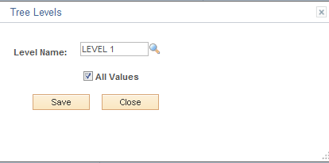

Level Name - select the first Level of the Tree.

All Values – for the first Level in the Tree, the All Values checkbox is defaulted on to represent all Project Value will be rolled-up to this Level.

Click to save the first Level of the Tree.

NOTE: Add as many Levels to the Tree as necessary to accomplish the desired hierarchy structure.

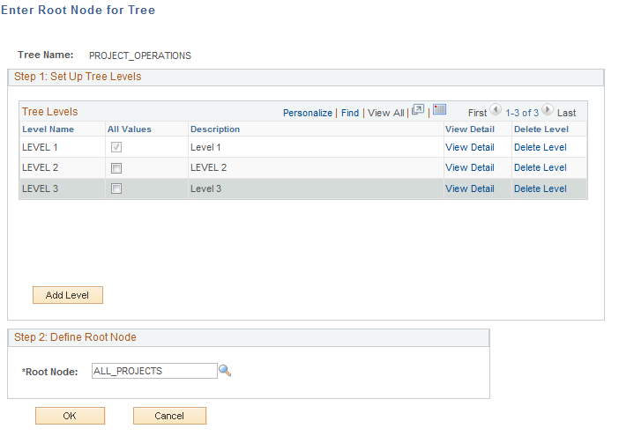

Once all desired Levels are added to the Tree, they should be visible in the Tree Levels section of the page.

Root Node – select the ‘Root Node’ or top value for the Tree. The Root Node will be the initial value at the top of the Tree that all lower-level values will roll up to.

NOTE: The Root Node for a Project Tree is generally a Project ID created specifically for this purpose. It is not a Project ID that will capture Project transactions but rather a ‘Roll-Up’ value that is only used to represent the top level on the Tree.

Click to enter the Project Tree page.

Tree Manager Page

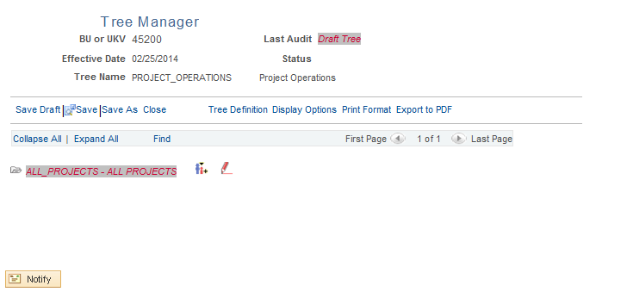

The Tree Manager page will initially display the values populated for the Definition and the Root Node. The user will at this point begin to define the Tree values that make up the hierarchal definition of the tree.

Click to insert a ‘Child Node’ under the Root Node.

NOTE: The Tree icons displayed at the right of any Tree Node allow the user to Edit a Node value, Insert Child Node values, Insert Sibling Node values, etc. Use these icons to manage creation of the Project Tree.

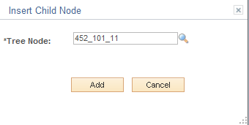

Tree Node - Select the Child Node value.

Click to insert this Node Value.

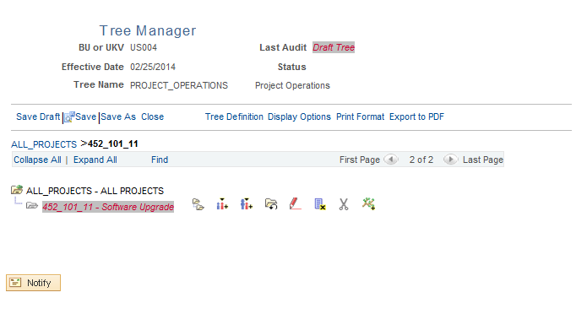

The Tree Node that was inserted as a Child Node is visible on the Tree.

NOTE: Continue to use the Tree Icons to define add, edit or delete additional Node values on the Tree until it is completely defined.

Click the Save Draft link to save the Project Tree.

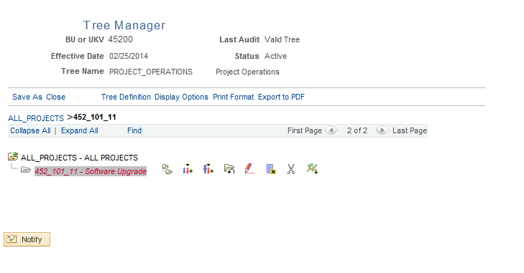

The Project Tree should save in a Valid status and be available for use.

