COR351 Higher Education

Payroll Processing Manual

Revised: November 1, 2012
Table of Contents

Document History 4
Payroll Process Flow Details 5
Step 1 – Load HR Data 5
Step 2 – Load Payroll Data 9
Step 3 – Additional Reports for Verification 13
Step 4 – Run Payroll Unsheet – (IF NECESSARY) 17
Step 5 – Run Pre-Distribution Audit Report 19
Step 6 – Run Pay Confirmation Process 22
Step 7 – Check Payroll Error Messages 25
Step 8 – Check Pay Calendar for Flags 28
Step 9 – Check Paycheck Data for Advice and Check Numbers 30
Step 10 – Run Distribute Actuals 32
Step 11 – Run Funding Reports 38
Step 12 – Run Finalize Funding Reports 41
Step 13 – Run GL Process 44
Step 14 – Check Pay Calendar Flags 47
Step 15 – Load Payroll Fund Transfer 49
Step 16 – Validate PFT Funding 53
Step 17 – Fax Documents to OMES 56
Off-Cycle Payrolls 57
Off-Cycle Calendars 57
Off-Cycle Payroll Processing Steps (Checklist) 59
Step 1 – Check for the Existence of Off-Cycle Pay Calendars 59
Step 2 – Load HR Data 60
Step 3 – Load Payroll Data 64
Step 4 – Additional Reports for Verification 68
Step 5 – Run Payroll Unsheet – (IF NECESSARY) 72
Step 6 – Run Pre-Distribution Audit Report 74
Step 7 – Run Pay Confirmation Process 76
Step 8 – Check Payroll Error Messages 79
Step 9 – Check Pay Calendar for Flags 82
Step 10 – Check Paycheck Data for Advice and Check Numbers 84
Step 11 – Run Distribute Actuals 86
Step 12 – Run Funding Reports 87
Step 13 – Run Finalize Funding Reports 90
Step 14 – Run GL Process 92
Step 15 – Check Pay Calendar Flags 96
Step 16 – Load Payroll Fund Transfer 98
Step 17 – Validate PFT Funding 102
Step 18 – Fax Documents To OMES 104

Authorized by: [_CORE_] Original Issue: [10/31/2011]
Maintained by: [_HCM Lead__] Current Version: [11/01/2012]
Review Date: [10/31/2013]

Document History

Document Revision | Date | Description
1.0  1.1 | 10/31/2011  11/01/2012 | Initial Document  Updated name change to OMES.

Payroll Process Flow Details
The following pages outline, in detail, the pay cycle processes of the Regular Pay Cycles for Higher Education agencies of the State of Oklahoma and what is run when, how, and why. This training manual reviews each step, sequentially as listed on the HED Upload and Payroll Processing Steps checklist, while explaining the procedures for processing a payroll in the PeopleSoft Release 9.0 environment. By the end of this manual, you will be familiar with PeopleSoft 9.0 as well as having a step-by-step guide for processing your own payrolls.

Step 1 – Load HR Data
The file will automatically load in Update mode which will perform all edits and return an report that will list any errors/inconsistencies within the load file.

Navigation: OK Custom Reports/Processes > Higher Ed Processes > Higher Ed HR File Upload(0022)

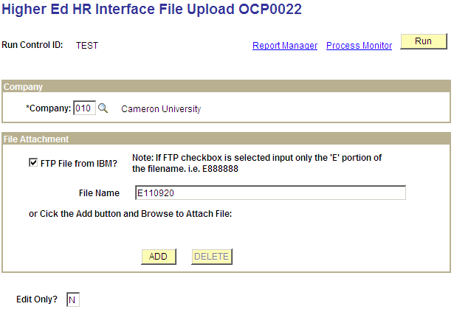

Enter Agency Number in the Company field.

Check FTP File from IBM.

Enter file name. (Only the ’E’ portion).

Enter ‘N’ for no edit or ‘Y’ for edit in the Edit only? box.

Or Click the and Browse to attach files.

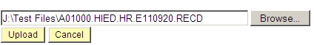

Click and select the file to be uploaded.

Click .

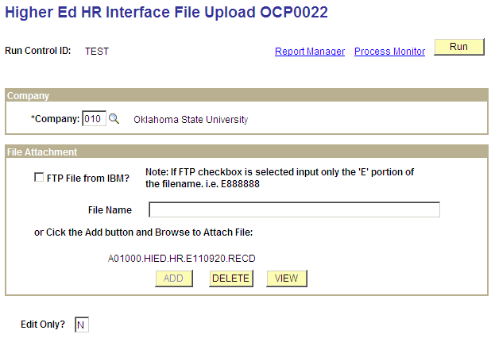

Enter ‘N’ for no edit or ‘Y’ for edit in the Edit only? box.

Click . You will be taken to the ‘Process Scheduler Request’ page

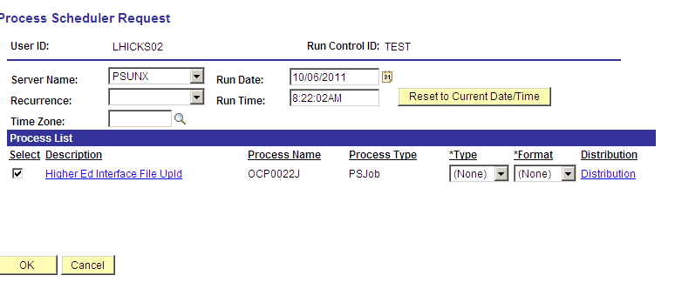

Server Name choose PSUNX.

In the ‘Process List’ group:
- Check box should be checked next to Higher Ed Interface File Upld
- Type should be set to (None)
- Format should be set to (None)

Click . You will be taken back to the Higher Ed HR Interface File Upload parameters page. In the top right hand side of the page a Process Instance number will now be shown. This process instance number is what you will use to monitor the completion of this job on the Process Monitor, take note of the Process Instance number and click the Process Monitor link.

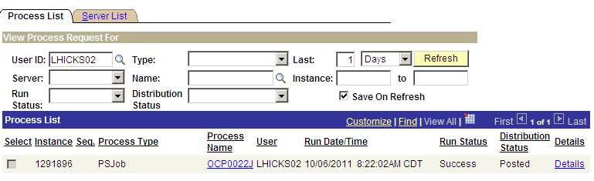

When the run status column shows Success and the Distribution Status column shows Posted. Click the OCP0022J link under Process Name.

NOTE: If the Run Status ever displays Error or No Success, review the error or no success and correct as needed. If assistance is required, write down your process instance number and contact the Help Desk. DO NOT continue working until the error has been cleared and you have a successful completion of this process.

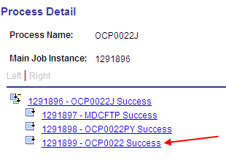

To view the error report, click the xxxxxx – OCP0022 link. Click View the Log/Trace link.

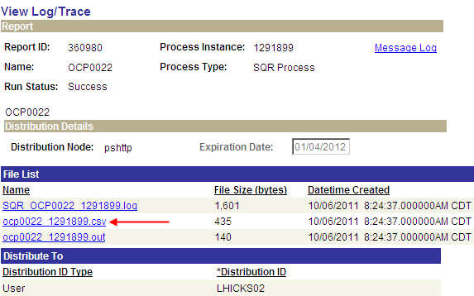

In the ‘File List’ group box select the file with the .csv extension (ocp0022 xxxxxxx.csv).

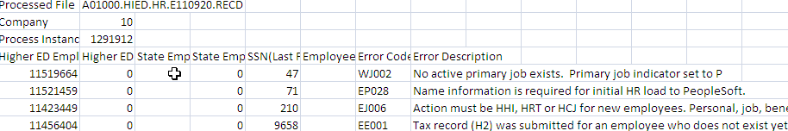

Repeat the above steps as often as necessary until all errors have been resolved.

Step 2 – Load Payroll Data

The payroll file will perform all edits and return a report that will list any errors/inconsistencies within the load file. Payroll is an all or nothing load, all errors must be corrected.

Navigation: OK Custom Reports/Processes > Higher Ed Processes > Higher Ed Payroll Data Upload >

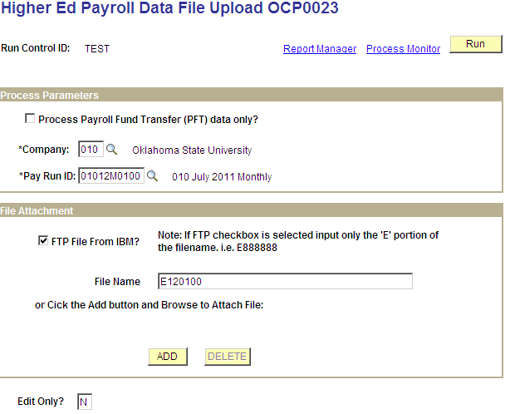

Enter Agency Number in the Company field.

Enter the Pay Run ID.

Check FTP File from IBM.

Enter file name. (Only the ‘E’ portion).

Enter ‘N’ for no edit or ‘Y’ for edit in the Edit only? Box.

Click the and Browse to attach files.

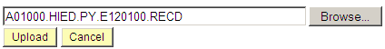

Click and select the file to be uploaded.

Click .

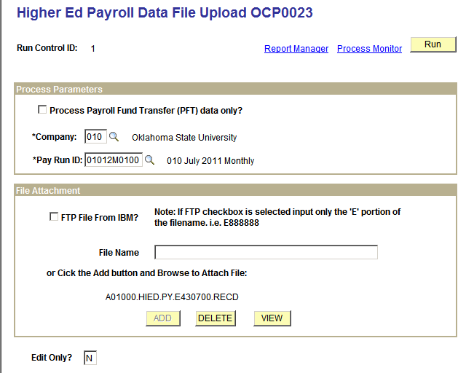

Enter ‘N’ for no edit or ‘Y’ for edit in the Edit only? Box

Click . You will be taken to the ‘Process Scheduler Request’ page.
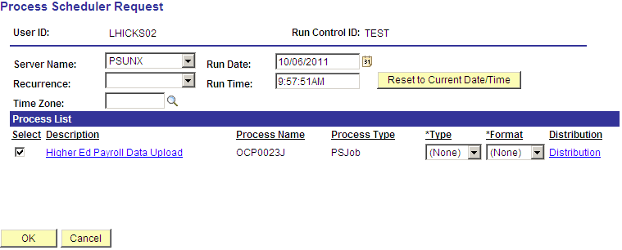

Only choose PSUNX server.

In the ‘Process List’ group:
- Check box should be checked next to Higher Ed Payroll Data Upload
- Type should be set to (None)
- Format should be set to (None)

Click You will be taken back to the Higher Ed HR Interface File Upload parameters page. In the top right hand side of the page a Process Instance number will now be shown. This process instance number is what you will use to monitor the completion of this job on the Process Monitor, take note of the Process Instance number and click the Process Monitor link.

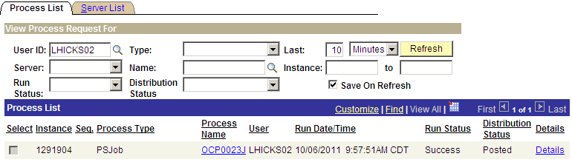

When the run status column shows Success and the Distribution Status column shows Posted. Click the OCP0023J link under Process Name.

NOTE: If the Run Status ever displays Error or No Success, review the error or no success and correct as needed. If assistance is required, write down your process instance number and contact the Help Desk. DO NOT continue working until the error has been cleared and you have a successful completion of this process.

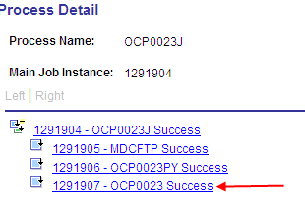

To view the error report, click the xxxxxx – OCP0023 link. Click View the Log/Trace link.

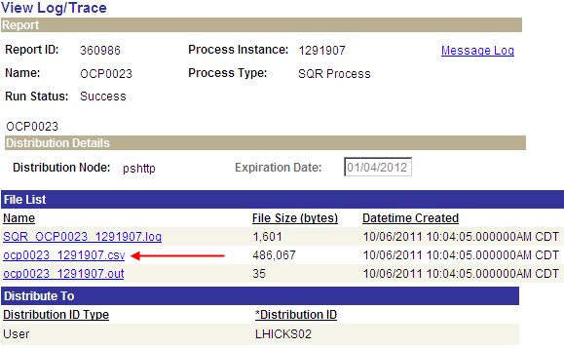

In the ‘File List’ group box select the file with the .csv extension (ocp0023 xxxxxxx.csv).

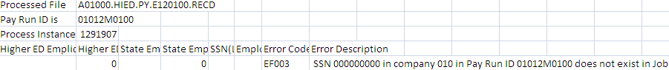

Review the report and correct errors on the load file.

Repeat the above steps as often as necessary until all errors have been resolved.

Step 3 – Additional Reports for Verification
Additional reports used for further verification of your pay cycles are as follows. Both of these reports are run and viewed/printed using the same steps.

Navigation: Payroll for North America > Payroll Processing USA > Pay Period Reports > Payroll Register – Name (0233)

The Payroll register report lists all employee payroll data pertaining to this pay cycle (i.e. gross earnings, deductions, taxes, and net pay) and can be used to reconcile employee Gross to Net calculations. The report itemizes, by employee, check detail information listing employee earnings, and employee/employer deductions and taxes. The last page is a summary of totals covering the entire pay cycle.

There are three (3) versions of this customized report. The changes were requested by the State of Oklahoma.

- Payroll Register Name (0233) - Sorted in last name order.
- Payroll Register Mail Drop (0312) – Sorted by the Mail Drop Field (Warrant Sequence Number on Payroll date)
- Payroll Register Div/Name (0312C) – Sorted by Division and then Name.

Navigation: Payroll for North America > Payroll Processing USA > Pay Period Reports >Payroll Register – Name (0233)

After entering the Run Control ID you are taken to the Payroll Register-Name (0233) parameters page.

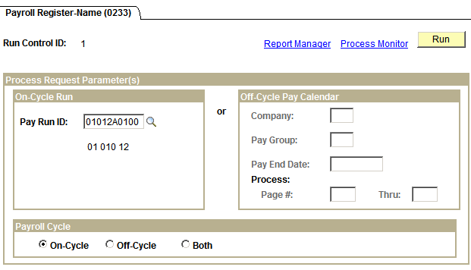
In the On-Cycle Run group box, left side of page, enter the Pay Run ID associated with the pay cycle you are running. In the Payroll Cycle group box, bottom of page, click the radio button next to On-Cycle. Click .

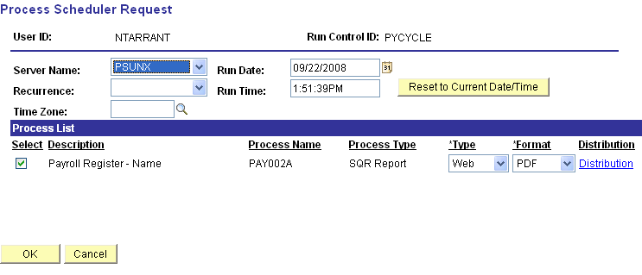

On the Process Scheduler Request page make sure Server Name is set to ‘PSUNX’.

In the ‘Process List’ group box:
- Check box should be checked next to Payroll Register-Name.
- Type should be set to Web
- Format should be set to PDF.

Click .

When screen goes back to the Payroll Register parameters page, take note of the Process Instance number and click Process Monitor link. When the process runs to a Success and Distribution Status shows Posted, click Details link.

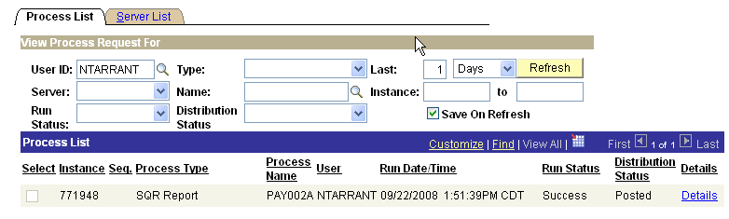

Clicking Details link takes you to the Process Detail page, shown below and click View Log/Trace link.
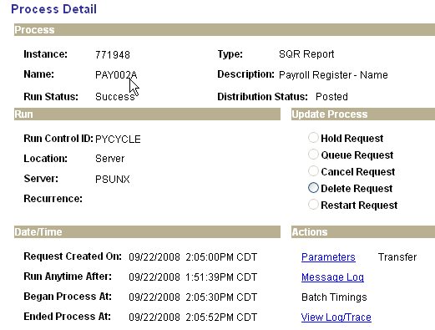

One the View Log/Trace page, in the File List group box, click the file with the .PDF extension.

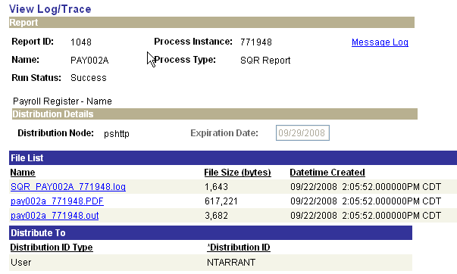

When you click the pay002a xxxxxx.PDF in the File List group box you are actually opening up the report to view and/or print.
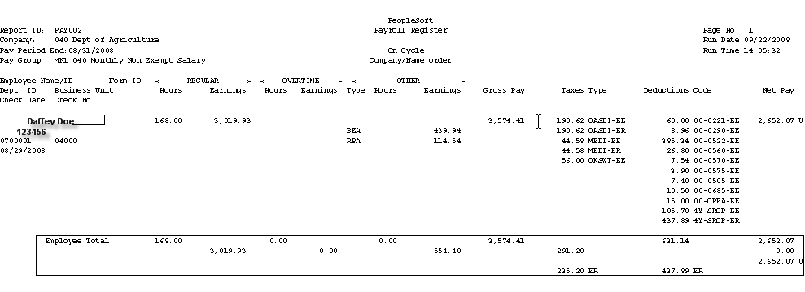

The heading of the Payroll Register lists the Report ID page #, Company, Run Date (date report was run on), Pay Period End Date, and Run Time. Data listed on this report is in alphabetical order by last name. For each employee listed you will see the hours/earnings, and other earnings that the employee is being paid which comprises the Gross Pay. It also lists in detail the Taxes and Deductions (employee (EE) and employer (ER)), and Net Pay. The ‘U’ after the Net Pay amount indicates this report is listing payroll data for the employee that is currently ‘Unconfirmed’. The data in the boxed in area under the employee is a summary of the total employee’s earnings, taxes and deductions (EE and ER), and Net Pay.

If you go to the last page of the Payroll Register you will see a summary page for the entire company.

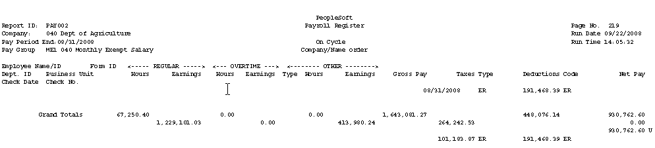

This page displays summarized grand totals of all earnings, taxes and deductions (EE and ER) and net pay. These totals will later be used to reconcile with the Funding Distribution and Payroll Budget Checking reports.

As you can see, this report can get rather large but you can print the entire report, a page, or certain pages of this report.

Navigation: Payroll for North America > Payroll Processing USA > Pay Period Reports >
Payroll Summary

This report summarizes total number of employees’ paid, gross payroll, taxes, deductions and net pay for this pay cycle. It also summarizes those totals by major categories such as OVT.

Step 4 – Run Payroll Unsheet – (IF NECESSARY)
This process deletes all the paysheets that have been created for the specified Pay Run ID – basically you are starting over. This step is only necessary if the load file that is loaded into the paysheets had incorrect or missing data and has to be reloaded.

Navigation: Payroll for North America > Payroll Processing USA > Update Paysheets > Pay Unsheet

After entering a Run Control ID you are taken to the Pay Unsheet parameters page.

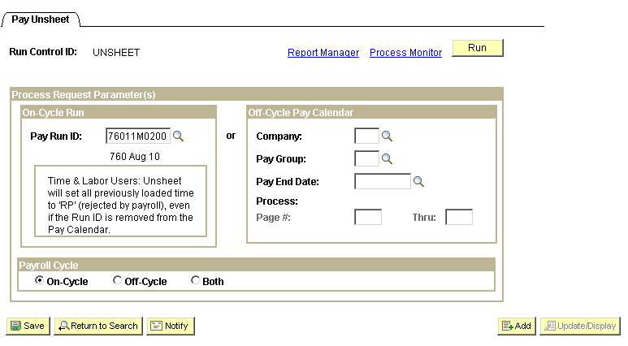

Enter the Pay Run ID you have been using in the On-Cycle Run group box. Click the radio button next to On-Cycle in the Payroll Cycle group box.

Click .

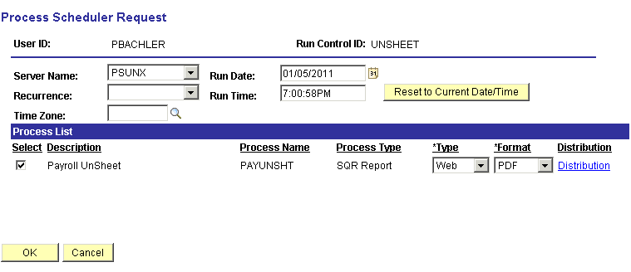

Only choose PSUNX server.

In the ‘Process List’ group:
- Check box should be checked next to Payroll Unsheet
- Type should be set to Web
- Format should be set to PDF

Click .

When screen goes back to the Pay Unsheet parameter page, take note of the Process Instance number and click Process Monitor link. When the process runs to Success and Distribution Status shows Posted, you can start over.

Step 5 – Run Pre-Distribution Audit Report
The Pre-Distribution Audit Report audits payroll and configuration data. The report identifies any errors that could be encountered when you run the Actuals Distribution (PSPPFUND) or the Actuals GL Interface (PAYGL02). This report is executed after the Payroll Data Upload and before Actuals Distribution.

Navigation: Payroll for North America > Payroll Distribution > Commitment Accounting USA > Predistribution Audit Report

After entering a Run Control ID you will be taken to the Predistribution Audit Report run control parameters page.

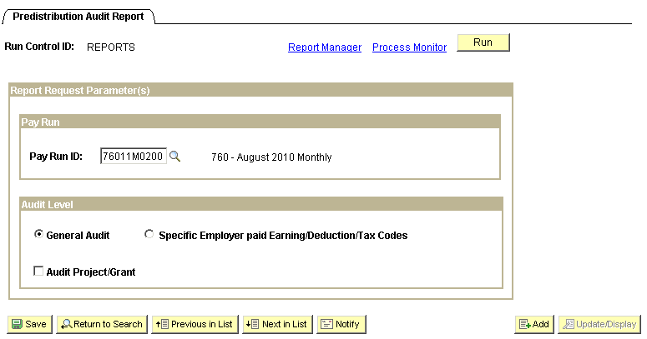

Enter the Pay Run ID of the current payroll being processed. Verify that only the General Audit radio button is checked. When all data fields have been correctly filled in, click .

You will be taken to the ‘Process Scheduler Request’ page.

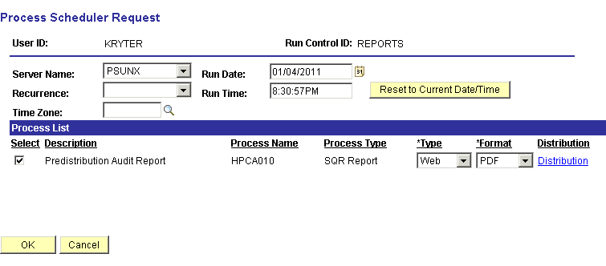

Only choose PSUNX server.

In the ‘Process List’ group:
- Check box should be checked next to Predistribution Audit Report
- Type should be set to Web
- Format should be set to PDF

Click .

You will be taken back to the Predistribution Audit Report parameters page. In the top right hand side of the page a Process Instance number will now be shown. This process instance number is what you will use to monitor the completion of this job on the Process Monitor.

When the screen goes back to the Predistribution Audit Report parameter page, take note of the Process Instance number and click Process Monitor link.

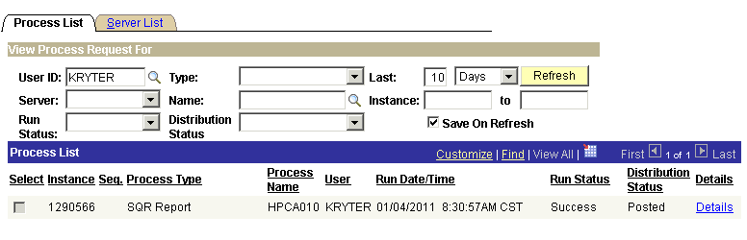

When the run status column shows Success and the Distribution Status column shows Posted. Click Details link. On the Process Detail page click View Log/Trace link.
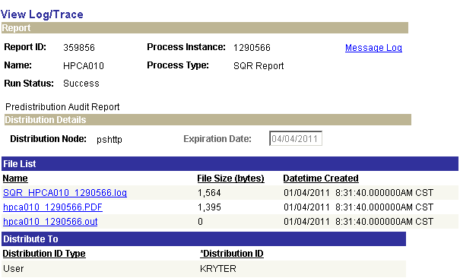

If there are entries on the Audit report for this pay cycle, there will be a file in the ‘File List’ group box with a .PDF extension. Click the .PDF file to open and print your Audit report. This report will list all employees and the issues identified that need attention.

Step 6 – Run Pay Confirmation Process
The pay confirmation process edits the database for any open unconfirmed prior period pay calendars. The confirmation process also assigns check/advice numbers, updates all employee balance tables, updates Pay Calendar flags, and updates flags on all associated rows of data on the PAY_.... tables that store employee detailed paycheck data.

Navigation: Payroll for North America > Payroll Processing USA > Produce Payroll > CA Confirm Pay (0432)

After entering a Run Control ID you are taken to the Pay Confirmation parameters page.

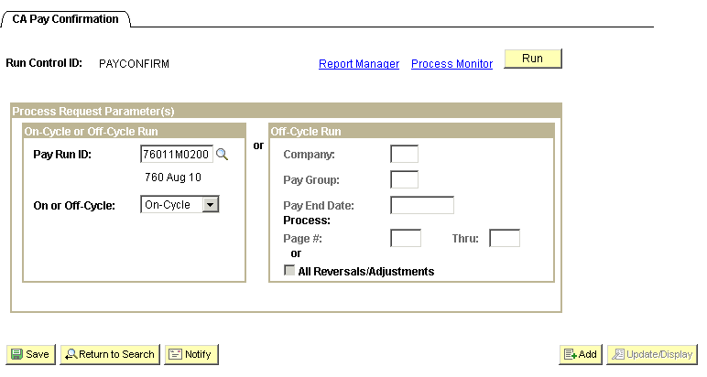

In the On-Cycle or Off-Cycle Run group box, enter the correct Pay Run ID and select On-Cycle, then click .

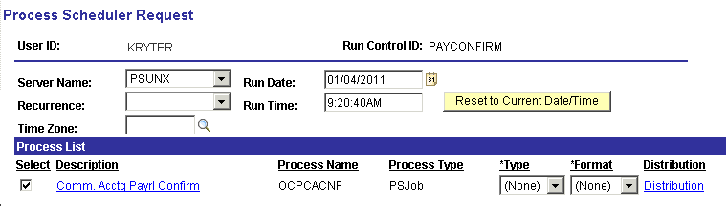

Only choose PSUNX server.

In the ‘Process List’ group:
- Check box should be checked next to Comm. Acctg Payrl Confirm
- Type should be set to (None)
- Format should be set to (None))

Click .
When the screen goes back to the Pay Confirmation parameters page, take note of the Process Instance number and click Process Monitor link.

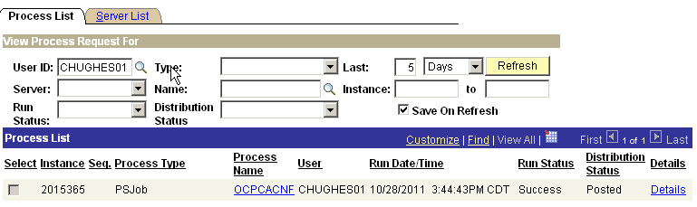

When the job has run to Success and Distribution Status says Posted, under Process Name click the OCPCACNF link on the correct process instance row.

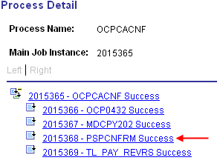

Clicking the xxxxxxx - PSPCNFRM link takes you to the Process Detail page; click the View Log/Trace link.

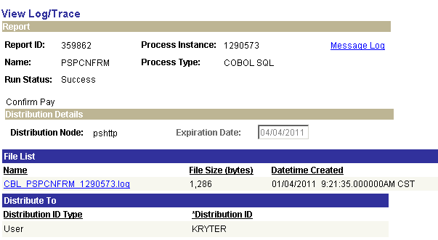
On the View Log/Trace page open the log to check for any ‘Check Messages!!!!’ statements. If you find any, do not go any further and call the CORE Team immediately, then call the Help Desk to open a case.

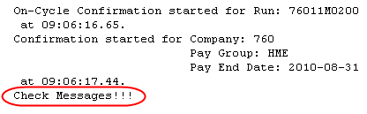

A log showing all confirmations were successful would look similar to the one below.

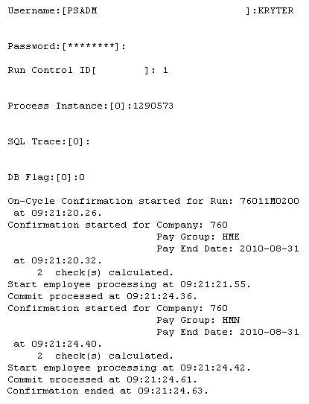

Step 7 – Check Payroll Error Messages
If your agency does not have any error messages, when trying to view errors you will get the message “No Payroll Error Messages exist for this agency…” If errors exist they must be corrected and step 10 rerun until no errors appear.

Navigation: Payroll for North America > Payroll Processing USA > Review Processing Messages > Review Payroll Error Messages

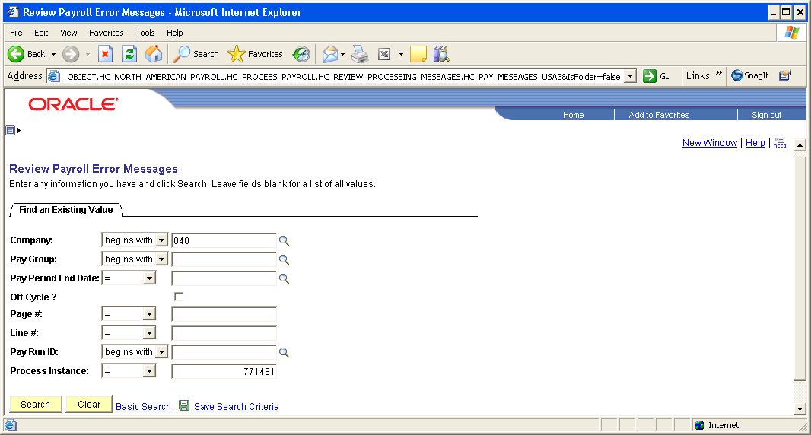

Enter the Company and Process Instance from the step above and click .
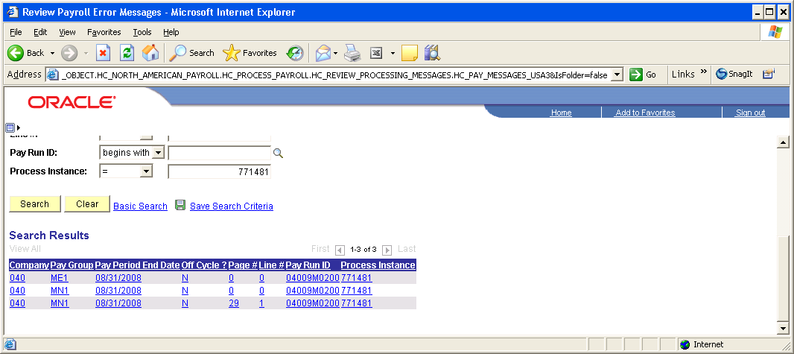

As seen above, if there are errors they will be listed. To review the error message click each line item. Make sure these errors are corrected and re-run steps 10 until no errors appear.

If you want to see an error report, which also gives hints for what has caused the error(s) you can navigate to:

Navigation: Payroll for North America > Payroll Processing USA > Review Processing Messages > Payroll Error Message Report

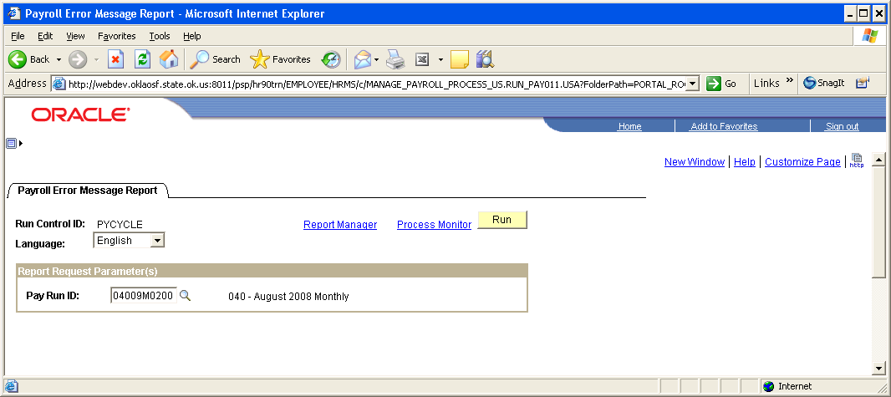

On the Payroll Error Message Report parameters page enter the correct Pay Run ID and click .
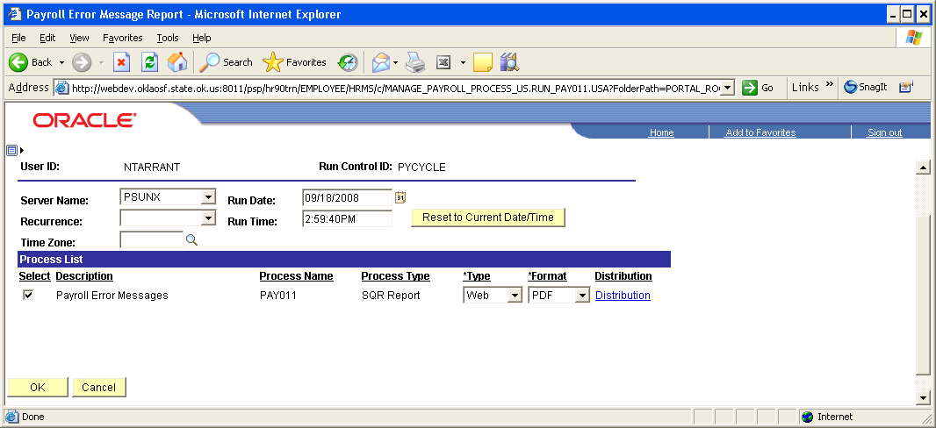

Make sure the PSUNX is selected next to Server Name.

In the ‘Process List’ group box:
Check box should be checked next to Payroll Error Messages.
Type should be set to Web
Format should be set to PDF.

Click .

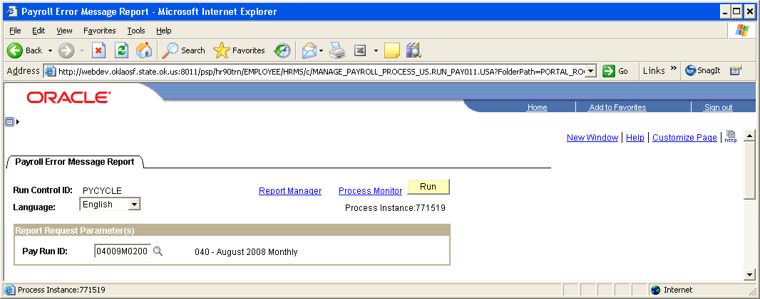

Make a note of the Process Instance and click Process Monitor link. When the report runs to a Success and is Posted click Details then View Log/Trace links. Click the .PDF file in the File List to open the report and print the report. Remember to correct all errors listed and re-run steps 16 and 17 until there are no errors displayed.

Step 8 – Check Pay Calendar for Flags
To verify that all paychecks have been confirmed, review the Pay Calendar(s) making sure a checkmark appears in the box in front of the Payroll Confirmation Started and Payroll Confirmation Run labels for every pay group that is active with this Pay Run ID.

Navigation: Payroll for North America > Payroll Processing USA > Create and Load Paysheets > Review Pay Calendars

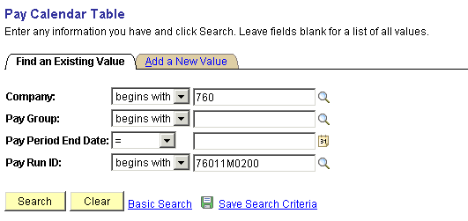

On the Pay Calendar Table search criteria page, enter the Company and Pay Run ID that is being used. Click . At the bottom of the page a list of pay calendars will appear that are associated with the Pay Run ID.

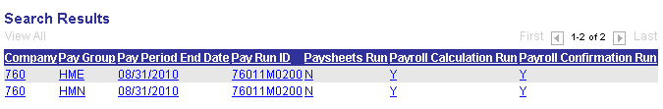

Click the first row in the list and you will be taken to the first Pay Calendar in the list.
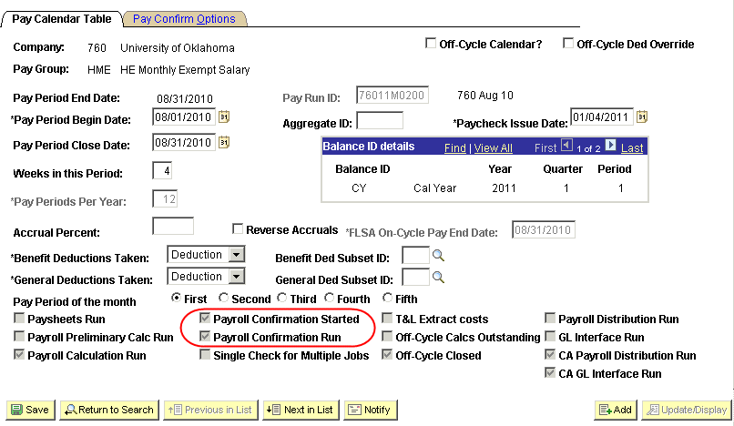

Make sure the check boxes are checked next to Payroll Confirmation Started and Payroll Confirmation Run. Click to review the next calendar in the list. Continue this process until there are no more calendars to review (the button will be grayed out).

NOTE: If any of these checkmarks are missing, stop and contact Help Desk. Do NOT Proceed Any Further.

Step 9 – Check Paycheck Data for Advice and Check Numbers
A review of the paycheck data is required making sure the words Advice or Check appears under the column labeled ‘Form Number’ along with a number in the column labeled ‘Paycheck Number’.

Navigation: Payroll for North America > Payroll Processing USA > Produce Payroll >
Review Paycheck

On the Review Paycheck search criteria page enter the Company and Pay Period End Date.

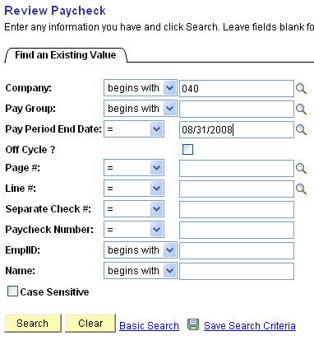

Click .
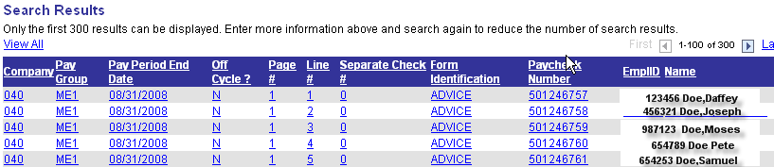

You should see the word ADVICE or CHECK under the heading Form Identification, and the actual check/advice umber under the heading Paycheck Number.

If this information is missing, contact the Help Desk then the CORE Team to help you resolve this issue.

Step 10 – Run Distribute Actuals
The Actuals Distribution process (PSPPFUND) distributes actual earnings, employer deductions, and employer taxes across the funding sources established. This process is executed after the confirm process for the current payroll.

Navigation: Payroll for North America > Payroll Distribution > Commitment Accounting > Distribute Actuals

After entering a Run Control ID you will be taken to the Actuals Distribution run control parameters page.

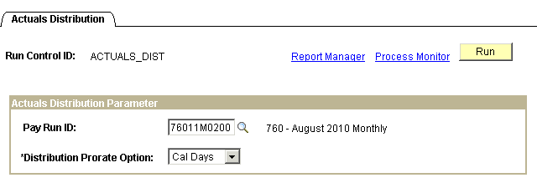

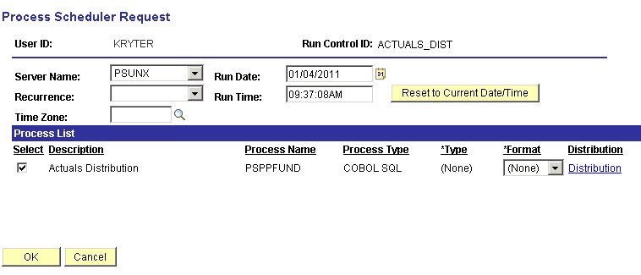
Enter the Pay Run ID of the current payroll being processed; select ‘Cal Days’ as the Distribution Prorate Option. When all data fields have been correctly filled in, click You will be taken to the ‘Process Scheduler Request’ page.

Only choose PSUNX server.

In the ‘Process List’ group:
- Check box should be checked next to Actuals Distribution
- Type should be set to (None)
- Format should be set to (None)

Click
When screen goes back to the Acuals Distribution parameters page, take note of the Process Instance number and Click Process Monitor link. Once the job has run to Success status and Distribution Status shows Posted, click Details link.

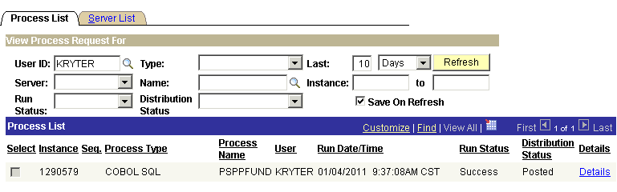

When the job has a Run Status of Success and Distribution Status shows Posted, click Details link.

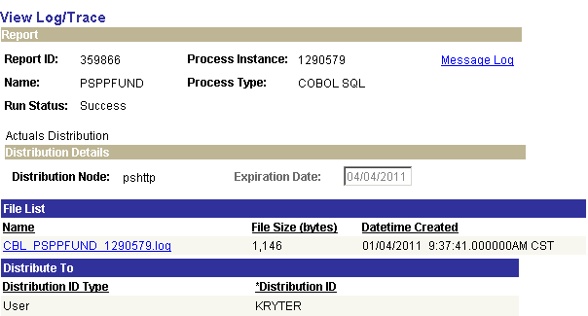

On the Process Details page click View Log/Trace link. Click CBL PSPPFUND xxxxx.log link to view and or print the log. Look for the “Check Messages!!!” statement. A clean log will look similar to the one of the next page. If you do not see any “Check Messages!!!” statement, continue with Step 11..

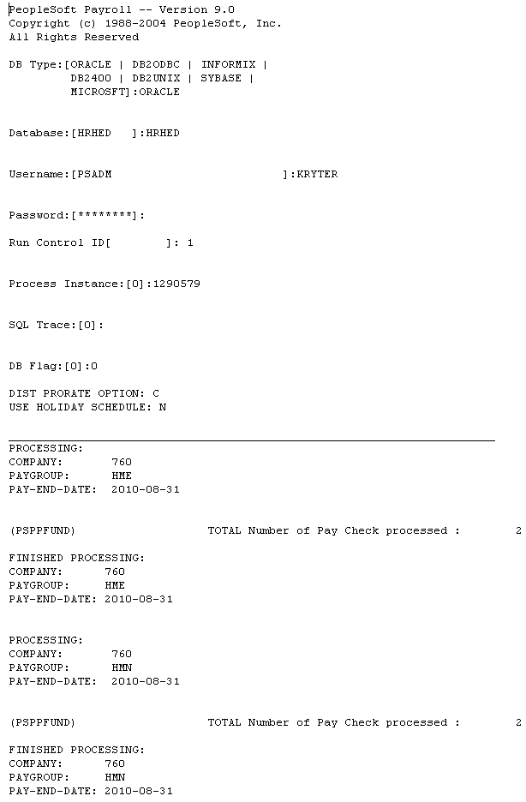

If you see Check Messages!!!, stop and go to the Error Messages to find out what needs to be corrected.
You can view error messages online.

Navigation: Payroll for North America > Payroll Processing USA > Review Processing Messages > Review Payroll Error Messages

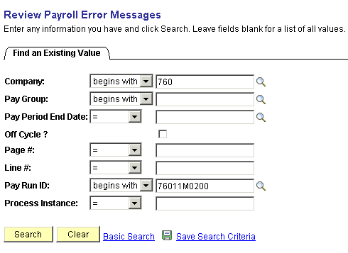

Enter your agency number and the Pay Run ID for the payroll you’re running. By entering the Pay Run ID you will only pull up error messages specific to that payroll.

You can also create and print an error messages report. This will give you the same error messages that you can see online, but in a report form. The report may be easier to read if you have a lot of errors.

Navigation: Payroll for North America > Payroll Processing USA > Review Processing Messages > Payroll Error Messages Report

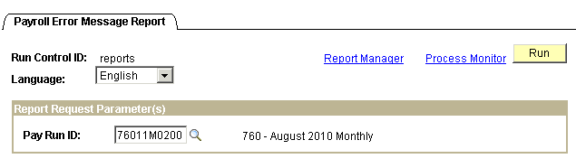

Enter the Pay Run ID, click . You will be taken to the ‘Process Scheduler Request’ page.
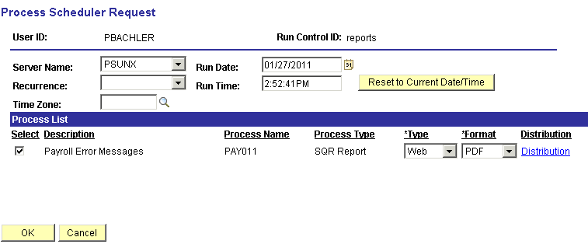

Only choose PSUNX server.

In the ‘Process List’ group:
- Check box should be checked next to Payroll Error Messages
- Type should be set to Web
- Format should be set to PDF

Click

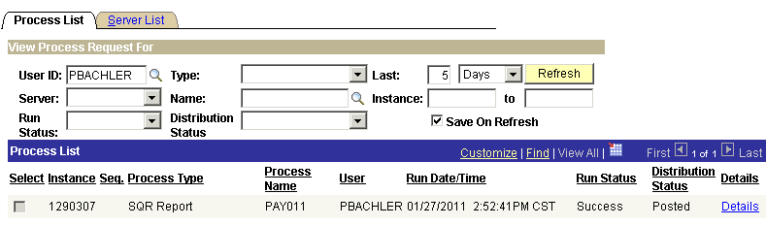

When screen goes back to the Payroll Error Messages Report parameters page, take note of the Process Instance number and Click Process Monitor link. Once the job has run to Success status and Distribution Status shows Posted, click Details link.

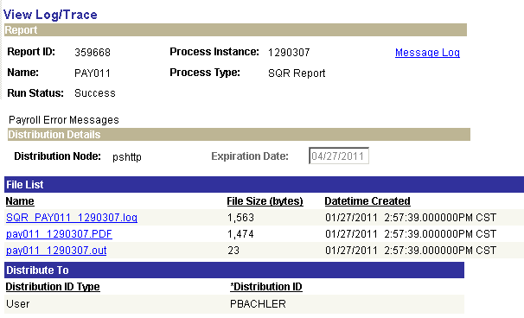

On the Process Details page click View Log/Trace link. Click the pay011 xxxxxxx.PDF link to view and or print the error report.

Step 11 – Run Funding Reports

Budget Check (0025)
This report show the total cost of the payroll and available funding for the cash/allotment. Review the reports looking for any errors and/or areas lacking sufficient funds. If sufficient funds are NOT available, review the PFT Funding Report to ensure sufficient funds have or will be transferred.

Funding Distribution (0108) - Optional
This report is also created during the execution of running the funding reports. The ‘Funding Distribution’ report shows how payroll funding is being distributed through the departments. Totals are reconciled back to the ‘Payroll Register’.

Navigation: Payroll for North America > Payroll Distribution > Prepare GL Information > Commitment Accounting > Funding Rpts (OCP400)

After entering a Run Control ID you will be taken to the Funding Reports run control parameters page. If you don’t have a Run Control ID for running this process, click the Add a New Value Tab and enter a value.

On the run control page below, enter the current payrolls Pay Run ID and your agency’s Business Unit.

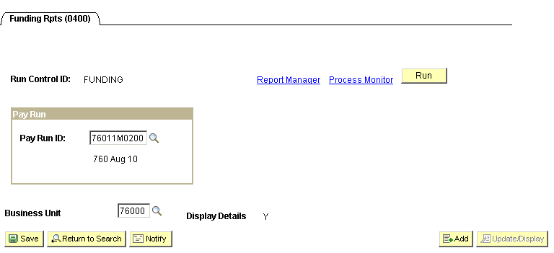

When all data fields have been correctly filled in, click You will be taken to the ‘Process Scheduler Request’ page.

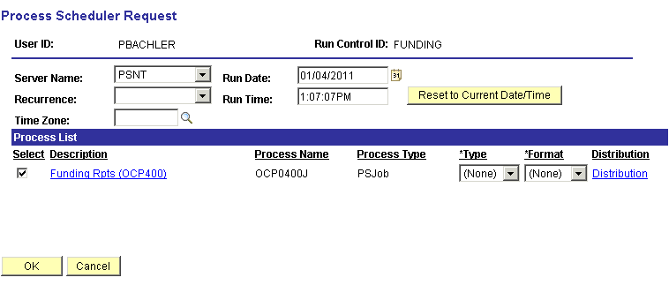

Make sure a Server Name is selected (the system will automatically change the server behind the scene if it is different from what has been selected).

NOTE: If you use the same Run Control ID for the same processes, the system will save the server selected and you will only have to select it the first time when you create the Run Control.

In the ‘Process List’ group:
- Check box should be checked next to Funding Rpts (OCP400)
- Type should be set to (None)
- Format should be set to (None)

Click .

When the page goes back to the Funding Reports parameters page, take note of the Process Instance number and click Process Monitor link.

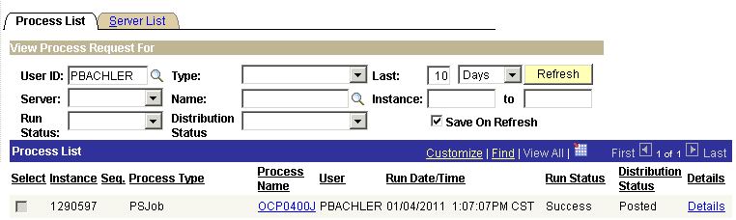

When the process has a Run Status of Success and Distribution Status shows Posted, click the OCP0400J link under Process Name.
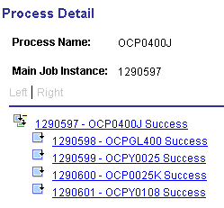

To view and reconcile the Budget Check report, click the xxxxxxx - OCPY0025 link. Click the View Log/Trace link.

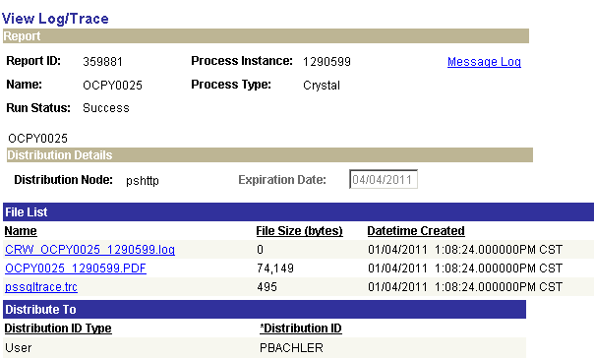

Click OCPY0025 xxxxxx.PDF link to view and/or print the log.

To view the Funding Distribution (optional) report, click the xxxxxxx - OCPY0108 link. Click the View Log/Trace link. In the ‘File List’ group box select the file with the .PDF extension.

The last page of the Budget Check report will show a Gross Payroll Total that should reconcile with payroll totals from the Payroll Register and Funding Distribution reports.

Step 12 – Run Finalize Funding Reports
Budget Check (0025), Funding Distribution (0108) and the Payroll Claim Document (0118)

After running the Funding Reports and validating that the funding is accurate and available, run the ‘Finalize Funding Reports’ step. This step sets a flag, indicating no other changes will be made to the Actuals Distributions and are ready for the next process.

Navigation: Payroll for North America > Payroll Distribution > Prepare GL Information > Commitment Accounting > Finalize Funding Rpts (OCP400)

After entering a Run Control ID you will be taken to the Finalize Funding Rpts (OCP400) run control parameters page.

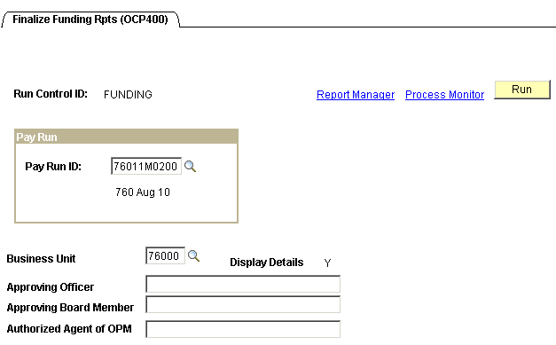

Enter the Pay Run ID and Business Unit. If your Claim Document requires the name(s) of ‘Approving Officer’, ‘Approving Board Member’, and/or ‘Authorized Agent of OPM’ printed on the report, key them in the fields provided.

Click .
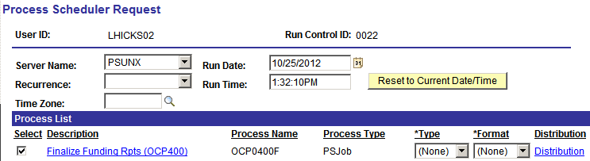

Only choose PSUNX server.

In the ‘Process List’ group:
- Check box should be checked next to Finalize Finding Rpts (OCP400)
- Type should be set to (None)
- Format should be set to (None)

Click

When screen goes back to the Finalize Funding Rpts parameters page, take note of the Process Instance number and click Process Monitor link.

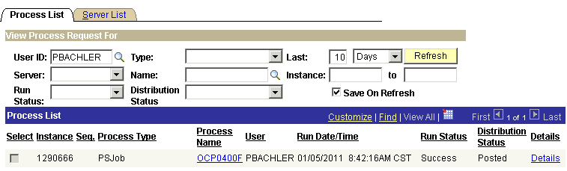

When the run status column shows Success and the Distribution Status column shows Posted. Click OCP0400F link, under the Process Name in the middle of the page. On the Process Detail page click View Log/Trace link.

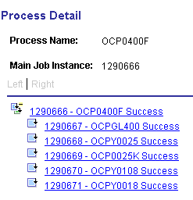

To view and print the Budget Check report, click the xxxxxxx - OCPY0025 link. Click the View Log/Trace link. In the ‘File List’ group box select the file with the .PDF extension.

To view and print the Funding Distribution report, click the xxxxxxx - OCPY0108 link. Click the View Log/Trace link. In the ‘File List’ group box select the file with the .PDF extension.

To view and print the Payroll Claim Document report, click the xxxxxxx - OCPY0018 link. Click the View Log/Trace link. In the ‘File List’ group box select the file with the .PDF extension.

NOTE: If the Final Funding Reports were created with a budget deficit, your Finance Officer must sign the ‘Notice of Deficit Statement’ and make arrangements with OMES to be allowed to continue processing.

Step 13 – Run GL Process
This process populates the HR aAccounting Line Table and sends the data to Financials from which General Ledger Journal entries are created

Navigation: Payroll for North America > Payroll Distribution > Provide GL Information > Commitment Accounting Actuals

After entering a Run Control ID you are taken to the Commitment Accounting Actuals parameters page.

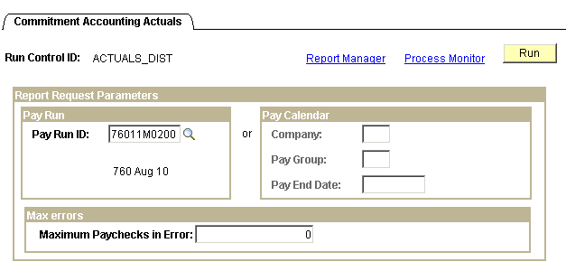

Enter the Pay Run ID, click .

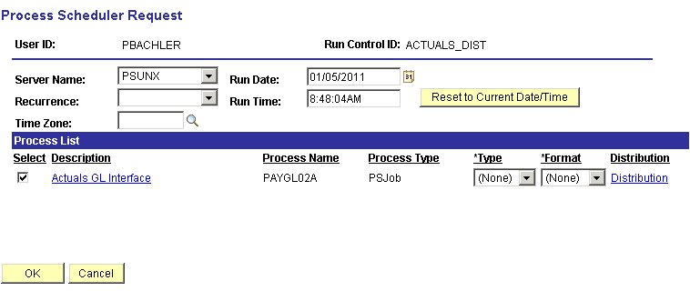

On the Process Scheduler Request page, Server Name should be set to ‘PSUNX’.

In the ‘Process List’ group:
- Check box should be checked next to Actuals GL Interface
- Type should be set to (None)
- Format should be set to (None)

Click .
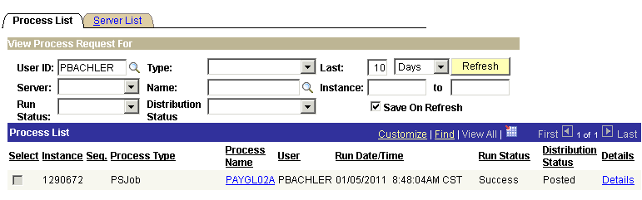

When screen goes back to the Commitment Accounting Actuals parameters page, take note of the Process Instance number and click Process Monitor link. When the process runs to Success and Distribution Status shows Posted, click the PAYGL02A link under Process Name.

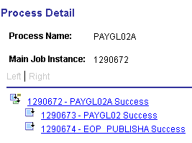

From the Process Detail page click the xxxxxxx - PAYGL02 link. On the View Log/Trace page click View Log/Trace link.

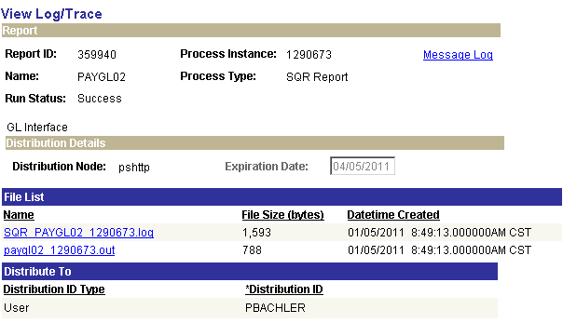

In the File List, click the file with the .out extension. This opens what is known as the Trace Log.
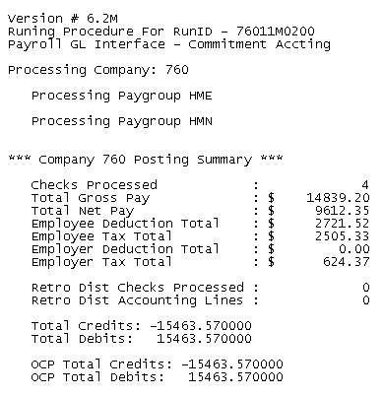

Make Sure the Total Debits and Total Credits equal each other, and reconcile with the Budget Checking and Claim Document reports. Print this file, write your name and phone number on it. Submit this Trace Log to OMES along with the Budget Checking and signed Claim Document reports.

Step 14 – Check Pay Calendar Flags
Once again the pay Calendar(s) need to be reviewed making sure a checkmark appears in the box in front of the CA GL Interface Run for every pay group that is active with this Pay Run ID.

Navigation: Payroll for North America > Payroll Processing USA > Create and Load Paysheets > Review Pay Calendars

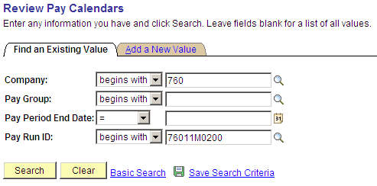

On the Pay Calendar Table search criteria page, enter the Company and Pay Run ID that is being used. Click .

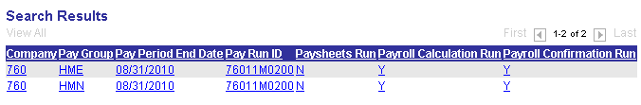

If more than one Pay Calendar is associated with the Pay Run ID a list will appear at the bottom of your screen. Click the first file in the list. Otherwise, you will be taken directly to the Pay Calendar Table page.
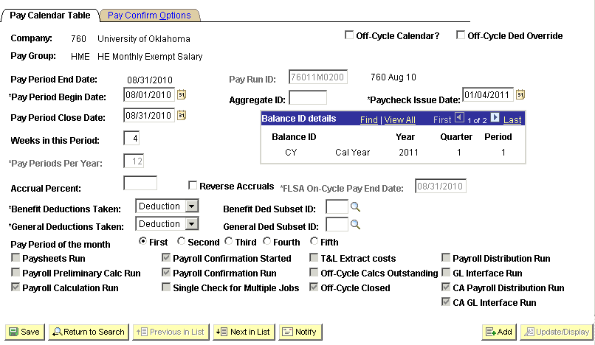

There should be a checkmark in the box in front of the label CA GL Interface Run. Click button to view the next Pay Calendar. If this button is grayed out there are no more calendars to view.

NOTE: If the checkmark is missing, stop and contact Help Desk. Do NOT Proceed Any Further.

Step 15 – Load Payroll Fund Transfer
This process will transfer funds to the 905 account to ensure sufficient funds.

Navigation: OK Custom Reports/Processes > Higher Ed Processes > Higher Ed Payroll Data Upload > Update Mode

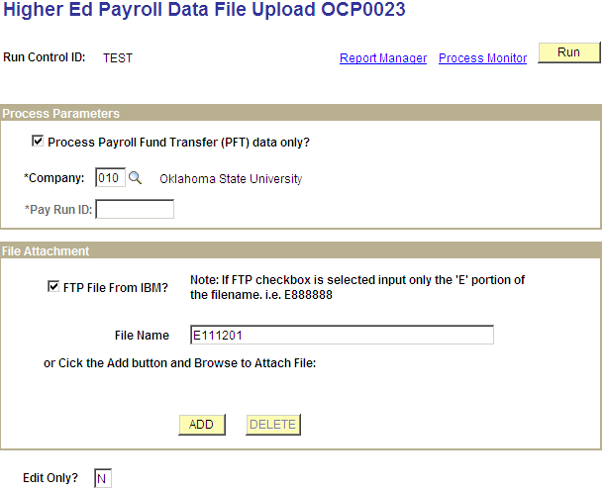

Check Process Payroll Fund Transfer (PFT) data only?

Enter agency number in the Company field.

Check FTP File from IBM. Enter file name, (only the ‘E’ portion), or click and Browse to attach files.

Click .

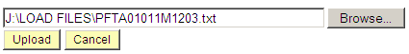

Click and select the file to be uploaded.

Click .

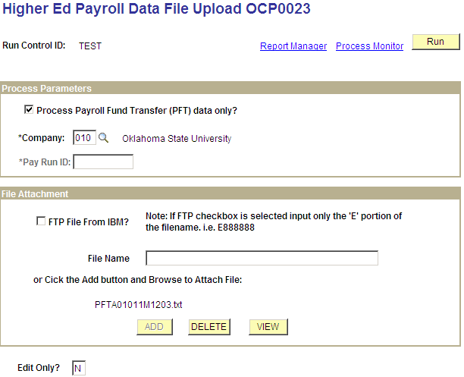

Enter ‘N’ for no edit or ‘Y’ for edit in the Edit only? Box.

Click . You will be taken to the ‘Process Scheduler Request’ page.

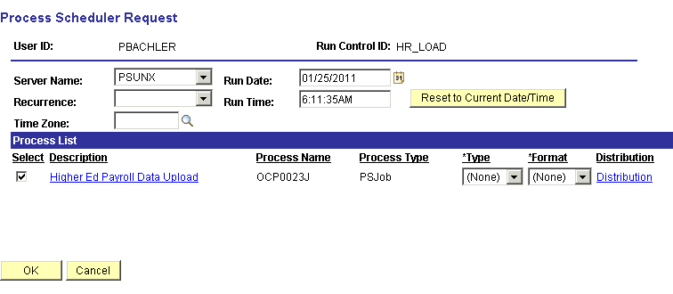

Only choose PSUNX server.

In the ‘Process List’ group:
- Check box should be checked next to Higher Ed Payroll Data Upload
- Type should be set to (None)
- Format should be set to (None)

Click .

You will be taken back to the Higher Ed Payroll Data Upload parameters page. In the top right hand side of the page a Process Instance number will now be shown. This process instance number is what you will use to monitor the completion of this job on the Process Monitor.

When screen goes back to the Higher Ed Payroll Data Upload parameters page, take note of the Process Instance number and click Process Monitor link.

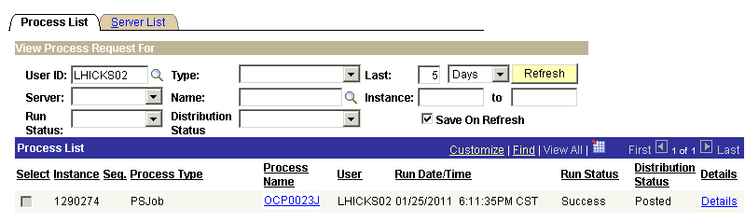

When the run status column shows Success and the Distribution Status column shows Posted. Click the OCP0023J link under Process Name.
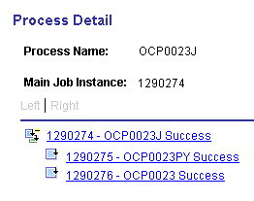

To view the error report, click the xxxxxx – OCP0023 link. Click View the Log/Trace link.

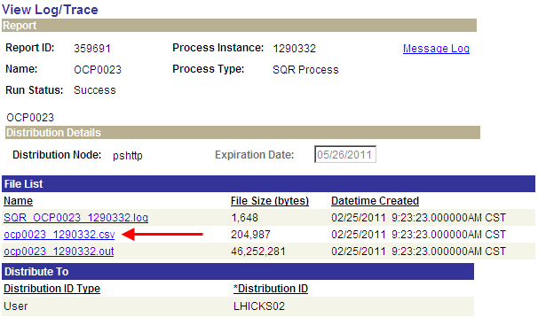

In the ‘File List’ group box select the file with the .csv extension (ocp0023 xxxxxxx.csv).

Review the report to ensure no errors are listed. If errors are found, correct as necessary and repeat the above steps.
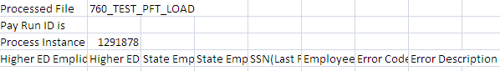

Step 16 – Validate PFT Funding
This process checks General Ledger for available allotment and cash to ensure there are sufficient funds available to process the PFT.

Navigation: OK Custom Reports/Processes > Higher Ed Processes > Validate PFT Funding (0522)

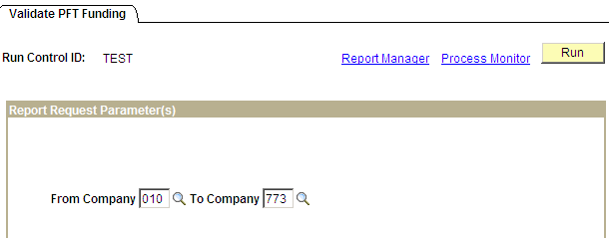

Enter From Company and To Company fields.

Click . You will be taken to the ‘Process Scheduler Request’ page.

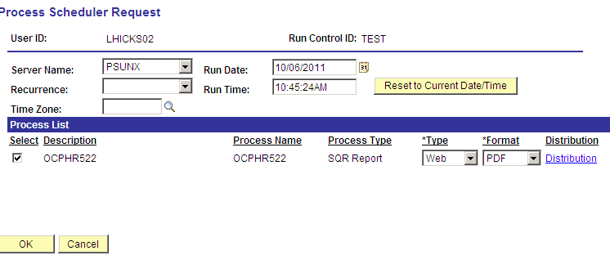

Only choose PSUNX server.

In the ‘Process List’ group:
- Check box should be checked next to OCPHR522
- Type should be set to Web
- Format should be set to PDF

Click

You will be taken back to the Validate PFT Funding parameters page. In the top right hand side of the page a Process Instance number will now be shown. This process instance number is what you will use to monitor the completion of this job on the Process Monitor, take note of the Process Instance number and click Process Monitor link.

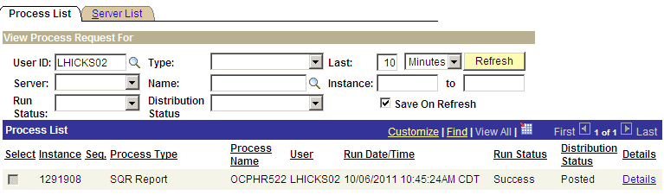

When the run status column shows Success and the Distribution Status column shows Posted. Click Details link. On the Process Detail page click View Log/Trace link.

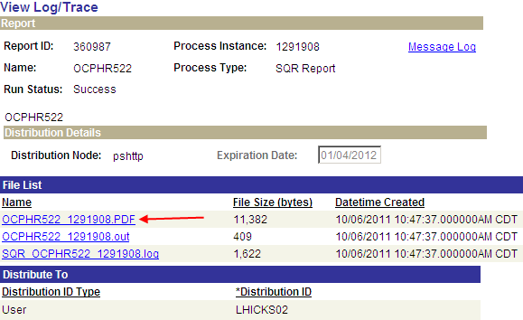
In the ‘File List’ group box select the file with the .PDF extension (OCPHR522 xxxxxxx.PDF).

Review the report and verify there are no deficits, redo transfer the appropriate amounts as necessary.

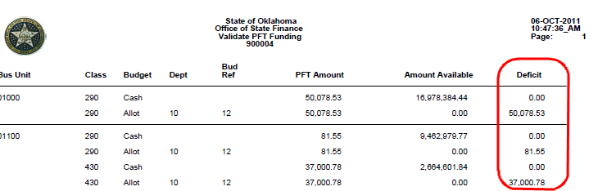

Step 17 – Fax Documents to OMES
The Office State Finance requires that each Higher Education agency payroll processor send three (3) documents.

The documents are:

- Validate PFT Funding Report from Step 16 (required if Budget Deficit)
or
Final Budget Check Report from Step 12 (only if no Budget Deficit)
- Final Claim Document from Step 12
- CA GL Interface Trace File from Step 13

The above documents must be faxed to OMES by 3:00 PM in order for your payroll to be released to Office of State Treasurer on that day. Otherwise, the payroll will be held until the paperwork is faxed to OMES.

Fax # 405 521-3383 to Elsa at Oklahoma Management and Enterprise Services

Once the Oklahoma Management and Enterprise Services receives your documents the reports will be reviewed and the payroll will be released to be picked up by a process that sends the checks and direct deposits to the State Treasurer’s Office for processing.

Off-Cycle Payrolls

Off-Cycle Calendars
Now that you have seen how to use a pay calendar for your main and supplemental payroll processing, this section will help you understand another dimension to the pay calendar, which is the Off-Cycle concept. The Off-Cycle Calendar checkbox is located in the upper right hand area of the pay calendar page.

NOTE: Check Reversals are processed by DCAR. Do not submit reversal on the Interface Files.

The State of Oklahoma uses off-cycle pay calendars to process adjustments due to checks in error, processing of employee shift differential, overtime and termination payouts (that were not turned in on time to be included in the on-cycle), etc. To request an off-cycle calendar be created the agency is to file a Help Desk case to be sent to the CORE Team specifying the Pay Group(s) and Paycheck Issue Date. CORE will create the calendar(s) attaching an off-cycle Pay Run ID to each calendar. The agency will be notified once the calendar(s) have been created.

NOTE: The standards pertaining to the number of off-cycles allowed per pay period are as follows:

- Monthly Anticipatory Payrolls – One (1) Off-Cycle for adjustments, retro pay, overtime, etc.
- Bi-Weekly Payrolls – One (1) Off-Cycle for adjustments, retro-pay, missed overtime, etc.

Agencies exceeding the allowable limits of off-cycles, as noted above, must submit a justification for requesting the creation of the additional pay cycle calendar. This request should be on the agency letterhead and include the agency name and number, the pay group(s) and pay period off-cycle is covering, and the reason for exceeding the maximum number of off-cycles allowed. The letter is to be signed by the agency director or a designee listed on the Signature Card, OMES Form 13. The letter is then FAXED to Steve Wilson (405) 521-3383. CORE is only allowed to create additional off-cycle calendars, when the limit is being exceeded, after receiving the approval from Steve Wilson with the Office State Finance.

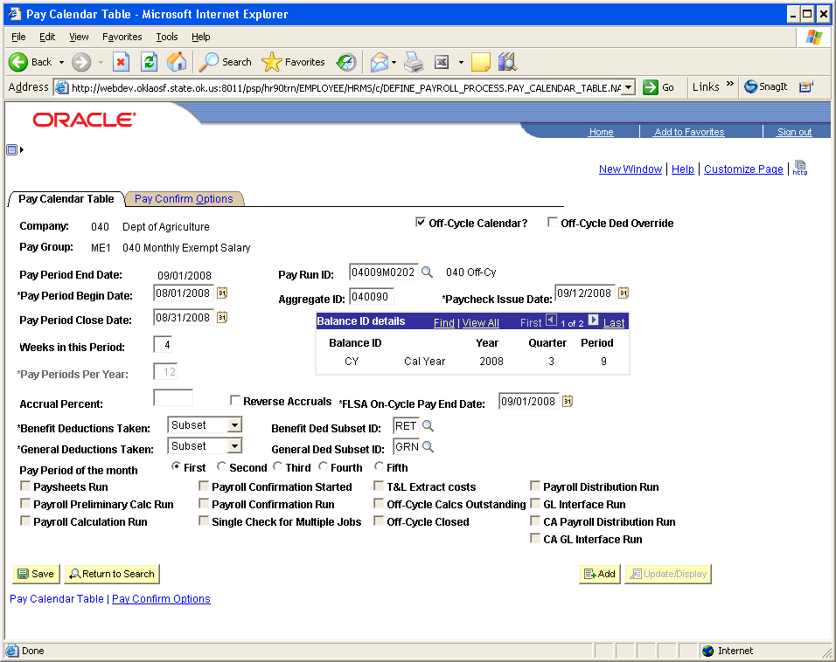

The check issue date of an Off-Cycle Calendar is always later than the pay period end date (similar to supplemental pay cycles), however, all data included in this off-cycle will be in the same pay period begin and end dates as the associated on-cycle payroll based on the Pay Period Begin Date and Pay Period Close Date. The off-cycle calendars will show the pay period end date being at least one day later than the on-cycle.

NOTE: The system uses the Paycheck Issue Date on all calendars to update Calendar Year balances. Fiscal Year balances are updated using the Pay Period End Date.

Off-Cycle Payroll Processing Steps (Checklist)

Step 1 – Check for the Existence of Off-Cycle Pay Calendars
Navigation: Payroll for North America > Payroll Processing USA > Create and Load Paysheets > Review Pay Calendars

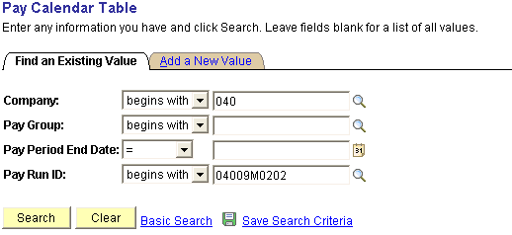

Enter the Company and Pay Run ID to check that an off-cycle calendar exists for each of the pay groups you are processing. Click .

Review the Pay Calendar(s) making sure they are setup with the correct Pay Group(s) and dates requested.
Step 2 – Load HR Data

The file will automatically load in Update mode which will perform all edits and return a report that will list any errors/inconsistencies within the load file.

Navigation: OK Custom Reports/Processes > Higher Ed Processes > Higher Ed HR File Upload

Enter Agency Number in the Company field.

Check FTP File from IBM.

Enter file name. (Only the ’E’ portion).

Or click the and Browse to attach files, click .

Click and select the file to be uploaded.

Click .

Enter ‘N’ for no edit or ‘Y’ for edit in the Edit only? Box

Click . You will be taken to the ‘Process Scheduler Request’ page.

Choose only PSUNX for the server.

In the ‘Process List’ group:
- Check box should be checked next to Higher Ed Interface File Upld
- Type should be set to (None)
- Format should be set to (None)

Click . You will be taken back to the Higher Ed HR Interface File Upload parameters page. In the top right hand side of the page a Process Instance number will now be shown. This process instance number is what you will use to monitor the completion of this job on the Process Monitor, take note of the Process Instance number and click the Process Monitor link.

When the run status column shows Success and the Distribution Status column shows Posted. Click the OCP0022J link under Process Name.

NOTE: If the Run Status ever displays Error or No Success, review the error or no success and correct as needed. If assistance is required, write down your process instance number and contact the Help Desk. DO NOT continue working until the error has been cleared and you have a successful completion of this process.

To view the error report, click the xxxxxx – OCP0022 link. Click View the Log/Trace link.

In the ‘File List’ group box select the file with the .csv extension.

Review the report to ensure no errors are listed. If errors are found, correct as necessary and repeat the above steps.

Step 3 – Load Payroll Data

The payroll file will perform all edits and return a report that will list any errors/inconsistencies within the load file. Payroll is an all or nothing load, all errors must be corrected.

Navigation: OK Custom Reports/Processes > Higher Ed Processes > Higher Ed Payroll Data Upload

Enter Agency Number in the Company field.

Enter the Pay Run ID.

Check FTP File from IBM.

Enter file name. (Only the ‘E’ number)

Or click the and Browse to attach files, Click .

Click and select the file to be uploaded.

Click .

Enter ‘N’ for no edit or ‘Y’ for edit in the Edit only? box

Click . You will be taken to the ‘Process Scheduler Request’ page.

Only choose PSUNX server.

In the ‘Process List’ group:
- Check box should be checked next to Higher Ed Payroll Data Upload
- Type should be set to (None)
- Format should be set to (None)

Click You will be taken back to the Higher Ed Payroll Data File Upload parameters page. In the top right hand side of the page a Process Instance number will now be shown. This process instance number is what you will use to monitor the completion of this job on the Process Monitor, take note of the Process Instance number and click Process Monitor link.

When the run status column shows Success and the Distribution Status column shows Posted. Click the OCP0023J link under Process Name.

To view the error report, click the xxxxxx – OCP0023 link. Click View the Log/Trace link.

In the ‘File List’ group box select the file with the .csv extension

Step 4 – Additional Reports for Verification
Additional reports used for further verification of your pay cycles are as follows. Both of these reports are run and viewed/printed using the same steps.

The Payroll register report lists all employee payroll data pertaining to this pay cycle (i.e. gross earnings, deductions, taxes, and net pay) and can be used to reconcile employee Gross to Net calculations. The report itemizes, by employee, check detail information listing employee earnings, and employee/employer deductions and taxes. The last page is a summary of totals covering the entire pay cycle.

There are three (3) versions of this customized report. The changes were requested by the State of Oklahoma.

- Payroll Register Name (0233) - Sorted in last name order.
- Payroll Register Mail Drop (0312) – Sorted by the Mail Drop Field (Warrant Sequence Number on Payroll date)
- Payroll Register Div/Name (0312C) – Sorted by Division and then Name.

Navigation: Payroll for North America > Payroll Processing USA > Pay Period Reports >Payroll Register – Name (0233)

After entering the Run Control ID you are taken to the Payroll Register-Name (0233) parameters page.

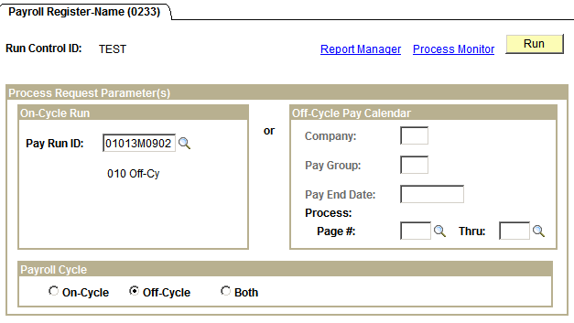

In the On-Cycle Run group box, left side of page, enter the Pay Run ID associated with the pay cycle you are running. In the Payroll Cycle group box, bottom of page, click the radio button next to On-Cycle. Click .

On the Process Scheduler Request page make sure Server Name is set to ‘PSUNX’.

In the ‘Process List’ group box:
- Check box should be checked next to Payroll Register-Name.
- Type should be set to Web
- Format should be set to PDF.

Click .

When screen goes back to the Payroll Register parameters page, take note of the Process Instance number and click Process Monitor link. When the process runs to a Success and Distribution Status shows Posted, click Details link.

Clicking Details link takes you to the Process Detail page, shown below and click View Log/Trace link.

One the View Log/Trace page, in the File List group box, click the file with the .PDF extension.

When you click pay002a xxxxxx.PDF in the File List group box you are actually opening up the report to view and/or print.

The heading of the Payroll Register lists the Report ID page #, Company, Run Date (date report was run on), Pay Period End Date, and Run Time. Data listed on this report is in alphabetical order by last name. For each employee listed you will see the hours/earnings, and other earnings that the employee is being paid which comprises the Gross Pay. It also lists in detail the Taxes and Deductions (employee (EE) and employer (ER)), and Net Pay. The ‘U’ after the Net Pay amount indicates this report is listing payroll data for the employee that is currently ‘Unconfirmed’. The data in the boxed in area under the employee is a summary of the total employee’s earnings, taxes and deductions (EE and ER), and Net Pay.

If you go to the last page of the Payroll Register you will see a summary page for the entire company.

This page displays summarized grand totals of all earnings, taxes and deductions (EE and ER) and net pay. These totals will later be used to reconcile with the Funding Distribution and Payroll Budget Checking reports.

As you can see, this report can get rather large but you can print the entire report, a page, or certain pages of this report.

Navigation: Payroll for North America > Payroll Processing USA > Pay Period Reports >
Payroll Summary

This report summarizes total number of employees’ paid, gross payroll, taxes, deductions and net pay for this pay cycle. It also summarizes those totals by major categories such as OVT.

Step 5 – Run Payroll Unsheet – (IF NECESSARY)
This process deletes all the paysheets that have been created for the specified Pay Run ID – basically you are starting over. This step is only necessary if the load file that is loaded into the paysheets had incorrect or missing data and has to be reloaded.

Navigation: Payroll for North America > Payroll Processing USA > Update Paysheets > Pay Unsheet

After entering a Run Control ID you are taken to the Pay Unsheet parameters page.

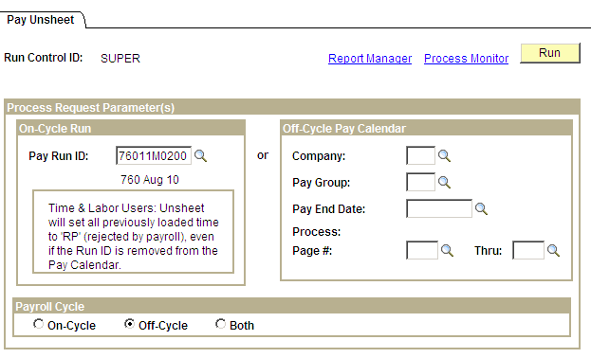

Enter the Pay Run ID you have been using in the Off-Cycle Run group box. Click the radio button next to On-Cycle in the Payroll Cycle group box. Click .

Make sure the Server Name is set to ‘PSUNX’.

In the ‘Process List’ group box:
- Check box should be checked next to Payroll Unsheet
- Type should be set to Web
- Format should be set to PDF.

Click .

When screen goes back to the Pay Unsheet parameter page, take note of the Process Instance number and click Process Monitor link. When the process runs to Success and Distribution Status shows Posted, you can start over.

Step 6 – Run Pre-Distribution Audit Report
This Pre-Distribution Audit Report audits payroll and configuration data. The report identifies any errors that could be encountered when you run the Actuals Distribution (PSPPFUND) or the Actuals GL Interface (PAYGL02). This report is executed after Paysheet Create and before Actuals Distribution.

Navigation: Payroll for North America > Payroll Distribution > Commitment Accounting USA > Predistribution Audit Report

After entering a Run Control ID you will be taken to the Predistribution Audit Report run control parameters page.

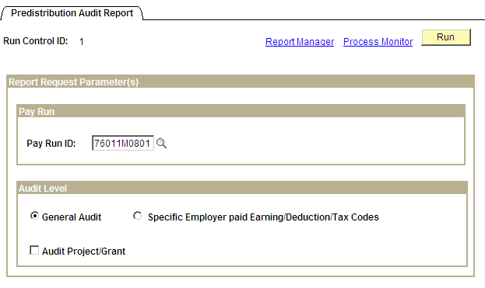

Enter the Pay Run ID of the current payroll being processed and check the General Audit radio button. When all data fields have been correctly filled in, click . You will be taken to the ‘Process Scheduler Request’ page.

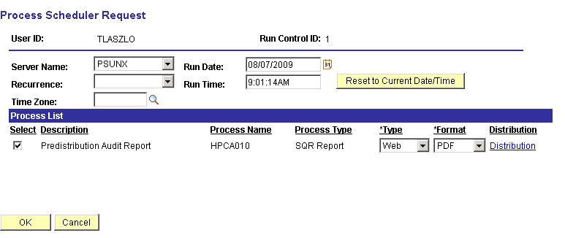
Make sure the Server Name is set to PSUNX.

In the ‘Process List’ group:
- Check box should be checked next to Predistribution Audit Report
- Type should be set to Web
- Format should be set to PDF

Click You will be taken back to the Predistribution Audit Report parameters page. In the top right hand side of the page a Process Instance number will now be shown. This process instance number is what you will use to monitor the completion of this job on the Process Monitor.

When screen goes back to the Predistribution Audit Report parameter page, take note of the Process Instance number and click the Process Monitor link.

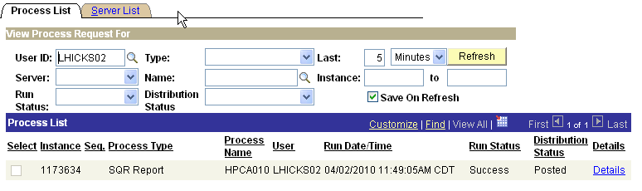

When the run status column shows Success and the Distribution Status column shows Posted. Click Details link. On the Process Detail page click View Log/Trace link.

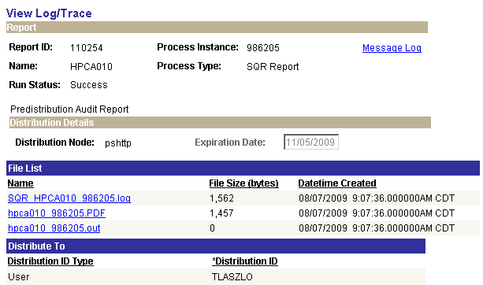

If there are entries on the Audit report for this pay cycle, there will be a file in the ‘File List’ group box with a .PDF extension. Click the .PDF file to open and print your Audit report. This report will list all employees and the issues identified that need attention. The following is a list of possible audit findings and resolutions:

Step 7 – Run Pay Confirmation Process
The pay confirmation process will edit the database for outstanding unconfirmed paychecks being processed associated with a prior calendar. The confirmation process also assigns check/advice numbers, updates all employee balance tables, and updates flags on all associated rows of data on the PAY_.... tables that store employee detailed paycheck data.

Navigation: Payroll for North America > Payroll Processing USA > Produce Payroll > CA Confirm Pay (0432)

After entering a Run Control ID you are taken to the Pay Confirmation parameters page.

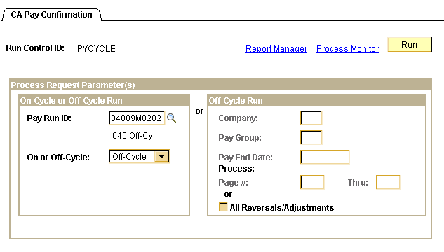

In the On-Cycle or Off-Cycle Run group box, enter the correct Pay Run ID and select Off-Cycle and click .

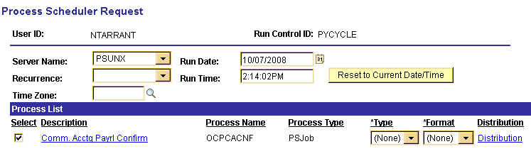
On the Process Scheduler Request page make sure Server Name is set to ‘PSUNX’.
In the ‘Process List’ group box:
- Check box should be checked next to Comm.Acctg Payrl Confirm
- Type should be set to (None)
- Format should be set to (None).

Click . You will be taken back to the CA Pay Confirmation parameters page. In the top right hand side of the page a Process Instance number will now be shown. This process instance number is what you will use to monitor the completion of this job on the Process Monitor.

When screen goes back to the Validate PFT Funding parameters page, take note of the Process Instance number and Click the Process Monitor link.

When the Run Status column shows Success and Distribution Status column shows Posted, click the OCPCACNF link on the correct process instance row.

Clicking the xxxxxx - OCPCACNF link takes you to the Process Detail page where you click the View Log/Trace link.
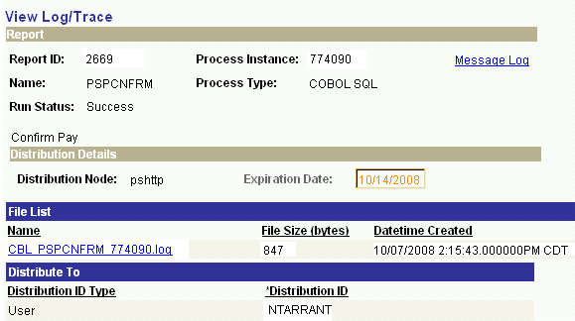

On the View Log/Trace page open the log to check for any ‘Check Messages!!!!’ statements.

NOTE: If you find any, stop and call the Help Desk immediately, 405 521-2444 or 866 521-2444.

A log showing all confirmations were successful would look similar to the one on the next page.

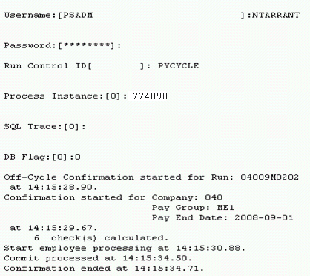

Step 8 – Check Payroll Error Messages
If your agency does not have any error messages, when trying to view errors you will get the message “No Payroll Error Messages exist for this agency…” If errors exist they must be corrected and step 10 rerun until no errors appear.

Navigation: Payroll for North America > Payroll Processing USA > Review Processing Messages > Review Payroll Error Messages

Enter the Company and Process Instance from the step above and click .

As seen above, if there are errors they will be listed. To review the error message click each line item. Make sure these errors are corrected and re-run steps 10 until no errors appear.

If you want to see an error report, which also gives hints for what has caused the error(s) you can navigate to:

Navigation: Payroll for North America > Payroll Processing USA > Review Processing Messages > Payroll Error Message Report

On the Payroll Error Message Report parameters page enter the correct Pay Run ID and click .

Make sure the PSUNX is selected next to Server Name.

In the ‘Process List’ group box:
Check box should be checked next to Payroll Error Messages.
Type should be set to Web
Format should be set to PDF.

Click .

Make a note of the Process Instance and click Process Monitor link. When the report runs to a Success and is Posted click Details then View Log/Trace links. Click the .PDF file in the File List to open the report and print the report. Remember to correct all errors listed and re-run steps 16 and 17 until there are no errors displayed.

Step 9 – Check Pay Calendar for Flags
To verify that all paychecks have been confirmed, review the Pay Calendar(s) making sure a checkmark appears in the box in front of the Payroll Confirmation Started and Payroll Confirmation Run labels for every pay group that is active with this Pay Run ID.

Navigation: Payroll for North America > Payroll Processing USA > Create and Load Paysheets > Review Pay Calendars

On the Pay Calendar Table search criteria page, enter the Company and Pay Run ID that is being used. Click . At the bottom of the page a list of pay calendars will appear that are associated with the Pay Run ID.

Click the first row in the list and you will be taken to the first Pay Calendar in the list.

Make sure the check boxes are checked next to Payroll Confirmation Started and Payroll Confirmation Run.

NOTE: If any of these checkmarks are missing, stop and contact Help Desk immediately, (Help Desk 405 521-2444 or 866 521-2444. Do NOT Proceed Any Further.

Step 10 – Check Paycheck Data for Advice and Check Numbers
A review of the paycheck data is required making sure the words Advice or Check appears under the column labeled ‘Form Number’ along with a number in the column labeled ‘Paycheck Number’.

Navigation: Payroll for North America > Payroll Processing USA > Produce Payroll >
Review Paycheck

On the Review Paycheck search criteria page enter the Company and Pay Period End Date.

Click .

You should see the word ADVICE or CHECK under the heading Form Identification, and the actual check/advice umber under the heading Paycheck Number.

If this information is missing, contact the Help Desk then the CORE Team to help you resolve this issue.

Step 11 – Run Distribute Actuals
The Actuals Distribution process (PSPPFUND) distributes actual earnings, employer deductions, and employer taxes across the funding sources established. This process is executed after the confirm process for the current payroll.

Navigation: Payroll for North America > Payroll Distribution > Commitment Accounting USA > Distribute Actuals

After entering a Run Control ID you will be taken to the Actuals Distribution run control parameters page.

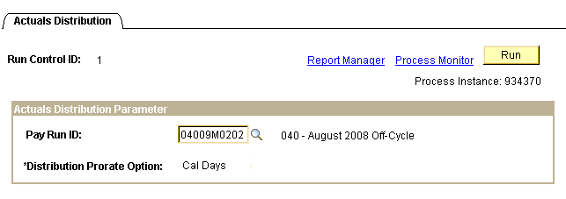

Note the Process Instance number in the upper right hand corner. Click Process Monitor link to view the completion of your job. Once the job has run to Success and Distribution Status shows Posted, click the Details link. On the Process Details page click View Log/Trace link to view and/or print the log. Review the log and look for errors.

Step 12 – Run Funding Reports

Budget Check (0025) and Budget Check for Projects (0025K)
These reports show the total cost of the payroll and available funding for the cash/allotment and project budgets. Review the reports looking for any errors and/or areas lacking sufficient funds. If sufficient funds are NOT available, make the necessary changes to the Actuals Distribution at the employee level. After the changes are made re-run the reports until the funding is no longer in a deficit.

Funding Distribution (0108) - Optional
This report is also created during the execution of running the funding reports. The ‘Funding Distribution’ report shows how payroll funding is being distributed through the departments.

Navigation: Payroll for North America > Payroll Distribution > Prepare GL Information > Commitment Accounting > Funding Rpts (OCP400)

After entering a Run Control ID you will be taken to the Funding Rpts (0400) Run Control Parameters page. If you don’t have a Run Control ID for running this process click the Add a New Value Tab and enter a value.

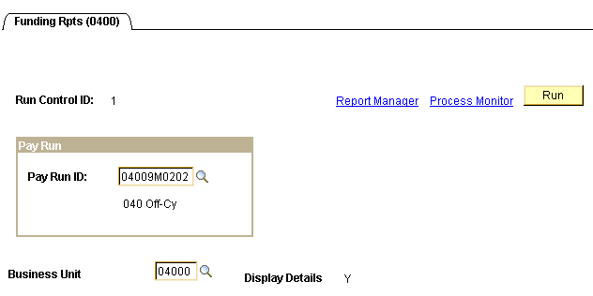

Enter the current payroll’s Pay Run ID and the Business Unit (Display Details is grayed out and is always set to Y).

When all data fields have been correctly filled in, click . You will be taken to the ‘Process Scheduler Request’ page.
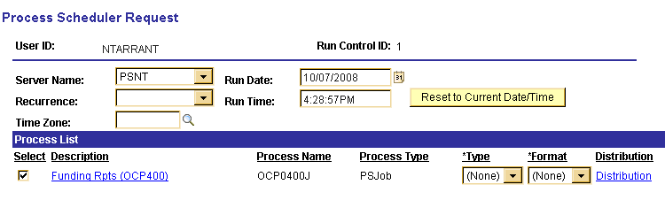

Make sure the Server Name is set to PSNT.

In the ‘Process List’ group:
- Check box should be checked next to Funding Rpts (OCP400)
- Type should be set to (None)
- Format should be set to (None)

Click . You will be taken back to the Funding Reports parameters page. In the top right hand side of the page a Process Instance number will now be shown. This process instance number is what you will use to monitor the completion of this job on the Process Monitor.

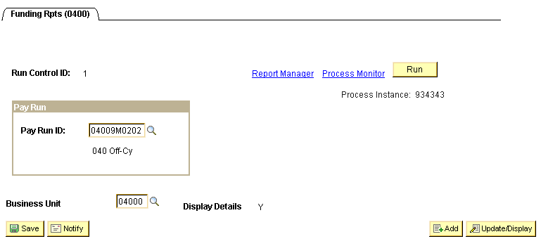

Click Process Monitor.link.
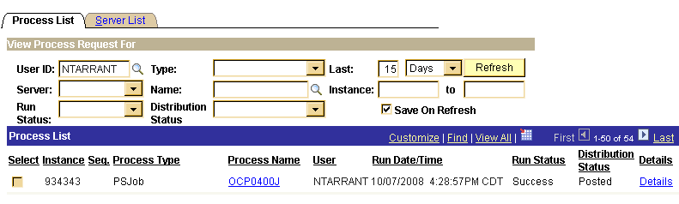

When the run status column shows Success and the Distribution Status column shows Posted. Click OCP0400J link, under the Process Name column.

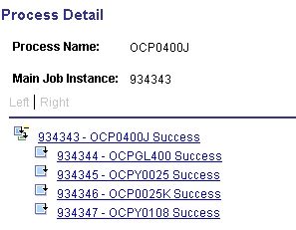

To view and reconcile the Budget Check report, click the xxxxxx - OCPY0025 link. Click the View Log/Trace link. In the ‘File List’ group box select the file with the .PDF extension.

To view and reconcile the Project Budget Check report, click the xxxxxx - OCP0025K link. Click the View Log/Trace link. In the ‘File List’ group box select the file with the .PDF extension.

To view and reconcile the Funding Distribution report , click the xxxxxx - OCPY0108 link. Click the View Log/Trace link. In the ‘File List’ group box select the file with the .PDF extension.

The State of Oklahoma will NOT allow payrolls to process beyond this point until ALL deficits are cleared up.

The last page of the Budget Check report(s) will show a Gross Payroll Total that should reconcile with payroll totals from the Payroll Register and Funding Distribution reports.

Step 13 – Run Finalize Funding Reports

Budget Check (0025), Budget Check for Projects (0025K), Funding Distribution (0108) and the Payroll Claim Document (0118)

After running the Funding Reports and validating that the funding is accurate and available, run the ‘Finalize Funding Reports’ step. This step sets a flag, indicating no other changes will be made to the Actuals Distributions and are ready for the next step.

Navigation: Payroll for North America > Payroll Distribution > Prepare GL Information > Commitment Accounting > Finalize Funding Rpts (OCP400)

After entering a Run Control ID you will be taken to the Finalize Funding Rpts (OCP400) run control parameters page.

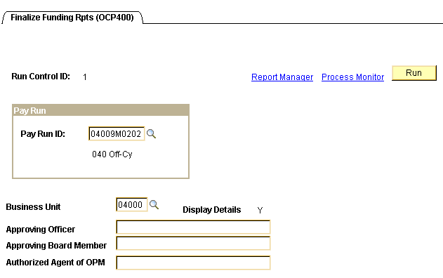

Enter the Pay Run ID and Business Unit. If your Claim Document requires the name(s) of ‘Approving Officer’, ‘Approving Board Member’, and/or ‘Authorized Agent of OPM’ printed on the report, key them in the fields provided.

Click .
In the ‘Process List’ group box:
- Check box should be checked next to Finalize Funding
- *Type should be set to (None)
- *Format should be set to (None)

Click .

When screen goes back to the Finalize Funding Rpts parameters page, take note of the Process Instance number and click Process Monitor link. When the run status column shows Success and the Distribution Status column shows Posted, click OCP0400F link under the Process Name in the middle of the page. On the Process Detail page click View Log/Trace link.

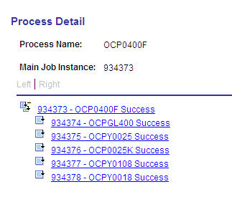

To view and print the Budget Check report, click the xxxxxx – OCPY0025 link. Click View Log/Trace link. In the ‘File List’ group box select the file with the .PDF extension.

To view and print the Project Budget Check report, click the xxxxxx – OCP0025K link. Click View Log/Trace link. In the ‘File List’ group box select the file with the .PDF extension.

To view and print the Funding Distribution report, click the xxxxxx – OCPY0108 link. Click View Log/Trace link. In the ‘File List’ group box select the file with the .PDF extension.

To view and print the Payroll Claim Document report, click the xxxxxx – OCPY0018 link. Click View Log/Trace link. In the ‘File List’ group box select the file with the .PDF F extension.

NOTE: If the Final Funding Reports were created with a budget deficit, your Finance Officer must sign the ‘Notice of Deficit Statement’ and make arrangements with OMES to be allowed to continue processing.

Step 14 – Run GL Process
This process populates the HR Accounting Line Table and sends the data to Financials from which General Ledger journal entries are created.

Navigation: Payroll for North America > Payroll Distribution > Provide GL Information > Commitment Accounting Actuals

After entering a Run Control ID you are taken to the Commitment Accounting Actuals parameters page.

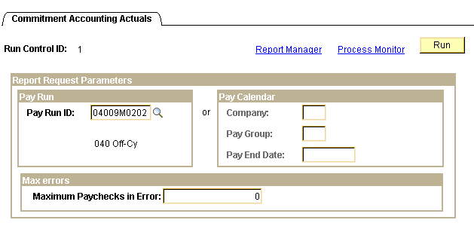

Enter the Pay Run ID and click .

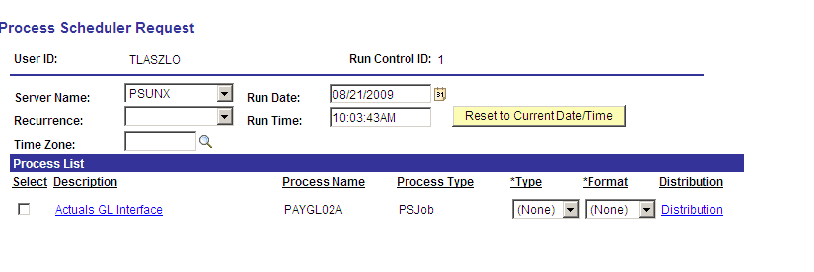
On the Process Scheduler Request page, Server Name must be set to ‘PSUNX’.

In the ‘Process List’ group box:
- Check box should be checked next to Actuals GL Interface
- Type should be set to (None)
- Format should be set to (None)

Click . When screen goes back to the Commitment Accounting Actuals parameters page, take note of the Process Instance number and click Process Monitor link. When the process runs to a Success and Distribution Status shows Posted. Click the PAYGL02A link under Process Name.

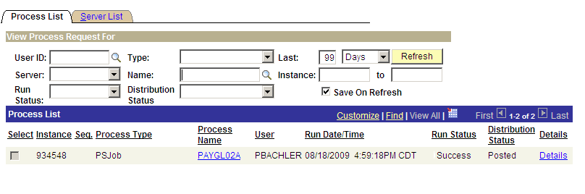

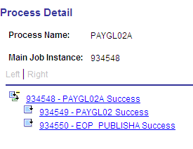

From the Process Detail page click the xxxxxx – PAYGL02 Success link. On the View Log/Trace page click View Log/Trace link.
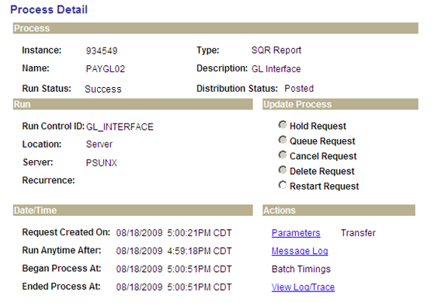

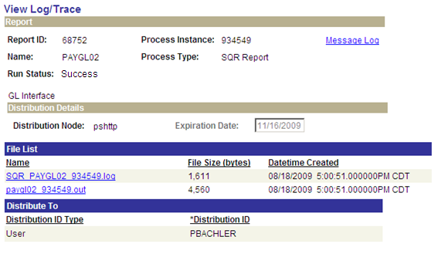

In the File List, click the file with the .out extension. This opens what is known as the Trace Log.
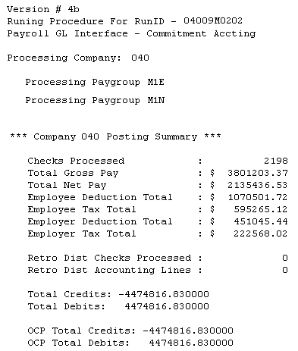

Make sure the Total Debits and Total Credits equal each other, and reconcile with the Budget Checking and Claim Document reports. Print this file, write your name and phone number on it. Submit this Trace Log to OMES along with the Budget Checking and signed Claim Document reports.

Step 15 – Check Pay Calendar Flags
Once again the Pay Calendar(s) need to be reviewed making sure a checkmark appears in the box in front of the CA GL Interface Run for every pay group that is active with this Pay Run ID.

Navigation: Payroll for North America > Payroll Processing USA > Create and Load Paysheets > Review Pay Calendars

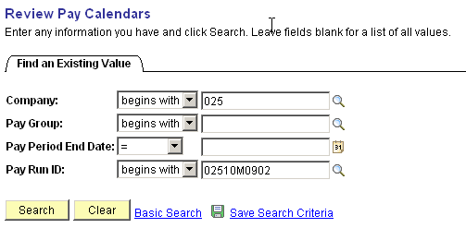

On the Pay Calendar Table search criteria page, enter the Company and pay Run ID that is being used. Click Review the flags checked on the Pay Calendar(s).

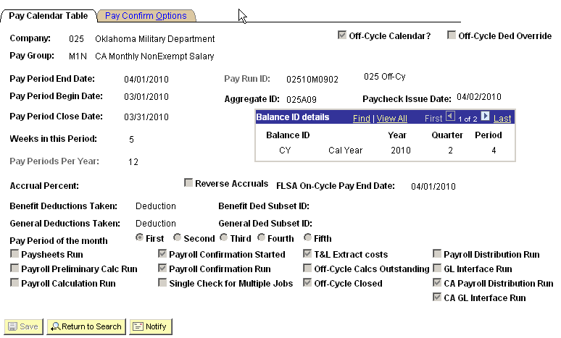

There should be a checkmark in the box in front of the label CA GL Interface Run for all the pay groups that are attached to this Pay Run ID.

NOTE: If the checkmark is missing, stop and contact Help Desk. Do NOT Proceed Any Further.

Step 16 – Load Payroll Fund Transfer
This process will transfer funds to the 905 account to ensure sufficient funds.

Navigation: OK Custom Reports/Processes > Higher Ed Processes > Higher Ed Payroll Data Upload

Check Process Payroll Fund Transfer (PFT) data only?

Enter agency number in the Company field.

Check FTP File from IBM. Enter file name, (only the ‘E’ number), or click and Browse to attach files.

Click .

Click and select the file to be uploaded.

Click .

Enter ‘N’ for no edit or ‘Y’ for edit in the Edit only? Box

Click . You will be taken to the ‘Process Scheduler Request’ page.

Only choose PSUNX server.

In the ‘Process List’ group:
- Check box should be checked next to Higher Ed Payroll Data Upload
- Type should be set to (None)
- Format should be set to (None)

Click .

You will be taken back to the Higher Ed Payroll Data Upload parameters page. In the top right hand side of the page a Process Instance number will now be shown. This process instance number is what you will use to monitor the completion of this job on the Process Monitor.

When screen goes back to the Higher Ed Payroll Data Upload parameters page, take note of the Process Instance number and click Process Monitor link.

When the run status column shows Success and the Distribution Status column shows Posted. Click the OCP0023J link under Process Name.

To view the error report, click the xxxxxx – OCP0023 link. Click View the Log/Trace link.

In the ‘File List’ group box select the file with the .csv extension (ocp0023 xxxxxxx.csv).

Review the report to ensure no errors are listed. If errors are found, correct as necessary and repeat the above steps.

Step 17 – Validate PFT Funding
This process checks General Ledger for available allotment and cash prior to starting your payroll to ensure there are sufficient funds available to process the PFT.

Navigation: OK Custom Reports/Processes > Higher Ed Processes > Validate PFT Funding (0522)

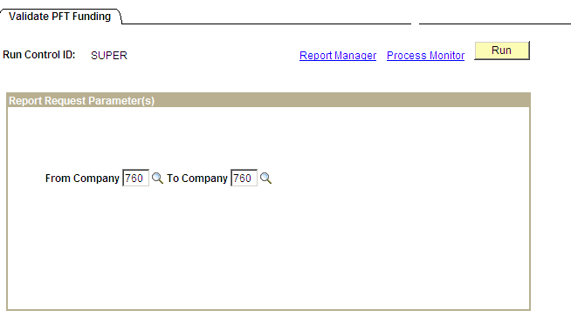

Enter Company To and Company From fields.

Click . You will be taken to the ‘Process Scheduler Request’ page.

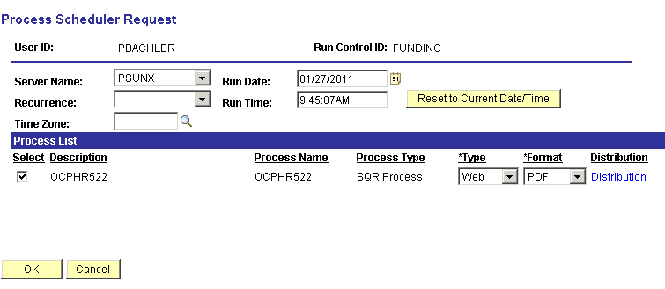

Make sure the Server Name is set to PSUNX.

In the ‘Process List’ group:
- Check box should be checked next to OCPHR522
- Type should be set to Web
- Format should be set to PDF

Click .

You will be taken back to the Validate PFT Funding parameters page. In the top right hand side of the page a Process Instance number will now be shown. This process instance number is what you will use to monitor the completion of this job on the Process Monitor, take note of the Process Instance number and Click the Process Monitor link.

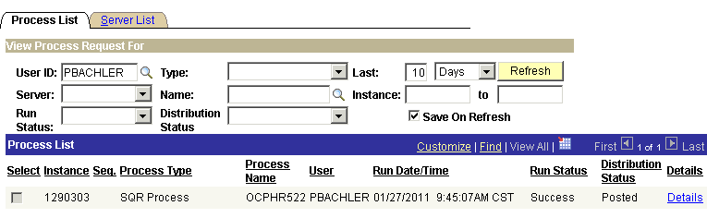

When the run status column shows Success and the Distribution Status column shows Posted. Click Details link. On the Process Detail page click View Log/Trace link.

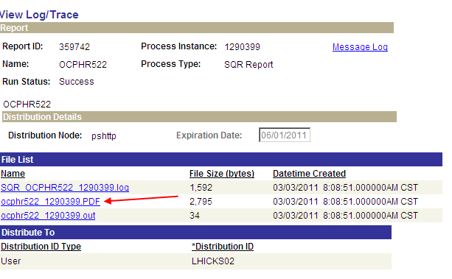

In the ‘File List’ group box select the file with the .PDF extension (ocphr522 xxxxxxx.PDF).

Review the report and transfer money to the appropriate accounts as necessary.

Step 18 – Fax Documents To OMES
Office State Finance requires that each agency payroll processor send them three (3) documents. They are:

- Validate PFT Funding Report from Step 17 (required if Budget Deficit)
or
Final Budget Check Report from Step 13 (only if no Budget Deficit)
- Final Claim Document from Step 13
- CA GL Interface Trace File from Step 14

The above documents must be faxed to OMES by 3:00 PM in order for your payroll to be released to Office of State Treasurer on that day. Otherwise, the payroll will be held until the paperwork is faxed to OMES.

Fax # 405 521-3383 to Elsa at Oklahoma Management and Enterprise Services

Once the Oklahoma Management and Enterprise Services receives your documents the reports will be reviewed and the payroll will be released to be picked up by a process that sends the checks and direct deposits to the State Treasurer for processing.

