COR301 Part I

Managing Positions Manual

Revised: March 5, 2019

Authorized by: [_CORE_] Original Issue: [06/01/2004]
Maintained by: [____Human Resources Lead___] Current Version: [03/05/2019]
Review Date: [02/26/2020]

Table of Contents

Document History 4
Managing Positions 5
Overview 5
Objectives 6
Add a New Position 7
Description Tab 9
Specific Information Tab 12
Budget and Incumbents Tab 13
Updating Position Data 14
Inactivate a Position 15
Allocate a Position 16
Description Tab 16
Classified Position 17
Unclassified Position 17
Update a Job Code / Level 18
Description Tab 18
Update a Department and/or Location 20
Description Tab 20
Position Summary 21
General Tab 21
Work Location Tab 21
Payroll Information Tab 22
Position History 23
Position Budget Status 25
Amounts 26
Changes 26
Position Reports 27

Document History

Document Revision | Date | Description
1.0 | 06/01/2004 | Initial Document
1.1 | 11/28/2008 | Upgrade 9.1
1.2 | 07/15/2010 | ADA Compliant
1.3 | 03/05/2019 | Manual Update

Managing Positions

Overview

PeopleSoft Human Capital Management employs its integrated, table-driven design to help your organization keep an effective-dated history of all positions, regardless of whether they are filled.

The State of Oklahoma has chosen to use Position Management. This requires that the position be properly configured prior to being associated with an employee. Position Management allows you to set up all the position information in advance. When an employee is hired, he is assigned to a position, and the system uses the position information to fill out several fields in the job data record. This process saves time and reduces errors for those involved in the hiring process.

When new positions are created, PeopleSoft Human Capital Management uses data that was entered in the Department and Job Code Tables to insert the default values into several position information fields. Defaults can be overridden to enter exceptions for a particular position. Positions are actually established in the system by the Human Capital Management (HCM) within the Office of Management and Enterprise Services (OMES). However, agencies will have certain responsibilities for updating and maintaining some position information.

Positions are defined on the Position Info pages, where you will create and maintain position information. After a position is allocated and established, you will be able to update certain data related to it, such as work location, department, and shift information. Other information is protected and will be updated either through changes to other tables or possibly through the position allocation process.

The Position Info component contains three (3) pages.

Description | Position effective date, status, reason for action (new position, allocation, etc.). Location-specific information such as company (Agency) and department. Information about the job associated with the position, such as job code, regular or temporary, and full or part time.
Specific Information | Information on maximum head count and whether the position is budgeted.
Budget and Incumbents | The position’s current budget and incumbents.

Valid Reasons for adding/updating position information are:

Reason Code | Description | When To Use
INA | Position Inactivated | Use to update the position Status from Active to Inactive. Has to be authorized by HCM!
ALC | Allocation | Use to indicate that the assigned job code has been updated when a position is audited after it was initially established.
NEW | New Position | Used only by HCM when a new position is established.
DRC | Direct Reclassification | Use to update the assigned level on the Job Code of a classified position only as directed by HCM.
LVL | Level Change | Used by an agency to reflect the assigned job family level of a classified position.
UPD | Position Data Update | Use when making updates to work location, department, FTE or other data not associated with a position allocation.
XFR | Transfer | Use to transfer a position from one agency to another - usually only as a result of legislation.
DSD | Detail to Special Duty – Hold | Used when inactivating a position so it can not be used while an employee is on special duty.
RSD | Return from Special Duty | Use when re-activating a position so an employee can be returned to their position after a detail.

Objectives

At the completion of this section, you will be familiar with the processes used to:

Create New Positions
- Classified
- Unclassified

Update Existing Positions
- Inactivate
- Allocate Positions and Update Job Codes
- Update Department or Location

Position Inquiries

Run a standard report

Add a New Position

New positions will be added to the system only by designated personnel in the Human Capital Management (HCM) within the Office of Management and Enterprise Services (OMES) upon receipt of required information from an agency. The number of positions an agency is authorized to establish is generally limited to the FTE limits set by the legislature. Exceptions are permitted for positions specifically exempted from FTE limits, such as seasonal, Carl Albert Executive Fellows, and other agency-specific exceptions. New classified positions are established upon receipt of an HCM-39 for a position audit or as requested by an agency which has been delegated position allocation authority. Unclassified positions are established only by the Human Capital Management (HCM) within the Office of Management and Enterprise Services (OMES) upon receipt of a request from an agency, verification of the unclassified authorization for the position, and verification that it is within the established FTE limits.

Navigation: Organizational Development > Position Management > Maintain Positions/Budgets > Add/Update Position Info

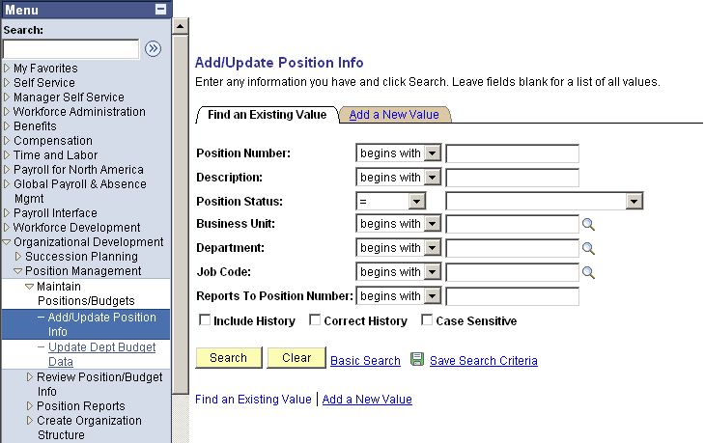

To add a new position, click Add a New Value link for a new page which will allow you to enter a new position number.
The following page will be displayed.

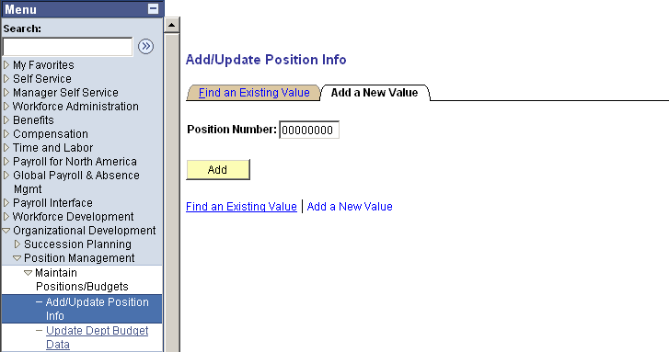

NOTE: HCM will assign Position Numbers. The first three (3) digits will reflect the company (agency) number. (Example: 54800001). The next five (5) numbers are simply assigned in numerical sequence as new positions are established.

Enter the assigned number in the Position Number field and click . The following page will be displayed:

Description Tab

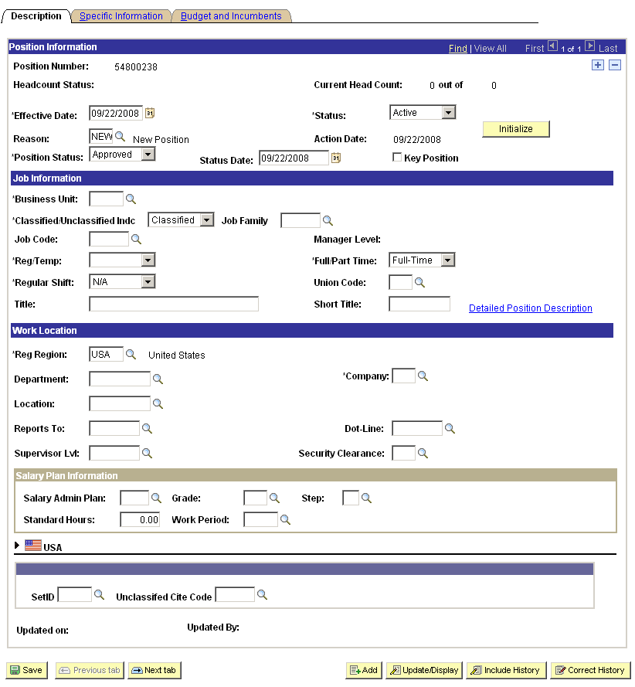

*Effective Date: – Enter the date the new position becomes effective. The default is the current date (system date).

NOTE: A position must be allocated and established before an employee can be assigned to it.

*Status: – Defaults to Active; Indicates whether the status of the position is Active or Inactive.

Reason: – Rationale for creating the new position. Since a new position is being created, the system defaults to NEW.

Initialize – This button is displayed only when adding a new position. Click to copy the characteristics of a similar existing position. When clicked, a dialog box prompts for the number of the position you want to copy. Click to populate the Position Information component with the information of the position you selected. Override any information that does not apply to the new position.

*Position Status: – Indicates whether the position is Approved, Frozen, or Proposed. The State of Oklahoma uses Approved.

Status Date: – Displays the date that a position first held a particular Status value. For a new Position, the Status Date will be the same as the Effective Date. The system defaults the Effective Date into this field.

*Business Unit: – This number will be the same as the Company (Agency) number with two additional zeros. Example: Agency 025 = Business Unit 02500.

*Classified/Unclassified Indc – Select ‘Classified’ for a classified position or ‘Unclassified’ if the position is to be unclassified. To establish an unclassified position, a valid unclassified authorization will be required.

If the Position is Classified:

- Job Family – Enter the Job Family (first 3 characters of the 4-character code for job family and level) determined for the position as the result of the position audit.

- Job Code – Job Code will default from Job Family at Level I [A]. Example: Job Family = E24, Job Code will default to E24A. After the position is established, this may be updated by the agency as a result of their level review.

If the Position is Unclassified:

- Job Family – Job Family does not apply and should remain blank.

- Job Code – Enter the Job Code for the position. This is determined by the agency and must be included in the request for the position.
Reg / Temp – Indicates whether this is a regular position or a temporary position. Other options used by the State of Oklahoma include: Project, Seasonal, or Student.

Full / Part – Indicates whether the position is full- or part-time.

Title – Displays the title for this position.

Regulatory Region – Defaults to USA.

Department – From the list of available options, select the Department this position is associated with. Use the Lookup (magnifying glass) to see the available options. The agency must provide this information to HCM. Agencies will be able to make updates to this information.

Company – Defaults from the first three digits of the business unit when the department is entered. This number will be the same as the Agency number. This information is not subject to update.

Location Code – The Location Code identifies the physical location where the person who will occupy this position will work. Use the Lookup to search for the associated Location Code. The agency must provide this information to HCM. Agencies will be able to make updates to this information.

Reports To information and Dot-Line information – Used to generate organizational reports in Position Management.

Once the Job Code is entered, the following fields are defaulted:

- Salary Admin Plan, Grade, Standard Hours, Work Period, FLSA Status – Indicating the salary components and hours for this position. Verify that the values are correct and change if necessary.

SetID and Unclassified Cite Code – If this is an Unclassified position, select the SetID for the agency (agency code plus 2 zeros) and Unclassified Cite Code authorizing the position. Use the Lookup to identify authorized codes.

Specific Information Tab

Some values on the Specific Information Tab affect how information is processed through the system.

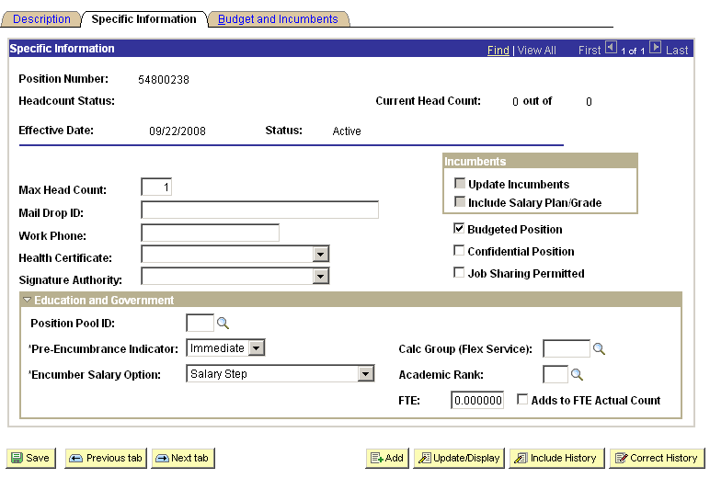

Enter information into the following fields:

Maximum Head Count – Enter the maximum head count allowed for this position. This would normally be one (1).

Update Incumbents – This box has been grayed out to prevent accidental selection. Incumbent data is not automatically updated since posting requirements may have to be met and qualifications must be certified.

Budgeted Position – The Budgeted Position box should be checked so the system knows that this is a budgeted position.

Click next to Education and Government section to enter FTE information.

FTE - Enter the FTE value for this position to be used for defining an FTE budget.

Adds to FTE Actual Count – Select to exclude this position when processing FTE edits for budgeting and report purposes.

Budget and Incumbents Tab

The Budget and Incumbents page is used to view the position’s current budget and incumbents. Since this is a new position, there will be no incumbents.

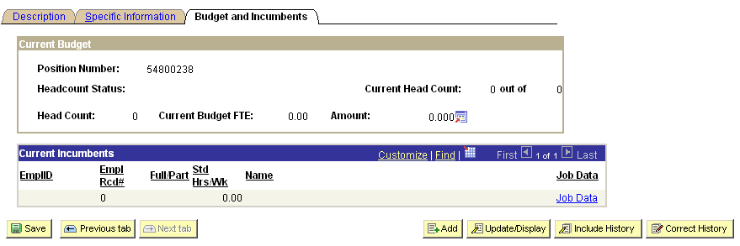

Current Incumbents – When employees have been assigned to the position in Job Data, the group box will display the Employee ID, Employee Record Number, and Name. Click to save the new position in the system.

Updating Position Data

Position information (including allocations) is updated in PeopleSoft by inserting effective-dated rows. This allows you to keep a chronological history of all the updates made to the position without losing any of the data that was already in the record. Future dated rows can also be inserted. To update a position follow the navigation listed below:

Navigation: Organizational Development > Position Management > Maintain Positions/Budgets > Add/Update Position Info

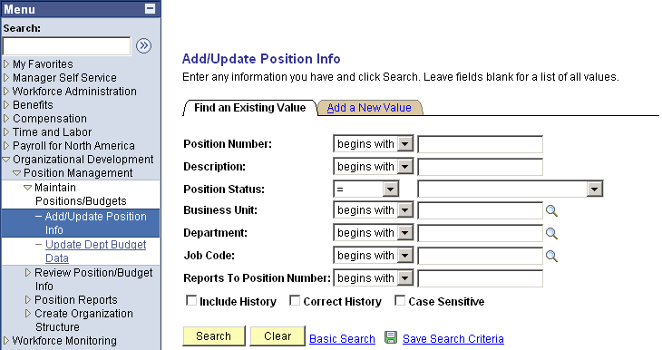

Enter the Position Number and click .

Once you have selected the position number you wish to work with, the Description page will be displayed.

The search process described above is used to find the correct position record for any update to position information: Inactivating (abolishing) a Position, allocating a position after a position audit, assigning a level, making a Department or Location update, etc.

Inactivate a Position

Select a position by searching for the Position Number as directed in “Updating Position Data”. To inactivate a position, use only the Description page. Only HCM is authorized to inactivate a position.

Description

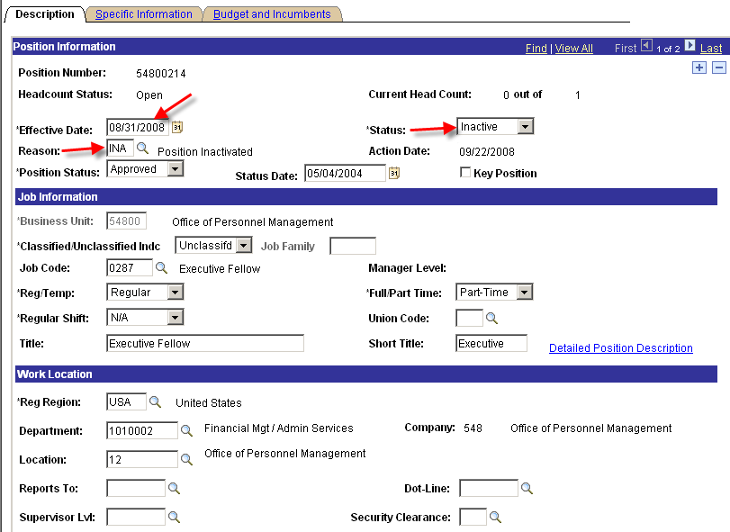

Click to ‘Insert Row’.

*Effective Date: – Defaults to the current date. Change if necessary.

Status – Change to ‘Inactive’.

Reason – Select ‘INA’ – Position Inactivated.

Click .

Allocate a Position

When a new position is created, or after a position audit is completed, the allocation information is entered to show the Job Family to which the position has been assigned. Only HCM or an agency with position delegation authority will be able to allocate classified positions to a job family.

Use the process described in “Updating Position Data” to find the correct position.

Only the Description Tab is needed to enter allocation information. However, other updates such as department or location may be made if needed.

Description Tab

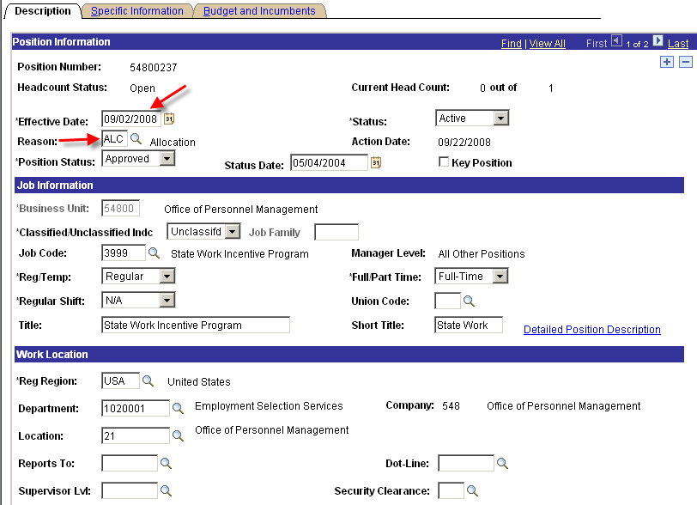

Click to insert a row.

*Effective Date: – Defaults to the current date. Change if necessary.

Reason: – Select ‘ALC’ – Allocation.

Classified Position

Classified Indicator – May be updated only by the Human Capital Management (HCM) office within the Office of Management and Enterprise Services (OMES).

Job Family – This field shows the Job Family to which a classified position has been allocated and may be updated, after completion of a job audit, only by HCM or an agency with delegation authority to allocate positions.

Job Code – At the time an update is made to the Job Family, this field will automatically default to Level I of the Job Family. A level change may then be made if appropriate.

Unclassified Position

Unclassified positions will be updated for merit system agencies only by the Human Capital Management (HCM) office within the Office of Management and Enterprise Services (OMES), upon receipt of required information from an agency, and verification of the unclassified authorization and FTE limits. Non-merit agencies will make allocations on their positions since verification of a non-merit unclassified authorization is not required.

Job Code – Insert the new Job Code. The value must be all numeric characters. If the Job Code is not all numeric, an error message will be displayed stating that this is an Invalid Job Code and you will not be allowed to continue.

SetID and Unclassified Cite Code – Enter the cite code describing the authority for the unclassified position. Use the Lookup if needed. The cite code for non-merit agencies is normally NM but another code may be required in some cases, such as I001 for Carl Albert Undergraduate interns, I002 for Carl Albert Executive Fellows, or T008 for temporary positions.

Click .

Update a Job Code / Level

An update to a classified Job Code may be required when a new position is established, after completion of a position audit, or as a result of a level review by an agency. For a classified position, the job code is used to show the level to which the agency has assigned the position. The first three (3) digits must match the Job Family. The fourth digit will normally be assigned by the agency, but may be assigned by HCM as a result of an appeal by the employee during a classification grievance. Unclassified Job Codes will be updated by HCM for merit system agencies upon receipt of a request from an agency. Non-merit agencies will update the job code on their positions as needed.

Find the correct position by searching for the Position Number as directed in “Updating Position Data”.

Only the Description and Job Information pages are needed to update a job code. However, other updates, such as department or location, may be made if needed.

Description Tab

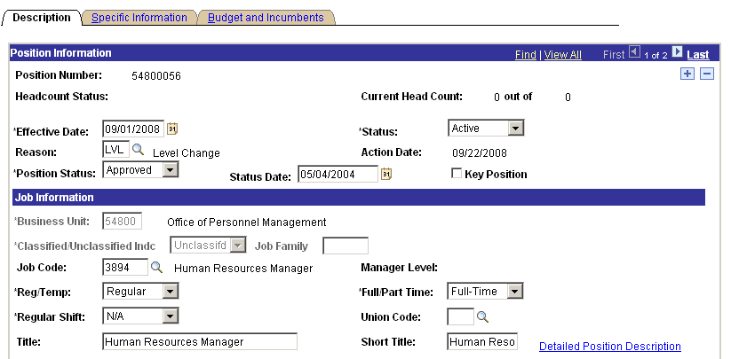

Click to insert a row.

*Effective Date: – Defaults to the current date, change if necessary. This can be on the same date a Job Family allocation was made, but CANNOT be earlier.

Reason: – Select ‘LVL’ - Level Change.
*Classified/Unclassified Indc and Job Family – These fields will be grayed out and cannot be updated by the agency.

Job Code – Insert the new four (4) characters Job Code. The first three (3) characters of the Job Code must match the three (3) character code in Job Family. If they do not, an error message will be displayed stating that this is an Invalid Job Code and you will not be allowed to continue.

Click .

NOTE: Company and Business Unit will be grayed out. These fields are not available to be updated.

Update a Department and/or Location

Find the correct position by searching for the Position Number as directed in “Updating Position Data”.

To update a Department number or Location, use the Description page.

Description Tab

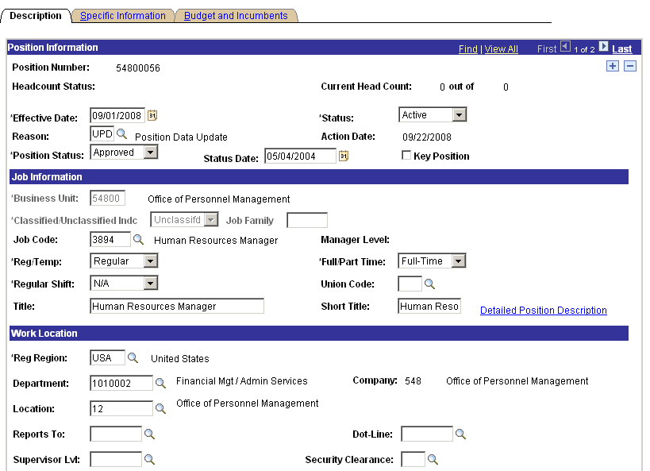

Click to insert a row.

*Effective Date: – Defaults to the current date, change if necessary
Reason: – Select ‘UPD’ – Position Data Update
Department: – Select the new department from the Lookup, if applicable.
Location: – Select a new location from the Lookup, if applicable

Click .

NOTE: Company and Business Unit will be grayed out. These fields are not available to be updated.

Position Summary

To see a high-level summary of a position, use Position Data Summary. These display-only pages contain historical information on positions and incumbents.

Navigation: Organizational Development > Position Management > Review Position/Budget Info > Position Summary
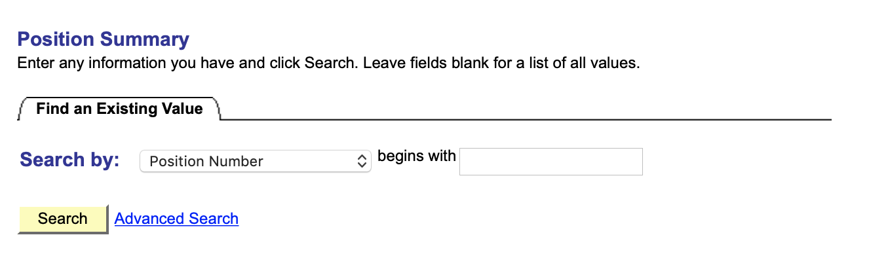
Enter the Position Number then click .

General Tab

The Position Data Summary – General Tab lists the Effective Date, Action Reason, Status, Status Date, Max Head Count, and Budgeted indicator.

View additional data by selecting the ‘Work Location’ and ‘Payroll Information’ Tabs.

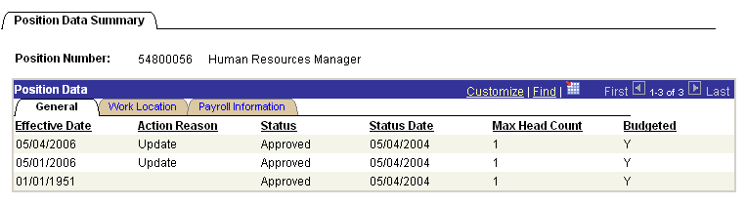

Work Location Tab

The Work Location Tab lists the Effective Date, Reports To, Business Unit, Location, Job Code, and Department.

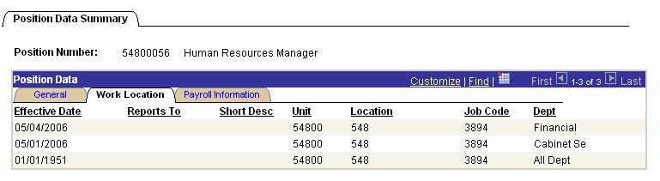

Payroll Information Tab

The Payroll Information Tab lists Effective Date, Reg/Temp, Full/Part Time, Standard Hours, Work Period and Shift.

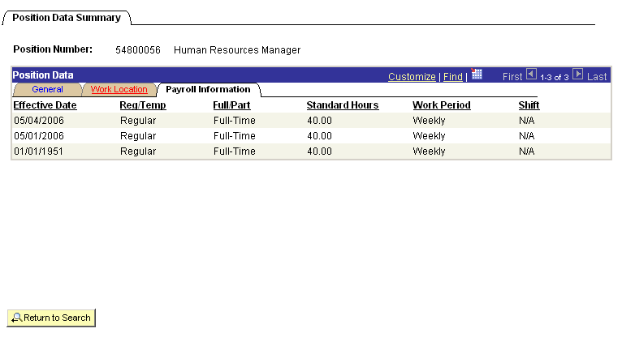

Click to view another position.

Position History

Position History is used to view incumbent salary information. This information can be used to anticipate approximate salary for a new position, examine exit reasons, and explore ways to reduce turnover in a position.

Navigation: Organizational Development > Position Management > Review Position/Budget Info > Position History

Find the correct position by searching for the Position Number as directed in “Updating Position Data”.

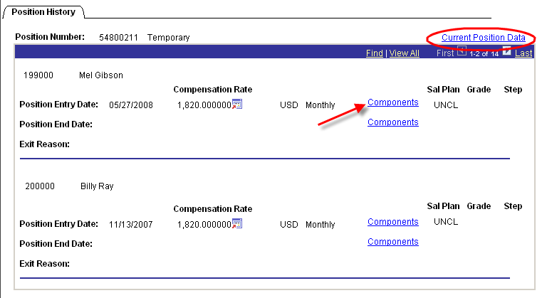

Position History displays the Position Entry Date, Position End Date, Compensation Rate, Salary Plan, and Grade.

Components – This link can be used to view the salary either at the Position Entry Date or Position End Date associated with the employee’s position.
Current Position Data – Use this link to access the Current Position Data Page:

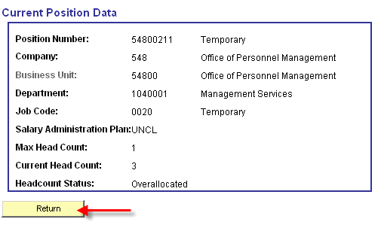

Click to go back to Position History.

Position Budget Status

Position Budget Status shows a condensed view of the position information.

Navigation: Organizational Development > Position Management > Review Position/Budget Info > Budget Status

Find the correct position by searching for the Position Number as directed in “Position History”.

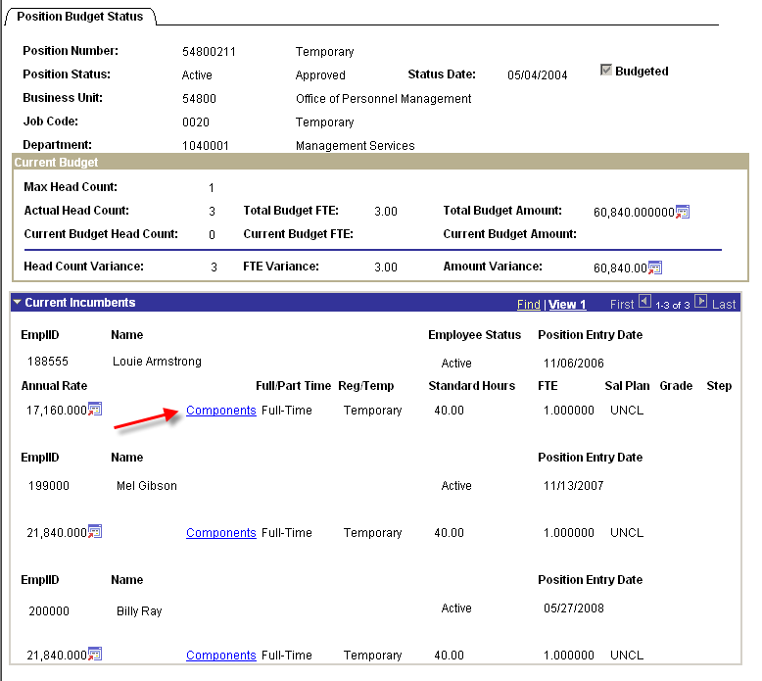

Current Incumbents – Displays information on the current incumbent(s).

Information includes: EmplID, Name, Employee Status, Position Entry Date, Annual Rate, Full/Part Time, Reg/Temp, Standard Hours, FTE, and Salary Plan and Grade.

The Components link accesses the Salary Components Page.
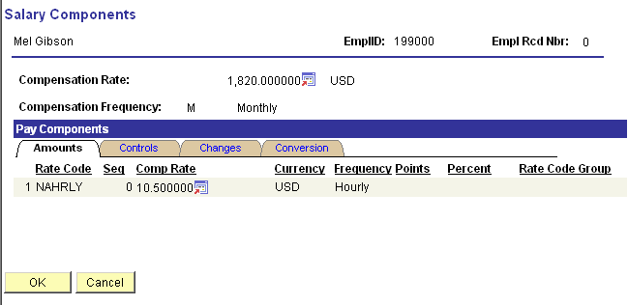

Amounts

Information includes: Rate Code, Sequence, Details, Compensation Rate, and Frequency

Changes

Information includes: Change Amount and Change Percent

NOTE: Compensation Rate and Frequency are displayed on the Amounts and the Changes Tabs.

Click to get back to the Position Budget Status page.

Position Reports

Navigation: Organizational Development > Position Management > Position Reports

