COR216 P-Card Voucher Build Manual

Table of Contents

Table of Contents 3
Document History 5
Introduction 6
Bank of America 7
Default Information 7
Charges Recorded in Works 8
Reviewing Transactions in Works 9
Voucher Build Process 11
Step 1 – Voucher Build Request 11
Voucher Build Page 12
Process Scheduler Request 13
Process Instance 13
Process List 14
Step 2 – Reviewing the Voucher Build Process Message 15
Process Messages Page 15
Build Errors Page 16
Step 3 – Correcting Built Vouchers in Recycle Status 18
Voucher Error Summary Page 18
Go to Review Error Icon 19
Step 4 – Match, Document Tolerance, and Budget Check On Demand Action 20
P-Card Vouchers Built In Postable Status 21
P-Card Voucher Payment Page 23
Verifying Encumbrance Liquidations 24
Integrating Assets from P-Card Vouchers 25
Correcting Asset Voucher Distribution Lines 26
Voucher Error Summary Page 26
Built Asset Voucher Lines and Distribution Lines 27
Updating Asset Voucher Lines and Distribution Lines 27
Single Asset – One Funding 28
Single Asset – Split Funding 29
Multiple Assets – One Funding 31
Multiple Assets – Multiple Funding 32
Multiple Assets – Split Funding 34
Non Asset Transaction Built with Profile ID 36
Asset Transaction with No Profile ID Recorded In Works 36
P-Card Voucher Checklist 37

Authorized by: [_EBS_] Original Issue: [11/01/2004]
Maintained by: [____AP Lead___] Current Version: [10/01/2016]
Review Date: [10/1/2014]

Document History
Document Revision | Date | Description
1.0 | 10/01/2005 | Initial Document
1.1 | 11/28/2007 | Updated
1.2  2.0  2.1 | 03/04/2011  05/01/2014  10/01/2016 | Updated for BOA and Asset Interface  Upgrade Update  Updated BOA Print Screens and Report

Introduction
Authorized state employees can make authorized purchases using the state approved credit card. The credit card is issued by Bank of America and the transaction detail resulting from charges made by employees are sent to the bank from participating merchants. Bank of America furnishes a website that is accessible by authorized employees to review and edit the transactions made by each cardholder. After transactions have been reviewed and edited, they are downloaded on a designated date to the State’s mainframe computer and loaded into the State’s system Voucher Build staging tables. Each agency is responsible for creating vouchers for its agency from the data in the staging tables using the P-Card Voucher Build Process.

This guide contains instructions for creating the vouchers using the Voucher Build process after they have been loaded into the staging tables. This guide does not contain instructions for reviewing and editing transactions through the Bank of America Works website; nor, does it include instructions for loading the transactions into the Voucher Build Staging Tables.

Bank of America
Bank of America provides internet based access to P-Card transaction information via the Bank of America Works website. Many payers responsible for building the P-Card Voucher will not have access to Works, but because the information recorded in Works is used to build the voucher, it is helpful to understand the relationship between Works and PeopleSoft.

Default Information
The agency P-Card administrator enters default information into the Works page when a charge card is issued to a cardholder. It serves to default the funding and PO information in the Works transaction pages when the card is used to make a charge. The P-Card administrator must update the default information for all cardholders at the beginning of each fiscal year to ensure the charges made after a new fiscal year begins are recorded to the proper funding and will liquidate against the current fiscal year encumbrances.

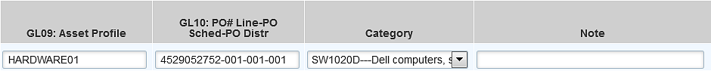

GL01 – Account Code – assigned in Works based on the MCC codes for each merchant
GL02 – Fund Type and Class
GL03 – Department ID and- Program Code
GL04 – CFDA #
GL05 – Project, Activity, Source Type, Category, Subcategory – Must have implemented Projects
GL06 – Operating Unit and Chartfield2
GL07 – Sub Account
GL08 – Business Unit
GL09 – Asset Profile – Must have implemented Asset Management
GL10 – Purchase Order, Line, Schedule, and Distribution Line

Default account codes are assigned in Works based on the MCC codes for each merchant. The Merchant (Category) Code, or MCC code, is a standard code the credit card industry uses to categorize merchants based on the types of goods or services provided by the merchant.

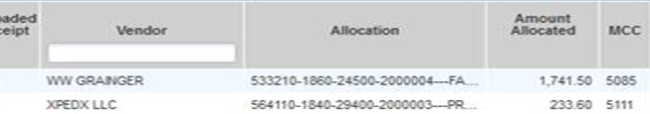

These default codes may not be appropriate in some circumstances and the transactions should be edited to assign the correct account codes.

Charges Recorded in Works
Charges are recorded to the funding and PO in Works based on the default information. If changes to the default account code, funding and/or encumbrances need to be made, a Works administrator or assignee is able to edit the transaction information.

Below is selected information copied from Works for one transaction. The total charge would have originally been recorded to the default funding and PO information for the cardholder, but since it is split between two chartfield strings and PO encumbrances, the Works administrator edited the transaction. These are the values that will be loaded in the PeopleSoft Voucher, regardless of whether or not the values are valid in PeopleSoft

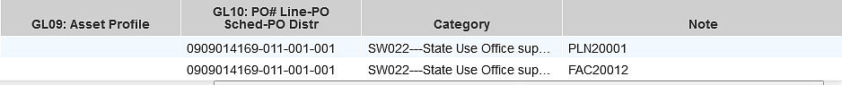

NOTE: Invalid values loaded in PeopleSoft will cause the voucher to be saved in recycle status. The values will either need to be corrected or removed.

NOTE: The PO, line, schedule, and distribution line recorded in Works at the time the transactions are downloaded to PeopleSoft will be the encumbrance linked to the charge when the voucher is built in PeopleSoft, regardless of whether the expenditure distribution in Works agrees to the funding on the PO distribution line. The Bud Ref is not included in Works. It is populated on the voucher based on the PO, distribution line linked to the charge in Works.

Reviewing Transactions in Works
On-line review and editing of account codes, funding, and PO encumbrances should be done in Works at least weekly or possibly daily to efficiently process the voucher for payment. A particular report designed to review the transactions by account code, funding, and PO encumbrances during the billing cycle and at the end of the month before the data is downloaded into PeopleSoft is the Agency Spend Report.

Exporting the Agency Spend Report

Reports > Template Library > Select Agency Spend Report > Click Modify/Run

The following screen displays. Select Program Card (Business Unit), Post Dates, and Sort Columns by GL: PO#-PO Line-PO Sched-PO Distr to generate the report.

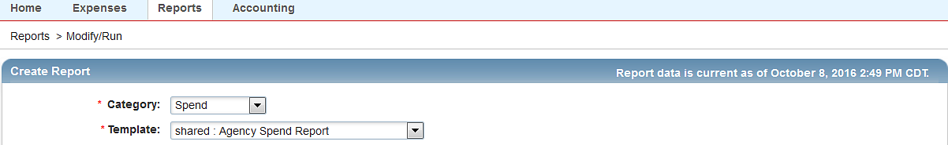
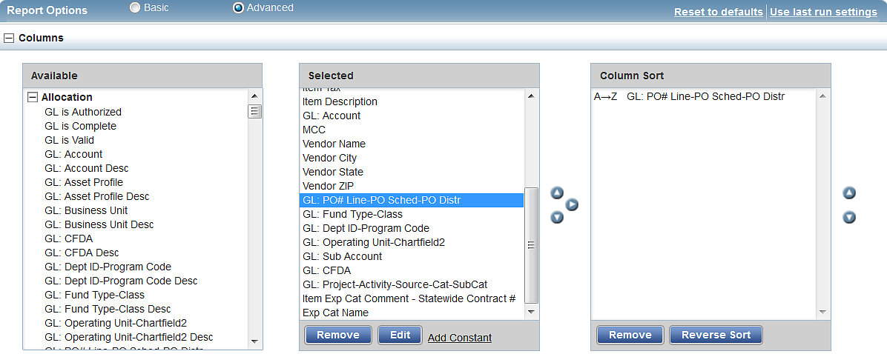
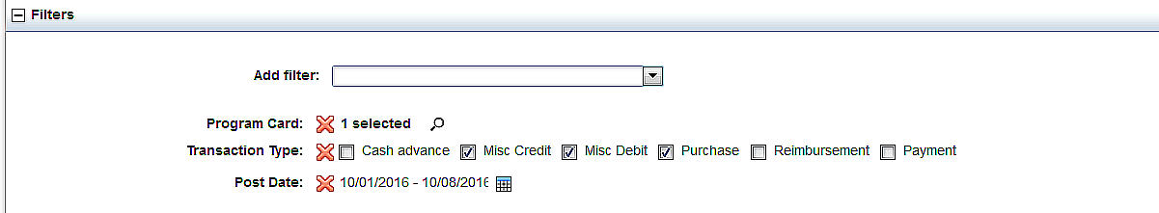

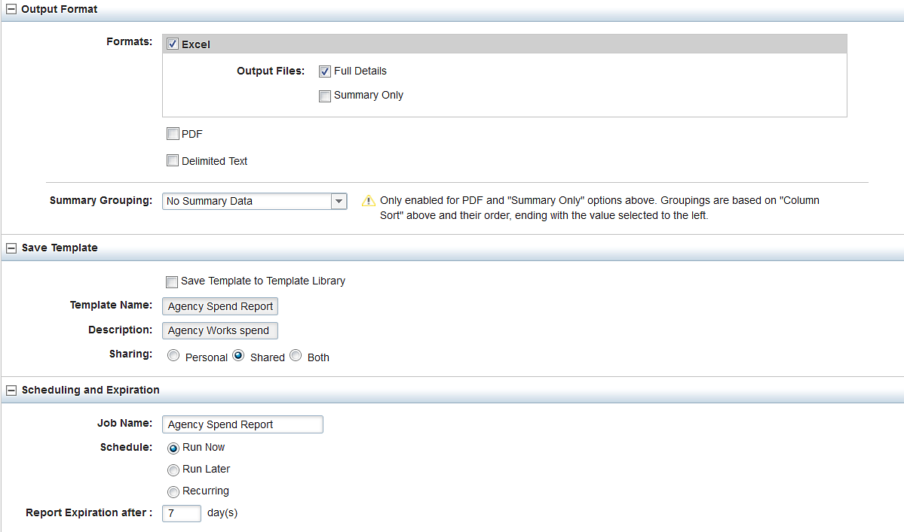

The report can be exported to Excel, and Works gives the option to save a Report Template to your Personal Template Library so filters do not have to modified or changed often.

Below is a print screen of selected columns from the Agency Spend Report after it was exported to Excel.

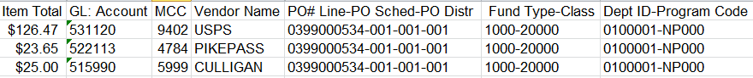

Transactions can be sorted by the GL: PO# Line-PO Sched-PO Distr column to compare the sum of P-Card expenditures by PO ID, PO Line, PO Schedule, and PO Distribution Line to the remaining encumbrances on the Outstanding Orders report during the billing cycle and before the voucher is built. This will minimize document tolerance exceptions after the voucher is built.

Another report providing transaction data that can also be sorted by PO, PO Line, PO Schedule, and PO Distribution line is the RPT 170 – Transaction Detail Data. It can be used to check for sufficient funding on the lines, and to identify missing or invalid ChartFields.

Voucher Build Process
After the Works transaction information is downloaded to the staging loading tables, the voucher(s) can be built using the Voucher Build Process.

Step 1 – Voucher Build Request
Navigation: Accounts Payable > Batch Processes > Vouchers > Voucher Build

Select or Add a Run Control ID created specifically to run the PCARD Interface. Make the Run Control ID unique by adding initials, business unit, etc.

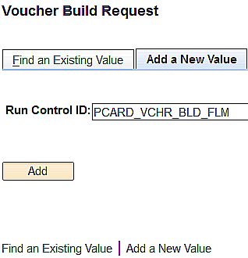

Click or enter an existing run control ID and click .

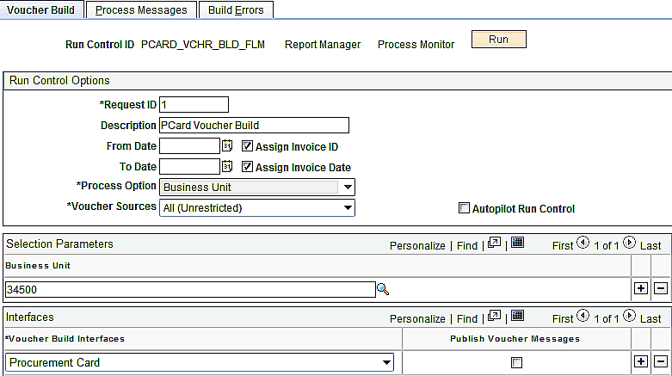

Voucher Build Page
The fields on the Voucher Build page must be populated correctly to build the vouchers.

- Request ID and Description: The request ID value can be “1” to signify the one request being run, or it can be anything meaningful. The description field should also contain a meaningful description.

- Dates: Leave the date fields blank. The Voucher Build process will pick up ALL vouchers in the staging tables since the last time the Voucher Build was run.

- Voucher Process Option: Business Unit. This field is not available to update.

Voucher Sources: All (Unrestricted). Change the value from New Voucher Data to All (Unrestricted). Unbuilt vouchers in the staging tables can be in different stages depending on voucher build results. The All (Unrestricted) Voucher Source allows all vouchers to be built regardless of the stage.

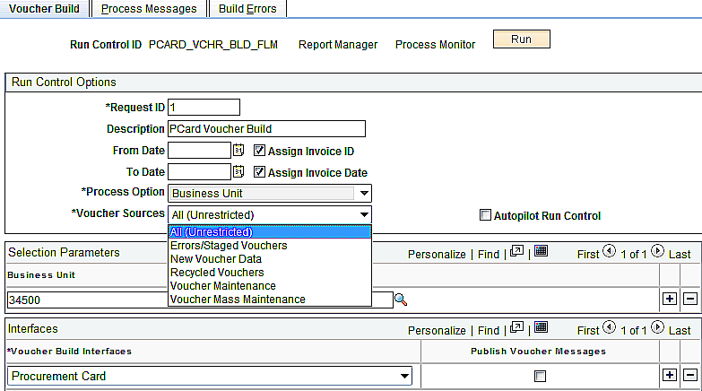
- Business Unit: Enter the five digit business unit number. It will be used to retrieve the data from the voucher build staging tables and create the voucher(s) for the agency. Users with access to more than one business unit can run the voucher build process for multiple business units by clicking the plus icon and entering additional business units.

- Voucher Batch Interfaces: Procurement Card. There are a number of choices in this dropdown menu. Ensure “Procurement Card” is chosen.

Click at the top right of the Voucher Build page to access the Process Scheduler Request page after populating the fields.

Process Scheduler Request
Within the Process Scheduler Request page, the Server Name is PSUNX and the Process selected is Voucher Build.

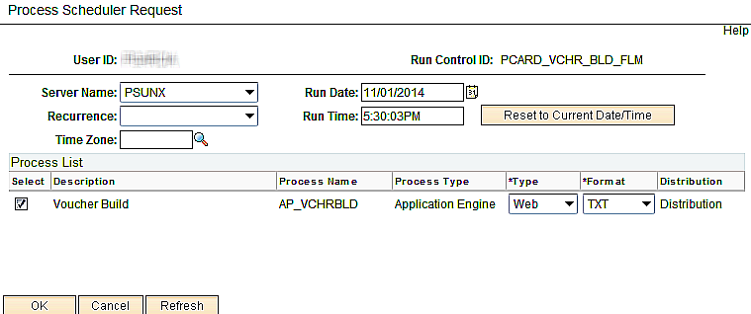

Click at the bottom of the page to run the process.

Process Instance
The Voucher Build page will appear with the Process Instance indicated at the top right of the page. In addition, there is a Process Monitor link that can be selected to view your progress on the Process List page.

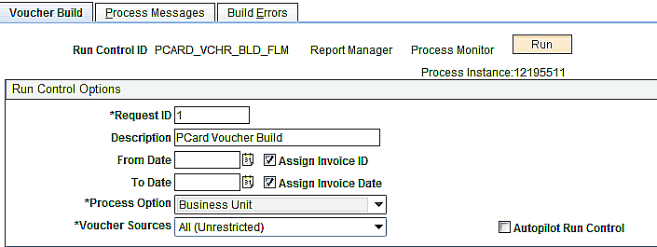

Process List
Clicking the Process Monitor link from the Voucher Build page opens the Process List. Occasionally click the button at the top of the Process List page. The process will run until the Run Status is Success and the Distribution Status is Posted.

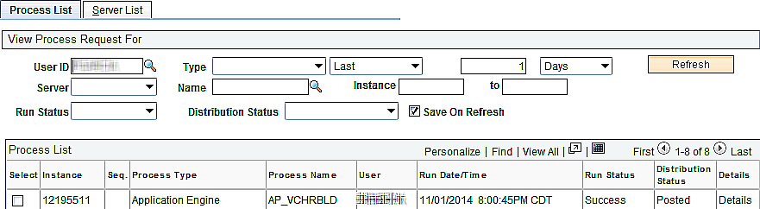

If you receive a “Success” message, then you are ready to proceed to Step 2, Review the Voucher Build Process messages.

If you receive a No Success Run Status message, contact the OMES Helpdesk by calling 405-521-2444 or by emailing HelpDesk@omes.ok.gov and provide the User ID and the Process Instance number. Ask for a priority of Same Business Day. You will not be able to proceed with voucher creation until this issue is resolved.

Running the process more than once will not build the voucher after a job has run to No Success because the voucher staging tables are no longer populated. The Office of Management & Enterprise Services technical staff will need to reload them.

- DO NOT DELETE the process instance since the Details link provides messages that the technical staff uses when resolving the case.
- Voucher IDs are assigned even when a job runs to No Success. They are not reassigned when the job is rerun after the staging tables are reloaded, nor are they accessible through the Accounts Payable Voucher Search page. Maintain the missing numbers for the agency’s internal records in the event the voucher ID is randomly selected for audit.

Click on the Go back to Voucher Build Request link to return to the Voucher Build Request page.

Step 2 – Reviewing the Voucher Build Process Message

Process Messages Page
Upon returning to the Voucher Build Request page, click the Process Messages page to determine if and how many vouchers processed successfully or are in recycle status.

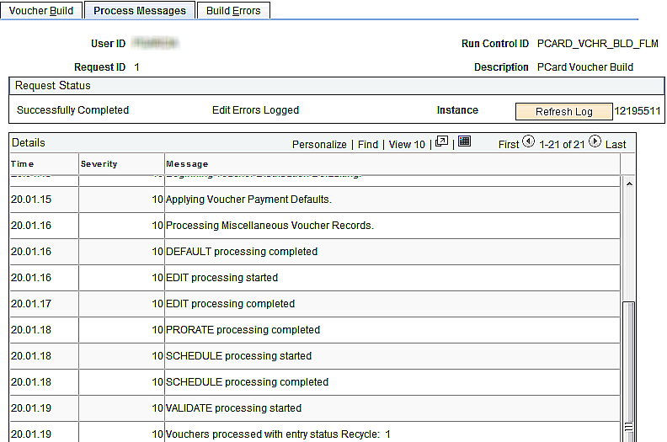

In this example, one voucher processed in Recycle status. To examine any error messages, go to the Build Errors page.

NOTE: If the voucher processed with an entry status of Postable, access the voucher directly through the Regular Entry Voucher Search Screen using the Procurement Card Voucher Source or the Supplier ID 0000001101.

NOTE: Most agencies will have only one P-Card voucher per billing cycle, but if P-Card transactions are charged against multiple PO IDs, PO lines, PO schedules, and/or PO distribution lines that create more than 50 voucher lines per voucher, PeopleSoft will automatically create additional vouchers. The limitation applies to voucher lines only and not voucher distribution lines.

Build Errors Page
Before the PCard transactions are loaded into the Voucher Build Staging tables, Central Purchasing runs several edits to minimize the risk of PCard vouchers building with pre-edit errors (critical errors that prevent the voucher from creating until the errors are corrected). Edits include validation of the Supplier ID and location used on the PCard authority order and the existences of the PO/Lines/Schedule/ Distribution Line numbers, PO Match and Budget Check statuses, account codes, etc. When these errors are identified, the agency is required to correct them before the PCard transactions are loaded.

Vouchers could possibly build with pre-edit errors. For example, if a a PO change order results in an uncorrected PO budget check error status after the staging tables are successfully loaded, the voucher will build in a pre-edit error status when voucher build is executed. Pre-edit error(s) will need to be corrected so voucher build can be re-executed.

More often, the Build Error page identifies the PCard voucher(s) that built in recycle status. The voucher build edits do not validate ChartField values. This occurs during voucher build.

Select the Build Errors page to identify the PCard voucher(s) in recycle status and review the errors.

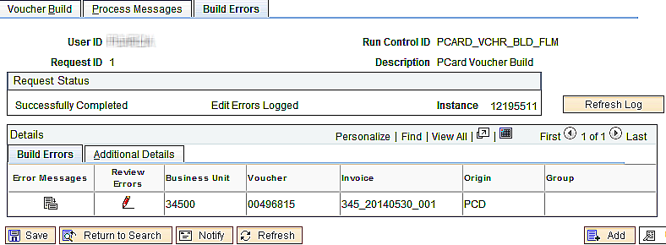

Click the Error Message to review the Voucher Build Error Detail.

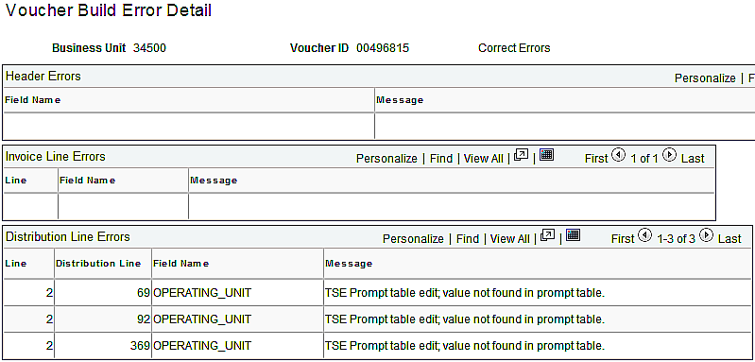

Errors are reported at the Header, Invoice Line, and Distribution Line levels. In this example, the Operating Units loaded from Works on the identified voucher distribution lines are not valid values. Click the Correct Errors link to access the Error Summary page on the Voucher, which also lists these error messages.

Clicking the Review Errors also accesses the Error Summary page on the Voucher directly.

Step 3 – Correcting Built Vouchers in Recycle Status

Voucher Error Summary Page
When the PCard voucher builds in Recycle Status, clicking the Correct Errors link or the Review Errors icon on the Build Errors page on the Voucher Build Request Component accesses the Voucher Error Summary page.

The Voucher Error Summary page lists the voucher build errors and identifies the errors that resulted in a Recycle status. Whenever there are Voucher Line and/or Distribution Line errors, the voucher lines and distribution lines with invalid chartfield values are identified.

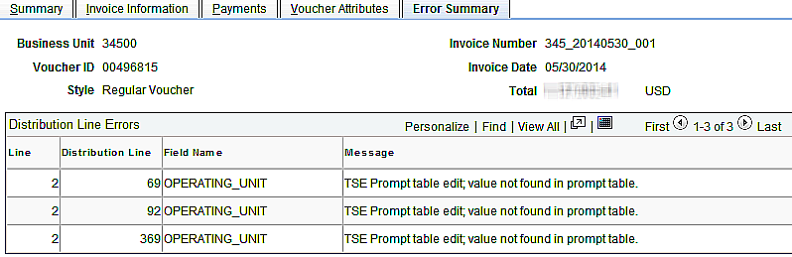

Upon identifying the voucher errors, take the corrective action. In the example, the voucher has three Distribution Line Errors.

- Distribution Line Errors – ChartField values are populated in the voucher directly from Works and are edited in the voucher. Invalid ChartField values are listed on this page by Voucher Line and Voucher Distribution Line. By default, the first three errors display. Activate the View All to view all Distribution Line Errors when there are more than three. The voucher had invalid values populated in the Operating Unit field that needed to be corrected or removed from the Voucher Distribution Lines.

NOTE: Even when the voucher builds in a Postable Status, P-Card Voucher Lines and Voucher Distribution Lines should be reviewed to ensure the expenditures are recorded to the correct accounts and funding.

NOTE: The PCD Origin indicates that the voucher was built with the Procurement Card Voucher Build interface. DO NOT DELETE vouchers with an origin of PCD. The Voucher Build process includes PeopleSoft code to include the agency program account number with the electronic payment so the bank can apply the payment correctly. If the voucher did not build as expected, correct the voucher rather than deleting it. Contact the Office of Management & Enterprise Services Helpdesk if assistance is required.

Go to Review Error Icon
Built vouchers in recycle status display the Go to Review Error icon in the following locations:

- Voucher ID field on the Invoice Information page for voucher header errors
- Invoice Lines scroll area for voucher line errors.
- Distribution Lines grid for voucher distribution line errors

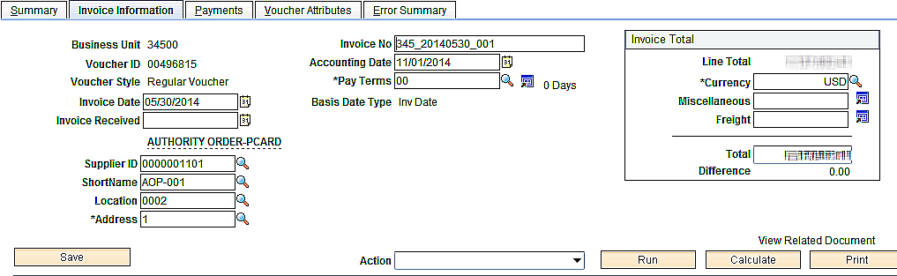
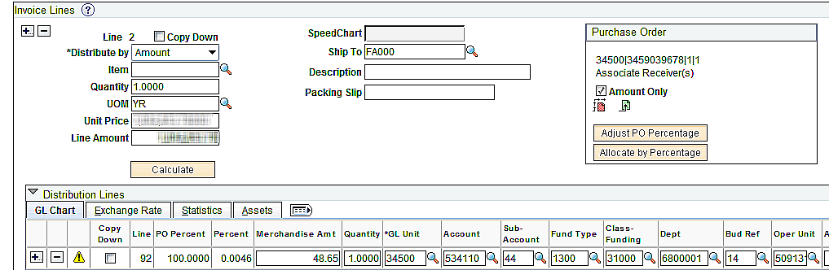

Each Go to Review Errors icon can be clicked to display each error, or the Error Summary page can be selected to view all the errors on the Invoice Information page.

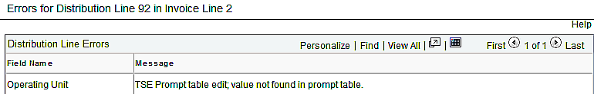

The following information is populated as a result of the Voucher Build process and should not be changed.

- Invoice Number: Includes the agency number and billing cycle date.
- Invoice Date: The date the billing cycle ended.
- Supplier and Location::The Supplier ID and location associated with the Remit To Supplier.

Step 4 – Match, Document Tolerance, and Budget Check On Demand Action
Due to the short timeframe between the date the voucher build is available and the date the voucher must be submitted to the Office of Management & Enterprise Services for payment, a super-user should run the on-demand action of “Match, Doc Tol, Bdgt” after the voucher is reviewed and/or corrected, and the Entry Status of the P-Card voucher is Postable. The voucher must have a Match status of No Match and a Document Tolerance Status of Valid before it will budget check.

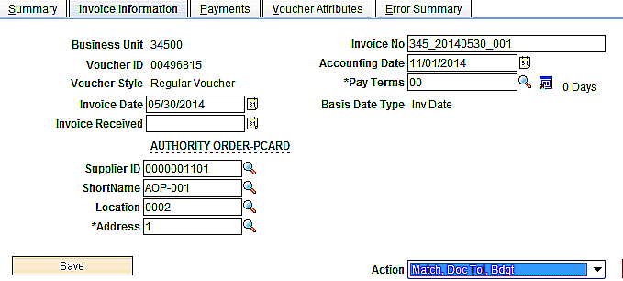

The two (2) reasons the Office of Management & Enterprise Services requests that the On-Demand Action be run for P-Card vouchers:

- To research and resolve document tolerance and budget checking errors immediately.
- To ensure proper encumbrances are liquidated.

NOTE: Refer to the COR112 Purchase Order Voucher Manual for Document Tolerance and Budget Checking exception and resolution information.

P-Card Vouchers Built In Postable Status
If the P-Card voucher(s) build(s) in a Postable Status, search by either Supplier ID #0000001101 or Procurement Cards Voucher Source on the Voucher Search page to identify and access the voucher(s).

Navigation: Accounts Payable > Vouchers > Add/Update > Regular Entry > Find an Existing Value

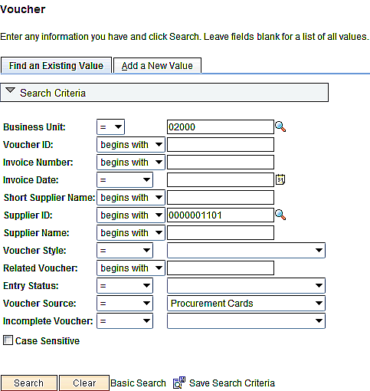

Click to access the Voucher Component.

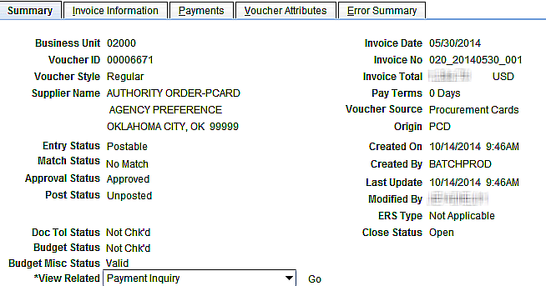

The PCD Origin indicates that the voucher was built with the Procurement Card Voucher Build interface. DO NOT DELETE vouchers with an origin of PCD. The Voucher Build process includes PeopleSoft code to include the agency’s 16 digit corporate account number with the electronic payment so the bank can apply the payment correctly. If the voucher did not build as expected, correct the voucher rather than deleting it. Contact the Office of Management and Enterprise Services Helpdesk if assistance is required.

P-Card Voucher Payment Page
The Remit To Supplier ID 0000300518, Location 0002, Account of EFT, and Pay Group of PC populate in the P-Card voucher during voucher build and must not be changed.

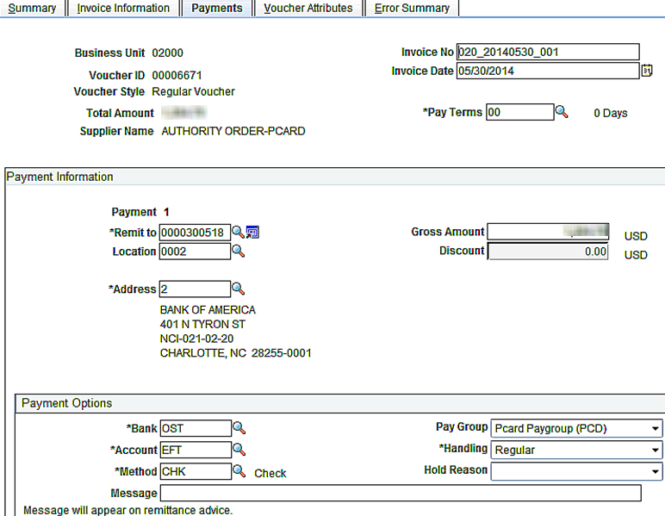

After completing the voucher, print the voucher, batch slip, and the Billing Statement report from Works and submit the batch to the Office of Management and Enterprise Services by 5:00 p.m. on the scheduled submission deadline. Fax copies to 521-3383 if interagency mail cannot accommodate the deadline. The faxed copies will be replaced with the originals upon receipt.

NOTE: Agency with a credit balance for a particular billing cycle should build the voucher but retain the batch until there are sufficient charges to recoup the credit. The batch slip listing the unpaid vouchers from the prior and the current billing cycles should accompany the vouchers with the required Billing Statement documentation.

Verifying Encumbrance Liquidations
Navigation: Purchasing > Purchase Orders > Review PO Information > PO Accounting Entries

After the P-Card voucher is budget checked but before it is paid, review the PO Accounting Entries to ensure the correct encumbrances were entered in Works and liquidated in PeopleSoft.

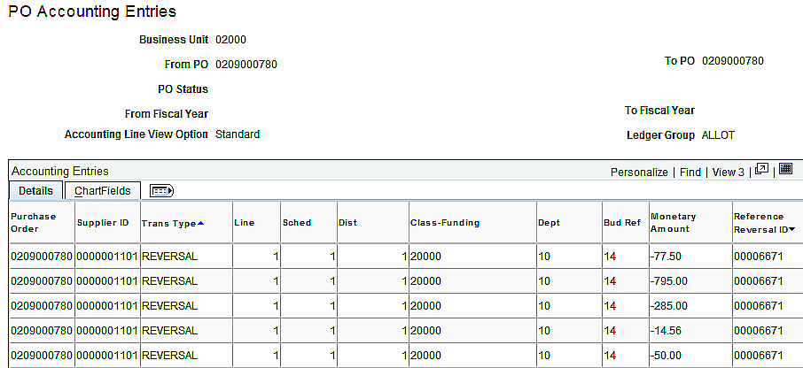

If the voucher liquidated incorrect PO distribution lines based on the data copied from Works, copy the PO Line(s), PO Schedule(s), and PO Distribution Line(s) onto the voucher to make the necessary changes to the correct PO distribution lines, and delete the erroneous Voucher Distribution Lines. Re-budget check the voucher and rerun the PO Accounting Entries. Complete this before the warrant number is recorded on the voucher. Do not delete the built P-Card voucher.

NOTE: Refer to the PO Accounting Entries chapter in the COR112 Purchase Order Voucher Manual for additional information about this Component.

Integrating Assets from P-Card Vouchers
An Asset Profile field is available in Works for agencies that have implemented Asset Management. Transactions with Asset Profiles loaded from Works into PeopleSoft trigger the creation of separate voucher lines by transaction date and Asset Profile ID during voucher build, allowing asset quantities and unit costs to be interface directly to the Asset Management Pre-AM Interface table.

Run the Procurement Voucher Build Process using the navigation below and the steps in the Voucher Build Process Chapter, Step 1.

Navigation: Accounts Payable > Batch Processes > Vouchers > Voucher Build.

Whenever asset transactions are loaded into PeopleSoft from Works, the voucher build process omits the quantities in the voucher distribution lines with Asset Profile IDs, causing the voucher to be built in Recycle Status.

Since every voucher with an Asset Profile ID loaded from Works will build with Recycle errors, access the Build Errors page upon returning to the Voucher Build Request Component to obtain the P-Card Voucher ID. See the Build Errors Page in the Voucher Build Process Chapter, Step 2.

Correcting Asset Voucher Distribution Lines
Click the Correct Errors link or the Review Errors icon on the Build Errors page on the Voucher Build Component to access the Voucher Error Summary page.

Voucher Error Summary Page
The Voucher Error Summary Page identifies the Voucher Lines and Voucher Distribution Lines with Asset Profiles and omitted quantities.

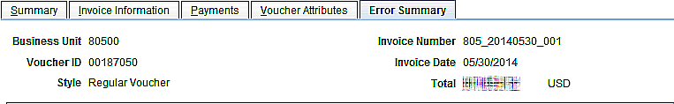
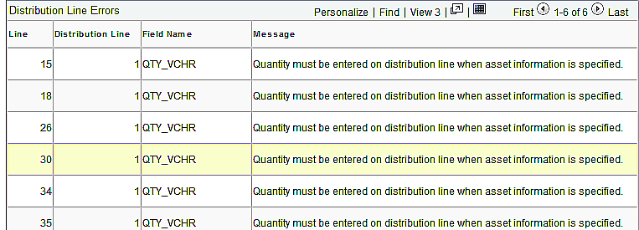

Select the Invoice Information page to add the quantities and make any additional changes to the asset transactions.

NOTE: A Voucher Line is automatically built for asset transactions from Works by transaction date and Asset Profile ID.

Built Asset Voucher Lines and Distribution Lines
Transactions from Works roll up into Voucher Lines and Distribution Lines based on similar PO ID, PO Line, PO Schedule, PO Distribution Lines, and ChartField distribution. The exception is asset transactions, which build as separate Voucher Lines based on transaction dates and Profile IDs in Works.

In the example on the previous page, six (6) asset Voucher Lines were created. Asset Profile IDs were associated with purchases in Works on five different dates during the billing cycle: one of these dates had charges with two different Asset Profile IDs.

Voucher Line 26, noted in the Voucher Error Summary page, is used to illustrate how asset Voucher Lines build.

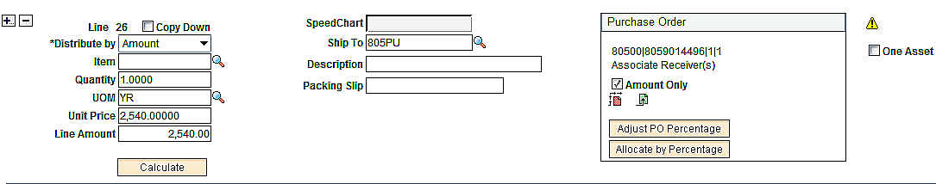

- The Voucher Line populated with no description, a quantity of 1, a UOM of YR, and a unit price that equals the charged amount.
- The number of Voucher Distribution Lines built is based on the funding recorded in Works.
- The Voucher Distribution Line Quantity is omitted.

Updating Asset Voucher Lines and Distribution Lines
How each asset Voucher Line and Distribution Line is updated depends on how many assets were purchased and how they are funded. The different scenarios illustrated on the following pages use the voucher lines on the Voucher Error Summary page on the previous page.

Single Asset – One Funding
Voucher Line 26 is selected to illustrate the fields that must be updated to interface a single asset purchased with the PCard to Asset Management when it is recorded to one chartfield distribution.

Voucher Line and Distribution Line after Voucher Build

Voucher Line and Distribution Line after Fields are Updated for Single Asset – One Funding

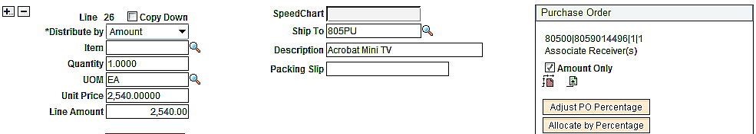

Since one asset was purchased and is recorded to one funding, none of the dollar amounts need to be changed. Update/verify the following fields:

- Description: Enter the description of the item purchased.

- Unit of Measure: Change from YR to EA.

- Voucher Distribution Line Quantity: Enter 1.

- Profile ID: Verify to ensure correct Profile ID is populated.

Single Asset – Split Funding
Voucher Line 30 is selected to illustrate the fields that must be updated to interface a split-funded single asset purchased on the PCard to Asset Management.

Voucher Line and Distribution Line after Voucher Build

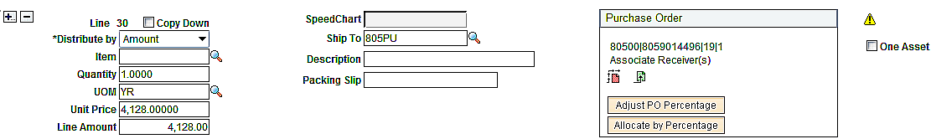

Voucher Line and Distribution Line after Fields are Updated for Single Asset – Split Funding

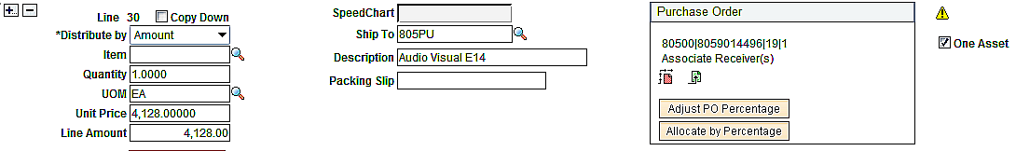
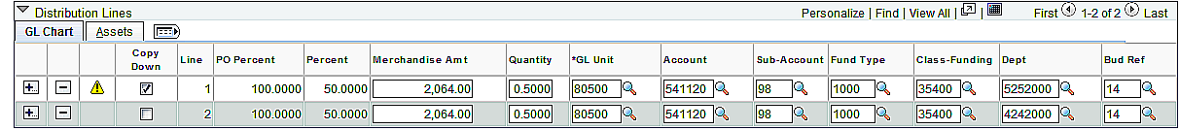

In the example, one (1) asset was purchased, but the asset was split 50/50 between two different departments. Since only one asset was purchased, none of the dollar amounts need to be changed in the Voucher Line. The following fields should be udpated/verified:

- Description: Enter the description of the item purchased.

- Unit of Measure: Change from YR to EA.

- Check the One Asset box to combine split asset distribution lines into a single asset ID when the voucher is interfaced to Asset Management.

- Voucher Distribution Line 1 Amount: Enter the dollar amount attributable to the chartfield distribution on distribution line 1.

- Voucher Distribution Line 1 Quantity: Enter the percentage attributable to the chartfield distribution on distribution line 1.

- Copy Down: Check the Copy Down checkbox on distribution line 1. The following message displays.
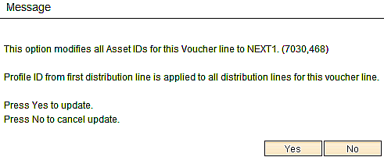

- Click .

- : Click to add voucher distribution line 2.

- Voucher Distribution Line 2 Amount: Enter the dollar amount and make the necessary change to the chartfield distribution on distribution line 2.

- Voucher Distribution Line 2 Quantity: Enter the percentage attributable to the chartfield distribution on distribution line 2. The sum of the percentages must total 1.

- Assets Tab: Click the asset tab.

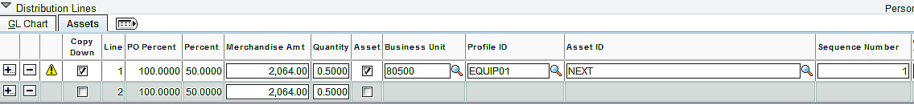

- Asset Checkbox: Check to enter the Business Unit on each copied distribution line.

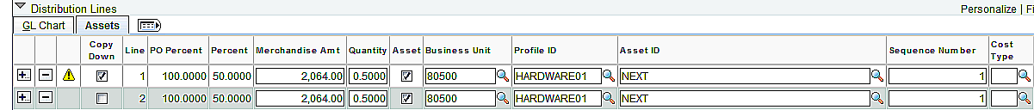

- Profile ID: Verify to ensure correct Profile ID is populated. In this illustration, the profile ID was changed from EQUIP01 to HARDWARE01.

- Sequence Number: Selecting the Use One Asset ID option causes the system to assign a value of 1 to the Sequence Number field found in the Asset tab on the Voucher Distribution Line. The Profile ID must be the same on all the Voucher Distribution Lines.

NOTE: The asset transaction may or may not have been edited in Works to record the P-Card purchase to multiple funding. If the transaction was edited, multiple Voucher Distribution Lines will build with blank quantities. If the transaction was not edited to add the additional funding, Voucher Distribution Lines can be added after the voucher is built.

Multiple Assets – One Funding
Voucher Line 34 is selected to illustrate the fields that must be updated to interface multiple assets purchased on a single PCard transaction to Asset Management when they are recorded to one chartfield distribution.

Voucher Line and Distribution Line after Voucher Build

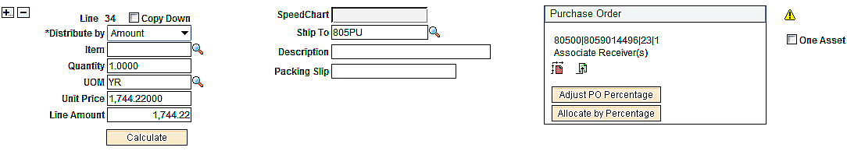

Voucher Line and Distribution Line after Fields are Updated for Multiple Assets – One Funding

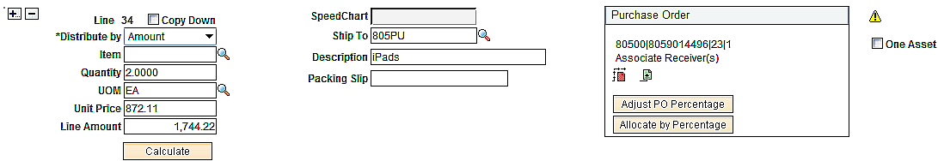

The Extended Amount represent the total dollar amount spent for all the assets purchased and should not be changed. In this example, the items purchased are the same, all have the same unit price, and they are recorded to the same ChartField distribution. The following fields should be udpated/verified:

- Description: Enter the description of the items purchased.
- Quantity: Enter the number of items purchased.
- Unit of Measure: Change from YR to EA.
- Unit Price: Change the unit price for the item. Quantity x Unit Price must equal Extended Amount.
- Voucher Distribution Line Quantity: Enter the number of items purchased.
- Profile ID: Verify to ensure correct Profile ID is populated.

NOTE: The P-Card Authority Order cannot be marked to match by Amount Only in order for Multiple Assets to interface to Asset Management properly.

Multiple Assets – Multiple Funding
Voucher Line 35 is selected to illustrate the fields that must be updated to interface multiple assets purchased on a single PCard transaction to Asset Management when they are recorded to more than one chartfield distribution.

Voucher Line and Distribution Line after Voucher Build

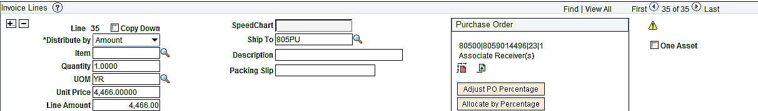

Voucher Line and Distribution Line after Fields are Updated for Multiple Assets – Multiple Funding

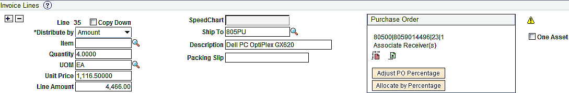
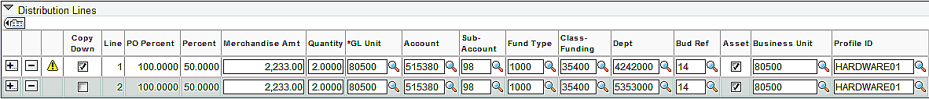

In the example, four of the same assets were purchased with the same unit price, but two are recorded to one deparment and two are recorded to another department. The Extended Amount represent the total dollar amount spent for all the assets purchased and should not be changed. The following fields should be udpated/verified:

- Description: Enter the description of the items purchased.

- Quantity: Change the number of items purchased.

- Unit of Measure: Change from YR to EA.

- Unit Price: Change the unit price for the items. Quantity x Unit Price must equal Extended Amount.

- Voucher Distribution Line 1 Amount: Enter the dollar amount attributable to the chartfield distribution on distribution line 1.

- Voucher Distribution Line 1 Quantity: Enter the number of items attributable to the chartfield distribution on distribution line 1.

- Copy Down: Check the Copy Down checkbox on distribution line 1.

- : Click to add voucher distribution line 2.

- Voucher Distribution Line 2 Amount: Enter the dollar amount and make the necessary change to the chartfield distribution on distribution line 2.

- Voucher Distribution Line 2 Quantity: Enter the number of items attributable to the chartfield distribution on distribution line 2. The quantities are whole numbers and must equal the Voucher Line Quantity..

- Profile ID: Verify to ensure correct Profile ID is populated.

NOTE: The asset transaction may or may not have been edited in Works to record the P-Card purchase to multiple funding. If the transaction was edited, multiple Voucher Distribution Lines would build with blank quantities. If the transaction was not edited to add the additional funding, Voucher Distribution Lines can be added after the voucher is built.

NOTE: The P-Card Authority Order cannot be marked to match by Amount Only in order for multiple assets to interface to Asset Management properly.

Multiple Assets – Split Funding
Voucher Line 15 is selected to illustrate the fields that must be updated to interface multiple assets purchased on a single P-Card transaction to Asset Management when they are split funded.

Voucher Line and Distribution Line after Voucher Build

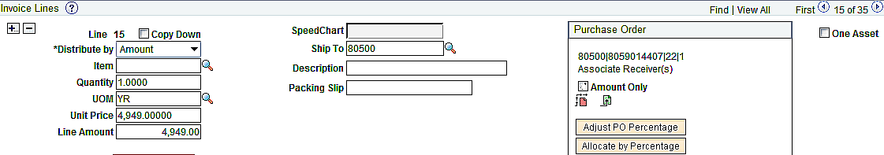

Voucher Line and Distribution Line after Fields are Updated for Multiple Assets – Split Funding

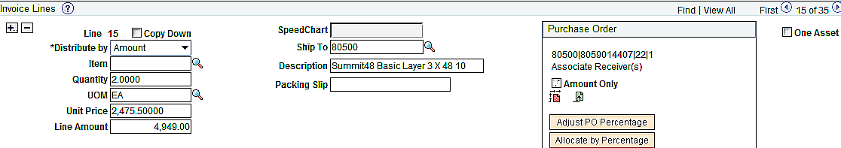
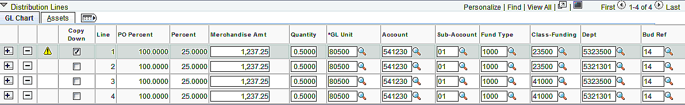

In the example, two of the same assets were purchased with the same unit price, but each asset is split 50/50 to different classes and departments. The Extended Amount represent the total dollar amount spent for all the assets purchased and should not be changed. The following fields should be udpated/verified:

- Description: Enter the description of the items purchased.

- Quantity: Change the number of items purchased.

- Unit of Measure: Change from YR to EA.

- Unit Price: Change the unit price for the items. Quantity x Unit Price must equal Extended Amount.
- Voucher Distribution Line 1 Amount: Enter the dollar amount attributable to the chartfield distribution on distribution line 1.

- Voucher Distribution Line 1 Quantity: Enter the percentage attributable to the chartfield distribution on distribution line 1.

- Copy Down: Check the Copy Down checkbox on distribution line 1.

- : Click to add the number of voucher distribution lines necessary.

- Copied Voucher Distribution Line Amounts: Enter the dollar amounts and make the necessary changes to the chartfield distribution on each copied distribution line.

- Copied Voucher Distribution Line Quantities: Enter the percentage attributable to the chartfield distribution on each copied distribution line. The sum of the percentages must total the Voucher Line Quantity.

- Assets Tab: Click the asset tab.

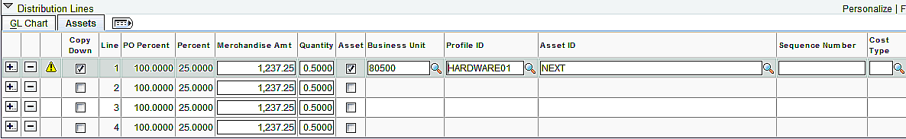

- Asset Checkbox: Check to enter the Business Unit on each copied distribution line.

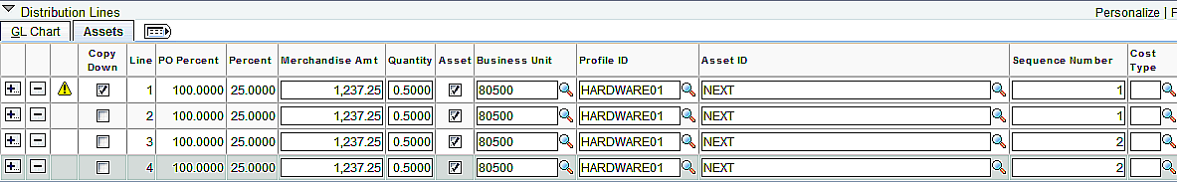

- Profile ID: Verify to ensure correct Profile ID is populated on distribution line 1. Enter the same profile ID in copied distribution lines.

- Sequence Number: Enter the same sequence number, beginning with 1, to identify split Voucher Distribution Lines that should be combined into a single asset ID when voucher is interfaced to Asset Management. In the example, the first and second Voucher Distribution Lines and the third and fourth Voucher Distribution Lines will combine into two single assets and still maintain the funding used to purchase the assets in Asset Management.

- Cost Type: Populate with C to designate a CAFR asset when the assets unit price is equal to or greater than $25,000.

NOTE: The P-Card Authority Order cannot be marked to match by Amount Only in order for multiple assets to interface to Asset Management properly.

Non Asset Transaction Built with Profile ID
A Profile ID can be added to a PCard purchase in Works that is not an asset. The transaction will build as a separate Voucher Line with a zero quantity. The quantiy will need to be added to the Voucher Distribution Line and the Asset Checkbox will need to be deselected. Voucher Line 18 is used to illustrate a PCard transaction with a Profile ID incorrectly added in Works.

Distribution Line Asset Tab after Voucher Build

Distribution Line Asset Tab after Asset Box is Deselected

Since this purchase amount is less than the asset threshold amount, deselect the Asset Checkbox to prevent the charge from interfacing to Asset Management and add the quantity to be able to save the voucher.

- Voucher Distribution Line Quantity: Enter 1.
- Asset Checkbox: Deselect to remove AM Business Unit, Profile ID, and Asset ID.

NOTE: Profile ID can be added incorrectly to any PCard transaction. even for agencies that have not mplemented Asset Management.

Asset Transaction with No Profile ID Recorded In Works
Transactions recorded with an asset account code but no Profile ID in Works will roll up with other charges into a Voucher Line and Voucher Distribution Line with similar PO ID, PO Line, PO Schedule, PO Distribution Lines, and ChartField values. The Voucher Distribution Line quantity will be populated with a 1 and will not be identified as an asset transaction. Without the Profile ID, the asset will not interface to Asset Management.

If an asset purchase was not designated with a Profile ID in Works but it should be interfaced to Asset Management, copy the PO Line, PO Schedule, and PO Distribution Line onto the voucher to create a separate Voucher Line so that the correct quantity and unit price can be recorded, and the Asset Profile can be added on the Voucher Distribution Line(s). Delete the original Voucher Distribution Line that copied from Works.

P-Card Voucher Checklist
 | Task | Initials | Date | Comment
1.01 | Create voucher(s) when voucher build is available. Refer to P-Card Scheduled Paycycle calendar maintained by the helpdesk.
 | - Accounts Payable> Batch Processes> Vouchers> Voucher Build.
 | - Enter Run Control ID.
 | - Run the Procurement Card interface.
1.02 | Return to Voucher Batch Request and check for errors.
 | - Process Messages page identifies number of vouchers processed with Entry Status of Recycle or Postable.
 | - Build Errors page lists the voucher ID(s) and invoice number(s) of the vouchers that are in Recycle status.
 | - Click Examine Error Message link to identify errors at the voucher header, line, and/or distribution line level.
 | - Click Correct Errors link to access voucher and correct errors for vouchers with Entry Status of Recycle.
1.03 | Search by Supplier ID or Voucher Source on the Voucher search page to identify the voucher(s) created when the vouchers was created in a Postable status.
 | - Accounts Payable> Voucher> Add/Update> Regular Entry> Find an Existing Value.
 | - Search by Supplier ID 0000001101 or Procurement Card Voucher Source.
2.01 | Review the voucher.
 | - Verify the amounts and funding.
 | - Verify that the accounts are proper as inappropriate account codes assigned based on the MCC codes for each merchant may not have been changed in Works.
2.02 | Run the on-demand action of “Match, Doc Tol, Bdgt” after the voucher is reviewed and/or corrected, and the Entry Status of the P-Card voucher is Postable.
 | - Correct document tolerance exceptions.
 | - Run the Vouchers Processed against PO report to research.
 | - Request CPO increase the encumbrance, or if Works linked the expenditure to the incorrect PO distribution line, copy the PO onto the voucher, make the necessary changes to the correct PO distribution line, and delete the erroneous voucher distribution line.
 | - Correct budget checking errors.
 | - Link to the Commitment Control Line Exception page to research.
 | - Correct the voucher/PO and rerun the on-demand budget checking.
2.03 | Run PO Accounting Entries to ensure the correct encumbrances are liquidated.
 | - If the voucher liquidated incorrect PO distribution line(s) based on the data copied from Works, copy the PO into the voucher, make the necessary changes to the correct PO distribution line(s), and delete the erroneous voucher distribution line(s). Re-budget check the voucher and rerun PO Accounting Entries.
 | - Request the P-Card administrator modify card defaults to ensure future vouchers liquidate encumbrances properly.
2.04 | Do not change the Supplier ID, Remit To Supplier, the invoice number, the invoice date, or the PC pay group.
3.01 | Print the voucher jacket(s) and obtain authorized signatures on the voucher jacket(s).
3.02 | Attach voucher jacket(s) to the Billing Statement.
3.03 | Run a PC Batch Slip and obtain proper signatures.
3.04 | Attach the Batch Slip to the voucher(s).
4.01 | Submit batch to the Office of Management & Enterprise Services by 5:00 p.m. on the scheduled submission deadline. Fax copies to 405-521-3383 if interagency mail cannot accommodate the deadline. The faxed copies will be replaced with the originals upon receipt.
 | - Retain the batch if the voucher is for a credit amount.
 | - Submit the batch slip listing the unpaid vouchers from the prior and current billing cycles when there are sufficient charges to recoup the credit. The Billing Statement should accompany the vouchers from each billing cycle.
5.01 | Ensure the appropriate review and documentation of reportable 1099 transactions for subsequent transmission to the Office of Management & Enterprise Services per the guidelines provided separately to the state agencies.

