COR198 ELM Internal Catalog

Administrator Manual

Authorized by: [_CORE_] Original Issue: [07/31/2009]
Maintained by: [____ELM Lead___] Current Version: [01/01/2011]
Review Date: [12/31/2011]

Table of Contents
Document History 4
ELM Overview 5
Role Definitions 5
ELM Glossary 6
ELM Sign In 8
Set Learning Environment 10
Creating Catalog Entry 11
Creating Catalog Entry (From Item to Session) 11
Adding Attachments and Files to Activity 37
Activating an Activity 41
Rebuild Indexes 43
Canceling an Activity 45
Deleting an Activity 48
Cloning an Activity 50
Security Access Process 55
HCM Resources 56

Document History

Document Revision | Date | Description
1.0 | 07/31/2009 | Initial Document
1.1 | 07/23/2010 | Update and ADA compliance
1.2 | 11/22/2010 | Added screen shot in Item Maintenance
1.3 | 01/01/2011 | Added the Change Learning Environment page

ELM Overview
Enterprise Learning Management, (ELM) is internet-based training solution that enables the State of Oklahoma to manage, track, deliver and report on learning delivered through established methods, within or outside of the organization. ELM is the State of Oklahoma's central system of record for learners, managers, instructors, and administrators.

Role Definitions
ELM Internal Catalog Administrator – Each agency will identify a Catalog Administrator within their respective agencies to manage their Learning Environments for their employees.

ELM Glossary
Activity Roster: Shows all learners enrolled in an activity, (course).

Activities: Activities is an instance of a catalog item, (equals “course”).

Catalog: This is a repository of detailed information about all learning activities and programs available to the agencies employees, partners and customers. Learners can browse and search the catalog for relevant learning activities and programs. Rule: The categories, learning activities, and programs that learners can view are determined by the learner group(s) the user belongs.

Category: Classification of catalog items and programs to help the learners and managers easily find appropriate courses. Rule: Catalog items and programs can belong to multiple categories.

Catalog Item: Represents a specific topic of study for which learning activities are offered, (equals course). Rule: May have multiple learning activities associated.

Certification: Program enforces a fixed time period within which the learner must complete all items to become certified in a particular area. Rule: There is an expiration date, completion rules and recertification rules. Can apply a single set of expiration rules to the entire program or define different expiration rules for each section of the program, (cascading expirations).

Certification Status: Status of Certification Program.

Component: This is a descriptive title for types of training that can be provided: Web-Based, Sessions, Assignment, Survey, Test, Webcast, Recorded Webcast or Podcast.

Curriculum: Program has no built-in frame for completion. Rule: The record of completion does not expire; therefore, the learner needs to only complete the curriculum once.

Delivery Method: Defines how course offerings are presented to users, i.e., Classroom, Self-paced, Blended.

Enroll vs. Register: The term enrollment is used for activities, (course) and the term registration is used for programs. Rule: Before learners can participate in a learning activity or program, they must enroll in the activity or register for the program.

Learner Group: Learner Groups are defined groups of learners that share some of the same learner attributes, such as the same department, region or job code. Rule: Specify the categories, catalog items, activities and programs a learner can access through the catalog.

Learning Component: Building block of an activity or course. There are six (6) basic types of components: Session, Web-Based, Webcast, Test, Survey and Assignment.

Learning Environment: Provides a way to create separate domains within the learning catalog for Office Personnel Management HRDS courses and CORE courses and individual agency offered courses. Rule: Also enables administrators to access the resources available for assignment, i.e., equipment, facilities, rooms, materials instructors.
Learning History The history of completed activities for a learner.

Learning Plan: The Learning Plan is a list of planned activities for a learner.

Nested Program: A Nested Program exists as a section within another program. Rule: Nested Program cannot include another nested program.

Objectives: Enables learner of manager to target and recommend learning for an individual. Rule: The system can assign objectives to learners based on their position or job requirements. Managers can assign objectives to team members; learners can self-assign objectives; and administrators can assign objectives to groups of learners. Learners can search the catalog for activities and programs to meet specific objectives. The system can track learner progress toward meeting objectives and maintain a history of each learner’s met objectives.

Process Instance: A unique number that identifies each process request. This value is automatically incremented and assigned to each requested process when the process is submitted to run.

Process Request: A single "run request," such as an SQR or Crystal report.

Program: Represents a significant learning goal that can be achieved by completing multiple learning activities, i.e., certificate, license, skill or competency. Programs can be used to guide learners along a specific learning path, presenting activities in a logical sequence. Two (2) types of programs: Curriculum and Certification.

Program Roster: Summary showing all learners for a program.

Run Control ID: A unique ID, associating each operator with his or her own run control table entries.

Supplemental Learning: Learning offered outside of learning catalog, i.e., conferences, skill development training, agency required training, etc.

ELM Sign In
As with all other Oracle applications, you will receive a User ID and Password for the Training Administration module from CORE Security. The Sign-In Screen example is provided below and is the same as other PeopleSoft sign-in applications.

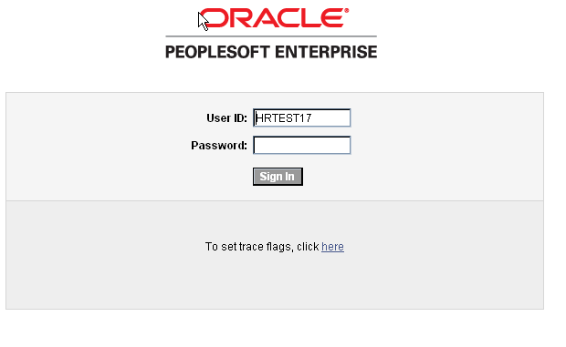

Oracle - PeopleSoft Sign-in Link:
https://corehr.oklaosf.state.ok.us/psp/mrhri/?cmd=login&languageCd=ENG&

After your initial log in, the system will prompt you to change your password. The new password must be at least eight (8) characters long with at least one number. You can choose small or capital letters.
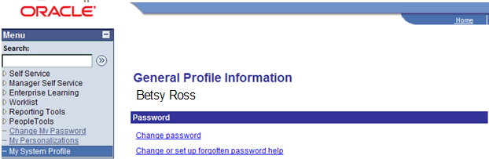

On the My System Profile Link on the Menu bar set up forgotten password help.

Click My System Profile.
Click Change or set up forgotten password help link.

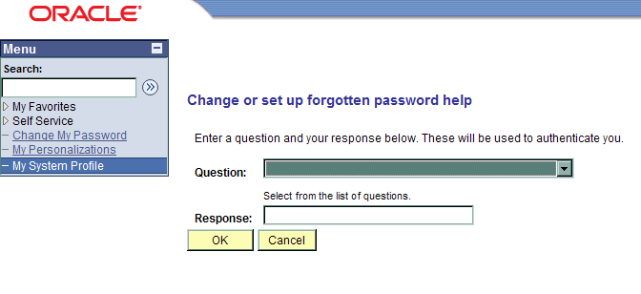

Choose the on the Question field, and select the question.
Enter answer in the Response field.
Click .

If you forget your password, please call the Office of State Finance Help Desk: 405 521-2444 or 866 521-2444. The Help Desk can reset your password over the phone. If you have not been active in the Enterprise Learning application for more than 60 days, you will lose your security access. To regain security access, resubmit the OSF Form 304.

CORE Security Link: http://www.ok.gov/OSF/CORE/Security/index.html

Set Learning Environment
To obtain access to the various Learning Environments to be able to see the courses offered from CORE and Office of Personnel Management, the Learning Environment must be changed. Your agency will be the default environment. To be able to enroll employees in CORE or HRDS courses, the Learning Environment must reflect either Office of State Finance or Office of Personnel Management respectively.

Navigation: Enterprise Learning > Set Learning Environment

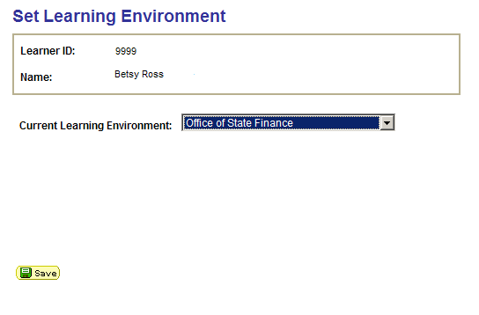

Choose to select Office of State Finance for CORE courses or Office of Personnel Management for HRDS courses.

Click

To view your agency’s courses, choose the and select your agency’s name and click

Creating Catalog Entry
The catalog supplies detailed information about each activity. Within this detailed information is a description of its content, learning objectives, prerequisites, and other features.

Creating Catalog Entry (From Item to Session)
Catalog items are specific topics of learning. All activities that belong to a given catalog item share the same prerequisites, equivalent courses, and objectives.

When you define a catalog item, you select the prerequisites, equivalent courses, and objectives that apply to all of the catalog item’s activities. You also select various default values for the activities.

To define catalog items:

- Enter the catalog item’s name, course code, and other basic information.
- Select required and recommended prerequisites.
- Identify equivalent catalog items.
- Add notes and attach files.
- Define security by selecting the learning environments and learner groups that can access the catalog item.
- Select categories and objectives for the catalog item.
- Define delivery methods for the catalog item’s activities.

Navigation: Enterprise Learning > Catalog > Maintain Items

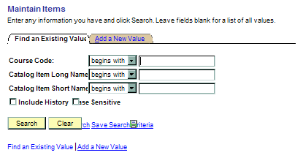

Click Add a New Value Tab.

NOTE: Use the Item Details - Catalog Item Basic Data page to enter the name, course code, and other basic information for a catalog item.

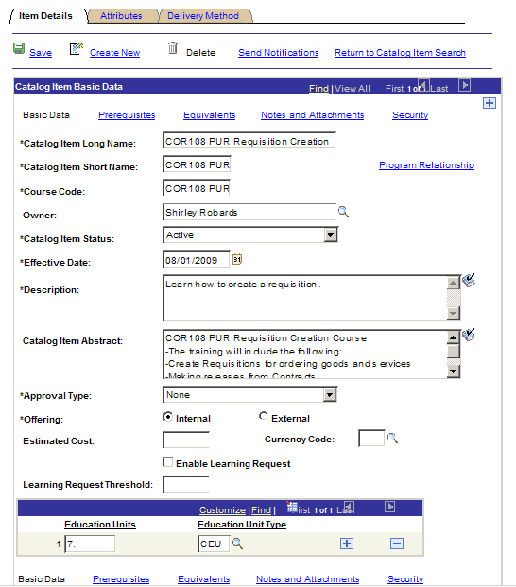

Enter Catalog Item Long Name.

Enter Catalog Item Short Name.

Enter Course Code.

Choose next to the Owner field, and select correct Owner.

NOTE: The Owner field is for informational purposes. This could be the person to contact with issues concerning this catalog item.

Choose next to the Catalog Item Status field, and select Active.

Click Effective Date field.

NOTE: The Effective Date defaults to the date entered. The date CANNOT be forward dated because the Learning Administrator will not be able to see the Item, (Course) until the date has been reached. When the Item(s) are entered for a go-live date, a current or past date will ensure the Learning Administrator can view and manage the Catalog Items.

Enter Description. (This is the Short field).

Enter Catalog Item Abstract field. Catalog Item Abstract field is shorter version of Course Description. (This is the Long field).

Choose next to the Approval Type field, and select correct Type.

NOTE: Use the Approval Type field to specify whether a manager or learning administrator's approval is required to enroll internal learners in activities that are associated with this catalog item. If you select Learning Admin, you must select the administrator through the Administrator field on the Activity Details page.

On the Offering field, click either Internal (offered by agency) or External (offered by external vendor).

Enter Estimated Cost

Enter Currency Code

Enable Learning Request box defaults in as checked to trigger system to send Administrator notice of request for training from learners.

Enter number for Learning Request Threshold field.

Click and choose correct type Education Units.

Click Prerequisites link, (if this Item has a prerequisite, if not skip this step).
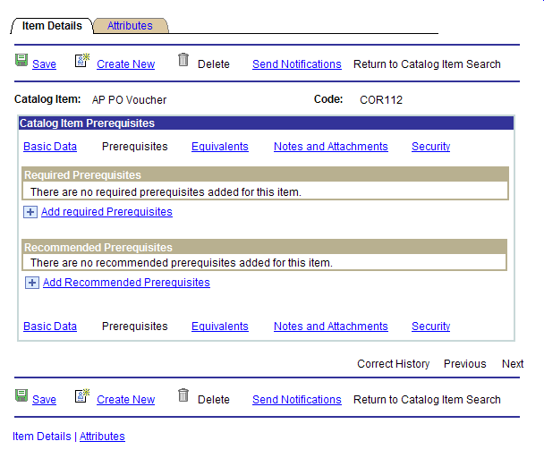

Click Add Required Prerequisites link.

Click Add Recommended Prerequisites link.

NOTE: Use the Item - Prerequisites page to define required and recommended prerequisites. Prerequisites can be other catalog items or objectives, and they are listed on the enrollment pages. To enroll in an activity when prerequisites have been selected, a learner must complete any required prerequisites or an equivalent catalog item, if applicable. If a Recommended Prerequisites is utilized, the system will allow the learner to take the Item in any order they choose.

Click Security link.
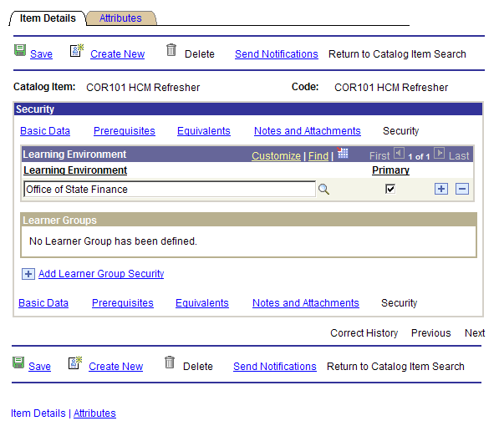

NOTE: Use the Item - Security page to share a catalog item with other learning environments and to select the learner groups that can access the catalog item. By default, the administrator's Learning Environment is designated as the primary environment. As with categories, initially an administrator can make a catalog item available only to learner groups that are associated with the administrator's environment.

Click Add Learner Group Security link.

NOTE: The Learner Group Description defines the learner groups that can enroll in this catalog item.

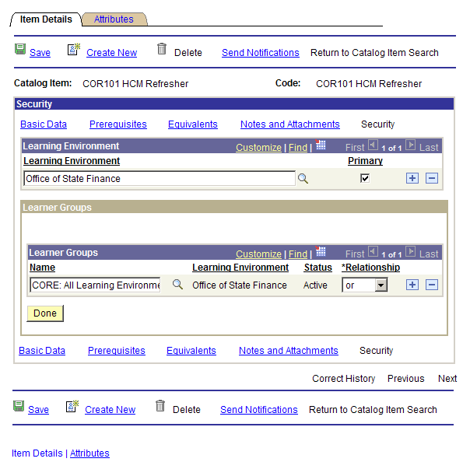

Choose next to the Learner Group Name field, and select Agency Name.

Click on the Relationship field and choose OR.

Click .

Click Attributes Tab.

NOTE: Use the Attributes page to associate categories and objectives with a catalog item.

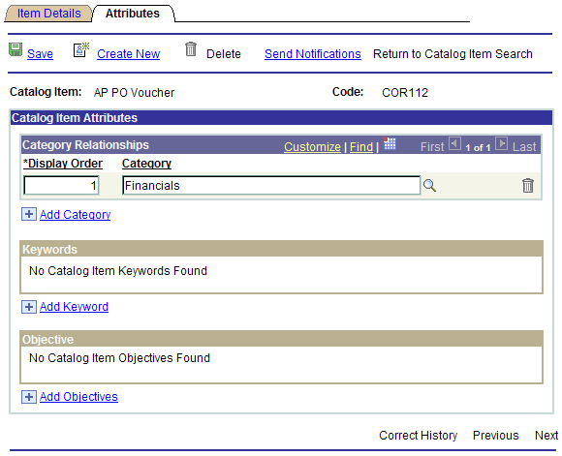

Click Add Category link.

NOTE: The Display Order field specifies the relative order in which a catalog item is to appear within the selected category. Assigning the same number to more than one item does not prevent those items from being displayed, but their order will be unpredictable.

Enter Display Order

Choose next to the Category field, and select correct Category.

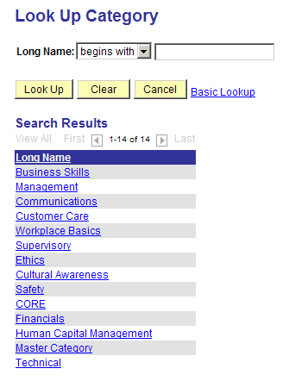

NOTE: The Category field defines the category this item belongs to. When learners search the catalog by the Business Skills category, only items belonging to Business Skills will be displayed. Items can be placed in more than one category.

To add another category to an Item, click Add Category link and enter Display Order and click next to the Category field, and select correct Category.

Keywords and Objectives can also be added to the search function for the Item.

Click
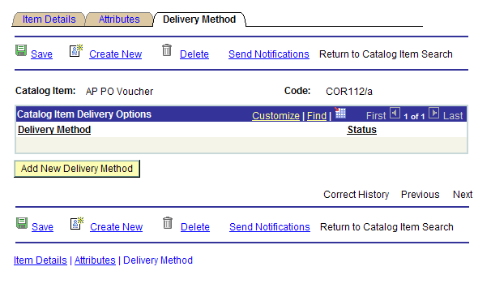

Click Delivery Method Tab.

Click .
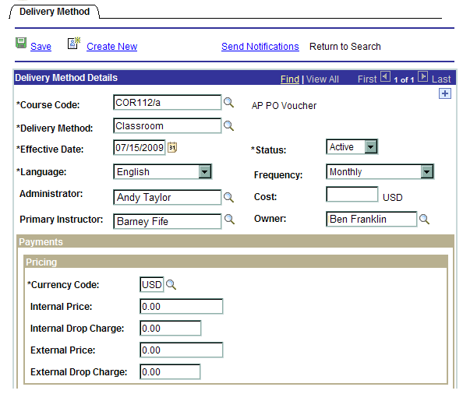
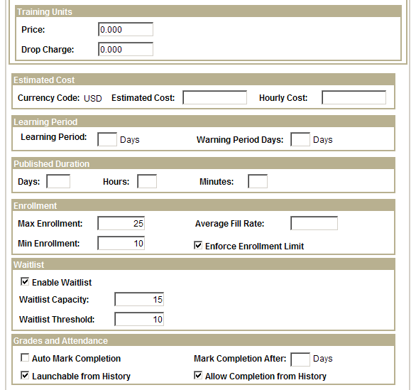
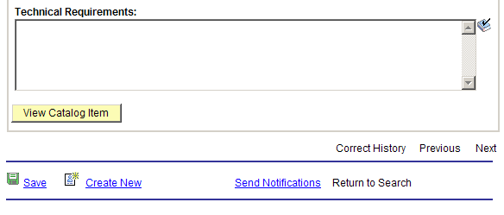
Choose next to the Delivery Method field, and select correct delivery method.

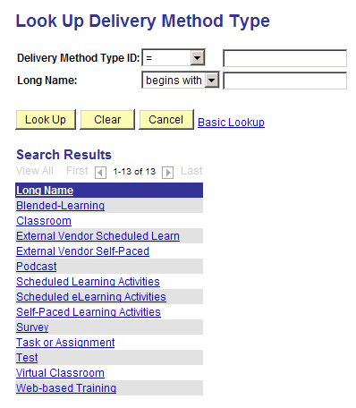

Effective Date Field: Use the Effective Date to define when this delivery method is available to this catalog item.

Choose next to the Status field, and select Active.

Language Field: English Defaults

Choose next to the Frequency field, and select correct frequency.
Choose next to the Administrator field, and select Learning Administrator entering the Item.

NOTE: The functional person in charge of the Course content.

Enter Cost, if applicable.

NOTE: Cost is not a required field.

Choose next to the Primary Instructor field, and select correct Instructor.

The following sections are optional: Payments, Training Units, Estimated Costs, Learning Period, and Published Duration,

Enter Max Enrollment, for the primary facility the Item will be held. This number can be changed with the Activity as different facilities are utilized.

Enter Min Enrollment.

Check Enforced Enrollment Limit.

Check Enable Waitlist.

Enter Waitlist Capacity, (this field will assist the Learning Administrator track if further Activities need to be scheduled.

Enter Waitlist Threshold

Click

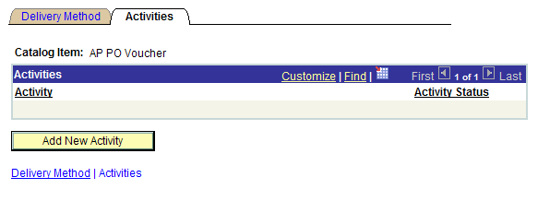

Click Activities Tab. (Activities = Course Offering)

Click

NOTE: The Activity Details page defines the general and pricing information for this activity. Most of the fields are populated from the Catalog Item details. These defaults can be modified for the individual activity.

NOTE: The information on the Activity Details page will override any information that was entered on the Delivery Methods page. This page should be used as the main page of reference for these fields.

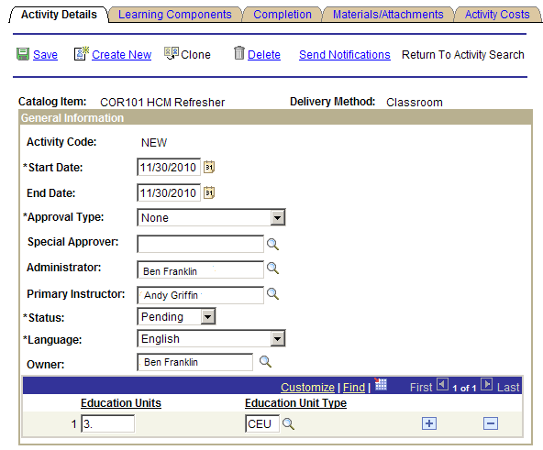

Activity Code: The Activity Code field populates automatically.

Enter Start Date.

NOTE: The Start Date indicates the first day of the activity. The Start Date can trigger notifications, such as activity start reminders, to enrolled students. You can also use the Start Date field to control access to third-party vendor content that should not be made available before a certain date.

Enter End Date.

NOTE: The End Date indicates the last day of the activity. For self-paced activities that will be available indefinitely, the End Date field should be left blank.

Choose next to the Approval Type field, and select correct Type. Default for this field is None.

NOTE: Use the Approval Type field to indicate the level of approval the learner needs in order to enroll in this activity.

Choose next to the Special Approver field, and select correct Approver.

Choose next to the Administrator field, and select correct Administrator for the Activity.
Choose next to the Primary Instructor field, and select correct Instructor, (please see note).

NOTE: Next Steps: When first entering a new Item and Activity, the Instructor(s) will need to be associated with the Item and Activity after the Activity has been entered. The Instructors cannot be associated with an Item or Activity until the Items and Activities have been built.

Enter Status: Choose PENDING.

NOTE: Later in the process this status will be changed after the Sessions, (course dates) have been completed. If an Active status is chosen at this time, it will be posted, as the Activity is being built in the Catalog.

Choose next to the Language field, and select correct Language. English will default into this field.

Choose next to the Owner field, and select correct Owner.

NOTE: The Owner is the person who is notified when the minimum enrollment is not met for the activity, (Learning Administrator). By default, the system displays the name of the administrator who creates the activity. If the agency is charging for Activities, (courses), the Owner field also affects where the Revenue of a class is deposited. If a cost is associated with the class, the Owner field must contain a person that belongs to the Department, or if applicable, the Division, to which the money will be funded.

Enter Education Units.

NOTE: Use hours the course is going to be provided, i.e., 4 hours = 4, 7 hours = 7, 2 day – 7 hours-a-day = 14.

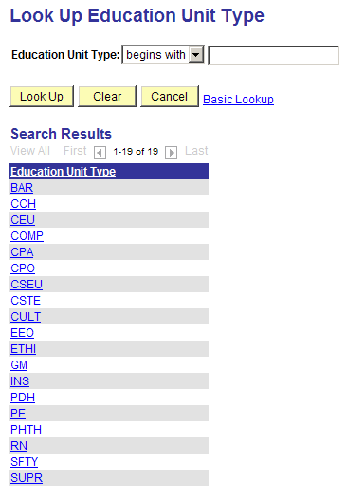

Choose next to the Education Unit Type field, and select Unit type.
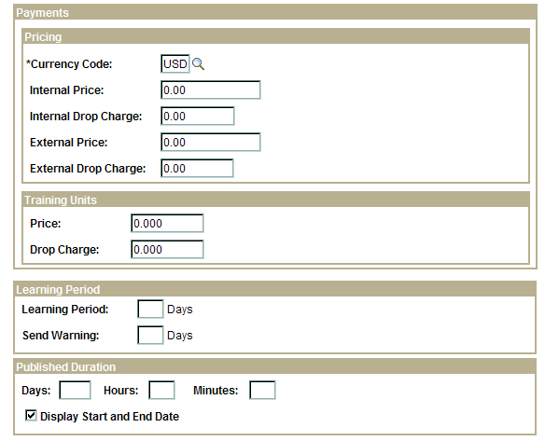

REMINDER: Remember the fields that have an * (asterisk) are the only required fields.

Payments Section is not being used at this time.

Training Units are prepaid units that external organizations can purchase at a discounted price. They enable you to pre-sell training that learners can use at a later date. The system depletes training units from the prepaid account each time a learner from the customer organization uses the account to pay for enrollment, registration, or drop fees, (This is a future feature).

Learning Period: Used for Self-Paced Study. Enter the number of days after the start date or enrollment date (whichever is greater) that learners have to complete the activity. Learning periods are particularly useful for learning activities that contain web-based, test, or survey learning components.

Published Duration: For the Days, Hours, and Minutes: Enter an estimate of how long the activity should take. This should be the total of the duration of the learning components that make up this activity, plus any other time you think it might take the learner to complete. The activity duration you enter here appears on the Activity Details and Activity Progress pages. Duration is the amount of time the learning activity should actually take to complete, whereas the learning period is the amount of time the learner has to complete the activity. Display Start and End Date: Select if you want to display the activity start and end date to learners. The default for this field is selected.
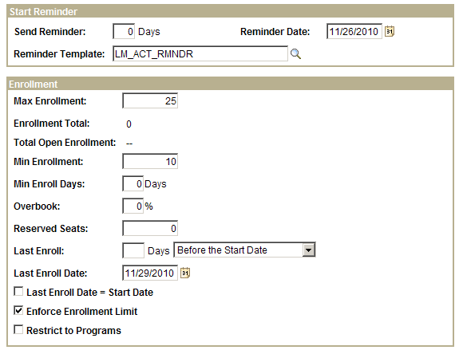

Reminder Date: Choose the icon to select a specific date. Choosing the specific Reminder Date is the most reliable method. Two (2) working days before the Activity Date is the standard.

NOTE: A scheduled PeopleSoft Application Engine process performs the activity reminder notification.

Enter Reminder Template: Select LM_ACT_RMNDR to send a reminder to the learners.

Max Enrollment (maximum enrollment): Enter the maximum number of learners you want to enroll in this activity. When this number has been reached, the system closes the activity to further enrollment unless overbooking is permitted; in which case the system continues to enroll learners up to the user-specified overbook percentage. Enrollment Total: Displays the number of learners who have successfully enrolled in the activity. The total reduces if enrollments are cancelled or postponed. The enrollment process keeps this field updated.

Total Open Enrollment: The system displays the total amount of seats that are currently available for open enrollment.

Min Enrollment (minimum enrollment): Enter the minimum number of learners you want to be enrolled for this activity.
Min Enroll Days (minimum enrollment days): Enter the number of days before the activity start date that you want the minimum enrollment notification sent to the enrollment administrator and activity owner to alert them that the minimum enrollment has not been reached.

Overbook: Enter the percentage above the maximum enrollment value that you will allow enrollment. The overbook value, multiplied by the maximum enrollment number, is the total number of enrollments that the system accepts before the system assigns the waitlist status to a learner who tries to enroll in this activity.

Reserved Seats: Enter the number of reserved seats. Only a training administrator can enroll learners into reserved seats. Use reserved seats to reserve seats for groups of learners without naming specific learners.

Last Enroll (last enrollment): Enter the number of days Before the Start Date or After the Start Date to indicate the last day enrollment is permitted. This is useful, for instance, when you want to close enrollment to accommodate the ordering of materials for the activity.

Last Enroll Date: Choose the icon to select a specific date. Choosing the specific Reminder Date is the most reliable method. Alternatively, you can specify how many days before or after the activity start date learners can enroll in the Last Enroll field or you can set the last enroll date at the activity start date by selecting the Last Enroll Date = Start Date check box.

OR use the Last Enroll Date = Start Date (box): Select if you want the last day learners can enroll in this activity to equal the activity start date.

Enforce Enrollment Limit: Select Enforce Enrollment Limit box to prevent learners from enrolling in this activity when the maximum enrollment number plus the overbook percentage is reached. You must select this check box to have the system generate a waitlist for this activity.

Restrict to Programs: Select this box if you want this activity to only be available to a learner who is enrolled in programs that require this activity for completion. Administrators can enroll learners in activities that are restricted to programs by using the Enroll Learners component.
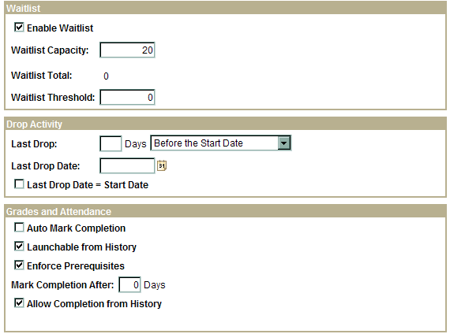

Enable Waitlist: Select Enable Waitlist box if you want the system to accept waitlisted learners for this activity when the maximum enrollment number has been reached. If overbooking is permitted, the system does not waitlist learners until the overbook percentage is reached.

Waitlist Capacity: Enter the maximum number of learners that the system can put on the waitlist.

Waitlist Total: Displays the number of learners on the waitlist. The enrollment process increases or decreases this number as learners are added to or removed from the waitlist.

Waitlist Threshold: Enter the number of learners on the waitlist that will trigger a notification to the administrator.

Last Drop: Enter the number of days Before the Start Date or After the Enrollment Date that a learner can drop the activity without paying the drop fee. Alternatively, you can enter a specific date in the Last Drop Date field.

Last Drop Date: Choose the icon to select a specific date. Choosing the specific Last Drop Date is the most reliable method. Last Drop Date field is also used to determine when a learner can drop the activity without paying a drop fee.

OR use the Last Drop Date = Start Date (box): Select if you want the last day learners can drop this activity without having to pay a drop fee to equal the activity start date.

Grades and Attendance: Launchable from History, Enforce Prerequisites and Allow Completion for History are defaulted.
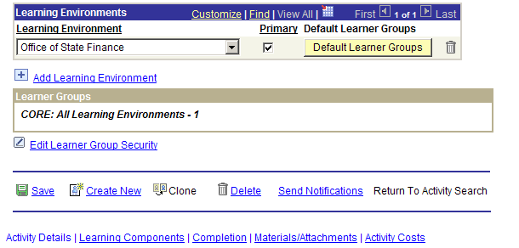

Click .

Click
Click Learning Components Tab.

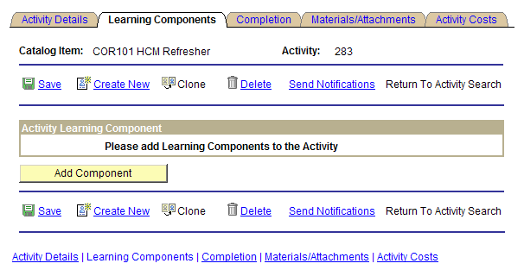

Click .

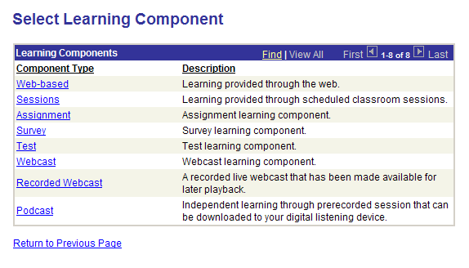

Click Sessions link.

NOTE: Component is a type of training that can be provided: Web-Based, Sessions, Assignment, Survey, Test, Webcast, Recorded Webcast or Podcast. The component name appears on the Activities Details page.

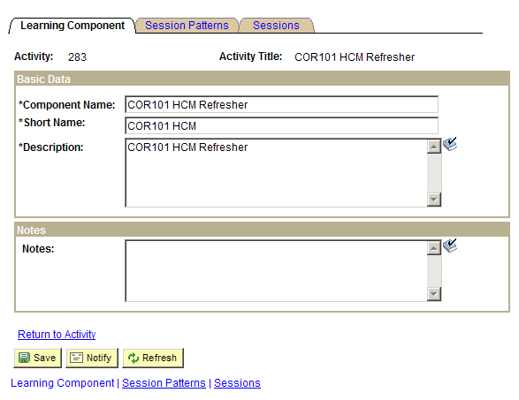

Enter Component Name, (Name of course). Hint: Copy Paste from Activity Title.

Enter Short Name. Hint: Copy Paste from Activity Title

Enter Description. Hint: Copy Paste from Activity Title
Click Session Patterns Tab.

NOTE: Use the Session Patterns Tab to create session patterns, i.e., Monday – Friday, 8:00 AM – 4:00 PM or Tuesday and Thursday, 9:00 AM – 4:30 PM. Use session patterns to generate actual sessions when the session has a repeating pattern.

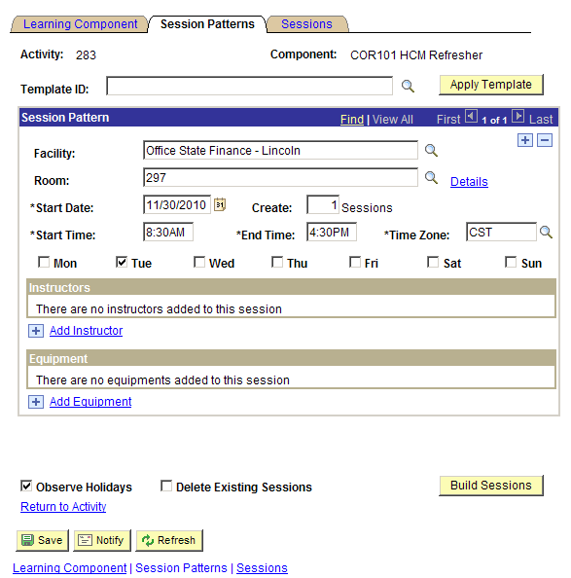

Template ID field is not being used.

Choose , next to Facility field, and select Facility.

Choose , next to Room field, and select Room.

Review Start Date field.

Click Create field and enter 1 Sessions.

Enter Start Time.

Enter End Time.

Choose , next to Time Zone field, and select CST.

Check the CORRECT day of the week(s).
Click Add Instructor link and choose correct instructor. Use this field if you intend to inform the learners who the instructor will be for this Activity.

NOTE: For the instructor name to be visible in this field, the instructor profiles must have previously been added, to be able to select the instructor for a Session.

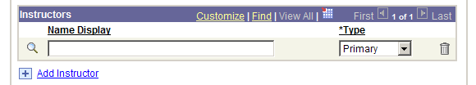

Select to select the Instructor.

Choose next to Type list field, and select Primary.

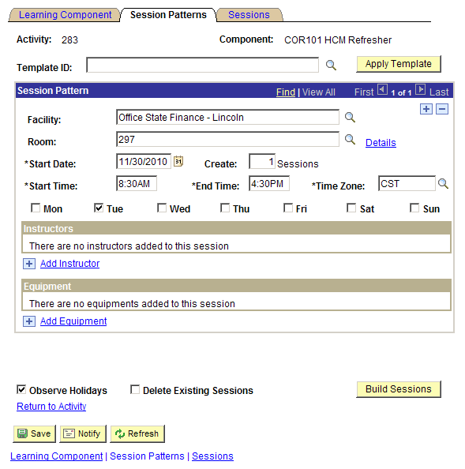

Click !
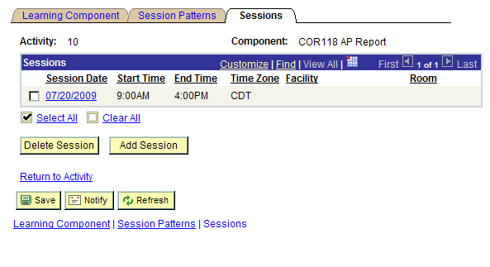

Review the Session data for accuracy.

Click

Click Return to Activity link.

If you are ready to enrollment, change Status to Active.

Click

Adding Attachments and Files to Activity
Enterprise Learning Management enables you to associate materials, attach files, and add notes to activities. You will use the shipping fields to track the progress of ordered materials. Distribute activity handouts, a syllabus, or other online materials by attaching Word files, Excel files, or files of any other format.

Navigation: Enterprise Learning > Catalog > Maintain Activities

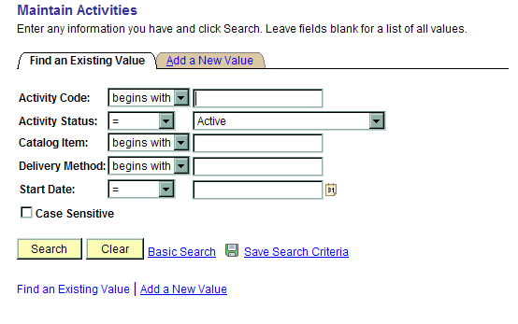

Click Activity Code field and enter Activity Code.

Click .
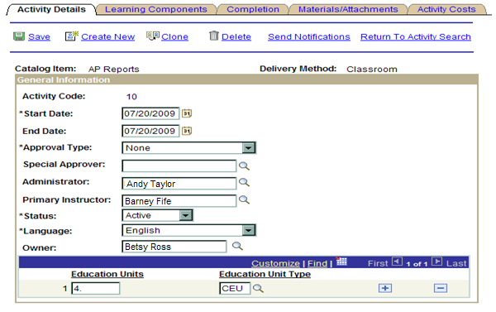

Click Materials/Attachments Tab.

NOTE: Use the Materials/Attachment page to add, edit, or remove activities. The Description field defines the material to be associated with this activity. You must use material that has already been defined.

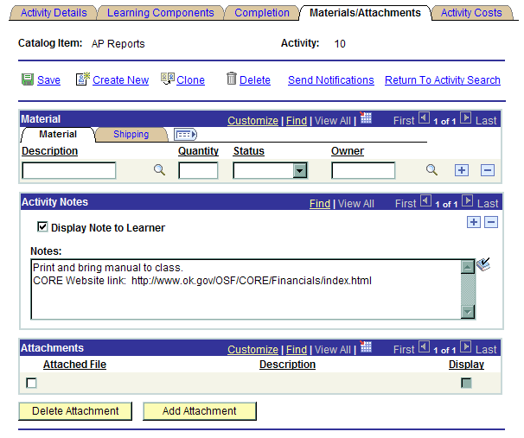

Choose , next to Material Description field and select Material Type.

Enter Quantity.

Choose , next to Status field, and select Progress or Shipped.

NOTE: Select Progress when you are in the process of assembling the materials, or when you have placed an order with a supplier for the materials and are still waiting to receive them. Update to Shipped when the supplier or carrier advises you that the order has been dispatched and provides you with shipping details, some of which—such as tracking number.

Use the Activity Notes section to display notes to learners enrolled in this activity.

Check Display Note to Learner.
Enter desired information into the Notes field, i.e., Remember to print and bring manuals to class.
Click .

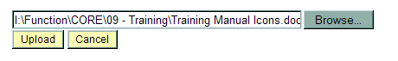

Click .

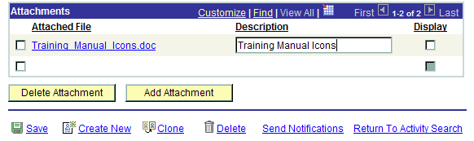

Click .

Click .

Click .

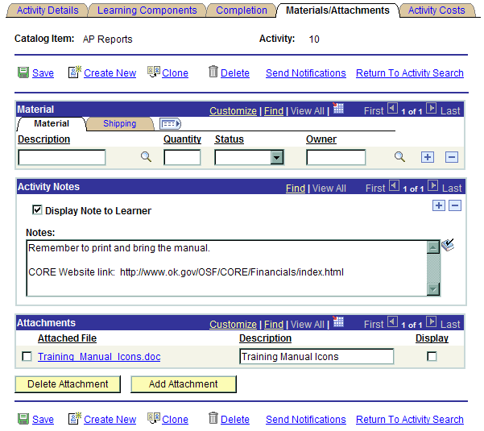

Click

Activating an Activity
The initial status for all new activities is Pending. After you set up an activity and are ready for enrollment, return to the Maintain Activities Page to change the status.

Navigation: Enterprise Learning > Catalog > Maintain Activities

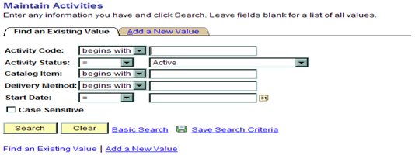

Enter Pending in Activity Status and click , or

Enter Activity Code and click .

NOTE: After creating an Activity, you will have to make the activity Active for it to be seen in the Catalog. Use the Activity Status field to activate or cancel an activity.

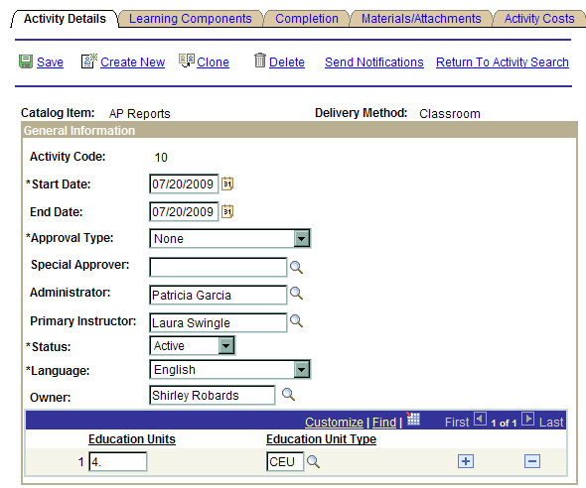
Choose , next to Status field, and select Active.

NOTE: Once an activity is activated, it will be added to the catalog, enabling learners to enroll in the activity.

Click

Rebuild Indexes
To be able to enroll learners immediately after creating an Activity, a process called Rebuild Indexes must be completed. The Rebuild Indexes process is run every 55 minutes, however, there are times when you create the activity and want to enroll the learners at that time.

Navigation: Enterprise Learning > Catalog > Rebuild Indexes

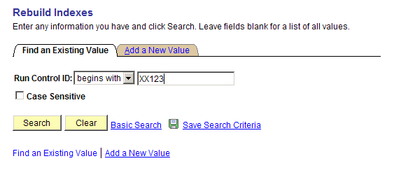

Enter Run Control ID, (Must be a unique combination of letters and numbers).

Click .

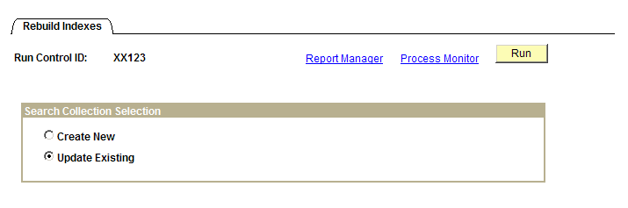

Click .
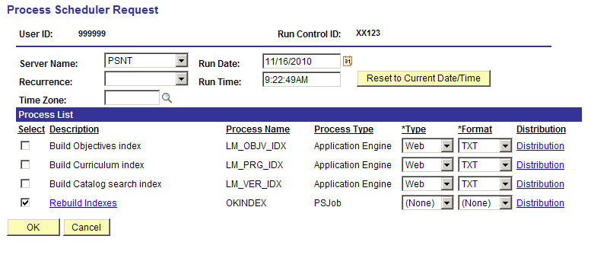

Check for the Rebuild Indexes line.

Click .

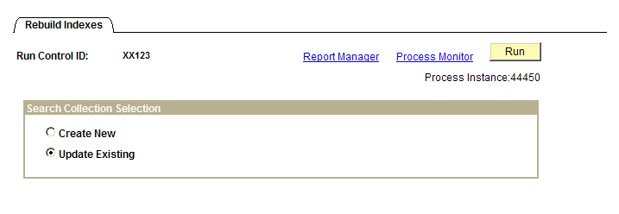

Note the Process Instance number in case a help desk case needs to be submitted.

Click Process Monitor link.

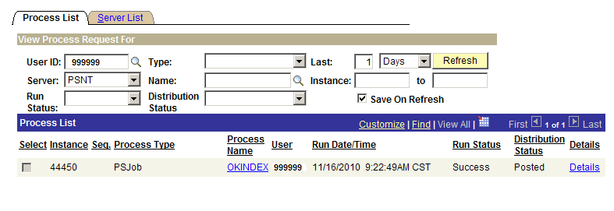

Click button repeatedly until Run Status is Success and Distribution Status is Posted.

Wait about five (5) minutes and learners can be enrolled in the new Activity.

Canceling an Activity
Activities are cancelled when their status is changed to inactive. When an activity’s status changes to Inactive, the system automatically drops all enrollments and notifies learners by email. Changing the status to Inactive, Concluded, or Closed prevents self-service enrollment; however, administrators can still enroll learners in these activities. Inactive and Concluded activities do not appear in the learning catalog. After an Activity has been completed, it is recommended that the Inactive status be used. The Inactive status does not send a notification to the enrolled Learners. Canceling an activity does not automatically release the resources (equipment, rooms, and instructors) that have been associated.

Navigation: Enterprise Learning > Catalog > Maintain Activities

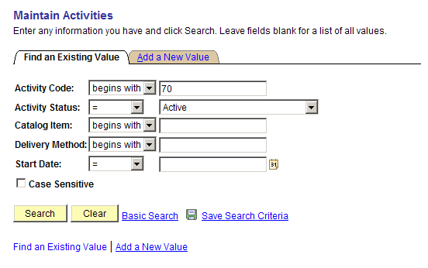

Enter Activity Code.

Click .
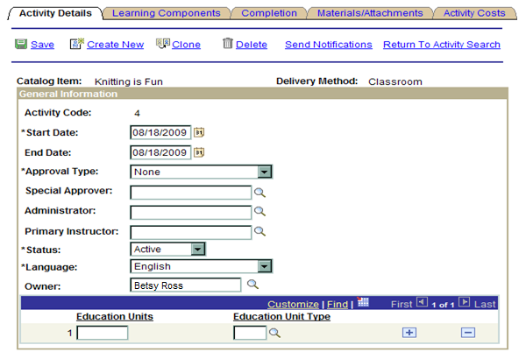

Choose , next to Status field, and select Inactivate.

NOTE: Use the Status field to activate or inactivate an activity.

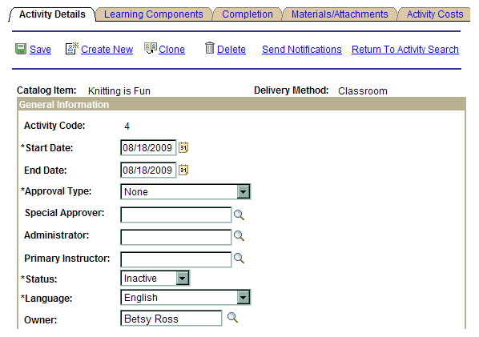

Click
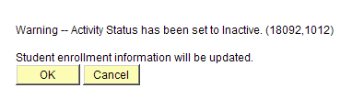

Click .

Deleting an Activity
When you wish to completely remove an activity from the catalog and not offer it again, you should delete the activity from the system. You cannot delete activities once learners have begun the enrollment process.

Navigation: Enterprise Learning > Catalog > Maintain Activities

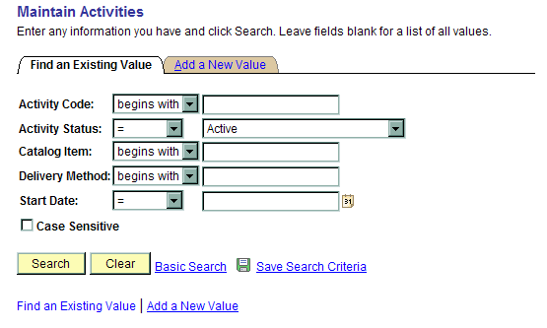

Click Activity Code and enter Activity Code.

Click .

NOTE: If the activity has any enrollments, you cannot delete the activity.

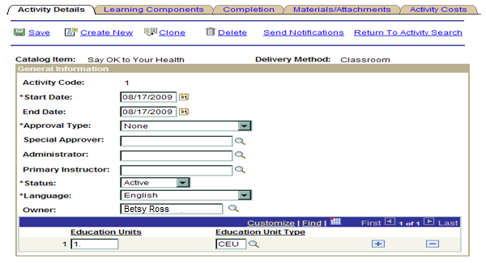

Click Delete link.

Click to delete.

Cloning an Activity
Cloning an Activity consists of recreating an existing activity and changing specific details in order to create a separate Activity.

Navigation: Enterprise Learning > Catalog > Maintain Activities

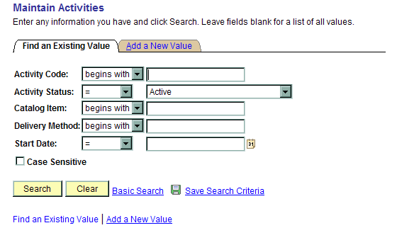

Enter Activity Code.

Click .

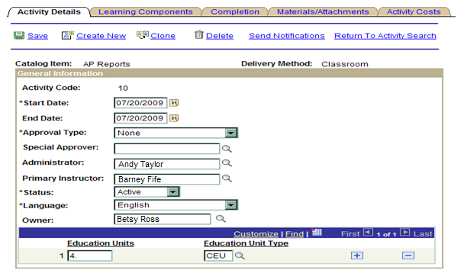

Click link.
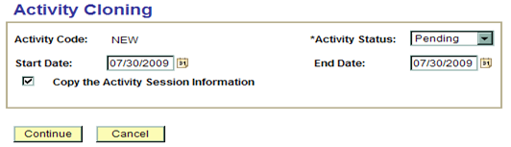

Enter Start Date.

Enter End Date.

Check Copy the Activity Session Information.

Click .

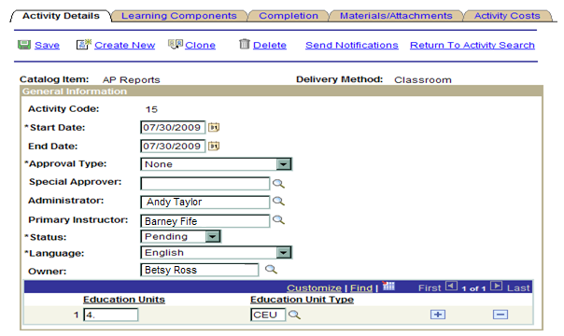

Enter Education Units and Education Unit Type.

Click Learning Components Tab.
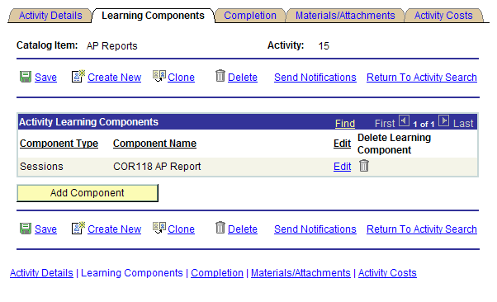

Click Edit link.

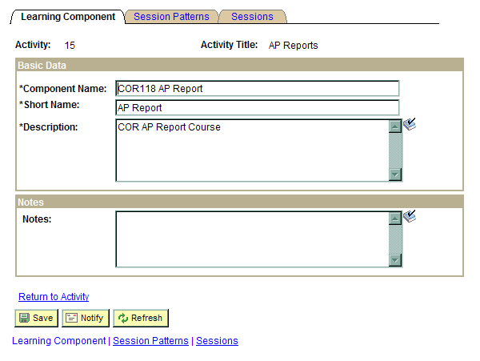

Click Session Patterns Tab.
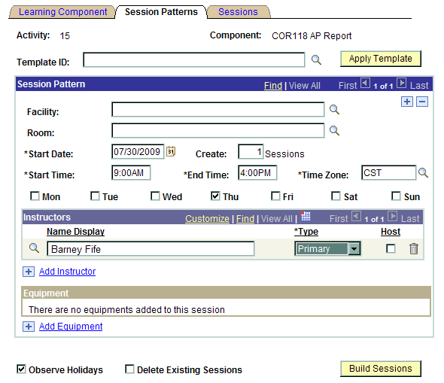

Click on Facility field and choose facility.

Click on Room field and choose room.

Enter Start Date.

Click Create field and enter 1 Sessions.

Enter Start Time and End Time

NOTE: More than one (1) session can be created. A session is a 24 hour period. For example, a two-day class would be two (2) sessions. Each session is created for the same learners enrollment.

Click the CORRECT day-of-the-week for the session.

Click Add Instructor link.
Choose next to Instructor Type list field, and select Primary.

Click .

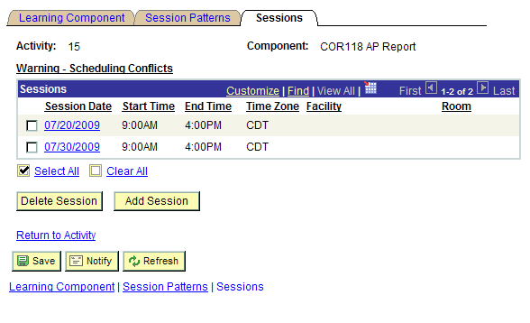

Click

Note the Activity Number.

Security Access Process
OSF Form 304ELM must be completed and signed and sent to the CORE Office.

CORE Office
3812 N. Santa Fe Ave., Suite 100
Oklahoma City, OK 73118

The Internal Catalog Administrator must check off the following boxes on the OSF Form 304ELM to gain access to the ELM System:

Internal Catalog Administrator

CORE Security Link: http://www.ok.gov/OSF/CORE/Security/index.html

HCM Resources
CORE Website Link
http://www.ok.gov/OSF/CORE/HRMS/index.html

CORE Website – What you will find
- Full Suite of HCM Manuals
- HCM Module News
- Training Schedule - (provided on the CORE Calendar)

CD HR Navigation Tool (upon request)

•OSF Help Desk
- E-Mail: helpdesk@osf.ok.gov
- Phone Numbers: 405 521.2444 or Toll Free 866 521.2444

