COR175 Payroll Processing

Revised: December 01, 2011

Authorized by: [_CORE_] Original Issue: [09/14/2009]
Maintained by: [____Payroll Lead___] Current Version: [12/01/2011]
Review Date: [06/01/2012]

Table of Contents
Table of Contents 3
Document History 5
Main Payroll Process Flow Details 6
Step 1 – Run Pre-Funding Reports 6
Step 2 – Run Longevity Part-Time Report 10
Step 3 – Run Full-Time Longevity Process 17
Step 4 – Run Report Longevity Employees on Paid Leave 20
Step 5 - Enter Time in Time and Labor 25
Step 6 – Run Query – GO_TL_WEEKLY_ELAPSED_TME 27
Step 7 – Approve Reported Time 28
Step 8 – Run Time Administration Process 32
Step 9 – Check and Resolve Exceptions 36
Step 10 – Approve Time 38
Step 11 – Check Payable Time Detail 41
Step 12 – Run Employee Leave Error Report 43
Step 13 – Run Employee Leave Audit Report 45
Step 14 – Run Presheet Audit Report 47
Step 15 – Create Pay Sheets (On-Cycle) - Process 49
Step 16 – Make Changes to Payline as Needed 55
Step 17 – Run Precalculation Audit Report 60
Step 18 – Run Preliminary Calculation Process 62
Step 19 – Check Payroll Error Messages 66
Step 20 – Run Query –GO_TL_PAY_TIME_BY_PAY_PERIOD 69
Step 21 – Run Payroll Register Report 71
Step 22 – Deductions Not Taken Report 75
Step 23 – Additional Reports 78
Step 24 – Run Pre-Distribution Audit Report 79
Step 25 – Run Payroll Unsheet – (If Necessary) 83
Step 26 – Run Final Calculation Process 85
Step 27 – Run Query –GO_TL_PAY_TIME_BY_PAY_PERIOD 88
Step 28 – Check Pay Calendar Flags for Pay Calculation Checkmark 90
Step 29 – Run Pay Confirmation Process 92
Step 30 – Check Pay Calendar for Flags 96
Step 31 – Check Paycheck Data for Advice and Check Numbers 98
Step 32 – Check to Be Sure ALL Paysheets Have Been Confirmed 100
Step 33 – Run PY Pull Costs 101
Step 34 – Run Distribute Actuals 104
Step 35 – Run Funding Reports 107
Step 36 – Correct Employee Actuals Distribution 111
Step 37 – Re-Run Funding Reports 119
Step 38 – Run Finalize Funding Reports 120
Step 39 – Run GL Process 128
Step 40 – Check Pay Calendar Flags 132
Step 41 – Fax Documents to Office State Finance 134
Step 42 – Run PY To AP Extract Process 135
Step 43 – Run Deduction Register (0205) 137
Step 44 – Print Earnings Statements (Run this process only if you are not on ESS) 140
Step 45 – Run Credit Union Report 143
Off-Cycle Payrolls 145
Off-Cycle Calendars 145
Off-Cycle – Adding a Paysheet 147
Off-Cycle Payroll Processing Steps (Checklist) 151
Step 1 – Check for the Existence of Off-Cycle Pay Calendars 151
Step 2 – Enter Time into Time and Labor 153
Step 3 – Run Query – GO_TL_WEEKLY_ELAPSED_TIME 156
Step 4 – Approve Reported Time 158
Step 5 – Run Time Administration 162
Step 6 – Check and Resolve Exceptions 164
Step 7 – Approve Time 165
Step 8 – Check Payable Time Detail 167
Step 9 – Run Load Time and Labor 169
Step 10 – Run Precalculation Audit Report 172
Step 11 – Make Any Changes and Updates (If Necessary) 174
Step 12 – Run Calculation Process 179
Step 13 – Check Payroll Error Messages 183
Step 14 – Run Query –GO_TL_PAY_TIME_BY_PAY_PERIOD 186
Step 15 – Run Calculation Process 188
Step 16 – Run Payroll Register Report 192
Step 17 – Run Pre-Distribution Audit Report 196
Step 18 – Run Payroll Unsheet – If Necessary 200
Step 19 – Run Pay Confirmation Process 202
Step 20 – Check Pay Calendar For Flags 206
Step 21 – Check Paycheck Data for Advice and Check Numbers 208
Step 22 – Check To Be Sure ALL Paysheets Have Been Confirmed 209
Step 23 – Run PY Pull Costs 210
Step 24 – Run Distribute Actuals 213
Step 25 – Run Funding Reports 216
Step 26 – Correct Employee Actuals Distribution 219
Step 27 – Re-Run Funding Reports 227
Step 28 – Run Finalize Funding Reports 228
Step 29 – Run GL Process 236
Step 30 – Check Pay Calendar Flags 240
Step 31 – Fax Documents To OSF 242
Step 32 – Run PY To AP Extract Process 243
Step 33 – Run Deduction Register (0205) 246
Step 34 – Print Earnings Statements 249
Step 35 – Run Credit Union Report 251
Step 36 – Run Leave Accrual Process 253
Step 37 – Run Leave Accrual Statements 254
Online Checks 256
Overview 256
Paysheet Create Message 257
Online Paysheet Page 257

Document History

Document Revision | Date | Description
1.0 | 09/14/2009 | Initial Document
1.1 | 09/29/2009 | Revised to update after initial Commitment Accounting Training
1.2 | 11/16/2009 | Revised to update before Group B training
1.3 | 11/24/2009 | Continued revision before Group B training
1.4 | 12/31/2009 | Revised the manual to be ADA compliant
1.5 | 05/01/2010 | Revised to update screen shots for Commitment Accounting
1.6  1.7  1.8 | 07/20/2010  09/30/2010  12/01/2011 | Revised to standardize the manual  Revised – Updated

Main Payroll Process Flow Details

The following pages outline, in detail the pay cycle processes of the Regular Pay Cycles (Main and Supplemental) for the State of Oklahoma. These pages outline the payroll process and who runs what, when, how, and why. This training manual reviews each step, sequentially as listed on the Payroll Processing Steps checklist, while explaining the procedures for processing a payroll in the PeopleSoft Release 9.0 environment. By the end of this class, you will be familiar with PeopleSoft 9.0 as well as having a step-by-step guide for processing your own payrolls.

Step 1 – Run Pre-Funding Reports

Pre-Budget Check (0025) and Pre-Budget Check for Projects (0025K)
These two (2) reports are the same as the Budget Check report; however they are a Pre-Budget Check report. The reports use the previous pay run information and the current budget data in GL to provide an estimate as to whether or not the current payroll will pass budget checking. Review the reports looking for any errors and/or areas lacking sufficient funds. If sufficient funds are NOT available, determine if any changes need to be completed to adjust funding. These adjustments can be made at the employee level, position level or department level on the Department Budget Table.

This process can be executed at any time prior to running any other payroll processes.

Navigation: Payroll for North America > Payroll Distribution > Prepare GL Information >Commitment Accounting > Pre-Funding Rpts (OCP400)

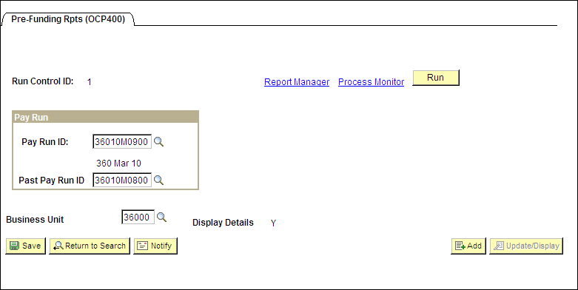
On the run control page below, enter the current payroll’s Pay Run ID, the Past Pay Run ID, the Business Unit and click . If you don’t have a Run Control ID for running this process click the tab labeled Add a New Value and enter a value. You will be taken to the ‘Process Scheduler Request’ page.

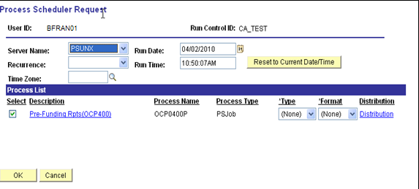

On the Process Scheduler Request page, set the Server Name to PSUNX.

In the ‘Process List’ group box:
- Check box should be checked next to Pre-Funding Rpts (OCP400)
- *Type should be set to (None)
*Format should be set to (None)
Click .

When the page goes back to the Pre-Funding Rpts OCP400 parameters page, take note of the Process Instance number and click Process Monitor link.

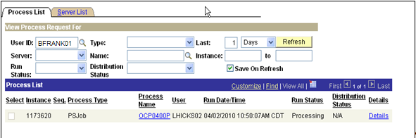

When the process runs to a Success and Distribution Status shows Posted, click the OCP0400P link under Process Name column.
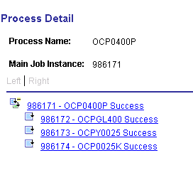

To make sure that pre-budget checking reports processed without errors, click the xxxxxx – OCPGL400 link to view the error report.

To view and reconcile the Pre-Budget Check report, click the xxxxxx – OCPY0025 link. Click View the Log/Trace link. In the ‘File List’ group box select the file with the .PDF extension.

To view and reconcile the Pre-Budget Check Projects report, click the xxxxxx – OCP0025K link. Click the View Log/Trace link. In the ‘File List’ group box select the file with the .PDF extension.

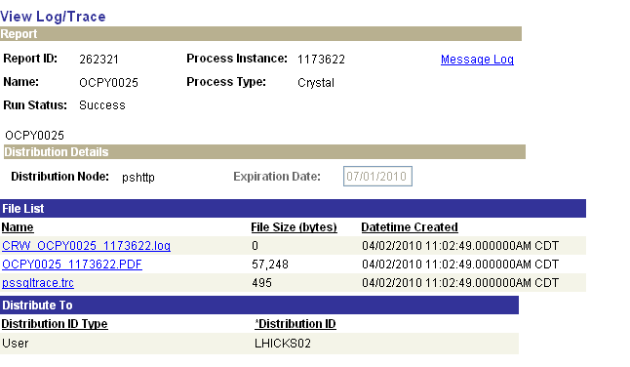
To view/print the report, click the link with the ‘.PDF’ extension (OCPY0025 xxxxxx.PDF). The Report Header will display that it is a “Pre-Budget” report. If the report shows a deficit, either money needs to be moved into the chart of accounts, or, the employees listed need to have their distribution changed.

The last page of this report will show a Gross Payroll Total that is an estimate of the current payroll funding based on the previous payroll.



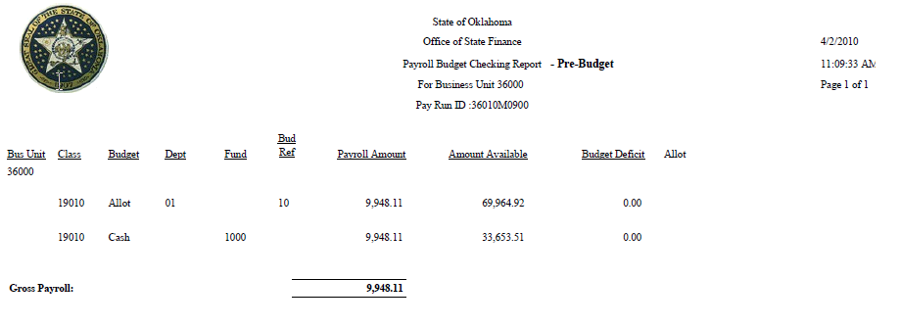

Step 2 – Run Longevity Part-Time Report

This is a report that will list any part-time employees eligible to receive a partial longevity payout. The Payroll Administrator will take the information from this report, manually calculate the prorated payment and will enter the information into the employee’s Time and Labor Timesheet using the LONGV Time Reporting Code.

Navigation: OK Custom Reports/Processes > OK Reports > Payroll > MDC Lgvty Cmp (0024)

On the run control page, below, enter a Run Control ID and click . If you don’t have a Run Control ID for running this process click Add a New Value Tab and enter a value.

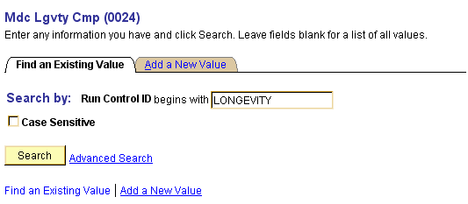

On the Longevity Pay parameters page click the radio button next to Report Part Time located in the ‘Process Type’ group box. In the ‘Input Parameters’ group box enter the Company and Run ID that will be used to process this pay cycle.

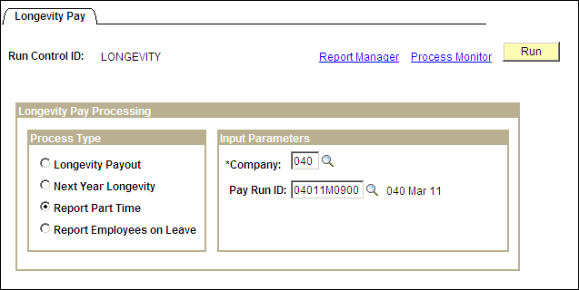
Click . You will be taken to the ‘Process Scheduler Request’ page.

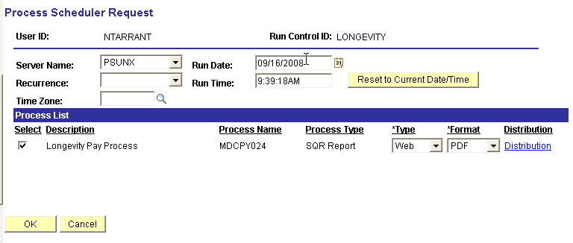

Make sure the Server Name is set to PSUNX.

In the ‘Process List’ group:
- Check box should be checked next to Longevity Pay Process
- Type should be set to Web
- Format should be set to PDF.

Click . You will be taken back to the Longevity Pay parameters page. In the top right hand side of the page a Process Instance number will now be shown. This process instance number is what you will use to monitor the completion of this job on the Process Monitor.

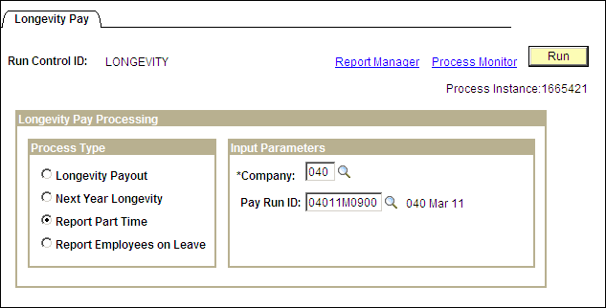

Click the Process Monitor link in the upper right hand corner of the page.
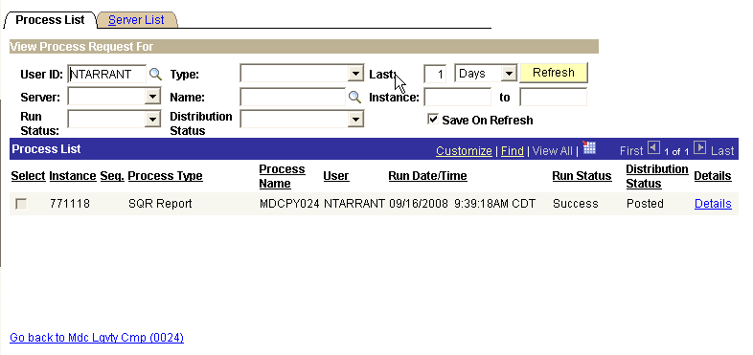

While on the Process Monitor page click repeatedly until Success appears under the Run Status column and Posted appears in the Distribution Status column along side your Process Instance number.

Critical NOTE: If the Run Status ever displays Error or No Success, write down your process instance number and contact the Help Desk. DO NOT continue working until the error has been cleared and you have a successful completion of this process.

Once the page displays a Run Status of Success and Distribution Status of Posted, click Details link.
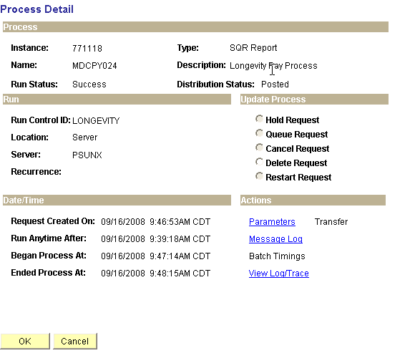

On the Process Detail page click View Log/Trace link. This will take you to the View Log/Trace detail page.
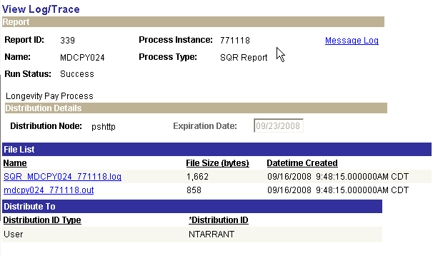

If you click the SQR MDCPY024 xxxxxx.log link you will see technical information describing the process you just ran. If you click the mdcpy024 xxxxxx.out link you will see a listing showing the employees that were looked at during the process. In this example since there was no one to report for this pay cycle, the last line in the listing states, ‘No Rows Found to be processed’, (shown below).

NOTE: In the File List grouping above, SQR MDCPY024 771118.log file, the six digit number (771118) is the process instance and will change for every process. Throughout the manual we will refer to file names using xxxxxx instead of the number shown.

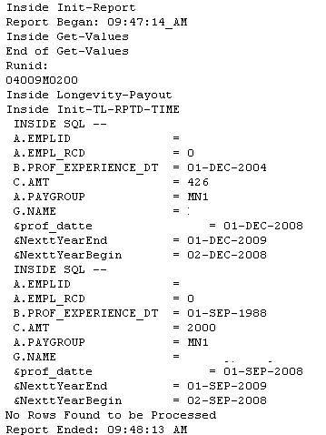

When employees meet the programs criteria there will be three (3) files displayed in the File List group box, as shown below.
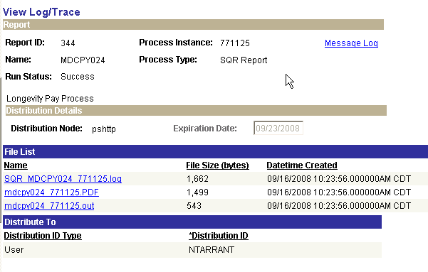

In this case there were part time employees eligible for prorated longevity payments. The report listing the employees can be displayed by clicking the file having the .PDF extension. Once you click the report link and open it up, print the report and use it as your working document to prorate your part time employees’ longevity payments.

Step 3 – Run Full-Time Longevity Process
This Longevity process selects employees eligible to receive Longevity payments and inserts the Longevity payments into Time and Labor (Timesheet) on the employee’s anniversary month and day. The Time Reporting Code of LONGV is used in this process to enter the data. The data entered during this process can be checked against the Longevity Amounts Report.

Navigation: OK Custom Reports/Processes > OK Reports > Payroll > MDC Lgvty Cmp (0024)

After entering a Run Control ID you will be taken to the Longevity Pay parameters page.

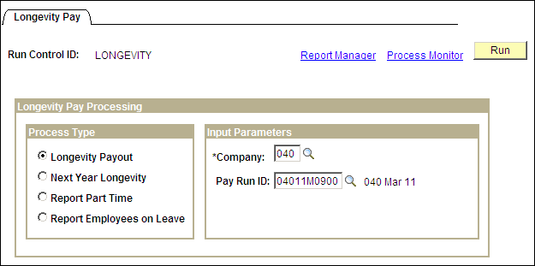

In the ‘Process Type’ group box click the radio button next to Longevity Payout. In the ‘Input Parameters’ group box enter the Company and Pay Run ID of the pay cycle that you are processing. When all data fields have been correctly filled in, click You will be taken to the ‘Process Scheduler Request’ page.

Make sure the Server Name is set to PSUNX.

In the ‘Process List’ group:
- Check box should be checked next to Longevity Pay Process
- Type should be set to Web
- Format should be set to PDF

Click . You will be taken back to the Longevity Pay parameters page. In the top right hand side of the page a Process Instance number will now be shown. This process instance number is what you will use to monitor the completion of this job on the Process Monitor.
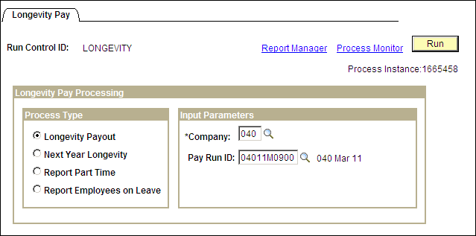

Click Process Monitor link in the top right hand corner of the page. When the run status column shows Success and the Distribution Status column shows Posted, click Details link. On the Process Detail page click View Log/Trace link.
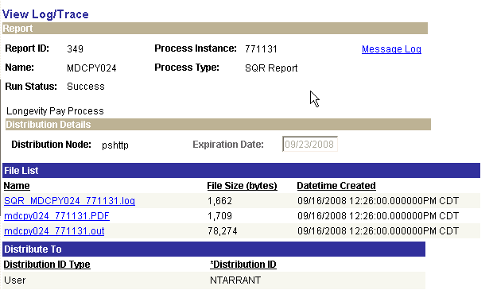

If employees are being paid Longevity on this pay cycle, and data was entered into Reported Elapsed Time, there will be a file in the ‘File List’ group box with a .PDF extension. Click the .PDF file to open and print your Longevity report. This report will list all employees and the longevity amounts they are being paid. Later on, when looking at your payroll register, you can use this report to reconcile the employees having Longevity payouts.

NOTE: If you want to verify that the longevity amounts were inserted correctly, you can navigate to the employee(s) Timesheet in Time and Labor, to review the data. LONGV is the TRC that should be associated with the employee’s payment.

Step 4 – Run Report Longevity Employees on Paid Leave

This will give you a report of any employees on a PAID leave of absence eligible for longevity for the period, which you will need to enter into the time sheet.

Navigation: OK Custom Reports/Processes > OK Reports > Payroll > MDC Lgvty Cmp (0024)

After entering a Run Control ID you will be taken to the Longevity Pay parameters page.

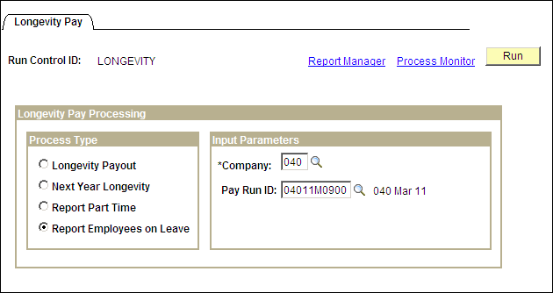

In the ‘Process Type’ group box click the radio button next to Longevity Payout. In the ‘Input Parameters’ group box enter the Company and Pay Run ID of the pay cycle that you are processing. When all data fields have been correctly filled in, click You will be taken to the ‘Process Scheduler Request’ page.

Make sure the Server Name is set to PSUNX.

In the ‘Process List’ group:
- Check box should be checked next to Longevity Pay Process
- Type should be set to Web
- Format should be set to PDF

Click . You will be taken back to the Longevity Pay parameters page. In the top right hand side of the page a Process Instance number will now be shown. This process instance number is what you will use to monitor the completion of this job on the Process Monitor.

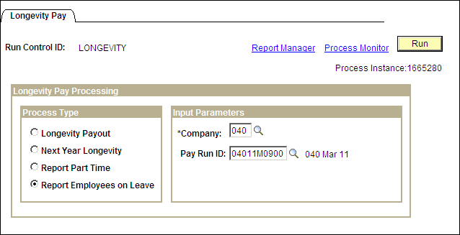

Click the Process Monitor link in the upper right hand corner of the page.

While on the Process Monitor page click repeatedly until Success appears under the Run Status column and Posted appears in the Distribution Status column along side your Process Instance number.

Critical NOTE: If the Run Status ever displays Error or No Success, write down your process instance number and contact the Help Desk. DO NOT continue working until the error has been cleared and you have a successful completion of this process.

Once the page displays a Run Status of Success and Distribution Status of Posted, click Details link.

On the Process Detail page click View Log/Trace link. This will take you to the View Log/Trace detail page.

If you click the SQR MDCPY024 xxxxxx.log link you will see technical information describing the process you just ran. If you click the mdcpy024 xxxxxx.out link you will see a listing showing the employees that were looked at during the process. In this example since there was no one to report for this pay cycle, the last line in the listing states, ‘No Rows Found to be processed’, (shown below).

Step 5 - Enter Time in Time and Labor

The navigation for entering time, if there is time that needs to be entered into Time and Labor for hourly employees and exceptional time reporting data for salaried employees, is as follows.

Navigation: Manager Self Service > Time Management > Report Time > Timesheet

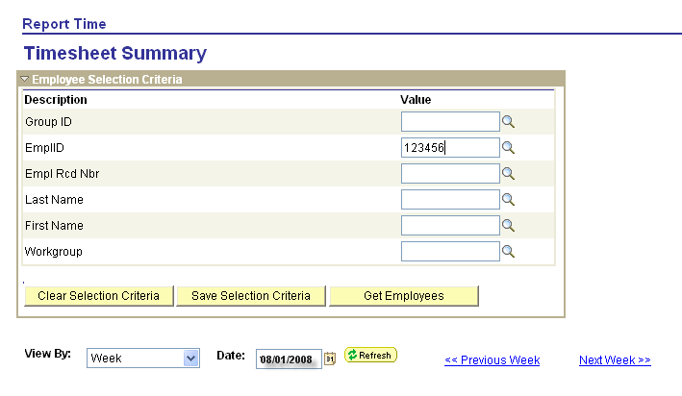

In the Employee Selection Criteria group box enter your search criteria. At the bottom of the page enter the date of the week you want to enter time for the employee. Click .

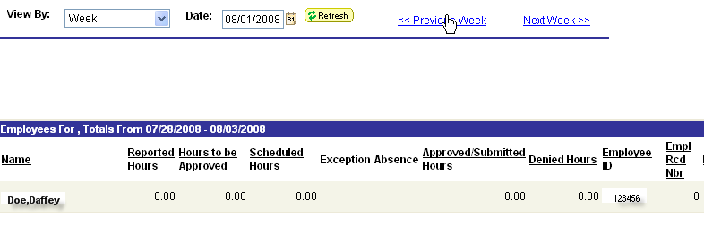
At the bottom of the page employee(s), pertaining to your search criteria entered above, will display. Click the employee name to open up the employee’s time sheet.

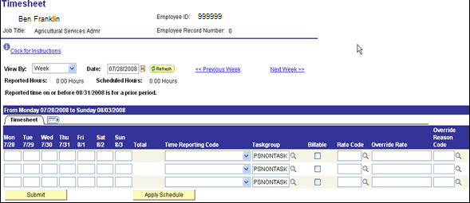

NOTE: For detailed instructions for entering Time can be found in the COR106 Time and Labor training manual.

Step 6 – Run Query – GO_TL_WEEKLY_ELAPSED_TME

This query lists reported time entered on Timesheets for a given period.

Navigation: Reporting Tools> Query > Query Viewer

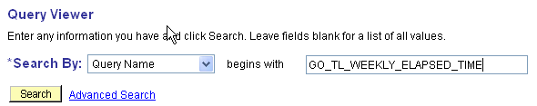

On the Query Viewer page enter the Query Name, as shown, and click .

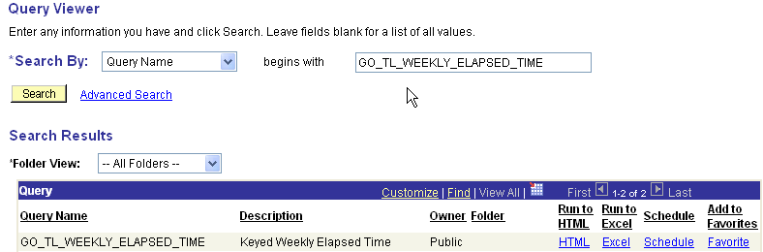

On the Query Viewer page you have a choice on where you want the output to go. HTML will give you the report on line. Excel will download the results of the query to an Excel spreadsheet, if your work station is properly setup. Clicking on either link will take you to the next page.

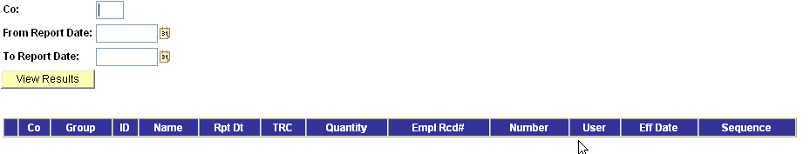

To run this query, enter your Agency number in the field labeled Co: along with the From and To dates. When you have completed filling in the data, click .

Step 7 – Approve Reported Time

Once an employee’s time has been reported and submitted, it is available for you to approve. You can approve a employee’s reported time directly on their timesheet or using the Approve Reported Time page.

Navigation: Manager Self Service > Time Management > Approve Time and Exceptions > Reported Time

Approve Reported Time provides the same employee selection criteria as the timesheet.

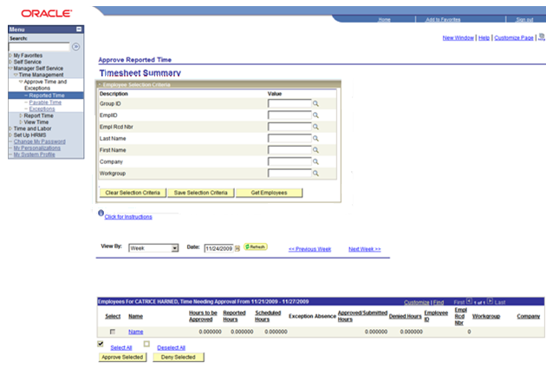

The View By selections includes:
- All Time After
- All Time Before
- Day
- Week
It is strongly recommended that you use the ‘View By = All Time Before’ to ensure all reported time requiring approval for previous pay periods display.

Step 1 – View by – select All Time Before

Step 2 – Date: Click  to open a calendar and select the start day of the next Pay Period.

Step 3 – Click to display timesheets for all of your employees

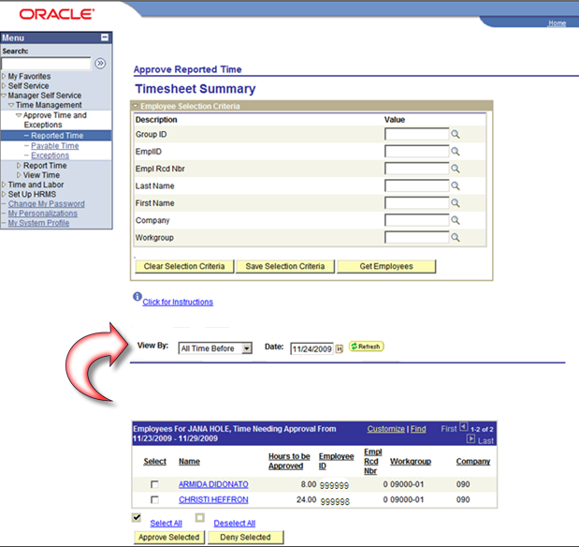
All of your employees with reported time requiring Approval display. You can Approve or Deny reported time. To review the time requiring approval you can click on the employee’s hyperlinked name; this will open the employee’s timesheet. Once you have reviewed the time, you can click ‘Return to Select Employee’ hyperlink to return to the Approve Reported Time page.

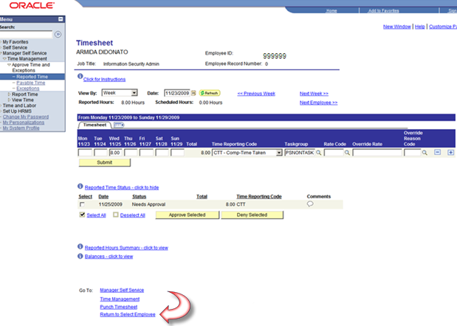

You can approve reported time for one, several, or all emploees.

Approve/Deny for Employee
You can use the following steps to approve reported time for one or several employees:

Step 1 – check the Select box next to the employee(s) requiring approval

Step 2 – click to approve reported time for the selected employees
- or –
click to deny reported time for the selected employees.
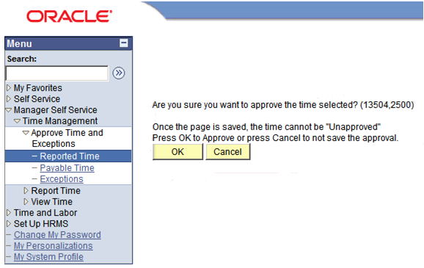

Step 3 – A warning page displays providing you with the opportunity to change your entry. Click to process your entry.

Step 8 – Run Time Administration Process

This process edits time entered on Timesheets and sets payable time in Time and Labor to ‘Estimated – Ready for Payroll’ if all data passes the edits, creates ‘Exceptions’ where there are conflicts that need to be resolved, and clears up exceptions where altering data has been entered. If in the above payroll steps data was entered into Timesheets in Time and Labor, the Time Administration process must be run.

Navigation: Time and Labor > Process Time > Request Time Administration

After entering a Run Control ID you will be taken to the Request Time Administration page.

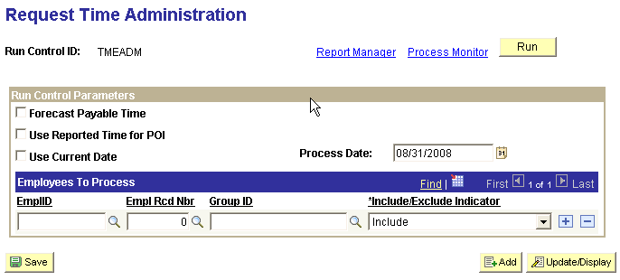
\
When running this process for a regular pay cycle make sure the check boxes located under ‘Run Control Parameters’ are all unchecked. In the ‘Employees To Process’ group box click the Group ID field lookup icon and select the group you will be running.
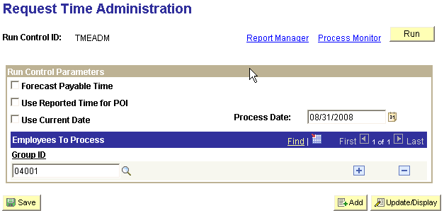

If you will be running this process for more than one group click to add another row. Then click which takes you to the Process Scheduler Request page.

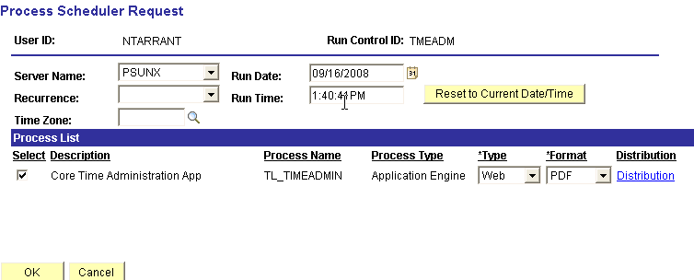

Make sure ‘Server Name’ is PSUNX.

In the ‘Process List’ group box:
- Check box should be checked next to Core Time Administration App
- Type should be set to Web
- Format should be set to PDF.

Click .
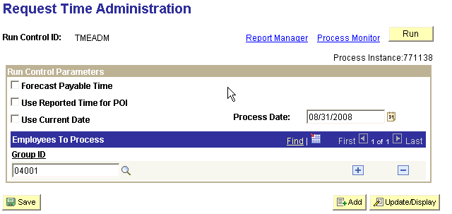

Remember your Process Instance number, found in the upper right hand corner of the page, and click Process Monitor link. When your job completes successfully where Run Status shows Success and Distribution Status shows Posted, click Details link.

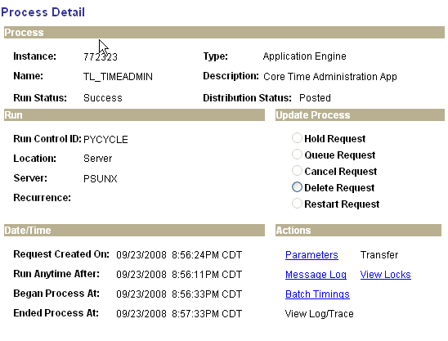

On the process Details page click View Log/Trace link.
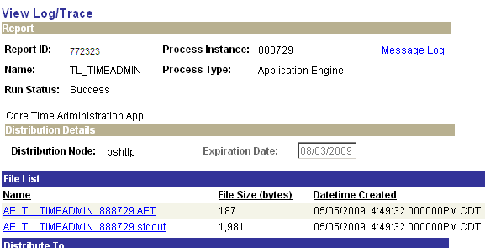

Click the AE TL TIMEADMIN xxxxxx.stdout link and review the file checking for any exceptions.

NOTE: If the Time Admin process status went to a ‘No Success’ or ‘Error’ status, on the Process Details page click Message Log link to open the log file to review for error indications and clean up. Contact the CORE Team is need assistance.

NOTE: Additional detailed instructions on running Time Administration and checking and cleaning up errors can be found in the COR106 Time and Labor Revised training manual.

NOTE: For those agencies that enter employee data on a daily basis, the Time Administration process should be run nightly. Time Administration should always be run the night before an agency is to start payroll processing due to the amount of time it could take to process all the time that has been entered into Time and Labor.

Step 9 – Check and Resolve Exceptions

All exceptions needing to be resolved will be listed. This is data that has been entered into Time and Labor, processed through Time Administration but cannot be loaded into paysheets.

NOTE: Ignoring exceptions, allowing them to increase with time, extend Time Administration processing time. To keep processing time to a minimum, always clean up any exceptions.

Navigation: Manage Self Service > Time Management > Approve Time and Exceptions > Exceptions

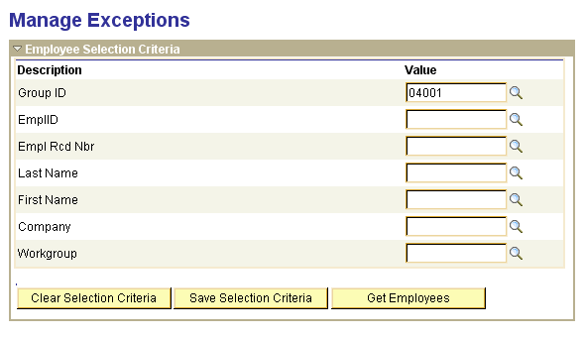

After navigating to the Manage Exceptions parameter page, enter your selection criteria and click . If there are no exceptions, based on your search criteria you will receive the following message:

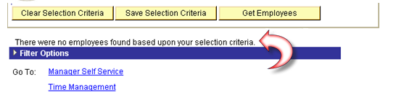

If there are exceptions a list will appear. When this occurs you need to review and resolve all data marked as exception.

NOTE: For more detailed instructions for clearing up exceptions refer to the COR106 Time and Labor training manual.

Step 10 – Approve Time

Time needing review and approval that has been entered into Time and Labor and processed through Time Administration must be approved before it can be loaded to paysheets.

Navigation: Manage Self Service > Time Management > Approve Time and Exceptions > Payable Time

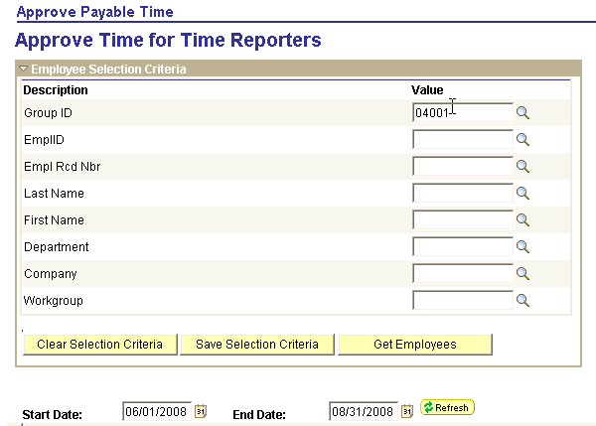

Enter your search criteria and click . If there were employee data needing review and approval a list would appear, as shown below. It is suggested that you enter a large date range (go back at least two or three months) to capture any TRCs that may have an old date.
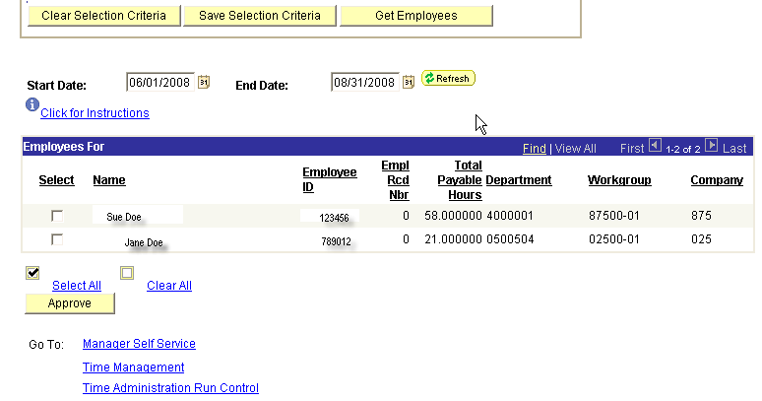

From here you can click Select All link and click .

You will be asked to confirm the Approval, click .

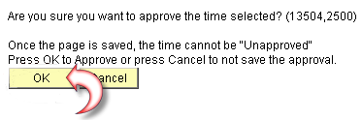

Another Dialogue box will appears informing you that the approvals have been saved.

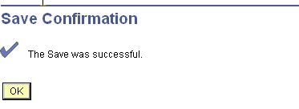

Click .
The payable status immediately changes to Closed (for comp-time TRCs) or to Approved – Ready for Payroll (if the TRC feeds to payroll like ANNLV or SCKTK). During the next Preliminary Calculation process payroll will pick up and process the Approved – Ready for Payroll TRCs.

NOTE: For more detailed instructions on approving time refer to the COR106 Time and Labor Manual.

Step 11 – Check Payable Time Detail

This is where an agency can view all payable time. At this point all time should be ready to be sent to payroll. If not, refer to steps 7 and 8 above.

Navigation: Manage Self Service > Time Management > View Time > Payable Time Detail

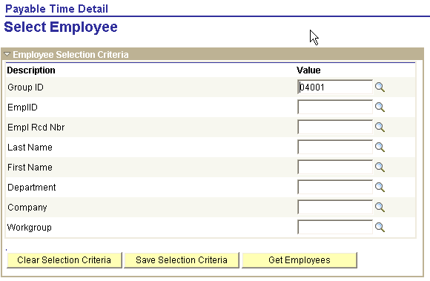

On the Payable Time Detail parameters page, once again, enter your search criteria and click .
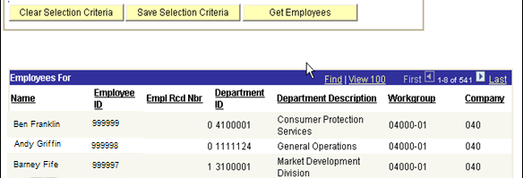

As shown above, all employees in your selection criteria having payable time will be listed on the bottom of the page. To review employees’ details click the employee name.

NOTE: For more detailed instructions refer to the COR106 Time and Labor training manual.

Step 12 – Run Employee Leave Error Report

Only run this report if your agency is using PeopleSoft to handle your sick and annual leave plans. This report identifies employees enrolled in a leave plan that shouldn’t be and employees that need to be enrolled in a leave plan. If employees do appear on the report notify your benefits administrator to update their Leave Plan enrollments.

Navigation: OK Custom Reports/Processes > OK Reports > Payroll > Leave Error Report (0057)

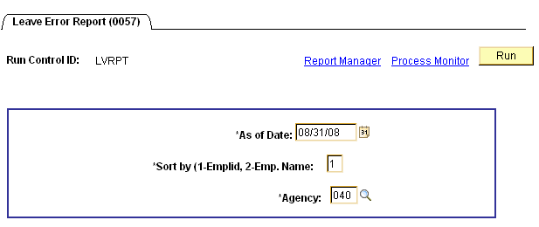

On the Leave Error report (0057) parameters page enter the pay period end date in the *As of Date, enter the number associated with how you want the report sorted in the *Sort by field, and enter the *Agency number. When all fields are filled in click .

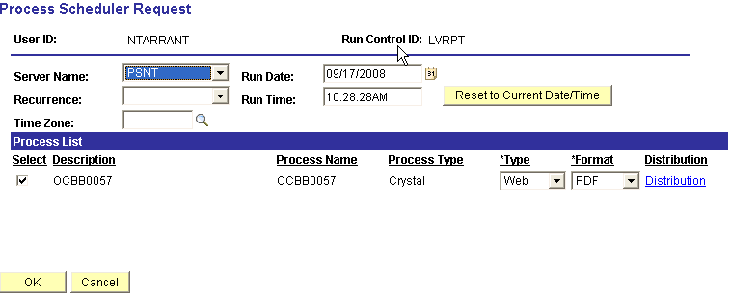

Make sure ‘Server Name’ is PSNT.

NOTE: Whenever Process Type is Crystal, the Server Name must be set to PSNT.

In the ‘Process List’ group box:
- Check box should be checked next to OCBB0057
- Type should be set to Web
- Format should be set to PDF.

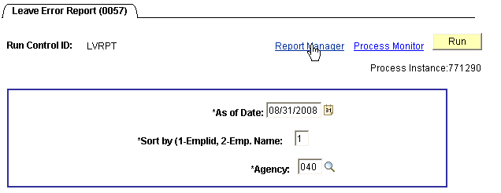

Click .

Back on the Leave Error report (0057) parameters page, note the Process Instance number in the upper right hand corner. Click Process Monitor link to view the completion of your job. Once the job has run to Success, displayed under Run Status, and Distribution Status shows Posted click Details link to take you to the Process Details page. Then click View Log/Trace link to open and/or print the report. Make sure you notify your Benefits Coordinator of anyone appearing on the report.

Step 13 – Run Employee Leave Audit Report

Only run this report if your agency is using PeopleSoft to handle your sick and annual leave plans. This report identifies employees who should be moved to the Supplemental Pay Cycle group and Vice Versa (based on your agency’s leave policy).

Navigation: OK Custom Reports/Processes > OK Reports > Payroll > Leave Accrual Audit Rpt (0056)

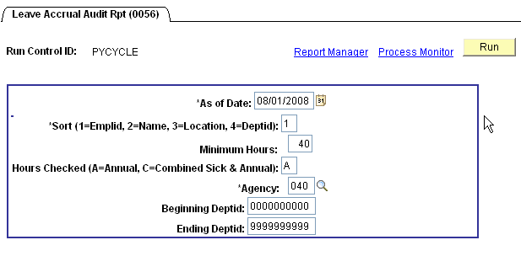

Fill in the criteria as required for your agency. The *As of Date must be the pay period begin date, and enter the number associated with how you want the report sorted in the *Sort field. The Minimum Hours field is where you enter your Agency’s limitation for moving an employee from the Main pay cycle to the Supplemental pay cycle. The Hours Checked field informs the process that the minimums hours entered above pertains to employees’ Annual Leave balances (A) or Combined Sick and Annual Leave balances (C). Enter the *Agency number. Beginning Deptid and Ending Deptid fields are not required. If you leave them with the default values the report will pull on all employees in your agency. If you fill in these with actual Department IDs the report will pull on all employees your agency that is in those Departments only. When you have finished filling in the fields, click .
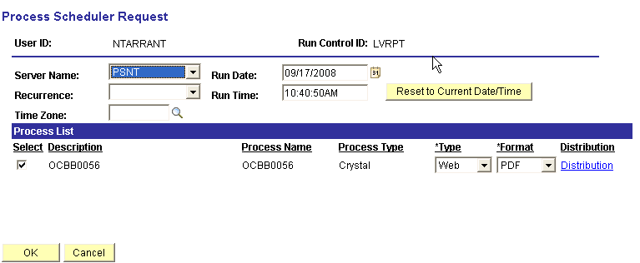

On the Process Scheduler Request page since this is a Crystal report the Server Name MUST be set to PSNT.

In the ‘Process List’ group box:
- Check box should be checked next to OCBB0056
- Type should be set to Web
- Format should be set to PDF.

Click .

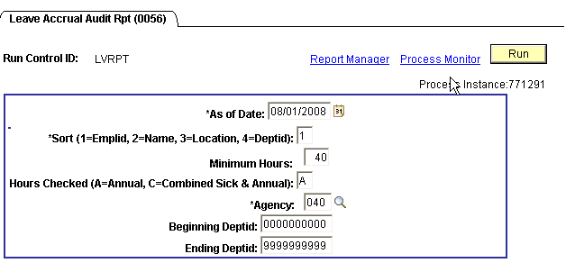

Note the Process Instance number in the upper right hand corner. Click Process Monitor link to view the completion of your job. Once the job has run to Success status and Distribution Status shows Posted, click Details link. On the Process Details page click View Log/Trace link to view and/or print the report. Make sure you notify your HR Administrator of anyone appearing on the report. They will need to add an effective dated row to their Job record and move them into the correct Pay Group.

Step 14 – Run Presheet Audit Report

This report lists any data errors related to employees that could cause a paysheet not to be created and/or a paysheet to be created incorrectly. All errors listed on this report must be corrected prior to moving on to Step 13. This step must be repeated until the report is error free.

Navigation: Payroll for North America > Payroll Processing USA > Create and Load Paysheets > Presheet Audit (0191)

After entering your Run Control ID you will be taken to the Presheet Audit (191) parameters page.

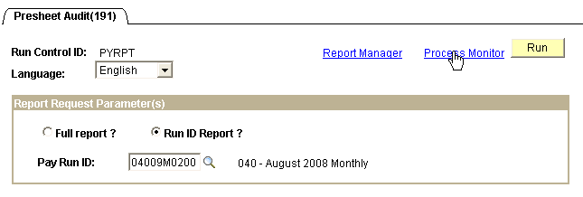

Click the radio button next to Run ID Report and enter the correct Pay Run ID for the pay cycle you are currently running. Click .
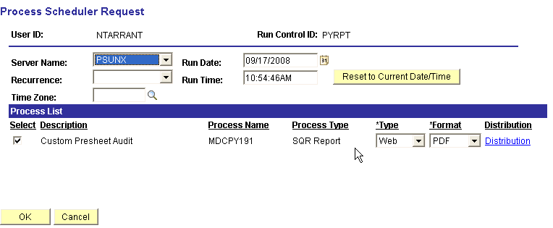

On the Process Scheduler Request page, make sure the Server Name is set to PSUNX.

In the ‘Process List’ group box:
- Check box should be checked next to Custom Presheet Audit
- Type should be set to Web
- Format should be set to PDF.

Click .

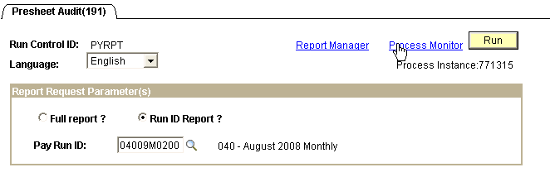

Back on the Presheet Audit (191) parameters page, note the Process Instance number in the upper right hand corner. Click Process Monitor link to view the completion of your job. Once the job has run to Success status and the Distribution Status shows Posted, click Details link. On the Process Details page click View Log/Trace link to access the report. From here you can view and/or print the report. Any errors listed on this report must be corrected and the report re-ran until this report is error free.

Step 15 – Create Pay Sheets (On-Cycle) - Process

The create paysheets process will create paysheets for active employees in the PayGroup(s) whose Pay Calendars have the same Run ID as the one you are currently using.

Navigation: Payroll for North America > Payroll Processing USA > Create and Load Paysheets > Create Paysheets

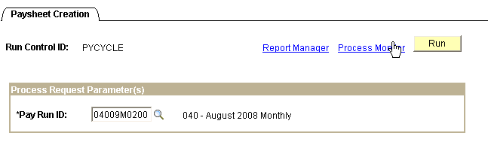

After entering a Run Control ID you are taken to the Paysheet Creation parameters page (above) where you will enter the Pay Run ID pertaining to the pay cycle you are processing. Click .

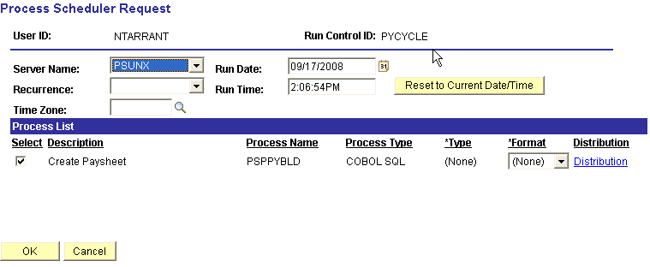

On the Process Scheduler Request page, make sure the Server Name is set to PSUNX.

In the ‘Process List’ group box:
Check box should be checked next to Create Paysheet
Type should be set to (None)
Format should be set to (None).

Click .
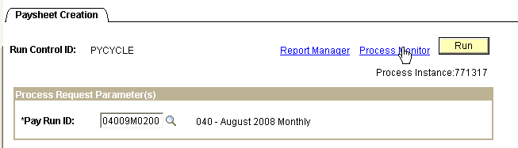

Back on the Paysheet Creation parameters page note the Process Instance number in the upper right hand corner. Click Process Monitor link to view the completion of your job.

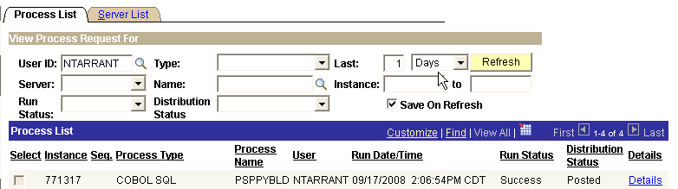

Once the job has run to Success, shown in Run Status column, and Distribution Status shows Posted, click Details link.
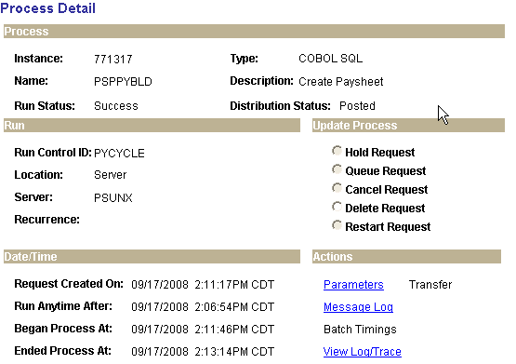

On the Process Detail page click View Log/Trace link.

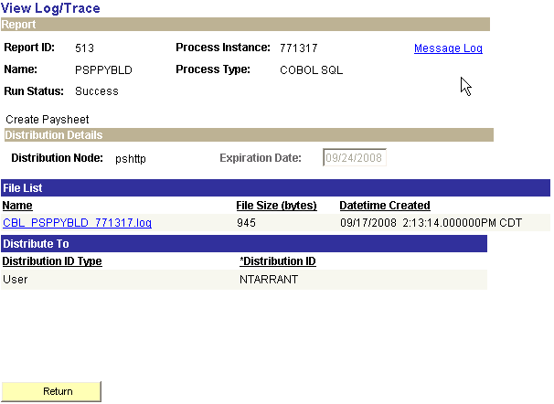
On the View Log/Trace page in the File List group box click CBL PSPPYBLD xxxxxx.log link which will open the log file. Scroll through the file looking for any lines that state Check Messages!!!

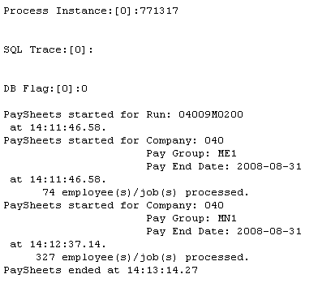

Above is the content of the log that was just run. As you can see, it displays the Process Instance, Pay Run ID we well as the Pay Groups that were accessed and the number of employees that had paysheets created per each Pay Group. During the above process there were no errors encountered, that is why you see no “Check Messages!!!” statement.

If the “Check Messages!!!” statement did appear you will need to follow the guidelines below to review the data needing corrections made.

Navigate: Payroll for North America > Payroll Processing USA > Review Payroll Error Messages

On the Review Error Messages search criteria page fill in the Company and Process Instance, and click .
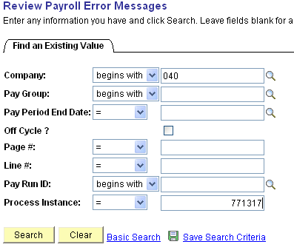

If there were errors, messages would appear at the bottom of the screen. When there are no messages you will get this message box.

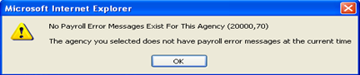

If you want a Report listing the errors, to print off, follow the guidelines below:

Navigate: Payroll for North America > Payroll Processing USA > Payroll Error Message Report

Enter a Run Control ID and click .

On the Payroll Error Message Report parameters page enter the Current Pay Run ID that you are using and click .

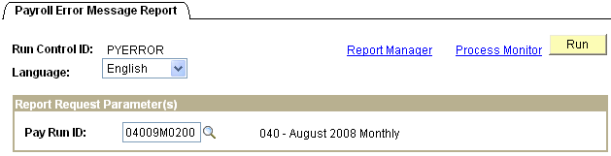

On the Process Scheduler Request page select PSUNX for the Server Name, make sure the check box is checked next to Payroll Error Messages, *Type should be set to Web, *Format should be set to PDF. Click .
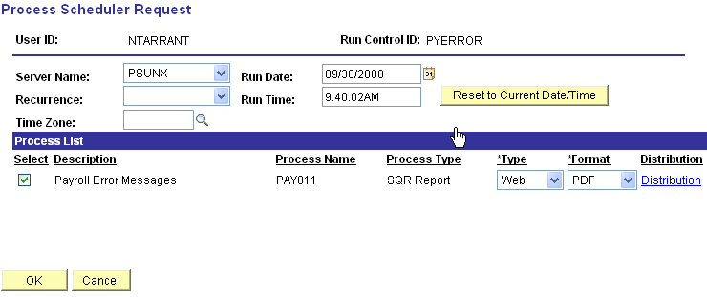

When you are back on the Payroll Error Message Report parameters page, make note of the Process Instance in the upper right hand corner. Click Process Monitor link.

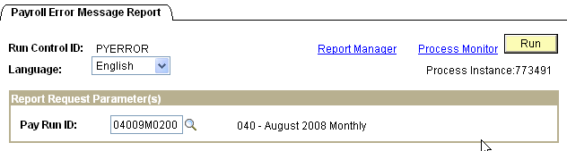

On the Process Monitor page when Run Status goes to Success, and Distribution Status shows Posted, click Details link.

On the Process Detail page click View Log/Trace link.

On the View Log/Trace page click the file having the .PDF extension in the File List to open and print the report.

Step 16 – Make Changes to Payline as Needed

If you to need to make corrections to a Payline, due to error message resulting from the Paysheet Creation process (such as missing Tax State, etc.) or, deductions/taxes need amounts adjusted on this pay cycle you need to access the employees’ Payline in order to make these corrections/changes.

NOTE: Do not ever make any additions and/or changes to earnings directly on the payline, these changes must come from a change made to the employee’s Job record and/or Time and Labor allowing proper distribution of the earnings.

Navigation: Payroll for North America > Payroll Processing USA > Update Paysheets >
By Payline Security

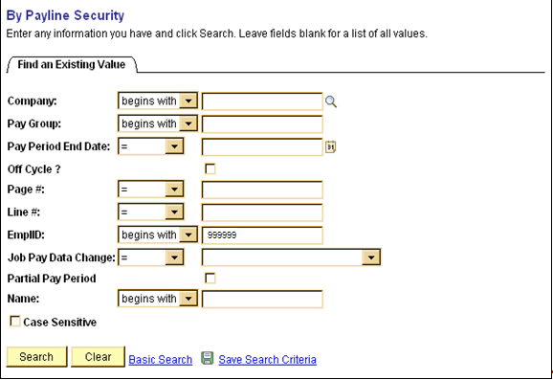

On the above search criteria page, enter the employee’s EmplID that you need to make the Payline adjustment(s) for. You may use any of the other criteria for searching paylines to update, using EmplID, if known, is easiest. Click .
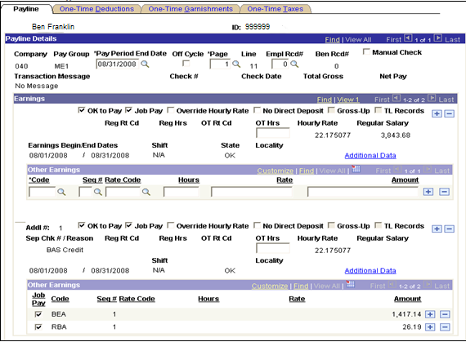

Above is what uncalculated paylines for an employee could look like. If the employee is missing earnings, never add a payline here to add an earnings code and amount.

If a deduction, tax, and/or garnishment amount needs to be adjusted on this pay cycle only, click the appropriate one-time override tab as indicated below.

One-Time Deductions Tab:

If a one-time deduction override for this employee is required on this pay cycle, click One-Time Deductions Tab.
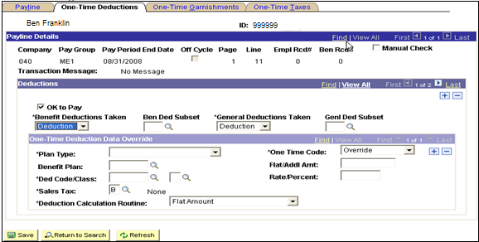

Always make sure the OK to Pay check box is checked, .

If there should be NO benefit deductions taken on this pay cycle for this employee, click and select ‘None’ from the drop down list under *Benefit Deductions Taken. If only deductions associated with a Deduction Subset should be used on this pay cycle for this employee, click and select ‘Subset’ from the drop down list under *Benefit Deductions Taken, then click under Ben Ded Subset and select the correct subset to use.

If there should be NO general deductions should be taken on this pay cycle for this employee, click and select ‘None’ from the drop down list under *General Deductions Taken. If only deductions associated with a Deduction Subset should be used on this pay cycle for this employee, click icon and select ‘Subset’ from the drop down list under *General Deductions Taken, then click under Genl Ded Subset and select the correct subset to use.

For Deduction(s) specification changes (override, refunded, additional amount deducted, or an arrears payback) click the One-Time Code and select the correct processing specification to use.

When the necessary changes are added, click

If the employee has more than one deduction code that needs adjustments, (remember some deduction code/class changes made should be for employee and employer) on this pay cycle, click the in the One-Time Deduction Data Override group box and continue. Remember to always click
One-Time Garnishments Tab:

If a one-time garnishment deduction override for this employee is required on this pay cycle, click the One-Time Garnishments Tab.

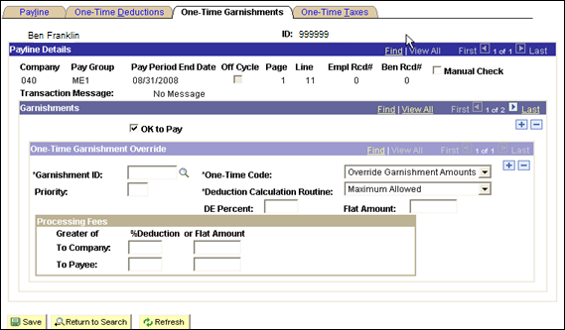

Always make sure the OK to Pay check box is checked, .

Enter the information, as required pertaining to the garnishment for this employee, on this page and click If the employee has more than one garnishment that needs adjustments for this pay cycle, click in the One-Time Garnishment Override group box and continue. Remember to pay close attention when selecting the correct *One-Time Code and *Deduction Calculation Routine from the drop down lists using the icon next to each label. Remember to always click when finished.

One-Time Taxes Tab:

If a one-time tax override for this employee is required on this pay cycle, click the One-Time Taxes Tab.
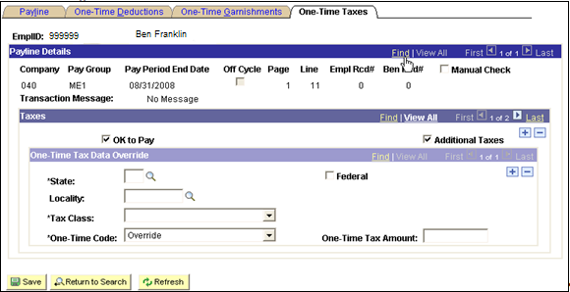

Always make sure the OK to Pay check box is checked .

Enter the information, as required pertaining to the specific tax for the employee, on this page and click Be careful to select the correct *Tax Class and *One-Time Code from the drop down lists by clicking .

NOTE: The drop down list will list specific EE and ER tax codes where appropriate.

If the employee has more than one tax type that needs adjustments for this pay cycle or Tax Class (employee versus employer), click in the One-Time Tax Data Override group box and continue. Remember to always click

Step 17 – Run Precalculation Audit Report

This audit report checks for payroll errors such as earnings and deduction codes not in earnings/deduction groups associated with the company but are associated with the employees being paid.

Navigation: Payroll for North America > Payroll Processing USA > Produce Payroll > Precalculation Audit Report

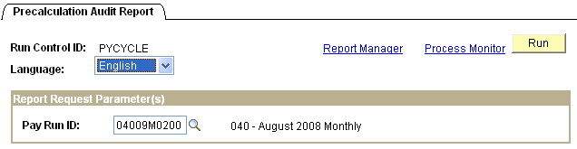

After entering your Run Control ID you are taken to the Precalculation Audit Report parameters page. Make sure the Language selected is ‘English’. Enter the Pay Run ID associated with the pay cycle you are processing. Click .

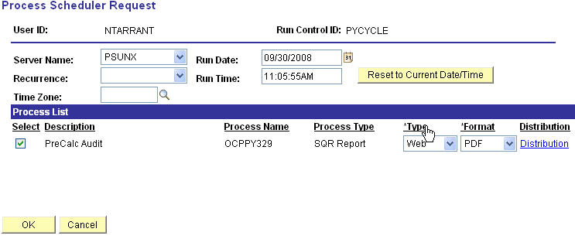

On the Process Scheduler Request page, make sure Server Name is set to PSUNX.

In the ‘Process List’ group box:
- Check box should be checked next to PreCalc Audit
- Type should be set to Web
- Format should be set to PDF.

Click .
Take note of the Process Instance and access the Process Monitor by clicking the link. When the job has run to Success, click Details link on the correct process instance row. Click View Log/Trace link. The View Log/Trace page will look like this:

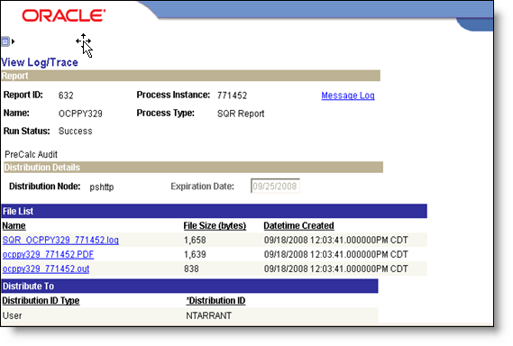

To view/print the report, click ocppy329 xxxxxx.PDF file. Any errors listed on the report must be corrected prior to going on to Step 17.

Step 18 – Run Preliminary Calculation Process

This process pulls in Payable Time from Time and Labor, calculates employee earnings, deductions, and taxes based on employees’ various data records. If an employee has been hired, since the paysheet Creation process ran, and the effective date of the Hire is within this pay cycle, the Preliminary Calculation process will create the paysheet as well as calc the new employees pay.

Navigation: Payroll for North America > Payroll Processing USA > Produce Payroll >
Pay Calculation (0346)

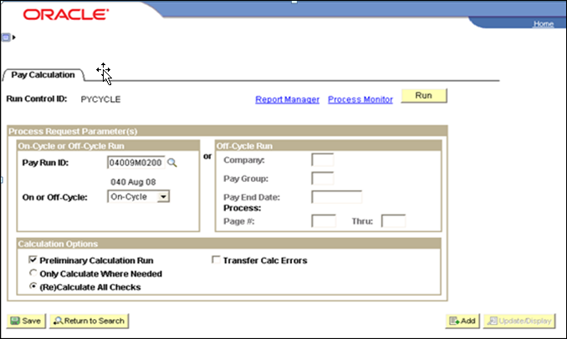

On the Pay Calculation parameters page, in the ‘On-Cycle or Off-Cycle Run’ group box enter the correct Pay Run ID and select On-Cycle by clicking and choose On-Cycle.

In the ‘Calculation Options’ group box check the box next to Preliminary Calculation Run, and click the radio button next to (Re)Calculate All Checks. Click .
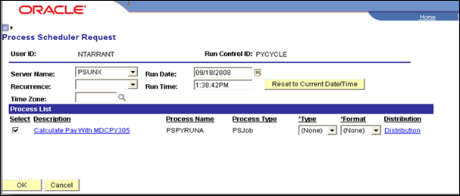

On the Process Scheduler Request page make sure Server Name is set to PSUNX.

In the ‘Process List’ group box:
- Check box should be checked next to Calculate Pay with MDCPY305.
- Type should be set to (None)
- Format should be set to (None).

Click .

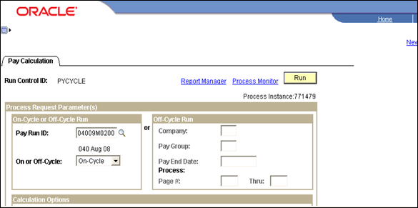
Back on the Pay Calculation parameters page, take note of the Process Instance and access the Process Monitor by clicking the link.

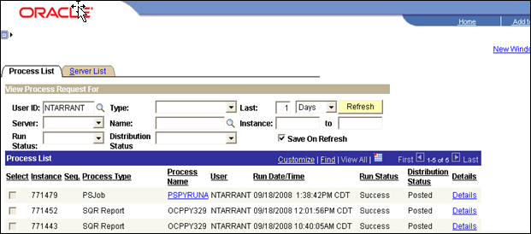

When the job has run to Success and Distribution Status shows Posted, click the PSPYRUNA link on the correct process instance row.

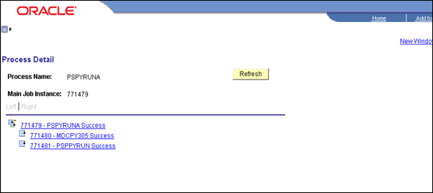

On the Process Detail page the link on this page that is associated with the log that we want to read is the last one in the list, xxxxxx – PSPPYRUN Success. Click this link to open up the Process Detail page and then click View Log/Trace link.
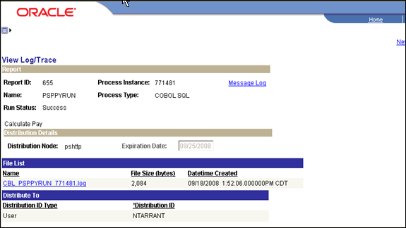

Click CBL PSPYRUN xxxxxx.log to read and look for ‘Check Messages!!’ statement(s). When viewing the log take note of the Process Instance number. This number will be used in the next step.

If this message appears it means there is data that could not be processed. The reasons for the error, etc., will be listed on the Error Report.

Step 19 – Check Payroll Error Messages

If your agency does not have any error messages, when trying to view errors you will get the message “No Payroll Error Messages exist for this agency…” If errors exist they must be corrected and steps 16 and 17 rerun until no errors appear.

Navigation: Payroll for North America > Payroll Processing USA > Review Processing Messages > Review Payroll Error Messages

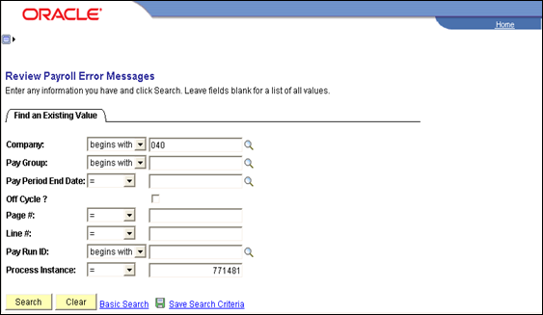

Enter the Company and Process Instance from the step above and click .
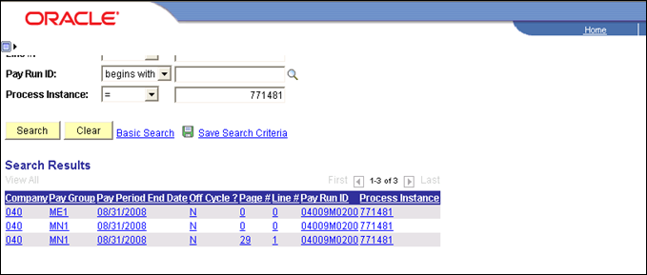

As seen above, if there are errors they will be listed. To review the error message click each line item. Make sure these errors are corrected and re-run these two steps (Step 17 and 18) until no errors appear.

If you want to see an error report, which also gives hints for what has caused the error(s) you can navigate to:

Navigation: Payroll for North America > Payroll Processing USA > Review Processing Messages > Payroll Error Message Report

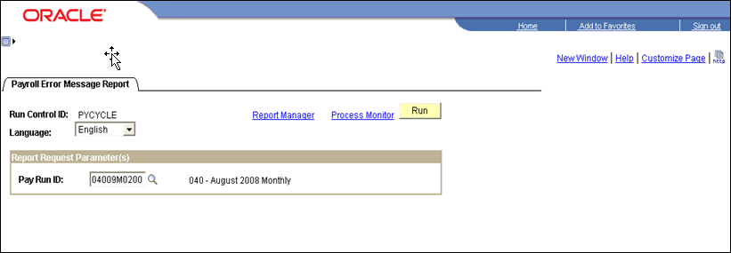

On the Payroll Error Message Report parameters page enter the correct Pay Run ID and click .
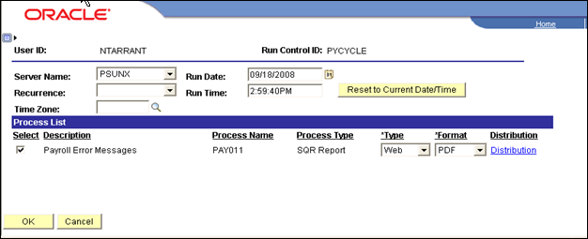

Make sure the PSUNX is selected next to Server Name.

In the ‘Process List’ group box:
- Check box should be checked next to Payroll Error Messages.
- Type should be set to Web
- Format should be set to PDF.

Click .

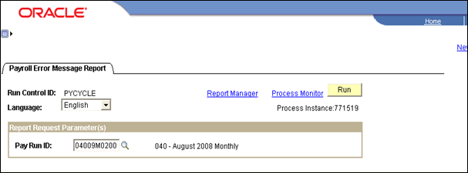

Make a note of the Process Instance and click Process Monitor link. When the report runs to a Success and is Posted click Details then View Log/Trace links. Click the .PDF file in the File List to open the report and print the report. Remember to correct all errors listed and re-run steps 16 and 17 until there are no errors displayed.

Step 20 – Run Query –GO_TL_PAY_TIME_BY_PAY_PERIOD

This query will identify employees with time in Time and Labor that was rejected by payroll (status of RP), or is estimated and ready for payroll but did not feed into the paysheets (status of ES). The data did not get fed into payroll due to the edits performed in the prior Preliminary Calculation process, or prior pay cycle processing if they weren’t cleared up earlier. Always clear up rejected time.

Navigation: Reporting Tools > Query > Query Viewer > GO_PAY_TIME_BY_PAY_PERIOD

On the Query Viewer ‘Search Criteria’ page enter the query name.

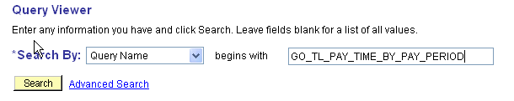

Click .

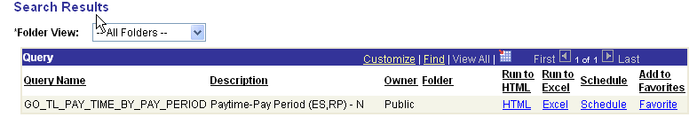

On the Search Results page click on either HTML or Excel which ever output you prefer.

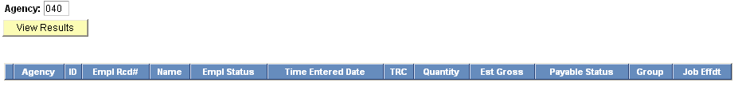

Enter the agency number and click .
Time having an ‘RP’ status would be listed as shown below.

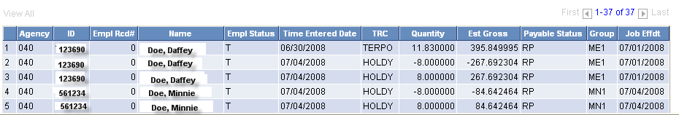

Please clean up all RP time and review ES time that did NOT get fed into payroll making sure all time was currently sent to payroll for the paygroups being processed. Letting time stay in the RP status extends processing time for Time Administration and payroll calculations. For detailed information pertaining to Time and Labor data having a payable status of RP, refer to COR106 Time and Labor training manual.

Step 21 – Run Payroll Register Report

The Payroll register report lists all employee payroll data pertaining to this pay cycle (i.e. gross earnings, deductions, taxes, and net pay) and can be used to reconcile employee Gross to Net calculations. The report itemizes, by employee, check detail information listing employee earnings, and employee/employer deductions and taxes. The last page is a summary of totals covering the entire pay cycle.

There are three (3) versions of this customized report. The changes were requested by the State of Oklahoma.

- Payroll Register Name (0233) - Sorted in last name order.
- Payroll Register Mail Drop (0312) – Sorted by the Mail Drop Field (Warrant Sequence Number on Payroll date)

- Payroll Register Div/Name (0312C) – Sorted by Division and then Name.

Navigation: Payroll for North America > Payroll Processing USA > Pay Period Reports >Payroll Register – Name (0233)

After entering the Run Control ID you are taken to the Payroll Register-Name (0233) parameters page.

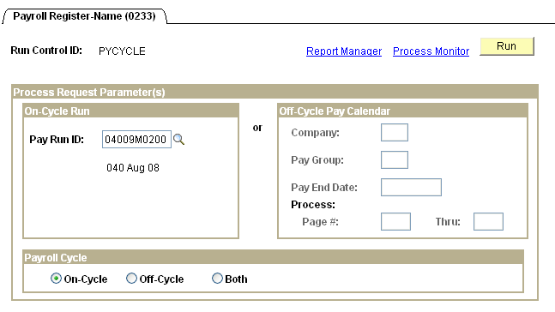

In the On-Cycle Run group box, left side of page, enter the Pay Run ID associated with the pay cycle you are running. In the Payroll Cycle group box, bottom of page, click the radio button next to On-Cycle. Click .
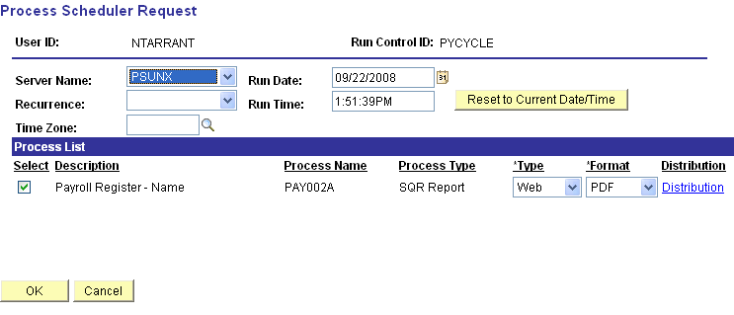

On the Process Scheduler Request page make sure Server Name is set to ‘PSUNX’.

In the ‘Process List’ group box:
- Check box should be checked next to Payroll Register-Name.
- Type should be set to Web
- Format should be set to PDF.

Click .

When screen goes back to the Payroll Register parameters page, take note of the Process Instance number and click Process Monitor link. When the process runs to a Success and Distribution Status shows Posted, click Details link.

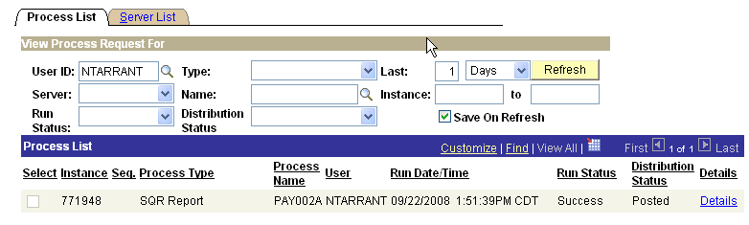

Clicking Details link takes you to the Process Detail page, shown below and click View Log/Trace link.
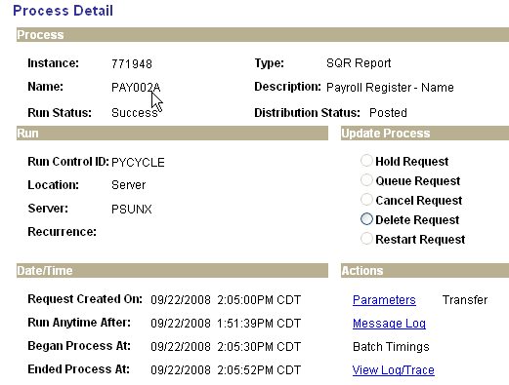

One the View Log/Trace page, in the File List group box, click on the file with the .PDF extension.

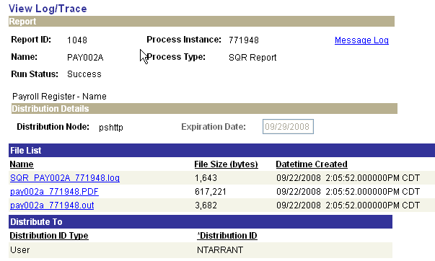

When you click on pay002a xxxxxx.PDF in the File List group box you are actually opening up the report to view and/or print.
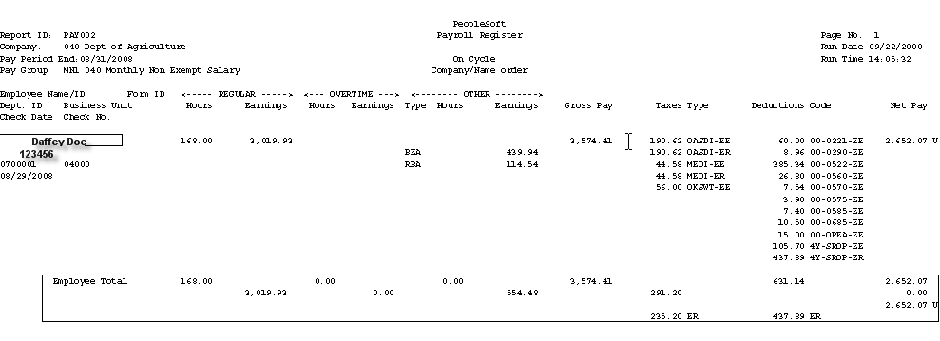

The heading of the Payroll Register lists the Report ID page #, Company, Run Date (date report was run on), Pay Period End Date, and Run Time. Data listed on this report is in alphabetical order by last name. For each employee listed you will see the hours/earnings, and other earnings that the employee is being paid which comprises the Gross Pay. It also lists in detail the Taxes and Deductions (employee (EE) and employer (ER)), and Net Pay. The ‘U’ after the Net Pay amount indicates this report is listing payroll data for the employee that is currently ‘Unconfirmed’. The data in the boxed in area under the employee is a summary of the total employee’s earnings, taxes and deductions (EE and ER), and Net Pay.

If you go to the last page of the Payroll Register you will see a summary page for the entire company.

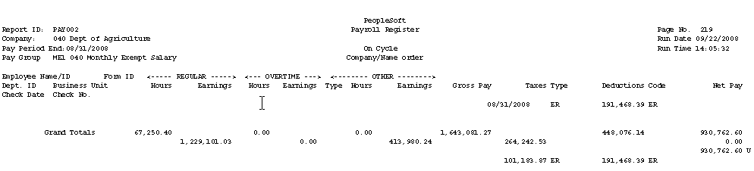

This page displays summarized grand totals of all earnings, taxes and deductions (EE and ER) and net pay. These totals will later be used to reconcile with the Funding Distribution and Payroll Budget Checking reports.

As you can see, this report can get rather large but you can print the entire report, a page, or certain pages of this report.

Step 22 – Deductions Not Taken Report

This report lists, by employee, any deductions that were not taken due to insufficient funds.

NOTE: The State of Oklahoma does not allow for partial deductions to be taken nor do they allow for taking deductions in arrears (deductions not taken in prior payrolls).

Navigation: Payroll for North America > Payroll Processing USA > Pay Period Reports >Deductions Not Taken

After entering a Run Control ID you are taken to the Deductions Not Taken parameters page.

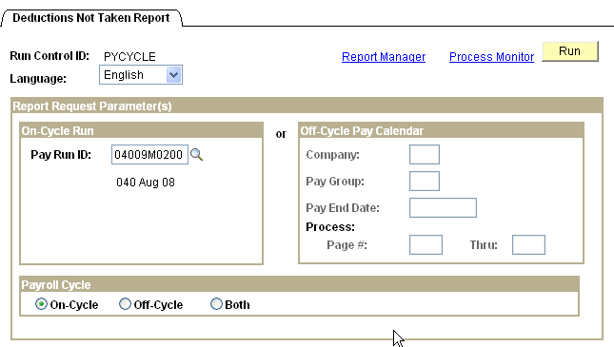

After entering the Pay Run ID in the On-Cycle Run group box, and checking the On-Cycle radio button in the Payroll Cycle group box, click which takes you to the Process Scheduler Request page.
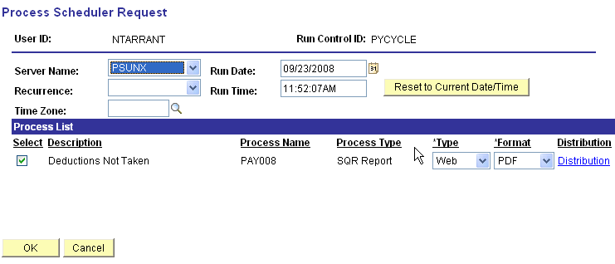

Make sure the Server Name is set to ‘PSUNX’.

In the ‘Process List’ group box:
- Check box should be checked next to Deductions Not Taken.
- Type should be set to Web
- Format should be set to PDF.

Click .

When screen goes back to the Deductions Not Taken parameter page, take note of the Process Instance number and click Process Monitor link. When the process runs to a Success and Distribution Status shows Posted, click Details link, then click View Log/Trace link.
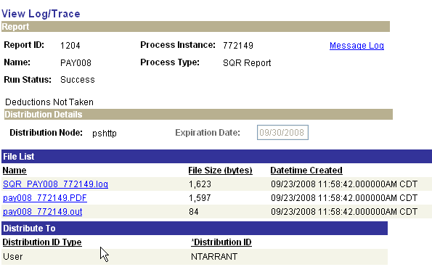

To open and view/print reports from the View Log/Trace page you always click the file in the File List having the .PDF extension. Review everyone listed on this report making sure they are being paid correctly on this cycle. Also, if any employee shows Deferred Comp "deductions not taken" you MUST go into the paysheet, click the One-Time Deduction Tab and turn off the Employer Share of that deduction.

Step 23 – Additional Reports

Additional reports used for further verification of your pay cycles are as follows. All three of these reports are run and viewed/printed using the same steps as outlined in Step 22 above.

Navigation: Payroll for North America > Payroll Processing USA > Produce Payroll >Employees Not Processed Report

This report provides a list of all the rows of earnings where OK-To-Pay has been turned off.

Navigation: Payroll for North America > Payroll Processing USA > Pay Period Reports >
Other Earnings Report

This report provides a list of employees that were paid other earnings in addition to their regular salary.

Navigation: Payroll for North America > Payroll Processing USA > Pay Period Reports >
Payroll Summary

This report summarizes total number of employees’ paid, gross payroll, taxes, deductions and net pay for this pay cycle. It also summarizes those totals by major categories such as OVT.

Step 24 – Run Pre-Distribution Audit Report

This Pre-Distribution Audit Report audits payroll and configuration data. The report identifies any errors that could be encountered when you run the Actuals Distribution (PSPPFUND) or the Actuals GL Interface (PAYGL02). This report is executed after Paysheet Create and before Actuals Distribution.

Navigation: Payroll for North America > Payroll Distribution > Commitment Accounting USA > Predistribution Audit Report

After entering a Run Control ID you will be taken to the Predistribution Audit Report run control parameters page.

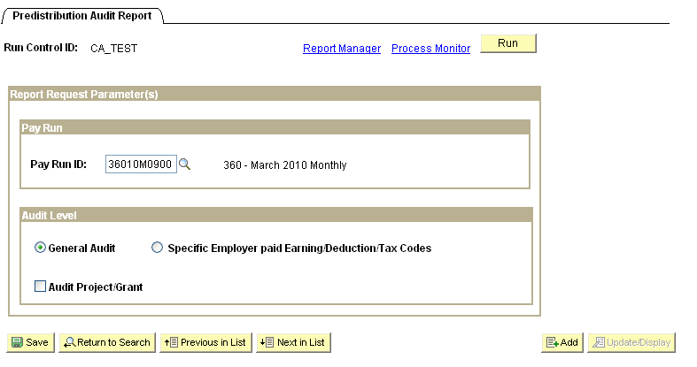

Enter the Pay Run ID of the current payroll being processed and check the General Audit radio button. When all data fields have been correctly filled in, click . You will be taken to the ‘Process Scheduler Request’ page.
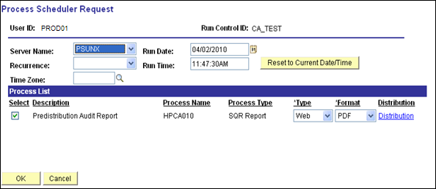

Make sure the Server Name is set to PSUNX.

In the ‘Process List’ group:
- Check box should be checked next to Predistribution Audit Report
- Type should be set to Web
- Format should be set to PDF

Click . You will be taken back to the Predistribution Audit Report parameters page. In the top right hand side of the page a Process Instance number will now be shown. This process instance number is what you will use to monitor the completion of this job on the Process Monitor.

When screen go back to the Predistribution Audit Report parameter page, take note of the Process Instance number and Click the Process Monitor link.
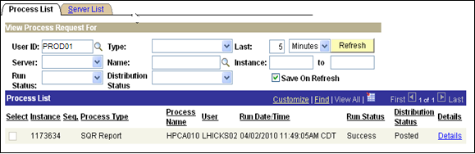

When the run status column shows Success and the Distribution Status column shows Posted. Click Details link. On the Process Detail page click View Log/Trace link.

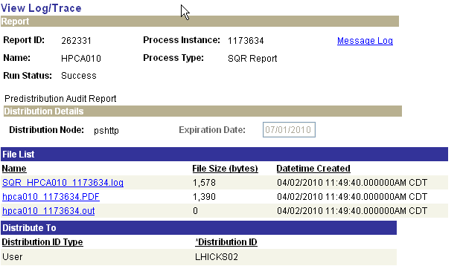

If there are entries on the Audit report for this pay cycle, there will be a file in the ‘File List’ group box with a .PDF extension. Click the .PDF file to open and print your Audit report. This report will list all employees and the issues identified that need attention.
The following is a list of possible audit findings and resolutions:

Jobcode is not currently active or does not exist:
This error occurs when the TL task group/profile does not match the Agency on the Job record. These are usually a transferred employee that did not have their TL employee data updated correctly. Communicate this to the T&L administrators for your agency. The administrator will have to correct the changes, run time admin, approve the time and then when calc runs turn off OK to pay on the old TL record (even though it may not have any time).

Position Number is not currently active or does not exist:
This error occurs when the position an employee is in has been made inactive and there is time reported past the inactive date. To fix this adjust the time or reactivate the position.

Department Budget Date record is not defined for Budget Department:
Anytime this message occurs with a 5 digit department that represents the business unit/agency the agency has created a position and hired someone into that ‘bad’ department. Send a helpdesk ticket requesting that the Job record be corrected to reflect the accurate department. Make sure that any lines remaining on the paysheet with the wrong department are not OK to pay.

No Budgeting Distribution in effect for Budget Department:
This error is identifying an issue with either the DBT or the person (it is usually the person). Check that the DBT is in effect for the correct effective date (usually July 1 of the fiscal year or the first of the month during the conversion process). If there is not a DBT entry, contact the helpdesk requesting an entry be created. If however a DBT entry exists, then look at the T&L data, time may have been entered prior to conversion date to Commitment Accounting. Any time entered with a date prior to the conversion to commitment accounting will have to be handled as an off-cycle.

Step 25 – Run Payroll Unsheet – (If Necessary)

This process deletes all the paysheets that have been created for the specified Pay Run ID – basically you are starting over. It moves any payable time from the paysheet back to Time and Labor payable time and sets the payable status to ‘Rejected by Payroll’. This status setting means that it was kicked back by payroll but will be processed by payroll the next time you run a preliminary calculation for these employees.

Navigation: Payroll for North America > Payroll Processing USA > Update Paysheets > Pay Unsheet

After entering a Run Control ID you are taken to the Pay Unsheet parameters page.

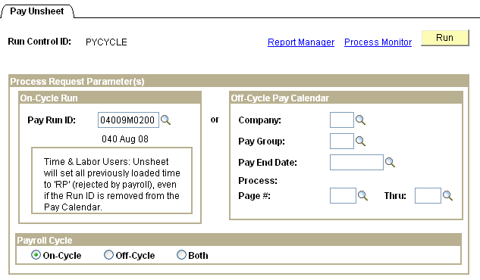

Enter the Pay Run ID you have been using in the On-Cycle Run group box. Click the radio button next to On-Cycle in the Payroll Cycle group box. Click .
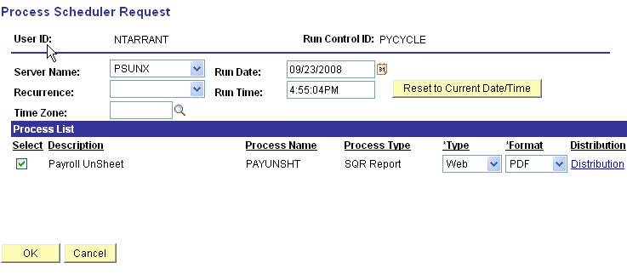

Make sure the Server Name is set to ‘PSUNX’.

In the ‘Process List’ group box:
- Check box should be checked next to Payroll Unsheet
- Type should be set to Web
- Format should be set to PDF.

Click .

When screen goes back to the Pay Unsheet parameter page, take note of the Process Instance number and click Process Monitor link. When the process runs to a Success and Distribution Status shows Posted, navigate to review paysheets and try to pull up data associated with this Run ID (you should not get any paysheets to view). This guarantees that all paysheets were unsheeted correctly.

Now you need to follow the processing steps below:

Pay Unsheet Process:

- Run Step 14
- Run Step 15
- Run Step 16
- Run Step 17
- Run Step 18
- Run Step 19
- Run Step 20
- Run Step 21
- Run Step 22
- Run Step 23
- Run Step 24
- Run Step 25

Step 26 – Run Final Calculation Process

This process calculates all the paysheets again and updates the Pay Calendar by pay group, putting a checkmark in the box beside the Pay Calculation line. Once this process runs to a successful completion, any changes to employee data tables in HCM and/or Time and Labor will NOT be loaded into paysheets.

Navigation: Payroll for North America > Payroll Processing USA > Produce Payroll >Pay Calculation (0346)

After entering a Run Control ID you are taken to the Pay Calculation parameters page.

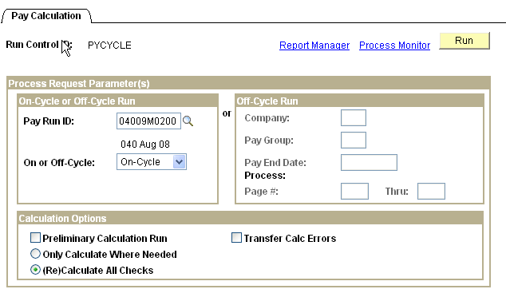

In the On-Cycle or Off-Cycle Run group box enter the correct Pay Run ID and select On-Cycle in the drop down box next to ‘On or Off-Cycle’.

In the Calculation Options group box make sure the ‘Preliminary Calculation Run’ check box is unchecked, and the radio button next to ‘(Re)Calculate All Checks’ is selected.

Click .
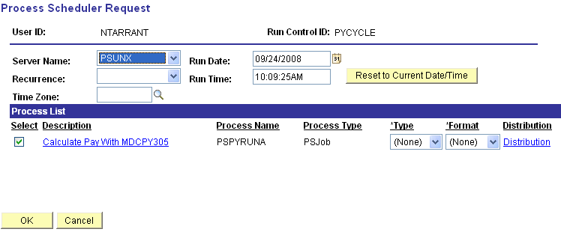

The Process Scheduler Request page should be setup where Server Name is set to ‘PSUNX’.

In the ‘Process List’ group box:
- Check box should be checked next to Calculate Pay with MDCPYj305
- Type should be set to (None)
- Format should be set to (None).

Click .

When screen goes back to the Pay Calculation parameter page, take note of the Process Instance number and click Process Monitor link.

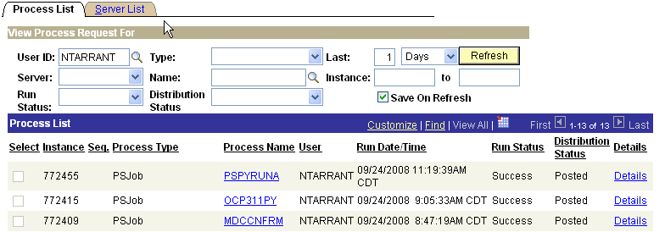

When the job has run to Success and Distribution Status says Posted, click the PSPYRUNA link on the correct process instance row.
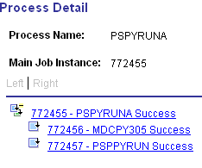

In the Process Detail list click the xxxxxx – PSPPYRUN link. Click View Log/Trace on the Process Detail page which will take you to the View Log/Trace page.

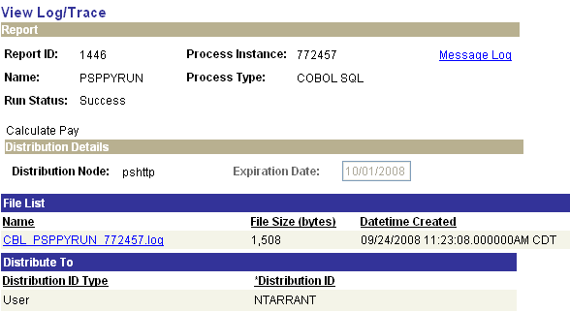

Open the log file by clicking on CBL PSPPYRUN xxxxxx.log link. Review this file looking for any ‘Check Messages!!!’ statements.

Critical NOTE: If there were ‘Check Messages!!!’ statements found on the .log file navigate to ‘Review Processing Messages’ and read all messages pertaining to this run. (For detailed instructions refer to Step 18 above.) Make corrections where necessary and re-run this step (Step 27) until the .log file does NOT contain any ‘Check Messages!!!’ statements.

Step 27 – Run Query –GO_TL_PAY_TIME_BY_PAY_PERIOD

This query will identify employees with time in Time and Labor that was rejected by payroll (status of RP), or is estimated and ready for payroll but did not feed into the paysheets (status of ES). The data did not get fed into payroll due to the edits performed in the prior Preliminary Calculation process, or prior pay cycle processing if they weren’t cleared up earlier. Always clear up rejected time.

Navigation: Home > PeopleTools > Query Manager > Use > Query Viewer >GO_PAY_TIME_BY_PAY_PERIOD

On the Query Viewer ‘Search Criteria’ page enter the query name.

Click .

Click either HTML or Excel which ever output you prefer.

Enter the agency number and click .

Time having an ‘RP’ and/or ‘ES’ status that needs to be reviewed is reflected be below.
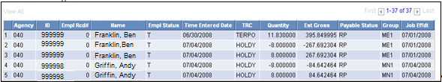

Clean up all RP time. Letting time stay in this status extends processing time for Time Administration and payroll calculations. For detailed information pertaining to Time and Labor data having a payable status of RP, refer to COR106 Time and Labor training manual.

Any time having a status of ES should be reviewed to make sure all payable time was sent to payroll associated with the pay groups being processed.

Step 28 – Check Pay Calendar Flags for Pay Calculation Checkmark

This step takes you to the Pay Calendar page(s) where you will make sure the flag(s) are set correctly showing your Final Calculation process was successful.

Navigation: Payroll for North America > Payroll Processing USA > Create and Load Paysheet >Review Pay Calendars

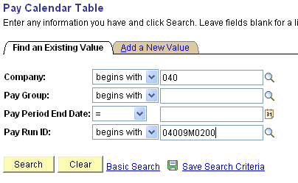

On the Pay Calendar Table search criteria page, enter the Company and Pay Run ID that is being used. Click At the bottom of the page a list of pay calendars will appear that are associated with the Pay Run ID.

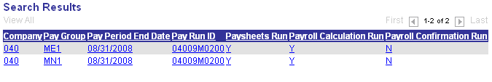

Click the first row in the list and you will be taken to the first Pay Calendar in the list.
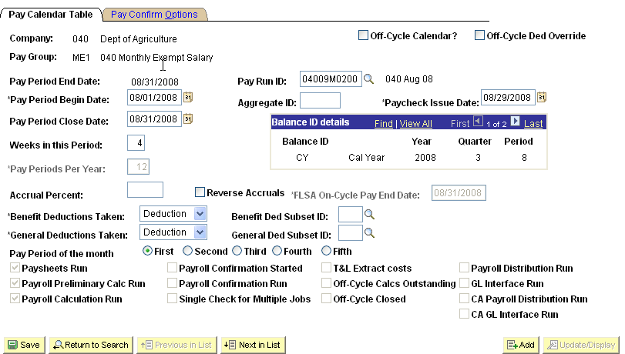

Make sure the check box is checked next to Paysheets Run, Payroll Preliminary Calc Run and Payroll Calculation Run. Click to review the next calendar in the list. Continue this process till there are no more calendars to review (the button will be grayed out).

NOTE: If any of the check marks are missing, stop and contact the Help Desk.

Step 29 – Run Pay Confirmation Process

The pay confirmation process does the same editing as the preliminary and final calculation processes along with editing the database for any outstanding unconfirmed paychecks being processed associated with a prior calendar. The process also checks for any time from Time and Labor that is in a period prior to the effective date of the commitment accounting. If any time is found, the confirm process will fail, and you will have to go back to Step 21, to clean up the prior period time and reprocess the payroll. The confirmation process also assigns check/advice numbers, updates all employee balance tables, updates Pay Calendar flags, and updates flags on all associated rows of data on the PAY_.... tables that store employee detailed paycheck data.

Navigation: Payroll for North America > Payroll Processing USA > Produce Payroll >CA Confirm Pay (0432)

After entering a Run Control ID you are taken to the Pay Confirmation parameters page.

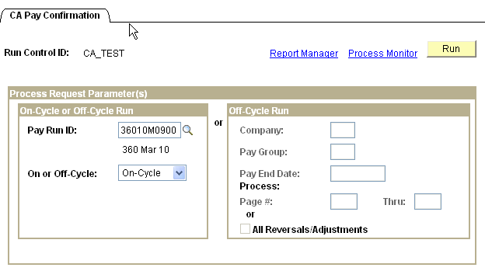

In the On-Cycle or Off-Cycle Run group box, enter the correct Pay Run ID and select On-Cycle, then click .
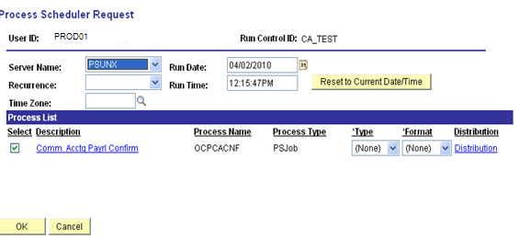

On the Process Scheduler Request page make sure Server Name is set to ‘PSUNX’.

In the ‘Process List’ group box:
- Check box should be checked next to Comm. Acctg Payrl Confirm
- *Type should be set to (None)
- *Format should be set to (None).

Click .

When the screen goes back to the Pay Confirmation parameters page, take note of the Process Instance number and click Process Monitor link.

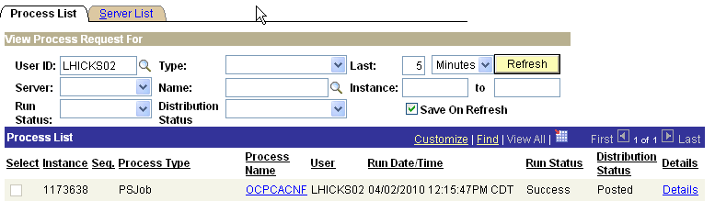

When the job has run to Success and Distribution Status says Posted, click the OCPCACNF link on the correct process instance row.
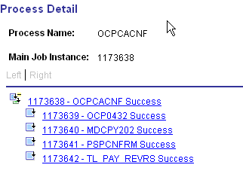

Clicking the xxxxxxx - PSPCNFRM link takes you to the Process Detail page; click the View Log/Trace link.

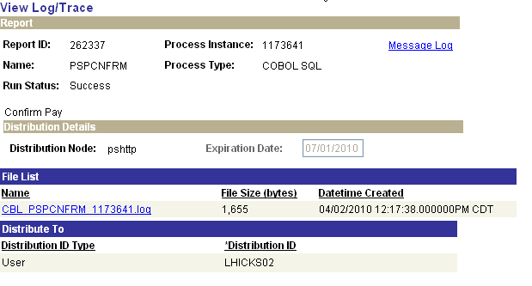

On the View Log/Trace page open the log to check for any ‘Check Messages!!!!’ statements. If you find any, do not go any further and call the CORE Team immediately, then call the Help Desk to open a case. A log showing all confirmations were successful would look similar the one below.
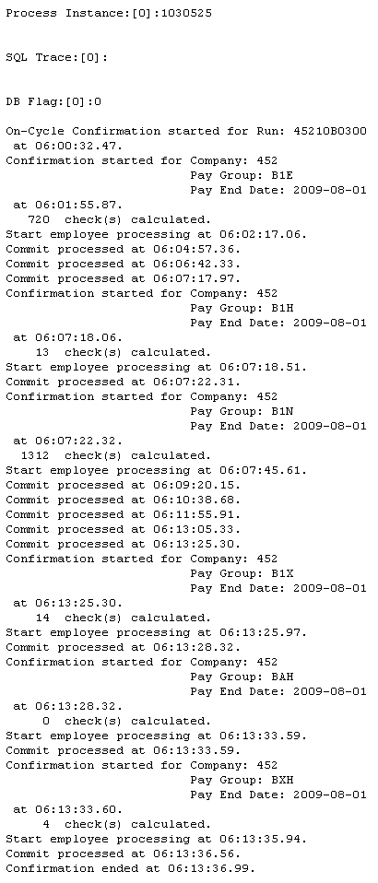

Step 30 – Check Pay Calendar for Flags

Once again the pay Calendar(s) need to be reviewed making sure a checkmark appears in the box in front of the Payroll Confirmation Started and Payroll Confirmation Run labels for every pay group that is active with this Pay Run ID.

Navigation: Payroll for North America > Payroll Processing USA > Create and Load Paysheets >Review Pay Calendars

On the Pay Calendar Table search criteria page, enter the Company and Pay Run ID that is being used. Click At the bottom of the page a list of pay calendars will appear that are associated with the Pay Run ID.

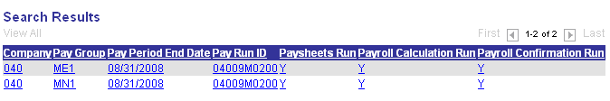

Click the first row in the list and you will be taken to the first Pay Calendar in the list.
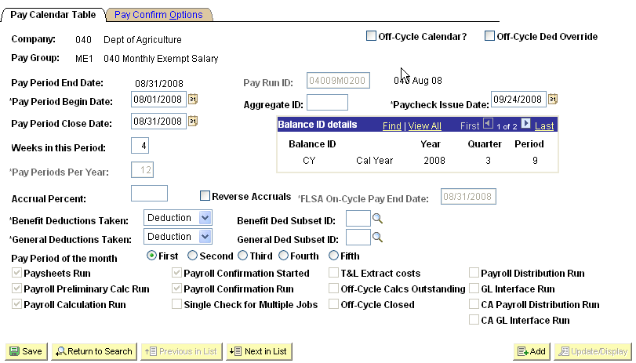

Make sure the check boxes are checked next to Payroll Confirmation Started and Payroll Confirmation Run. Click to review the next calendar in the list. Continue this process till there are no more calendars to review (the button will be grayed out).

NOTE: If any of these checkmarks are missing, stop and contact Help Desk, then the CORE Team immediately to help you resolve this issue. Do NOT Proceed Any Further.

Step 31 – Check Paycheck Data for Advice and Check Numbers

A review of the paycheck data is required making sure the words Advice or Check appears under the column labeled ‘Form Number’ along with a number in the column labeled ‘Paycheck Number’.

Navigation: Payroll for North America > Payroll Processing USA > Produce Payroll >
Review Paycheck

On the Review Paycheck search criteria page enter the Company and Pay Period End Date.

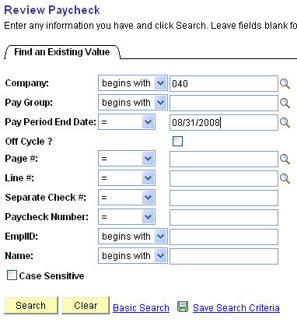

Click .
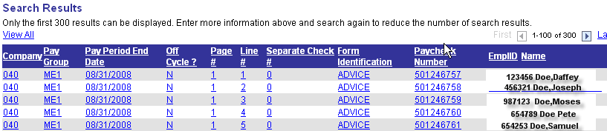

You should see the word ADVICE or CHECK under the heading Form Identification, and the actual check/advice umber under the heading Paycheck Number.

If this information is missing, contact the Help Desk then the CORE Team to help you resolve this issue.

Step 32 – Check to Be Sure ALL Paysheets Have Been Confirmed

This step is to make sure all the paysheets were confirmed.

Navigation: Payroll for North America > Payroll Processing for USA > Update Paysheets > By Paysheet

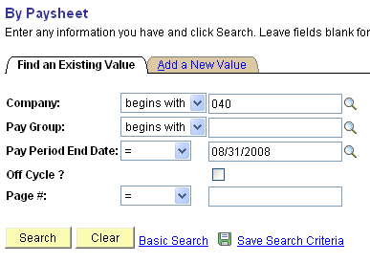

On the By Paysheet search criteria page enter your company number and Pay Period End Date and click No paysheets should appear at the bottom of this page, instead the screen should like the one below with the message ‘No matching values were found’.
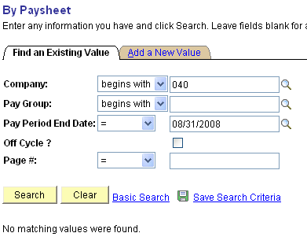

If paysheets are listed, contact the Help Desk then the CORE Team to help you resolve the issue immediately. Do NOT proceed any further.

Step 33 – Run PY Pull Costs

This process, generally referred to as PY_PULL_COST, is run after confirming all pay cycles (both on and off cycles). The process updates payable time entries in Time and Labor as follows:

- If payable time is distributed, but not diluted, the Extract process changes the payable status to Distributed (DP). (Will come into play in Phase II.)
- If payable time is distributed and diluted, the extract process changes the status to Diluted (DL). (Will come into play in Phase II.)
- For time that is not being distributed, the Load Time and Labor process sets the payable time status to Closed (CL). (Will come into play in Phase II.)
- Provides cross-reference numbers generated during the consolidation process, the calculated costs, and percentages that represent how payroll consolidated the payable time rows.
- Sets the publish date and publish switch.
- If payable time is pulled into paysheets, and OK-to-Pay is cleared (setting to Not-OK-to-Pay) for those related earnings, these rows of payable time are not paid and are set to ‘Ignore’ with reason of ‘Not OK to Pay’

Navigation: Payroll for North America > Payroll Distribution > Additional Integrations >Extract Time and Labor Costs

After entering the Run Control ID you are taken to the Time and Labor Cost Extract parameters page.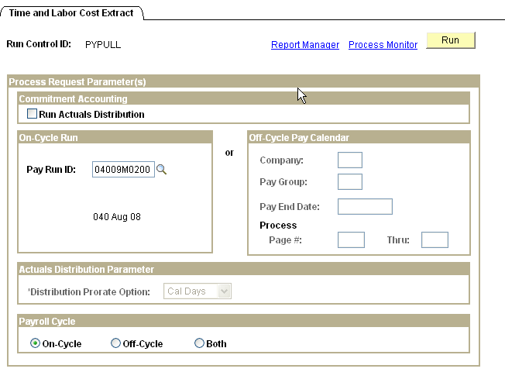

In the On-Cycle Run group box enter the Pay Run ID. Check the On-Cycle radio button. Click and it will then take you to the Process Scheduler Request page.

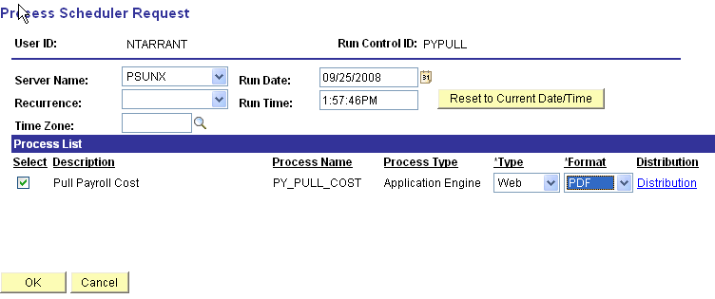

On the process Scheduler Request page set Server Name to ‘PSUNX’.
In the ‘Process List’ group box:
- Check box should be checked next to Pull Payroll Cost
- *Type should be set to Web
- *Format should be set to PDF.

Click .

When screen goes back to the Time and Labor Cost Extract parameters page, take note of the Process Instance number and click Process Monitor link. When the process runs to status of Success and Distribution Status shows Posted, click Details link. Click View Log/Trace link on the Process Detail page.

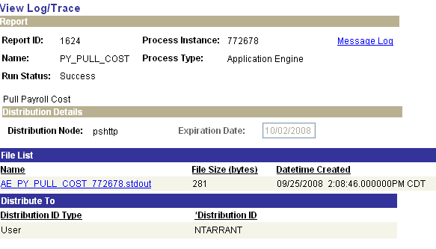

Click the AE PY PULL COST 772678.stdout link to open the app engine output file. If the process ran successfully your log should read similar to the one below.

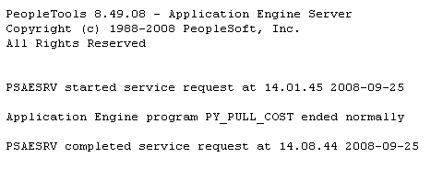

Step 34 – Run Distribute Actuals

The Actuals Distribution process (PSPPFUND) distributes actual earnings, employer deductions, and employer taxes across the funding sources established. This process is executed after the confirm process for the current payroll.

Navigation: Payroll for North America > Payroll Distribution > Commitment Accounting > Distribute Actuals

After entering a Run Control ID you will be taken to the Actuals Distribution run control parameters page.

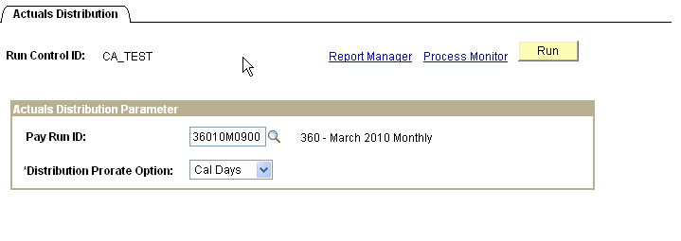

Enter the Pay Run ID of the current payroll being processed; select ‘Cal Days’ as the Distribution Prorate Option. When all data fields have been correctly filled in, click You will be taken to the ‘Process Scheduler Request’ page.
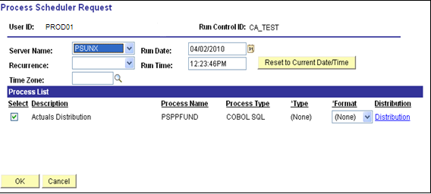

Make sure the Server Name is set to PSUNX.

In the ‘Process List’ group:
- Check box should be checked next to Actuals Distribution
- Type should be set to (None)
- Format should be set to (None)

Click .

When screen goes back to the Acuals Distribution parameters page, take note of the Process Instance number and Click Process Monitor link. Once the job has run to Success status and Distribution Status shows Posted, click the Details link.

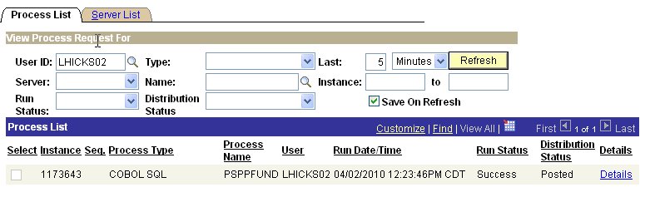
When the job has run to Success status and Distribution Status shows Posted, click the Details link.

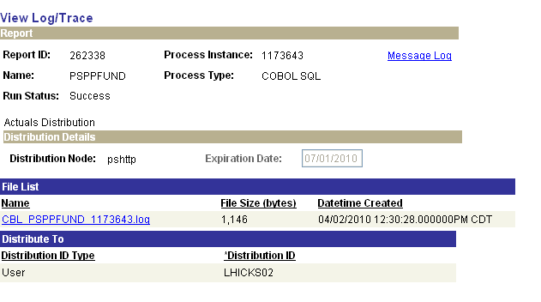

On the Process Details page click View Log/Trace link. Click CBL PSPPFUND xxxxx.log link to view and or print the log. Look for the Check Messages statement.

Step 35 – Run Funding Reports

Budget Check (0025) and Budget Check for Projects (0025K)
These reports show the total cost of the payroll and available funding for the cash/allotment and project budgets. Review the reports looking for any errors and/or areas lacking sufficient funds. If sufficient funds are NOT available, make the necessary changes to the Actuals Distribution at the employee level. After the changes are made re-run the reports until the funding is no longer in a deficit.

Funding Distribution (0108)
This report is also created during the execution of running the funding reports. The ‘Funding Distribution’ report shows how payroll funding is being distributed through the departments. Totals are reconciled back to the ‘Payroll Register’ run in Step 22.

Navigation: Payroll for North America > Payroll Distribution > Prepare GL Information > Commitment Accounting > Funding Rpts (OCP400)

After entering a Run Control ID you will be taken to the Funding Rpts (0400) run control parameters page. If you don’t have a Run Control ID for running this process click the Add a New Value Tab and enter a value.

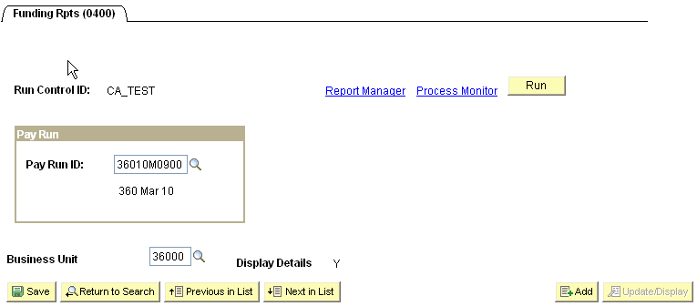

On the run control page below, enter the current payrolls Pay Run ID and the Business Unit.
When all data fields have been correctly filled in, click You will be taken to the ‘Process Scheduler Request’ page.

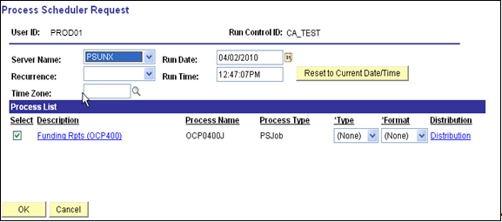

Make sure the Server Name is set to PSUNX.

In the ‘Process List’ group:
- Check box should be checked next to Funding Rpts (OCP400)
- Type should be set to (None)
- Format should be set to (None)

Click .

When the page goes back to the Funding Reports parameters page, take note of the Process Instance number and click Process Monitor link.

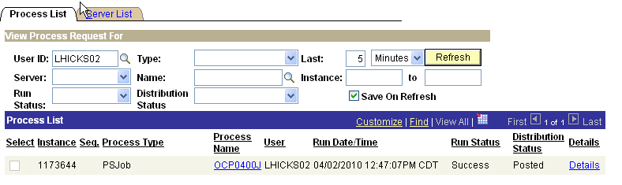

When the process runs to a Success and Distribution Status shows Posted, click the OCP0400J link under Process Name column.
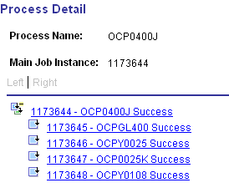

To view and reconcile the Budget Check report, click the xxxxxx – OCPY0025 link. Click the View Log/Trace link. In the ‘File List’ group box select the file with the .PDF extension.

To view and reconcile the Project Budget Check report, click the xxxxxx – OCP0025K link. Click the View Log/Trace link. In the ‘File List’ group box select the file with the .PDF extension.

To view and reconcile the Funding Distribution report , click the xxxxxx – OCPY0108 link. Click the View Log/Trace link. In the ‘File List’ group box select the file with the .PDF extension.

The State of Oklahoma will NOT allow payrolls to process beyond this point until ALL deficits are cleared up.

The last page of the Budget Check report(s) will show a Gross Payroll Total that should reconcile with payroll totals from the Payroll Register and Funding Distribution reports.
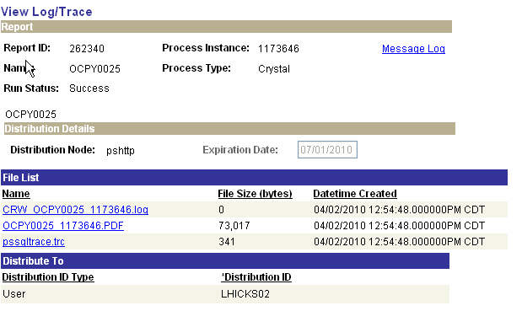

On the Process Details page click View Log/Trace link. Click OCPY0025 xxxxxx.PDF link to view and or print the log.

Step 36 – Correct Employee Actuals Distribution

NOTE: The State of Oklahoma will NOT allow payrolls to process beyond the Funding Reports step until ALL deficits are cleared up.

In order to clear up deficits Use the Review Actuals Distribution page to modify funding distribution after the Actuals Distribution process and before posting to the General Ledger. The funding source can be changed but the total dollar amount must stay the same.

Navigation: Payroll for North America > Payroll Distribution > Commitment Accounting USA Review Actuals Distribution

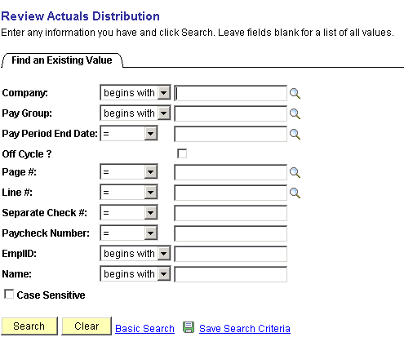

On the above search criteria page, enter the Company, Pay Group, Pay Period End Date and the employee’s EmplID that requires a funding adjustment. You may use any of the other criteria for searching the Actuals Distribution, the more fields you provide the faster the data is returned. Click .
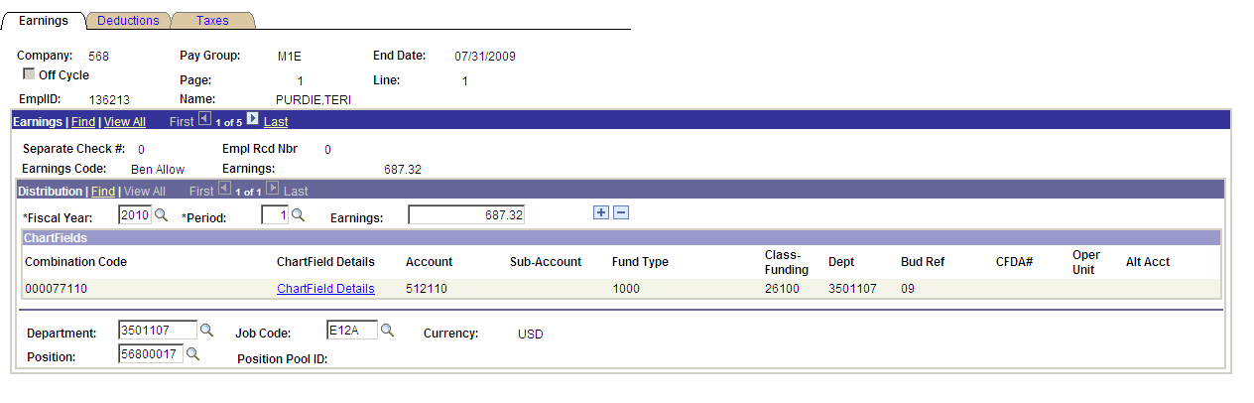

The Earnings page displays the Actuals Distribution that was distributed during the Actuals Distribution process (PSPPFUND). 1 of 5 rows of data is available to change funding.

Funding can be changed by selecting the Chartfield Details link.

Example Changing the Chartfield Details:

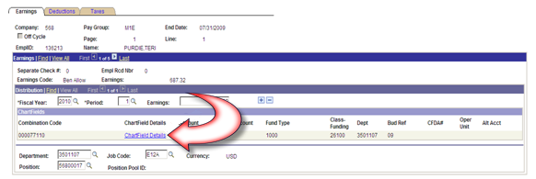

Select the Chartfield Details link:
If you know the new Combination Code, enter it in the appropriate field and click .

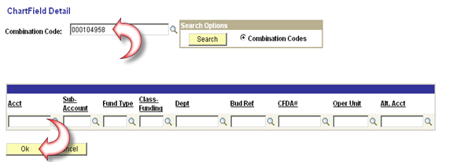

Otherwise follow these steps:

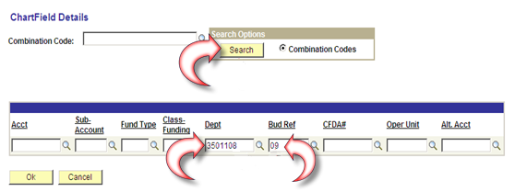

Enter the Dept and BudRef.
Click , pulls up all valid GL Combo Codes for the Department and Fiscal specified.

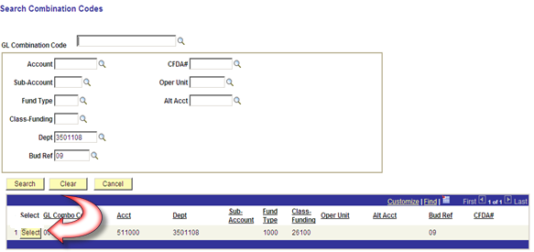

Locate the valid Combo Code and click to the left of the GL Combo Code.
This will take you back to the ChartField Detail page. The Acct, Fund Type, and Class-Funding fields are now also populated.

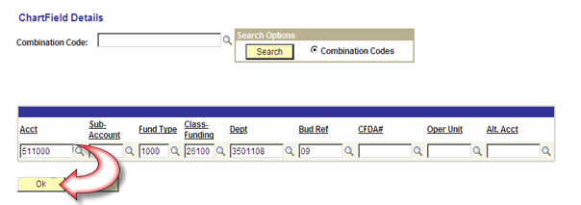

Click to go back to the Review Actuals page.
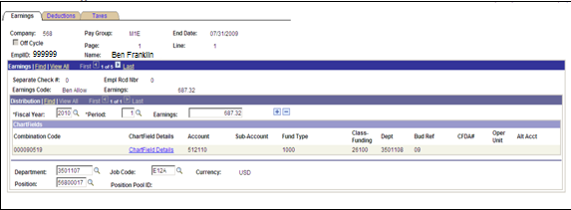

The Review Actuals page for Earnings is returned with the new Combo Code displayed. Change the Combo Code for each Earnings row.

Since the Earnings records were changed to a new combo code, the Deductions and Taxes also need to change to the new Combo Code.

Select the Deduction Tab:

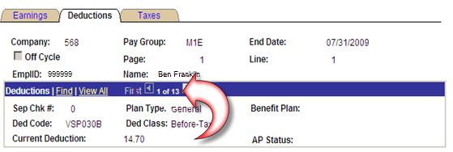

Notice that the number of records total is 13. The first deduction displayed above is VSP030B. This is an EMPLOYEE deduction. Only EMPLOYER deductions are distributed. Select the View All link and change the Combo Code on ALL of the EMPLOYER deductions.
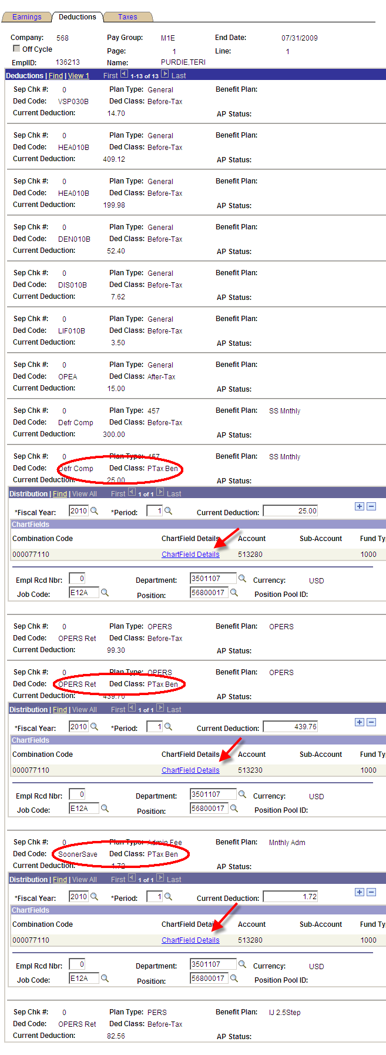
For each EMPLOYER deduction follow the directions above for changing the chartfields.

Select the Taxes Tab:

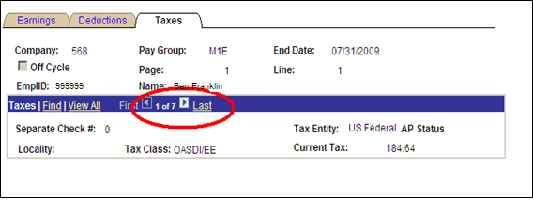

Select the View All link to display all of the Taxes.
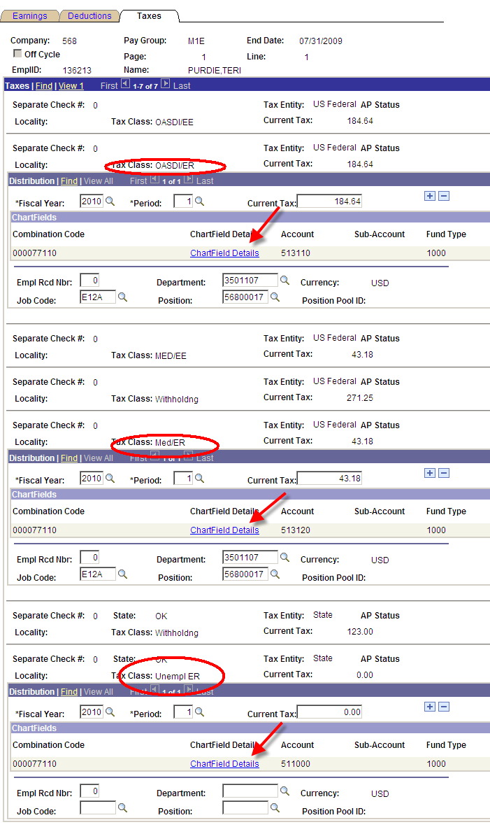

For each EMPLOYER paid tax, change the combo codes using the same steps above for changing the Chartfield Details.

Step 37 – Re-Run Funding Reports

Budget Check (0025), Budget Check for Projects (0025K) and Funding Distribution (0108)
Re-run the Funding Reports to verify that the changes made during the “Correct Employee Actuals Distribution” has corrected the budget deficit. See Step 37 above for instructions on running these reports.

Navigation: Payroll for North America > Payroll Distribution > Prepare GL Information > Commitment Accounting > Funding Rpts (OCP400)

After entering a Run Control ID you will be taken to the Funding Rpts (0400) run control parameters page.

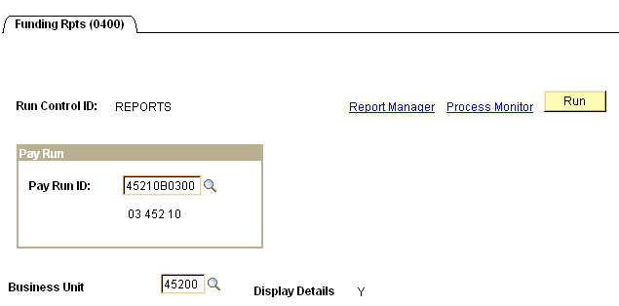

Step 38 – Run Finalize Funding Reports

Budget Check (0025), Budget Check for Projects (0025K), Funding Distribution (0108) and the Payroll Claim Document (0118)

After re-running the Funding Reports and validating that the funding is accurate and available, run the ‘Finalize Funding Repots’ step. This step sets a flag, indicating that no other changes will be made to the Actuals Distributions and are ready for the next step.

Navigation: Payroll for North America > Payroll Distribution > Prepare GL Information > Commitment Accounting > Finalize Funding Rpts (OCP400)

After entering a Run Control ID you will be taken to the Finalize Funding Rpts (OCP400) run control parameters page.

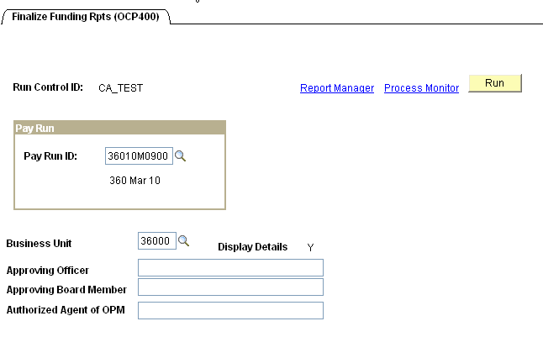

Enter the Pay Run ID and Business Unit. If your Claim Document requires the name(s) of ‘Approving Officer’, ‘Approving Board Member’, and/or ‘Authorized Agent of OPM’ printed on the report, key them in the fields provided. Click .
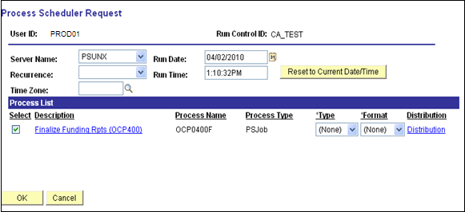

In the ‘Process List’ group box:
- Check box should be checked next to Finalize Funding Rpts (OCP400)
- *Type should be set to (None)
- *Format should be set to (None).

Click .

When screen goes back to the Finalize Funding Rpts parameters page, take note of the Process Instance number and click Process Monitor link.

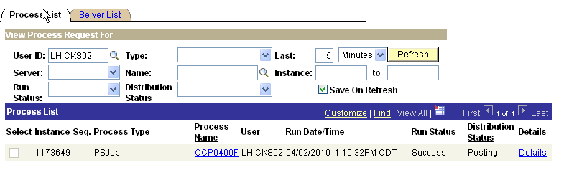

When the run status column shows Success and the Distribution Status column shows Posted. Click OCP0400F link under the Process Name in the middle of the page. On the Process Detail page click View Log/Trace link.
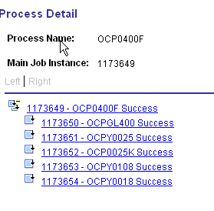

To view and print the Budget Check report, click the xxxxxx – OCPY0025 link. Click the View Log/Trace link. In the ‘File List’ group box select the file with the .PDF extension.

To view and print the Project Budget Check report, click the xxxxxx – OCP0025K link. Click the View Log/Trace link. In the ‘File List’ group box select the file with the .PDF extension.

To view and print the Funding Distribution report, click the xxxxxx – OCPY0108 link. Click the View Log/Trace link. In the ‘File List’ group box select the file with the .PDF extension.

To view and print the Payroll Claim Document report, click the xxxxxx – OCPY0018 link. Click the View Log/Trace link. In the ‘File List’ group box select the file with the .PDF extension.

NOTE: If the Final Funding Reports were created with a budget deficit, your Finance Officer must sign the ‘Notice of Deficit Statement’ and make arrangements with OSF to be allowed to continue processing.

Re-Running the Funding Distribution Report (0108) in an Excel Format
The reports produced by the OCP_400F process (Finalize Funding Rpts) can be run multiple times. The Funding Distribution Report (0108) can be run in an Excel format for distribution or data manipulation. The steps to produce the Funding Distribution Report in an Excel format are essentially the same as those used to run the Finalize Funding Rpts. These steps are as follows:
Navigation: Payroll for North America > Payroll Distribution > Prepare GL Information > Commitment Accounting > Finalize Funding Rpts (OCP400)

After entering a Run Control ID you will be taken to the Finalize Funding Rpts (OCP400) run control parameters page.

Enter the Pay Run ID and Business Unit. If your Claim Document requires the name(s) of ‘Approving Officer’, ‘Approving Board Member’, and/or ‘Authorized Agent of OPM’ printed on the report, key them in the fields provided. Click .
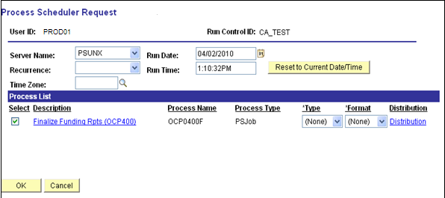

In the ‘Process List’ group box:
- Check box should be checked next to Finalize Funding Rpts (OCP400).
- *Type should be set to (None).
- *Format should be set to (None).

Select the Finalize Funding Rpts (OCP400) link. Once selected, you will see this page.

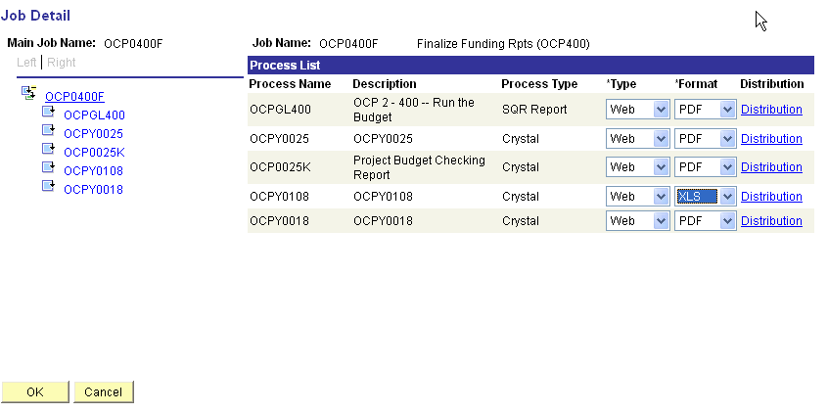

OCPY0108 is the Funding Distribution report. Select ‘Type’ of Web, and ‘Format’ of XLS from the drop-down.

Click .
After clicking , you will be returned to the Process Scheduler page.

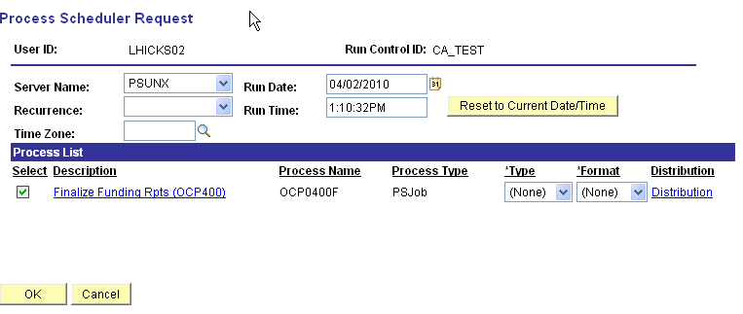

Click again to start the process.

When screen goes back to the Finalize Funding Rpts parameters page, take note of the Process Instance number and click Process Monitor link.

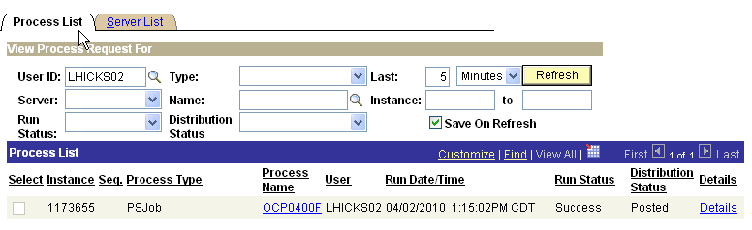

When the run status column shows Success and the Distribution Status column shows Posted, click the OCP0400F link under the Process Name in the middle of the page. On the Process Detail page click View Log/Trace link.
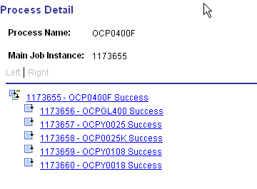

To view and print the Funding Distribution report, click the xxxxxx – OCPY0108 link.

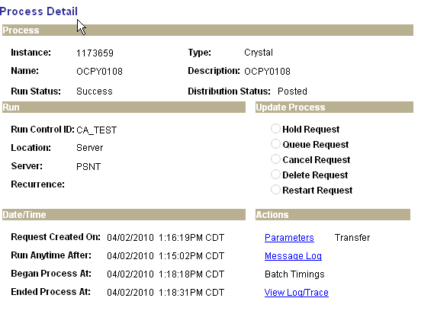

Click the View Log/Trace link. In the ‘File List’ group box select the file with the .XLS extension.
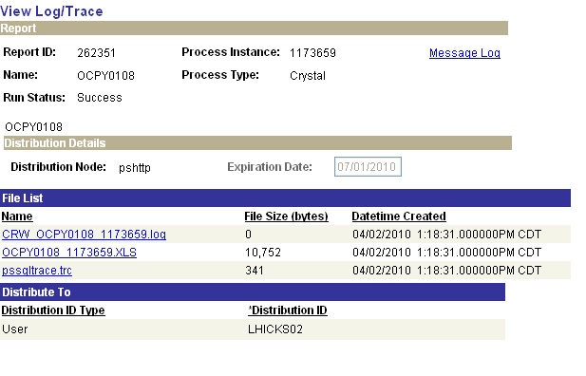

Step 39 – Run GL Process

This process populates the HR Accounting Line Table and sends the data to Financials from which General Ledger journal entries are created.

Navigation: Payroll for North America > Payroll Distribution > Provide GL Information > Commitment Accounting Actuals

After entering a Run Control ID you are taken to the Commitment Accounting Actuals parameters page.

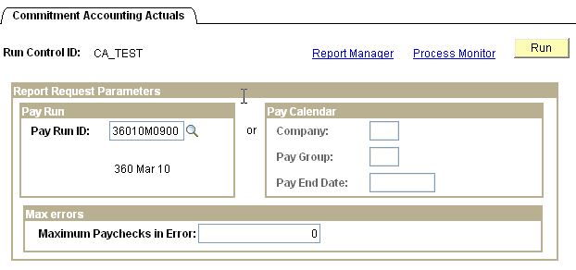

Enter the Pay Run ID and click

.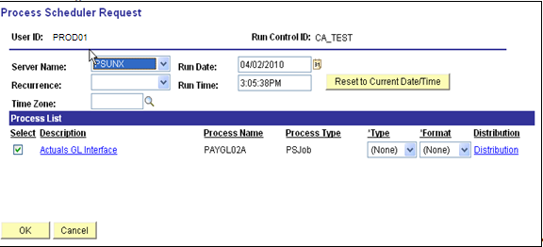

On the Process Scheduler Request page, Server Name must be set to ‘PSUNX’.

In the ‘Process List’ group box:
- Check box should be checked next to Actuals GL Interface
- Type should be set to (None)
- Format should be set to (None)

Click .

When screen goes back to the Commitment Accounting Actuals parameters page, take note of the Process Instance number and click Process Monitor link. When the process runs to a Success and Distribution Status shows Posted, click the PAYGL02A link under Process Name.

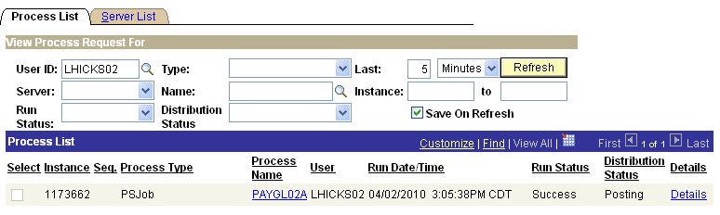

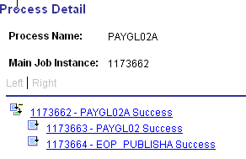

From the Process Detail page click the xxxxxx – PAYGL02 Success link. On the View Log/Trace page click View Log/Trace link.

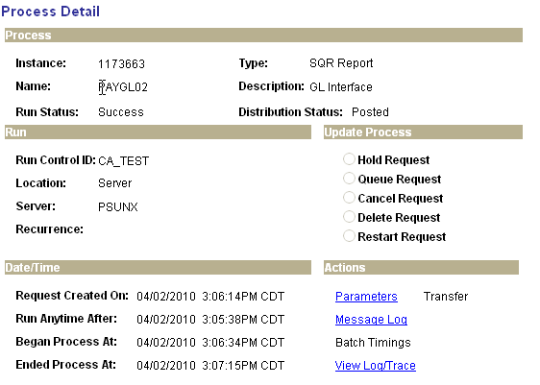

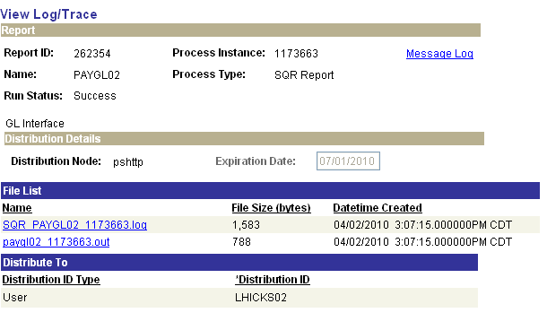

In the File List, click the file having the .out extension. This opens what is known as the Trace Log.
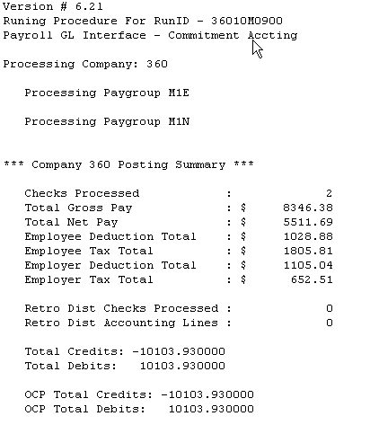

Make sure the Total Debits and Total Credits equal each other, and reconcile with the Payroll Register, Budget Checking and Claim Document reports. Print this file, write your name and phone number on it. Submit this Trace Log to OSF along with the Budget Checking and signed Claim Document reports.

Note: If there are discrepancies between the reports, etc., have a Helpdesk case created, then phone CORE Support Team.

Step 40 – Check Pay Calendar Flags

Once again the pay Calendar(s) need to be reviewed making sure a checkmark appears in the box in front of the CA GL Interface Run for every pay group that is active with this Pay Run ID.

Navigation: Payroll for North America > Payroll Processing USA > Create and Load Paysheets >Review Pay Calendars

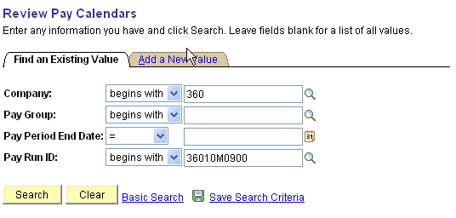

On the Pay Calendar Table search criteria page, enter the Company and Pay Run ID that is being used. Click . If more than one Pay Calendar is associated with the Pay Run ID a list will appear at the bottom of your screen. Click the first one in the list. Otherwise, you will be taken directly to the Pay Calendar Table page.

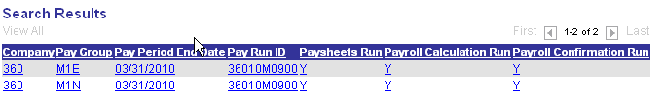

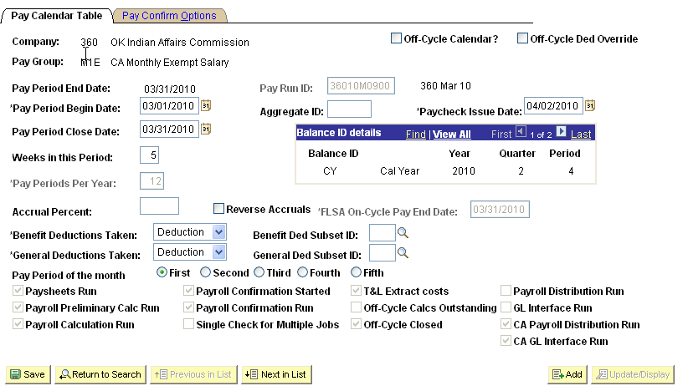

There should be a checkmark in the box in front of the label CA GL Interface Run. Click the button to view the next Pay Calendar. If this button is grayed out there are no more calendars to view.

NOTE: If the checkmark is missing, contact the CORE Team immediately for help in resolving this issue.

Step 41 – Fax Documents to Office State Finance

Office State Finance requires that each agency payroll processor send three (3) documents.

The documents are:

- The final Budget Check Report from Step 40
- The final Claim Document from Step 40 also and
- The CA GL Interface Trace File from Step 41 must be faxed to OSF by 3:00 PM in order for your payroll to be released to Office State Treasurer on that day. Otherwise, the payroll will be held until the paperwork is faxed to them.

Fax # 405 521-3383 to Elsa at Office State Finance

Once the Office State Finance receives your documents the reports will be reviewed and the payroll will be released to be picked up by a process that sends the checks and direct deposits to the State Treasurer for processing.

Step 42 – Run PY To AP Extract Process

This process extracts non-tax deductions based on how the deduction code has been setup.

Navigation: Payroll for North America > Payroll Distribution > Accounts Payable Information > Extract CA Non-Tax Deductions

After entering a Run Control ID you will be taken to the CA Non-Tax Deductions Extract parameter page.

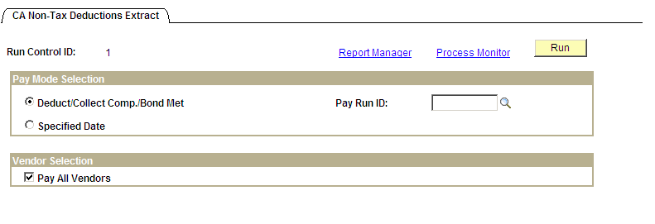

In the Pay Mode Selection group box, select the radio button next to Deduct/Collect Comp./Bond Met and enter the Pay Run ID associated with the pay cycle that you just confirmed. In the Vendor Selection group box make sure the check box is checked next to ‘Pay All Vendors’. Click

You may receive a ‘Warning Message’, click.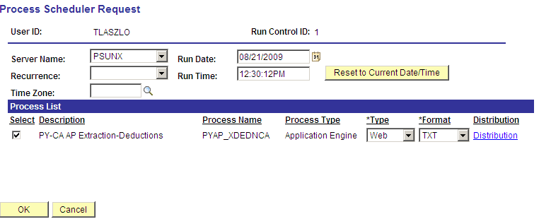

On the Process Scheduler Request page set Server Name to ‘PSUNX’.

In the ‘Process List’ group box:
- Check box should be checked next to PY-CA AP Extraction - Deductions
- *Type should be set to Web
- *Format should be set to TXT

Click .

If you receive a ‘Warning Message’, click .

When screen goes back to the Non Tax Deductions Extract parameters page, take note of the Process Instance number and click Process Monitor link. When the process runs to a Success and Distribution Status shows Posted move onto the next step. If you want to make sure deductions are in an ‘Extracted’ status you can navigate to Review Paycheck data (Payroll for North America > Payroll Processing USA > Produce Payroll > Review Paycheck). Enter the search criteria to pull up an employee’s check data associated with this confirmed payroll. Click ‘Paycheck Deductions’ in the Deductions group box then click the Deduction Details 3 Tab.

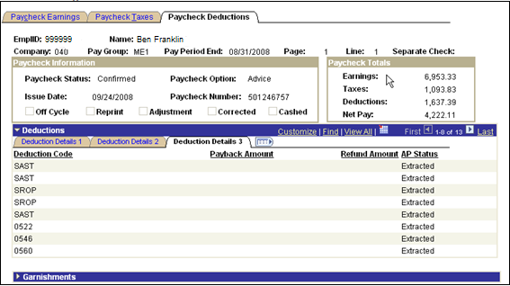

Under the AP Status column you will see the word ‘Extracted’ appear next to each deduction that was to be extracted based on the deduction code setup.

Nightly batch processing runs the AP Voucher Post process for agencies.

Step 43 – Run Deduction Register (0205)

This process creates a report listing all employee deductions pertaining to this payroll. The report is sorted by Deduction Code after which the sort is by employee name. The sections of the report pertaining to deduction data that was sent to AP is to be forwarded to Accounts Payable for reconciliation processing.

Navigation: Payroll for North America > payroll Processing USA > Pay Period Reports > Deduction Register (0205)

After entering a Run Control ID you are taken to the Deduction Register (0205) parameters page.

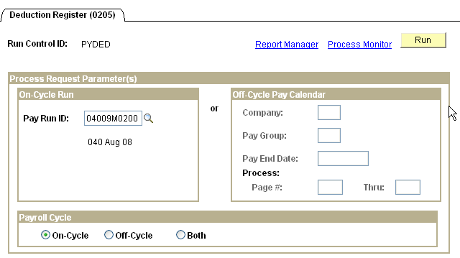

Enter the Pay Run ID associated with the pay cycle that you just confirmed in the On-Cycle Run group box. In the Payroll Cycle Section, click the radio button.

Click .
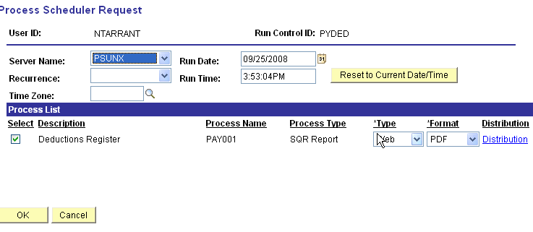

On the Process Scheduler Request page set Server Name to ‘PSUNX’.

In the ‘Process List’ group box:
- Check box should be checked next to Deductions Register
- *Type should be set to Web
- *Format should be set to PDF

Click .

When the screen goes back to the Deduction Register (0205) parameters page, take note of the Process Instance number and click Process Monitor link. When the process runs to a Success and Distribution Status shows Posted, click Details link. On the Process Detail page click View Log/Trace link.
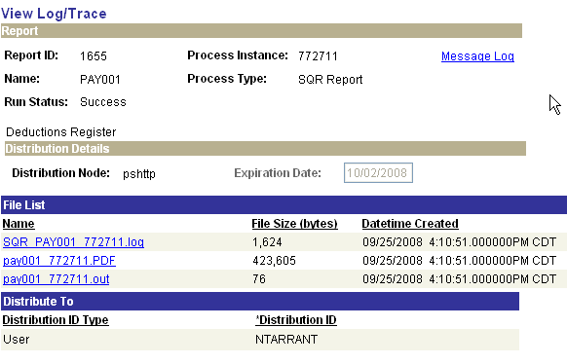

To view and print the Deduction Register click the file in the File List having the .PDF extension (pay001 xxxxxx.PDF).

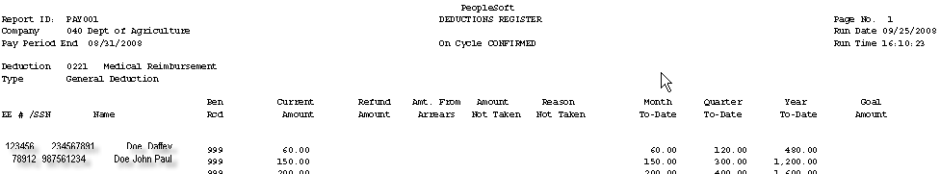

The report will look similar to the above listing deductions in descending/alphabetical order. At the end of each deduction code there is a subtotal line. Print the pages that are required in AP for reconciliation.

Step 44 – Print Earnings Statements (Run this process only if you are not on ESS)

This process prints the Employee Earnings Statements to be handed out.

Navigation: OK Custom reports/Processes > OK reports > Payroll > Earnings Statement (0040)

After entering the Run Control ID you are taken to the DDP Advice Print parameters page.

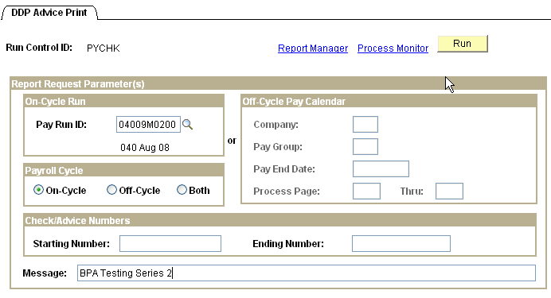

In the On-Cycle Run group box enter the Pay Run ID that you have just confirmed. In the Payroll Cycle group box click the radio button next to On-Cycle. If you want to have a Message appear on the statements enter it in the Message box on the bottom of the page. When data is filled in correctly, click .

NOTE: If you need to reprint statement(s) due to them being lost etc., but don’t need to reprint the entire batch, enter the starting and ending check/advice numbers in the Check/Advice Numbers group box.

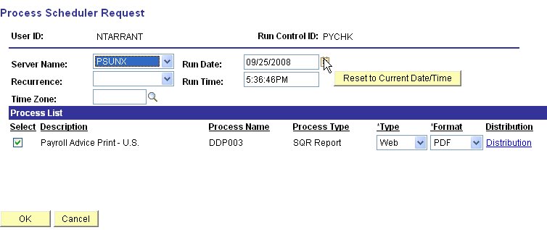

On the Process Scheduler Request page set Server Name to ‘PSUNX’.

In the ‘Process List’ group box:
- Check box should be checked next to Payroll Advice Print – U.S.
- *Type field set to Web
- Format should be set to PDF

Click .

When the screen goes back to the DDP Advice Print parameters page, take note of the Process Instance number and click Process Monitor link. When the process runs to a status of Success and Distribution Status shows Posted click Details link. On the Process Detail page click View Log/Trace link.
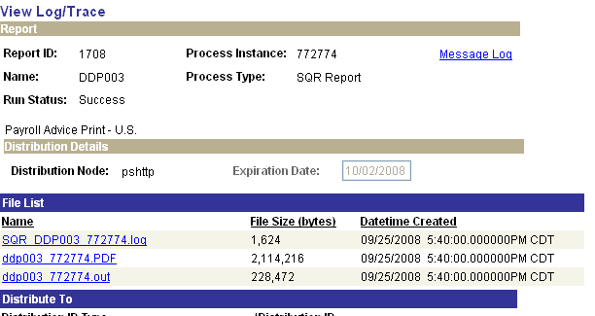

To view and print the Earnings Statement click the file in the File List having the .PDF extension (ddp003 xxxxxx.PDF).

Step 45 – Run Credit Union Report

Only run this report if it is applicable to your agency.

Navigation: OK Custom reports/Processes > Agency Processes > Deduction File (0105)

After entering the Run Control ID you are taken to the Deduction File (0104) parameters page.

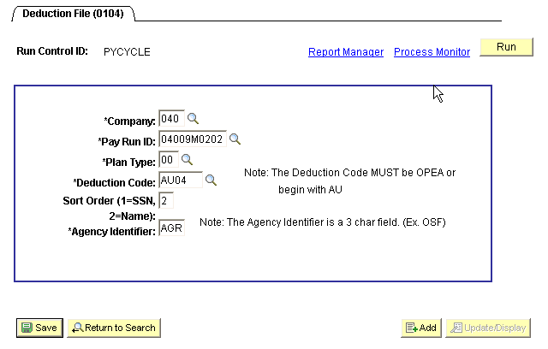

Fill in all the fields with the required data and click .

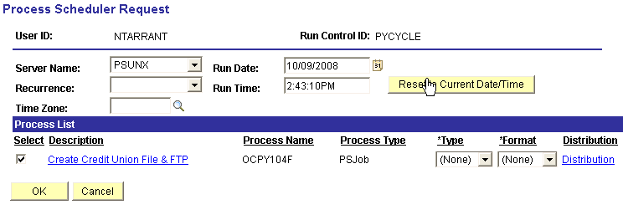
On the Process Scheduler Request page set Server Name to ‘PSUNX’.

In the ‘Process List’ group box:
- Check box should be checked next to Create Credit union File & FTP
- *Type should be set to (None)
- *Format should be set to (None)

Click .

When screen goes back to the Deduction File (0104) parameters page, take note of the Process Instance number and click Process Monitor link. When the process runs to a Success and Distribution Status shows Posted click the OCPY104F link.

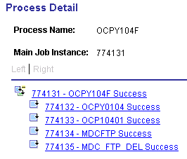

From the Process Detail page above, if you:

- Click xxxxxx – OCPY0104 you will be taken to the View Log/Trace page where you can open up the files to view the data that was picked up in the file.
- Click xxxxxx – OCPY10401 you will be taken to the View Log/Trace page where you can open up the file to view the completed results of the app engine job.
- Clicking on the last two in the list above allows you to view the status of the FTP processes that have completed.

Off-Cycle Payrolls

Off-Cycle Calendars

Now that you have seen how to use a pay calendar for your main and supplemental on-cycle payroll processing, this section will help you understand another dimension to the pay calendar, which is the Off-Cycle concept. The Off-Cycle Calendar checkbox is located in the upper right hand area of the pay calendar page.

The State of Oklahoma uses off-cycle pay calendars to process adjustments due to checks in error, processing of employee shift differential, overtime and termination payouts (that were not turned in on time to be included in the on-cycle), leave adjustments, etc. To request an off-cycle calendar be created the agency is to file a Help Desk case to be sent to the CORE Team specifying the Pay Group(s) and Paycheck Issue Date. CORE will create the calendar(s) attaching an off-cycle Pay Run ID and Aggregate Tax ID to each calendar. The agency will be notified once the calendar(s) have been created.

NOTE: Standards pertaining to the number of off-cycles allowed per pay period are as follows:

- Monthly Anticipatory Payrolls – One (1) Off-Cycle for adjustments, retro pay, overtime, etc. If your agency is on the PeopleSoft Leave System, One (1) Off-Cycle to run annual/sick leave processing.
- Bi-Weekly Payrolls – One (1) Off-Cycle for adjustments, retro-pay, missed overtime, etc.

Agencies exceeding the allowable limits of off-cycles, as noted above, must submit a justification for requesting the creation of the additional pay cycle calendar. This request should be on the agency letterhead and include the agency name and number, the pay group(s) and pay period off-cycle is covering, and the reason for exceeding the maximum number of off-cycles allowed. The letter is to be signed by the agency director or a designee listed on the Signature Card, OSF Form 13. The letter is the FAXED to Steve Wilson (405) 521-3383. CORE is only allowed to create additional off-cycle calendars, when the limit is being exceeded, after receiving the approval from Steve Wilson.

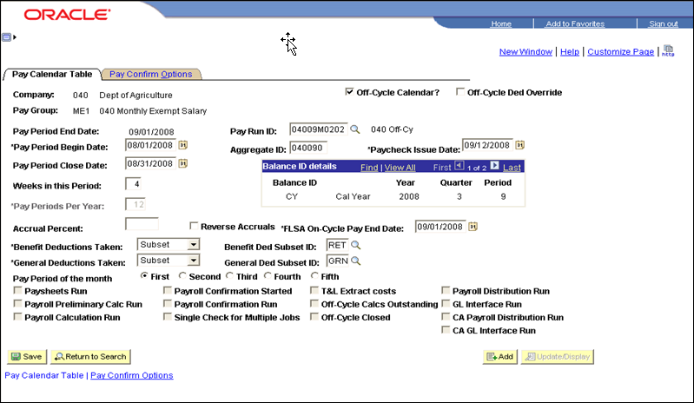

The check issue date of an Off-Cycle Calendar is always later than the pay period end date (similar to supplemental pay cycles), however, all data included in this off-cycle will be in the same pay period begin and end dates as the associated on-cycle payroll based on the Pay Period Begin Date and Pay Period Close Date. The off-cycle calendars will show the pay period end date being at least one day later than the on-cycle. All checks/advices processed as an off-cycle is included as part of the employees’ on-cycle earnings during the tax calculation processes due to the use of an Aggregate ID.

The Benefit Deductions Taken field is set to ‘Subset’ and the Benefit Ded Subset ID is set to ‘RET’ allowing the addition of earnings that should be included in retirement benefits. The General Deductions Taken field is set to ‘Subset’ and the General Ded Subset ID is set to ‘GRN’ allowing any garnishments deductions, required by court orders, be deducted from the off-cycle payroll.

NOTE: The system uses the Paycheck Issue Date on all calendars to update Calendar Year balances. Fiscal Year balances are updated using the Pay Period End Date.

Off-Cycle – Adding a Paysheet

Once your off-cycle calendar(s) have been created, you can start your off-cycle payroll process. If an employee you are paying is NOT active in HR (i.e. Leave of Absence, Terminated, etc.) you must manually create an off-cycle paysheet for him/her. As long as the employee is active, paysheets will be created during the Time & Labor Load process.

The process to manually add a paysheet to an off-cycle pay calendar for inactive employee(s) is as follows:

Navigation: Payroll for North America > Payroll Processing USA > Update Paysheets > By Paysheet

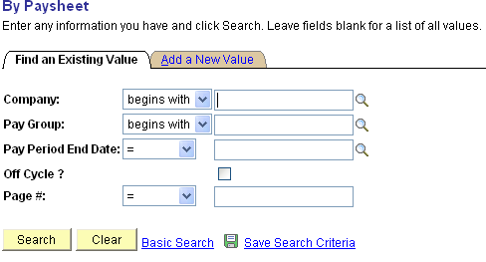

To manually add a paysheet to an off-cycle pay calendar for inactive employees, on the By Paysheet search criteria page click the Add a New Value Tab. This tab is very misleading, what you are doing is going to a page where you will add criteria to manually create a paysheet for an employee.

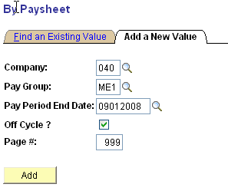
On the Add a New Value criteria page, enter the agency number in Company field, Pay Group the employee was in last, Pay Period End Date (this is the pay period end date shown on the off-cycle calendar), check the ‘Off Cycle?’ box, and enter a Page #. (When manually entering a paysheet always use a large number starting with at least 999). Click .

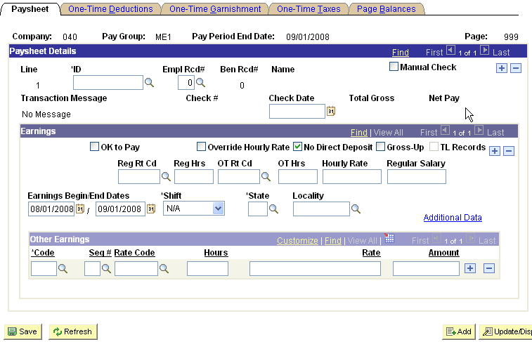

The Paysheet page will appear almost blank. In the Paysheet Details group box you will start by entering the employee number for the person you need to compensate in the *ID field. Take notice of the defaulted in value of ‘0’ in the Empl Rcd# field and make any necessary change to reflect the proper job. The Check Date will be filled in during the Off-Cycle confirmation process.

Click the OK to Pay check box. The system automatically checks the No Direct Deposit box as off-cycle checks are generally not sent electronically to the bank. Change this if the employee wants the money direct deposited.

To change and/or add the Combo Code, click Additional Data link.
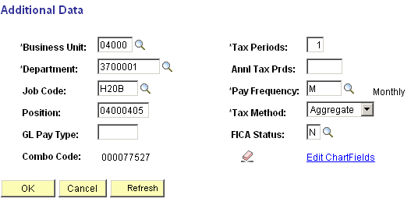

Click icon which will delete the Combo Code listed, if there is one.

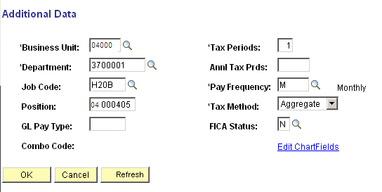

Click Edit ChartFields link.

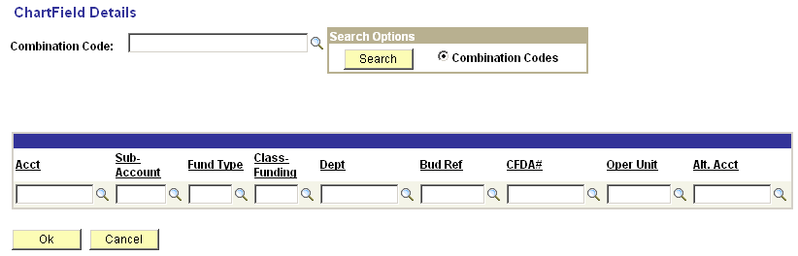
If you know the Combo Code you need, enter it in the field next to Combination Code: and click If the Combo Code appears in the Combination Code: field, click If you don’t know the Combo Code you want, or if it didn’t appear in the Combination Code: field, enter the account, fund, class fund, dept, and bud/ref (or any combination of the listed fields) and click If more than one combo code fits your search criteria a list will appear at the bottom of the page.

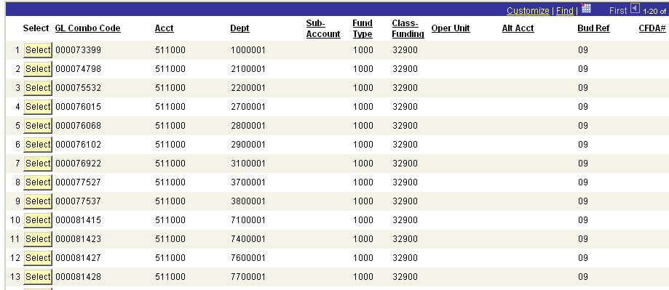

Click next to the correct data and you will be taken back to the Chartfield Details page. Click and you will be taken back to the Additional Data page which will include the Combo Code you selected.

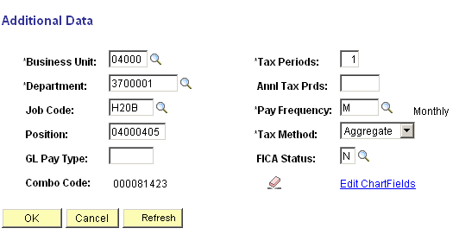

Click When all the data is correct, click .

NOTE: All time on an off-cycle must load into paysheets using the Time and Labor Load process as described in the ‘Off-Cycle Processing Steps’ below.

Off-Cycle Payroll Processing Steps (Checklist)

For all Off-Cycle processing, you will either add paysheets manually and/or create them by running the Load Time and Labor process which also loads time and/or adjusting data entered into Time and Labor and successfully run through Time Administration.

Step 1 – Check for the Existence of Off-Cycle Pay Calendars

NAVIGATION: Payroll for North America > Payroll Processing USA > Create and Load Paysheets > Review Pay Calendars

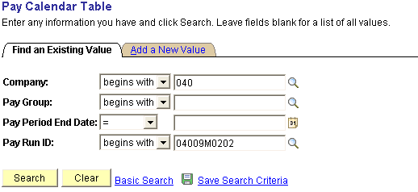

Enter the Company and Pay Run ID to check that an off-cycle calendar exists for each of the pay groups you are processing. Click .
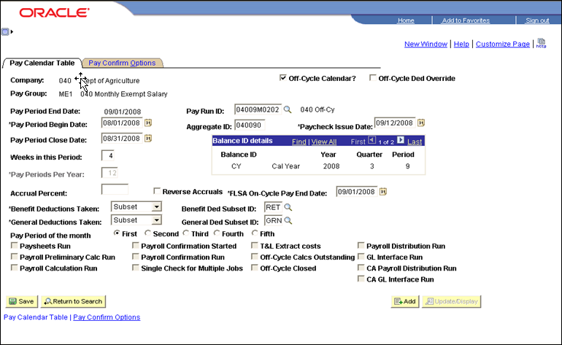

Review the Pay Calendar(s) making sure they are setup with the correct Pay Group(s) and dates requested. Also, check to make sure there is a number in the Aggregate ID field.

Step 2 – Enter Time into Time and Labor

NAVIGATION: Manager Self Service > Time Management > Report Time > Timesheet

If there are multiple employees that you need to add data for, enter the Group ID to pull up the entire list of employees associated with that work group. If there is only one (or a few employees) it could be easier to get their timesheets on an individual basis. Either way will work. Enter the date of the week you want to enter the data for in the Date field.

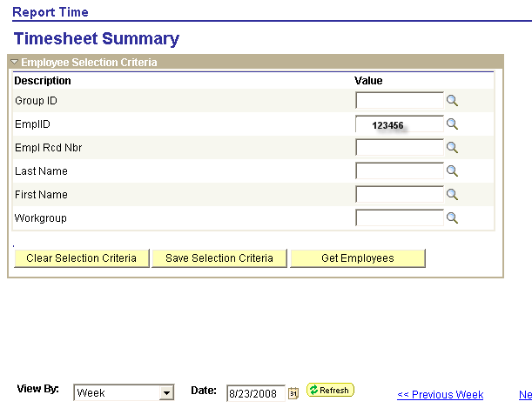

Once your search criteria is entered click  The list of employee(s) will appear at the bottom of the screen.

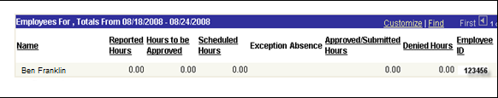

Click the employee name and you are then taken to an empty timesheet where you can enter the data.

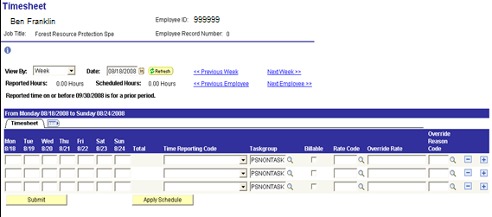

Enter all data into the Timesheet and click .
This takes you to the Submit Confirmation page (shown below) where you click .

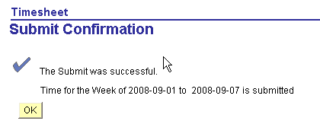

Your screen will come back and look similar to the following:
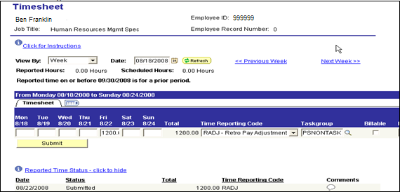

Repeat these steps till all data has been entered into employee Timesheets.

NOTE: For more detailed information refer to the Time and Labor training manual.

Step 3 – Run Query – GO_TL_WEEKLY_ELAPSED_TIME

This query audits data that has been entered into Timesheets.

Navigation: Reporting Tools> Query > Query Viewer

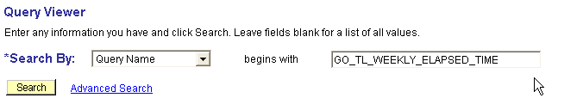

On the above page enter the Query Name, as shown, and click .

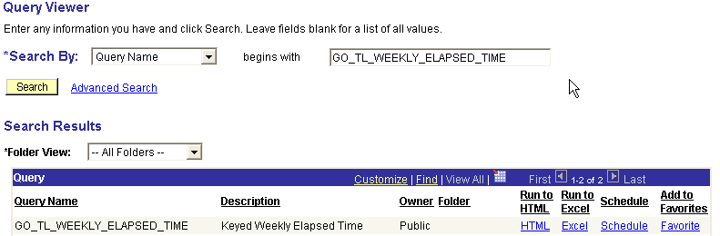

On the Query Viewer page you have a choice on where you want the output to go. HTML will give you the report on line. Excel will download the results of the query to an Excel spreadsheet, if your work station is properly setup. Clicking either link will take you to the next page.

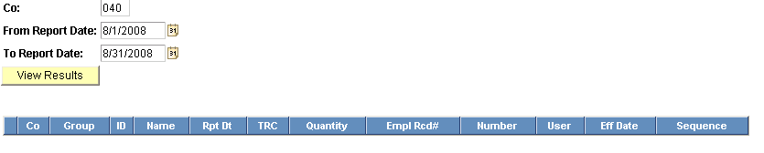
To run this query you must enter your agency number in the field labeled ‘Co:’. Then enter the period of time that you want the report to cover in the ‘From Report Date:’ and ‘To Report Date:’ fields. When you have completed filling in the data, click .

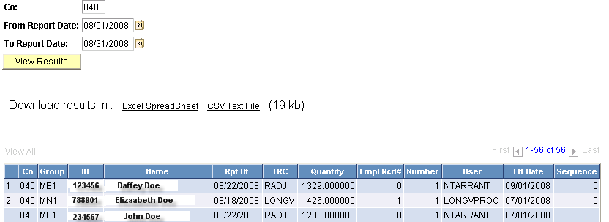

The results will list all data entered into Timesheets, based on the dates indicated. The Rpt Dt column displays the date the data is associated with in Time and Labor. Review the list for accuracy making sure everyone’s data has been entered and entered correctly.

Step 4 – Approve Reported Time

Once an employee’s time has been reported and submitted, it is available for you to approve. You can approve a employee’s reported time directly on their timesheet or using the Approve Reported Time page.

Navigation: Manager Self Service > Time Management > Approve Time and Exceptions > Reported Time

Approve Reported Time provides the same employee selection criteria as the timesheet.

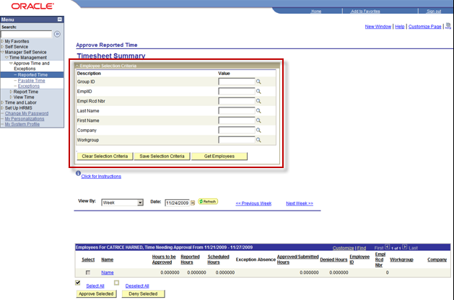

The View By selections includes:
All Time After
All Time Before
Day
Week

It is strongly recommended that you use the ‘View By = All Time Before’ to ensure all reported time requiring approval for previous pay periods display.

Step 1 – View by – select All Time Before

Step 2 – Date: Click to open a calendar and select the start day of the next Pay Period.

Step 3 – Click to display timesheets for all of your employees

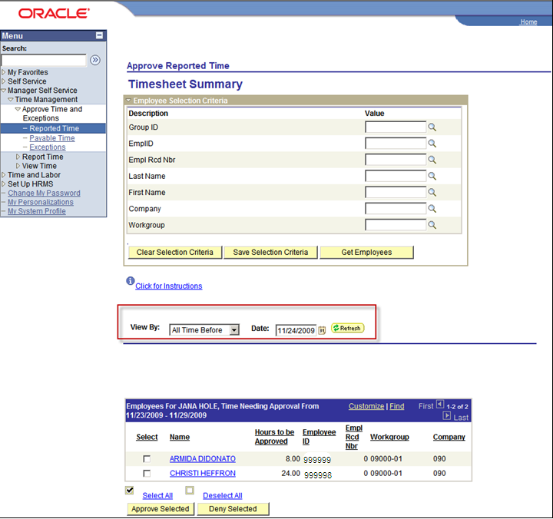

All of your employees with reported time requiring Approval display. You can Approve or Deny reported time. To review the time requiring approval you can click on the employee’s hyperlinked name; this will open the employee’s timesheet. Once you have reviewed the time, you can click ‘Return to Select Employee’ hyperlink to return to the Approve Reported Time page.

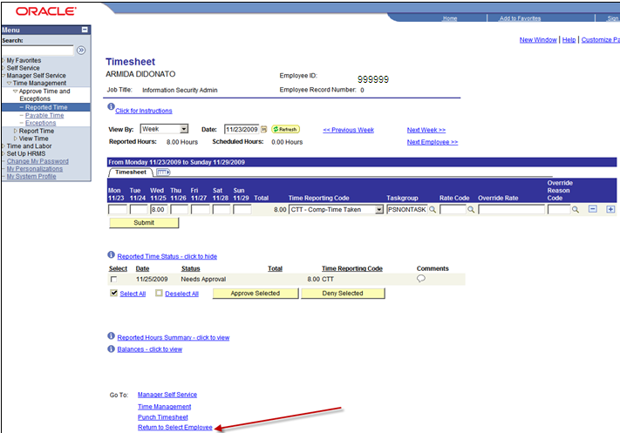

You can approve reported time for one, several, or all emploees.
Approve/Deny for Employee

You can use the following steps to approve reported time for one or several employees:

Step 1 – check the Select box next to the employee(s) requiring approval

Step 2 – click to approve reported time for the selected employees
- or –
click to deny reported time for the selected employees.

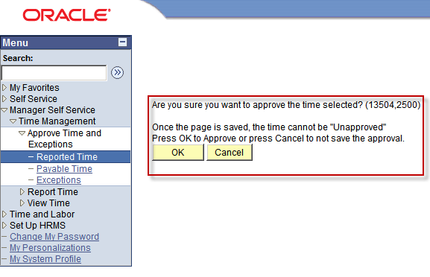

Step 3 – A warning page displays providing you with the opportunity to change your entry. Click to process your entry.

Step 5 – Run Time Administration

Time Administration converts reported and scheduled time into payable time allowing it to be passed to other applications such as Payroll and Project Costing. It executes defined rules, determines the period to process, and calculates prior period adjustments.

Navigation: Time and Labor > Process Time > Request Time Administration

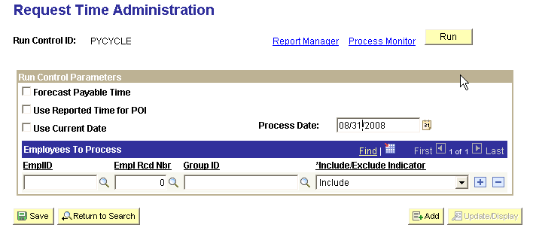

To run Time Administration, enter the pay period end date of your On-Cycle payroll in the field labeled ‘Process Date’. If the data is to be processed in payroll using an off-cycle calendar, then this date should be the pay period end date of your last On-Cycle payroll processed. If there are only a few employees you want to run Time Administration for, enter their EmplID and Empl Rcd Nbr in the fields shown. Click to add more than one employee. If you are running Time Administration for the entire group then enter the Group ID (Ex: 04001 for salaried employees in Agency 040). If there are more than one group click to add another row. When all the data is entered click .
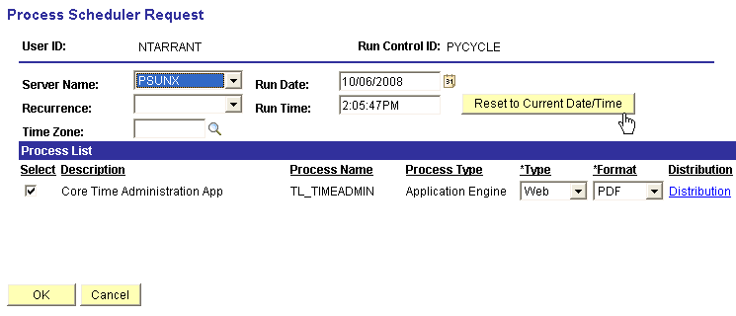

On the Process Scheduler Request page set Server Name to ‘PSUNX’.

In the ‘Process List’ group box:
- Check box should be checked next to CORE Time Administration App
- *Type should be set to Web
- *Format should be set to PDF

Click .

When screen goes back to the Request Time Administration parameters page, take note of the Process Instance number and click Process Monitor link. When the process runs to a Success and Distribution Status shows Posted click Details link. On the Process Detail page click View Log/Trace link. Open the log file and check for Exceptions.

NOTE: If additional information is required refer to Time and Labor training manual.

Step 6 – Check and Resolve Exceptions

An exception is data that has been entered into Time and Labor, processed through Time Administration but cannot be loaded into paysheets. In order to review and resolve exceptions the administrator needs to access the Exceptions page.

NOTE: Ignoring exceptions allowing the number of exceptions to increase with time, extends Time Administration processing time. To keep processing time to a minimum, always clean up any exceptions.

Navigation: Manage Self Service > Time Management > Approve Time and Exceptions > Exceptions

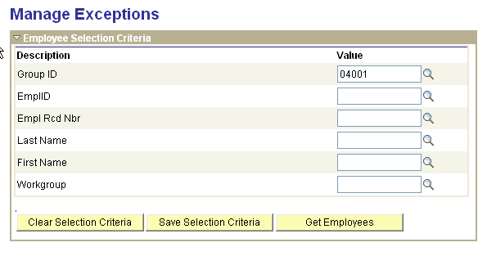

After navigating to the Manage Exceptions parameters page, enter your selection criteria and click .

If there are no exceptions, based on your search criteria you will receive the following message.

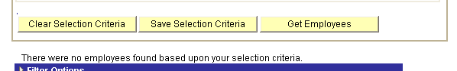

Otherwise, an exceptions list will appear. When this occurs you will need to review and resolve the data in question.

NOTE: For more detailed instructions for clearing up exceptions refer to the COR106 Time and Labor training manual.

Step 7 – Approve Time

Time needing review and approval that has been entered into Time and Labor and processed through Time Administration must be approved before it can be loaded to paysheets.

Navigation: Manage Self Service > Time Management > Approve Time and Exceptions > Payable Time

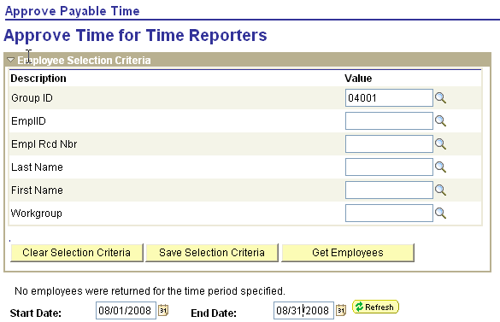

Enter your search criteria and click . If there were employee data needing review and approval a list would appear, as shown below. It is suggested that you enter a large date range (go back at least two or three months) to capture any TRCs that may have an old date.

From here you can click Select All and click .

You will be asked to confirm the Approval, click .

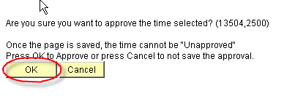
Another Dialogue box appears informing you that the approvals have been saved.

Click again.

The payable status immediately changes to ‘Closed’ for comp-time TRCs or to ‘Approved – Ready for Payroll’ if the TRC is to feed into payroll like ANNLV or SCKTK. During the next Preliminary Calculation process payroll will pick up and process the ‘Approved – Ready for Payroll’ TRCs.

NOTE: For more detailed instructions on approving time refer to the COR106 Time and Labor training manual.

Step 8 – Check Payable Time Detail

This is where an agency can view all payable time. At this point all time should be ready to be sent to payroll.

Navigation: Manage Self Service > Time Management > View Time > Payable Time Detail

On the Payable Time Detail parameters page, once again, enter your search criteria and click .
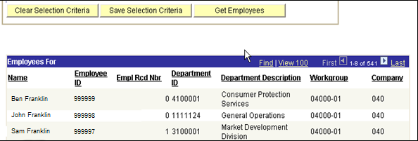

As shown above, all employees in your selection criteria having payable time will be shown here. To review employees’ details click the employee name.

NOTE: For detailed instructions refer to the COR106 Time and Labor training manual.

Step 9 – Run Load Time and Labor

The ‘Load Time and Labor’ process creates and loads paysheets from data entered into timesheets, processed through Time Administration, and where necessary, approved. This process also loads data into manually created paysheets for terminated employees that have been successfully processed through Time Administration.

NAVIGATION: Payroll for North America > Payroll Processing USA > Create and Load Paysheets > Load Time and Labor

After entering a Run Control ID, click This action will take you to the Load Time and Labor parameters page.

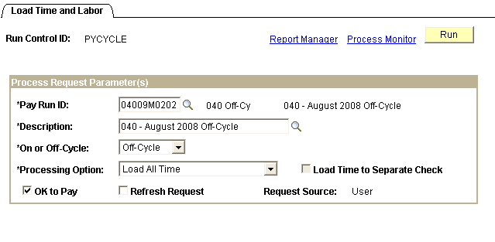

Enter the off-cycle Pay Run ID and tab out of the field. The Description field will automatically fill in. Select ‘Off-Cycle’ from the drop down list, by clicking next to *On or Off-Cycle. Select ‘Load All Time’ from the drop down list, by clicking next to *Processing Options.

Click .

NOTE: If you only want to load data pertaining to certain employee(s) and/or TRC code(s), in the *Processing Options selection list click ‘Load Filtered Time’. An additional tab labeled Filters displays. If you click the Filters Tab you are taken to a page where you can limit the data being loaded into paysheets.

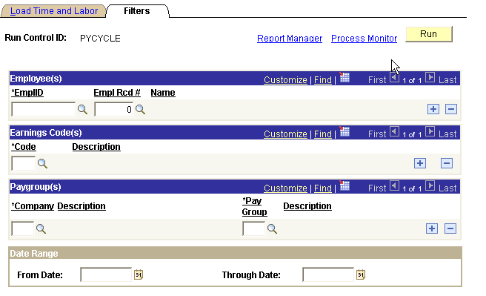

Once the filtered data is entered, click If all the time in Time & Labor that you have entered and processed through Time Admin is to be processed during this off-cycle, there is no need to fill in this page.
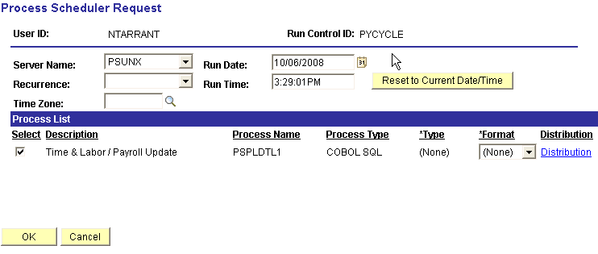

On the Process Scheduler Request page set Server Name to ‘PSUNX’.

In the ‘Process List’ group box:
- Check box should be checked next to Time & Labor/Payroll Update
- Type should be set to (None)
- Format should be set to (None)

Click .

When screen goes back to the Load Time and Labor parameters page, take note of the Process Instance number and click Process Monitor link. When the process runs to a Success and Distribution Status shows Posted click Details link. On the Process Detail page click View Log/Trace link. Open the log file (CBL PSPLDTL1 xxxxxx.log) and check for any errors. Resolve the errors and/or exceptions and re-run Step 5, Step 6, Step 7, Step 8, and Step 9.

Step 10 – Run Precalculation Audit Report

This audit report checks for payroll errors such as earnings and deduction codes not in earnings/deduction groups associated with the agency but are associated with the employees being paid.

Navigation: Payroll for North America > Payroll Processing USA > Produce Payroll > Precalculation Audit Report

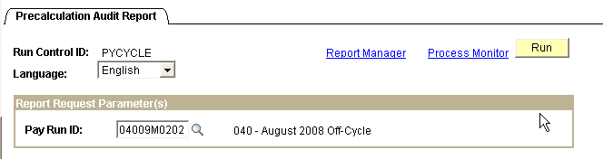

After entering your Run Control ID you are taken to the Precalculation Audit Report parameters page. Make sure the Language selected is ‘English’. Enter the Pay Run ID associated with the off-cycle payroll you are processing. Click .

On the Process Scheduler Request page, make sure Server Name is set to PSUNX.

In the ‘Process List’ group box:
- Check box should be checked next to PreCalc Audit
- Type should be set to Web
- Format should be set to PDF

Click .
Take note of the Process Instance and access the Process Monitor by clicking the link. When the job has run to Success, click Details link on the correct process instance row. Click the View Log/Trace link. The View Log/Trace page will look like this:

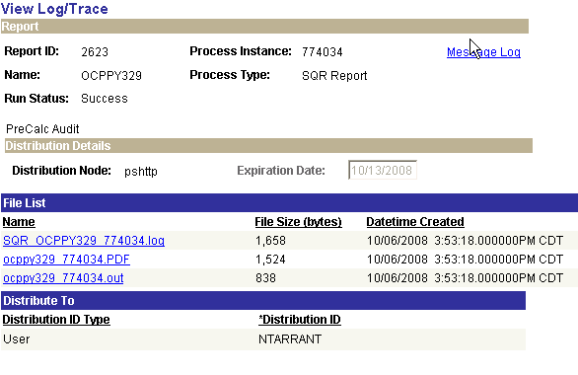

To view/print the report, click ocppy329 xxxxxx.PDF file. Any errors listed on the report must be corrected prior to going on to the next step.

Step 11 – Make Any Changes and Updates (If Necessary)

If you to need to make corrections to a Payline, due to error message resulting from the Load Time and Labor creating paysheets (such as missing Tax State, etc.) or, deductions/taxes need amounts adjusted on this pay cycle you need to access the employees’ Payline in order to make these corrections/changes.

NOTE: Do not ever make any additions and/or changes to earnings and/or leave directly on the payline, these changes MUST come from a change in Time and Labor allowing proper distribution of the earnings.

Navigation: Payroll for North America > Payroll Processing USA > Update Paysheets > By Payline Security

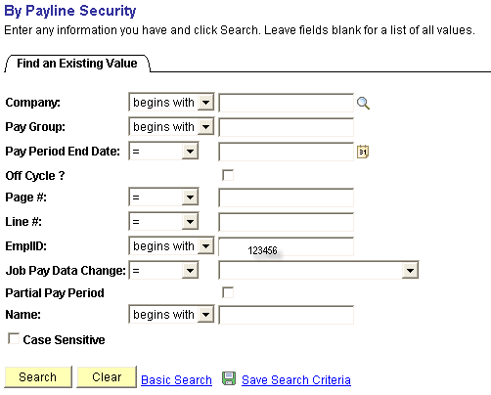

On the above search criteria page, enter the employee’s EmplID that you need to make the Payline adjustment(s) for. You may use any of the other criteria for searching pay lines to update, using EmplID, if known, is easiest. Click .
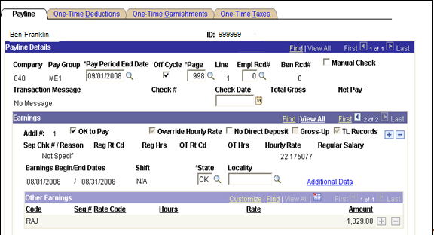

Above is the uncalculated paylines for our terminated employee. If the employee is missing earnings, never add a payline here to add an earnings code and amount.

If a deduction, tax, and/or garnishment amount needs to be adjusted on this off-cycle only, (the processes are the same as when running an on-cycle but reviewed in detail here again), click the appropriate one-time override tab as indicated below.

One-Time Deductions Tab:

If a one-time deduction override for this employee is required on this pay cycle, click the One-Time Deductions Tab.
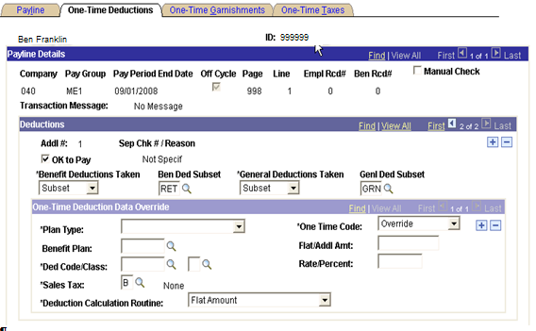

Always make sure the OK to Pay check box is checked, .

If there should be NO benefit deductions taken on this pay cycle for this employee, click the icon and select ‘None’ from the drop down list under *Benefit Deductions Taken. If only deductions associated with a Deduction Subset should be used on this pay cycle for this employee, click and select ‘Subset’ from the drop down list under *Benefit Deductions Taken, then click under Ben Ded Subset and select the correct subset to use.

If NO general deductions should be taken on this pay cycle for this employee, click and select ‘None’ from the drop down list under *General Deductions Taken. If only deductions associated with a Deduction Subset should be used on this pay cycle for this employee, click and select ‘Subset’ from the drop down list under *General Deductions Taken, then click under Genl Ded Subset and select the correct subset to use.

For Deduction(s) specification changes (override, refunded, additional amount deducted, or an arrears payback) click the One-Time Code icon and select the correct processing specification to use.

When the necessary changes are added, click

If the employee has more than one deduction code that needs adjustments, (remember some deduction code/class changes made should be for employee and employer) on this pay cycle, click in the One-Time Deduction Data Override group box and continue. Remember to always click
One-Time Garnishments Tab:

If a one-time garnishment deduction override for this employee is required on this pay cycle, click the One-Time Garnishments Tab.

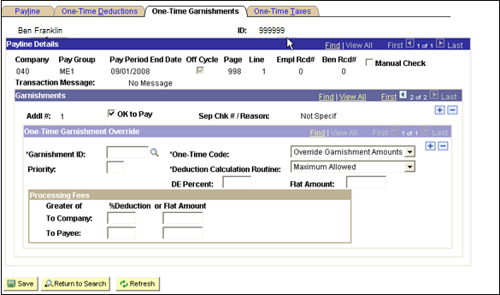

Always make sure the OK to Pay check box is checked, .

Enter the information, as required pertaining to the garnishment for this employee, on this page and click If the employee has more than one garnishment that needs adjustments for this pay cycle, click in the One-Time Garnishment Override group box and continue. Remember to pay close attention when selecting the correct *One-Time Code and *Deduction Calculation Routine from the drop down lists using the icon next to each label. Remember to always click

One-Time Taxes Tab:

If a one-time tax override for this employee is required on this pay cycle, click the One-Time Taxes Tab.
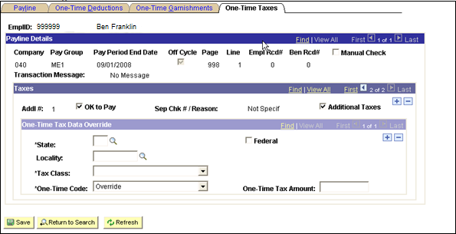

Always make sure the OK to Pay check box is checked.

Enter the information, as required pertaining to the specific tax for the employee, on this page and click Be careful to select the correct *Tax Class and *One-Time Code from the drop down lists by clicking the button.

NOTE: The drop down list will list specific EE and ER tax codes where appropriate.

If the employee has more than one tax type that needs adjustments for this pay cycle or Tax Class (employee versus employer), click in the One-Time Tax Data Override group box and continue. Remember to always click

Step 12 – Run Calculation Process

The off-cycle calculations process employee earnings based on data loaded from the Time and Labor Load process. Running the calculation processes as an Off-Cycle will NOT load any data from employee HCM Job, Compensation, Additional Pay, and General Deduction tables. The off-cycle calculation process only calculates earnings loaded into paysheets from a Time and Labor source along with calculating taxes and deductions allowed through the use of deduction subsets.

Navigation: Payroll for North America > Payroll Processing USA > Produce Payroll >Pay Calculation (0346)

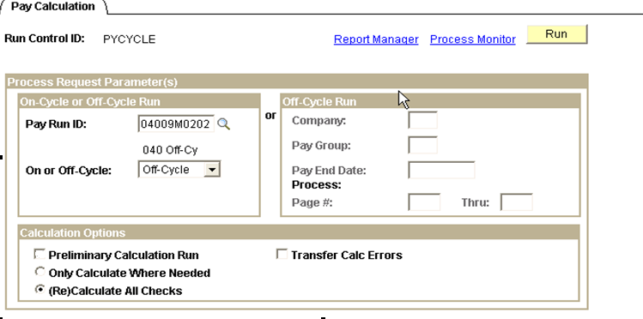

On the Pay Calculation parameters page, in the ‘On-Cycle or Off-Cycle Run’ group box enter the correct Pay Run ID and select Off-Cycle by clicking the ‘On or Off-Cycle’ icon.

In the ‘Calculation Options’ group box uncheck the box next to Preliminary Calculation Run, and click the radio button next to (Re)Calculate All Checks. Click .

NOTE: Once you start running the off-cycle calculation processes using the left side of the page, you must continue running all processes using the left side of the pages and running them only by Pay Run ID. You can run the off-cycle calculation processes using the right side of the page, running each process by Pay Group, but then you must complete all calculation and confirmation processes using the right side of the page processing by Pay Group.

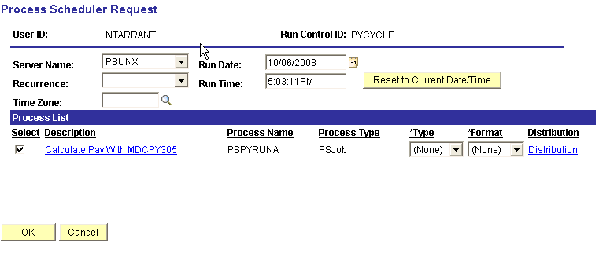

On the Process Scheduler Request page make sure Server Name is set to PSUNX.

In the ‘Process List’ group box:
- Check box should be checked next to Calculate Pay with MDCPY305
- Type should be set to (None)
- Format should be set to (None)

Click .

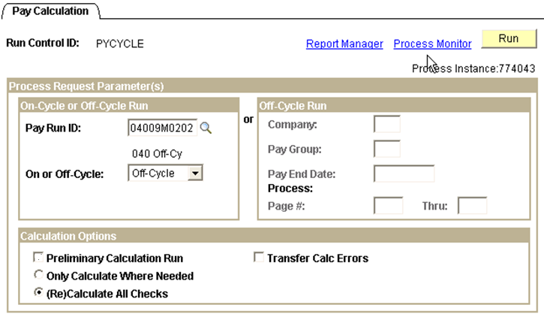
Back on the Pay Calculation parameters page, take note of the Process Instance and access the Process Monitor by clicking the link.

When the job has run to Success and Distribution Status shows Posted, click the PSPYRUNA link on the correct process instance row.

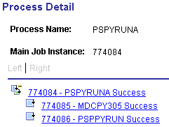

On the Process Detail page the link on this page that is associated with the log that we want to read is the last one in the list, xxxxxx – PSPPYRUN Success. Click on this link to open up the Process Detail page and then click View Log/Trace link.

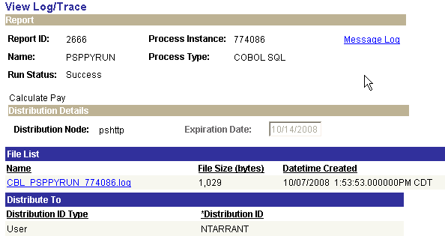
Click CBL PSPYRUN xxxxxx.log to read and look for ‘Check Messages!!’ statement(s). When viewing the log take note of the Process Instance number. This number will be used in the next step. If this message appears it means there is data that could not be processed. The reasons for the error, etc., will be listed on the Error Report. When viewing the log take note of the Process Instance number. This number will be used in the next step if you need to check for error messages.

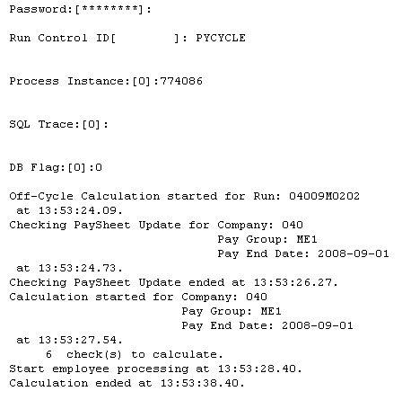

Step 13 – Check Payroll Error Messages

If your agency does not have any error messages, when trying to view errors you will get the message “No Payroll Error Messages exist for this agency…” If errors exist they must be corrected and steps 12 and 13 rerun until no errors appear.

Navigation: Payroll for North America > Payroll Processing USA > Review Processing Messages > Review Payroll Error Messages

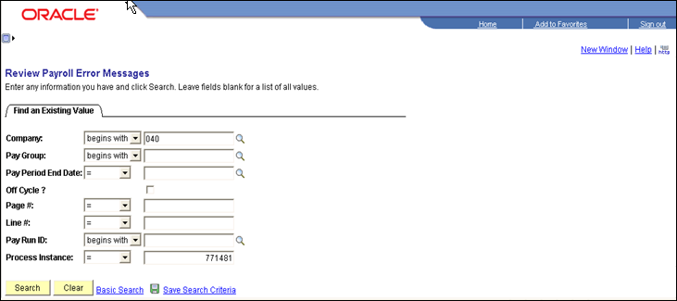

Enter the Company and Process Instance from the step above and click .
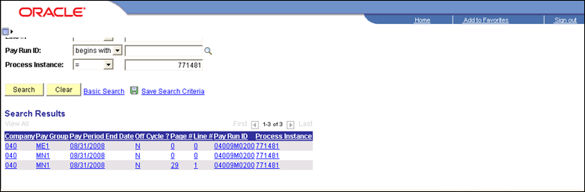

As seen above, if there are errors they will be listed. To review the error message click each line item. Make sure these errors are corrected and re-run these steps 12 and 13 until no errors appear.

If there aren’t any errors once you click you would receive this message:

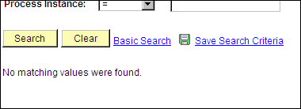

If you want to view and/or print an error report, which also gives hints for what has caused the error(s) you can navigate to:

Navigation: Payroll for North America > Payroll Processing USA > Review Processing Messages > Payroll Error Message Report

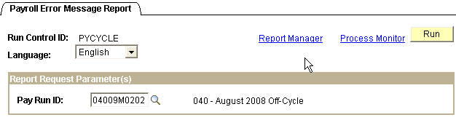
On the Payroll Error Message Report parameters page enter the correct Pay Run ID and click .
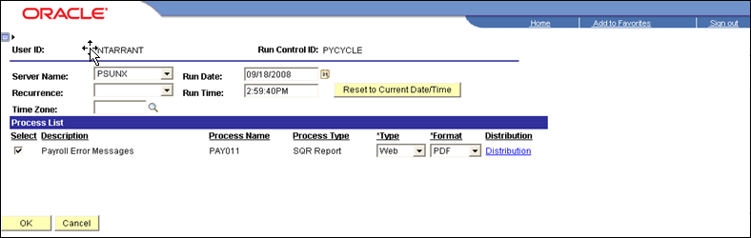

Make sure the PSUNX is selected next to Server Name.

In the ‘Process List’ group box:
- Check box should be checked next to Payroll Error Messages.
- *Type should be set to Web
- *Format should be set to PDF.

Click .

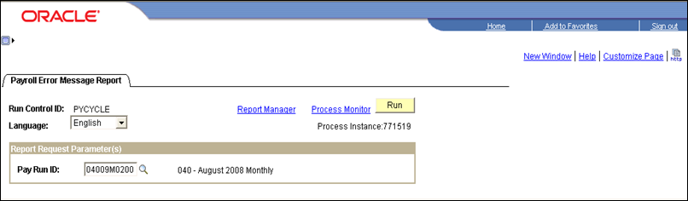

Back on the Payroll Error Message Report parameters page make a note of the Process Instance and click Process Monitor link. When the report runs to a Success and is Posted click Details then View Log/Trace links. Click on the .PDF file in the File List to open the report and print the report. Remember to correct all errors listed and re-run steps 12 and 13 until there are no errors displayed.

Step 14 – Run Query –GO_TL_PAY_TIME_BY_PAY_PERIOD

This query will identify employees with time in Time and Labor having a payable status of rejected by payroll (‘RP’) and estimated, ready for payroll (‘ES’). The data was rejected by payroll due to the edits performed in the prior Preliminary Calculation process, or prior pay cycle processing if they weren’t cleared up earlier. Review and correct all rejected time.

Navigation: Home > PeopleTools > Query Manager > Use > Query Viewer > GO_PAY_TIME_BY_PAY_PERIOD

On the Query Viewer ‘Search Criteria’ page enter the query name.

Click .

On the Search Results page click on either HTML or Excel which ever output you prefer.

Enter the agency number and click .
Time having an ‘RP’ status would be listed as shown below.

Please clean up all RP time. Letting time stay in this status extends processing time for Time Administration and payroll calculations. For detailed information pertaining to Time and Labor data having a payable status of RP, refer to COR106 Time and Labor training manual.

NOTE: If any corrections have been made in Time and Labor, re-run Time Administration, then start with Step 12 and come forward. If there are still errors to clear up, redo this same process until all issues are resolved. Sometimes adjusted data in Time and Labor will not load into payroll and you might have to rerun the Load Time and Labor process using Filter Tab for the employee having the problem.

Step 15 – Run Calculation Process

If any corrections were made in Time and Labor and Time Administration was re-run, or changes were made in Payroll, re-run Calculation process. If no changes were made you can skip this step.

Navigation: Payroll for North America > Payroll Processing USA > Produce Payroll > Pay Calculation (0346)

On the Pay Calculation parameters page, in the ‘On-Cycle or Off-Cycle Run’ group box enter the correct Pay Run ID and select Off-Cycle by clicking on the ‘On or Off-Cycle’ icon.

In the ‘Calculation Options’ group box uncheck the box next to Preliminary Calculation Run, and click the radio button next to (Re)Calculate All Checks. Click .

NOTE: Once you start running the off-cycle calculation processes using the left side of the page, you must continue running all processes using the left side of the pages and running them only by Pay Run ID. You can run the off-cycle calculation processes using the right side of the page, running each process by Pay Group. But then you must complete all calculation and confirmation processes using the right side of the page processing, for each Pay Group.

On the Process Scheduler Request page make sure Server Name is set to PSUNX.

In the ‘Process List’ group box:
- Check box should be checked next to Calculate Pay with MDCPY305
- Type should be set to (None)
- Format should be set to (None)

Click .

Back on the Pay Calculation parameters page, take note of the Process Instance number and click the Process Monitor link.

When the job has run to Success and Distribution Status shows Posted, click on the PSPYRUNA link on the correct process instance row.

On the Process Detail page the link on this page that is associated with the log that we want to read is the last one in the list, xxxxxx – PSPPYRUN Success. Click on this link to open up the Process Detail page and then click View Log/Trace link.

Click on CBL PSPYRUN xxxxxx.log to read and look for ‘Check Messages!!’ statement(s).

If this message appears it means there is data that could not be processed. The reasons for the error, etc., will be listed on the Error Report. When viewing the log take note of the Process Instance number. This number will be used if you need to review error messages. (Refer to Step 13, above, for reviewing messages).

Step 16 – Run Payroll Register Report

The Payroll register report lists all employee payroll data pertaining to this pay cycle (i.e. gross earnings, deductions, taxes, and net pay) and can be used to reconcile employee Gross to Net calculations. The report itemizes, by employee, check detail information listing employee earnings, and employee/employer deductions and taxes. The last page is a summary of totals covering the entire pay cycle.

There are three (3) versions of this customized report that you can run, but are processed using the same pages. The changes were requested by the State of Oklahoma.

- Payroll Register - Name (0233) – Sorted in last name order
- Payroll Register - Mail Drop (0312) – Sorted by the Mail Drop Field
(Warrant Sequence Number on Payroll Data)
- Payroll Register - Div/Name (0312C) – Sorted by Division and then Name

Navigation: Payroll for North America > Payroll Processing USA > Pay Period Reports >Payroll Register – Name (0233)

After entering the Run Control ID you are taken to the Payroll Register parameters page.

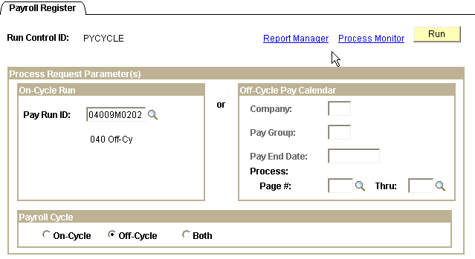\
In the On-Cycle Run group box, left side of page, enter the Pay Run ID associated with the pay cycle you are running. In the Payroll Cycle group box, bottom of page, click the radio button.

Click .

On the Process Scheduler Request page make sure Server Name is set to ‘PSUNX’.

In the ‘Process List’ group box:
- Check box should be checked next to Payroll Register-Name.
- Type should be set to Web
- Format should be set to PDF.

Click .

When screen goes back to the Payroll Register parameters page, take note of the Process Instance number and click Process Monitor link. When the process runs to a Success and Distribution Status shows Posted, click Details link.

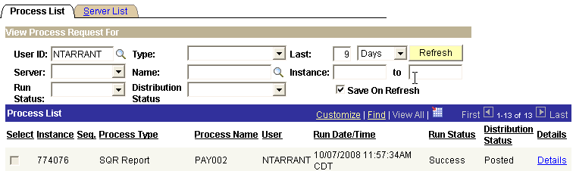

Clicking Details link will take you to the Process Detail page, shown below, where you click View Log/Trace link. On the View Log/Trace page, in the File List group box, click the file having the .PDF extension.
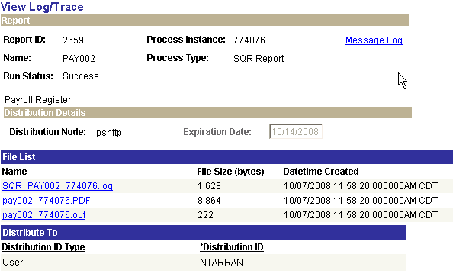

When you click the pay002a xxxxxx.PDF list in the File List group box you will are actually opening up the report to view and/or print.

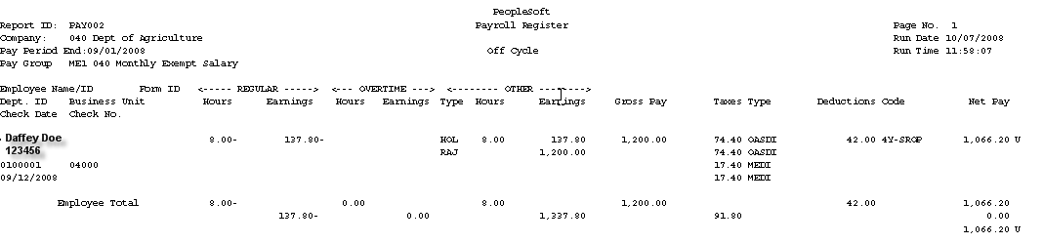

The heading of the Payroll Register lists the Report ID page #, Company, Run Date (date report was run on), Pay Period End Date, and Run Time. Data listed on this report is in alphabetical order by last name. For each employee listed you will see the hours/earnings, and other earnings that the employee is being paid which comprises the Gross Pay. It also lists in detail the Taxes and Deductions (employee (EE) and employer (ER)), and Net Pay. The ‘U’ after the Net Pay amount indicates this report is listing payroll data for the employee that is currently ‘Unconfirmed’. The data in the boxed in area under the employee is a summary of the total employee’s earnings, taxes and deductions (EE and ER), and Net Pay.

If you go to the last page of the Payroll Register you will see a summary page for the entire company.
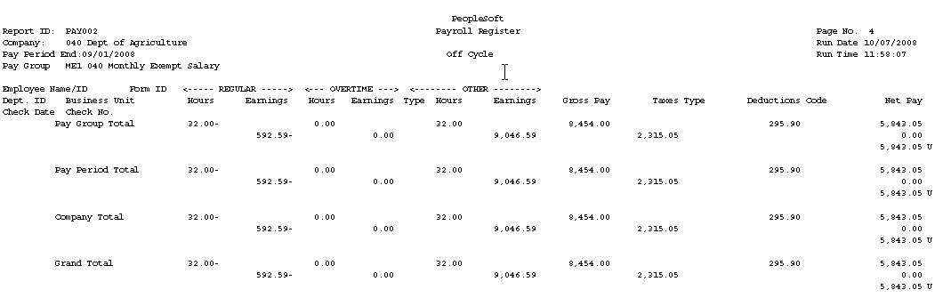

This page displays summarized grand totals of all earnings, taxes and deductions (EE and ER) and net pay. These totals will later be used to reconcile with the Funding Distribution and Payroll Budget Checking reports.

This report can get rather large but you can print the entire report, a page, or certain pages of this report.

Step 17 – Run Pre-Distribution Audit Report

This Pre-Distribution Audit Report audits payroll and configuration data. The report identifies any errors that could be encountered when you run the Actuals Distribution (PSPPFUND) or the Actuals GL Interface (PAYGL02). This report is executed after Paysheet Create and before Actuals Distribution.

Navigation: Payroll for North America > Payroll Distribution > Commitment Accounting USA > Predistribution Audit Report

After entering a Run Control ID you will be taken to the Predistribution Audit Report run control parameters page.

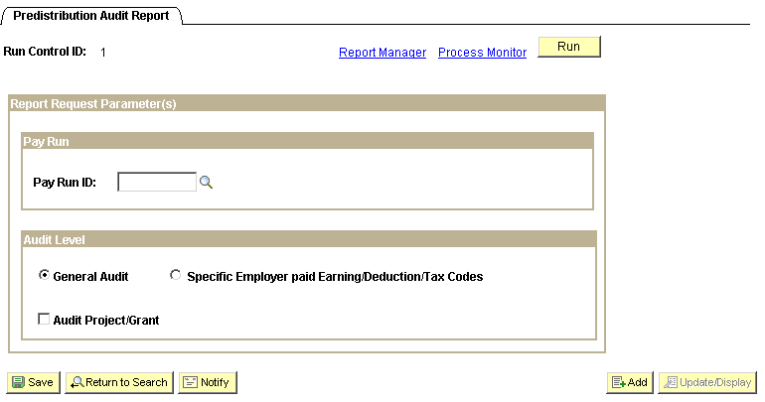

Enter the Pay Run ID of the current payroll being processed and check the General Audit radio button. When all data fields have been correctly filled in, click . You will be taken to the ‘Process Scheduler Request’ page.
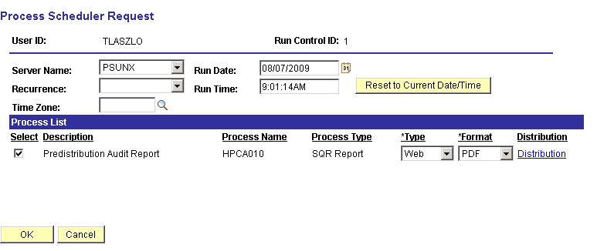

Make sure the Server Name is set to PSUNX.

In the ‘Process List’ group:
- Check box should be checked next to Predistribution Audit Report
- Type should be set to Web
- Format should be set to PDF

Click You will be taken back to the Predistribution Audit Report parameters page. In the top right hand side of the page a Process Instance number will now be shown. This process instance number is what you will use to monitor the completion of this job on the Process Monitor.

When screen goes back to the predistibution Audit report parameter page, take note of the Process Instance number and click the Process Monitor link.
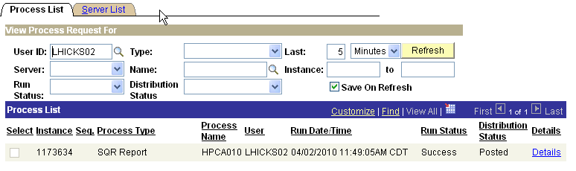

When the run status column shows Success and the Distribution Status column shows Posted. Click Details link. On the Process Detail page click View Log/Trace link.

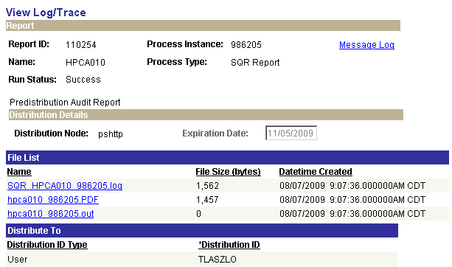

If there are entries on the Audit report for this pay cycle, there will be a file in the ‘File List’ group box with a .PDF extension. Click the .PDF file to open and print your Audit report. This report will list all employees and the issues identified that need attention. The following is a list of possible audit findings and resolutions:
Jobcode is not currently active or does not exist:
This error occurs when the TL task group/profile does not match the Agency on the Job record. These are usually a transferred employee that did not have their TL employee data updated correctly. Communicate this to the T&L administrators for your agency. The administrator will have to correct the changes, run time admin, approve the time and then when calc runs turn off OK to pay on the old TL record (even though it may not have any time).

Position Number is not currently active or does not exist:
This error occurs when the position an employee is in has been made inactive and there is time reported past the inactive date. To fix this adjust the time or reactivate the position.

Department Budget Date record is not defined for Budget Department:
Anytime this message occurs with a 5 digit department that represents the business unit/agency the agency has created a position and hired someone into that ‘bad’ department. Send a helpdesk ticket requesting that the Job record be corrected to reflect the accurate department. Make sure that any lines remaining on the paysheet with the wrong department are not OK to pay.

No Budgeting Distribution in effect for Budget Department:
This error is identifying an issue with either the DBT or the person (it is usually the person). Check that the DBT is in effect for the correct effective date (usually July 1 of the fiscal year). If there is not a DBT entry, contact the helpdesk requesting an entry be created. If however a DBT entry exists, then look at the T&L data, time may have been entered prior to conversion date to Commitment Accounting. Any time entered with a date prior to the conversion to commitment accounting will have to be handled as an off-cycle.

Step 18 – Run Payroll Unsheet – If Necessary

This process deletes all the paysheets that have been created for the specified Pay Run ID – basically you are starting over. It moves any payable time from the paysheet back to payable time and sets the payable status to ‘Rejected by Payroll’. This status setting means that it was kicked back by payroll but will be processed by payroll the next time you run a preliminary calculation for these employees.

Navigation: Payroll for North America > Payroll Processing USA > Update Paysheets > Pay Unsheet

After entering a Run Control ID you are taken to the Pay Unsheet parameters page. There are two ways to run this process for an Off-Cycle payroll. You can use the left side of the page and enter the Pay Run ID in the On-Cycle Run criteria box. Then select the radio button next to ‘Off-Cycle’ in the Payroll Cycle criteria box, at the bottom of the page. Or, you can follow the steps below to unsheet by Pay Group.

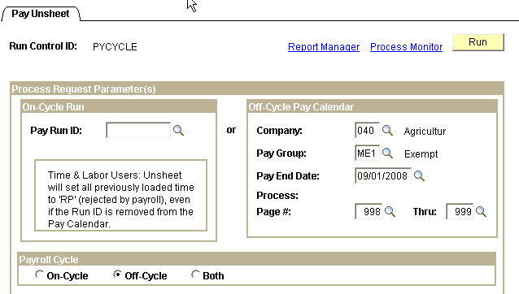

To unsheet an off-cycle payroll use the right side of the page and enter data in the Off-Cycle Pay Calendar criteria box. Enter the Company, Pay Group, and Pay End Date. In the Process Page # fields click the first Process: Page # field icon and select the lowest number in the list. Click the Thru: field icon and select the last number in the list. Click the radio button next to Off-Cycle in the Payroll Cycle group box and click .

NOTE: If your off-cycle payroll consists of more than one (1) Pay Group and you are using the right side of the page, run this process for each Pay Group.

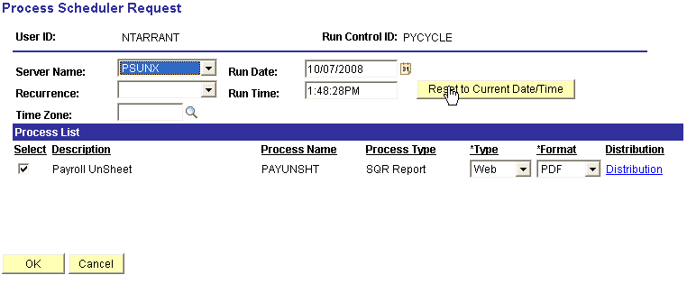

Make sure the Server Name is set to ‘PSUNX’.

In the ‘Process List’ group box:
- Check box should be checked next to Payroll UnSheet
- Type should be set to Web
- Format should be set to PDF

Click .

When screen goes back to the Pay Unsheet parameter page, take note of the Process Instance number and click Process Monitor link. When the process runs to a Success and Distribution Status shows Posted, navigate to review paychecks and try to pull up paychecks associated with this Run ID (you should not get any paychecks to view). This guarantees that all paysheets were unsheeted correctly.

Follow the processing steps below:

Pay Unsheet Process:

- Run Step 9
- Run Step 10
- Run Step 11
- Run Step 12
- Run Step 13
- Run Step 14
- Run Step 15
- Run Step 16
- Run Step 17
- Run Step 18
- Run Step 19

Step 19 – Run Pay Confirmation Process

The pay confirmation process does the same editing as the preliminary and final calculation processes along with editing the database for any outstanding unconfirmed paychecks being processed associated with a prior calendar. The confirmation process also assigns check/advice numbers, updates all employee balance tables, updates the bond log activity table, updates Pay Calendar flags, and updates flags on all associated rows of data on the PAY_.... tables that store employee detailed paycheck data.

Navigation: Payroll for North America > Payroll Processing USA > Produce Payroll > CA Confirm Pay (0432)

After entering a Run Control ID you are taken to the Pay Confirmation parameters page. If you have been using the left side of the page throughout the calculation processes follow the steps below. If you have been using the right side of the (processing by Pay Group) fill out the right side of the page in the Off-Cycle Run criteria box and run this process for each Pay Group.

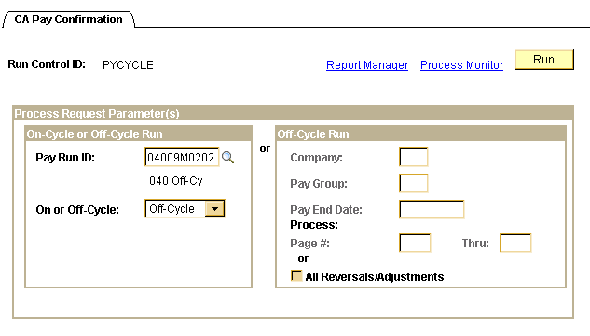

In the On-Cycle or Off-Cycle Run group box, enter the correct Pay Run ID and select Off-Cycle and click .
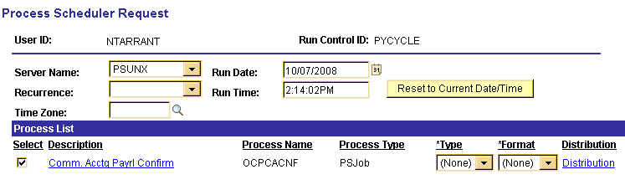

On the Process Scheduler Request page make sure Server Name is set to ‘PSUNX’.

In the ‘Process List’ group box:
- Check box should be checked next to Comm.Acctg Payrl Confirm
- Type should be set to (None)
- Format should be set to (None).

Click .

When the screen goes back to the Pay Confirmation parameters page, take note of the Process Instance number and click Process Monitor link.

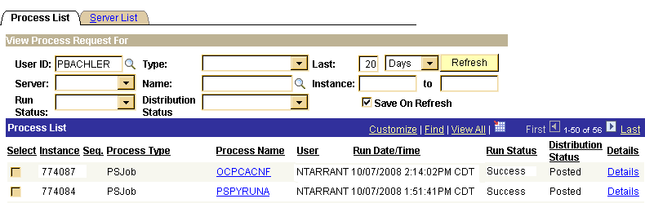

When the job has run to Success and Distribution Status says Posted, click the OCPCACNF link on the correct process instance row.
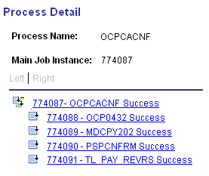

Clicking the xxxxxx - PSPCNFRM link takes you to the Process Detail page where you click the View Log/Trace link.

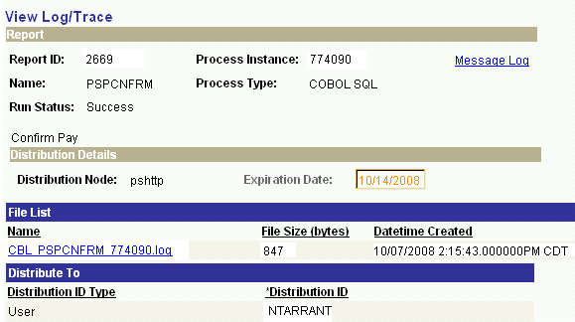

On the View Log/Trace page open the log to check for any ‘Check Messages!!!!’ statements.

NOTE: If you find any, stop and call the Help Desk asking them to open a case, as well as call the CORE Team immediately.

A log showing all confirmations were successful would look similar to the one on the next page.
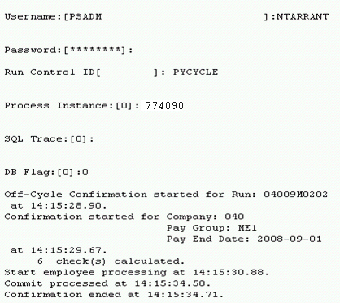

Step 20 – Check Pay Calendar For Flags

Once again the pay Calendar(s) need to be reviewed making sure a checkmark appears in the box in front of the Payroll Confirmation Started and Payroll Confirmation Run labels for every pay group that is active with this Pay Run ID.

Navigation: Payroll for North America > Payroll Processing USA > Create and Load Paysheets > Review Pay Calendars

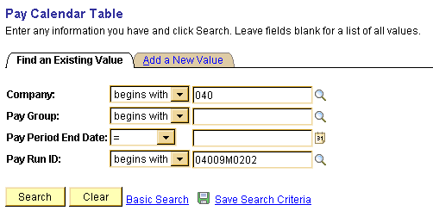

On the Pay Calendar Table search criteria page, enter the Company and Pay Run ID that is being used. Click . If there is more than one Pay Calendar associated with an off-cycle, a list of pay calendars that are associated with the Pay Run ID will appear at the bottom of the page. Click the first row and you will be taken to the first Pay Calendar in the list. If there is only one Pay Calendar associated with the off-cycle the Pay Calendar page will display.
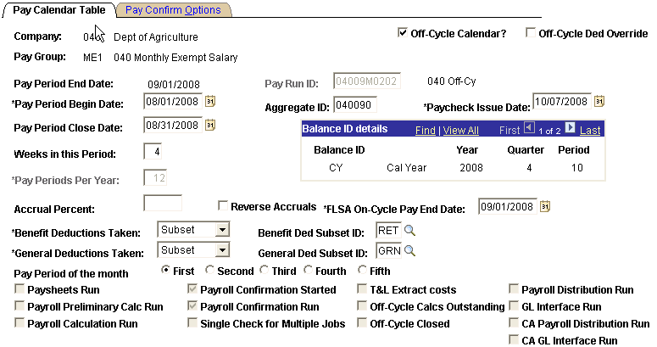

Make sure the check boxes are checked next to Payroll Confirmation Started and Payroll Confirmation Run.

NOTE: If any of these checkmarks are missing, stop and contact Help Desk, then the CORE Team immediately to help you resolve this issue. Do NOT Proceed Any Further.

Step 21 – Check Paycheck Data for Advice and Check Numbers

A review of the paycheck data is required making sure the words Advice or Check appear under the column labeled ‘Form Number’ along with a number in the column labeled ‘Paycheck Number’.

Navigation: Payroll for North America > Payroll Processing USA > Produce Payroll > Review Paycheck

On the Review Paycheck search criteria page enter the Company, Pay Period End Date, and check the box next to ‘Off-Cycle?’.

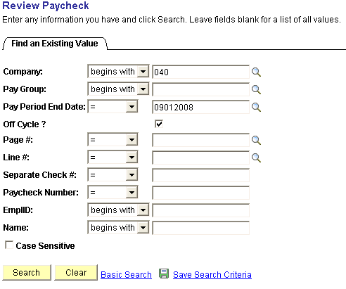

Click .
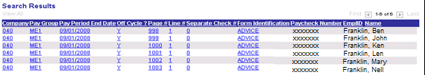

You should see the word ADVICE or CHECK under the heading Form Identification, and the actual check/advice umber under the heading Paycheck Number.

If this information is missing, contact the Help Desk then the CORE Team to help you resolve this issue.

Step 22 – Check To Be Sure ALL Paysheets Have Been Confirmed

This step is to make sure all the paysheets were confirmed.

Navigation: Payroll for North America > Payroll Processing for USA > Update Paysheets > By Paysheet

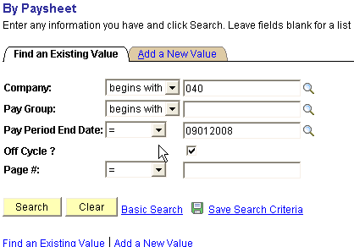

On the By Paysheet search criteria page enter your Company number, Pay Period End Date, check the box next to ‘Off-Cycle?’, and click No paysheets should appear at the bottom of this page, instead the screen should like the one below with the message ‘No matching values were found’.

If paysheets are listed, contact the Help Desk then the CORE Team to help you resolve the issue immediately. Do NOT proceed any further.

Step 23 – Run PY Pull Costs

This process, generally referred to as PY_PULL_COST, is run after confirming all pay cycles (both on and off cycles). The process updates payable time entries in Time and Labor as follows:

- If payable time is distributed, but not diluted, the Extract process changes the payable status to Distributed (DP). (Will come into play in Phase II).
- If payable time is distributed and diluted, the extract process changes the status to Diluted (DL). (Will come into play in Phase II).
- For time that is not being distributed, the Load Time and Labor process sets the payable time status to Closed (CL). (Will come into play in Phase II.)
- Provides cross-reference numbers generated during the consolidation process, the calculated costs, and percentages that represent how payroll consolidated the payable time rows.
- Sets the publish date and publish switch.
- If payable time is pulled into paysheets, and OK-to-Pay is cleared for those related earnings, these rows of payable time are not paid (set to ‘Ignore’ with reason of ‘Not OK to Pay’.) PY Pull Cost changes the payable time status to Rejected by Payroll (RP) allowing the data to be reprocessed.

Navigation: Payroll for North America > Payroll Distribution > Additional Integrations > Extract Time and Labor Costs

After entering the Run Control ID you are taken to the Time and Labor Cost Extract parameters page.

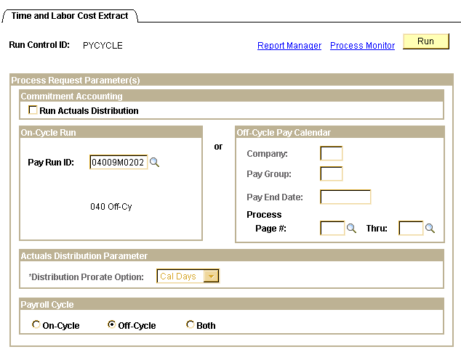
Enter the pay Run ID in the On-Cycle Run group box. Check the radio button next to Off-Cycle in the Payroll Cycle group box and click .

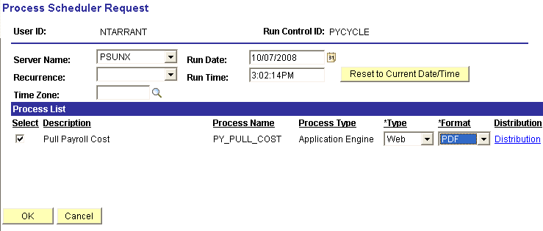

On the process Scheduler Request page set Server Name to ‘PSUNX’.

In the ‘Process List’ group box:
- Check box should be checked next to Pull Payroll Cost
- Type should be set to Web
- Format should be set to PDF.

Click .

The screen goes back to the Time and Labor Cost Extract parameters page. Take note of the Process Instance number and click Process Monitor link. When the process runs to Success and Distribution Status shows Posted, click Details link. Click View Log/Trace link on the Process Detail page.

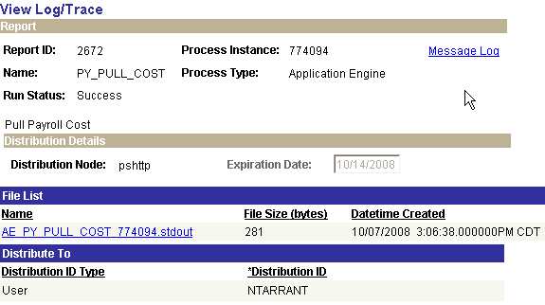
Click the AE PY PULL COST xxxxxx.stdout to open the trace log. If the process ran successfully your log should read similar to the one below.

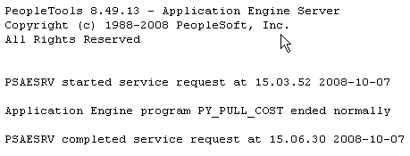

Step 24 – Run Distribute Actuals

The Actuals Distribution process (PSPPFUND) distributes actual earnings, employer deductions, and employer taxes across the funding sources established. This process is executed after the confirm process for the current payroll.

Navigation: Payroll for North America > Payroll Distribution > Commitment Accounting > Distribute Actuals

After entering a Run Control ID you will be taken to the Actuals Distribution run control parameters page.

Enter the Pay Run ID of the current payroll being processed; select ‘Cal Days’ as the Distribution Prorate Option. When all data fields have been correctly filled in, click You will be taken to the ‘Process Scheduler Request’ page.

Make sure the Server Name is set to PSUNX.

In the ‘Process List’ group:
- Check box should be checked next to Actuals Distribution
- Type should be set to (None)
- Format should be set to (None)

Click .

When screen goes back to the Acuals Distribution parameters page, take note of the Process Instance number and Click Process Monitor link. Once the job has run to Success status and Distribution Status shows Posted, click the Details link.

When the job has run to Success status and Distribution Status shows Posted, click the Details link.

On the Process Details page click View Log/Trace link. Click CBL PSPPFUND xxxxx.log link to view and or print the log. Look for the Check Messages statement.

Step 25 – Run Funding Reports

Budget Check (0025) and Budget Check for Projects (0025K)
These reports show the total cost of the payroll and available funding for the cash/allotment and project budgets. Review the reports looking for any errors and/or areas lacking sufficient funds. If sufficient funds are NOT available, make the necessary changes to the Actuals Distribution at the employee level. After the changes are made re-run the reports until the funding is no longer in a deficit.

Funding Distribution (0108)
This report is also created during the execution of running the funding reports. The ‘Funding Distribution’ report shows how payroll funding is being distributed through the departments. Totals are reconciled back to the ‘Payroll Register’ run in Step 18.

Navigation: Payroll for North America > Payroll Distribution > Prepare GL Information > Commitment Accounting > Funding Rpts (OCP400)

After entering a Run Control ID you will be taken to the Funding Rpts (0400) Run Control Parameters page.

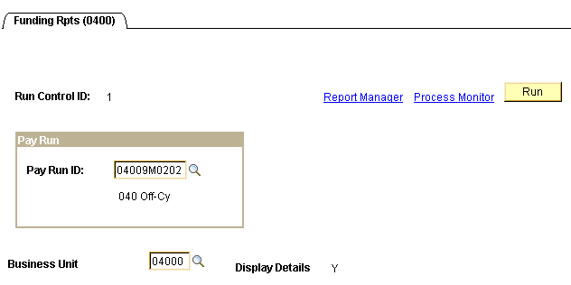

Enter the current payroll’s Pay Run ID and the Business Unit (Display Details is grayed out and is always set to Y). If you don’t have a Run Control ID for running this process click the Add a New Value Tab and enter a value.
When all data fields have been correctly filled in, click . You will be taken to the ‘Process Scheduler Request’ page.

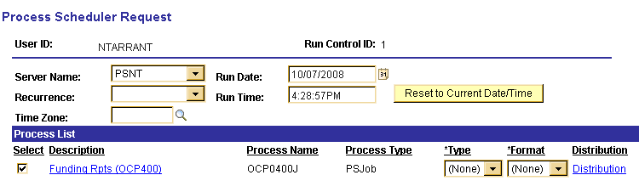

Make sure the Server Name is set to PSNT.

In the ‘Process List’ group:
- Check box should be checked next to Funding Rpts (OCP400)
- Type should be set to None
- Format should be set to None

Click . You will be taken back to the Funding Reports parameters page. In the top right hand side of the page a Process Instance number will now be shown. This process instance number is what you will use to monitor the completion of this job on the Process Monitor.

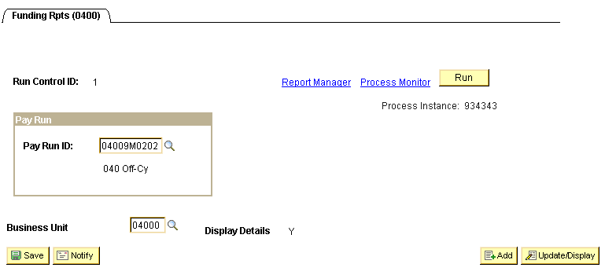

Click the Process Monitor link in the top right hand corner of the page.
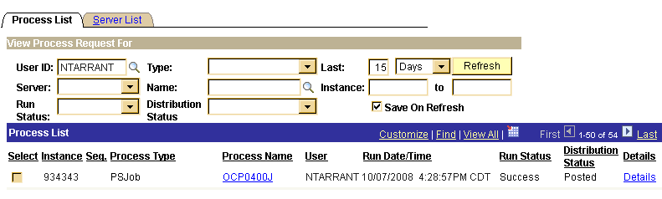

When the run status column shows Success and the Distribution Status column shows Posted. Click OCP0400J link under the Process Name column.

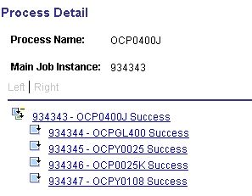

To view and reconcile the Budget Check report, click the xxxxxx - OCPY0025 link. Click the View Log/Trace link. In the ‘File List’ group box select the file with the .PDF extension.

To view and reconcile the Project Budget Check report, click the xxxxxx - OCP0025K link. Click the View Log/Trace link. In the ‘File List’ group box select the file with the .PDF extension.

To view and reconcile the Funding Distribution report , click the xxxxxx - OCPY0108 link. Click the View Log/Trace link. In the ‘File List’ group box select the file with the .PDF extension.

The State of Oklahoma will NOT allow payrolls to process beyond this point until ALL deficits are cleared up.

The last page of the Budget Check report(s) will show a Gross Payroll Total that should reconcile with payroll totals from the Payroll Register and Funding Distribution reports.

Step 26 – Correct Employee Actuals Distribution

The State of Oklahoma will NOT allow payrolls to process beyond the Funding Reports step until ALL deficits are cleared up.

In order to clear up deficits Use the Review Actuals Distribution page to modify funding distribution after the Actuals Distribution process and before posting to the General Ledger. The funding source can be changed but the total dollar amount must stay the same.

Navigation: Payroll for North America > Payroll Distribution > Commitment Accounting USA > Review Actuals Distribution

On the above search criteria page, enter the Company, Paygroup, Pay Period End Date and the employee’s EmplID that which requires a funding adjustment. You may use any of the other criteria for searching the Actuals Distribution, the more fields that provide the faster the data is returned.

Click .
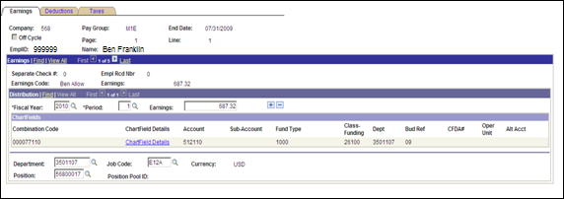

The Earnings page displays the Actuals Distribution that was distributed during the Actuals Distribution process (PSPPFUND). 1 of 5 rows of data is available to change funding.

Funding can be changed by selecting the Chartfield Details link.

Example Changing the Chartfield Details:

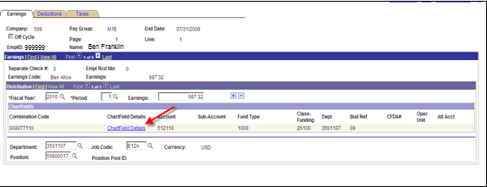

Select the Chartfield Details link:
If you know the new Combination Code, enter it in the appropriate field and click .

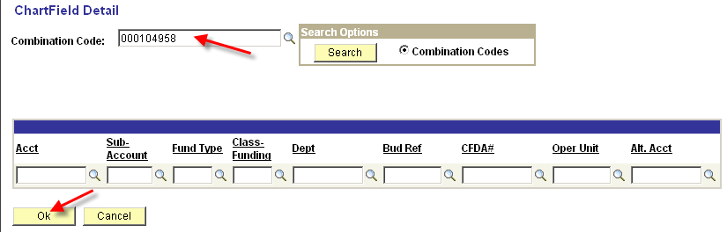

Otherwise follow these steps:

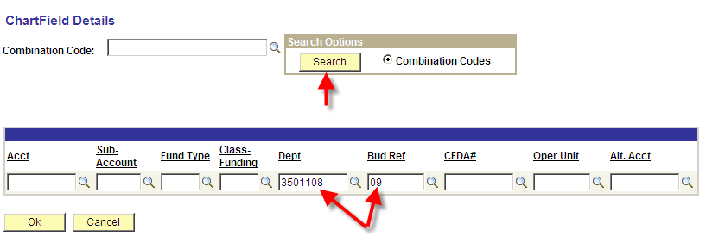

Enter the Dept and BudRef fields.
Click , pulls up all valid GL Combo Codes for the Department and Fiscal specified.

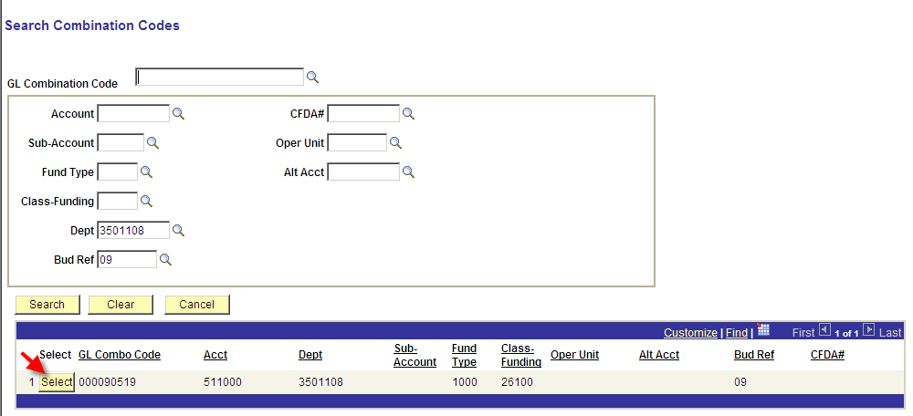

Locate the valid Combo Code and click to the left of the GL Combo Code. This will take you back to the ChartField Detail page. Notice, the Acct, Fund Type, and Class-Funding fields are now also populated.

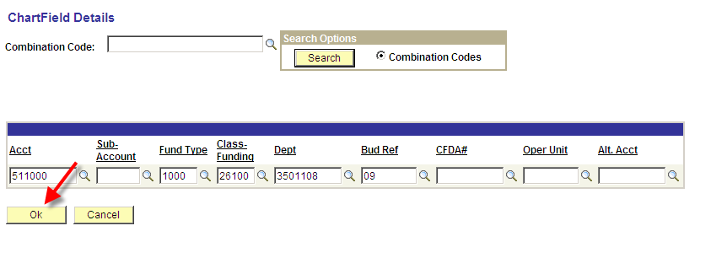

Click to go back to the Review Actuals page.
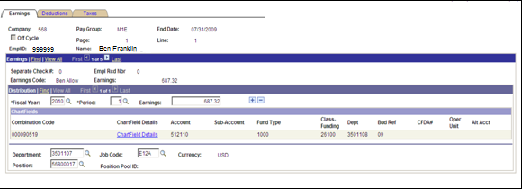

The Review Actuals page for Earnings is returned with the new Combo Code displayed. Change the Combo Code for each Earnings row.

Since the Earnings records were changed to a new combo code, the Deductions and Taxes also need to change to the new Combo Code.

Select the Deduction Tab:

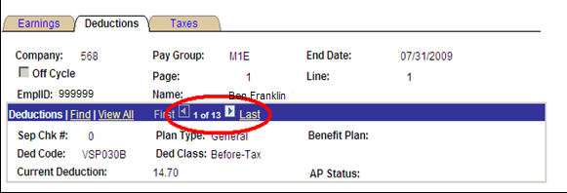

Notice that the number of records total is 13. The first deduction displayed above is VSP030B. This is an EMPLOYEE deduction. Only EMPLOYER deductions are distributed. Select the View All link and change the Combo Code on ALL of the EMPLOYER deductions.
For each EMPLOYER deduction follow the directions above for changing the chartfields.

Select the Taxes Tab:

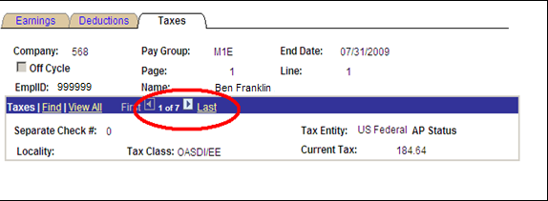

Select the View All link to display all of the Taxes.

For each EMPLOYER paid tax, change the combo codes using the same steps above for changing the Chartfield Details.

Step 27 – Re-Run Funding Reports

Budget Check (0025), Budget Check for Projects (0025K) and Funding Distribution (0108)
Re-run the Funding Reports to verify that the changes made during the “Correct Employee Actuals Distribution” has corrected the budget deficit. See Step 27 above for instructions on running these reports.

Navigation: Payroll for North America > Payroll Distribution > Prepare GL Information > Commitment Accounting > Funding Rpts (OCP400)

After entering a Run Control ID you will be taken to the Funding Rpts (0400) run control parameters page.

Step 28 – Run Finalize Funding Reports

Budget Check (0025), Budget Check for Projects (0025K), Funding Distribution (0108) and the Payroll Claim Document (0118)

After running the Funding Reports and validating that the funding is accurate and available, run the ‘Finalize Funding Repots’ step. This step sets a flag, indicating that no other changes will be made to the Actuals Distributions and are ready for the next step.

Navigation: Payroll for North America > Payroll Distribution > Prepare GL Information > Commitment Accounting > Finalize Funding Rpts (OCP400)

After entering a Run Control ID you will be taken to the Finalize Funding Rpts (OCP400) run control parameters page.

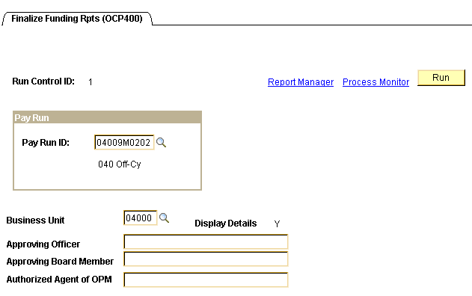

Enter the Pay Run ID and Business Unit. If your Claim Document requires the name(s) of ‘Approving Officer’, ‘Approving Board Member’, and/or ‘Authorized Agent of OPM’ printed on the report, key them in the fields provided.

Click .

In the ‘Process List’ group box:
- Check box should be checked next to Finalize Funding
- *Type should be set to (None)
- *Format should be set to (None)

Click .

When screen goes back to the Finalize Funding Rpts parameters page, take note of the Process Instance number and click Process Monitor link. When the run status column shows Success and the Distribution Status column shows Posted, click OCP0400F link under the Process Name in the middle of the page. On the Process Detail page click View Log/Trace link.

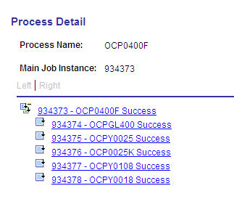

To view and print the Budget Check report, click the xxxxxx – OCPY0025 link. Click the View Log/Trace link. In the ‘File List’ group box select the file with the .PDF extension.

To view and print the Project Budget Check report, click the xxxxxx – OCP0025K link. Click the View Log/Trace link. In the ‘File List’ group box select the file with the .PDF extension.

To view and print the Funding Distribution report, click the xxxxxx – OCPY0108 link. Click the View Log/Trace link. In the ‘File List’ group box select the file with the .PDF extension.

To view and print the Payroll Claim Document report, click the xxxxxx – OCPY0018 link. Click the View Log/Trace link. In the ‘File List’ group box select the file with the .PDF extension.

NOTE: If the Final Funding Reports were created with a budget deficit, your Finance Officer must sign the ‘Notice of Deficit Statement’ and make arrangements with OSF to be allowed to continue processing.

Re-Running the Funding Distribution Report (0108) in an Excel Format
The reports produced by the OCP_400F process (Finalize Funding Rpts) can be run multiple times. The Funding Distribution Report (0108) can be run in an Excel format for distribution or data manipulation. The steps to produce the Funding Distribution Report in an Excel format are essentially the same as those used to run the Finalize Funding Rpts. These steps are as follows:

Navigation: Payroll for North America > Payroll Distribution > Prepare GL Information > Commitment Accounting > Finalize Funding Rpts (OCP400)

After entering a Run Control ID you will be taken to the Finalize Funding Rpts (OCP400) run control parameters page.
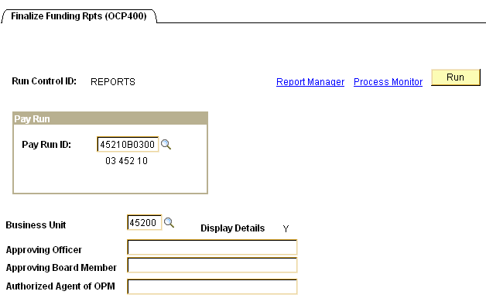

Enter the Pay Run ID and Business Unit. If your Claim Document requires the name(s) of ‘Approving Officer’, ‘Approving Board Member’, and/or ‘Authorized Agent of OPM’ printed on the report, key them in the fields provided. Click .
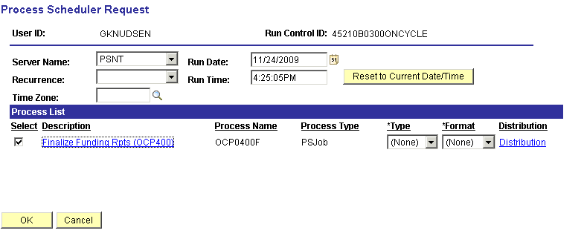

In the ‘Process List’ group box:
- Check box should be checked next to Finalize Funding Rpts (OCP400)
- Type should be set to (None)
- Format should be set to (None).

Select the Finalize Funding Rpts (OCP400) link. Once selected, you will see the following page.

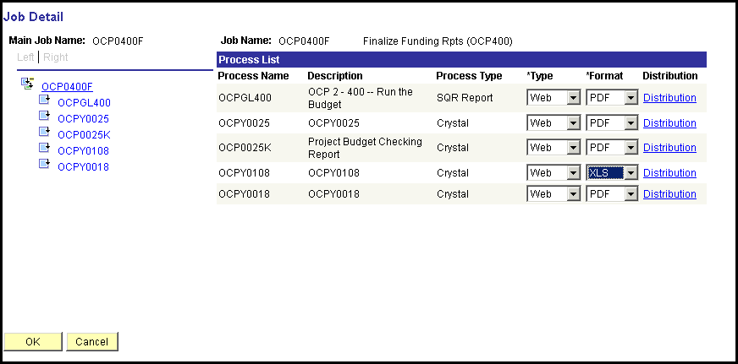

OCPY0108 is the Funding Distribution report. Select ‘Type’ of Web, and ‘Format’ of XLS from the drop-down.

Click .
After clicking , you will be returned to the Process Scheduler page.

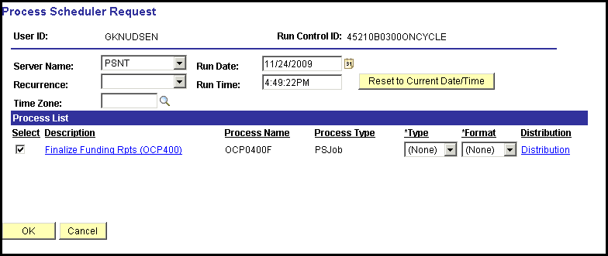

Click again to start the process.

When screen goes back to the Finalize Funding Rpts parameters page, take note of the Process Instance number and click Process Monitor link.

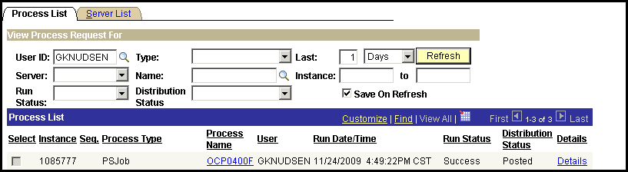

When the run status column shows Success and the Distribution Status column shows Posted, click OCP0400F link under the Process Name column. On the Process Detail page click View Log/Trace link.

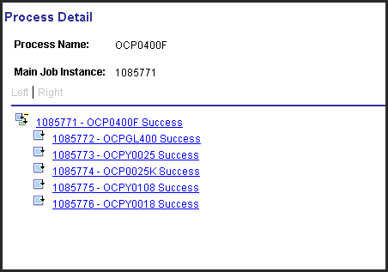

To view and print the Funding Distribution report, click the xxxxxx – OCPY0108 link.

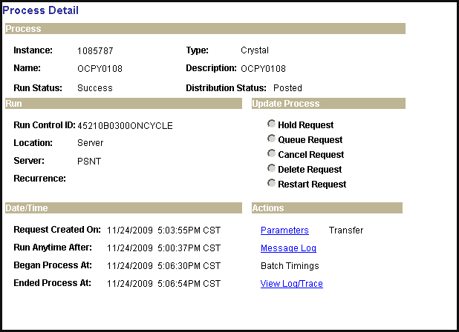

Click the View Log/Trace link. In the ‘File List’ group box select the file with the .XLS extension.
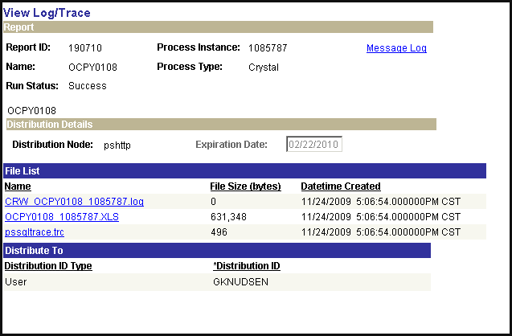

Step 29 – Run GL Process

This process populates the HR Accounting Line Table and sends the data to Financials from which General Ledger journal entries are created.

Navigation: Payroll for North America > Payroll Distribution > Provide GL Information > Commitment Accounting Actuals

After entering a Run Control ID you are taken to the Commitment Accounting Actuals parameters page.

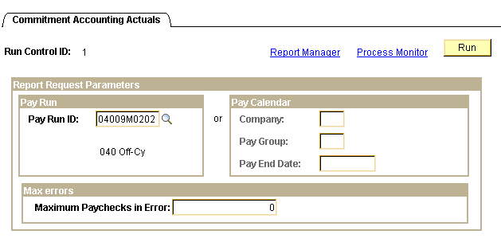

Enter the Pay Run ID and click .
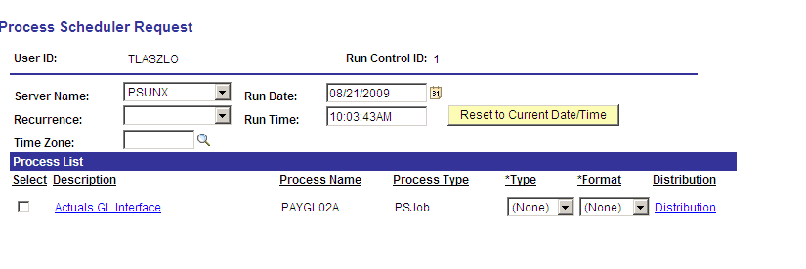

On the Process Scheduler Request page, Server Name must be set to ‘PSUNX’.

In the ‘Process List’ group box:
- Check box should be checked next to Actuals GL Interface
- Type should be set to (None)
- Format should be set to (None).

Click .

When screen goes back to the Commitment Accounting Actuals parameters page, take note of the Process Instance number and click Process Monitor link. When the process runs to a Success and Distribution Status shows Posted.

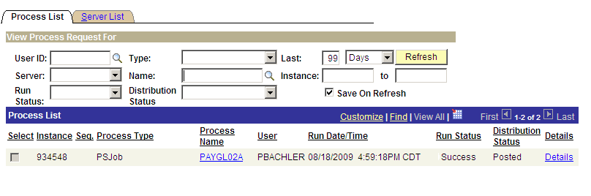

Click the PAYGL02A link under Process Name.
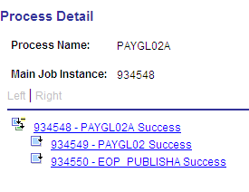

From the Process Detail page click the xxxxxx – PAYGL02 Success link. On the View Log/Trace page click View Log/Trace link.

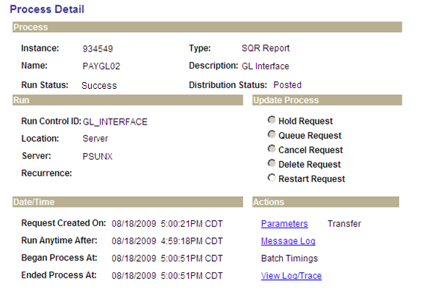

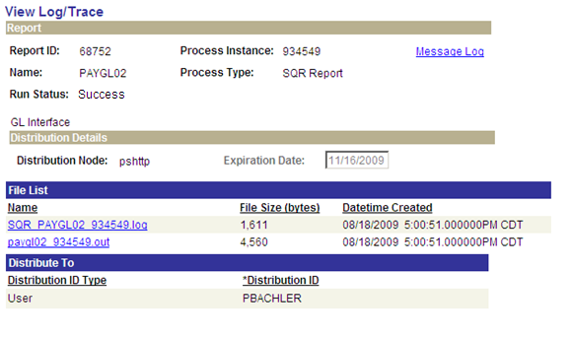

In the File List, click the file having the .out extension. This opens what is known as the Trace Log.

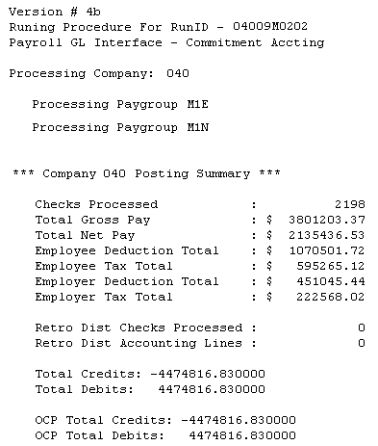

Make sure the Total Debits and Total Credits equal each other, and reconcile with the Budget Checking and Claim Document reports. Print this file, write your name and phone number on it. Submit this Trace Log to OSF along with the Budget Checking and signed Claim Document reports.

Step 30 – Check Pay Calendar Flags

Once again the pay Calendar(s) need to be reviewed making sure a checkmark appears in the box in front of the CA GL Interface Run for every pay group that is active with this Pay Run ID.

Navigation: Payroll for North America > Payroll Processing USA > Create and Load Paysheets > Review pay Calendars

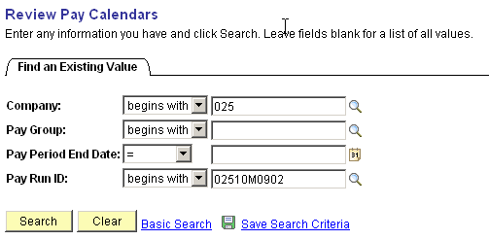

On the Pay Calendar Table search criteria page, enter the Company and pay Run ID that is being used. Click Review the flags checked on the Pay Calendar(s).
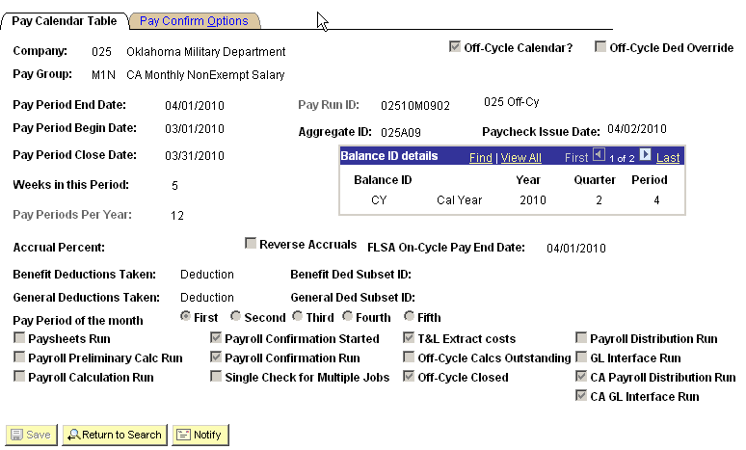

There should be a checkmark in the box in front of the label CA GL Interface Run for all the pay groups that are attached to this Pay Run ID.

If the checkmark is missing, stop and contact Helpdesk. Do not proceed any further.

Step 31 – Fax Documents To OSF

Office State Finance requires that each agency payroll processor send them 3 documents. They are:

- The final Budget Check Report from Step 30
- The final Claim Document from Step 30 and
- The CAGL Interface Trace File from Step 31 must be faxed to Office State Finance by 3:00 pm in order for your payroll to be released to Oklahoma State Treasurer’s Office on that day. Otherwise, the payroll will be held until the paperwork is faxed to them.

Fax # 405-521-3383 to Transaction Processing at Office State Finance.

Step 32 – Run PY To AP Extract Process

This process extracts non-tax deductions based on how the deduction code has been setup.

Navigation: Payroll for North America > Payroll Distribution > Accounts Payable Information > Extract CA Non-Tax Deductions

After entering a Run Control ID you will be taken to the CA Non-Tax Deductions Extract parameter page.

In the Pay Mode Selection group box, select the radio button next to Deduct/Collect Comp./Bond Met and enter the Pay Run ID associated with the pay cycle that you just confirmed. In the Vendor Selection group box make sure the check box is checked next to ‘Pay All Vendors’. Click .

You may receive a ‘Warning Message’, click .

On the Process Scheduler Request page set Server Name to ‘PSUNX’.

In the ‘Process List’ group box:
- Check box should be checked next to PY-CA AP Extraction - Deductions
- Type should be set to Web
- Format should be set to TXT

Click .
If you receive a ‘Warning Message’, click .

When screen goes back to the Non Tax Deductions Extract parameters page, take note of the Process Instance number and click Process Monitor link. When the process runs to a Success and Distribution Status shows Posted move onto the next step. If you want to make sure deductions are in an ‘Extracted’ status you can navigate to Review Paycheck data (Payroll for North America > Payroll Processing USA > Produce Payroll > Review Paycheck). Enter the search criteria to pull up an employee’s check data associated with this confirmed payroll. Click ‘Paycheck Deductions’ in the Deductions group box then click the Deduction Details 3 Tab.
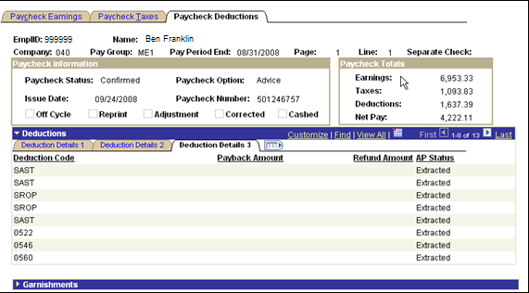

Under the AP Status column you will see the word ‘Extracted’ appear next to each deduction that was to be extracted based on the deduction code setup.

Nightly batch processing runs the AP Voucher Post process for agencies.

Step 33 – Run Deduction Register (0205)

This process creates a report listing all employee deductions taken for this payroll and is sorted by Deduction Code after which the sort is by employee name. The sections of the report pertaining to deduction data Sent to AP is to be forwarded to Accounts Payable for reconciliation processing.

Navigation: Payroll for North America > payroll Processing USA > Pay Period Reports > Deduction Register (0205)

After entering a Run Control ID you are taken to the Deduction Register (0205) parameters page.

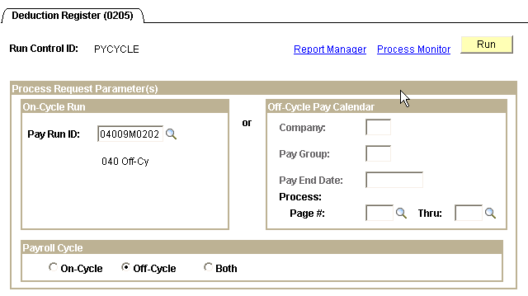

If you want to use the left side of the page enter the Pay Run ID associated with the pay cycle that you just confirmed in the Off-Cycle Run group box. In the Payroll Cycle group box click the radio button in front of Off-Cycle. Click .

NOTE: You can use the right side of the page, but the process then must be run for each Pay Group associated with the off-cycle payroll.

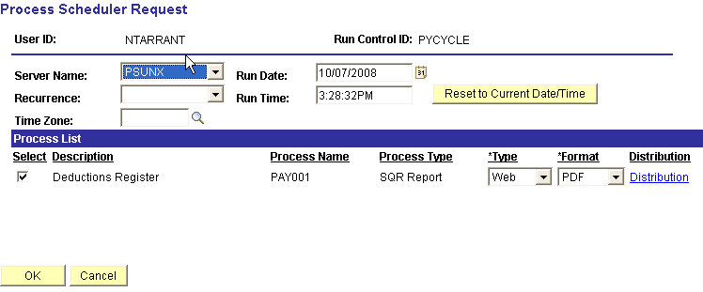

On the Process Scheduler Request page set Server Name to ‘PSUNX’.

In the ‘Process List’ group box:
- Check box should be checked next to Deductions Register
- Type should be set to Web
- Format should be set to PDF

Click .

When screen goes back to the Deduction Register (0205) parameters page, take note of the Process Instance number and click Process Monitor link. When the process runs to a Success and Distribution Status shows Posted, click Details link. On the Process Detail page click View Log/Trace link.
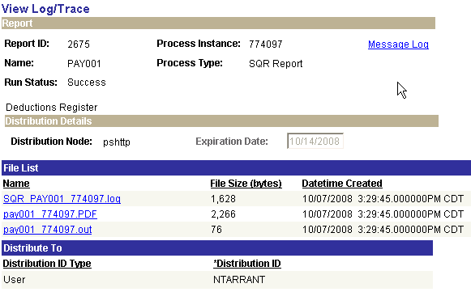

To view and print the Deduction Register click the file, in the File List, having the .PDF extension
(pay001 xxxxxx.PDF).

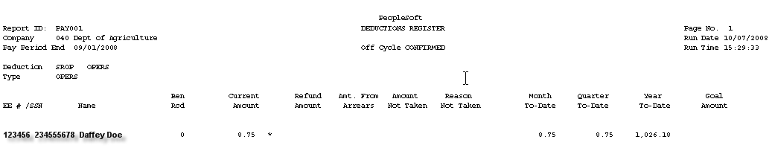

The report will look similar to the above listing deductions in descending/alphabetical order. At the end of each deduction code there is a subtotal line. Print the pages required to forward to AP for reconciliation.

Step 34 – Print Earnings Statements

This process prints the Employee Earnings Statements to be handed out.

Navigation: OK Custom reports/Processes > OK reports > Payroll > Earnings Statement (0040)

After entering the Run Control ID you are taken to the DDP Advice Print parameters page.

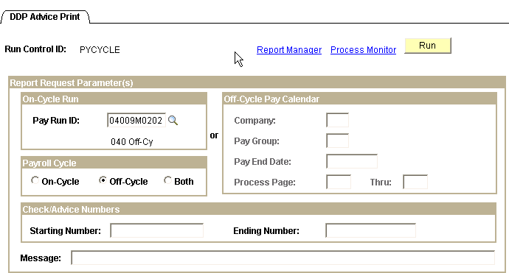

In the On-Cycle Run group box enter the Pay Run ID that you have just confirmed. In the Payroll Cycle group box click the radio button next to Off-Cycle. To have a Message appear on the statements, enter the message in Message field. When data has been filled in correctly click .

NOTE: If you need to reprint statement(s) due to them being lost etc., but don’t need to reprint the entire batch, enter the starting and ending check/advice numbers in the Check/Advice Numbers group box.

NOTE: Since this is an off-cycle you can run the off-cycle statements report(s) using the right side of the page also.

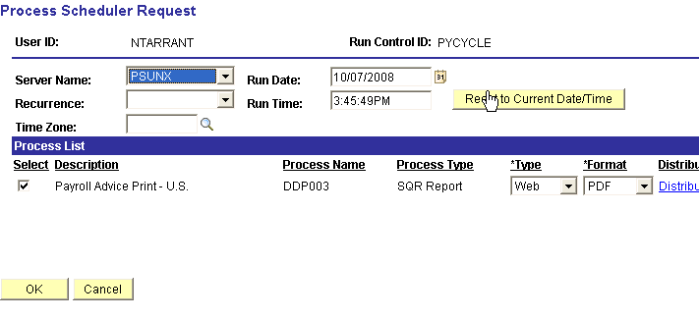

On the Process Scheduler Request page set Server Name to ‘PSUNX’.

In the ‘Process List’ group box:
- Check box should be checked next to Payroll Advice Print – U.S.
- *Type should be set to Web
- *Format should be set to PDF

Click .

When screen goes back to the DDP Advice Print parameters page, take note of the Process Instance number and click Process Monitor link. When the process runs to a Success and Distribution Status shows Posted, click Details link. On the Process Detail page click View Log/Trace link.

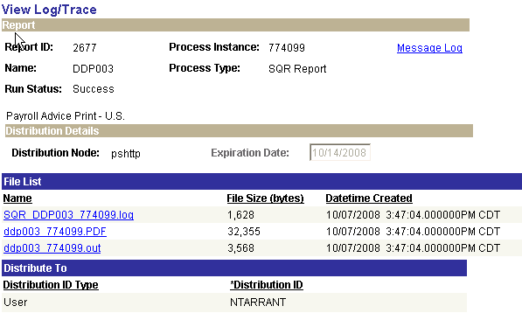

To view and print the Earnings Statement click the file, in the File List, having the .PDF extension (ddp003 xxxxxx.PDF).

Step 35 – Run Credit Union Report

Only run this report if it is applicable to your agency.

Navigation: OK Custom reports/Processes > Agency Processes > Deduction File (0105)

After entering the Run Control ID you are taken to the Deduction File (0104) parameters page.

Fill in all the fields with the required data and click .

On the Process Scheduler Request page set Server Name to ‘PSUNX’.

In the ‘Process List’ group box:
- Check box should be checked next to Create Credit union File & FTP
- Type should be set to (None)
- Format should be set to (None)

Click .

When screen goes back to the Deduction File (0104) parameters page, take note of the Process Instance number and click Process Monitor link. When the process runs to a Success and Distribution Status shows Posted click OCPY104F link.

From the Process Detail page above, if you:

Click xxxxxx – OCPY0104 you will be taken to the View Log/Trace page where you can open up the files to view the data that was picked up in the file.

Click on xxxxxx – OCPY10401 you will be taken to the View Log/Trace page where you can open up the file to view the completed results of the app engine job.

Clicking on the last two in the list above allows you to view the status of the FTP processes that have completed.

Step 36 – Run Leave Accrual Process

NOTE: Complete instructions are in the COR104 Base Benefits Manual pages 30 thru 33.

After ALL payrolls (main, supplemental and off-cycle payrolls) have been CONFIRMED for the calendar month run this leave accrual process only if you are using the PeopleSoft leave system - for sick and each annual leave plans. To prevent delays in printing Leave Statements use the checklist below to ensure the dates are entered correctly.

Run the accrual process for sick leave. | Navigation: Benefits > Manage Leave Accruals > Calculate Periodic Accrual  ALWAYS CHANGE THIS DATE!  ALWAYS CHANGE THIS DATE! | Company:  (Enter agency #)  Plan Type:  (Choose Sick)  Benefit Plan:  (Enter company number + SK, i.e. 400SK)  Accrual Process Date:  (Enter the next to last day of month the payrolls were run for…for example if March Payrolls are all confirmed enter 03/30/2008 as accrual process date.)
Run the accrual process for annual leave. | Navigation: Benefits > Manage Leave Accruals > Calculate Periodic Accrual  ALWAYS CHANGE THIS DATE!  ALWAYS CHANGE THIS DATE! | Company:  (Enter agency #)  Plan Type:  (Choose Vacation…the PeopleSoft plan type value for annual leave plans)  Benefit Plan:  (Enter company number + annual leave level…L1, L2, L3 or L4)  Accrual Process Date:  (Enter the next to last day of month the payrolls were run for…for example if March Payrolls are all confirmed enter 03/30/2008 as accrual process date.)

NOTE: For more details pertaining to running the Leave Accrual processes please refer to the COR104 Base Benefits Manual.

Step 37 – Run Leave Accrual Statements

NOTE: Complete instructions are in the COR104 Base Benefits Manual pages 34 thru 38.

Each agency using the PeopleSoft Leave Accrual System will be responsible for running the Leave Accrual Statements process. This process is run after the Leave Accrual Process has been run for every one of your agency specific sick and annual leave plans. Choose the last day of the month, sort order, and enter the agency number.

Navigation: OK Custom Reports/Processes > OK Reports > Benefits > Emp Leave Accrual Rpt (0053)

OR Bi-Wkly Emp Leave Rpt (0053)

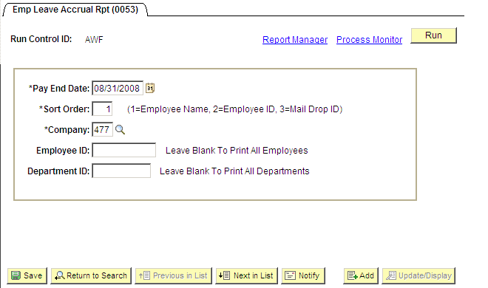

To ensure accuracy all leave statements must be run using the pay period end date which is entered in the *Pay End Date field. For the *Sort Order field you have the flexibility to sort by Employee Name, Employee ID, and Mail Drop. Enter your agency number in the *Company field.

NOTE: To run this process for a specific employee, enter the employee’s EmplID in the Employee ID field. If you want to run this process for just one department in your agency enter the department in the Department ID field.

Click .
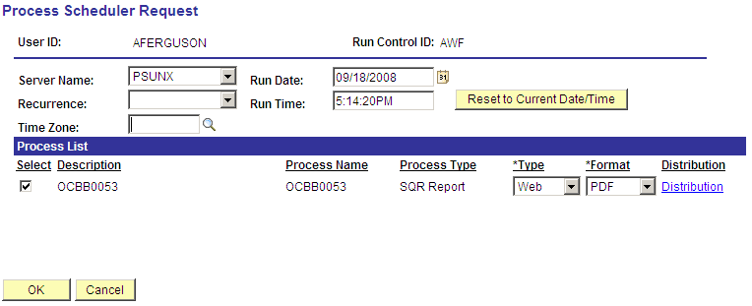

On the Process Scheduler Request page set Server Name to ‘PSUNX’.

In the ‘Process List’ group box:
- Check box should be checked next to OCBB0053
- *Type should be set to Web
- *Format should be set to PDF

Click .

When the screen goes back to the Employee Leave Accrual Rpt (0053) parameters page, take note of the Process Instance number and click Process Monitor link. When the process runs to a Success and Distribution Status shows Posted, click Details link. On the Process Detail page click View Log/Trace link.

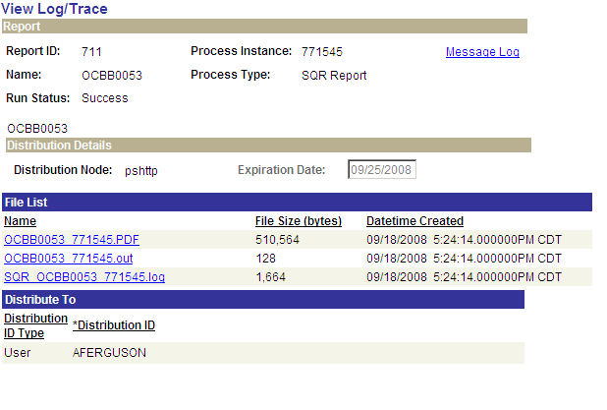

To view and print the Leave Statements click the file, in the File List, having the .PDF extension (OCBB0053 xxxxxx.PDF).

Online Checks

Overview
PeopleSoft offers a very handy and powerful method of creating on-demand or online checks for those times when you need to answer a “what if” question or just pay an employee earnings owed quickly. The “What if” or modeling functionality is helpful when you are setting up garnishments or when an employee wants to know the impact of changing his or her tax exemptions. With Online checks, you can answer the questions and then choose to delete the check without any harm to your current payroll.

The State of Oklahoma will only use the On-Line Check process for calculating what if scenarios. The State will NEVER use this process to create and print a check.

Navigation: Payroll For North America > Payroll Processing USA > Create On-Line Check

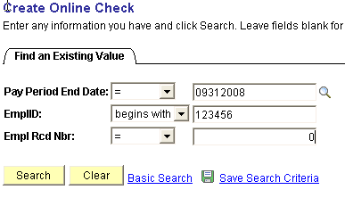

Enter the Pay Period End Date, EmplID, and Empl Rcd Nbr of the employee you want to use. The Pay Period End Date you choose should be the next open On-Cycle Pay Calendar. If you choose a Pay Period End Date for a calendar with no Pay Run ID attached, you will receive an error message.

As long as the employee does not already have a payline marked as Off-Cycle (for an online or regular check), the system will display the following message:

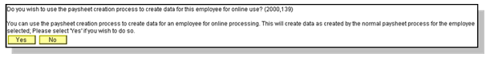

Paysheet Create Message

Click . If you click the system will create a paysheet with any applicable additional pay, holiday, and all deductions that would normally occur for the employee. In addition, the system might ask you if you want to load any payable time from Time & Labor.

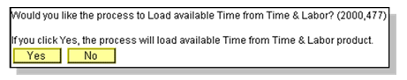

Click .

Online Paysheet Page

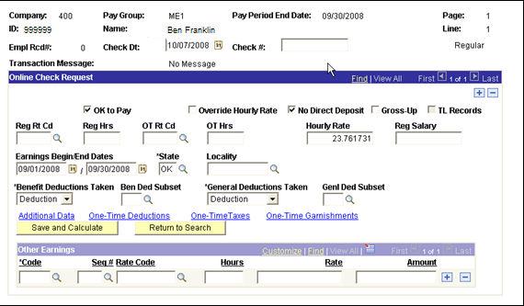

If you clicked when prompted by the Paysheet Create Message, ALL information such as salary, etc. has to be entered manually.
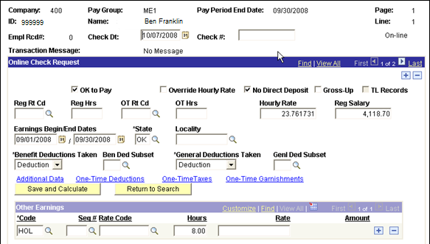

If you clicked when prompted by the Paysheet Create Message, the employee’s salary, etc. will be filled in automatically.

Check Date | The date will default to the current date – Leave the default. The State of Oklahoma does not use online checks to create actual checks, therefore the Check Date does not need to be changed.
Check # | Leave blank – The State of Oklahoma does not use online check to create actual checks, therefore the Check # field is not used.
Save and Calculate | Once you have entered all of the earnings data and additional data you are testing, you are ready to calculate the check.  Click Save and Calculate . The system will transfer you to the calculated results page.
Return to Search | If you wish to process an online check for another employee, click Return to Search to return to the Online Check search page.

You will notice that many of the fields on the Online Check Paysheet page are identical to those on the Paysheet page.

CAUTION: If you ever click to the Paysheet Creation process message, and the employee already has an active, unconfirmed paysheet using the same on-cycle Pay Calendar being processed in batch, the employee will receive a duplicate check. This assumes you confirm and print the check.

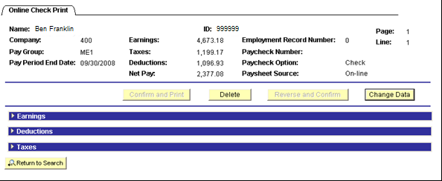

Use  to expand the earnings, deductions and taxes sections as needed.

Earnings

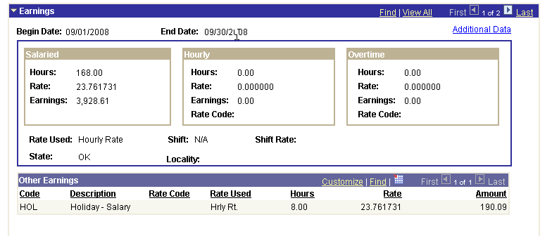
Deductions

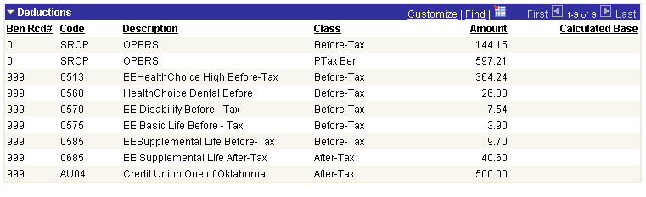

Taxes

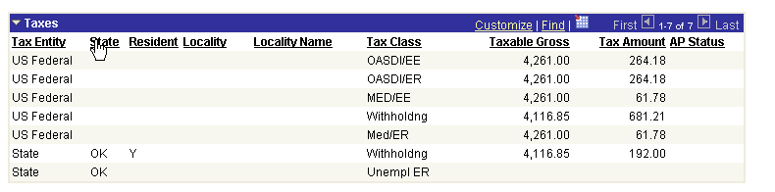

Once you have reviewed the calculated results, you have two (2) options:

- Use this button if you are satisfied with the results and ready to discard the online check. The system will delete the calculated results and return you to the online search page.

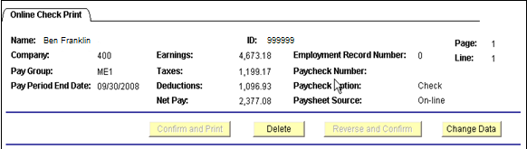

To verify that the paysheet has been deleted navigate to Review Paycheck

Enter the Company, EmplID, Empl Rcd Nbr, Pay Period End Date, click the check box next to Off-‘Cycle?’ and click .

NOTE: If the paysheet was NOT deleted, the paysheet will pull up. If that occurs, you can re-calculate the online check, and try to DELETE it again, OR you can use the Unsheet process to actually unsheet the paysheet. Remember, the On-Line Check process creates an off-cycle paysheet.

- Use this button if you want to change the data and recalculate the check.

Critical NOTE: NEVER LEAVE THE ON-LINE CHECK PROCESS WITHOUT CLICKING If you do, you will be leaving an off-cycle check attached to a Pay Calendar that is unconfirmed which will cause payroll calculation errors later on.

NOTE: The and buttons are grayed out. These two (2) options should never be used and therefore are not available at the State of Oklahoma.

