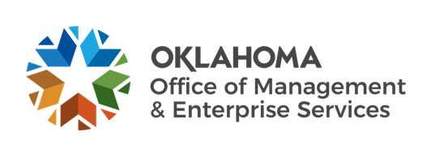 | 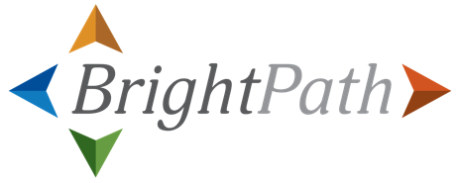

Teams Message – To be sent by agency leadership in early October

As you may be aware, next year our agency, along with other Oklahoma agencies, will adopt Workday, a cloud-based human capital management system. Workday will harmonize HR systems and processes across the state workforce. This means that State of Oklahoma agencies will use a centralized system and have a consistent set of processes for HR, learning and payroll-related tasks. There are many benefits to HR harmonization including increased efficiency, easier processes for managing HR data, and the opportunity for more seamless collaboration with other agencies.
I encourage you to watch this video featuring BrightPath Executive Sponsor and OMES Deputy Director Dana Webb as she explains more about HR harmonization across the state.

Message Links:
Harmonization video: https://brightpath.ok.gov/
If you need additional accommodations to view any of the items in this message, please email brightpath@omes.ok.gov.

