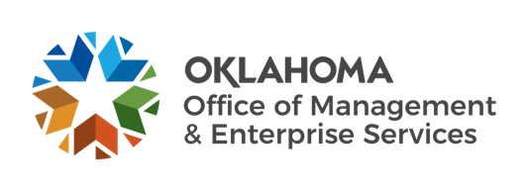 | 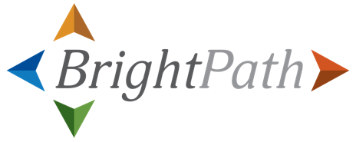

BrightPath October Talking Points:

Current project status:
- In late October, the BrightPath project will transition from the Configure and Prototype stage to Testing, the final stage in the configuration process. Testing will take place from October 2021-April 2022. During this time, Oklahoma representatives test and validate configuration demoed during Customer Confirmation Sessions.
- In September, workstream leads validated change impacts on the state workforce. Change impacts are the changes that will impact the Oklahoma workforce resulting from the Workday implementation. Over the coming months communications will raise awareness of these change impacts among agency leadership, HR representatives and the Oklahoma workforce.
- Harmonizing HR processes across the state workforce is critical to a successful Workday implementation and provides long-term benefits to state employees. In this harmonization video, BrightPath Executive Sponsor and OMES Deputy Director Dana Webb provides an overview of harmonization: what it is, why it is important and how it will benefit the State of Oklahoma workforce.
Testing stage: In the Configure and Prototype stage, Workday was configured to meet the needs of the Oklahoma workforce. During Testing, state representatives test this configuration for usability and accuracy in various activities. Below are two examples of testing activities:
- End-to-end testing: Starting in early November, members of the BrightPath project team will conduct end-to-end testing. During this process, representatives run through scenarios of complete Workday business processes that involve multiple functional areas and system integrations. This testing helps the project team identify and resolve any defects as we finalize configuration.
- User acceptance testing: Starting in early 2022, user acceptance testing begins. The BrightPath project will engage and train testers from many different Oklahoma agencies to test training materials and interact with Workday through hands-on experience. These sessions are led and coordinated by Oklahoma representatives and focus on confirming that agency end users can successfully perform relevant tasks.
Pulse readiness assessments: The first of four agency pulse assessments closed on Sept. 30. In October, the Change Agent Network will share the assessment results and next steps with the workforce from each state agency.
BrightPath website: Remember to leverage the BrightPath website as a source of the most up-to-date information on the BrightPath project. This month’s leadership update from Dana Webb is available on the Updates tab; the FAQ page is updated regularly, and the harmonization video is available on the website homepage.

Change Agent Network: Remember, the Change Agent Network is here to help answer questions and guide you through the preparation to transition to Workday. Reach out to your agency’s change agent(s) if you have any questions or want to learn more about the BrightPath project.
Document links:
- Harmonization video: https://brightpath.ok.gov
- BrightPath updates: https://brightpath.ok.gov/latest-updates
- BrightPath FAQs: https://brightpath.ok.gov/faqs
- BrightPath homepage: https://brightpath.ok.gov
If you need additional accommodations to view any of the items in this document, please contact brightpath@omes.ok.gov.

