Business Process

Human Capital Management

Shift Differential and Skill Based Pay

BP-01

Business Process Definition
This document defines the process established between Office of Personnel Management (OPM) and CORE Human Capital Management (HCM) Team regarding the setup of shift differential and skill based pay codes.

Process Steps

Responsibility: Agency Representative
Process Steps:
- Request approval of new a shift differential or skill based pay rate in writing to OPM.
- The request for a shift differential shall address the requirements of Merit Rule 530:10-7-7, and the request for a skill-based pay rate shall address the requirements for a skill-based pay program as identified in Merit Rule 530:10-7-24. If the request is for a shift differential or a skill-based pay differential, as opposed to a lump sum payment, the request shall indicate whether the differential will be included in annual and or sick leave usage and/or leave pay outs.

Responsibility: Office of Personnel Management (OPM)
Process Steps:
- Review request for approval or denial.
- Letter to the requesting agency, signed by the Administrator and Cabinet Secretary of Human Resources Administration, copy to CORE HCM Team, stating approval or denial of request.

Responsibility: Agency Representative
Process Steps:
- If approved, the agency is responsible for creating a Helpdesk Case requesting new shift differential or skill-based pay code be setup. The request needs to include all payment guidelines regarding the shift differential or skill-based pay.

Responsibility: CORE Human Capital Management Team
Process Steps:
- A member of the CORE team will check to make sure a copy of the approval from OPM is on file. If not, a request to OPM for a copy of the approval will be made. No setup of any shift differential or skill-based pay code will be allowed unless a copy of the OPM approval is on file.
- Once a copy of the approval is on file a CORE HCM Team member will setup and test the payment processing of the shift differential or skill-based pay making sure it meets all payment guidelines outlined in the request and approval documentation.

BP Flow of Request for New Shift Differential or Skill-Based Pay
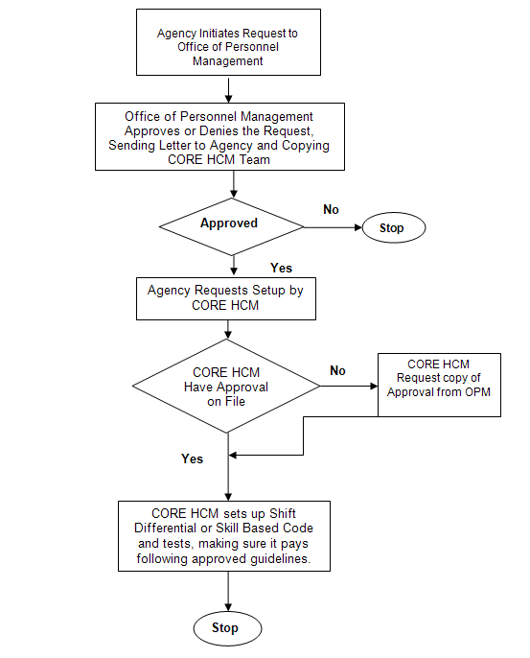

To begin a request for New Shift Differential or Skill-Based Pay, the agency initiates the request to the Office of Personnel Management (O.P.M.), who then approves or denies the request and sends a letter to the agency and a copy to the CORE H.C.M. Team. If the request is denied, the process stops. If the request is approved, the Agency requests setup by CORE H.C.M. If CORE does not have a copy of the approval on file, the CORE H.C.M. Team sends a request to O.P.M. Once CORE has the approval, they will set up the Shift Code or Skill Based Code and tests to assure it pays following approved guidelines.

