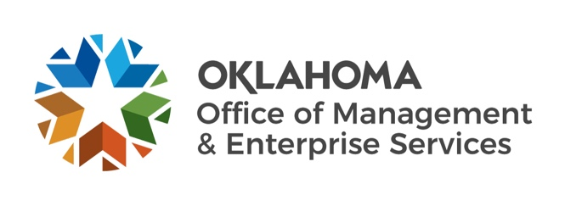
December 2021 BOE Budget Highlights
Purpose of December BOE meeting: Certify revenues accrued in FY-2021 and certify amounts available for appropriation for FY-2023.

FY 2021 highlights:
- Actual General Revenue Collections: $7,007,735,251, an increase of $282,005,880 or 4.2% from the June estimate. This surplus was deposited to the Constitutional Reserve Fund (Rainy Day) in July.
- Actual Total Certified Funds Collections: $7,299,188,407, an increase of $298,460,131 or 4.3% from the June estimate
FY 2022 highlights (no board actions):
- General Revenue Collections June Estimate = $6,642,298,328; Appropriations Authority (95%) = $6,310,183,411
- General Revenue Collections December Projection = $7,379,387,771, an outlook improvement of $737,089,443, or 11.1%
- Key drivers for improved general revenue fund outlook are expected increases in gross production taxes, sales tax, and use tax collections.
- All Certified Funds Collections June Estimate = 6,915,732,053; Appropriations Authority (95%) = $6,569,945,451
- All Certified and Authorized Funds Collections December Projection = $9,540,447,174, an outlook improvement of $808,189,574, or 9.3%
- Total Authorized Expenditures (Legislative appropriations and spending authorizations from all certified funds, authorized funds, cash, and all other sources): $9,064,748,251
FY 2023 highlights:
- General Revenue Collections Estimate: $7,325,259,231; Appropriations Authority (95%): $6,958,996,270.
- All Certified Funds Collections Estimate: $7,595,852,275; Appropriations Authority (95%): $7,216,059,661
- Total expenditure authority (all certified and authorized funds, plus unspent FY-2022 budget and available cash): $10,323,989,157

The Official December BOE packet can be found online at the following link: https://oklahoma.gov/omes/services/budget/boe-packets.html.

