AtHoc mobile app install user guide

Overview
Combined with the AtHoc management system, the AtHoc mobile app enhances OMES’ ability to communicate during a technology outage or other critical event, such as a cyber alert.

Steps for state-owned mobile device
Step 1: Go to your phone and select Comp Portal. | Step 2: Select Sign in.
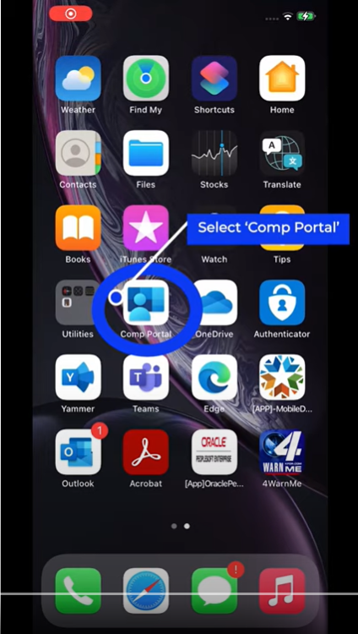 | 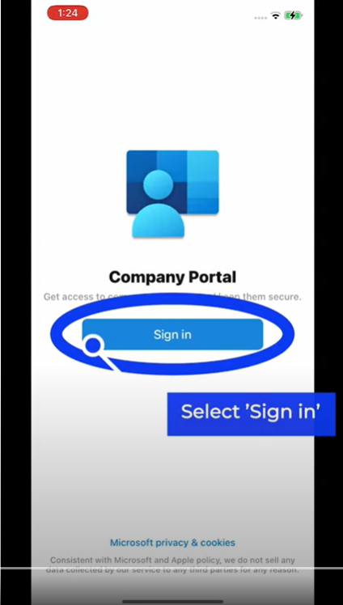

Step 3: Select Apps. | Step 4: Select the AtHoc App to install and follow the AtHoc setup instructions on Page 3 of this document.
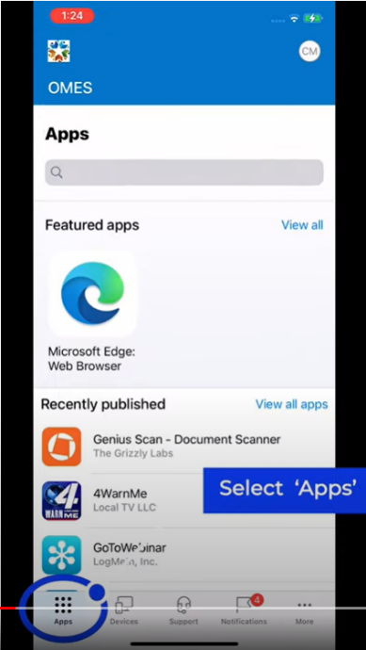

Steps for personal mobile device
Step 1: Go to the App Store and search “BlackBerry AtHoc.” | Step 2: Select Get.
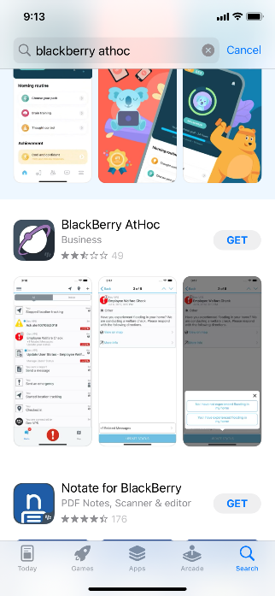 | 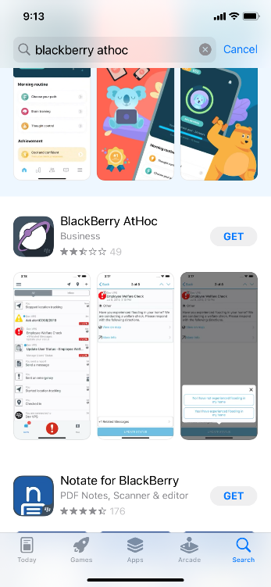
Step 3: Select Install. | Step 4: Enter your Apple ID password and select Sign In.
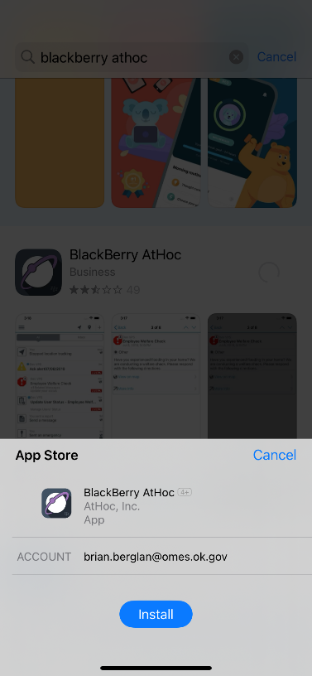 | 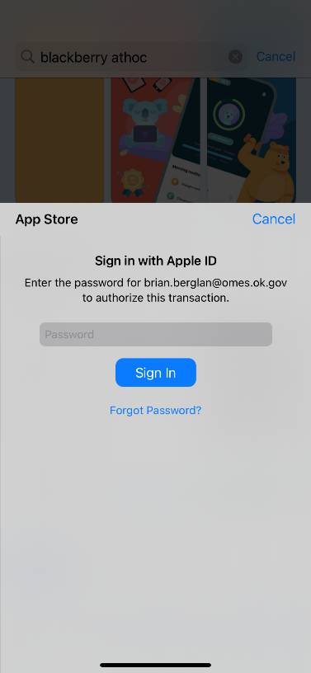

Steps for AtHoc application setup
Step 1: Open the app on your device and follow the next steps for setup. Select Allow. | Step 2: Select Allow.
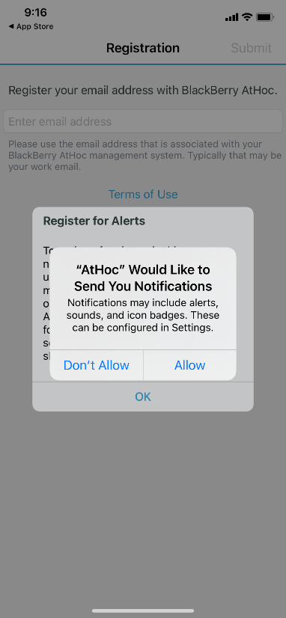 | 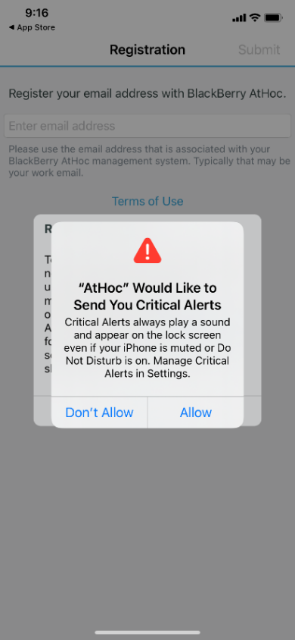
Step 3 Select OK. | Step 4: Enter your state email address.
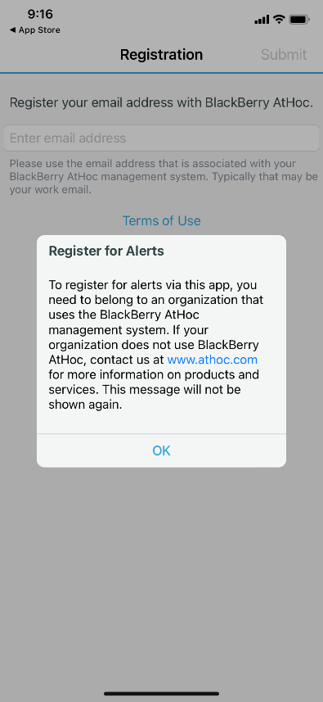 | 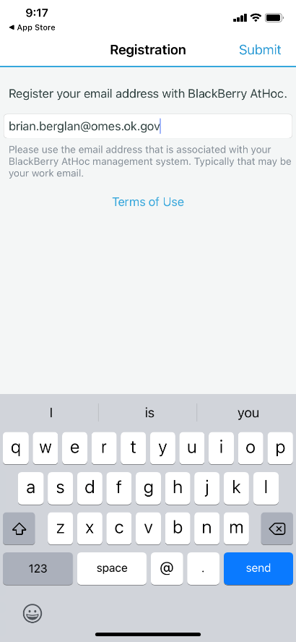
You will receive an email; follow the steps in  the email confirmation. | Step 5: Select Verify Now.
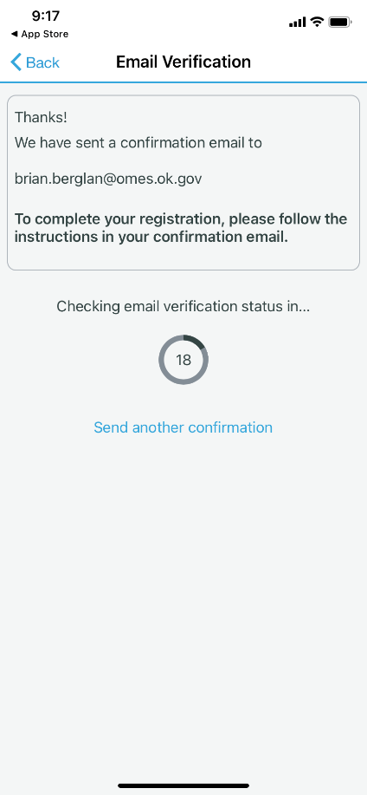 | 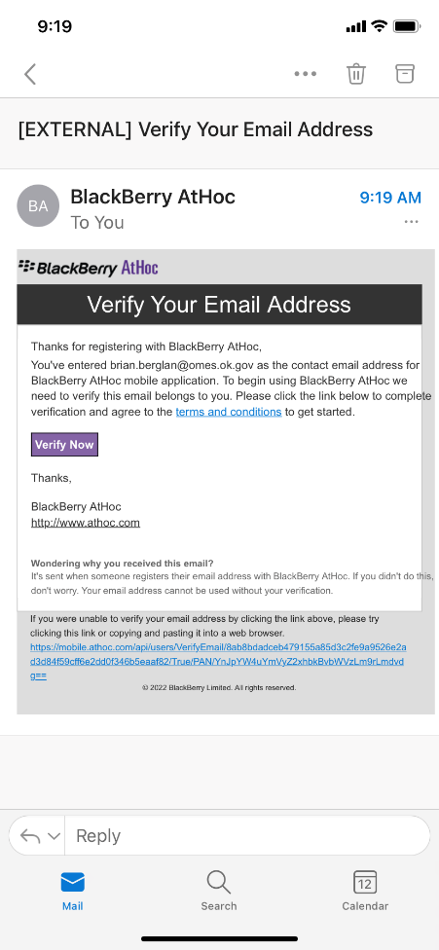
Step 6: Enter the organization code – STATEOK. | Step 7: Select Deny.
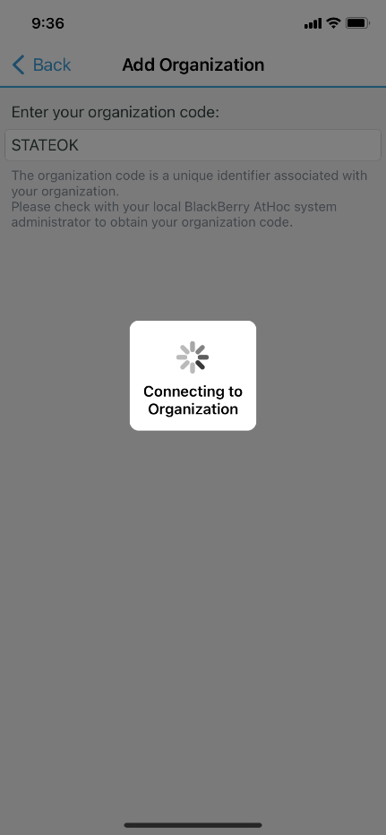 | 