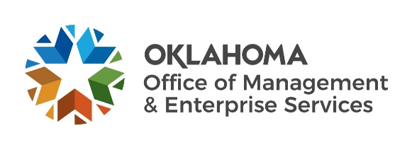 |  | Amendment of Solicitation

Date of Issuance: | 03/24/2020 |  | Solicitation No. |  | 3400001663
Requisition No. | 3400020553 |  | Amendment No. |  | 3
Hour and date specified for receipt of offers is changed: |  |  | No | Yes, to: | April 14, 2020 | 3:00PM CST
Pursuant to OAC 260:115-7-30(d), this document shall serve as official notice of amendment to the solicitation identified above. Such notice is being provided to all suppliers to which the original solicitation was sent.
Suppliers submitting bids or quotations shall acknowledge receipt of this solicitation amendment prior to the hour and date specified in the solicitation as follows:
(1) Sign and return a copy of this amendment with the solicitation response being submitted; or,
(2) If the supplier has already submitted a response, this acknowledgement must be signed and returned prior to the solicitation deadline. All amendment acknowledgements submitted separately shall have the solicitation number and bid opening date printed clearly on the front of the envelope.
ISSUED BY and RETURN TO:
U.S. Postal Delivery or Personal or Common Carrier Delivery:  Office of Management and Enterprise Services  ATTN: Darlene Saltzman  5005 N. Lincoln Blvd. Suite 200  Oklahoma City, OK 73105 |  | Darlene Saltzman
 |  | Contracting Officer
 |  | (405) 694-7016
 |  | Phone Number
 |  | darlene.saltzman@omes.ok.gov
 |  | E-Mail Address
Description of Amendment:
a. This is to incorporate the following:
On behalf of the State of Oklahoma, the Office of Management and Enterprise Services (OMES) gives notice of the following change to solicitation 3400001663.
Due to COVID-19 concerns, the office has been closed and all personnel that can have been mandated to telework. Because of this, the close date has been extended to 4/14/20 to allow for email responses.

Submit email responses to: OMESCPeBID@omes.ok.gov. For all responses that are unable to be submitted via email due to size limitations, the vendor is requested to submit Via a Cloud Service such as Dropbox. Provide link to cloud documents to same email as above.

The state is not responsible for incorrect link information.

b. All other terms and conditions remain unchanged.
Supplier Company Name (PRINT) |  |  |  | Date
Authorized Representative Name (PRINT) |  | Title |  | Authorized Representative Signature

