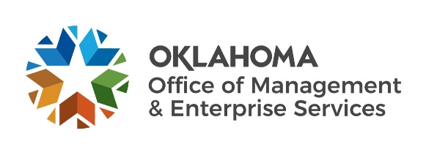 |  | Amendment of Solicitation

Date of Issuance: | 3/23/2022 |  | Solicitation No. |  | 2900000098
Requisition No. | 2900004817 |  | Amendment No. |  | 1
Hour and date specified for receipt of offers is changed: |  |  | No | Yes, to: | 4/14/22 | 3:00 pm CST
Pursuant to OAC 260:115-7-30(d), this document shall serve as official notice of amendment to the solicitation identified above. Such notice is being provided to all suppliers to which the original solicitation was sent.
Suppliers submitting bids or quotations shall acknowledge receipt of this solicitation amendment prior to the hour and date specified in the solicitation as follows:
(1) Sign and return a copy of this amendment with the solicitation response being submitted; or,
(2) If the supplier has already submitted a response, this acknowledgement must be signed and returned prior to the solicitation deadline. All amendment acknowledgements submitted separately shall have the solicitation number and bid opening date printed clearly on the front of the envelope.
ISSUED BY and RETURN TO:
U.S. Postal Delivery or Personal or Common Carrier Delivery:  OMES Central Purchasing  Will Rogers Building  ATTN: Teresa Terry  2401 N. Lincoln Blvd., Ste. 116  Oklahoma City, OK 73105 |  | Teresa Terry
 |  | Contracting Officer
 |  | (405) 521-6679
 |  | Phone Number
 |  | Teresa.terry@omes.ok.gov
 |  | E-Mail Address
Description of Amendment:
a. This is to incorporate the following:
On behalf of the State of Oklahoma, the Office of Management and Enterprise Services (OMES) gives notice of the following questions concerning this solicitation, QA period, which is now closing on April 1, 2022. All questions and procurement/agency responses are detailed below:

Attachment for Exhibit 2 which is now able to wrap on the discussion tab.

Q - Attachment D looks to be a standard boilerplate document for solicitations of this nature - custom software development. In Appendix 2 to State of Oklahoma Information Technology Terms beginning on page 17, there is a call out regarding CJIS compliance that seems to be standard CJIS verbiage. xxx has responded to a number of bids nationwide. This is the first time MTX is seeing this "requirement". Since the solution xxx will develop only accesses Personal Identifiable Information (PII) and no "CJIS related" data, we are writing to confirm that this part of the Solicitation is not applicable as a genuine requirement for this specific solicitation.

A – If you do not think this is applicable to your solution you may list it as an exception on your response.

b. All other terms and conditions remain unchanged.
Supplier Company Name (PRINT) |  |  |  | Date
Authorized Representative Name (PRINT) |  | Title |  | Authorized Representative Signature

