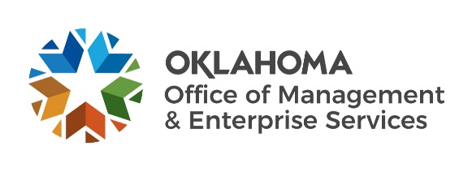 |  | Amendment of Solicitation

Date of Issuance: | 3/31/2022 |  | Solicitation No. |  | 1850000143
Requisition No. | 185000803 |  | Amendment No. |  | 1
Hour and date specified for receipt of offers is changed: |  |  | No | Yes, to: |  | CST
Pursuant to OAC 260:115-7-30(d), this document shall serve as official notice of amendment to the solicitation identified above. Such notice is being provided to all suppliers to which the original solicitation was sent.
Suppliers submitting bids or quotations shall acknowledge receipt of this solicitation amendment prior to the hour and date specified in the solicitation as follows:
(1) Sign and return a copy of this amendment with the solicitation response being submitted; or,
(2) If the supplier has already submitted a response, this acknowledgement must be signed and returned prior to the solicitation deadline. All amendment acknowledgements submitted separately shall have the solicitation number and bid opening date printed clearly on the front of the envelope.
ISSUED BY and RETURN TO:
U.S. Postal Delivery or Personal or Common Carrier Delivery:  OMES Central Purchasing  Will Rogers Building  ATTN: Teresa Terry  2401 N. Lincoln Blvd., Ste. 116  Oklahoma City, OK 73105 |  | Teresa Terry
 |  | Contracting Officer
 |  | (405) 521-6679
 |  | Phone Number
 |  | Teresa.terry@omes.ok.gov
 |  | E-Mail Address
Description of Amendment:
a. This is to incorporate the following:
On behalf of the State of Oklahoma, the Office of Management and Enterprise Services (OMES) gives notice of the following questions concerning this solicitation, received during the QA period, which closes on 4/6/2022. All questions and procurement/agency responses are detailed below:

- What type of warranty and duration are you looking to have quoted?
  - If you’d like warranty renewal options, for how many years?
We would like to know IF there are any warranties included and what those are. If they provide extended warranties, those can be quoted as well as an optional addition.

- Can you please provide the specific model of Barcode scanner/kit you’re looking to have quoted? For the Code Reader 2700, I was told there are multiple options.
D032274_01 CR2700

- When is Oklahoma Corporation Commission looking to submit an order by, and when do they want to receive the products on-site?
As soon as the bid is closed, evaluated and the PO issued is when we’d like to order the items.

b. All other terms and conditions remain unchanged.
Supplier Company Name (PRINT) |  |  |  | Date
Authorized Representative Name (PRINT) |  | Title |  | Authorized Representative Signature

