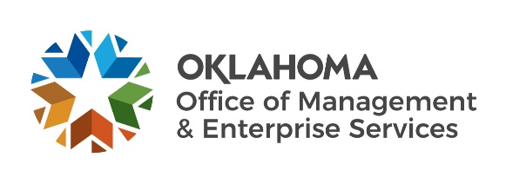 |  | Amendment of Solicitation

Date of Issuance: | 5/26/2022 |  | Solicitation No. |  | 1310004360
Requisition No. | 1310020930 |  | Amendment No. |  | 1
Hour and date specified for receipt of offers is changed: |  |  | No | Yes, to: |  | CST
Pursuant to OAC 260:115-7-30(d), this document shall serve as official notice of amendment to the solicitation identified above. Such notice is being provided to all suppliers to which the original solicitation was sent.
Suppliers submitting bids or quotations shall acknowledge receipt of this solicitation amendment prior to the hour and date specified in the solicitation as follows:
(1) Sign and return a copy of this amendment with the solicitation response being submitted; or,
(2) If the supplier has already submitted a response, this acknowledgement must be signed and returned prior to the solicitation deadline. All amendment acknowledgements submitted separately shall have the solicitation number and bid opening date printed clearly on the front of the envelope.
RETURN TO:
 |  | Nancy McFarland
 |  | Contracting Officer
 |  | (405) 521-6464
 |  | Phone Number
 |  | Nancy.mcfarland@omes.ok.gov
 |  | E-Mail Address
Description of Amendment:
a. This is to incorporate the following:
On behalf of the State of Oklahoma, the Office of Management and Enterprise Services (OMES) gives notice of the following questions concerning this solicitation, received during the Wiki QA period, which closed on . All questions and procurement/agency responses are detailed below:

Q1: Attachment B, Section 8.1 on page 9:
QUESTION: The limits of $5 million in Sections 8.1 B. and C. exceed what Granite carries as a policy. Granite carries a $1 million per occurrence and $2 million aggregate policy. Would this be amenable to the Department of Corrections? We also carry an Umbrella policy which may supplement these lower limits.

Response: The OMES vendor insurance requirements are statutory. Bids which do not meet program requirements will not be considered.

Q2: Attachment B, Section 17 on page 20:
QUESTION: Have funds been appropriated and made available for this Contract? If so, for how many years of performance? If not, when does the Department of Corrections anticipate funds being appropriated and made available? How will Offerors be so notified?

Answer: Both Oklahoma Department of Corrections (ODOC) as well as any awardee(s) to this solicitation must file ongoing reports to the RHC and OUSF program administrators. “Exhibit 1 – Locations” identify both the locations and the program(s) against which they qualify and currently receiving funding. Bidder’s solely responsible for ensuring they meet their own pre-award qualification and post-award reporting requirements. Bids which do not meet program requirements will not be considered.

For more information about RHC: https://www.usac.org/rural-health-care/

For more information about OUSF: https://oklahoma.gov/occ/divisions/public-utility/ousf.html

Response:

Q3:
Response:

Q4:

Response:

Q5:
Response:

Q6:

Response:

Q7:
Response:

Q8:
Response:

Q9:
Response:

Q10:
Response:

Q11:
Response:

Q12:
Response:

Q13:

Response:

Q14:

Response:

b. All other terms and conditions remain unchanged.
Supplier Company Name (PRINT) |  |  |  | Date
Authorized Representative Name (PRINT) |  | Title |  | Authorized Representative Signature

