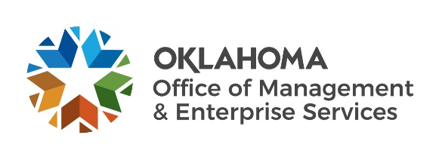 |  | Amendment of Solicitation

Date of Issuance: | 11/22/2021 |  | Solicitation No. |  | 1310004350
Requisition No. | 1310020782 |  | Amendment No. |  | 1
Hour and date specified for receipt of offers is changed: |  |  | No | Yes, to: |  | CST
Pursuant to OAC 260:115-7-30(d), this document shall serve as official notice of amendment to the solicitation identified above. Such notice is being provided to all suppliers to which the original solicitation was sent.
Suppliers submitting bids or quotations shall acknowledge receipt of this solicitation amendment prior to the hour and date specified in the solicitation as follows:
(1) Sign and return a copy of this amendment with the solicitation response being submitted; or,
(2) If the supplier has already submitted a response, this acknowledgement must be signed and returned prior to the solicitation deadline. All amendment acknowledgements submitted separately shall have the solicitation number and bid opening date printed clearly on the front of the envelope.
ISSUED BY and RETURN TO:
U.S. Postal Delivery or Personal or Common Carrier Delivery:  OMES Central Purchasing  Will Rogers Building  ATTN: Darlene Saltzman  2401 N. Lincoln Blvd., Ste. 116  Oklahoma City, OK 73105 |  | Darlene Saltzman
 |  | Contracting Officer
 |  | (405) 694-7016
 |  | Phone Number
 |  | Darlene.saltzman@omes.ok.gov
 |  | E-Mail Address
Description of Amendment:
a. This is to incorporate the following:
On behalf of the State of Oklahoma, the Office of Management and Enterprise Services (OMES) gives notice of the following questions concerning this solicitation, received during the Wiki QA period, which closed on 11/19/2021. All questions and procurement/agency responses are detailed below:
1. Has funding been approved for this contract?
Yes. ODOC has obligated funding for an award.

2. Does the State currently have a cell phone detection and location system installed? If yes,
who is the vendor and at what facilities?
ODOC currently has no systems matching the proposed requirements.

3. Is the RFP asking for services for only one facility? Has the facility(s) been selected?
While total locations for proposed deployment not known at this time, the primary facility will be the Lexington Assessment & Reception Center (LARC), 15151 OK-39, Lexington, OK 73051

4. Would the State be interested in a system that operates at multiple facilities?
ODOC is interested in systems which can be extended to operate in multiple facilities.

5. Is training required if only the supplier is operating the system?
An awarded supplier will be required to provide training as described within the Request for Proposal.

6. Does the State have a preference on what type of system is used?
ODOC has no preference at this time.

7. Does the VPAT have to be hosted on a URL?
You may attach copies of your VPAT forms instead of providing a URL..

8. What is the scoring methodology?
Scoring methodology will not be released.

b. All other terms and conditions remain unchanged.
Supplier Company Name (PRINT) |  |  |  | Date
Authorized Representative Name (PRINT) |  | Title |  | Authorized Representative Signature

