OFFICE OF MANAGEMENT & ENTERPRISE SERVICES

Information Technology Services

**Exhibit 1**



**Standard**

**Livescan Specification Document**

**2022 Revision 3-23-2022**

**TABLE OF CONTENTS**

1.0 General Background Overview 3

**1.1 References 3**

2.0 General Functional Requirements. (LV-Type-1 – Jail Use) 3

3.0 General Functional Requirements. (LV-Type-2 – Public/Non-Jail Use) 4

4.0 Livescan to State AFIS Workflow: 5

**4.1 Local and Remote Printing Requirements 5**

**4.2 LV Transaction Profile 6**

**4.3 LV Transaction (Criminal Adult) 7**

**4.4 LVJ Transaction (Criminal Juvenile) 8**

**4.5 LVA Transaction (Police Applicant) 9**

**4.5.1 LVCW Transaction (OSBI Handgun License/Concealed Weapon License) 10**

**4.6 LVN Transaction (Criminal Inquiry) 12**

**4.7 LVNR Transaction (Criminal Non-Reportable Offense) 13**

**4.8 LVC Transaction (Civilian Applicant) 14**

5.0 Minimum Technical Requirements 15

6.0 Warranty and Maintenance/Service Agreement 18

7.0 Added Value Items 19

8.0 Appendix – A 20

**8.1 Oklahoma Criminal Fingerprint Card (front) 21**

**8.2 Oklahoma Criminal Fingerprint Card (back) 22**

**8.3 Oklahoma Filing Report Form 23**

**8.4 Oklahoma Disposition Reporting Form 24**

**8.5 Oklahoma Left Palm Print Form 25**

**8.6 Oklahoma Right Palm Print Form 26**

**8.8 OSBI Mugshot Form 28**

**8.9 OSBI Hit or No-Hit Response Form 29**

9.0 OSBI OTN check digit algorithm. 30

10.0 Known Jail Record Management Systems in Use 31

11.0 Definition of Terms: 31

# General Background Overview

The state of Oklahoma has implemented a tightly integrated computerized criminal history system (CCH) and Automated Fingerprint Identification System (AFIS) that supports about 150 Livescan devices deployed statewide. AFIS is designed to support multiple workflows that come from Livescans deployed in the field. The integrated system is built using NIST-ITL-2011 and adheres to the FBI standards.

Given the above stated architecture, the state is seeking to setup a statewide contract for state and local law enforcement to procure Livescan fingerprint and mugshot capture stations that are compliant to the standards and specifications listed on this document. Once established, state and local law enforcement agencies may use this contract to procure new or replacement Livescan devices as needed.

The solicitation has specific functional and technical requirements that must be met for a supplier to have their products listed in the statewide contract.

## **References**

[Automated Fingerprint Identification System | Oklahoma State Bureau of Investigation](https://osbi.ok.gov/services/law-enforcement-programs/afis)

ANSI/NIST-ITL 1-2011: NIST Special Publication 500-290 Edition 3 (2015)

OSBI standard NIST Type-2 record specification document-V4.03,

*Revised July 02, 2018*

Mug Shot Interface Specifications Document Version 4.0

[ELECTRONIC BIOMETRIC TRANSMISSION SPECIFICATION (EBTS) Version 10.0 — BioSpecs (fbi.gov)](https://fbibiospecs.fbi.gov/file-repository/master-ebts-v10-final-20130702.pdf/view?msclkid=25348aeebc0b11ecb3691c5064016c2a)

[PalmGuidance v3.0 LFSU — BioSpecs (fbi.gov)](https://fbibiospecs.fbi.gov/file-repository/palmguidance-v3-0-lfsu.pdf/view?msclkid=75b369b0b06711ec92b3efd87f82caf4)

# General Functional Requirements. (LV-Type-1 – Jail Use)

1. The Livescan devices shall be equipped with a hard metal cabinet that features a lockable keyboard and scan platen.
2. The Livescan devices shall be equipped with a protected metal enclosure for a camera mount; camera mounts shall be adjustable.
3. The Livescan devices shall be equipped with a protected mount for a touch screen monitor; screen mounts shall be adjustable.
4. The Livescan devices shall be equipped with pedal switch for capturing prints.
5. The Livescan devices shall be equipped with a cabinet that has a lock on the front and back, in case enclosure access is needed. PC and other network components shall be securely mounted inside the cabinet. All components shall be secured in a manner which protects the components from unauthorized use or damage and prevents components from being used as a weapon against jail staff.
6. The Livescan devices shall be equipped with adjustable platen for ADA compliance.
7. The Livescan devices shall be capable of capturing and producing NIST compliant type-2, type-4, type-10 records and type-15 records.
8. The Livescan cabinet shall have industrial wheels to move the cabinet by slanting it, once on location the cabinet shall have leveling bolts for the Livescan to be leveled for production work.
9. The Livescan cabinet shall be equipped with a small power distribution unit to power the Livescan components from within the cabinet enclosure.
10. A full one-year warranty, including technical, hardware, and software maintenance (Livescan and Operating System software) support shall be included. See section 6.
11. An annual technical support/software maintenance plan covering the four years following the expiration of the warranty shall be submitted. The plan shall list the cost for each year of support and provide details about the level and types of service included. See Section 6.
12. Once Microsoft or the State of Oklahoma no longer support the Operating System (OS), an optional OS upgrade plan and cost estimate shall be provided to customers upon request.
13. The Livescan must include all LV Transaction workflows described in sections 4.0 through 4.8.

# General Functional Requirements. (LV-Type-2 – Public/Non-Jail Use)

1. The Livescan devices shall be equipped with a camera mount; camera mounts shall be adjustable.
2. The Livescan devices shall be equipped with a protected mount for a touch screen monitor; screen mounts shall be adjustable.
3. The Livescan devices shall be capable of capturing and producing NIST compliant type-2, type-4, type-10 records and type-15 records.
4. A full one-year warranty, including technical, hardware, and software maintenance (Livescan and Operating System software) support shall be included. Refer to section 6.
5. An annual technical support/software maintenance plan covering the four years following the expiration of the warranty shall be submitted. The plan shall list the cost for each year of support and provide details about the level and types of service included. See Section 6.
6. Once Microsoft or the State of Oklahoma no longer support the Operating System (OS), an optional OS upgrade plan and cost estimate shall be provided to customers upon request.
7. The Livescan must include all LV Transaction workflows described in sections 4.0 through 4.8.

# Livescan to State AFIS Workflow:

The Livescan transaction (LV) flow shows the sequence of functions that will occur on a given installation. The list of data elements that must be captured and submitted during the booking process are included on the attached OSBI fingerprint, palm print, filing, and disposition forms. All data submitted to the OSBI following the booking process must match the stated fields and formats shown in the attachments. The OSBI criminal and applicant cards are standard and provided as attachments. The fields that make up the OSBI type-2 record and the corresponding field edits can be found in the OSBI standard NIST Type-2 record specification document, V4.03.

## **Local and Remote Printing Requirements**

LV-1 and LV-2 type devices shall be capable of both local and remote printing of all cards and forms listed and shown in sections 8.0 through 8.9. Successful printing requires information in each field to be properly aligned and easily readable.

Printers shall be FBI compliant. <https://fbibiospecs.fbi.gov/certifications-1/cpl>

**4.1.1 Local Printing:** The Livescan devices shall be capable of printing fingerprint cards, palm print cards, mugshots and other OSBI forms listed and shown in sections 8.0 through 8.9. The printing shall be accomplished utilizing a networked printer with at least 2 paper bins, capable of printing the fingerprint cards on the first bin and the palm print and disposition formson the second bin simultaneously. Local printing shall be user configured via menu selection.

**4.1.2 Remote Printing:** The Livescan devices shall be capable of printing fingerprint cards, palm print cards, mugshots and other OSBI forms –listed and shown in sections 8.0 through 8.9. The printing shall be accomplished utilizing a centralized print server that will handle all the required printing services that come from all the Livescan capture stations. The Livescan device shall be capable of submitting print jobs to a remote queue as designated.

## **LV Transaction Profile**

The Livescan device must have the following profiles included:

1. LV Transaction (Criminal Adult)
2. LVJ Transaction (Criminal Juvenile)
3. LVA Transaction (Police Applicant)
4. LVCW Transaction (OSBI Handgun License)
5. LVN Transaction (Criminal Inquiry)
6. LVNR Transaction (Criminal Non-Reportable Offense)
7. LVC Transaction (Civilian Applicant)

## **LV Transaction (Criminal Adult)**

LV transaction type will be used when booking a criminal over 18 years of age.



**LV Data Flow Narrative**

* As soon as the Livescan operator starts a new booking, the Livescan must generate a valid Offender Tracking Number (OTN) using the OSBI OTN check digit algorithm as described in Section 9.0.
* After the OTN number is generated, the descriptor, fingerprint, palm print, and mug shot (including scars, marks, and tattoos (SMT)) data will be captured. When capturing mug shot and SMT data, the first four photos shall be mug shot (full face frontal, left profile, right profile, and optional angled pose). **Fingerprint, palm print (including upper, lower, and writer’s palm prints), and mug shot are required for all Criminal Transaction Submissions.**
* Once the data is captured, the booking is complete and all data is transmitted electronically to the OSBI. The user will be able to print fingerprint and palm print cards at this point in the process. The user shall be able to print any of the listed forms or cards for any stored transaction after this point in the workflow.
* At this point, the user will be able to print OSBI Filing and Disposition Forms so they can be forwarded to prosecutor.
* At this point the information will be searched at the OSBI and search results will be e-mailed back to a dedicated mail box assigned to each Livescan. The Livescan must retrieve the search result via e-mail and display result of a “Hit”, “No-Hit” or “In-Progress” response. The Livescan shall have a capability to print out the OSBI Hit or No-Hit Response Form, containing the information shown in section 8.9.

## **LVJ Transaction (Criminal Juvenile)**

LVJ transaction type will be used when booking a criminal under 18 years of age.



**LVJ Data Flow Narrative**

* As soon as the Livescan operator starts a new booking, the Livescan must generate a valid Offender Tracking Number (OTN) using the OSBI OTN check digit algorithm as described in Section 9.0
* After the OTN number is generated, the descriptor, fingerprint, palm print, and mug shot (including scars, marks, and tattoos (SMT)) data will be captured. When capturing mug shot and SMT data, the first four photos shall be mug shot (full face frontal, left profile, right profile, and optional angled pose). **Fingerprint, palm print (including upper, lower, and writer’s palm prints), and mug shot are required for all Juvenile Criminal Transaction Submission.**
* Once the data is captured the booking is complete and all data is transmitted electronically to the OSBI. The user will be able to print fingerprint and palm print cards at this point in the process. The user shall be able to print any of the listed forms or cards for any stored transaction after this point in the workflow. At this point, the user will be able to print OSBI Filing and Disposition Forms so they can be forwarded to prosecutor.
* At this point the information will be searched at the OSBI and search results will be e-mailed back to a dedicated mail box assigned to each Livescan. The Livescan must retrieve the search result via e-mail and display result of a “Hit”, “No-Hit” or “In-Progress” Response. The Livescan shall have a capability to print out the OSBI Hit or No-Hit Response Form, containing the information shown in section 8.9.

## **LVA Transaction (Police Applicant)**

LVA transaction type will be used when processing police applicants or personnel at the local agency or for other law enforcement agencies.

This transaction will NOT need to have the OTN number.

Mug shot will be optional for this transaction type.



**LVA Data Flow Narrative**

* Descriptor, fingerprint, palm print (including upper, lower, and writer’s palm prints), and optional mug shot data will be captured at this point.
* Once the data is captured, the transaction is complete and all data is transmitted electronically to the OSBI. The user will be able to print fingerprint and palm print cards at this point in the process. The user shall be able to print any of the listed forms or cards for any stored transaction after this point in the workflow.
* At this point the information will be searched at the OSBI and search results will be e-mailed back to a dedicated mail box assigned to each Livescan. The Livescan must retrieve the search result via e-mail and display result of a “Hit”, “No-Hit” or “In-Progress” Response. The Livescan shall have a capability to print out the OSBI Hit or No-Hit Response Form, containing the information shown in section 8.9.

### **LVCW Transaction (OSBI Handgun License/Concealed Weapon License)**

LVCW transaction type will be used when processing OSBI Handgun License applicants.

This transaction will NOT need to have an OTN number.

Mug shot and palm print will be optional for this transaction type.



**LVCW Data Flow Narrative**

* Descriptor, fingerprint, optional palm print (including upper, lower, and writer’s palm prints), and optional mug shot data will be captured at this point.
* Once the data is captured, the transaction is complete and all data is transmitted electronically to the OSBI. The user will be able to print fingerprint and palm print cards at this point in the process. The user shall be able to print any of the listed forms or cards for any stored transaction after this point in the workflow.

## **LVN Transaction (Criminal Inquiry)**

LVN transaction type will be used when processing Criminal Inquiry.

This transaction will NOT need to have the OTN number.



**LVN Data Flow Narrative**

* The AOL (Arrest Offense Literal) must be = **Criminal Inquiry**
* Descriptor, fingerprint, palm print (including upper, lower, and writer’s palm prints), and optional mug shot data will be captured at this point.
* Once the data is captured, the transaction is complete and all data is transmitted electronically to the OSBI. The user will be able to print fingerprint and palm print cards at this point in the process. The user shall be able to print any of the listed forms or cards for any stored transaction after this point in the workflow.
* At this point the information will be searched at the OSBI and search results will be e-mailed back to a dedicated mail box assigned to each Livescan. The Livescan must retrieve the search result via e-mail and display result of a “Hit”, “No-Hit” or “In-Progress” Response. The Livescan shall have a capability to print out the OSBI Hit or No-Hit Response Form, containing the information shown in section 8.9.

## **LVNR Transaction (Criminal Non-Reportable Offense)**

LVNR transaction type will be used when booking a criminal who has been arrested for (a) non-reportable offense(s) only.

* This transaction will use a regular sequence 10 digit number OTN (such as 0123456789).
* This transaction WILL NOT BE SENT to OSBI at the end of the booking process.



**LVNR Data Flow Narrative**

* As soon as the Livescan operator starts a new booking, the Livescan must generate a valid Offender Tracking Number (OTN) using the regular sequence 10 digit number such as 0123456789.
* After the OTN number is generated, the descriptor, fingerprint, palm print, and mug shot (including scars, marks, and tattoo (SMT)) data will be captured. When collecting mug shot and SMT data, the first four photos shall be mug shot (full face frontal, left profile, right profile, and optional angled pose). **Fingerprint, palm prints (including upper, lower, and writer’s palm prints), and mug shot are required for all Criminal Non-reportable Offense Transactions.**
* Once the data is captured, the transaction is complete. The user will be able to print fingerprint and palm print cards at this point in the process. The user shall be able to print any of the listed forms or cards for any stored transaction after this point in the workflow.
* At this point, the user will be able to print OSBI Filing and Disposition Forms so they can be forwarded to prosecutor.
* At the end of the booking, the transaction WILL NOT be submitted to OSBI.

## **LVC Transaction (Civilian Applicant)**

LVC transaction type will be used to capture a fingerprint for civilian applicant.

* There will be no OTN for this transaction.
* This transaction WILL NOT BE SENT to OSBI at the end of the process.



**LVC Data Flow Narrative**

* After the transaction is generated the descriptor, fingerprint, palm print, and mug shot data will be captured. **Fingerprint data is required for all Civilian Transaction Submissions. Palm print and mug shot data are optional.**
* Once the data is captured, the transaction is complete. The user will be able to print fingerprint and palm print cards at this point in the process. The user shall be able to print any of the listed forms or cards for any stored transaction after this point in the workflow.
* At the end of the process, the transaction WILL NOT be submitted to OSBI.

# Minimum Technical Requirements

1. The Livescan system shall be certified by the FBI as tested and in compliance with the FBI's Next Generation Identification (NGI) Image Quality Specifications (IQS) listed in Appendix F of the Electronic Biometric Transmission Specification (EBTS) Version 10.0.
2. The Livescan shall be capable of performing FBI certified WSQ 15:1 compression.
3. Image transmission must comply with the ANSI/NIST-ITL 1-2011 standard. Type-1, Type-2, Type-4, Type-10 and Type-15 are required for a tenprint transaction.
4. In order to communicate, the Livescan will use redundant Fast Ethernet cards (100Mb/s) using TCP/IP protocol with NFS capability.
5. The networkable printer shall contain two card trays, print double-sided, and be FBI certified.
6. The Livescan shall be able to assign/set a prefix of at least four characters in front of the Livescan transaction control number such as OCPD20010101.
7. The Livescan shall be able to **maintain unique Livescan transaction control numbers** (TCNs) that are date and time stamped, in addition to the booking number that is provided by the law enforcement agency’s local booking process.
8. The Livescan shall be able to communicate with any agency Jail/Record Management System to import inmate descriptor data into the Livescan. Known jail record management systems currently in use in Oklahoma are listed in section 10. It will be the responsibility of each agency purchasing a Livescan to provide record management system specifications to the successful supplier(s).
9. In order to have a single capture point, the Livescan shall be able to extract minutiae from captured fingerprints and palm prints and then perform slap to roll comparisons to ensure the correct placement of right and left hands and check for duplicate fingers.
10. The Livescan shall have a provision to allow OSBI remote access for troubleshooting, auditing and maintenance purposes. The device shall be configured to interface with remote support tools. Remote support tools may be also used by the supplier for updates.
11. A minimum 900 VA uninterruptible power supply will be required to protect the Livescan from power fluctuations.
12. The Livescan device shall be configured to use Offender Tracking Numbers (OTNs) assigned for each Livescan by the OSBI. The Livescan software shall use the OTN numbers and validate the check digit with every arrest using the algorithm provided by the OSBI. See section 9.0.
13. The Livescan device shall be able to support 6 different card and form types:
    1. Oklahoma State Criminal
    2. Oklahoma State Palm Print
    3. Oklahoma State Filing Report Form
    4. Oklahoma State Disposition Report Form
    5. Mugshot Photo Form
    6. OSBI Hit, No-Hit Response Form
14. After data capture, the Livescan software shall provide the user the option to print the card and form types specified in section 8.1 through 8.9.
15. The Livescan device shall be able to convert NIST compliant packets to OSBI state file format. Refer to OSBI standard NIST Type-2 record specification document, V4.03.
16. The Livescan device shall be able to perform the LV transaction flows described by the OSBI in Sections 4.0 through 4.8.
17. The Livescan device shall be able to store at least 4,000 compressed bookings / transactions in case of network problems.
18. The Livescan shall be configured with an email transport service that is able to receive secure email communication from the state AFIS. The software shall be able to present the message that comes from the state AFIS on a modal screen that requires acknowledgment from the operator. The software shall log the acknowledgement in the daily log file stored on the Livescan mirrored disk with a full date and time stamp.
19. The Livescan device shall be able to support the installation of software VPN such as Juniper Software VPN. This software VPN can be used to establish a connection from the Livescan device to state AFIS.
20. If the connection to the state AFIS goes down, the Livescan device shall be able to resubmit the transactions once the connection to state AFIS has been re-established.
21. The Livescan device shall have a transaction management module that allows the user to view if a transaction has been submitted to state AFIS and display the response received from state AFIS.
22. The Livescan transaction management module shall display name, type of transaction (TOT) or workflow name (such as Criminal Adult, Criminal Juvenile, etc.), transaction date and booking ID.
23. The Livescan transaction management module shall allow the user to resend the transaction to state AFIS in case the state AFIS did not receive the transaction from the device.
24. The Livescan device shall have a mirrored disk drive with RAID set capability for backing up and restoring data.
25. The NIST compliant type-4 data shall be converted to the current state AFIS search packet format for processing in the current state AFIS.
26. The minimum capture and print size for rolled prints is (1.6" x 1.5").
27. The minimum capture and print size for slaps is (1.9" x 3.2").
28. The maximum capture and print size for palm prints is (5.5" x 8") and writer’s palm is (1.75" x 5").
29. The Livescan must be able to capture upper, lower, and writer’s palm prints.
30. The Livescan mug shot capture must meet the OSBI Mug Shot Interface Specifications Document Version 4.0. Mug shot resolution should be between 600 and 1000 ppi.
31. The Livescan must be capable of capturing rolled and flat fingerprints, palm prints (including upper, lower, and writer’s palm prints), mugshots and scars, marks, and tattoos (SMT). The Livescan shall use a single sealed platen with no moving parts for the capture of finger and palm prints.
32. An integrated mug shot capture camera unit shall be mounted on the Livescan device frame and provide software control for adjusting and capturing mug shot and SMT pictures.

The Livescan device shall be configured with a utility software that can update the Livescan existing charge code list with an updated charge code list when provided by the OSBI. This is to ensure the Livescan has the current charge and code tables up to date with the OSBI AFIS System.

The design of Livescan data capture stations shall adhere to industry open systems standard for any non-proprietary operating system and system hardware. The Livescan shall be installed with Microsoft Windows 11 with full security patches or the latest operating system available at the time of installation.

1. The Livescan software shall be able to capture 20 tenprint images (rolled and flat impressions) and 6 palm print images (upper, lower and writer’s palm).
2. The Livescan shall be equipped with an FBI certified tenprint and palm print scanner capable of producing a 500 ppi image. See [Certified Products List — BioSpecs (fbi.gov)](https://fbibiospecs.fbi.gov/certifications-1/cpl).
3. The Livescan scanner shall be able to scan upper, lower, and writer’s palm prints to meet the latest palm capture capability. Palm print compression must be FBI compliant.
4. The mug shot capture software shall have an Auto Face Finder feature that adheres to NIST best practices and is FBI compliant.
5. The Livescan device shall have the ability to produce the following reports for auditing purposes:
   1. Booking Recap Report by Date, with workflow name (LV, LVJ) and charge description.
   2. State AFIS Response Review Report by Date.
   3. Transaction Submission Report by Date.

# Warranty and Maintenance/Service Agreement

6.1 Each Livescan device shall be covered by a full, one-year warranty covering all provided hardware and software.

6.2 The technical support/software maintenance plan should be all-inclusive, providing technical, hardware, and software (Livescan and Operating System Software) support for a single annual fee.

6.3 Both the warranty and maintenance/service plan shall include, but not be limited to, the following:

6.3.1 Proper printer configuration, ensuring the printer properly aligns information in the necessary fields and that information printed is legible.

6.3.2 If new workflows, transaction types or applicant codes are needed and developed by or for the OSBI, these updates shall be provided to all existing customers with a Livescan currently under warranty or covered by a maintenance/service plan.

6.4 Maintenance/Service agreement plan details provided with the bid shall include the following details:

6.4.1 A list of all hardware included with the system and an indication whether repair or replacement of each item is or is not included with the maintenance/service agreement. Any limitations when repair or replacement would not be included shall be clearly defined.

6.4.2 A list of all software included with the system and an indication whether update and support of the software is or is not included. Any limitations when updates or support are not included with the maintenance/service agreement shall be clearly defined.

6.4.3 How maintenance and support requests are submitted (website, phone number, e-mail, etc.) and hours when maintenance/support lines are monitored.

6.4.4 Timeliness for responding to maintenance/support requests, including both initial response, periodic updates, and final resolution.

6.4.5 Customer references – at least three customer references should be provided with contact information (name, agency, e-mail address, and phone number) for existing customers who have received maintenance/service support within the last 12 months.

# Added Value Items

Additional consideration will be given to responses which provide added value to the State through features which help ensure the efficiency, accuracy or quality of data submitted by the Livescan. This may include, but is not limited to the following examples:

7.1 Data quality controls – Programming which verifies the data entered into a field is consistent with expected values for that data field and/or other data already entered for the transaction. In the event data does not meet expected values, the system should provide a warning message and provide an opportunity for the user to override, unless otherwise specified.

A check of date of birth verifies the individual is 18 or older for an LV (criminal adult) transaction. If not, the system provides a warning to the user, but allows them to accept the date in the event a juvenile is being charged as an adult.

Date of arrest is compared to current date. If it is not the same, a warning message is provided to the user, but the user can accept in the event fingerprints were collected after the date of arrest.

7.2 Data entry controls – Programming which prevents a user from entering or selecting an invalid value.

Arrestee’s weight cannot exceed 499 lbs.

Applicant codes which are not accepted by the OSBI can be hidden from drop down menus. Allowable applicant codes may be updated by the OSBI periodically and provided as part of the warranty or maintenance/service plan.

Charges must be characterized as Felony or Misdemeanor.

Paperless Process – Options which enable information to be transmitted electronically instead of printed.

Filing and disposition forms may be e-mailed to a pre-defined and programmed e-mail address (which can be updated through the warranty and maintenance/service plan).

Elimination of duplicate transactions – When a transaction has been successfully submitted to the OSBI and a response received, the Livescan will not permit the user to re-send or edit the submission. A warning message will notify the user to contact the OSBI at a specified phone number or e-mail address.

Retention of data – The vendor provides certification that the most recent 4,000 bookings/transactions will be stored on the device without a degradation in performance.

Full palm capability –

The vendor has a Livescan device which can capture the full palm from distal fingertips to the wrist bracelet.

The vendor is developing a device which can capture the full palm from distal fingertips to the wrist bracelet and will provide upgrade capability to existing customers once the device is completed and certified.

Palm Image Quality Assessment Tool – The vendor provides a palm image quality assessment tool which searches distal fingertips from the palm images and compares to the rolled and slapped fingerprint impressions and requires at least one matching distal fingerprint for each hand. Palm images captured which do not meet this criteria result in a message displayed advising the operator to recollect the palm image and prevents the submission of palm images which lack the distal fingerprints.

# 8.0 Appendix – A

8.1 Oklahoma Criminal fingerprint card front

8.2 Oklahoma Criminal fingerprint card back

8.3 Oklahoma Filing report form

8.4 Oklahoma Disposition reporting form

8.5 Oklahoma left palm print card

8.6 Oklahoma right palm print card

8.7 FBI Civilian fingerprint card front

8.8 Oklahoma Mugshot Form

8.9 OSBI Hit, No-Hit Response Form

## **8.1 Oklahoma Criminal Fingerprint Card (front)**

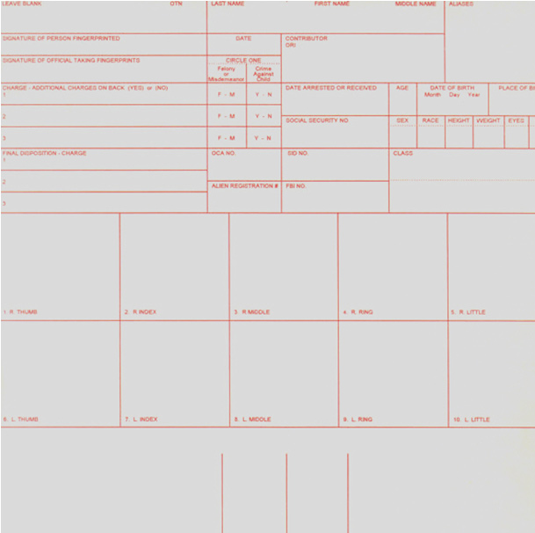

## **8.2** **Oklahoma Criminal Fingerprint Card (back)**

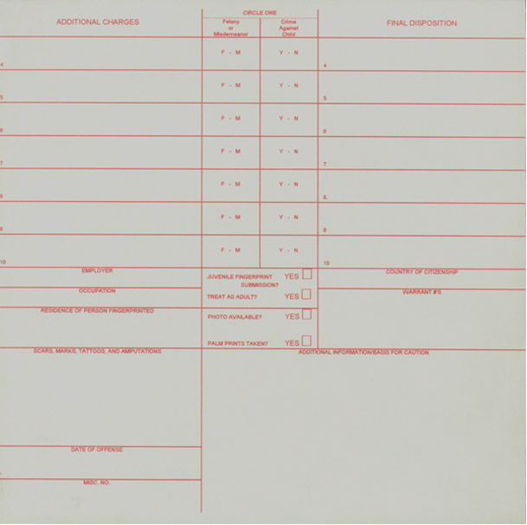

## **8.3 Oklahoma Filing Report Form**

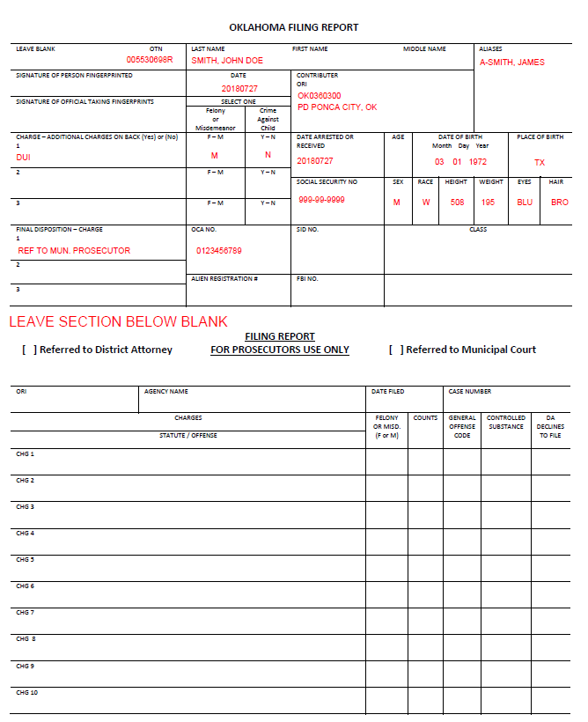

## **8.4 Oklahoma Disposition Reporting Form**

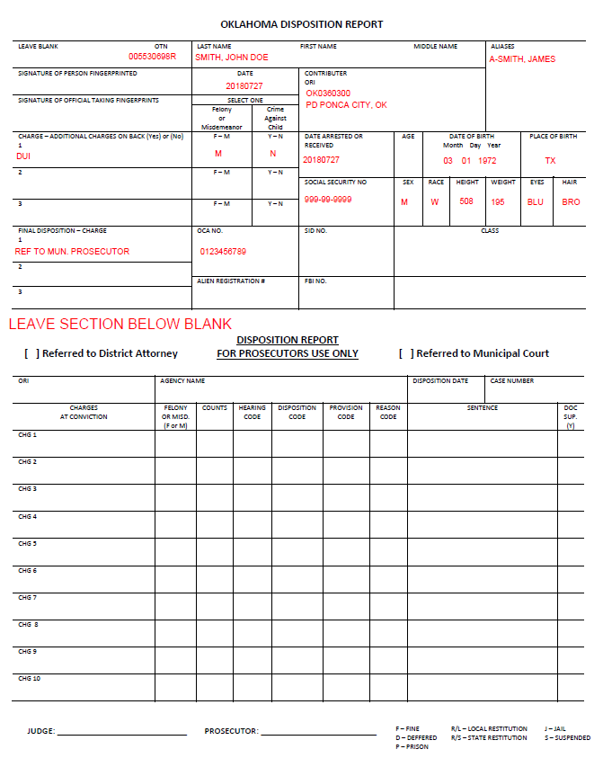

## **8.5 Oklahoma Left Palm Print Form**

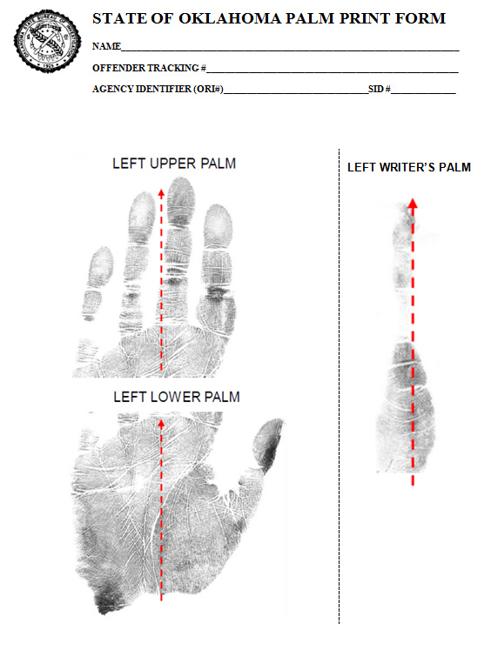

## **8.6** **Oklahoma Right Palm Print Form**

## **8.7 FBI Civilian Fingerprint Card (front)**

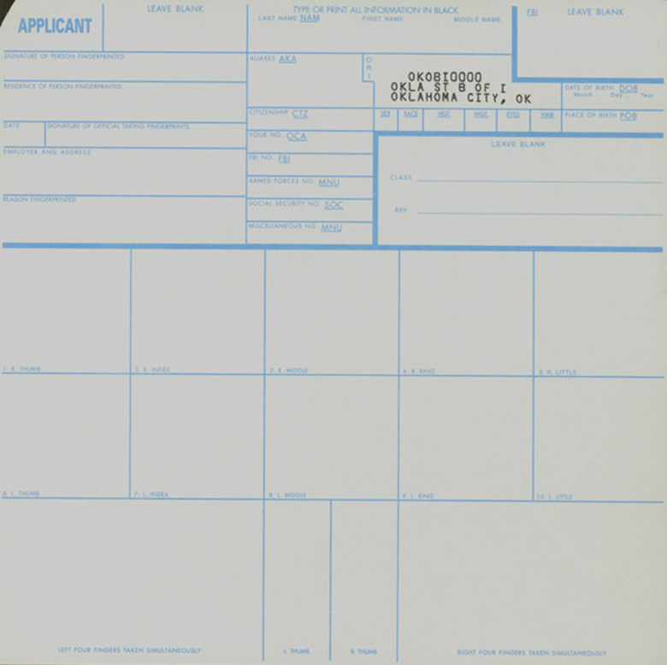

## **8.8 OSBI Mugshot Form**

## 

SMSMT/Tattoo

## **8.9 OSBI Hit or No-Hit Response Form**

## 

# 

# 9.0 OSBI OTN check digit algorithm.

OSBI Offender Tracking Number Check digit validation Algorithm.

OSBI OTN is a 10-byte field, the first 9 bytes are numeric and the 10th is an alphabetic suffix used for calculating the check digit.

An edit should check for the first 9 bytes to be numeric, leading zeros could be added if less than 9 bytes are entered for this part of the field.

The following letters are used as suffixes and their corresponding position numbers.

|  |  |  |  |  |  |  |  |  |  |  |
| --- | --- | --- | --- | --- | --- | --- | --- | --- | --- | --- |
| Z | J | K | L | M | N | Y | P | Q | R | H |
| 1 | 2 | 3 | 4 | 5 | 6 | 7 | 8 | 9 | 10 | 11 |

It is calculated as follows:

Constant *w* = 512 *x* = 1, 2, ..., 9

Position number = P*x n* = 0, 1, ..., 8

*X*  = 9

*n*  = 8

Formula: f = [ **∑** (w/2*n* * A*x*) ] MOD 11

*X* = 1

*n* = 0

P*x* = 11 – f

Then pick the corresponding suffix based on the calculated value of Px. It should match the OTN number entered; otherwise it is an error condition.

For example: OTN = 0 0 0 8 1 1 5 4 7 P

Digits 0 thru 7 above correspond with A1 thru A9

According to the formula:

f = [(512 * 0) +(256*0)+(128*0)+(64*8)+(32*1)+(16*1)+(8*5)+(4*4)+(2*7)] MOD 11

f = 630 MOD 11 = 3

P*x* = 11 -3 = 8

The letter corresponding to 8 is P, this matches the one entered, therefore it is a correct entry.

# 10.0 Known Jail Record Management Systems in Use

|  |  |
| --- | --- |
| System | Supplier |
| Offender Data Information System (ODIS) | Oklahoma State Bureau of Investigation (OSBI) |
| JailTracker | Global Public Safety |
| Inmate Management System | BluHorse |
| TIGER TRACK | TIGER Correctional Services |
| Jail Enterprise/Jail Pro | Central Square |
| Enterpol JMS | Enterpol by Huber and Associates |
| IMACS | Intellitech Corporation |
| Spillman | Motoroloa |
| SOMS | M&M Microsystems Inc. |
| New World Corrections | Tyler Technologies |
| Odyssey Navigator | Tyler Technologies |
| BOSS | Justice Solutions |

# 11.0 Definition of Terms:

FBI Certified – Means the device has been tested by and verified to comply with the Electronic Biometric Transmission Specification (EBTS) v. 10.0.

FBI Compliant - Same as FBI certified.

NIST Compliant - The device complies with ANSI/NIST-ITL 1-2011: NIST Special Publication 500-290 Edition 3 (2015).