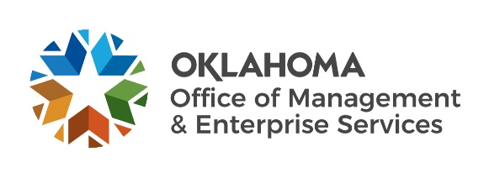 |  | Amendment of Solicitation

Date of Issuance: | 10/20/22 |  | Solicitation No. |  | 0900000545 FSA-ReBid
Requisition No. | 0900016526 |  | Amendment No. |  | 1
Hour and date specified for receipt of offers is changed: |  |  | No | Yes, to: |  | CST
Pursuant to OAC 260:115-7-30(d), this document shall serve as official notice of amendment to the solicitation identified above. Such notice is being provided to all suppliers to which the original solicitation was sent.
Suppliers submitting bids or quotations shall acknowledge receipt of this solicitation amendment prior to the hour and date specified in the solicitation as follows:
(1) Sign and return a copy of this amendment with the solicitation response being submitted; or,
(2) If the supplier has already submitted a response, this acknowledgement must be signed and returned prior to the solicitation deadline. All amendment acknowledgements submitted separately shall have the solicitation number and bid opening date printed clearly on the front of the envelope.
RETURN TO:
 |  | Darlene Saltzman
 |  | Contracting Officer
 |  | (405) 694-7016
 |  | Phone Number
 |  | darlene.saltzman@omes.ok.gov
 |  | E-Mail Address
Description of Amendment:
a. This is to incorporate the following:
On behalf of the State of Oklahoma, the Office of Management and Enterprise Services (OMES) gives notice of the following:
BAA added to bid posting. Please complete and return with your bid response.
Thank you,
Darlene

b. All other terms and conditions remain unchanged.
Supplier Company Name (PRINT) |  |  |  | Date
Authorized Representative Name (PRINT) |  | Title |  | Authorized Representative Signature

