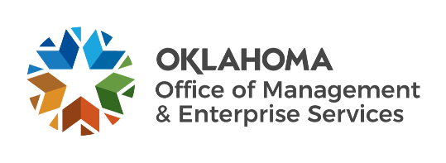 |  | Amendment of Solicitation

Date of Issuance: | 03/26/2020 |  | Solicitation No. |  | 0900000438
Requisition No. | 0900013700 |  | Amendment No. |  | 1
Hour and date specified for receipt of offers is changed: |  |  | No | Yes, to: | 04/28/2020 3:00PM | CST
Pursuant to OAC 260:115-7-30(d), this document shall serve as official notice of amendment to the solicitation identified above. Such notice is being provided to all suppliers to which the original solicitation was sent.
Suppliers submitting bids or quotations shall acknowledge receipt of this solicitation amendment prior to the hour and date specified in the solicitation as follows:
(1) Sign and return a copy of this amendment with the solicitation response being submitted; or,
(2) If the supplier has already submitted a response, this acknowledgement must be signed and returned prior to the solicitation deadline. All amendment acknowledgements submitted separately shall have the solicitation number and bid opening date printed clearly on the front of the envelope.
ISSUED BY and RETURN TO:
U.S. Postal Delivery:  Office of Management and Enterprise  Services, Central Purchasing  5005 N. Lincoln Blvd., Suite 200  Oklahoma City, OK 73105 -  or  Personal or Common Carrier Delivery:  Same as above  ,OK - |  | Joseph Farani
 |  | Contracting Officer
 |  | 405 - 550 - 1386
 |  | Phone Number
 |  | joseph.farani@omes.ok.gov
 |  | E-Mail Address
Description of Amendment:
a. This is to incorporate the following:
These Bidder Instruction sections are modified as follows:

Sec. 9.2. Due to the COVID 19 outbreak, a Bid shall be submitted via email to OMESCPeBID@omes.ok.gov. In person, commercial carrier or facsimile submittals shall not be accepted. The email Bid shall contain the Solicitation Number, Bid Response Due Date and Time in the subject line of the email.

Sec. 9.3. Due to the COVID 19 outbreak, this subsection is intentionally omitted.

Sec. 9.4. Due to the COVID 19 outbreak, this subsection is intentionally omitted.

Q1. Due to the Corona Virus Crisis, will the questions and bid response due dates be pushed out? It would be extremely helpful if the due dates were pushed out to May.
A1. The closing date is extended until April 28, 2020 at 3PM Central Time. Due to the COVID 19 outbreak, bids shall be submitted via email to OMESCPeBID@omes.ok.gov. In person, commercial carrier or facsimile submittals shall NOT be accepted. The email Bid shall contain the Solicitation Number, Bid Response Due Date and Time in the subject line of the email.

Q2. Is the Oklahoma Office of Management & Enterprise Services able to purchase products from the GSA? If so, can Bid Section Nine direct the agency to this pricing on the GSA?
A2. The State Purchasing Director may utilize contracts awarded by other governmental agencies, including agencies of the United States of America. Offerors may bid in accordance with GSA pricing if it is more advantageous to the State.

Q3. Can you provide the specific scope by agency, including quantities?
A3. This solicitation is not for a specific project. This solicitation is designed to be a contract vehicle to streamline the State’s procurement process and reduce administrative costs. The intent of this solicitation is to award statewide contract(s) for solutions that will be available to all procuring Agencies and Affiliates.

b. All other terms and conditions remain unchanged.
Supplier Company Name (PRINT) |  |  |  | Date
Authorized Representative Name (PRINT) |  | Title |  | Authorized Representative Signature

