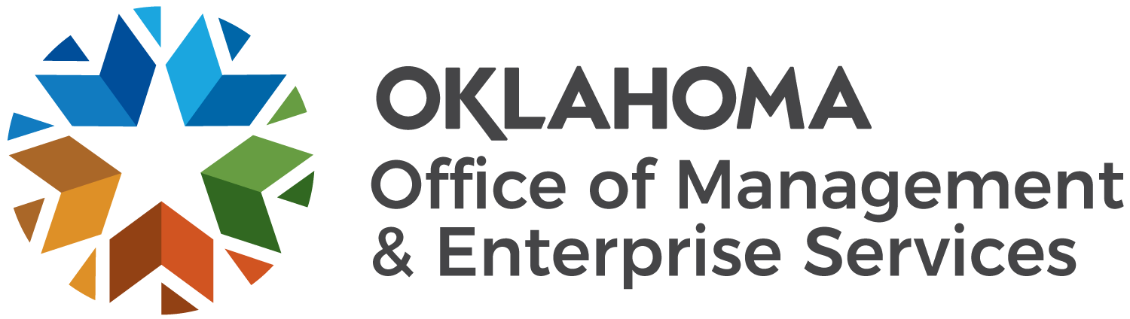 |  | Amendment of Solicitation

Date of Issuance: |  |  | 10/12/2022 |  |  | Solicitation No. |  |  |  |  |  |  | 8070001412
Requisition No. |  |  | 8070001412 |  |  | Amendment No. |  |  |  |  |  |  |  | 4
Hour and date specified for receipt of offers is changed: |  |  |  |  |  |  | No |  |  | Yes, to: |  |  |  |  |  |  |  |  |  | CST
Pursuant to OAC 260:115-7-30(d), this document shall serve as official notice of amendment to the solicitation identified above. Such notice is being provided to all suppliers to which the original solicitation was sent.
Suppliers submitting bids or quotations shall acknowledge receipt of this solicitation amendment prior to the hour and date specified in the solicitation as follows:
(1) Sign and return a copy of this amendment with the solicitation response being submitted; or,
(2) If the supplier has already submitted a response, this acknowledgement must be signed and returned prior to the solicitation deadline. All amendment acknowledgements submitted separately shall have the solicitation number and bid opening date in the subject line of the email.

ISSUED FROM:
 | Sheila Killingsworth |  |  |  |  |  |  |  |  |  | procurement@okhca.org
 | Contracting Officer |  |  |  |  |  |  |  |  |  |  | E-Mail Address
 | RETURN TO: | procurement@okhca.org
Description of Amendment:
 | a. This is to incorporate the following:
Updates to Solicitation 8070001412 include Amendment Four.

Addition is made to Bidder’s Library with the following attachments:
- 8070001412-A SoonerSelect Dental Solicitation Questions and Answers.pdf (Updated 10.12.2022)
- 8070001412-A SoonerSelect Dental Solicitation Questions and Answers.xlsx (Updated 10.12.2022)

b. All other terms and conditions remain unchanged.
Supplier Company Name (PRINT) |  |  |  | Date
Authorized Representative Name (PRINT) |  | Title |  | Authorized Representative Signature

