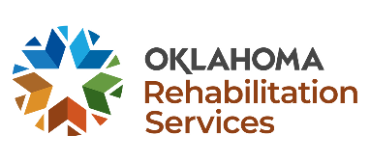
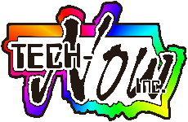
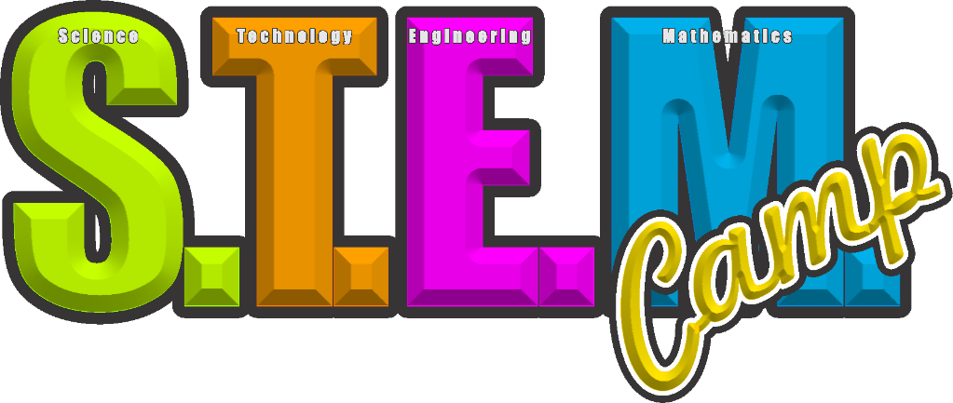
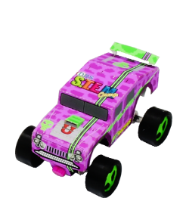
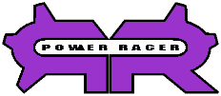
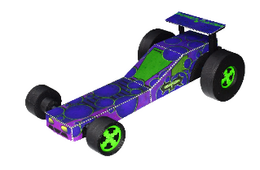
EAST TULSA
Who? Open to all Oklahoma students with disabilities, ages 14-19 (i.e., on an IEP, 504 Plan, or other documented physical, mental, or cognitive disabilities). Parents, guardians, and siblings are encouraged to support this learning experience by helping if needed, or wanted.
Tech-Now@hotmail.com
Contact - Renee Sansom Briscoe Email: RSansom@okdrs.gov

What: Learn to use computers, software, and related technologies to design and create:
Power Racer Dragster – Powered HT Racer – Full Color Patches for caps, jackets, and pants – Bracelet – T-Shirt – Mouse Pad – Pin Back Buttons – And More!

You will create all of this using a computer, printer, and related technologies! Most importantly, you will develop technology skills that will last a lifetime!

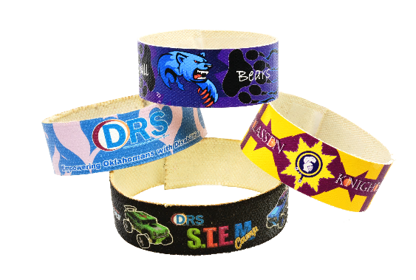
2022
Check Out STEM Camp Videos:

https://youtu.be/1fldqwdSzFI

https://youtu.be/-CNz3H3PLc4
Where?
Tulsa – Town and Country School;
8906 E 34th St, Tulsa, OK 74145

When?
JULY 6th – 8th, 2022
From 9am to 3pm

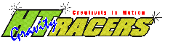
Register Now:

https://www.surveymonkey.com/r/HHR57BY

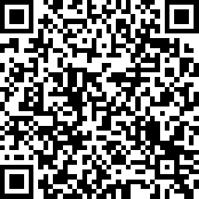

Listed below are the text descriptions of the poster images. The poster images all have Alt Text descriptions.

The DRS Logo
A five-sided star with colored chevrons around the sides, with each chevron made up of three shades of the colors dark blue, blue, green, red, and orange. The star is white and to the right side are the words Oklahoma Rehabilitation Services.
The STEM Camp LOGO.
The logo is comprised of a green S, an orange T, a magenta E, and a blue M, and the word camp in yellow letters at an angle across the right, bottom corner of the M.
The word technology in the color green.
The word design in the color orange.
The words product development in the color orange.
The word engineering in the color magenta.
A picture of four bracelets that are stacked upon one another. The bottom bracelet is black with DRS Stem Camp in the center with an image of a green HT Racer to the left and a blue racer to the right. Stacked on the left and right are two bracelets. A blue and pink heart covered bracelet with the DRS Logo, and a yellow and burgundy bracelet with a knight logo with the words Classen Knights.
The HT Racers Logo
The letters HT in neon green with the word Racers in bright yellow next to the HT. The word Gravity at a slight angle over the HT letters and in small letters along the top of the word Racers are the words Creativity In Motion.
An HT Racer Military Vehicle
A magenta-colored racer. Designed on the computer, printed, and assembled. The Racer is approximately 2.5 inches by 3.75 inches. It has the DRS, STEM Camp, and U Make This Stuff logos. The racer has a thin lime green double stripe that runs the length of the vehicle with a darker magenta alligator texture.

