

**PINNACLE PLAN MEASURES**

**MONTHLY SUMMARY REPORT**

**November 2024**

**PINNACLE PLAN MEASURES – MONTHLY SUMMARY REPORT – November 2024**

The Department of Human Services (DHS) is committed to improving the safety, permanency, and well-being of children served by the child welfare system. Public reporting is critical to ensuring transparency and accountability of the current performance on the measures included in the Pinnacle Plan. The OKDHS Metrics, Baselines, and Targets Agreement -3/7/13 outlines how the outcomes and other indicators are to be measured and reported. Monthly, Quarterly, and Semi-Annual Reports will be made published on the OKDHS Infonet and made available to the public.

Oklahoma is committed to good faith efforts and positive trending toward the goals outlined in the plan. Each monthly report will include four performance areas, comprised of ten specific metric elements. These are: Foster Care Safety, Counts for New Foster Homes and TFC homes, Worker Contacts, and Shelter Usage. The demographics of children served during the reporting period are included in monthly and semi-annual reports as context data. This information is provided to assist in understanding the population being served by the child welfare system.

Beginning with the August 2014 Monthly Report, there has been a decrease in the lag time to 30 days from the end of the reporting period to the time that the data is reported on Measure 2 – Resource Homes, Measure 3 – Frequency of Worker Contacts, and Measure 5 – Shelter Use. There will continue to be a 90-day lag time on Measure 1 – Foster Care Safety to allow time for the Program Review Process to be completed.

OKDHS was the first state agency to have a federally approved Statewide Automated Child Welfare Information System (KIDS System) and continually strives for high quality data. **The data in this report is subject to change due to ongoing data entry, changes in policy, changes in practice, and changes in definitions, and/or data quality issues that may be discovered through the process.**

If you have questions or feedback regarding the Pinnacle Plan, please email us at dhs.childwelfareplan@okdhs.org



1.1: Maltreatment in Care by Resource Caregivers

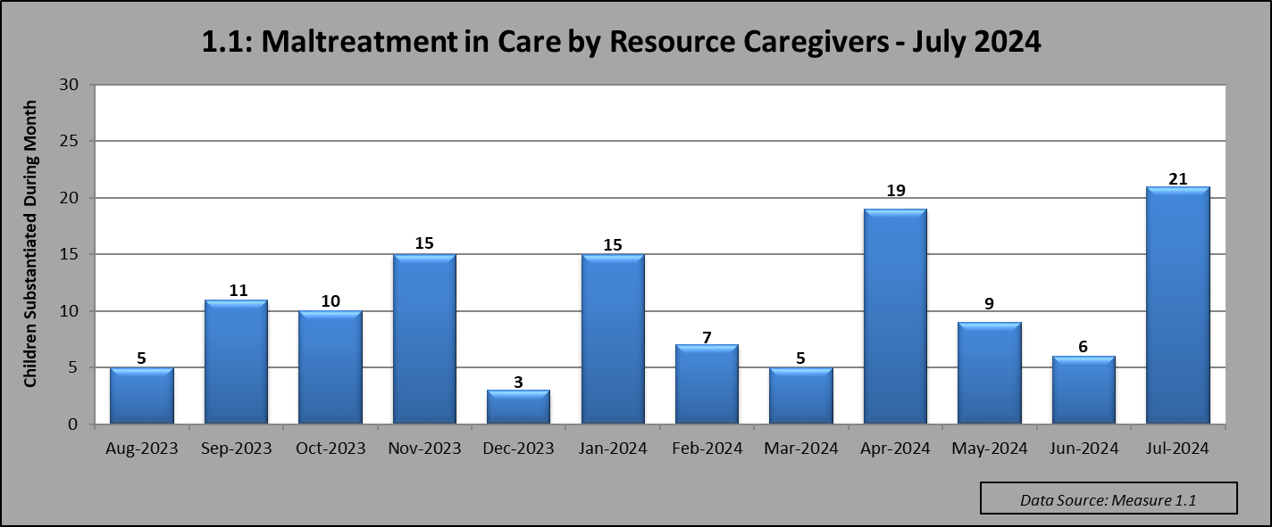

|  |
| --- |
| **Data:** The Maltreatment in Care Measure by Resource Caregiver incorporates a 90-day delay from the time the investigation is complete to the report date. This delay allows for further review which may result in changes in the findings. All substantiations on children in Out of Home Care will go through an automatic Program Review.  The data reported reflects substantiations in the month that the investigation was completed and not necessarily in the month that the abuse or neglect occurred. This measure includes all children placed in traditional foster care homes, kinship homes (relative or non-relative), therapeutic foster care homes, group homes, shelters, and residential facilities. This measure also includes children substantiated of maltreatment by the Office of Client Advocacy while placed in institutional settings. Every time a child is a substantiated as a victim, that child will be counted in the monthly reporting. Children who are victimized more than once will be counted in each month their victimization is substantiated. Note: This is different from the federal metric, which counts each child only once, even if a child is victimized more than once in the course of a year. |
| **Comments – November 2024:**  For the month of July 2024 there were a total of 21 substantiations of Maltreatment while in Out of Home Care. These victims were reported in 10 referrals for children in foster care and 0 referrals for children in OCA placements. Of the 21 children, 5 were placed in CW Foster Family Care, 5 were placed in CW Foster Family Care-Supported Home, 8 were placed in Kinship/Relative Foster Care, and 3 were placed in Kinship/Non-Relative Foster Care. Of the 21 substantiated victims in July 2024, 6 of the victims had a substantiated finding of threat of harm only. |

1.2: Maltreatment in Care by Parents  
  
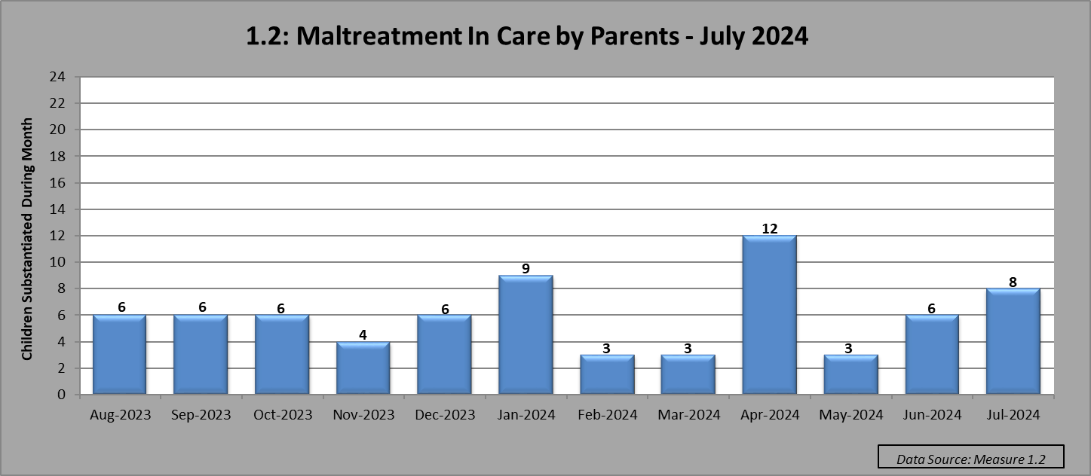

|  |
| --- |
| **Data:** The Maltreatment in Care by Parents measure incorporates a 90-day delay from the time the investigation is complete to the report date. This delay allows for further review which may result in changes in the findings. The data reflects substantiations in the month that the investigation was completed and not necessarily in the month that the abuse or neglect occurred.  Beginning with the November 2013 report, every time a child is a victim, that child will be counted. Children who are victimized more than once will be counted in each month their victimization is substantiated. Note: This is different from the federal metric, which counts each child only once, even if a child is victimized more than once in the course of a year. Also, children who are disclosing abuse that occurred prior to coming into DHS custody will not be included in the count of monthly victims. |
| **Comments – November 2024:**  For the month of July 2024, there were 8 substantiations of abuse by parents of children in out of home care. These 8 victims were reported in 5 referrals. Of the 8 children, 1 child was placed in Kinship/Relative Foster Care, 2 children were placed in Kinship-Non-Relative Foster Care, and 5 children were placed in Trial Reunification. Of the 8 substantiated victims in July 2024, five had a substantiated finding of threat of harm only. |
|

2.1: New Family Foster Care Homes  
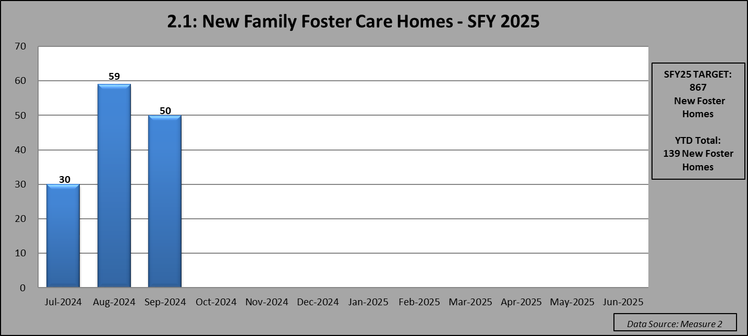



|  |
| --- |
| **Data:** Total Count of New Foster Homes includes all Foster Family Homes and Supported Foster Homes by month that they were opened using the agreed upon criteria. (This does not include Kinship or Tribal Homes.) The proposed target for SFY25 is 867 new foster homes. |
| **Comments – November 2024:** In September 2024, there were 50 foster homes opened that met the Pinnacle Plan criteria to be counted as new at the time of reporting. As of 9/30/24, there were a total of 139 new homes for SFY25. The Foster Family Care net gain as of 9/30/24 was -31 homes for SFY25. The proposed net gain target for SFY25 homes is 125. |

2.3: New Therapeutic Foster Care Homes   
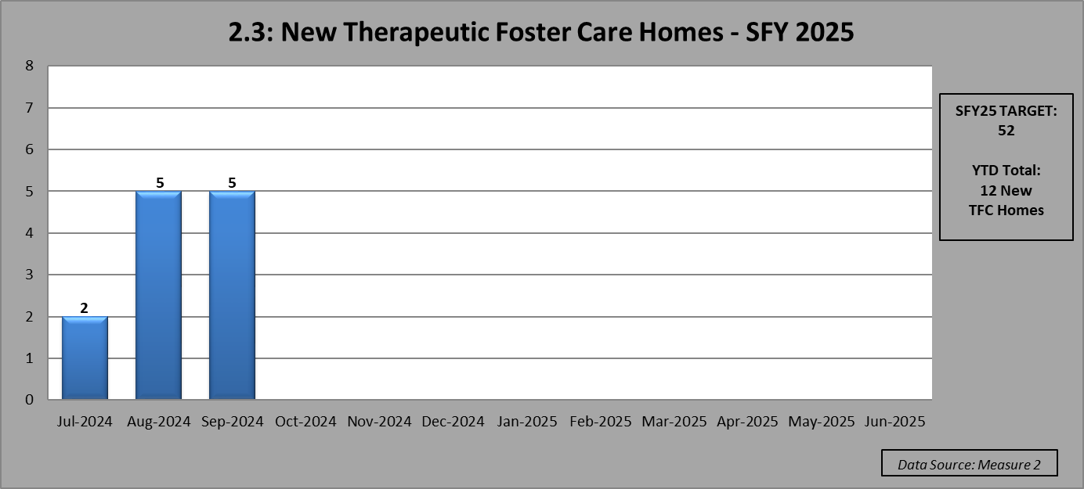



|  |
| --- |
| **Data:** Total Count of New Therapeutic Foster Homes includes all new TFC Homes, by month that they were opened using the agreed upon criteria. The proposed target for SFY25 is set at 52 new TFC Homes. |
| **Comments – November 2024:** In September 2024, there were 4 TFC homes opened and 1 ITFC home opened for a total of five new therapeutic homes during the month.  As of 9/30/24, there were a total of 12 new TFC and ITFC homes for SFY25.  The TFC net gain as of 9/30/24 was 5 homes for SFY25. The proposed Net Gain target for SFY25 homes is 28. |

3.1: Frequency of Worker Contacts  
 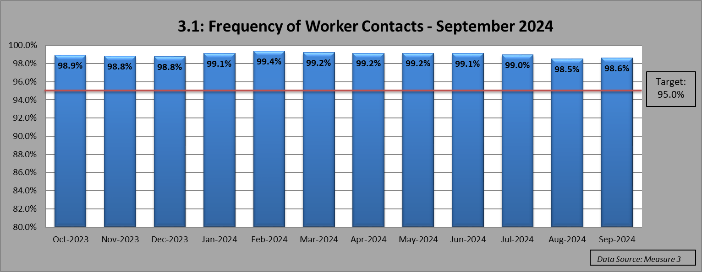

|  |
| --- |
| **Data:** The Data reflects the total number of required visits due to children in Out of Home Care and the number of total required visits made for a given month. Only one visit per month is counted even though multiple visits may have been made during the month. |
| **Comments – November 2024:** The visitation rate for all worker visits in September 2024 was 98.6%. |

3.2: Frequency of Primary Worker Contacts  
  
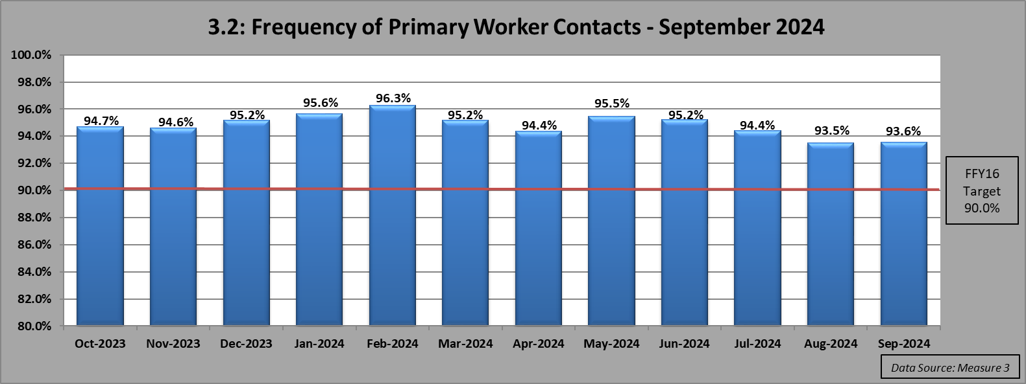

|  |
| --- |
| **Data:** TheData reflects the total number of required visits due to children in Out of Home Care and the number of total required visits made by the primary assigned worker for a given month. Only one visit per month by the primary worker is counted even though multiple visits may have been made by multiple workers during the month. Beginning in October 2015, the target for FFY16 is 90.0%. |
| **Comments – November 2024:** The worker visitation rate for primary workers in September 2024 was 93.6%. |

5.1: Shelter Use – Age 0-1 Years

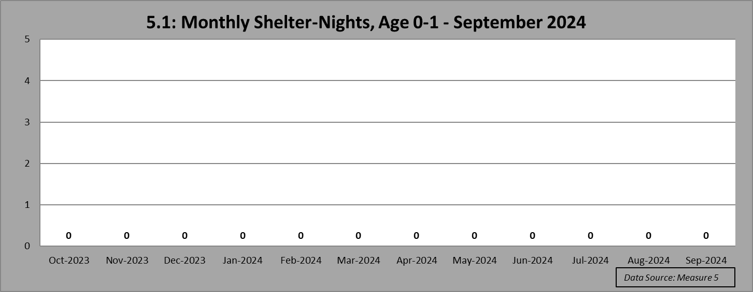

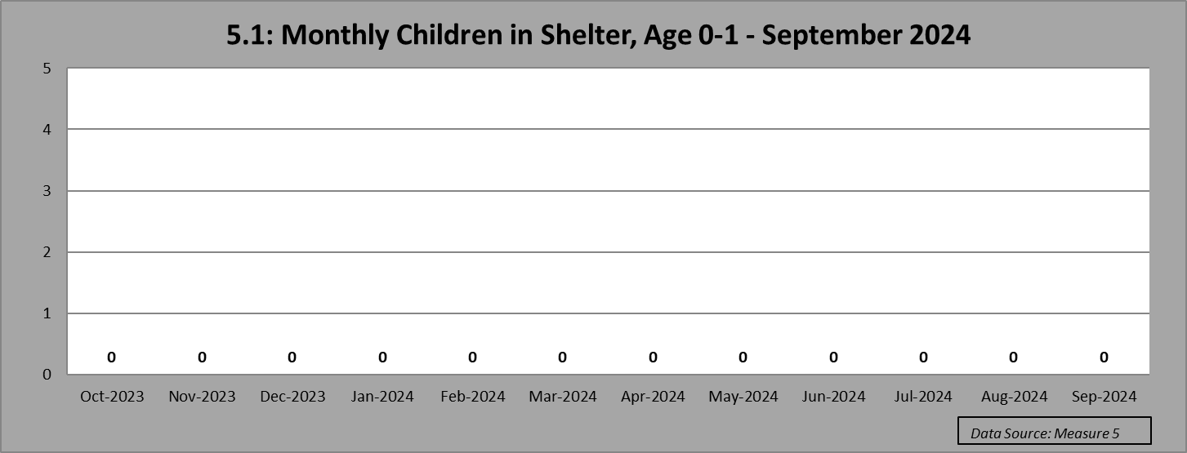

|  |
| --- |
| **Data**: Data shown for the number of children will count some children more than once if their shelter stay extended from one month into the next. This Pinnacle Plan Measure was implemented 12/31/12. Automatic exceptions will be made for children in the following circumstances: If the child is part of a sibling set of 4 or more or a child placed with a minor parent who is also in DHS custody. |
| **Comments – November 2024:** In September 2024, 0 children age 0-1 year spent a total of 0 nights in the shelter.  There were 1,224 children age 0-1 year in care in September 2024 and none of those children spent a night in the shelter (100% of children age 0-1 year). There were 87 children age 0-1 year removed during the month of September and none of the children had a shelter stay (100% of children in care age 0-1 year). |

5.2: Shelter Use – Age 2-5 Year

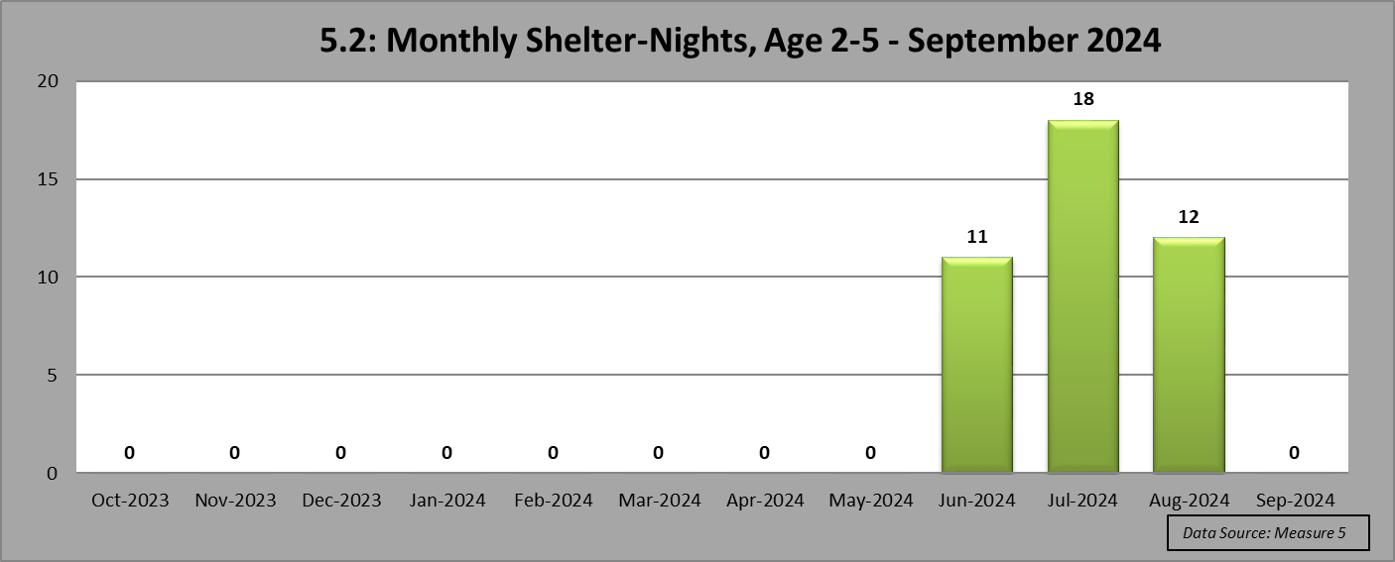

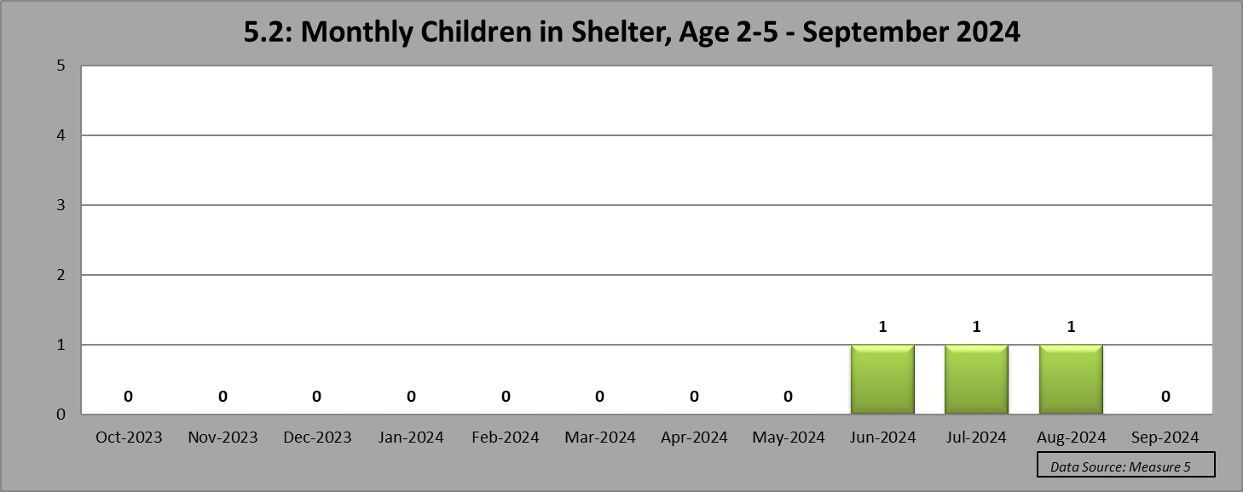

|  |
| --- |
| **Data:** Data shown for the number of children will count some children more than once if their shelter stay extended from one month into the next. The Pinnacle Plan commitment to stop the use of shelters for children age 2-5 years was implemented on 7/1/13. |
| **Comments – November 2024:** In September 2024, 0 children age 2-5 years spent a total of 0 nights in the shelter.  There were 1,706 children age 2-5 years in care in September 2024 and 1,706 of those children did not spend a night in the shelter (100% of children age 2-5 years). There were 88 children age 2-5 years removed during the month of September and 88 of those children did not have a shelter stay (100% of children in care age 2-5 years). |

5.3: Shelter Use – Age 6-12 Years

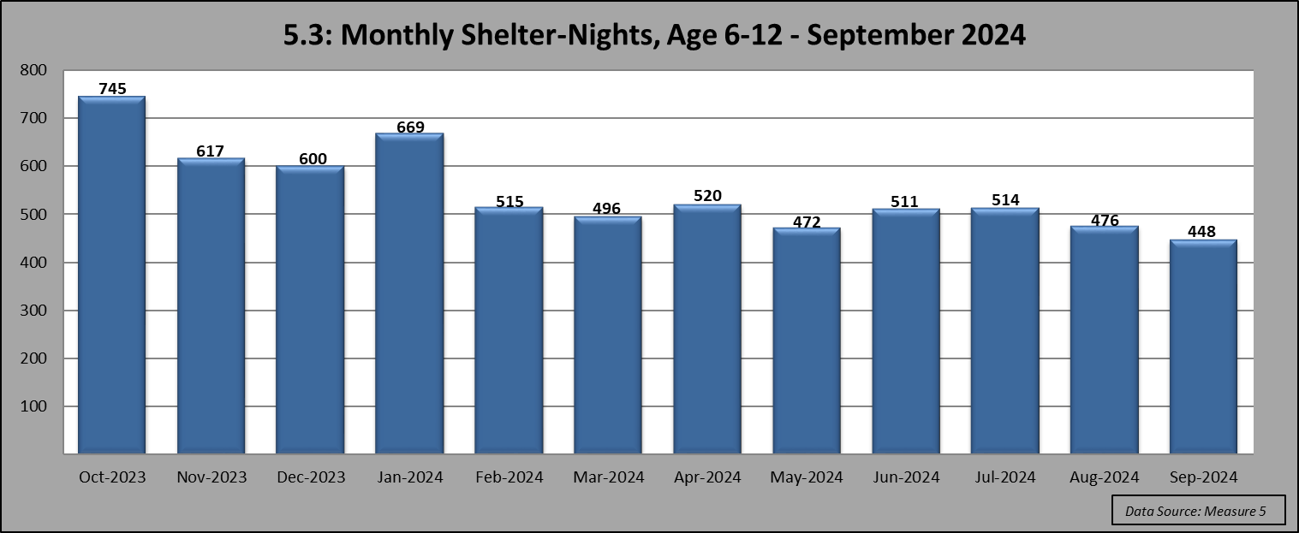

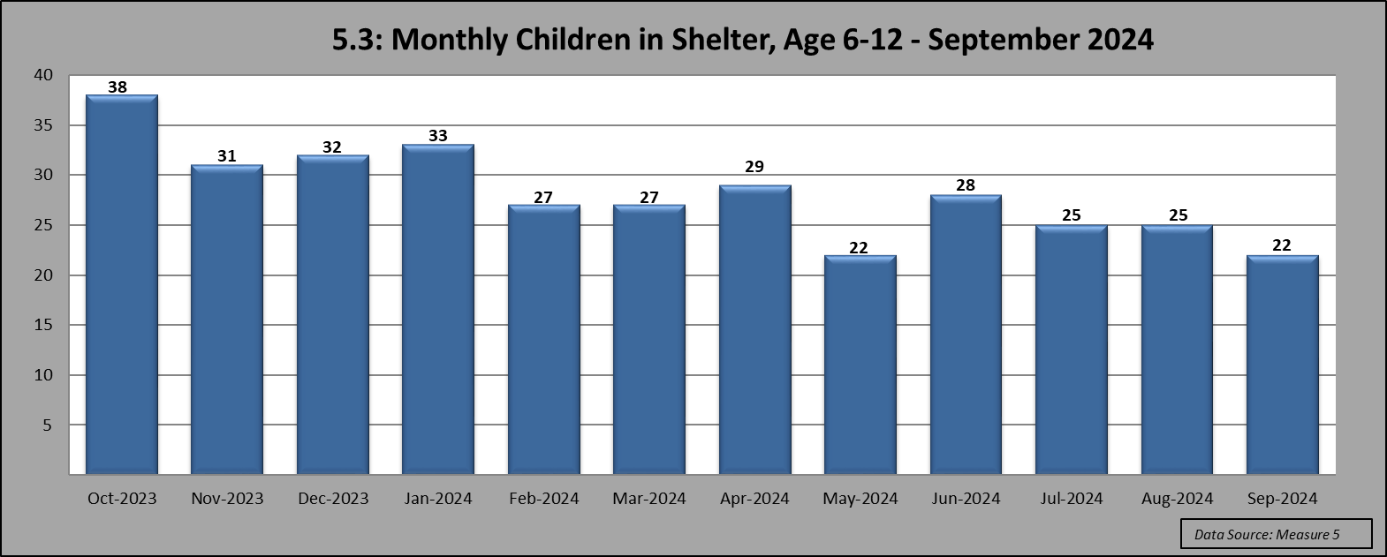

|  |
| --- |
| **Data:** Data shown for the number of children will count some children more than once if their shelter stay extended from one month into the next. The Pinnacle Plan commitment to stop the use of shelters for children age 6-12 years was fully implemented by 1/1/15. |
| **Comments – November 2024:** In September 2024, 22 children age 6-12 years spent a total of 448 nights in the shelter. There were 1,938 children age 6-12 years in care in September 2024 and 1,916 of those did not spend a night in the shelter (98.9% of children age 6-12 years).  There were 104 children age 6-12 years removed during the month of September and 103 of those children did not have a shelter stay (99.0% of children in care age 6-12 years). |

5.4: Shelter Use – Age 13 Years and Older

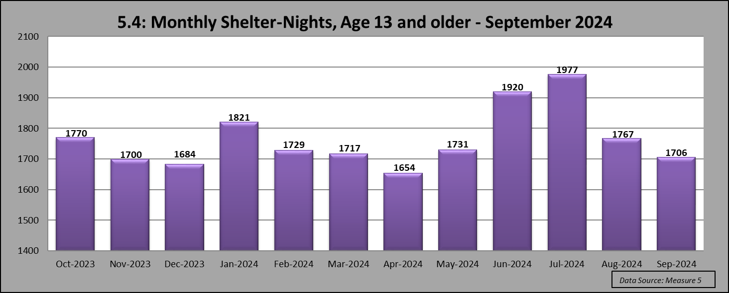

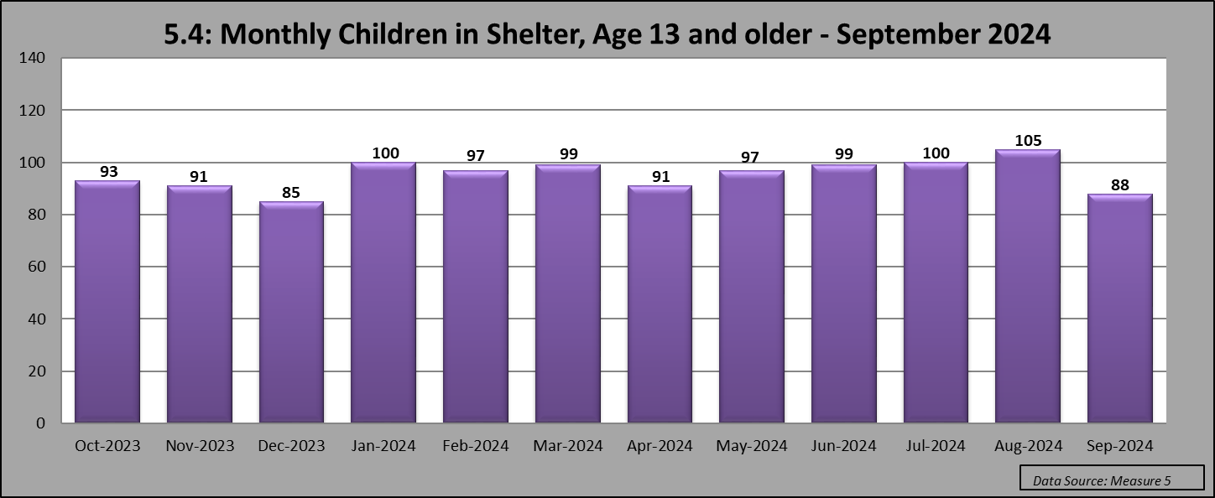

|  |
| --- |
| **Data:** Data shown for the number of children will count some children more than once if their shelter stay extended from one month into the next. |
| **Comments – November 2024:** In September 2024, 88 children age 13 and older spent a total of 1,706 nights in the shelter. There were 1,240 children age 13-18 years in care in September 2024.  Of those, 1,152 children did not spend a night in the shelter (92.9% of children in care age 13-18 years).  There were 44 children age 13-18 years removed during the month of September and 39 of these children did not have a shelter stay (88.6% of children in care age 13-18 years). |

7.1 Worker Caseloads

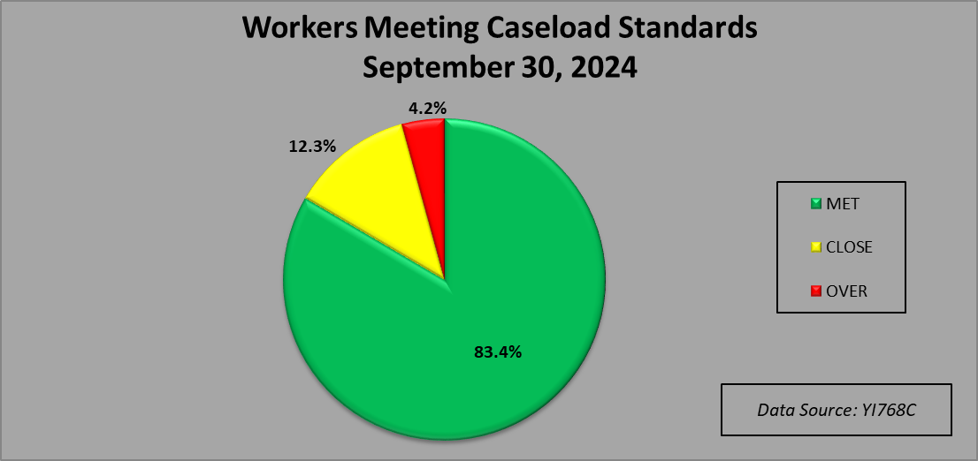



|  |
| --- |
| **Data:** Utilizing the standards set forth in the Pinnacle Plan, each individual type of case is assigned a weight and then the weights are added up in order to determine a worker’s caseload. The consolidated workload tracking process allows Oklahoma to factor in the worker’s “Workload Capacity.” A snapshot is taken every morning at 12:00 am of the workload of all Child Welfare workers. The entire workload of workers with a qualifying assignment to a case (CPS, PP, FCS, Adoption, and Resource) are calculated and compared against the caseload standards. The workload is classified as meeting standards if it is 100% or below a caseload. If the workload is over 100% but less than 120% of a caseload, it is considered to be “over but close”; otherwise the workload is considered to be over the standard. The measure tracks each worker - each day to determine if they meet the standard, and this is called a “worker day”. Work performed by Child Welfare Specialists, is broken into multiple categories. This measure will look specifically at Permanency Planning, Preventive/Voluntary, Investigation, Adoption, Resource Family Specialist, Recruitment, and Adoption Transition Unit Workers. For reporting purposes, the Quarterly totals will be included, as well as a point in time percentage of the number of workers “meeting,” “close,” and “over” workload standards on the last day of the reporting period. |
| **Comments – October 2024:** As of 9/30/24, using the point in time YI768C Workload data report, the percentage of Child Welfare Workers meeting the standard is 83.4%, with 12.3% being “Close”, and 4.2% being “Over Standard”. Of the 1,178 workers, 983 workers were meeting workload standards, 145 workers were close, and 50 workers were over the standard. For the period of July 1, 2024 – September 30, 2024, the quarterly data shows that the percentage of Child Welfare Workers “Met” the standard is 90.3%, with 7.8% being “Close,” and 2.0% “Over Standard.” |

7.1 Supervisor Caseloads

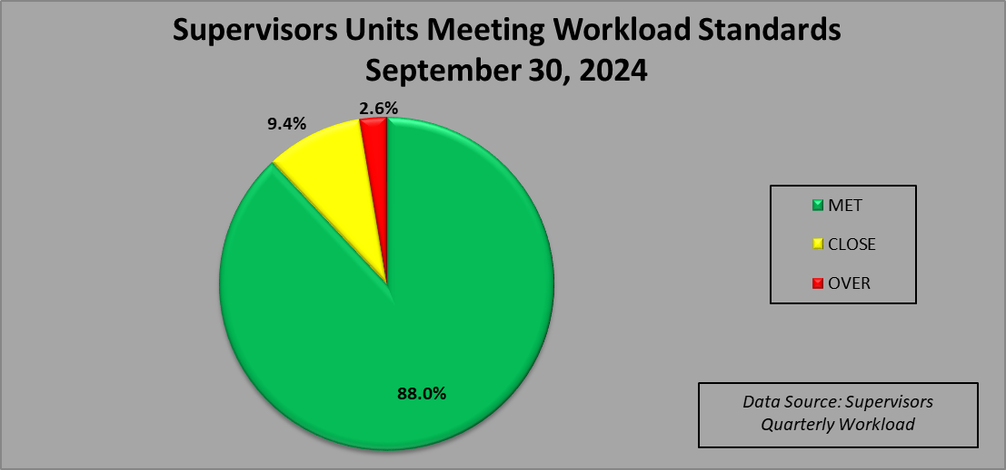

|  |
| --- |
| **Data:** This measure looks at Supervisor Units in regards to the worker standard per unit. There are two parts to determine if a supervisor unit meets the standard. First, the measure looks at the number of Child Welfare Workers each supervisor is currently supervising in their unit. The target is for each unit to have a ratio of 5 Child Welfare Workers to 1 Supervisor. If a Unit has a ratio of 5:1 or less, they are considered to meet the standard. Units are “Close” if they are 1-20% over with a ratio of 6:1. All Units with a ratio of 7:1 or over are considered “Over”. Each worker accounts for 0.2% of a supervisor’s workload capacity. Secondly, the measure looks at any of those supervisors who are currently supervising caseload carrying workers and also have primary assignments on their own workload. Because these workload assignments deduct from a supervisor’s capacity to supervise their workers, this additional caseload must be factored into the measurement. Initially a supervisor was allowed to carry up to two case assignments, and those case assignments would not be calculated into the total workload.  Any additional assignments on a supervisor's caseload would then be calculated at the same case type weight as on the worker's caseload and then combined with the supervisor capacity, which includes the number of workers supervised.  Beginning with the reporting period ending December 2019, supervisors were no longer allotted the one or two assignments that did not add to the overall workload total.  All assigned, countable work is now calculated into the supervisor’s workload.  With this combined calculation of the supervisor’s workload capacity, it is then determined how many of these supervisor units are meeting the workload standard. This information is based on KIDS ORG data and HRMD Data and is point in time as of the last date of the reporting period. |
| **Comments – October 2024:** As of 9/30/24, the total number of Child Welfare Supervisor Units “Meeting the Standard” is 88.0%, with 9.4% being “Close,” and 2.6% “Over Standard.” There are 350 supervisor units with 308 units meeting the standard, 33 units close and 9 units over the standard. |

Context Data



