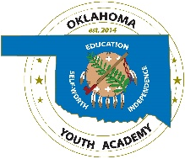 | State of Oklahoma  OKLAHOMA YOUTH ACADEMY CHARTER SCHOOL

Office of Juvenile Affairs Board

Oklahoma Youth Academy Charter School (OYACS) Learning Plan and Return to Learn Plan
Academics: OYACS provides education through a blended model. We will continue to provide education through an online learning management system with instructors in each classroom to provide instruction and assistance.
Masks/Face Coverings: In line with SB 658, masks will not be required unless state or federal officials advise that a mandate is necessary AND a state of emergency is declared by the governor.
Schedule: OYACS will be in session 5 days a week. Virtual school will be provided if necessary due to exposure and widespread illnesses.
Quarantines and Isolations: OYASC will comply and follow the recommendations of the CDC and any input from our medical staff.
Illness/Sickness: Students that are experiencing any symptoms of illness will be evaluated by our medical team and we will follow the recommendations.
Preventions Strategies: Disinfect working stations and classrooms, frequent washing and sanitizing of hands and proper covering of coughs and sneezes.
Physical Distancing: OYACS will make every effort to distance students and staff as much as possible.

