Office of Juvenile Affairs
Local Strategic Plan/Community Action with Targeted Solutions Plan
2022 Application for Community Based Youth Services Funding
Due Date:
It is recommended agencies participate in a virtual Pre-bid conference on March 17, 2021 from 1-2:30 PM at https://zoom.us/j/93408720916 . Recording of the event will be posted with the application details on the OJA website following the event.
Questions for the Pre Bid Conference must be submitted to cbys@oja.ok.gov by midnight March 13, 2021.

Application Due Date: April 9, 2021 at midnight.
Email applications to: cbys@oja.ok.gov

The Office of Juvenile Affairs (OJA) mission states that “[OJA] along with its community partners provide prevention, education, and treatment services for at-risk youth throughout Oklahoma. This joint effort creates a statewide system that supports and encourages young people to achieve their full potential." To this end, OJA provides state funds to Youth Servicing Agencies (OAYS) for prevention and diversion service provision to at-risk youth on an annual basis. To ensure that the application of these funds is data-driven and community-informed, catchment areas are required to complete regular needs assessments of the catchment areas they aim to serve. The Community Action with Targeted Solutions (CATS) process provides a method for completing this assessment.

CATS Project Goals
- Increase partnership.
- Explore and apply data.
- Prioritize needs.
- Implement targeted interventions.
- Evaluate outcomes.
- Promote community ownership.

This Request for Application (RFA) will serve as a local strategic plan. Quarterly reporting to the Office of Juvenile Affairs will be used to document progress made on the ongoing needs assessment process that is required for each catchment area and should reflect service needs and interventions for the entire catchment area. For greater understanding and assistance on the needs assessment process, access the CATS Manual at https://oklahoma.gov/oja.html . Quarterly Reports and Continuation proposal may be found as a separate file and noted as Appendices 1-5. Priority funding for the SFY 2022 contract period will be given to agencies who demonstrate the willingness and capability to implement the CATS process throughout their catchment area as evidenced by the submission of a plan that demonstrates the following competencies: 1) Understanding of culture (s) within the catchment area; 2) Engaging stakeholders and community members in the exploration of risk and protective factors, while simultaneously listening to the needs perceived by the community and stakeholder members; 3) Utilizing data combined with feedback from the community and stakeholders to establish priorities and target interventions; 4) Establish baseline data and plan for tracking outcomes; and 5) Creating an action plan with outcomes and a thorough description on how programmatic impact will be measured. Funding for Years II and III will be based on the ongoing quarterly reporting and annual updates to the Year I CATS plan.
OJA recognizes every agency is at a different place in their readiness for the assessment process. The level of readiness does not determine eligibility for funding. The willingness and ongoing effort to implement the CATS planning process (responding to the demonstrated needs and gaps in services throughout the catchment area) will be considered and used to determine the ability for agencies to respond to their community needs.
Table of Contents
Section 1: CATS Planning

Exploring Readiness | Pages 4
Planning Team | Pages 8
Timeline | Pages 10
Self-Reflection on Local Needs Assessment Process | Pages 13
Section 2: Listenting to Catchment Area Consumers and Stakeholders
Stakeholder and Consumer Input | Page 15
Community Risk and Protective Factors | Page 16
Section 3: Data Driven Priorities
Data Mapping Tool | Page 18
Missing Voices | Page 19
Consider the Root Needs | Page 20
Section 4: Planning and Service Delivery
Strategy Formulation Tool | Page 21
Section 5: Action Plan with Outcomes
Strategic Planning for Identified Community Need and Identified Service Delivery | Page 26
Section 6: Ongoing Partnership and Implementation
Commitment to Ongoing Partnership | Page 28
Tracking and Reporting on Outcomes and Impact | Page 28
Plan to Capture gaps and needs for future efforts | Page 28
Quarterly Reporting and Due Dates | Page 28
Updated CATS plan for Renewal of Contract | Page 28
Additional Documents to Submit with application | Page 28
Appendices
1 Quarter 1 Report
2 Quarter II Report
3 Quarter III Report
4 Quarter IV Report
5 Year II and III Strategic Plan Updates
6 Commitment to Implement the CATS Process (Needs Assessment Process)
7 Permission for Oklahoma Association of Youth Services to Negotiate on Behalf of Applicant Agency
8 Proposed Budget (Excel)
9 Supplier Contract Certification

Community Action with Targeted Solutions Strategic Plan

Date of Completion:

Youth Service Agency:

Executive Director:

Local Assessment Coordinator:

Section 1: CATS Planning
Exploring Readiness
Geographic Area (Include Counties, Major Towns/Cities, and School Districts in Your Catchment Area):
1. | 18.
2. | 19.
3. | 20.
4. | 21.
5. | 22.
6. | 23.
7. | 24.
8. | 25.
9. | 26.
10. | 27.
11. | 28.
12. | 29.
13. | 30.
14. | 31.
15. | 32.
16. | 33.
17. | 34.
If additional space is needed, you may attach the continuation to your application as a separate document titled, Attachment A: Geographic Area Continued.

Geography and Demographics
- Describe the urban versus rural makeup of the catchment area.

- Are services currently reaching all parts of the catchment area equitably?

- Sources Used to Determine Equitable Service Delivery:

- Funding sources used to ensure equitable service provision (e.g. CBYS funding, Medicaid, United Way, etc.).

- How feasible is it for the full catchment area to come together (in person or virtually), as part of the assessment process, planning for services needed, and in supporting service delivery?

- Describe any barriers and a plan to overcome those barriers.

- Describe unique demographic and geographic components of the area that need to be considered in assessing need and planning for service delivery (e.g., highly remote areas, digital deserts, tribal lands).

Community Relationships and Collaboration
- List current strategies under way to listen, build relationships, and collaborate with core stakeholders. Include the staff leading this connection/relationship.

  - Youth and families

  - Courts and law enforcement

  - Community leadership

  - Providers and placements

  - Schools

  - Juvenile service unit(s) staff

  - Cultural and faith partners

  - Other government agencies (e.g., public health, workforce development)

  - Business community

  - Other

- How would you describe the relationship (e.g., awareness, partnership, level of trust) between your agency and the catchment area?

- Does the community have existing community collaborations, such as taskforces, provider meetings, interdisciplinary teams, etc.? What is your agency’s involvement in these boards?

- What are the strengths that exist in your agency’s relationships with stakeholders?

- List one to three goals for increasing connection with the community. Goals could include formation of a stakeholder group, a desired partnership, or other ways of connecting.

Goal 1
Goal 2
Goal 3

- What might get in the way of developing a community-informed assessment and/or engaging the catchment area (e.g., distance, directed health measures, interpersonal/interagency dynamics, and current or past events/community trauma)?

Data
- How does your agency currently monitor youth/family need, service outputs, and youth/family outcomes?

- Describe your agency’s level of comfort with gathering, analyzing, and using data to decide what services are needed and tracking data.

- What assistance, if any, is needed in gathering and reviewing data?

Facilitation of the Process
- How comfortable is your agency with assessment processes?

- What makes your agency most apprehensive about this process?

- Where could you access assistance to feel more comfortable with the noted areas of apprehension (e.g., internal staff, community champion or partner, OAYS, OJA, peer agency, external facilitator, other)?

- If you are feeling little or no apprehension with the needs assessment process because you have a strong foundation, would you be willing and able to assist other youth service agencies with the needs assessment process?

Planning Team for Local Assessment
While YSAs are essentially responsible for the completion of their CATS plan, identifying the appropriate staff and partners to lead the effort is an important consideration. The planning team handles all logistics, facilitation, communication, and compilation of the plan. When selecting your team’s members, consider individuals with the following characteristics:
- Access and comfort with data at the local and state levels
- Staff with existing relationships to community stakeholders
- Community champions or gatekeepers who can serve as liaisons and experts in the community
- Detail-oriented individuals with expertise in project planning
- Facilitation staff to lead community conversations. This may require multiple staff to reach the diverse communities within your catchment area. It is critical your team reflects on the diversity of the communities served.
This team should meet regularly throughout the planning process to develop the timeline and event materials, review data, and modify the planning process as needed.

- Does your agency currently have a team to lead the local assessment process? Yes No

Use this application process to describe your plans to engage a planning team and set up a timeline for meeting. Any adjustments to by-laws or current procedures may be described as action steps. Agencies will have the opportunity to update and adjust timelines as part of the quarterly reporting process.

- In the table below, list the positions identified as planning team members or potential members and the status of their participating. If your agency is still in the midst of recruiting, please include the status of their recruitment and a brief description of how participation will be pursued. Use this table to identify the strength that this person will bring to the team (e.g. experience, organized, special experience, stakeholder in continuum, lived experience, engaged with community, etc.).
CATS Planning Team

Agency Coordinator
Role/Position | Status of Participation (Click Form Field to Select Active or Pending) | Plan to Engage Partner | Strength to Planning Team
Champion
Lived Experience
Stakeholder
Implementation Leader
Existing Coalition Leader
Community Member
Other
Other
**Remember to recruit from various points in the continuum of services and levels of influence. Also consider the racial, ethnic, and geographical make-up of the area. If you have a large area, include individuals from across the area. Be mindful of representing urban and rural voices.

CATS Plan Timeline
- This timeline is for a standard needs assessment process. It contains some of the most common steps. It will need to be individualized to your catchment area. You may add steps and dates for your catchment area’s unique plan and attach to your application. Remember, your plan may change along the way, so revisit the timeline regularly. You will report progress on your timeline quarterly. When determining due dates, consider the requirement to have a finalized plan with updated assessment information for the second year of funding (See Appendix V: CATS Plan Year II).
Step 1: Preparation
Step | When (Month &/or Quarter) | Progress
Convene planning team. | Quarter I (July-September)
Complete Readiness Questionnaire. | SFY 2022 Year I Application
Identify and get commitment of facilitator(s).
Identify and brief essential partners.
Identify communication strategies.
Inform the catchment area of the process.
Step 2: Listening
Step | When (Month &/or Quarter) | Progress
Map out stakeholder groups and communication strategies.
Create listening materials (e.g., survey, focus group questions, meeting, and agendas).
Hold focus groups, surveys, listening sessions, etc.
Compile results of meetings into themes.
Reach out to missing voices.
Step 3: Exploring Data and Identifying Priorities
Step | When (Month &/or Quarter) | Progress
Identify data needs based on themes from Step 2 themes.
Collect data from appropriate sources.
Lay out data into understandable format for the catchment area.
Invite stakeholders to data discussions.
Hold data discussions.
Compile stakeholder data discussion into themes from Step 2.
Prioritize needs.
Step 4: Planning
Step | When | Progress
Identify possible services or strategies for meeting the need.
Share priorities and possible service strategies with stakeholders.
Coordinate stakeholder meeting logistics.
Engage stakeholders in service delivery plan.
Compile action plan into the assessment and Submit to OJA for Year II funding. | Due June 15, 2022

Self -Reflection on Existing Local Needs Assessment Process
- Using the decision tree on page 13 of the CATS manual (see below) and the answers to your questions on pages 4-9, discuss your agencies current assessment process and steps needed to fully implement the CATS Assessment model. Use the CATS Manual to assist with your self-evaluation and response. This is a critical component of your local strategic plan and will be prioritized for funding.
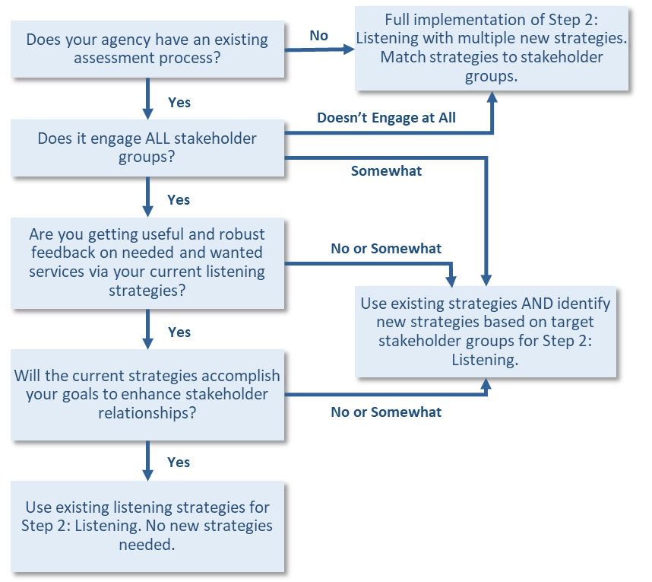
4. Continued

Section 2: Listening to Catchment Area Consumers and Stakeholders
Stakeholder and Consumer Input
- Stakeholder input in the assessment process is required. In the table below, place an X next to the stakeholders you currently engage and a P next to the stakeholders you plan to engage and strengthen a partnership with during SFY 2022. As a reminder you must have input from stakeholders throughout the juvenile justice continuum.

- Stakeholder and Community Feedback

Providers |  | Juvenile Justice Continuum  (Staff and Leaders) |  | Consumers |  | Community Leaders, Public/Private, Other
Child Welfare |  | Judges |  | Youth Groups (including those with lived experience) |  | Schools
Homeless/Housing |  | Prosecutors |  | Family Members |  | Community Colleges
Basic Needs |  | Counsel for children and youth |  | Community/Victims |  | Health Department
Domestic Violence |  | Intake Officers |  | Parent Groups |  | Health Professionals
Mental Health/Substance Abuse |  | Probation Workers |  | Self-Help Groups |  | HUD
Health Care |  | Law Enforcement |  | Caregivers/Parents (including those with lived experience) |  | Disability Services
Alternative Schools |  | Diversion |  |  |  | Housing Advocates
 |  | Court |  |  |  | Business Owners
 |  | In-Home Services |  |  |  | Hospitals/Urgent Care
 |  | Re-entry Workers |  |  |  | Mayor
 |  | Youth Offender (YO) Workers |  |  |  | Legislators
 |  | Diversion Programs |  |  |  | City Council
 |  | Court |  |  |  | Cultural Community  Leaders
 |  | Congregate Care (Secure and Non-Secure Providers) |  |  |  | School Board
 |  | School Resource Officers |  |  |  | Community Planners and Developers
 |  | Alternative Schools |  |  |  | Clergy/Faith Based
 |  |  |  |  |  | Youth Employers
 |  |  |  |  |  | Youth Sports, Clubs, Recreation
 |  |  |  |  |  | Rotary Clubs

Community Risk and Protective Factors
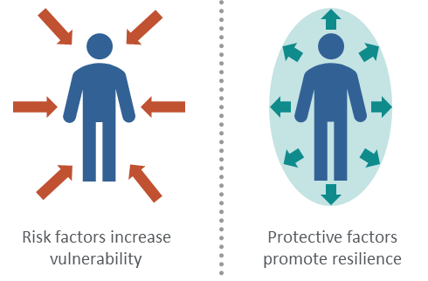
Risk and protective factors provide the philosophic framework for many youth assessments because they provide a comprehensive look at personal and environmental components that increase a youth’s vulnerability to negative outcomes and insulate them from these influences. This approach to assessment is based on the premise that to prevent a problem, the factors that predict or contribute to the development of that problem must be identified and addressed. Another way of putting it is our preventions and interventions should aim to reduce risk factors and increase protective factors in the youth and their environment. The CATS process uses the framework to align with best practice and common youth assessments, as well as promote strengths and action.

- Describe the risk factors identified in your community that your proposed interventions (protective factors) will target. Provide details on how these risks were identified and the protective factors that will be used in the intervention you are proposing. Cite sources of data that support the identified need.

Section 3: Data Driven Priorities

Gathering Data
Much of the work for this step occurs prior to the community conversations, as you do your “homework” to gather data related to the concerns raised during your listening to the community and stakeholders. Use the Data Mapping tool in the CATS manual to identify data needs, sources, and strategies for acquiring those data. The following fictional example demonstrates how to complete this tool. You’ll notice that the tool determines strategies for using statistical data and additional perspectives that can add greater insight. This tool also provides space to list stakeholders yet to be involved.

EXAMPLE: Data Mapping
Data Mapping
Catchment Area: _________________________________ Date:_____________________
Indicator Data Sources
Theme | Indicator | Source | How can we access it? | Context/Notes
School | School referrals to law enforcement | School district | Contact Superintendent  Mr. Smith – (123) 456-7890/jsmith@abcschool.org | School has an SRO that works with all truancy cases across the district. Talk to him.
 | Arrest data | OJA | Contact OJA | Look at time of arrests. Are they during school hours?
 | Suspensions/  expulsions | School district | Contact Superintendent  Mr. Smith – (123) 456-7890/jsmith@abcschool.org
Pro-Social Activities | Peer support groups | Our Town Youth Group | Jenny Smith, program coordinator, (123) 456-7890 | Afterschool and leadership programs, might know what youth want

Data Mapping Tool: Utilize the data mapping tool for each geographic area in your catchment area. This process will need to occur in your timeline as you assess the year I interventions. Use the table below to capture data you have used to identify your areas of focus for the Year I contract period.

Location: Date
Indicators and Sources
Risk or Protective Factor | Indicator | Source | How can we access it? | Context/Notes
Missing Voices
Name/Group | Perspective/Affiliation | Contact Information | Notes

Consider the Root Needs
As you explore the data the discussion should focus on what might be contributing to the data you see because that will uncover the true need. Then, you can decide which services are best suited to address those needs. This is also an opportunity to identify and address racial, ethnic, geographical, or gender disparities by considering the demographics within your other measures. For more information on data collection and data sources, go to Page 31 of the CATS Manual.

- Using the tables on pages 27-29 of the CATS Manual, describe what needs emerge as you examine the data and what possible factors are contributing to delinquency within your communities? Your mapping tools should support this response.

Section 4: Planning / Service Delivery Plan
Your service delivery plan will have the following components:
- Prioritized Needs
- Services, Partnerships, and Process Changes to Address Prioritized Needs.
- Outcome Indicators and Methods for Tracking and Measuring Outcomes of Supported Items.
- Action plan for Service Implementation

Planning for Service Delivery to Meet Identified Community Needs

Table I is a Strategy Formulation Tool this will be used to help you fill out Table II, which is your service delivery plan. In Table II, you will identify each prioritized risk factor, the services identified to meet the need, the location in the catchment area to be served with the identified service, and the Goals and Outcomes to be tracked. You must include baseline data for each outcome in each catchment area.

Table I: Strategy Formulation Tool
Goal Statement 1:
Priority/Topic/Impact Area:
Prepared by:

Objective  Specific, measurable, action oriented,  realistic, time limited  (Be thoughtful about how to reach the objective.) | Owner/  Responsible Person | Schedule |  | Who Else to Involve if Needed? | Support and Resources Needed | Indicators to Track and  Outcome Measure(s) | Baseline Data
 |  | Start  Date | End  Date

Goal Statement 2:
Priority/Topic/Impact Area:
Prepared by:

Objective  Specific, measurable, action oriented,  realistic, time limited  (Be thoughtful about how to reach the objective.) | Owner/  Responsible Person | Schedule |  | Who Else to Involve if Needed? | Support and Resources Needed | Indicators to Track and  Outcome Measure(s) | Baseline Data
 |  | Start  Date | End  Date

Goal Statement 3:
Priority/Topic/Impact Area:
Prepared by:

Objective  Specific, measurable, action oriented,  realistic, time limited  (Be thoughtful about how to reach the objective.) | Owner/  Responsible Person | Schedule |  | Who Else to Involve if Needed? | Support and Resources Needed | Indicators to Track and  Outcome Measure(s) | Baseline Data
 |  | Start  Date | End  Date

Goal Statement 4:
Priority/Topic/Impact Area:
Prepared by:

Objective  Specific, measurable, action oriented,  realistic, time limited  (Be thoughtful about how to reach the objective.) | Owner/  Responsible Person | Schedule |  | Who Else to Involve if Needed? | Support and Resources Needed | Indicators to Track and  Outcome Measure(s) | Baseline Data
 |  | Start  Date | End  Date

Goal Statement 5:
Priority/Topic/Impact Area:
Prepared by:

Objective  Specific, measurable, action oriented,  realistic, time limited  (Be thoughtful about how to reach the objective.) | Owner/  Responsible Person | Schedule |  | Who Else to Involve if Needed? | Support and Resources Needed | Indicators to Track and  Outcome Measure(s) | Baseline Data
 |  | Start  Date | End  Date

Table II: Strategic Planning for Identified Community Need and Identified Service Delivery
Identified Community Need  (Risk Factors/Priorities) | Program(s)/Service(s) to Meet the Identified Need  (Indicate Protective Factor to be Implemented) | Location(s) in the Community to be Served | Goals and Outcomes of the Identified  Community Need (List Baseline Data for each Outcome)

Identified Community Need  (Risk Factors/Priorities) | Program(s)/Service(s) to Meet the Identified Need  (Indicate Protective Factor to be Implemented) | Location(s) in the Community to be Served | Goals and Outcomes of the Identified  Community Need (List Baseline Data for each Outcome)
Table II Continued

Section 6: Ongoing Partnership and Implementation
This strategic plan is fluid and may be modified as you identify service gaps and needs for future efforts. Maintaining and establishing new partnerships will strengthen this process and ensure your community and stakeholders have a voice and are at the table. You will provide quarterly updates to OJA by the due dates noted in Table III below. The CATS plan update for SFY 2022 funding will be due on June 15, 2022 and must include eleven months of data and progress. As you strengthen the needs assessment process, you will likely discover gaps and needs for services. This will change your current plan and as long as the changes are documented as they are discovered through the quarterly reporting and annual plan update, you will have the ability to adjust to the newly identified needs. Budget revisions are a mechanism to allow you to meet those needs during the contract period. Your quarterly reporting, budget revision request, and data on service delivery will be used to support budget revision requests.
Table III: Progress Reporting and Annual Plan Due Dates
Quarter I Report | July-September | DUE OCT 15th | Submit Appendix 1 to cbys@oja.ok.gov
Quarter II Report | Oct-December | DUE JAN 15th | Submit Appendix 2 to cbys@oja.ok.gov
Quarter III Report | January-March | DUE April 15th | Submit Appendix 3 to cbys@oja.ok.gov
Quarter IV Report | April-June | Due July 15th | Submit Appendix 4 to cbys@oja.ok.gov
Annual Plan Updates | July-May | Due June 15th | Submit Appendix 5 to cbys@oja.ok.gov

Additional Documents Required with Application Submission:
Appendix 6: Commitment to Implement the CATS Process (Needs Assessment Process)
Appendix 7: Permission for Oklahoma Association of Youth Services to Negotiate on Behalf of Applicant Agency
Appendix 8: Proposed Budget form
Appendix 9: Supplier Contract Certification

CATS Manual Page 7
CATS Manual Page 7
CATS Manual Page 4
CATS Manual Page 18-19,60
CATS Manual Page 23-26
CATS Manual Page 63
CATS Manual Pages 32-39

