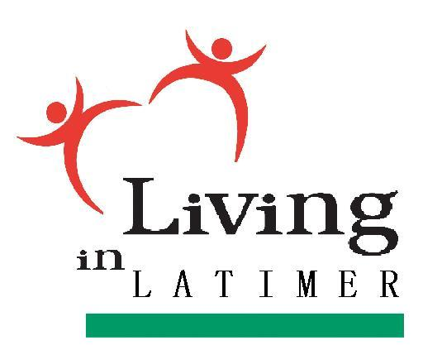 *Please note: new location Work Ready Oklahoma -107 NW 3rd, Wilburton
REGISTRATION FORM
2025

Agency Name:
Contact Name:
Address:
E-Mail:
Phone: Fax:
Presenter(s):
Guest(s):
Will you be setting up an informational booth at the event? □ Yes □ No
Spaces Needed: Electric Needed: □ Yes □ No

Please Register ASAP by E-mail or FAX to:
Claudia Jeffrey at Claudia.Jeffrey@kibois.org | FAX: 918-465-3053
For more information or questions please call Claudia at 918-465-3381.
Deadline: ________________

PROGRAM INFORMATION
9AM - 10AM – Check-in, Setup (YOU WILL NEED TO BRING YOUR OWN TABLE)
10AM – 2:00 PM –Information Booths Open with Networking opportunity.
12 NOON - 2PM – Information Booths Open to the Public
We are requesting each Agency to provide information about their agency/services to all who are in attendance. Please invite anyone from your agency who would benefit from these services. (i.e., personnel who see clients in need of local community resources).
This event is an effort to inform/educate our employees who need to know information for referrals, assistance, etc. as well as bring awareness to community members who may benefit from any and all information presented.
We are requesting a Door Prize from each Agency to be given out during the afternoon. Everyone in attendance will have the opportunity to win a door prize.
Help promote this great event on social media. If you haven’t done so, please consider “liking” our Facebook page. The link is https://www.facebook.com/livinginlatimer.
Thank you for your consideration!

