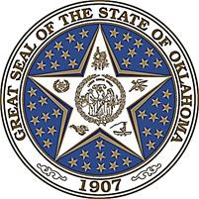

Commission for Educational Quality and Accountability (CEQA) REGULAR MEETING AGENDA
Wednesday, October 19, 2022
1:30 P.M.
5th Floor Conference Room
840 Research Pkwy, OKC, OK 73104

The Commission for Educational Quality & Accountability may take action on any agenda item.

- Call to Order: Secretary Ryan Walters, CEQA Chair

- Introduction of Commission Members and Roll Call: Ms. Ashley Poole, OEQA Administrative Specialist

- Welcome: Ms. Renee Launey-Rodolf, OEQA Interim Executive Director

- Approval of Minutes: August 17th, 2022, CEQA Regular Meeting – Secretary Ryan Walters, CEQA Chair

- Discussion: Proposed Permanent Rule Changes – Ms. Renee Launey-Rodolf, OEQA Interim Executive Director

- Presentation and Discussion – P12 Transfer Audits – Mr. David Kurt, OEQA Senior Coordinator

- Program Updates

- New Business

- Announcements

- Adjournment

Please call the Office of Educational Quality and Accountability (405) 522-5399 if you need special accommodations.

Office of Educational Quality & Accountability • 840 Research Parkway-Suite 455, OKC, OK 73104 • (405) 522-5399

