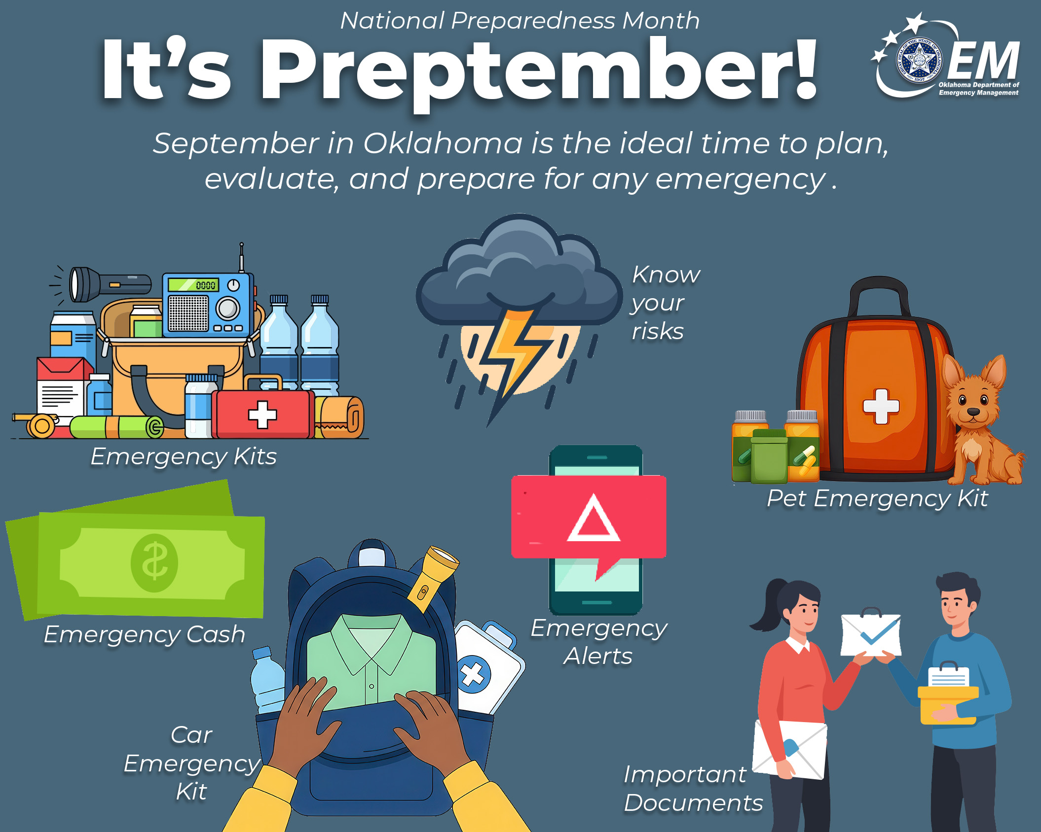

Preptember is here, Oklahoma!
September is the perfect time to take a few simple steps to get #ReadyOK✅ for whatever comes next. Start by talking with your family about where to meet, how to stay in touch📱, and what to do if you need to leave 🏠home quickly. A little planning now can make a big difference later.
Want a step-by-step guide? Check out OEM’s 12-ways to prepare: https://oklahoma.gov/oem/readyok/be-prepared/twelveways.html
#ReadyOK #Preptember #PreparednessMonth

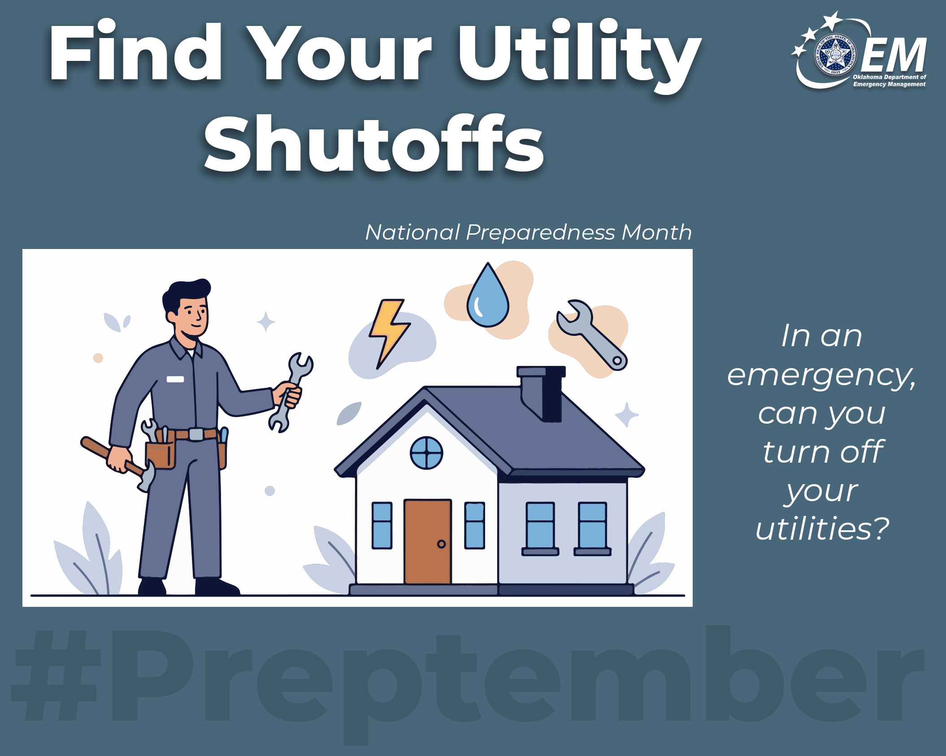

Locate Your Home’s Utility Shutoffs
If a pipe suddenly bursts, could you quickly turn off your water? 💧 After a storm, would you know how to safely shut off your gas?
Take just 10 minutes today to find your home’s main water, gas, and electrical shutoffs 🔧 ⚡🏠 and show everyone in your household where they are and how to use them. A few minutes now can prevent big problems later.
#ReadyOK #Preptember #PreparednessMonth

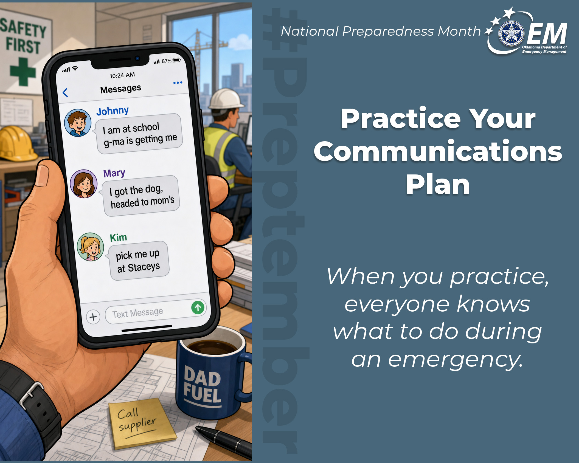

Practice Your Communication Plan
Disaster can strike at any time, and your 👨‍👩‍👧‍👦family might be separated with cell service overloaded or down. Make a simple communication plan now:
📱Text, don’t talk. It’s often easier to send a text or call long distance during an emergency.
✅Pick an out-of-state friend or relative for everyone to contact if you get separated.
2️⃣Choose two meeting places: one near your home and one outside your neighborhood in case you can’t return home.
✏️Write down and/or memorize family and emergency contact numbers and keep copies in your go-kits.
A few minutes of planning today can keep you connected when it matters most.
#ReadyOK #Preptember #PreparednessMonth

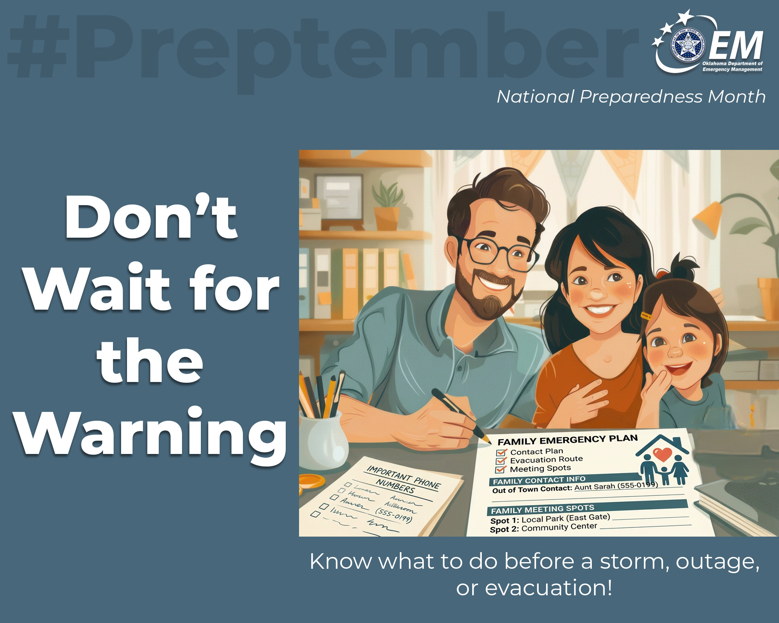

Don’t wait for the warning.
Make your👨‍👩‍👧‍👦 family emergency plan now so everyone knows what to do before a storm, outage, or evacuation. Decide how you’ll reconnect if cell service📱 is down: pick an out-of-town contact, write down important phone numbers, and choose two meeting spots in case you get separated.
Then practice the plan 📋so every person in your home knows who to call, where to go, and what to do. One simple conversation—and a quick drill—can prevent a lot of confusion in an emergency.
Learn more: https://oklahoma.gov/oem/readyok/be-prepared/preparednessathome.html
#PreparednessMonth #Preptember #ReadyOK

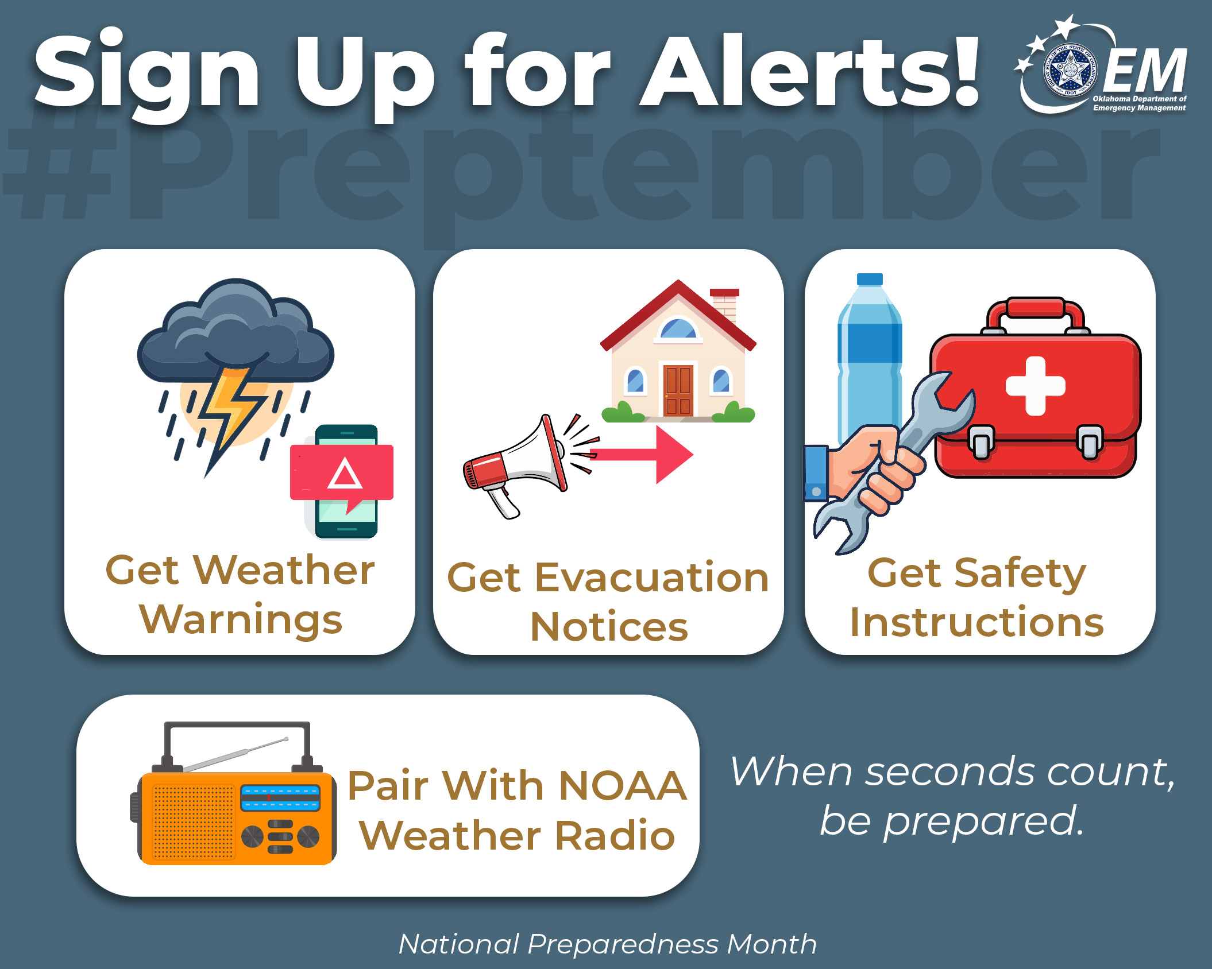

Check Your Alerts
📲🔔✅ Emergency alerts only help if they're turned on. Take one minute today to check your phone's emergency alert settings and make sure everyone in your household receives important notifications. Pair the alerts with a battery-powered or hand-crank NOAA All Hazards Weather Radio.
Learn more: https://oklahoma.gov/oem/readyok/be-prepared/twelveways/alertsandwarnings.html
#PreparednessMonth #Preptember #ReadyOK

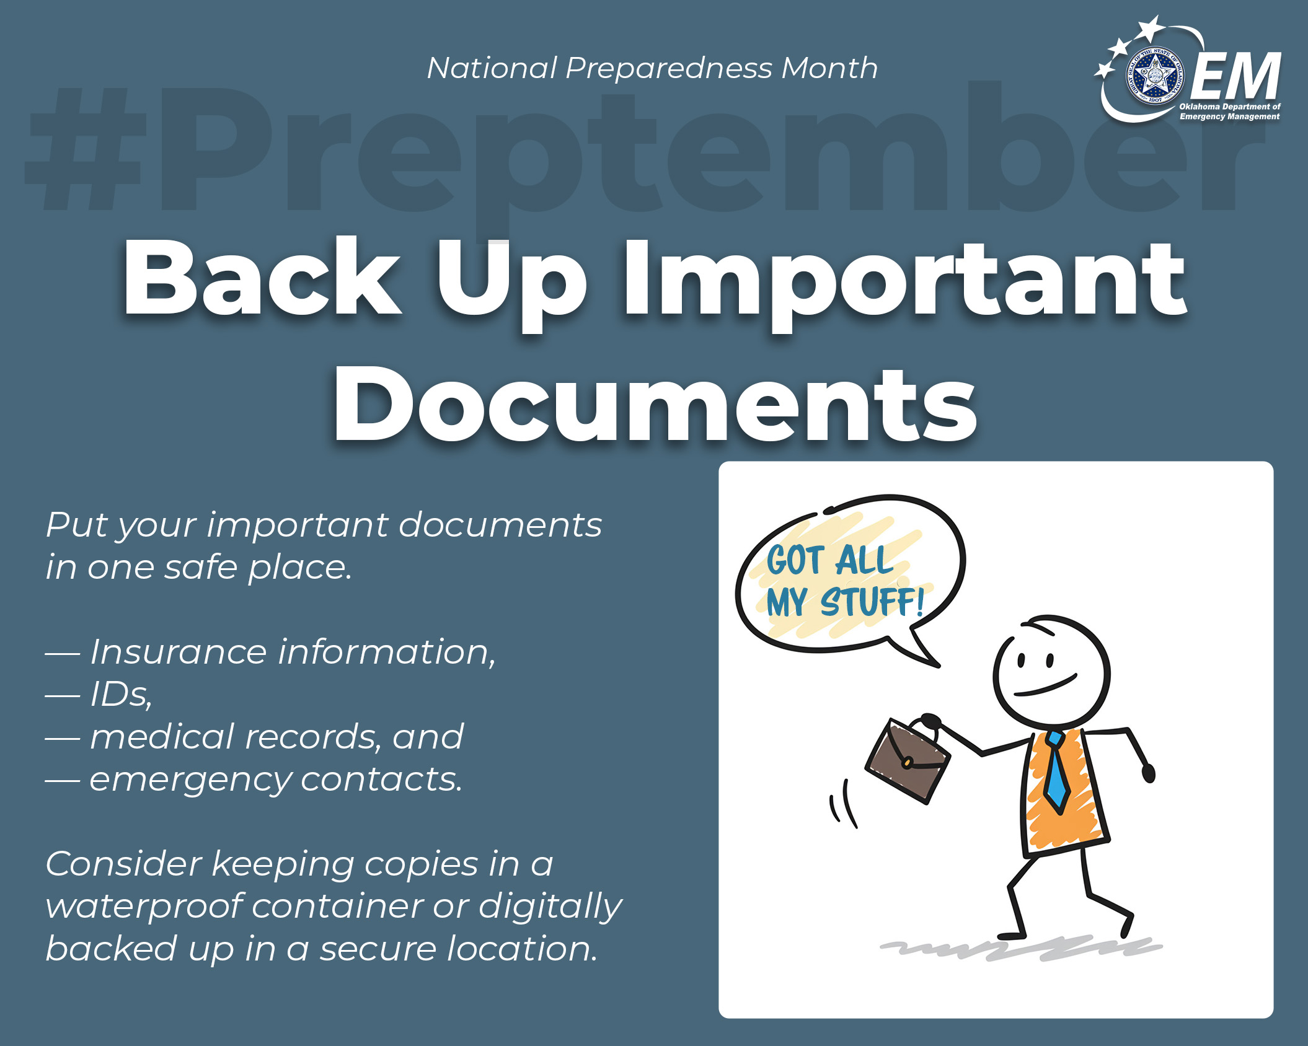

Safeguard Important Documents
Quick access to paperwork speeds recovery. 📂 Gather copies of IDs, insurance policies, medical records, and property documents. Store them in a waterproof, fireproof container and keep digital backups ready to go. 📄 🙌
Learn more: https://oklahoma.gov/oem/readyok/be-prepared/twelveways/safeguard-documents.html
#PreparednessMonth #Preptember #ReadyOK

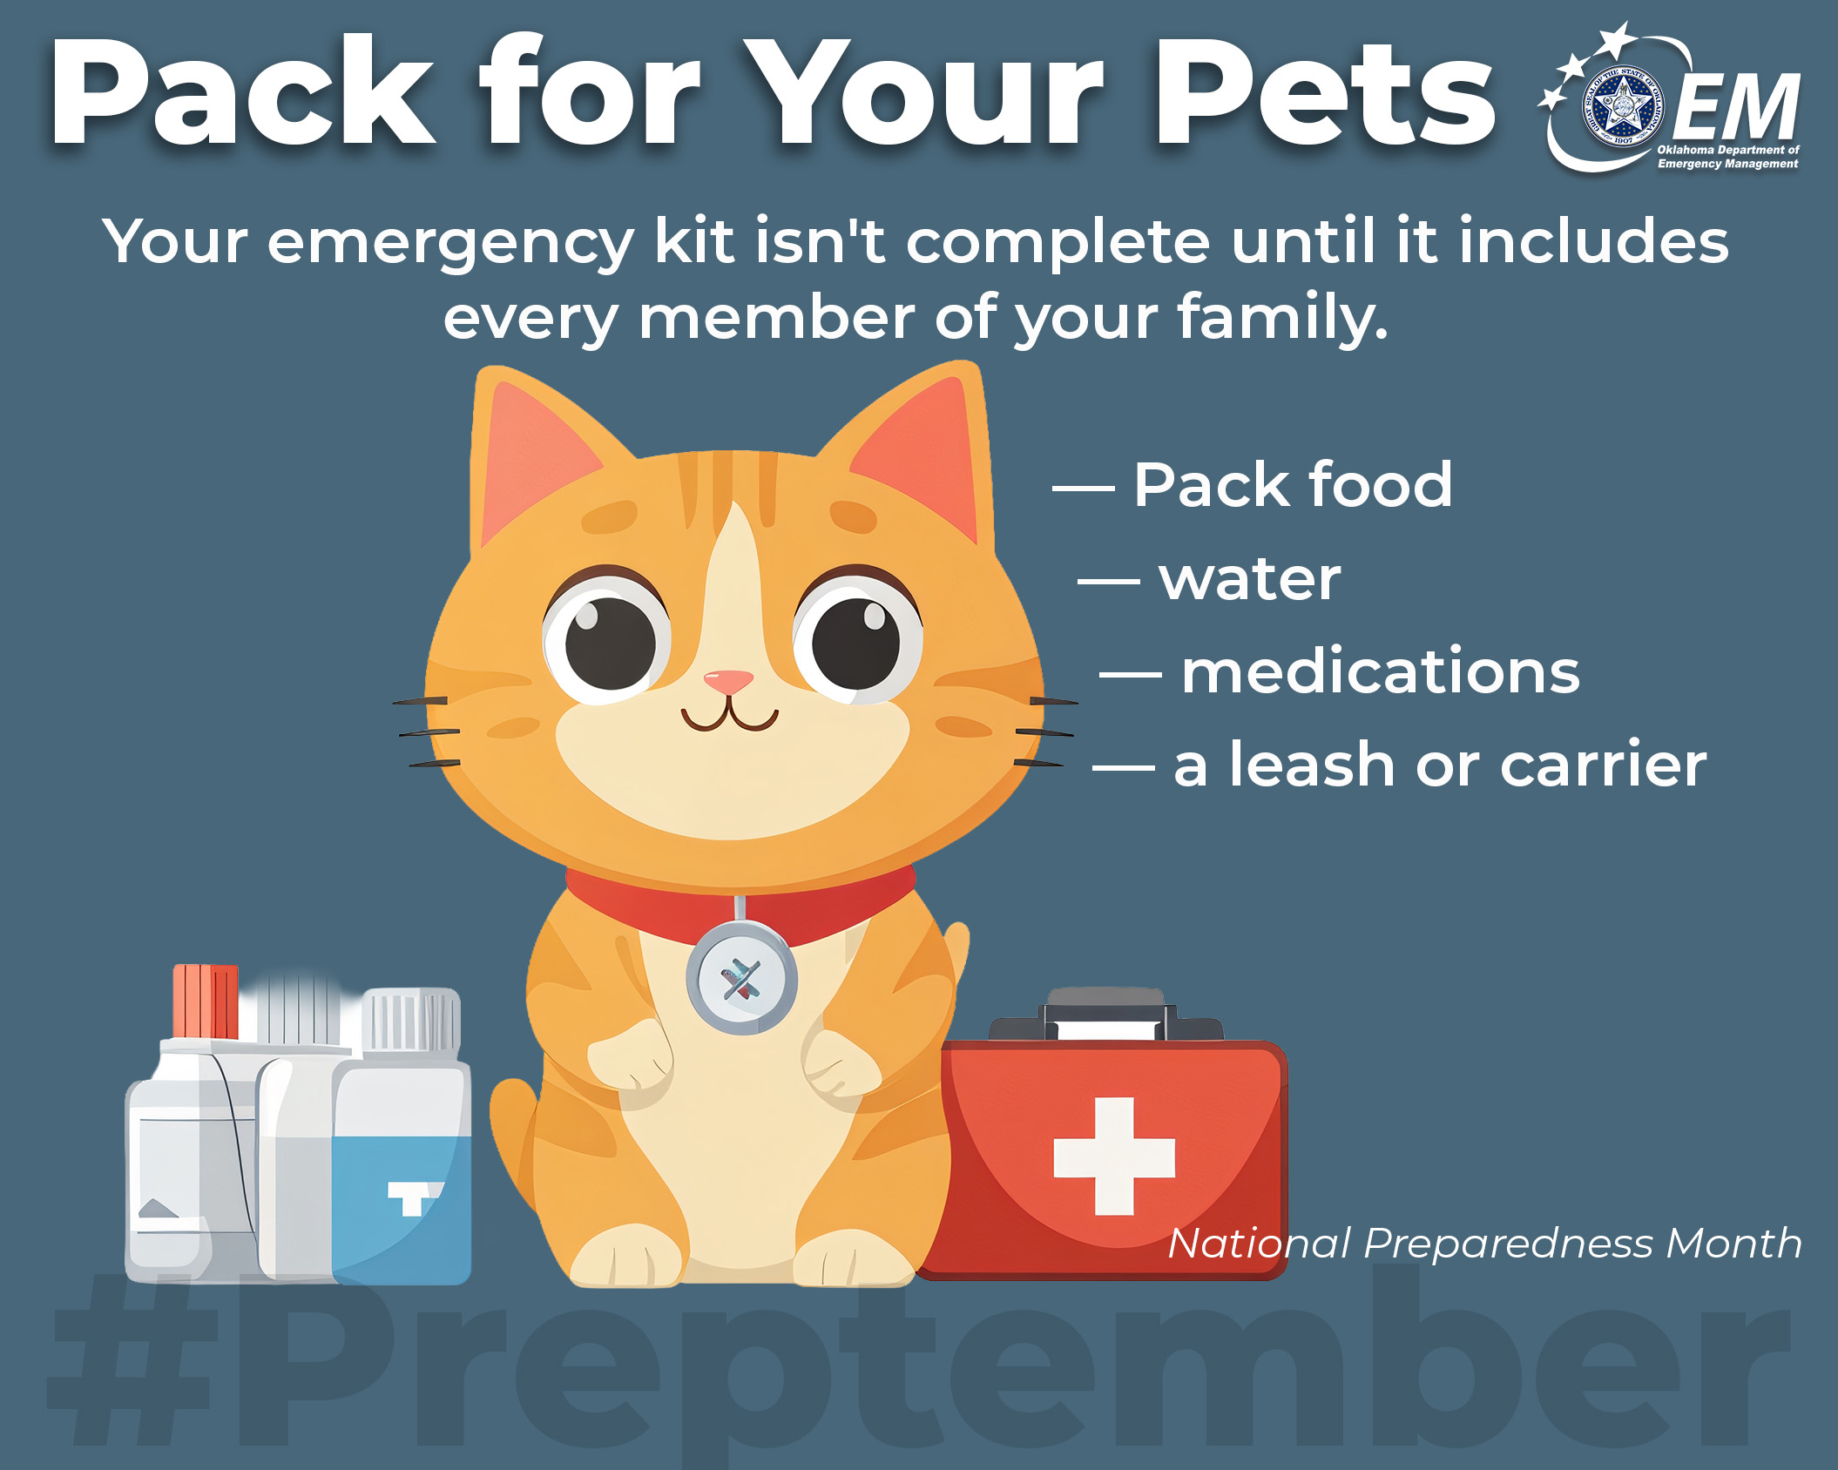

Don’t Forget the Pets
Pets are part of the family. 🐾 Pack food, water, bowls, leashes, medications, and a favorite toy or blanket so they’re ready to go when you are. A little prep keeps every member of the household safe. 🐶 🙌
#PreparednessMonth #Preptember #ReadyOK

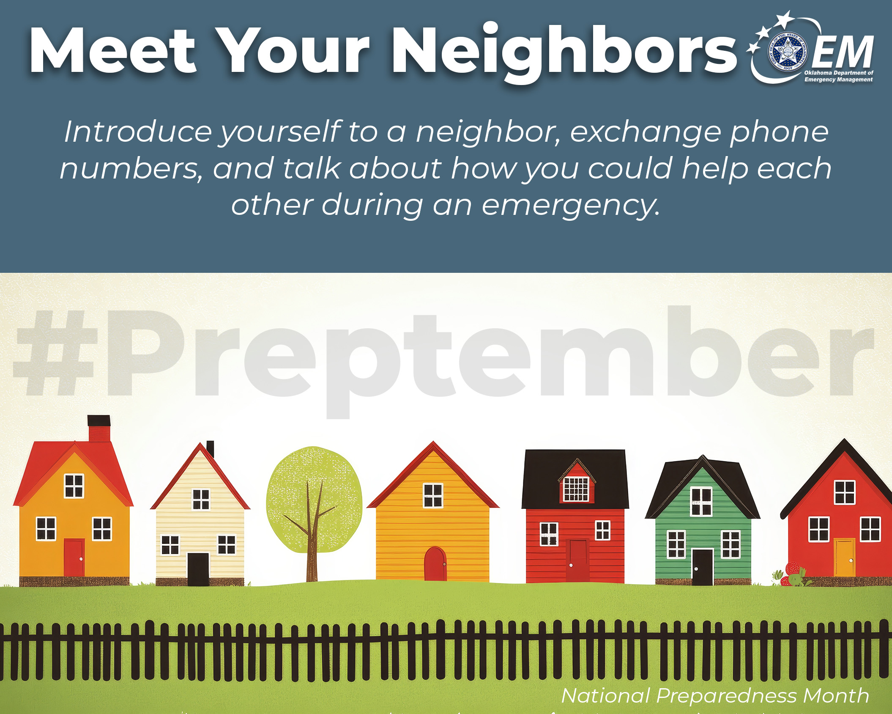

Talk With Neighbors
🤝🏡❤️Introduce yourself to a neighbor, exchange phone numbers, and talk about how you could help each other during an emergency. A shared plan turns neighbors into partners. 🤝 Knowing who can help makes the whole block stronger.
Learn more: https://oklahoma.gov/oem/readyok/be-prepared/twelveways/plan-with-neighbors.html
#PreparednessMonth #Preptember #ReadyOK

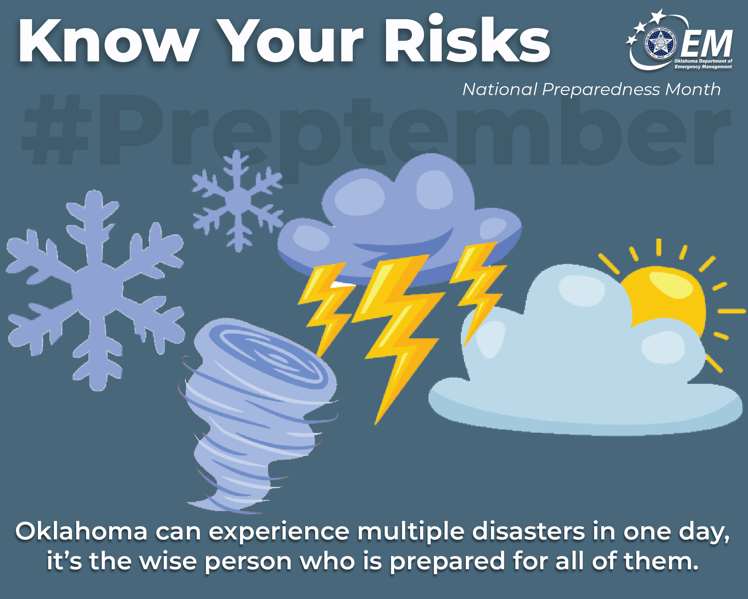

Know your local risks
Every Oklahoma community faces different hazards, from tornadoes and floods to wildfires and winter storms. Take a few minutes to learn what risks are most likely where you live and what to do before they happen. Awareness today can lead to better decisions tomorrow. 🌪️🌊🔥
Learn more: https://oklahoma.gov/oem/readyok/be-aware.html
#ReadyOK #KnowYourRisk #PreparednessMonth #Preptember

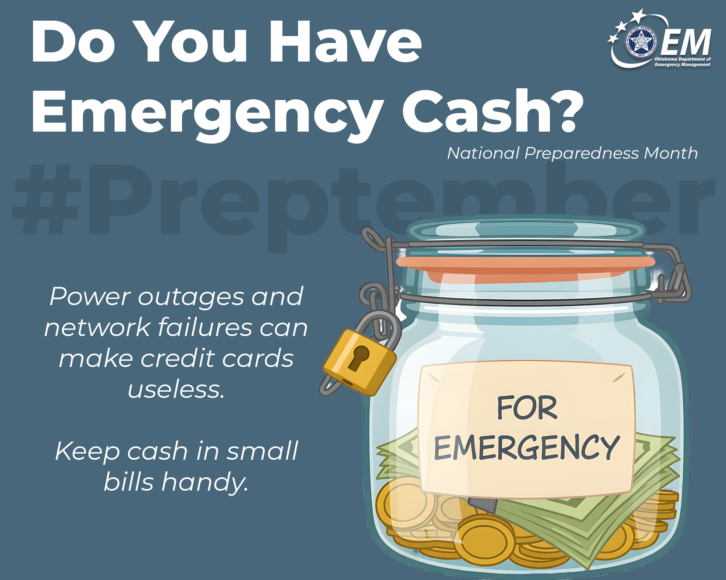

Set Aside Emergency Cash
Power outages and network failures can make cards useless. 💵 Keep a small amount of cash in small bills inside your kit. Even a modest emergency fund can cover gas, lodging, or supplies when you need them most. 💰 🙌
Learn more: https://oklahoma.gov/oem/readyok/be-prepared/twelveways/save-for-emergencies.html
#PreparednessMonth #Preptember #ReadyOK

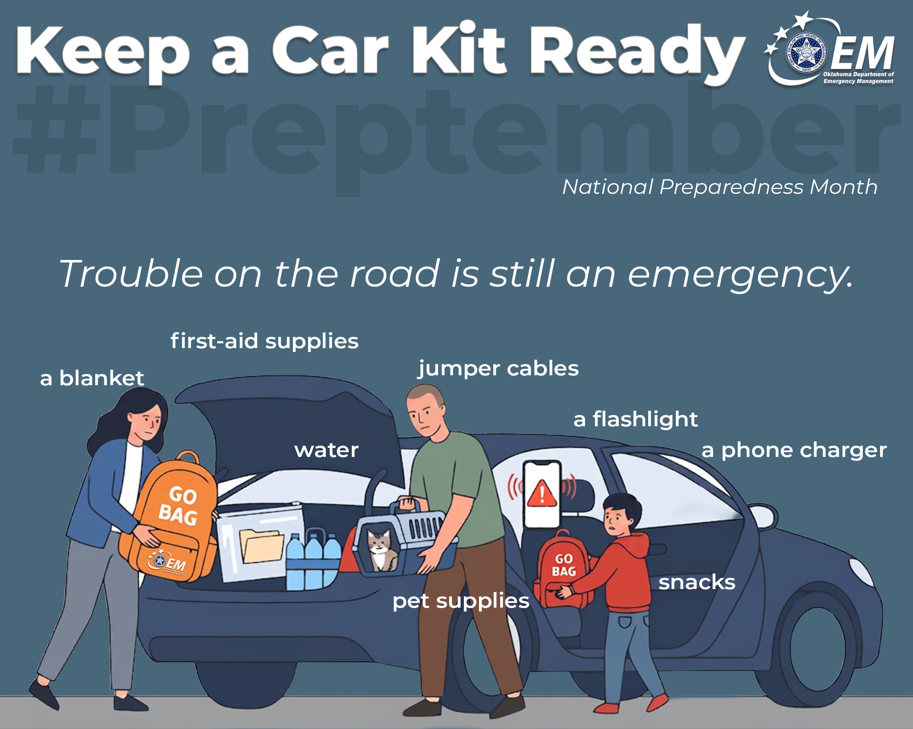

Make your car part of your plan.
🚗Keep a car kit ready with jumper cables, a flashlight, basic tools, water, snacks, a blanket, first-aid supplies, and a phone charger before you need them. Trouble on the road can still be an emergency, and being prepared can make a stressful situation much easier to manage — especially if you commute, travel with kids, or spend a lot of time on the road. 🔦🔋
#PreparednessMonth #Preptember #ReadyOK

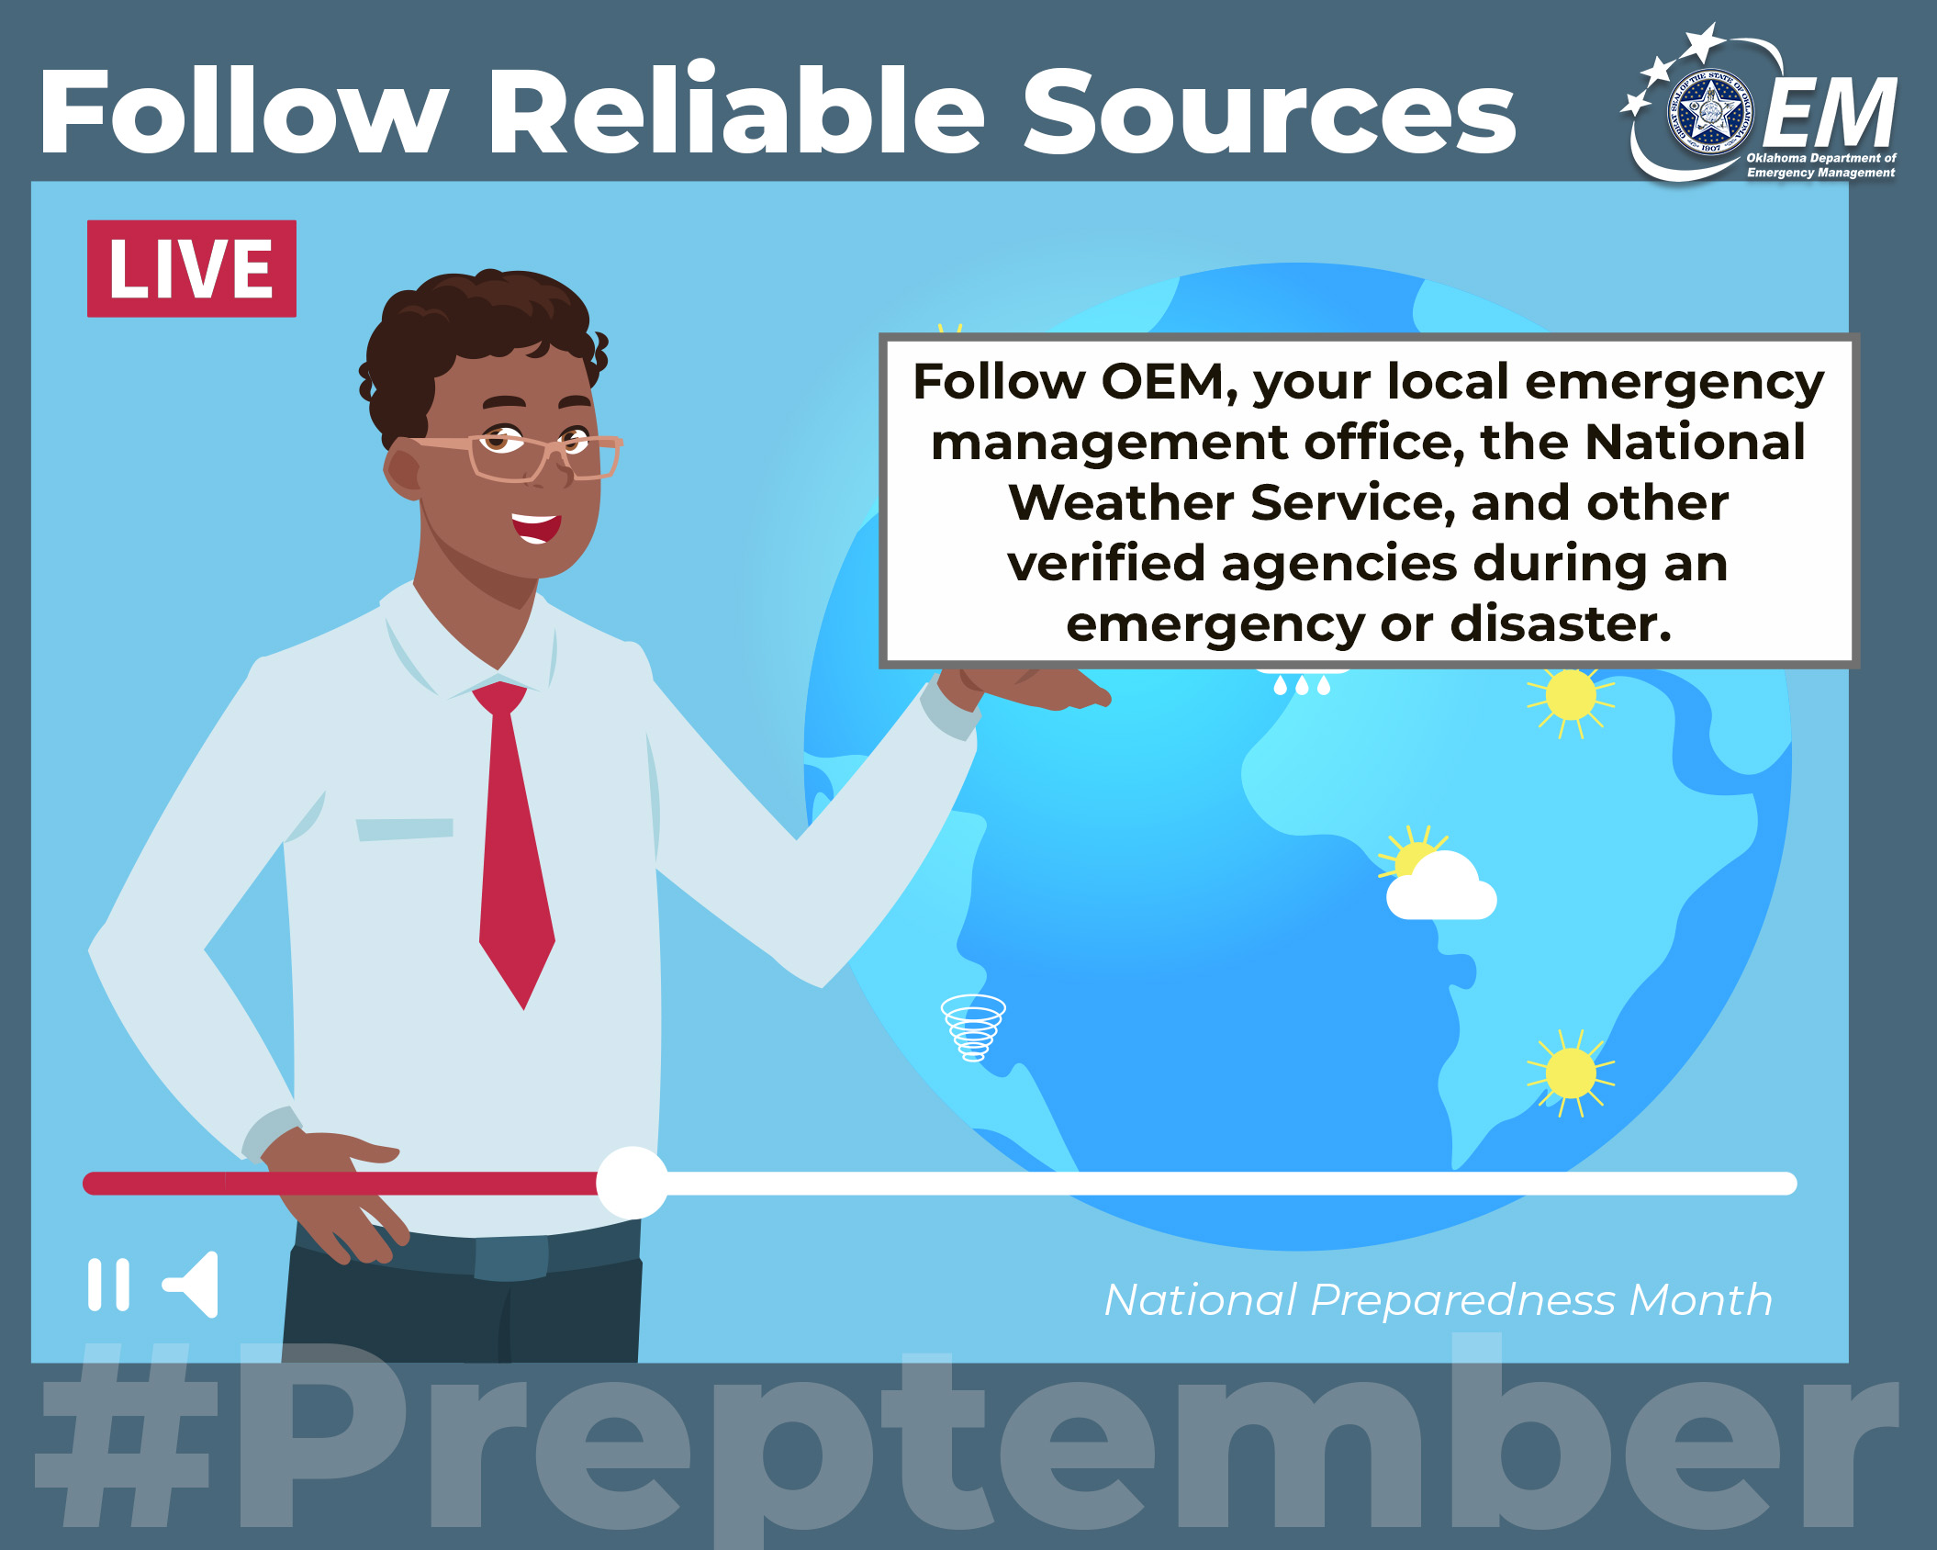

Follow Reliable Sources
When rumors fly, trust official channels. ✅ Follow OEM, your local emergency management office, the National Weather Service, and other verified agencies along with local news media. Accurate information helps you act fast and stay safe. 📡 🙌
#PreparednessMonth #Preptember #ReadyOK

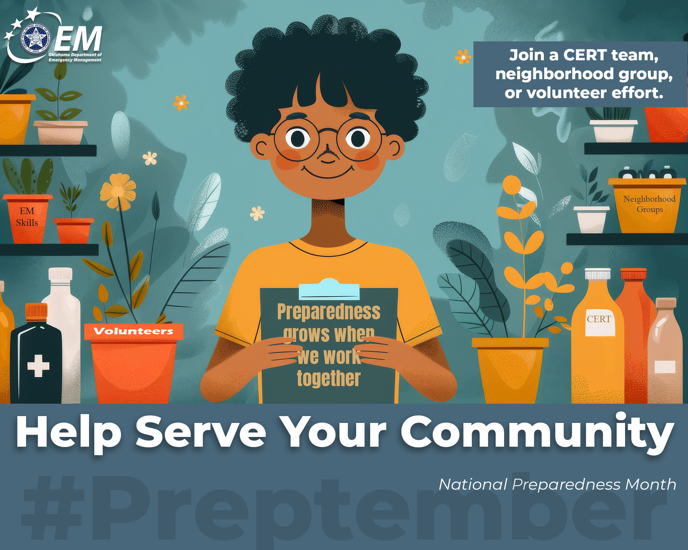

Get Involved in Your Community
Preparedness grows when people work together. 💪 Join a Community Emergency Response Team (CERT), neighborhood group, or volunteer effort. The skills and connections you build now strengthen everyone when a crisis hits. 🤝 🙌
Learn more: https://oklahoma.gov/oem/readyok/be-prepared/twelveways/get-involved-in-community.html
#PreparednessMonth #Preptember #ReadyOK

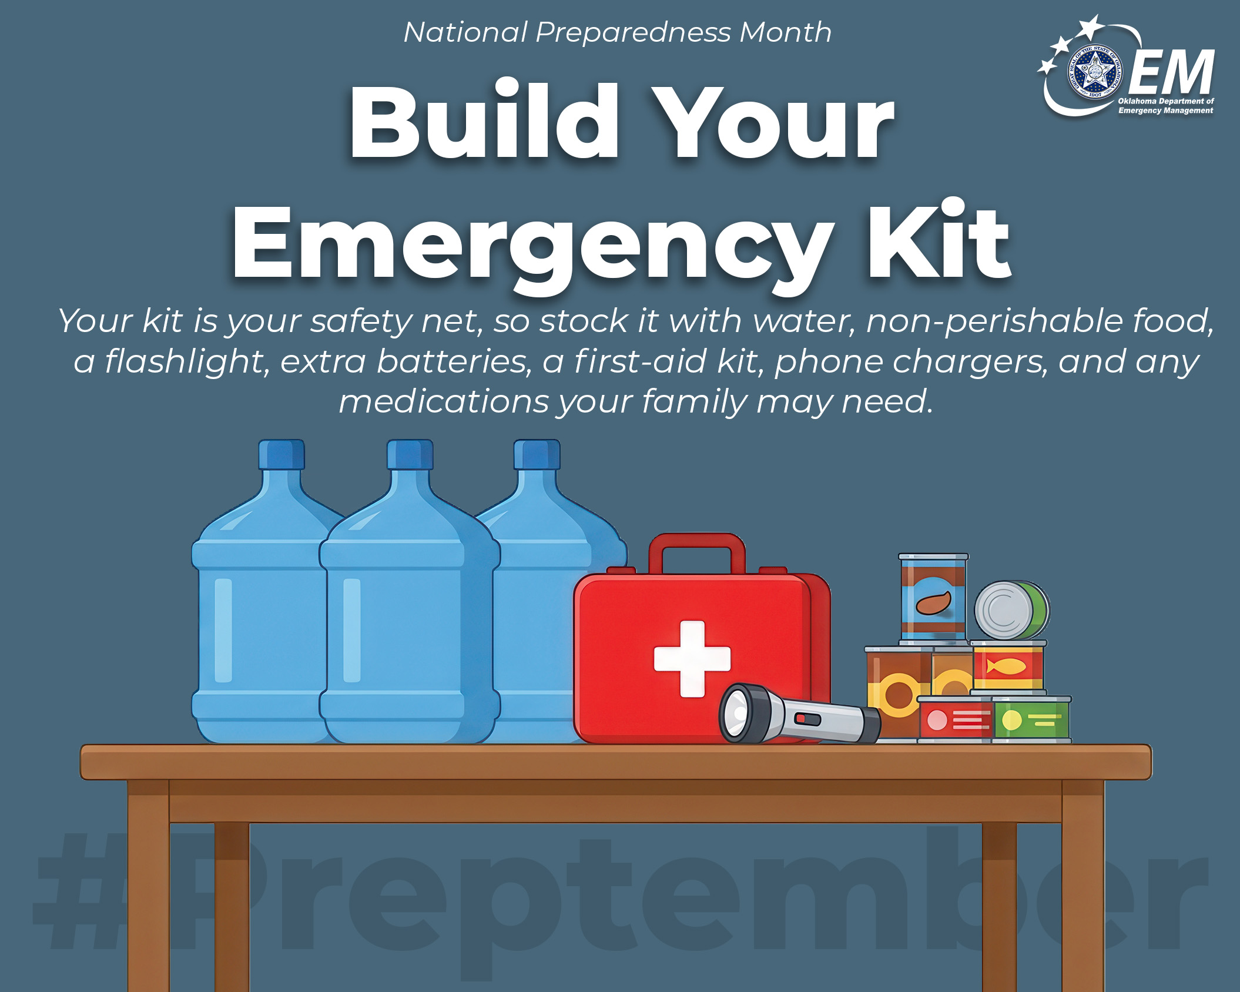

Build or refresh your emergency kit.
Your kit is your safety net, so stock it with water, non-perishable food, a flashlight, extra batteries, a first-aid kit, phone chargers, and any medications your family may need. Add copies of key documents and some small-bill cash, then take a few minutes to replace expired items and fill any gaps. 🧰🔦💧
Learn more: https://oklahoma.gov/oem/readyok/be-prepared/twelveways/assemble-or-update-supplies.html
#PreparednessMonth #Preptember #ReadyOK

