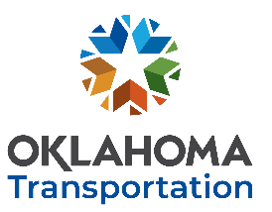
OKLAHOMA DEPARTMENT OF TRANSPORTATION https://oklahoma.gov/odot
RESEARCH IDEA
Please submit no later than December 12th, 2022 to be considered for FFY2024 funding.
Your submission grants ODOT permission to post a request for proposal open to all researchers.
Click here to enter text. Click here to enter text. Click here to enter text.
YOUR NAME TITLE DATE
Click here to enter text. Click here to enter text. Click here to enter text.
INSTITUTION EMAIL PHONE NUMBER
BRIEF DESCRIPTION: (THOSE WHO SUBMIT THIS FORM MAY BE CONTACTED BY ORI PERSONNEL FOR FURTHER CLARIFICATION)
Click here to enter text.

STATEMENT OF HOW YOUR IDEA RELATES TO TRANSPORTATION:
Click here to enter text.

WHAT EVENT, TECHNOLOGY OR INFORMATION SPARKED YOUR IDEA:
Click here to enter text.

HOW DO YOU THINK YOUR IDEA WILL IMPROVE TRANSPORTATION:
Click here to enter text.

ADDITIONAL COMMENTS:
Click here to enter text.

SUBMIT COMPLETED FORM
AS AN EMAIL ATTACHMENT
AND SEND TO: ODOT-spr@odot.org
Address email to:
Ronald F. Curb, Engineering Manager 2
Engineering Services Branch, Office of Research & Implementation

