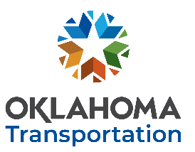
OKLAHOMA DEPARTMENT OF TRANSPORTATION https://www.oklahoma.gov/odot
INNOVATION DISCOVERED
Please submit no later than December 12th, 2022 to be considered for FFY2024 funding.
Your submission grants ODOT permission to post a request for proposal open to all researchers.
Click here to enter text. Click here to enter text. Click here to enter text.
YOUR NAME TITLE DATE
Click here to enter text. Click here to enter text. Click here to enter text.
INSTITUTION EMAIL PHONE NUMBER
BRIEF DESCRIPTION OF INNOVATION DISCOVERED: (THOSE WHO SUBMIT THIS FORM MAY BE CONTACTED BY ODOT PERSONNEL FOR FURTHER CLARIFICATION)
Click here to enter text.

WHERE HAS THE INNOVATION BEEN DEPLOYED? (OTHER THAN OKLAHOMA):
Click here to enter text.

HOW WILL AN OKLAHOMA DEPLOYMENT SAVE LIVES, TIME, MONEY and/or THE ENVIRONMENT?:
Click here to enter text.

WHAT SPECIFICATIONS and/or PROCEDURES MAY REQUIRE REVISION PRIOR TO TEST DEPLOYMENT:
Click here to enter text.

ADDITIONAL COMMENTS:
Click here to enter text.

SUBMIT COMPLETED FORM
AS AN EMAIL ATTACHMENT
AND SEND TO: ODOT-spr@odot.org
Address email to:
Ronald F. Curb, Senior Engineering Manager
Office of Research & Implementation

