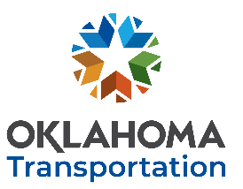
OKLAHOMA DEPARTMENT OF TRANSPORTATION hhttps://www.oklahoma.gov/odot
RESEARCH CONTINUATION REQUEST
Please submit no later than December 12th, 2022 to be considered for FFY2024 funding.
Your submission grants ODOT permission to post a request for proposal open to all researchers.
Click here to enter text. Click here to enter text. Click here to enter text.
YOUR NAME TITLE DATE
Click here to enter text. Click here to enter text. Click here to enter text.
INSTITUTION EMAIL PHONE NUMBER
CURRENT ITEM # AND PROJECT TITLE:
Click here to enter text.

BRIEF DESCRIPTION OF PROPOSED CONTINUED WORK:
Click here to enter text.

STATEMENT OF JUSTIFICATION AND ODOT SUPPORT:
Click here to enter text.

ADDITIONAL COMMENTS:
Click here to enter text.

PROPOSED PRINCIPAL INVESTIGATOR AND ODOT SUBJECT MATTER EXPERT, IF NOT YOU:
Click here to enter text.

Co-Signers:

Principal Investigator Date |  | ODOT Subject Matter Expert Date

SUBMIT COMPLETED FORM
AS AN EMAIL ATTACHMENT
AND SEND TO: bhurst@odot.org
Address email and Cc:
Ronald F. Curb, Engineering Manager 2
Engineering Services Branch, Office of Research & Implementation Form RCR-R1

