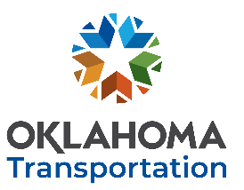
OKLAHOMA DEPARTMENT OF TRANSPORTATION hhttps://www.oklahoma.gov/odot
RESEARCH CONTINUATION REQUEST
Please submit no later than November 30th, 2023 to be considered for FFY2025 funding.
Your submission grants ODOT permission to post a request for proposal open to all researchers.
Click here to enter text. Click here to enter text. Click here to enter text.
YOUR NAME YOUR TITLE DATE
Click here to enter text. Click here to enter text. Click here to enter text.
YOUR INSTITUTION YOUR EMAIL YOUR PHONE NUMBER
CURRENT PROJECT ITEM # AND TITLE:
Click here to enter text.

BRIEF DESCRIPTION OF PROPOSED CONTINUED WORK:
Click here to enter text.

STATEMENT OF JUSTIFICATION AND ODOT SUPPORT:
Click here to enter text.

ADDITIONAL COMMENTS:
Click here to enter text.

PROPOSED PRINCIPAL INVESTIGATOR AND ODOT SUBJECT MATTER EXPERT, IF NOT YOU:
Click here to enter text.

Co-Signers:

Principal Investigator Date |  | ODOT Subject Matter Expert Date

SUBMIT COMPLETED FORM
AS AN EMAIL ATTACHMENT
AND SEND TO: ODOT-spr@odot.org
Address email to:
Ron F. Curb, PE Engineering Manager
Research & Implementation
Office of Innovation Form RCR-R2

